Clustering Project
The aim of this project is to perform clustering techniques on an artificial dataset and then use them on a real problem.

Theoretical part:

First a plot of the original data
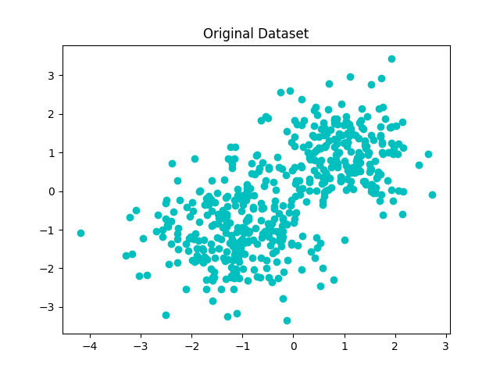
After performing K-means and Mixture of Gaussians, given multiple number of clusters, we obtain the following picture:

