Section 1: Picture in Picture using 2 webcams in Linux via Skype

- Install Skype version 2.1 beta (this is not the latest version of Skype)
  - Uninstall any existing versions of Skype
    - $ sudo apt-get remove skype
  - Download the .deb:
    - 64-bit: http://archive.canonical.com/ubuntu/pool/partner/s/skype/skype_2.1.0.81-1ubuntu5_amd64.deb
    - 32-bit: http://archive.canonical.com/ubuntu/pool/partner/s/skype/skype_2.1.0.81-1ubuntu5_i386.deb
  - Install that version by double-clicking the .deb and following the steps. You shouldn't need any additional packages.
- Install webcamstudio
  - Go to: http://code.google.com/p/webcamstudio/downloads/list
  - Select 0.57 beta 2 deb package
  - Double-click to install it.
  - Run webcamstudio:
    - $ webcamstudio
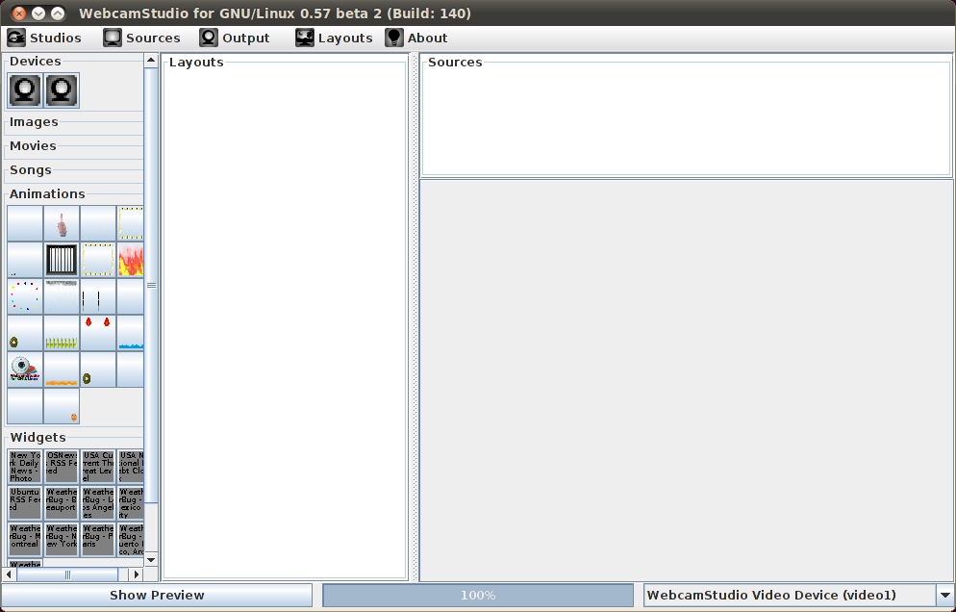

Configure webcam parameters:
- Click on both webcams in the upper left under Devices.
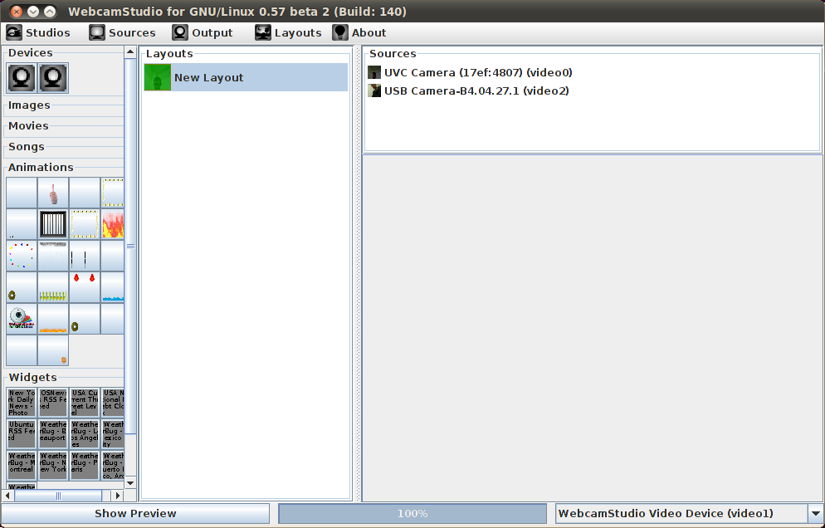
- Set the Output size to 640x480
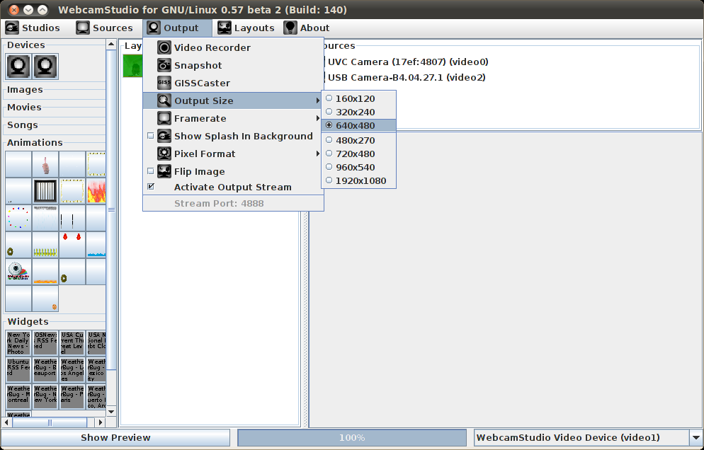
- Set the Framerate to 15 fps
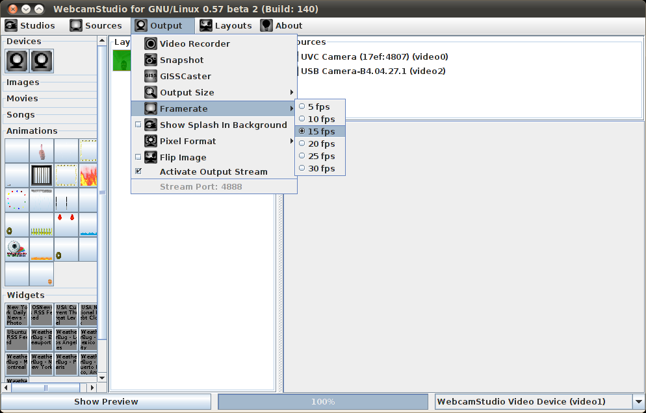
- Set the pixel format to UYVY
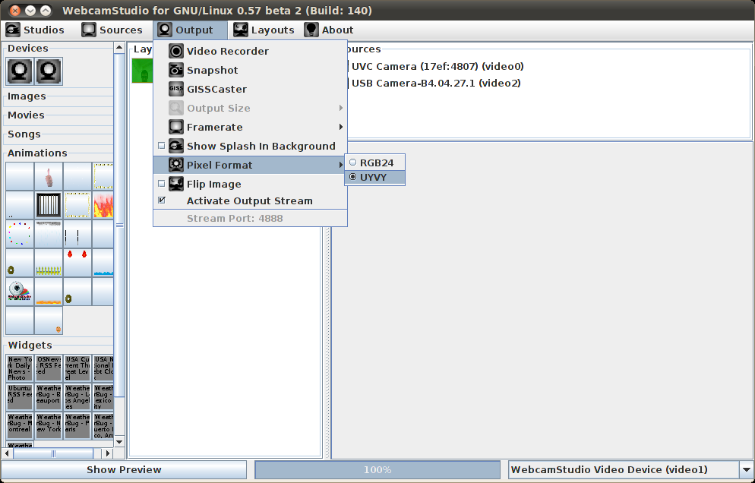
- Ensure Activate Output Stream is selected
- Ensure WebcamStudio Video Device (video#) is selected in the bottom right box.

Set up the Picture in Picture Parameters

- Select the camera you want to use for the main view (if you look very carefully you should see tiny live thumbnails of each image).
- Set the width to 640 and the height to 480
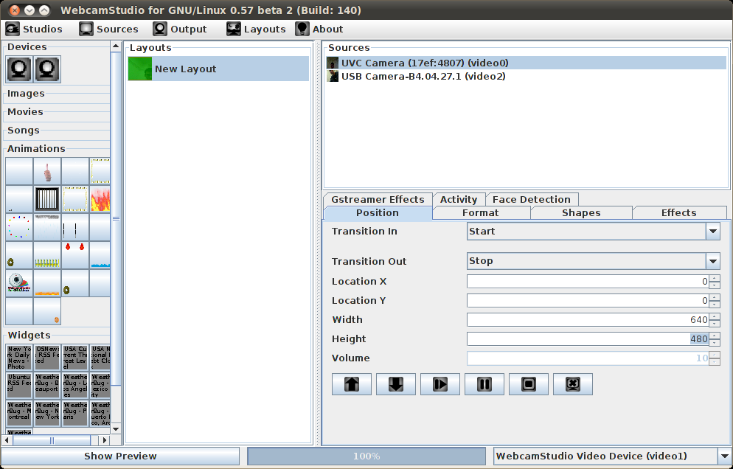
- Select the second camera
- Set the width and height appropriately (I used 100x100)
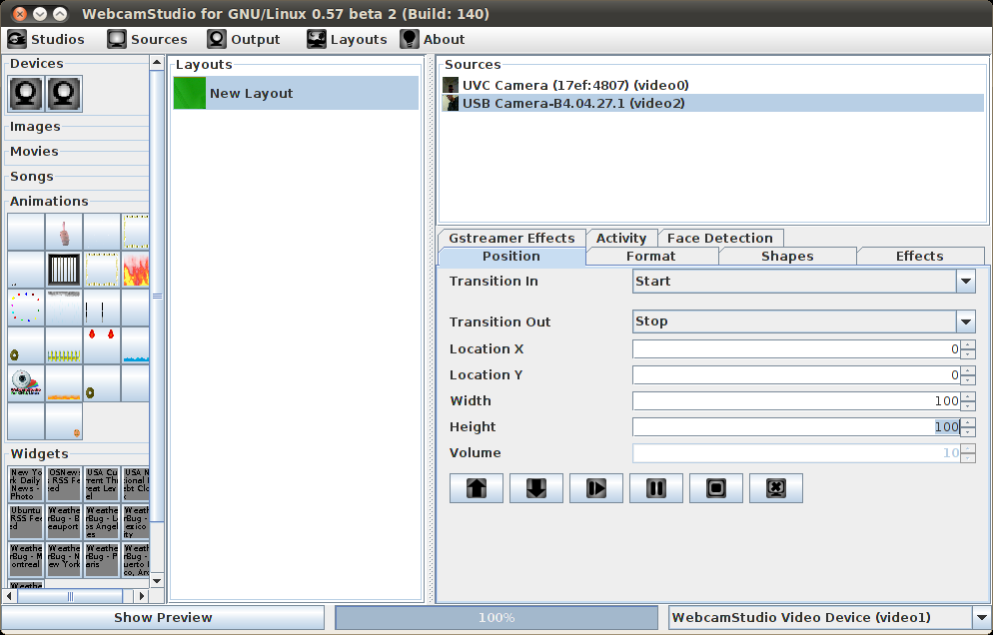
- Press the Up Arrow button to ensure that this camera is “on top.”
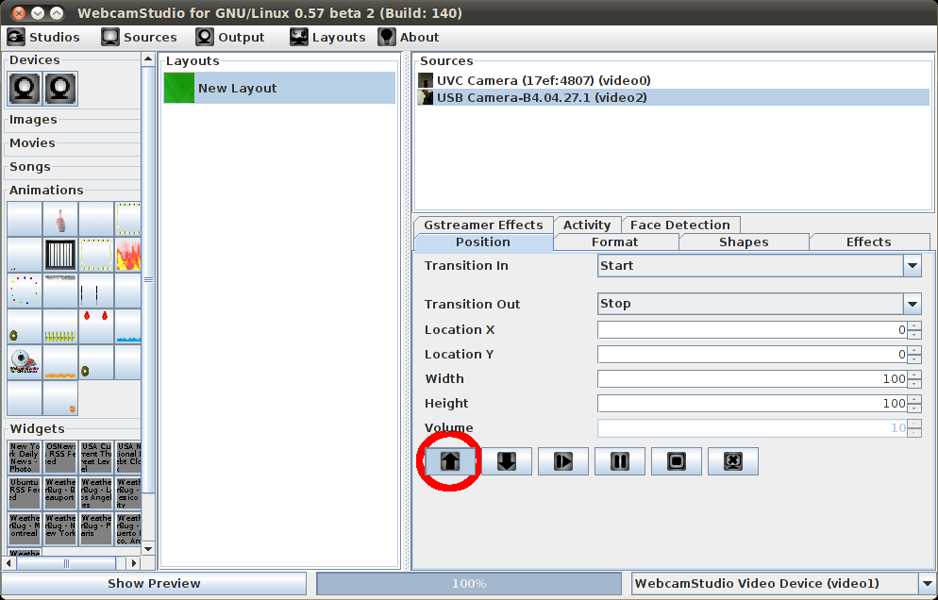
- Save the setup so next time you can load it easily. Studios > Save
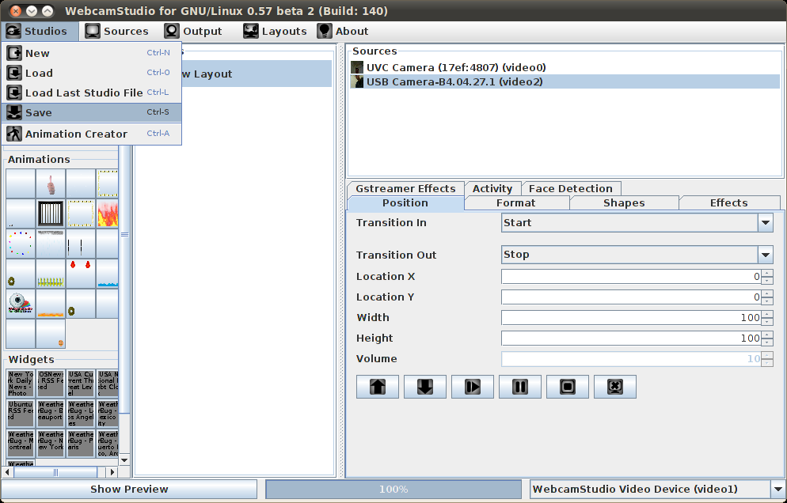
- Start the camera capture by right clicking on New Layout and selecting Activate
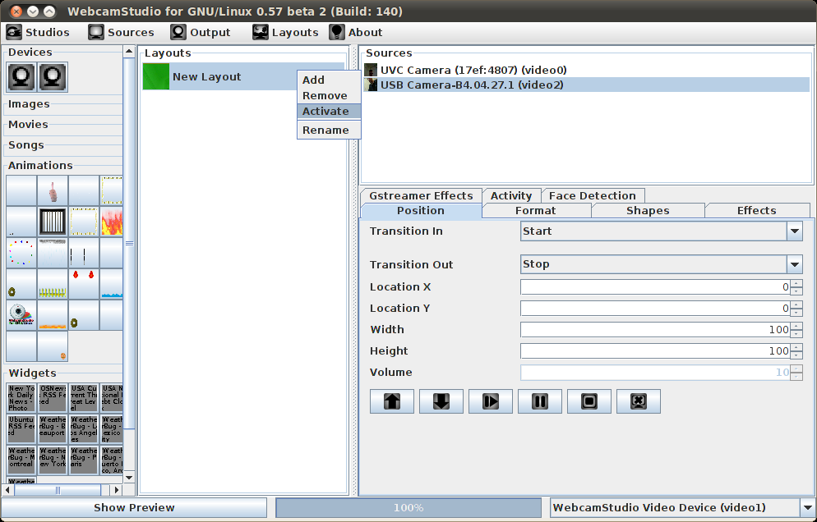
- Open Skype
- Sign in
- Open Options and go to Video Devices
- Select WebcamStudio as the webcam
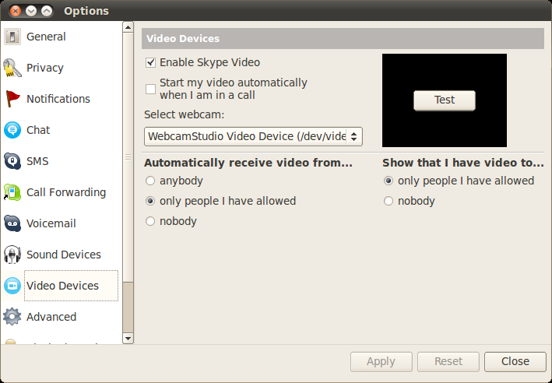
- You're ready to go! Try out a picture in picture call!

Section 2: Using the Skype API to Receive Commands Over Chat

- Install dependences
  - $ sudo apt-get install python-xlib
- Unpack telebotSkype.tar.gz into a convenient location.
  - $ tar -xvzf telebotSkype.tar.gz
  - With Skype running, run telebot_skype_chat.py
  - $ ./telebot_skype_chat.py
  - You should receive a message from Skype that a program is trying to connect. Allow it to, and remember the program.
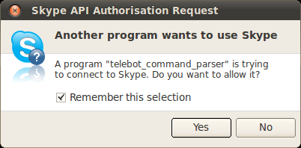
  - Now you should be ready to roll! Edit the commands you want in the source of telebot_skype_chat.py
