Fin & Shading Length Study
UTCI Performance vs. Vertical/Horizontal Shading Depth — 2070 SSP5-8.5 EPW
Atin Punyanitya | KMITL Architecture | Experiment Summary

1. Purpose
This experiment tests how the depth of combined vertical and horizontal shading fins affects outdoor thermal comfort (UTCI) on a generic Bangkok block, under the projected 2070 SSP5-8.5 climate scenario. The goal was to find the point at which extending the fins further stops producing a meaningful reduction in UTCI — the diminishing-returns threshold for passive shading.

2. Experiment Setup
Simulation run in Grasshopper with Ladybug UTCI analysis, using the morphed 2070 SSP5-8.5 EPW file as the climate input.
Parameter | Value
Test date / time | 24 April, 14:00 (peak solar / heat-load condition)
Climate input | Morphed EPW, 2070, SSP5-8.5
Analysis grid | 2.50 m grid size
Sensor height | 1.65 m (HumanToSky height)
Test points per iteration | 323
Context geometry | Surrounding buildings, floor slabs, walls, tower mass, plus vertical and horizontal shading fins
Shading increment | Vertical and horizontal fins extended 20 cm per iteration, from 0.20 m up to 3.60 m
Table 1. Simulation parameters.

3. Results

3.1 Per-Iteration UTCI Distribution
Across the 323 test points per iteration, the highest recorded UTCI value across all iterations was 46.28°C, occurring at the west and south-west grid points — consistent with low afternoon sun angles from those directions. The raw per-point plot shows a repeating ripple pattern, which is an artefact of how Grasshopper orders the test points (alternating south grid / north grid columns) rather than a real spatial signal.
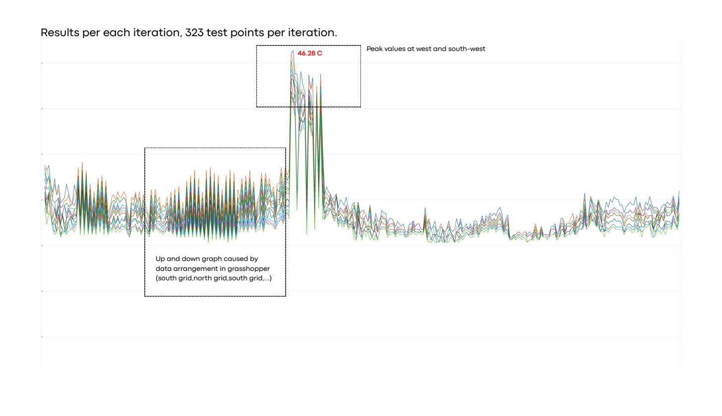
Figure 1. UTCI per test point, all iterations overlaid. Peak 46.28°C at west/south-west.

3.2 Average Temperature vs. Shading Length
The site-wide average UTCI decreases as shading length increases, but the rate of improvement drops off sharply. Average temperature falls from about 41.96°C at 0.20 m of shading to about 41.41°C at 3.60 m — a total reduction of roughly 0.55°C across the entire 3.4 m range tested. Most of that gain occurs in the first 1.5–2.0 m; beyond that, each additional 20 cm buys only a fraction of a degree.
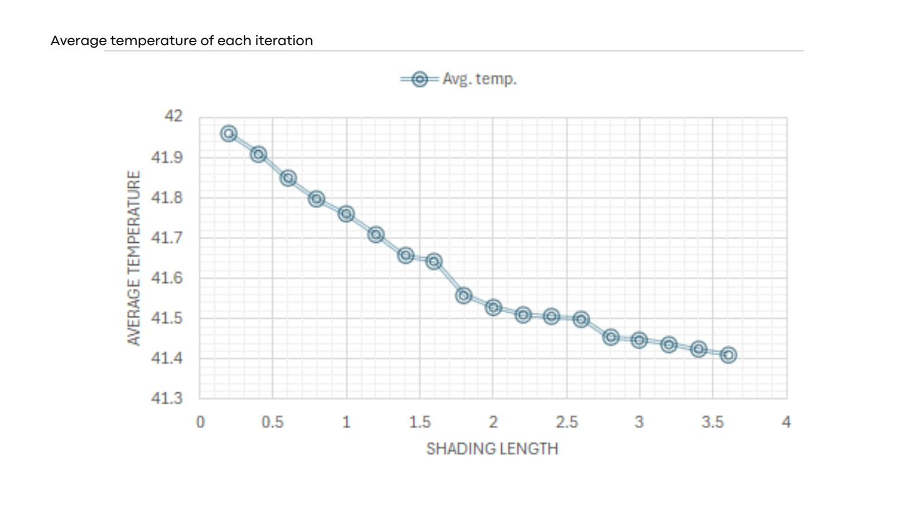
Figure 2. Average UTCI per iteration, plotted against shading length (m).

3.3 Min / Max Stabilisation
Tracking minimum, maximum, and mean UTCI per iteration revealed a stabilisation pattern:
- Minimum UTCI locks at 41.07064°C from 0.60 m of shading onward and does not change through 3.60 m.
- Maximum UTCI locks at 44.18714°C from 1.80 m through 3.40 m, then drops slightly at 3.60 m.
- Mean UTCI continues to decrease across the full range, but in progressively smaller increments.
Working logic applied: once an iteration produces no change (Δ = 0) across three consecutive data sets (min, max, mean), further shading extension at that depth was treated as not worth pursuing — since minimum values typically stop changing once shading extends past 1.00 m, and maximum reduction was prioritised because it represents the most extreme exposure point.

3.4 Selected Iterations
Based on the stabilisation pattern, three iterations were selected for detailed comparison: 1.40 m, 2.00 m, and 2.60 m of shading length.
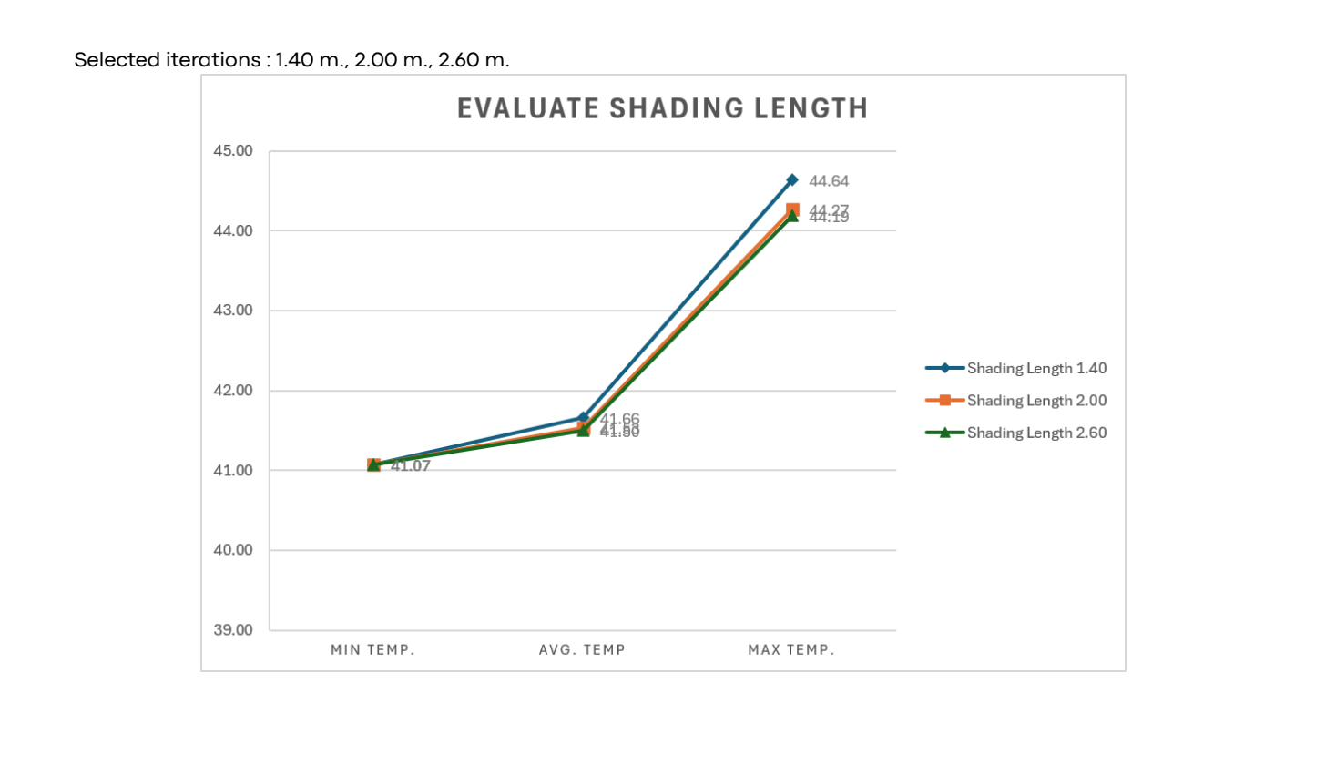
Figure 3. Min / average / max UTCI for the three selected shading lengths.
Temp. data | 1.40 m | 2.00 m | 2.60 m
Max. temp. (°C) | 44.64 | 44.27 (Δ 0.37) | 44.19 (Δ 0.45)
Min. temp. (°C) | 41.07 | 41.07 (Δ 0.00) | 41.07 (Δ 0.00)
Avg. temp. (°C) | 41.66 | 41.53 (Δ 0.13) | 41.50 (Δ 0.16)
Table 2. Performance comparison of selected iterations, with Δ measured against the 1.40 m baseline.
Increasing shading length from 2.00 m to 2.60 m reduced peak temperature by a further 0.08°C and average temperature by a further 0.03°C — confirming the diminishing-returns pattern already visible in the average-temperature curve (Figure 2).
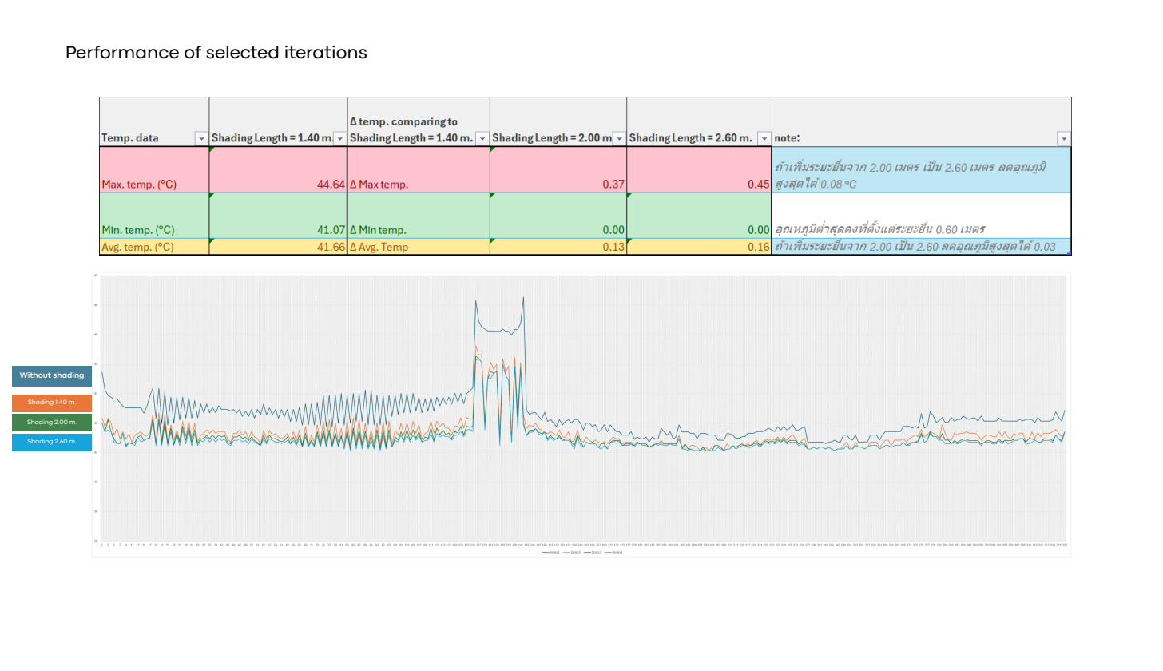
Figure 4. Full-day UTCI performance comparison: no shading vs. 1.40 m, 2.00 m, and 2.60 m shading.

4. Summary of Findings
- Shading is effective but bounded: extending fins from 0.20 m to 3.60 m reduces average UTCI by only ~0.55°C total, with most of that gain captured in the first 1.5–2.0 m.
- Minimum UTCI (41.07°C) is fixed from 0.60 m of shading onward — no amount of additional fin depth lowers it further at this sun angle and geometry.
- Maximum UTCI plateaus near 44.19–44.27°C from 1.80 m onward, with only marginal reduction (0.08°C) between 2.00 m and 2.60 m.
- The 1.40 m / 2.00 m / 2.60 m comparison set was selected as the range where additional shading depth produces measurable but rapidly diminishing returns.
- An open question remains whether the observed stabilisation in min/max values reflects a true geometric limit (the fin already blocks the maximum possible solar vector at this sun angle) or is partly an artefact of the 2.50 m analysis grid being too coarse to register smaller incremental shifts. This should be checked by re-running a subset of iterations at a finer grid resolution (e.g. 1.25 m) to see whether the locked values move.

