Adidas Website Clone Project

Table of Contents.

1. Introduction

2. Project Details

3. Features

4. Technologies

5. Challenges

6. References

7. Conclusion

Introduction.

This project is a clone of the Adidas website, focusing on replicating the footer section and implementing card carousels for the Men, Women,

and Kids sections.The goal was to create a visually appealing and responsive design using only HTML and CSS.

Project Details.

The Footer section was meticulously recreated to match the style of the Adidas website.

It includes links to various sections, social media icons, and copyright information.

The Men's Carousel mirrors the Women's Carousel but features Adidas products tailored for men.

It provides a visually engaging way for users to explore and navigate through the showcased products.

Similar to the Women's Carousel, HTML and CSS were utilized for structure and styling.

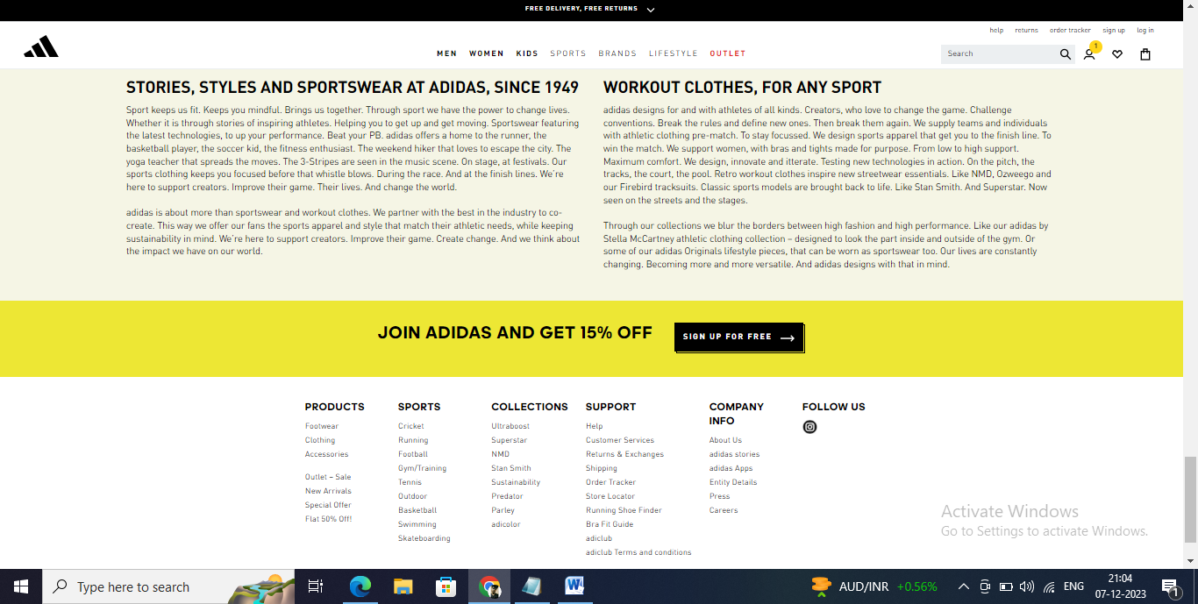

Features.

Footer Section: Implemented a replica of the Adidas website footer with relevant links and information.

Card Carousels:

* **Product Highlights:**

The carousel features a carefully chosen assortment of men's products, emphasizing popular and seasonal items.

* **Smooth Transitions:**

Users can navigate effortlessly through the carousel, thanks to smooth transitions between product cards. The design ensures a visually pleasing experience.

* **Responsive Design:**

The Men's Carousel adapts seamlessly to various screen sizes and resolutions, maintaining a consistent and attractive display across desktops, tablets, and mobile devices.

* **Interactive Navigation:**

Intuitive navigation controls, including arrow buttons and indicators, allow users to explore the showcased products at their own pace.

Technologies

The project was developed using the following technologies:

- HTML5

- CSS3

**FONT AWESOME**

Font Awesome is a comprehensive icon library that offers a vast selection of icons for various purposes, such as user interface design, web development and graphic design

Challenges

While working on the project, several challenges were encountered, including:

* Achieving responsive design across various devices.
* Ensuring compatibility with different web browsers.

References

* Adidas Official Website(https://www.adidas.com/)

Conclusion.

In conclusion, the project successfully replicated the footer section and implemented card carousels for Men, Women, and Kids sections, showcasing the ability to create a visually appealing and functional design using only HTML and CSS.