TenderCheck Installation and User Guide
This guide explains how to install and launch TenderCheck, configure model weights and environment variables, and complete an end-to-end bid compliance review workflow across project creation, document confirmation, automated verification, source-evidence inspection, bid remediation, and report export.
TenderCheck runs locally as a Streamlit web application. The user interface resides in SystemCode/src/app (with main.py as the entry point), while the processing and verification pipeline resides in SystemCode/src and is coordinated through tcui/real_backend.py and tcui/service.py across requirement classification, multi-document hybrid retrieval, structured slot extraction, and the symbolic rule engine (R01 to R09).

1 System Requirements
Before running TenderCheck, ensure that the local machine satisfies the following software and model requirements:
Component | Requirement and Configuration
Operating System | Windows, macOS, or Linux.
Python Version | Python 3.11 (verified on Python 3.11.9).
Python Dependencies | The root requirements.txt serves as the single unified dependency file for the entire system, covering the Streamlit interface, PyMuPDF parsing, PyTorch/Transformers classifiers, and OpenPyXL export (with numpy pinned to 1.x and pyarrow pinned to 16–19).
Classification Model Weights | Download the fine-tuned eight-class weight file model.safetensors (approximately 400 MB) from the Google Drive link in README.md and place it in SystemCode/models/roberta_wwm_ext/. Optionally place binary_filter/ in SystemCode/models/binary_filter/ (otherwise the built-in 24-feature structural scorer is used automatically).
DeepSeek API Key | Configure DEEPSEEK_API_KEY via an environment variable or root .env file for live structured slot extraction and AI remediation suggestions; if unconfigured, the system falls back to the offline rule-based extractor.
Web Browser | Current version of Chrome, Edge, or Firefox.

2 Installation
Run the following commands from the repository root in Windows PowerShell or a macOS/Linux terminal:
- Clone the repository and enter the project root directory.
git clone https://github.com/9zhuandachang/TenderCheck.git TenderCheck
cd TenderCheck
- Create and activate a Python 3.11 virtual environment.
python -m venv .venv
.venv\Scripts\activate # Windows PowerShell
source .venv/bin/activate # macOS / Linux
- Install the unified Python dependencies.
pip install -r requirements.txt
- Download and place the model weights and sample project package.
Download model.safetensors from the shared Google Drive model folder (https://drive.google.com/drive/folders/1cz9LNph8wSEhkGyagAS3LvDgFOKYCfOd?usp=drive_link) and copy it into SystemCode/models/roberta_wwm_ext/. Copy binary_filter/ and pretrained/ into their corresponding directories under SystemCode/models/.
To test with the S604 real-world engineering tender and bid package shown in this guide, request access via Google Drive (https://drive.google.com/file/d/1mqYmapAIKs0HrO5bH-0CABvPrrAW6Ccs/view?usp=drive_link). Because the S604 dataset originates from a proprietary corporate/personal bidding project, access will be granted upon request submission.
- Configure the DeepSeek API key.
Create a .env file in the repository root containing DEEPSEEK_API_KEY=sk-..., or export it in the current terminal session:
$env:DEEPSEEK_API_KEY="sk-..." # Windows PowerShell
export DEEPSEEK_API_KEY="sk-..." # macOS / Linux
- (Optional) Run the automated unit test suite to verify the installation.
python -m pytest SystemCode/tests/test_compliance_rules.py SystemCode/tests/test_compliance_reference.py \
SystemCode/tests/test_rule_contracts_and_suite.py SystemCode/tests/test_extraction_benchmark_and_eval.py

3 Starting and Configuring the Application
Run the following command from the repository root and open http://localhost:8501 in your browser:
streamlit run SystemCode/src/app/main.py
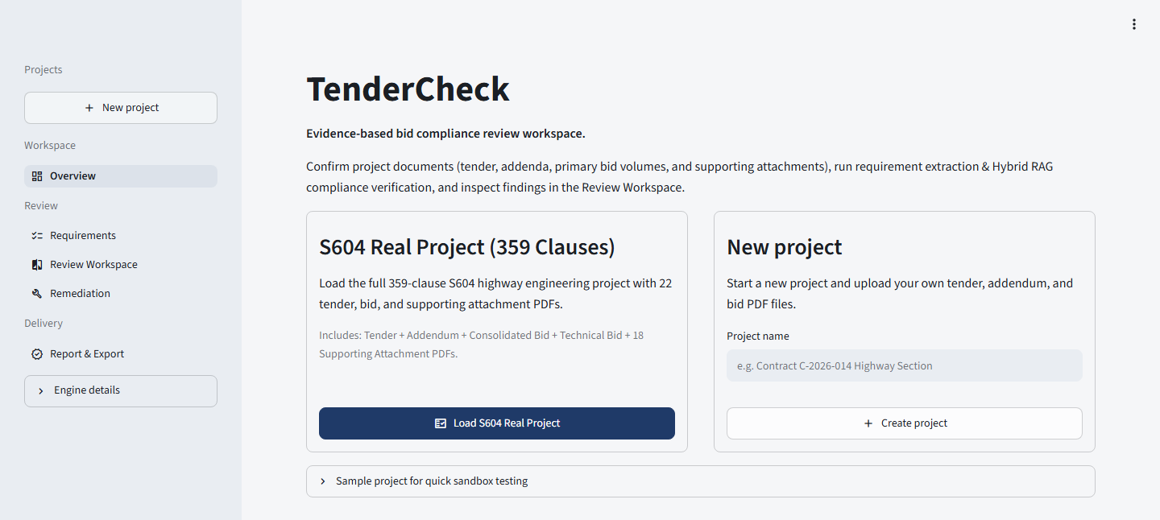
Figure 1. Application home page and left workspace navigation sidebar.
When launched, TenderCheck opens the home page shown in Figure 1. The functions of the sidebar navigation links and home-page entry cards are summarized below:
Navigation or Entry Control | Function Description
+ New project (left sidebar) | Returns to the project creation view at any time to start a new review package.
Overview | Manages uploaded tender, addendum, and bid PDF documents and triggers the automated verification pipeline.
Requirements | Lists all extracted tender and addendum clauses organized by requirement category.
Review Workspace | Displays side-by-side tender and bid PDF pages, structured field comparisons, and reviewer decision controls.
Remediation | Provides an in-place bid-page text editor with AI revision suggestions and automatic rule re-evaluation.
Report & Export | Filters the project compliance matrix and exports the two-sheet Excel review workbook.
Engine details | Displays the active classification models, retrieval backend, and symbolic rule engine version.
New project card | Creates a new review project where users can upload their tender, addendum, and bid PDFs.

Runtime behavior can be customized with the following environment variables:
Environment Variable | Default Value | Purpose
DEEPSEEK_API_KEY | Read from root .env or shell | Enables live DeepSeek slot extraction during review runs and AI revision suggestions in Remediation.
TENDERCHECK_DATA_DIR | SystemCode/data/app | Specifies the storage directory for tendercheck.db, uploaded project files, and saved bid edits (bid_page_edits.json).

4 User Workflow and Interface Guide
This section walks through the complete review workflow step by step alongside Figures 2 to 7 and explains the purpose of each interface button and control.

4.1 Step 1: Creating a Review Project (New Project)
Enter a project title in the New project card on the home page and click + Create project to initialize a new review workspace and navigate to Overview (or select an existing project from the Project dropdown in the left sidebar).
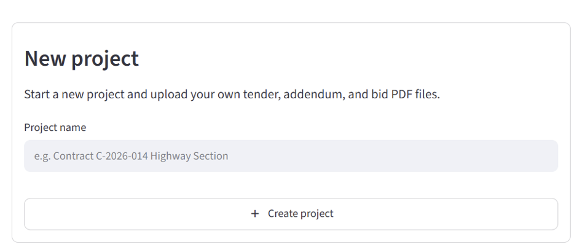
Figure 2. Creating a new review project via the New project form.
Control or Button | Operation and Function
Project name input | Defines the unique name of the review project; used to link uploaded PDFs, review rounds, and audit history.
+ Create project button | Creates the project record in the database and switches directly to the Overview document management page.

4.2 Step 2: Confirming and Uploading Project Documents (Overview - Step 1)
In Overview under Step 1 (Confirm Project Documents), verify that all required tender documents, addenda/clarifications, primary bid volumes, and supporting attachments are present and parsed before starting the automated check.
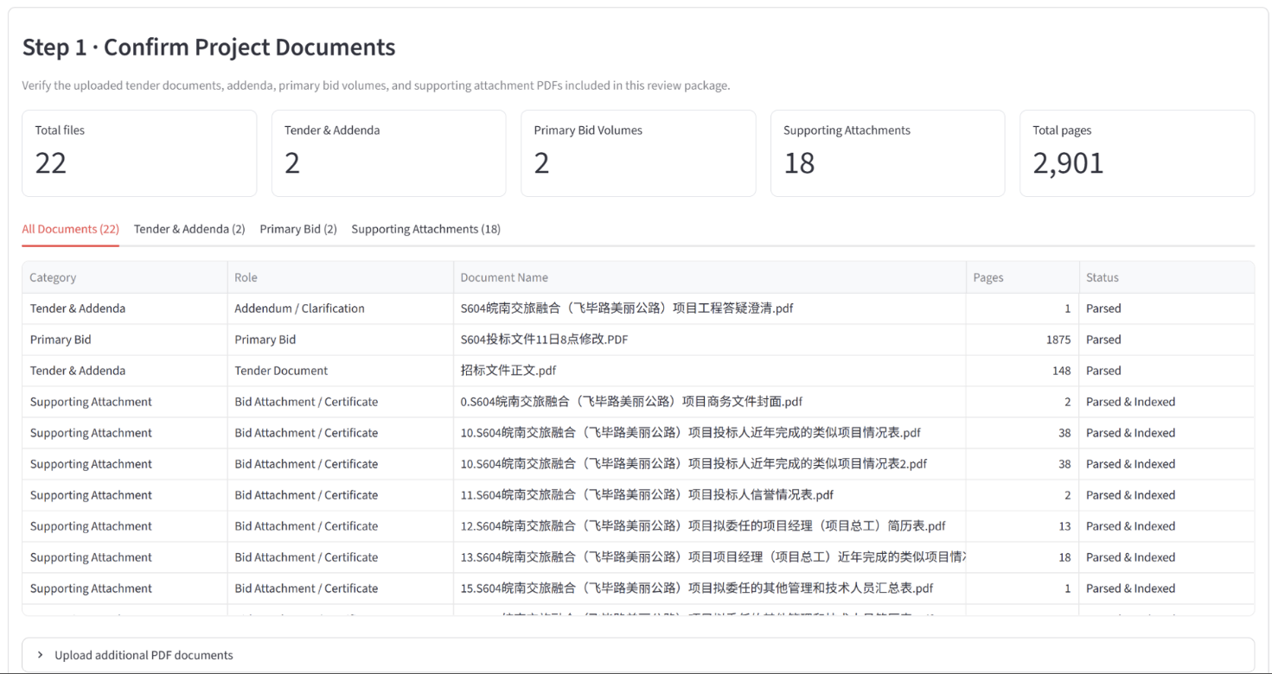
Figure 3. Document inventory, role filters, and upload panel in Overview (Step 1).
Control or Button | Operation and Function
Summary metric cards (Total files / Pages) | Displays total file count, tender and addendum count, primary bid volumes, supporting attachments, and total pages across the review package.
Document role tabs (All Documents, etc.) | Filters the document inventory table by role (All Documents, Tender & Addenda, Primary Bid, or Supporting Attachments).
Document inventory table (Status) | Lists each file's category, role, filename, page count, and processing status (Parsed or Parsed & Indexed).
Upload additional PDF documents | Expands the upload panel to attach new tender, addendum, primary bid, or supporting attachment PDFs with automatic PDF header and SHA-256 duplicate checks.

4.3 Step 3: Running the Review Pipeline and Viewing Summary Metrics (Overview - Step 2 & Step 3)
Once the document package is confirmed, trigger the automated compliance pipeline in Step 2. The system executes requirement extraction, multi-document hybrid RAG retrieval, global context and slot grounding, and symbolic rule evaluation. When complete, Step 3 displays the round summary metrics.
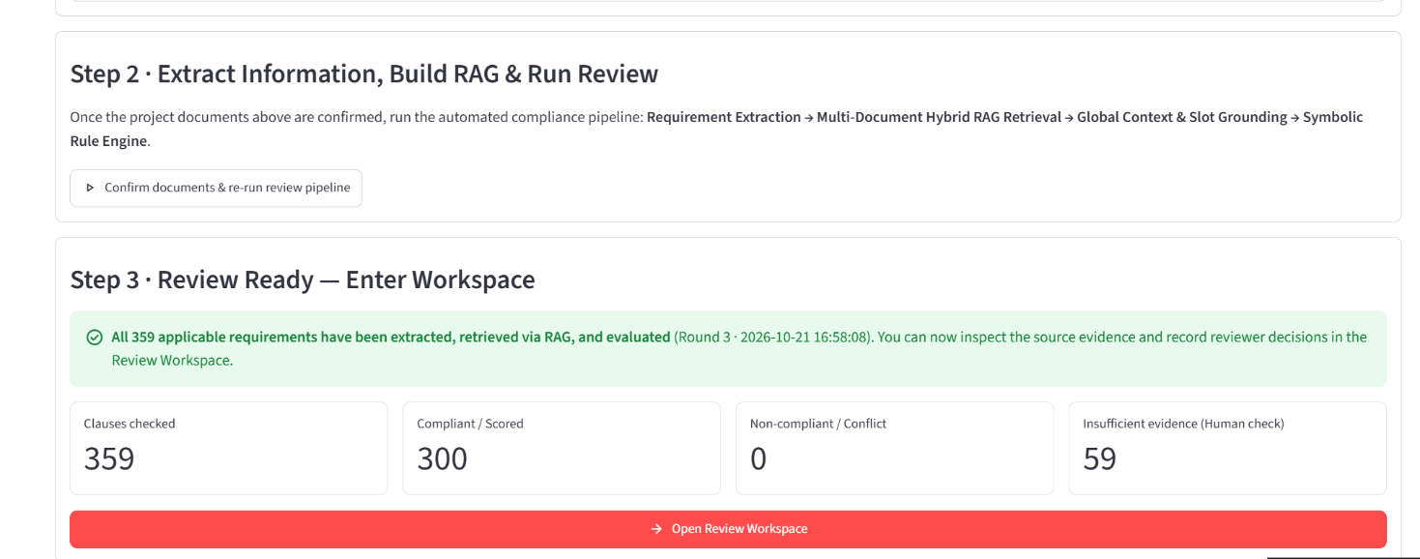
Figure 4. Running the automated review pipeline and inspecting summary metrics (Overview - Step 2 & Step 3).
Control or Button | Operation and Function
Confirm documents & re-run review pipeline | Starts or re-runs the automated verification pipeline in the background and saves the resulting clause findings under a new review round.
Clauses checked / Compliant / Scored | Shows the total number of evaluated clauses and the count of clauses determined to be Compliant or Scored by the rule engine.
Non-compliant / Conflict | Shows the number of clauses that failed a threshold check, lacked a mandatory commitment, or exhibited cross-document conflicting evidence.
Insufficient evidence (Human check) | Shows the number of clauses routed to human verification (such as physical seal/signature inspection or external administrative web checks).
Open Review Workspace button | Opens Review Workspace for the completed review round so reviewers can inspect clause-level source evidence.

4.4 Step 4: Filtering Clauses and Comparing Source Pages (Review Workspace - Upper Panel)
The upper portion of Review Workspace provides four filter controls, the left-hand clause checklist, and side-by-side tender and bid PDF page viewers with highlighted source passages.
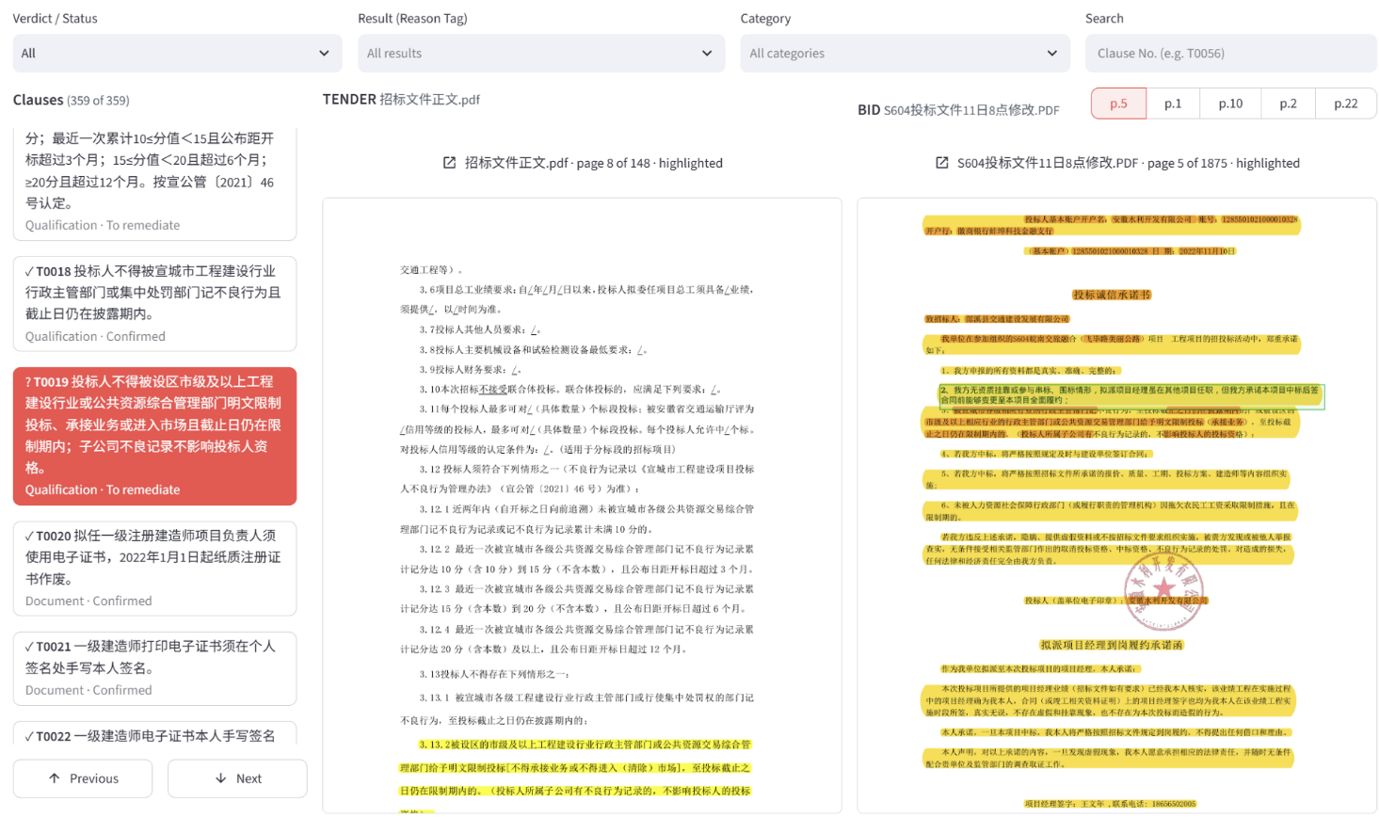
Figure 5. Multi-dimensional clause filters, checklist navigation, and side-by-side PDF evidence viewers (Review Workspace upper panel).
Filter or Navigation Control | Operation and Function
Verdict / Status filter | Filters the clause list by primary machine verdict (Compliant, Non-compliant, Insufficient evidence) or human review state (Unreviewed, Confirmed, To remediate, Resolved).
Result (Reason Tag) filter | Filters clauses by the nine fine-grained rule-engine reason tags: Compliant, Scored, Non-compliant, Conflicting Evidence, Seal and Signature Check, External Web Check, Performance Linkage, Subjective Scoring, and Attachment or Formula.
Category filter | Filters clauses by the eight requirement categories predicted by the classifier (Qualification, Document, Technical, Commercial, Schedule, Consistency, Integrity, and Scoring).
Search box | Locates a specific clause directly by clause identifier (for example, T0019 or T0056) or requirement keyword.
Left Clauses list and Previous / Next buttons | Displays each clause's ID, summary text, category, and review status; clicking a card or using Previous / Next steps through the filtered list.
BID evidence page tabs (p.5, p.1, p.10, etc.) | Switches across the retrieved bid evidence pages while highlighting the matched passage on the rendered PDF page; clicking the document header opens the full-page PDF viewer.

4.5 Step 5: Inspecting Field Comparisons and Recording Decisions (Review Workspace - Lower Panel)
Scrolling to the lower portion of Review Workspace reveals the clause comparison panel, which presents the normalized tender requirement, top five retrieved bid passages (E1 to E5), the structured Field / Bid response / Result comparison table, the diagnostic reason banner, the reasoning chain, and the reviewer action buttons.
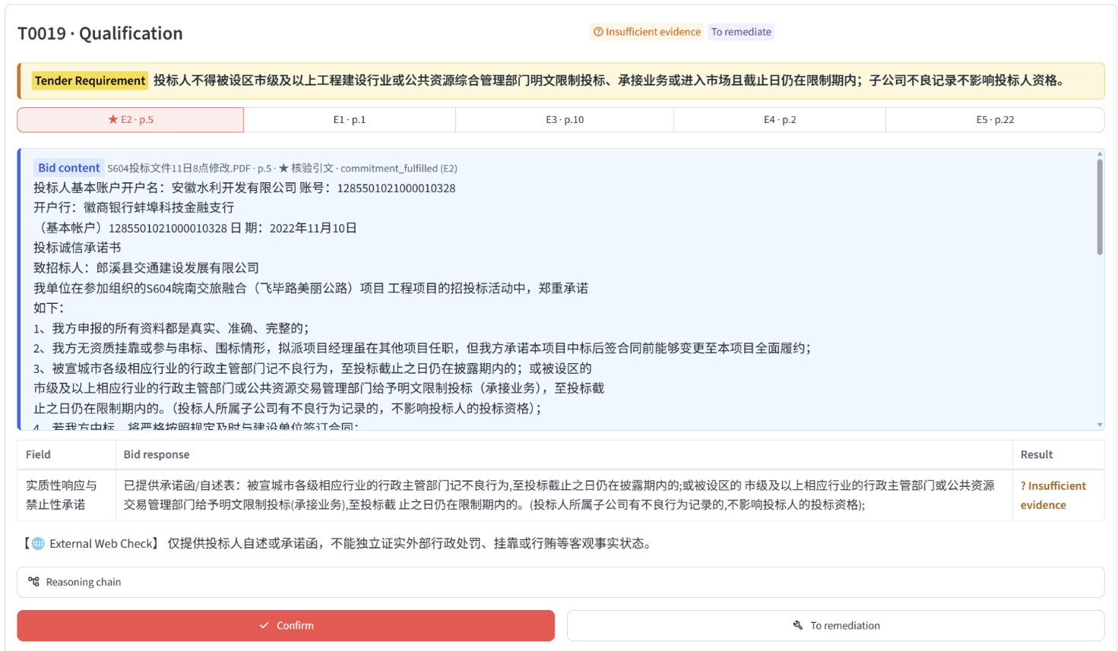
Figure 6. Structured field comparison, diagnostic reason banner, and reviewer decision buttons (Review Workspace lower panel).
Panel Field or Action Button | Interface Meaning and Operation
Tender Requirement and status badges | Displays the full requirement text alongside the machine verdict badge (such as Insufficient evidence) and the separate human review status badge (such as To remediate).
Evidence passage tabs (E2 p.5, E1 p.1, etc.) | Switches among the top five retrieved bid passages and page numbers; the primary verified passage is linked to both the Bid content box below and the PDF viewer above.
Bid content box | Displays the source bid volume name, page number, verified slot name, and full extracted text of the selected evidence passage.
Field | Displays the specific check dimension or quantitative constraint parsed from the tender clause (for example, substantive response and prohibition commitment in Figure 6).
Bid response | Displays the actual bidder response value, commitment statement, or qualification fact extracted from the bid passage and verified against the source quotation.
Result and diagnostic reason banner | Shows the symbolic rule outcome (Compliant, Non-compliant, or Insufficient evidence) in the Result column and explains the fine-grained reason below the table (such as External Web Check when a self-declaration must be verified against external administrative records).
Reasoning chain expander | Expands the step-by-step execution trace across classification, retrieval, slot extraction, and symbolic rule evaluation.
Confirm button | Records the reviewer's confirmation decision in the audit log and automatically advances to the next unreviewed non-passing clause.
To remediation button | Marks the clause as To remediate and opens the Remediation editor with the selected clause and bid page loaded.

4.6 Step 6: Editing Bid Text and Triggering Re-Evaluation (Remediation)
Clicking To remediation in the workspace or selecting Remediation in the left sidebar opens the bid correction interface shown in Figure 7. Users can select an open remediation item on the left, generate an AI draft suggestion or edit the bid page text directly on the right, and save the edit to trigger automatic re-extraction and rule re-evaluation.
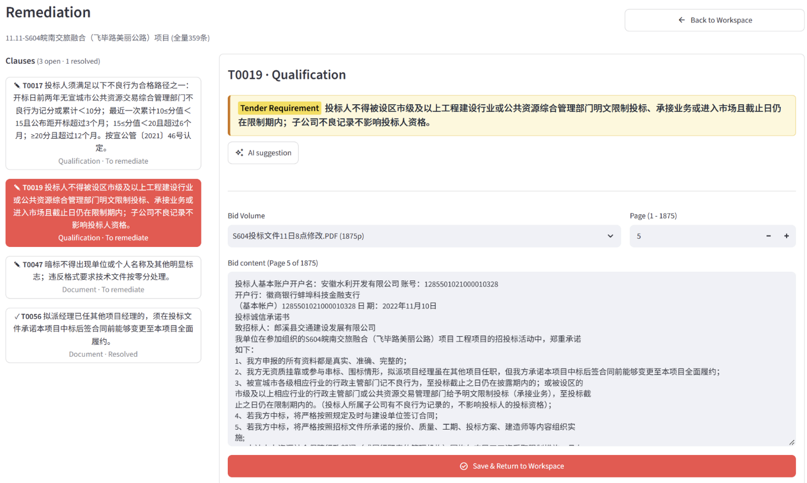
Figure 7. In-place bid page editor, AI revision suggestion, and save-and-re-evaluate workflow (Remediation).
Control or Button | Operation and Function
Left Clauses list (open / resolved) | Lists all clauses routed to remediation, distinguishing open items (To remediate) from completed items (Resolved).
Back to Workspace button | Returns to Review Workspace without saving uncommitted changes in the text editor.
AI suggestion button | Calls the language model to propose revised bid wording that addresses the selected tender requirement.
Bid Volume and Page selectors (- / +) | Selects the target bid PDF volume and navigates to the specific page number to inspect or edit.
Bid content text editor | Provides an editable text overlay for the selected bid page while preserving the original page text in a separate audit record.
Save & Return to Workspace button | Saves the modified bid page text, automatically re-runs slot extraction and symbolic rule verification (R01 to R09) for the clause, marks the item as Resolved if the new verdict is Compliant, and returns to Review Workspace.

4.7 Step 7: Filtering the Compliance Matrix and Exporting Reports (Report & Export)
After completing review and remediation, open Report & Export from the left sidebar. The page displays summary metrics for total clauses, compliant items, non-passing items, and remediation progress, and allows filtering the on-screen matrix by All clauses, Non-passing clauses, or Remediated clauses. Clicking the export button downloads a two-sheet Excel workbook (containing the full Compliance Matrix sheet and the Issues & Remediation sheet) for team handover and archiving.

