TenderCheck System Implementation

TenderCheck connects project intake, document processing, automated verification, human review, remediation and report delivery. The implementation follows two input streams: tender documents define what must be checked, while bid documents provide the evidence. These streams meet in retrieval and structured extraction, followed by quotation validation and symbolic rules. Reviewers inspect the evidence, correct the bid response and export the resulting review record.
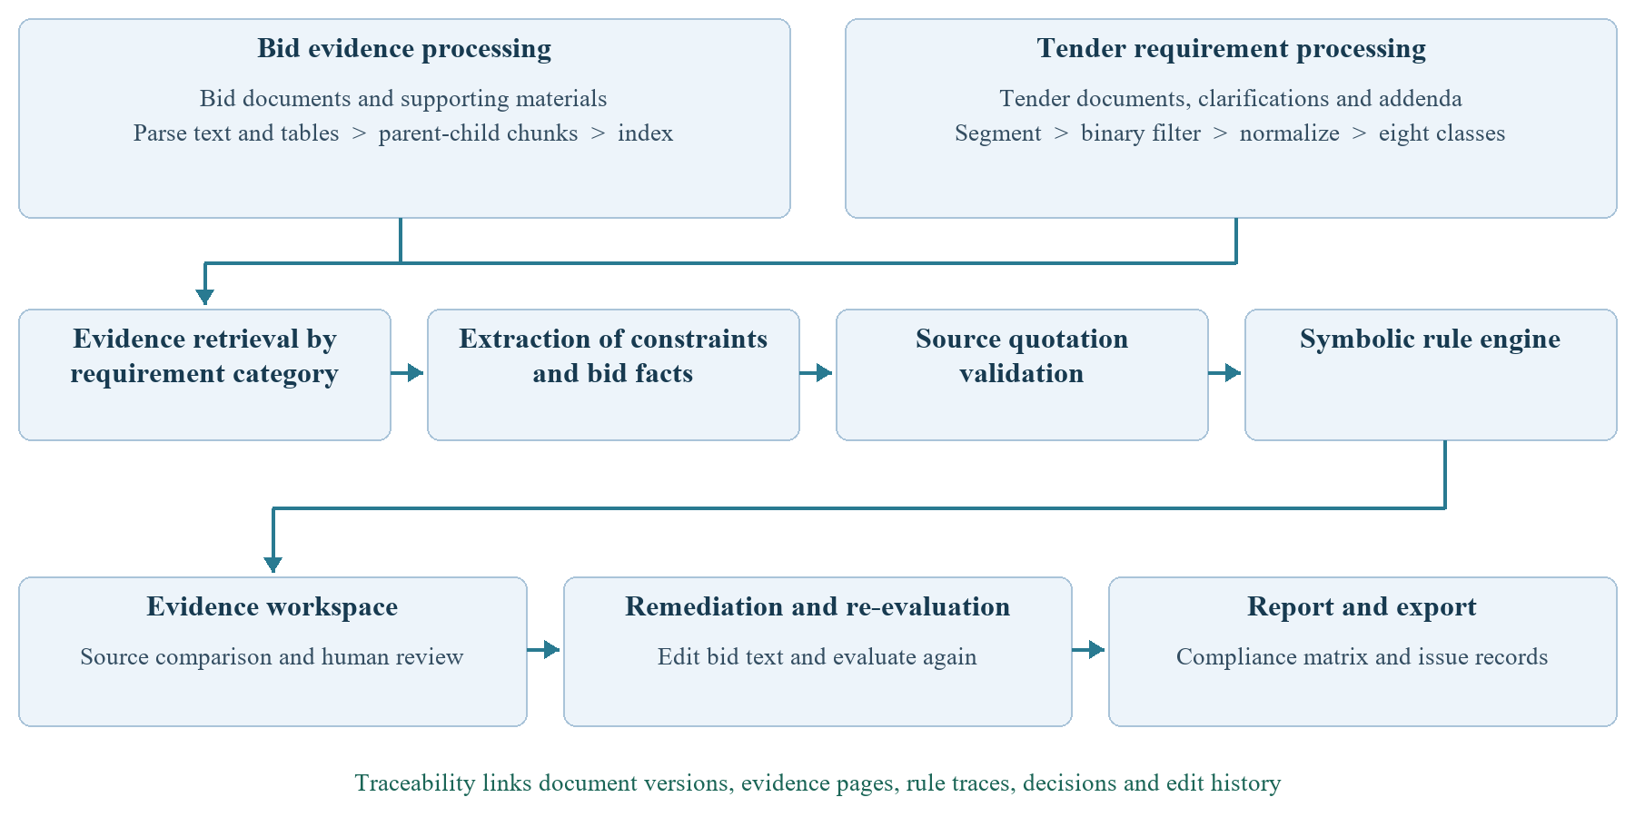
Figure 1. Implemented processing flow from documents to review delivery.

Implementation progress across the workflow
Stage | Implemented capability
1 Project intake | Create a named project and enter the document upload workflow.
2 Document processing | Confirm the file set, parse documents and submit the review pipeline.
3 Internal processing | Filter and classify requirements, retrieve evidence, extract facts and execute rules.
4 Evidence workspace | Compare source pages, inspect findings and record reviewer actions.
5 Remediation | Edit bid-page text, retain changes and re-evaluate the selected clause.
6 Report delivery | Filter the compliance matrix and export review and remediation records.

This chapter follows the current source and running interface. Screenshots establish visible functionality; their counts are not measures of accuracy. The interface and services share a Python application, with Streamlit, SQLite, local classification models and a language-model adapter providing the main implementation components.

1 Project Intake through New Project
New project is the entry point for a new review package. The form accepts a project name, rejects an empty name and creates a project record before switching to its workspace. The project identifier then links uploaded documents, requirements, review rounds and reviewer actions. This gives each review a defined scope and prevents unrelated document sets from being treated as one case.
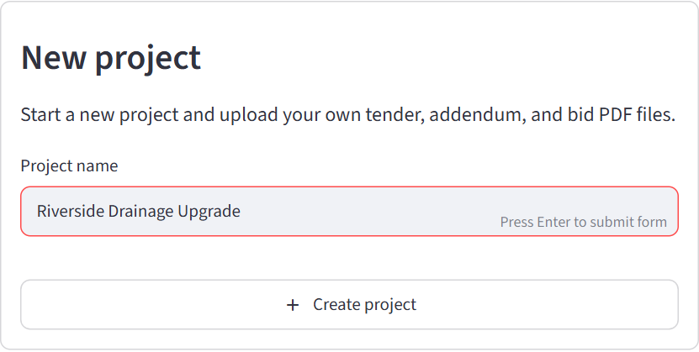
Figure 2. New project form for naming and creating a review project.

From project creation to document upload
After creation, the user uploads tender, addendum or clarification, and bid PDFs through the project upload panel in Overview. Creation and upload are consecutive actions: the New project form establishes the record, and the upload panel attaches the actual files. The service checks the PDF signature, detects identical files using SHA-256 and records version, category and parsing status.
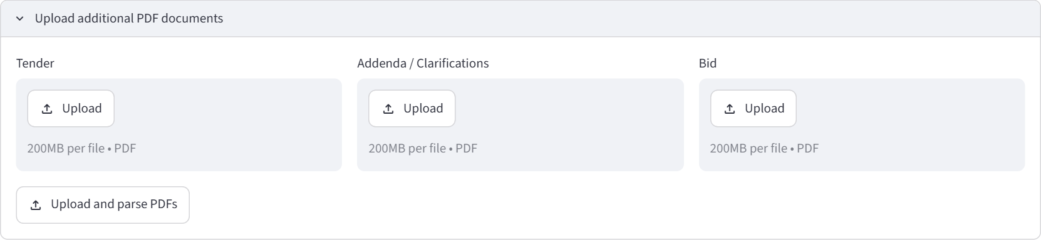
Figure 3. Document upload controls reached after project creation.
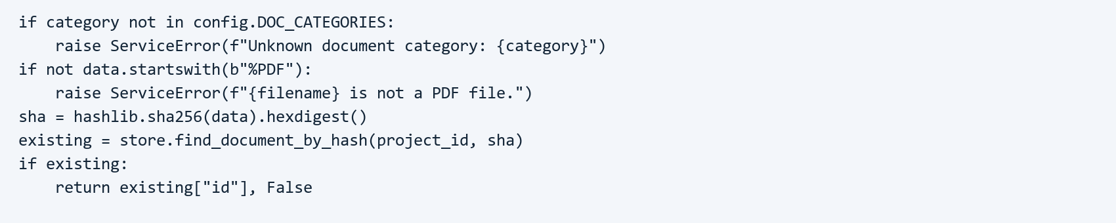
Figure 4. File-type validation and duplicate-file detection.
For bid-review teams, this intake sequence supports orderly handling of multiple volumes and revisions. For research, retaining document identity and version provides a basis for tracing an extracted requirement or a later evaluation result back to its input.

2 Tender and Bid Processing in Overview
Overview turns the uploaded files into an explicit review package. It separates tender and addenda, primary bid volumes and supporting attachments, and shows file counts, page counts, filenames and parsing status. Reviewers confirm that the intended documents are present before starting extraction and verification. This addresses a practical source of review errors: applying the right check to an incomplete or outdated file set.
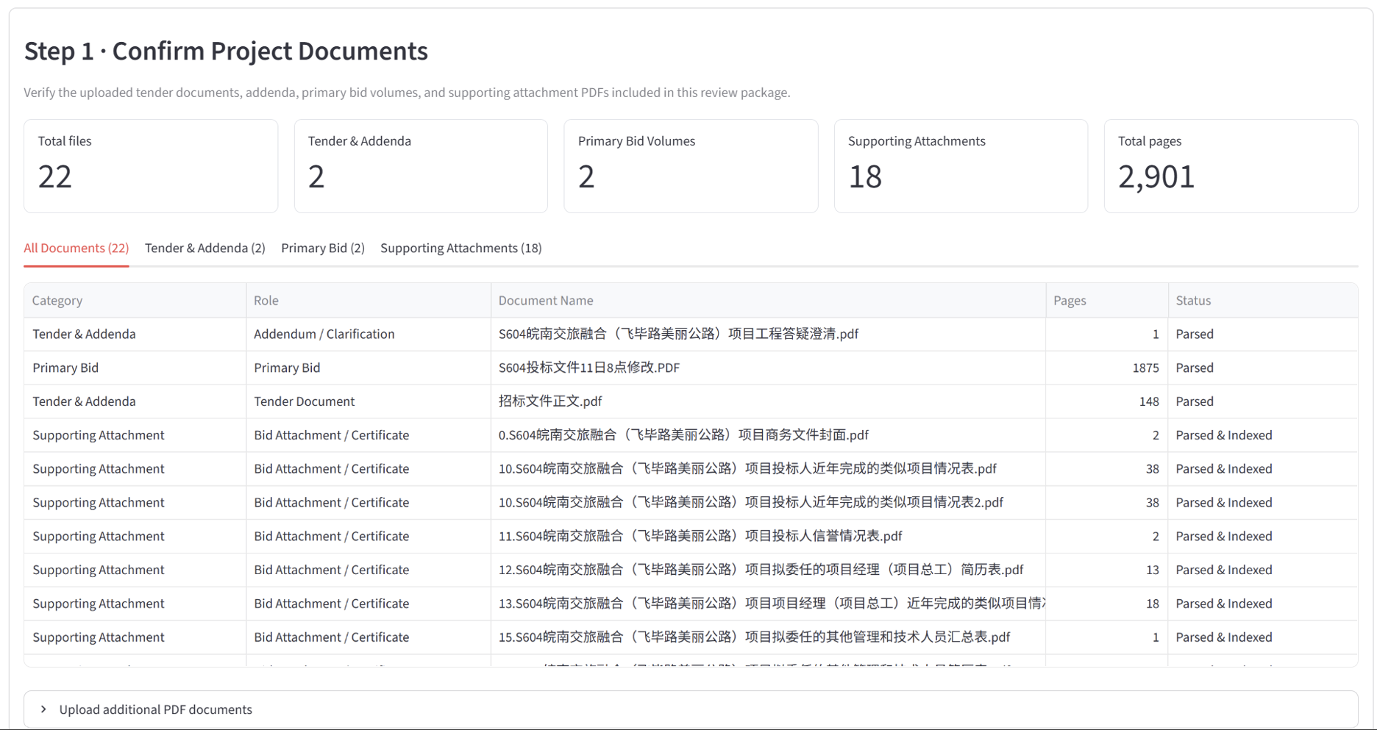
Figure 5. Overview document inventory and parsing status.

Submitting and tracking the processing pipeline
The pipeline action coordinates requirement extraction, evidence retrieval, structured fact extraction and rule evaluation. Service functions submit background jobs and store progress and outputs, allowing the interface to report the current stage. Completed results belong to a review round and can be opened in Review Workspace; later file changes can initiate another run.
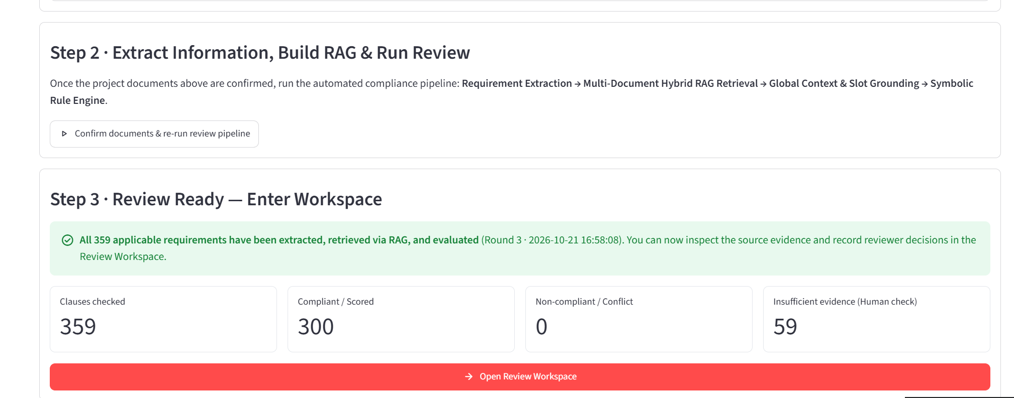
Figure 6. Overview action that starts or reruns the processing pipeline.

Processing responsibility | Output available to the next stage
Tender-side preparation | Clauses with source location, requirement text and category.
Bid-side preparation | Parsed pages, table representations and searchable evidence chunks.
Review coordination | Job state, review-round identifier and saved clause-level findings.

Keeping these intermediate outputs makes the workflow inspectable. Operationally, progress feedback and a clear review-round boundary help a team coordinate long-running work. Academically, the same boundaries allow errors in parsing, retrieval and reasoning to be examined separately.

3 Internal Processing and Automated Verification

Structural segmentation and binary requirement filtering
Tender documents and addenda are segmented using text, tables and section structure. The binary requirement model decides whether a candidate contains a review requirement. Chapter-aware filtering reduces background text, contents entries and instructions that should not become independent checks. A fallback retains high-scoring candidates if filtering produces no result, supporting recall without claiming that omissions are eliminated.
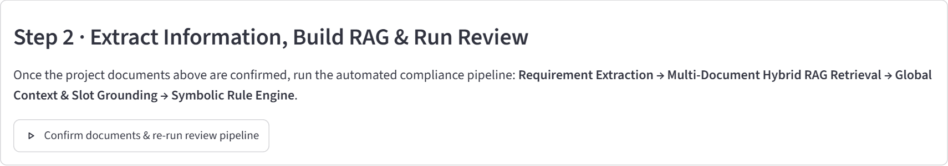
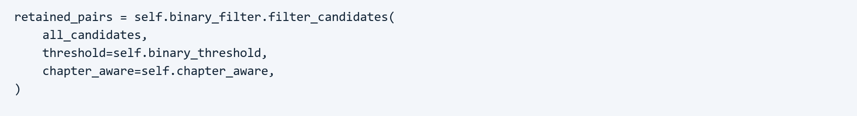
Figure 7. Binary filtering of candidate clauses with threshold and chapter context.

Normalization and the eight-class model
Retained candidates are normalized into requirement sentences. The eight-class model receives the requirement together with its section context and assigns a category. The local implementation loads the binary model and the roberta_wwm_ext classifier; each output retains source text, location and confidence information. The categories organize later evidence searches and reviewer filters rather than serving as compliance verdicts.
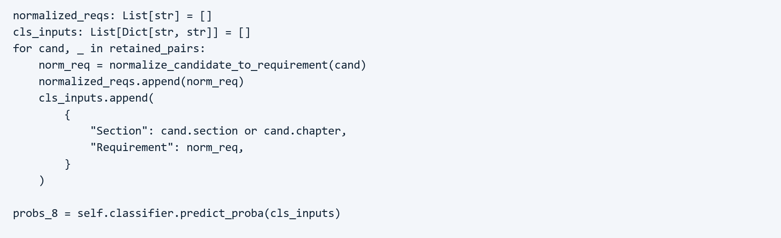
Figure 8. Normalized requirement text and section context passed to the eight-class model.

Category | Review focus
Qualification | Licences, qualifications, personnel eligibility and past performance.
Document | Required documents, signatures, seals and submission format.
Technical | Technical standards, construction methods and quality requirements.
Commercial | Prices, guarantees and commercial commitments.
Schedule | Deadlines, validity periods and completion dates.
Consistency | Agreement of entities, amounts, versions and statements.
Integrity | Prohibited conduct and integrity commitments.
Scoring | Scoring conditions, weights and calculation rules.

This two-stage design separates requirement detection from topic classification, making each model independently evaluable. For users, the resulting checklist reduces manual sorting and directs attention to the evidence needed for each type of requirement.

Evidence retrieval and structured fact extraction
Bid text and tables are parsed into parent and child chunks. Page-level parents retain context, while shorter children support BM25 retrieval. The Chinese upload path uses category-aware search to return up to five parent passages. DeepSeekSlotExtractor then separates tender constraints from bid facts, and global-context completion adds relevant parameters from other document sections. If model extraction fails, the current adapter invokes an offline fallback.
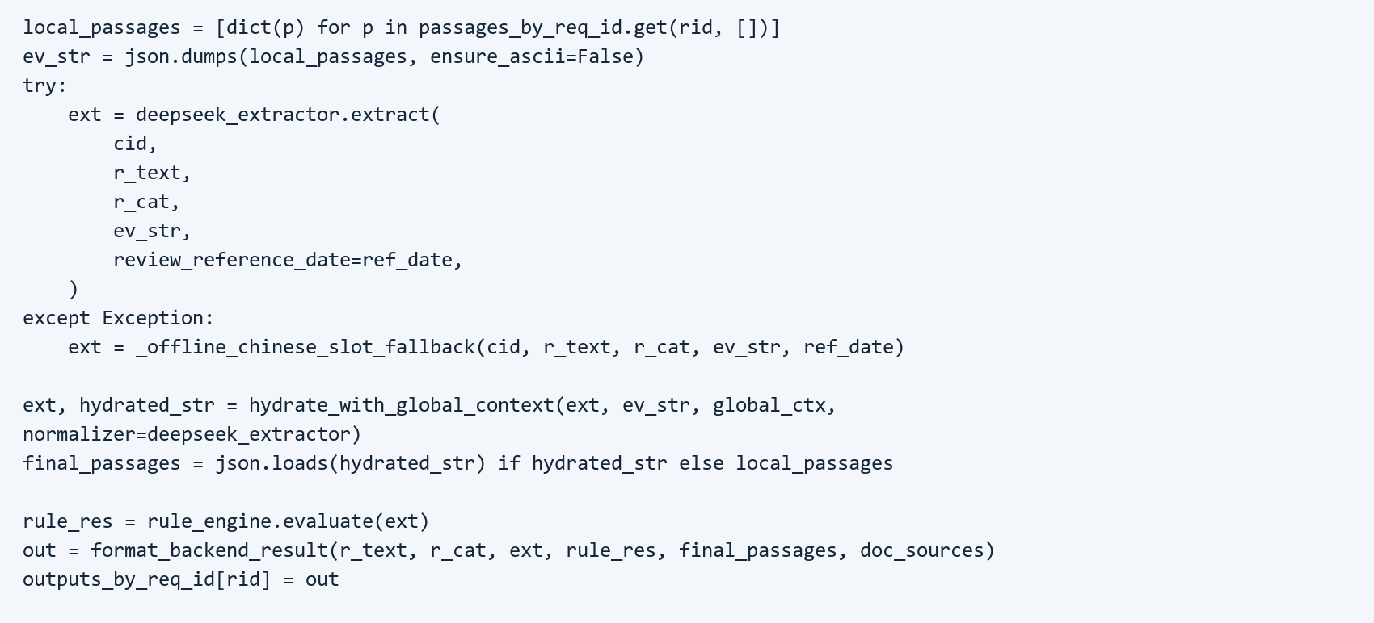
Figure 9. Fact extraction, fallback, context completion and rule evaluation.
Retrieval-augmented extraction links the language model to inspectable evidence, addressing the research need for grounded reasoning. In practical review, page-level context helps distinguish a requirement from the bidder's actual response. Combined with global-context anchor completion, the pipeline avoids missing key parameters from the bid letter or summary schedules when a single local retrieval window is limited.

Quotation validation and symbolic rule execution
The validation layer checks evidence identifiers, exact source quotations and referenced fields. Unsupported values remain unknown; text alone does not establish that a signature or seal is present. The rule engine then evaluates supported facts using rules R01 to R09 and returns a verdict, rule identifier, explanation and evidence references. Numeric rules normalize units and use Decimal comparisons.
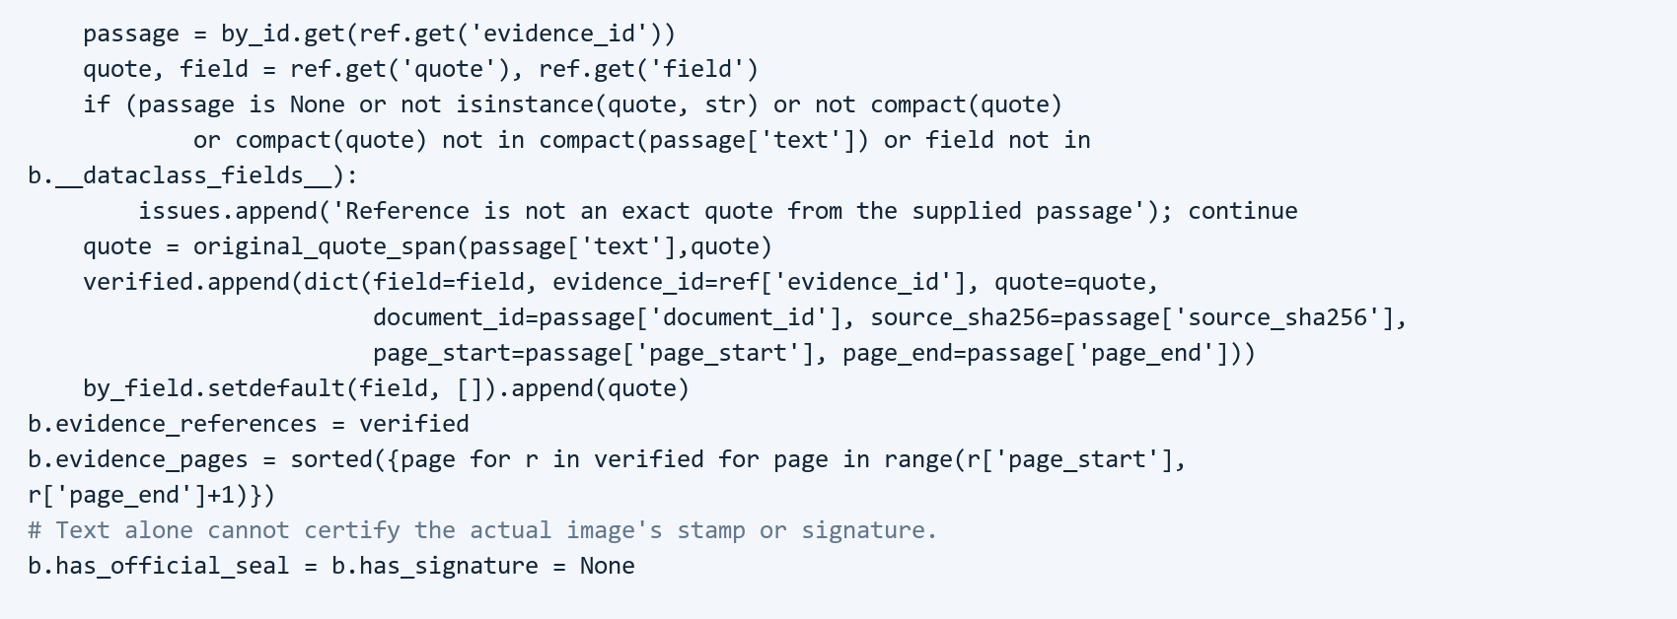
Figure 10. Source-quotation validation and preservation of unknown signature or seal states.
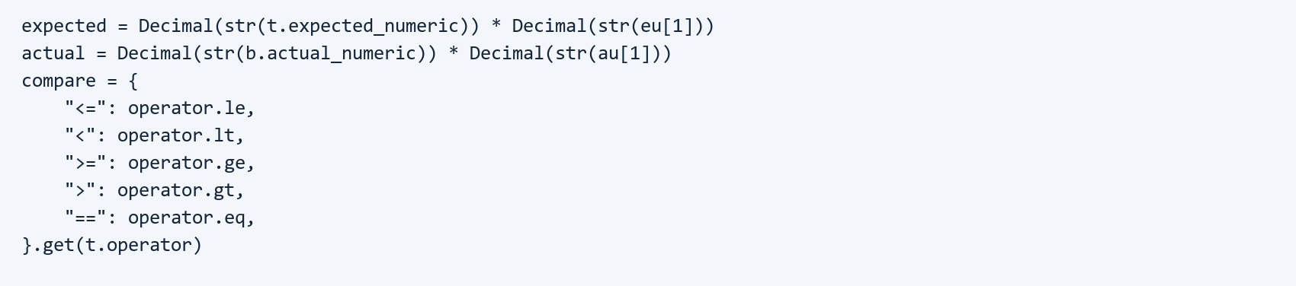
Figure 11. Unit normalization and operator selection for numeric checks.

4 Evidence Inspection in Review Workspace
Review Workspace connects each requirement to its original tender page, relevant bid pages and the recorded result. Its clause list and filters support navigation by verdict or review status, reason tag, category and clause number. A reviewer can therefore move from a high-level issue list to the exact supporting document without manually locating each reference again.
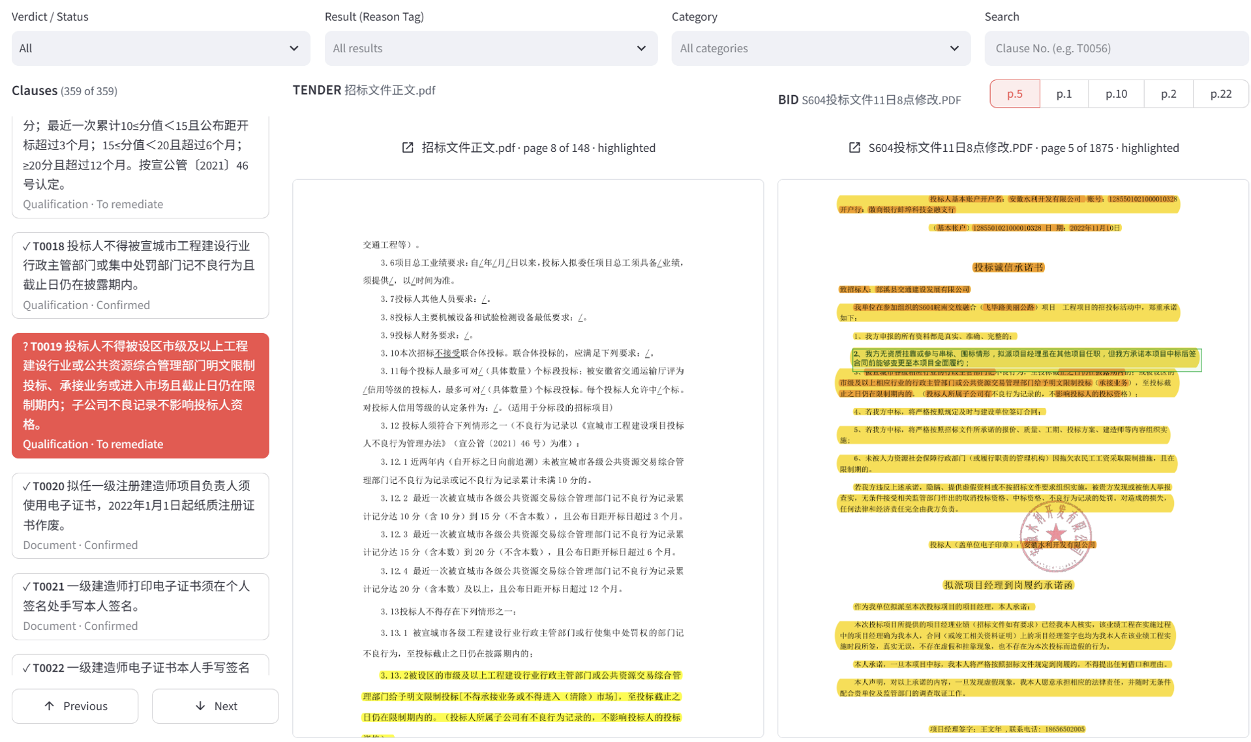
Figure 12. Clause navigation and side-by-side tender and bid evidence pages.

Workspace control | Implementation and user value
Verdict / Status filter | Filter clauses by primary system verdict (Compliant, Non-compliant, or Insufficient evidence) or human review status (Unreviewed or To remediate) while retaining the selected clause, helping reviewers prioritise unresolved items.
Result (reason tag) filter | Filter clauses by the nine fine-grained rule-engine reason tags: Compliant, Scored, Non-compliant, Conflicting Evidence, Seal and Signature Check, External Web Check, Performance Linkage, Subjective Scoring, and Attachment or Formula.
Category filter | Filter clauses by the eight requirement categories predicted by the classifier (Qualification, Document, Technical, Commercial, Schedule, Consistency, Integrity, and Scoring).
Search box | Locate a target clause directly by clause identifier (for example, T0019 or T0056) or requirement keyword.
Tender and addendum view | Switch between amended addendum clauses and original tender requirements to verify the effective source of the current constraint.
Bid evidence navigation (p.5, p.1, etc.) | Switch across matched bid evidence pages and highlight the exact supporting passage on the rendered PDF page.
Open source documents | Open the full-page document viewer to inspect surrounding page and cross-page table context beyond the extracted passage.

The arrangement supports evidence-based human decision making: a result can be challenged against its source. This is relevant to explainable AI and human-in-the-loop research, and to the market need to reduce repeated document navigation while keeping reviewers responsible for decisions.

Clause-level comparison and reviewer decisions
Below the source viewers, the clause panel presents the current requirement, selected bid content, extracted response field and rule result. It keeps the system verdict separate from human review status. A failed check can therefore be awaiting review, under remediation or already reviewed without silently changing the underlying machine result.
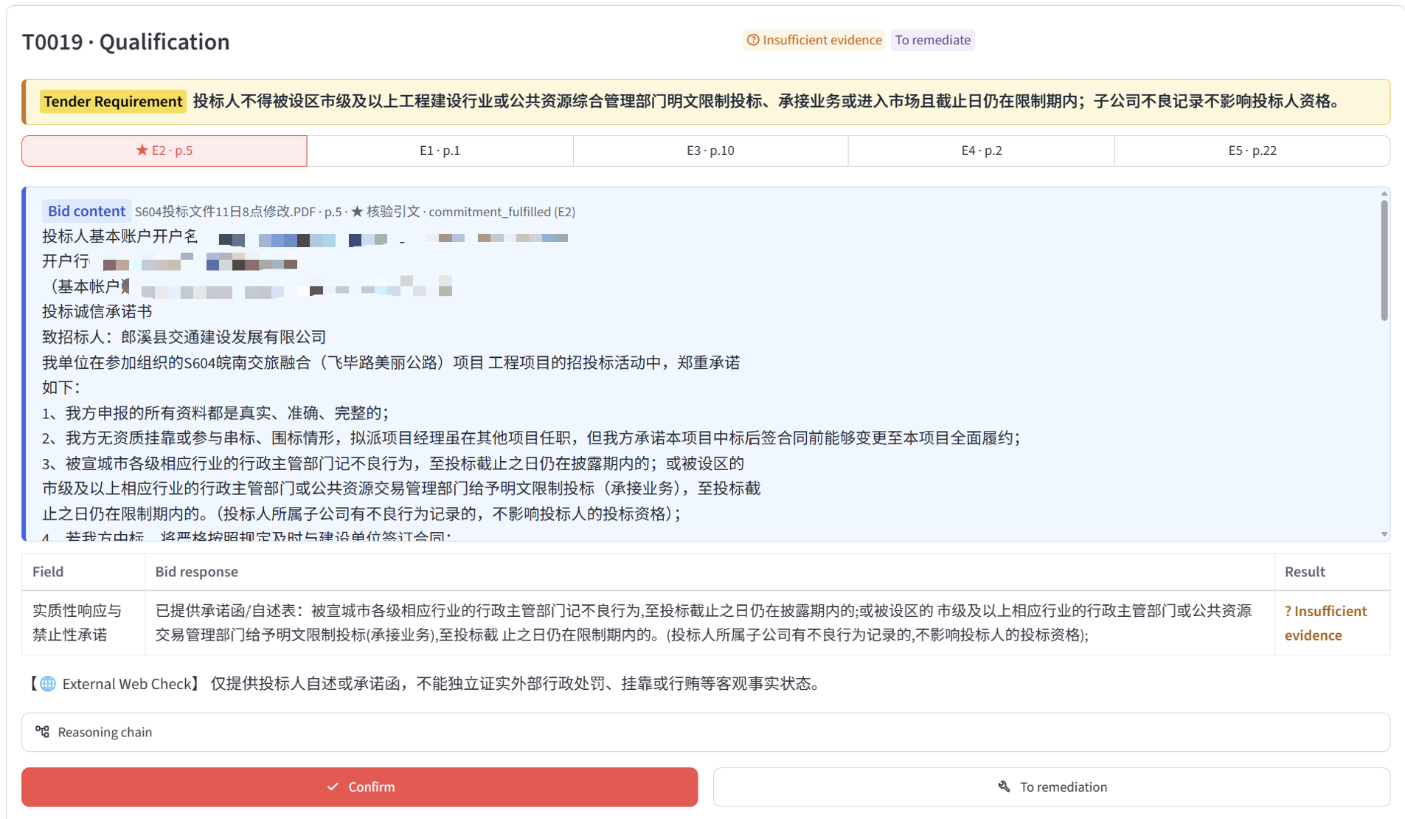
Figure 13. Requirement comparison, rule result and reviewer actions for a selected clause.

Inspection and action within one review context
Comparison field or control | Interface meaning and implemented behaviour
Evidence passage tabs (E1 to E5) | Switch among the top five retrieved bid passages and page numbers for the current clause; the primary verified passage is linked to both the extracted text panel and the right-hand PDF page viewer.
Field | Displays the specific check dimension or structured constraint extracted from the tender clause (for example, substantive response and prohibition commitment in Figure 13, or a numeric schedule limit).
Bid response | Displays the bidder's actual response value, commitment statement, or qualification fact extracted from the selected bid passage and verified against the source quotation.
Result | Displays the symbolic rule-engine comparison outcome (Compliant, Non-compliant, or Insufficient evidence) together with the fine-grained diagnostic reason banner below the table (such as External Web Check when external administrative records must be verified).
Reasoning chain | Exposes the recorded classification, retrieval, slot extraction, and symbolic rule evaluation stages; retrieval scores describe passage relevance rather than compliance confidence.
Confirm | Records the reviewer's confirmation decision for the current clause and advances to the next unreviewed non-passing clause.
To remediation | Creates or links a remediation item and opens the Remediation editor with the selected clause and bid page in context.
History | Shows recorded timestamp, actor, action, and note for accountability and multi-round audit traceability.

The workflow converts an algorithm output into a reviewable action. Its academic relevance is the preservation of intermediate explanations and human feedback; its practical value is a shorter path from locating an issue to assigning a correction. Storing the machine verdict separately from the human review status ensures end-to-end auditability from initial automated screening to final human sign-off.

5 Bid Correction in Remediation
Remediation retains the selected requirement while opening the associated bid document and page. The left list distinguishes open and resolved items; the editor shows the current bid-page text. Reviewers can request an AI suggestion, select a document volume or page, edit the response and save it before returning to the workspace. This turns issue detection into an actionable correction process.
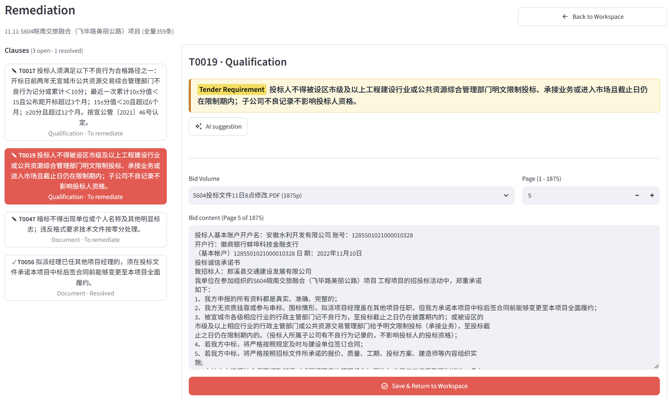
Figure 14. Remediation issue list, page selection, text editor and save action.

Saving an edit triggers re-evaluation
The service stores modified page text with its source path and page number, preserving the original text in a separate edit record. It then re-extracts the selected clause's facts and reruns the rule engine. An item closes only when the new verdict is compliant; otherwise it remains in remediation. The application uses a text-edit overlay, so saving here should not be described as rewriting the original PDF binary.
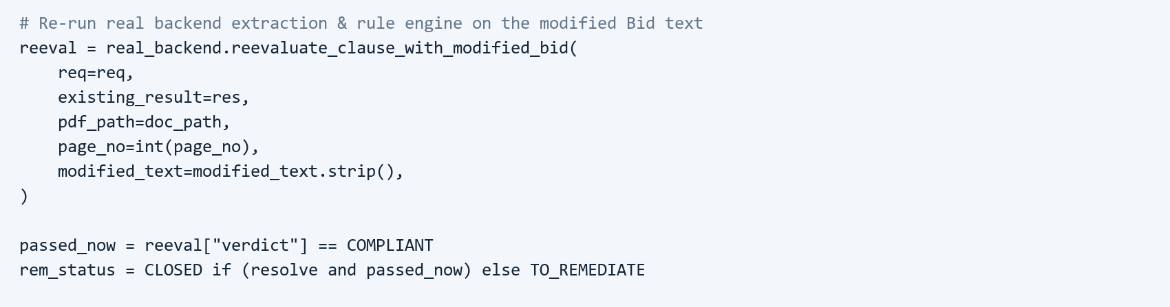
Figure 15. Re-evaluation and conditional closure after a bid-text edit.
This supports an auditable human-feedback loop: changes can be linked to revised findings rather than merely marked complete. It addresses the team's need to track issue resolution. AI suggestions remain proposed wording for human assessment; their generation depends on the configured model service.

6 Review Delivery through Report and Export
Report & Export aggregates the latest completed review round into a compliance matrix. Summary indicators show total clauses, compliant items, non-passing items and review or remediation progress. View filters focus on all clauses, non-passing clauses or remediated clauses. The matrix links each clause to its category, tender requirement, bid response, bid evidence, system verdict and review status.

7 Technical Challenges and Implemented Responses
The main implementation challenges arise at the boundaries between document structure, statistical models, evidence and human decisions. The following responses are present in the current code; the remaining limits define what still needs engineering or evaluation before broader use.
Challenge | Implemented response | Remaining boundary
Long documents and table structure | Use section-aware segmentation, table representations and page-level parent chunks. | Scans, merged cells and cross-page tables can still lose information.
Requirement omissions and noisy categories | Separate binary filtering from eight-class classification; preserve text, confidence and fallback candidates. | Cross-domain transfer beyond highway engineering projects requires further evaluation.
Local retrieval misses global parameters | Add project-wide context and document anchors after category-aware retrieval. | Anchor relevance and completion errors require cross-project checks.
Unsupported facts and inconsistent units | Validate quotations, retain unknown values, normalize units and apply deterministic rules. | Literal matching is not full semantic validation; signatures and subjective scores need human assessment.
Repeated work and long-running tasks | Use a submission lock, active-job checks and saved job progress. | In-process background threads do not provide durable recovery after a crash.
Unverified closure after editing | Store page-text edits, rerun extraction and rules, and close only compliant items. | Text overlays need version and concurrency controls for production use.

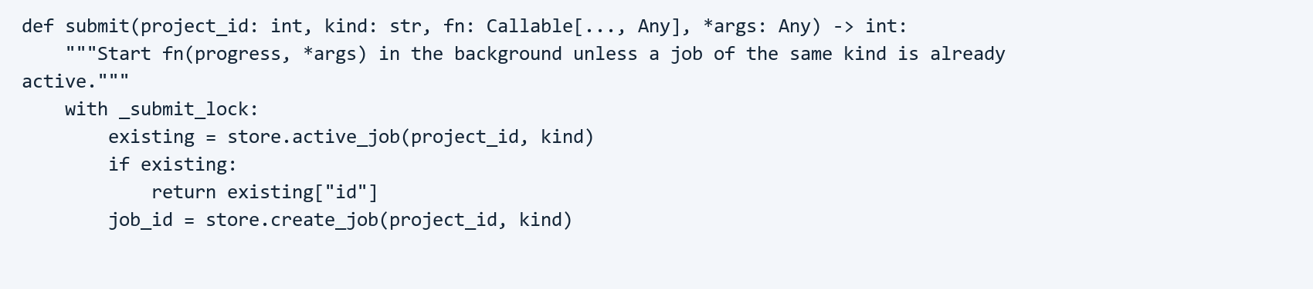
Figure 16. Active-job checks prevent duplicate submission of the same job type.

Feasibility and the next validation boundary
The implemented pages and service calls connect intake, verification, review, correction and export into a usable workflow. The strongest evidence here is the running interface, inspectable source logic and verified Excel output. Broader deployment still requires model and data availability, stable model-service access, authentication, backups and task recovery. Evaluation should measure requirement recall, category quality, evidence retrieval, incorrect acceptance and rejection, and reviewer workload across independent projects.

