2 System Design and Models
The system starts with purchase records, builds customer and product features, and produces segments, repurchase predictions, spending-potential rankings and product recommendations. This section follows the data flow through each stage, explaining inputs, processing and outputs. Detailed performance comparisons appear in Part 3.

2.1 Overall Architecture and Workflow
The system has two paths: offline development and app use. Offline development cleans data, builds samples, compares methods and saves models. During app use, uploaded purchase records are converted into features and passed to the trained models. A new upload or analysis date updates the results while keeping the models unchanged.
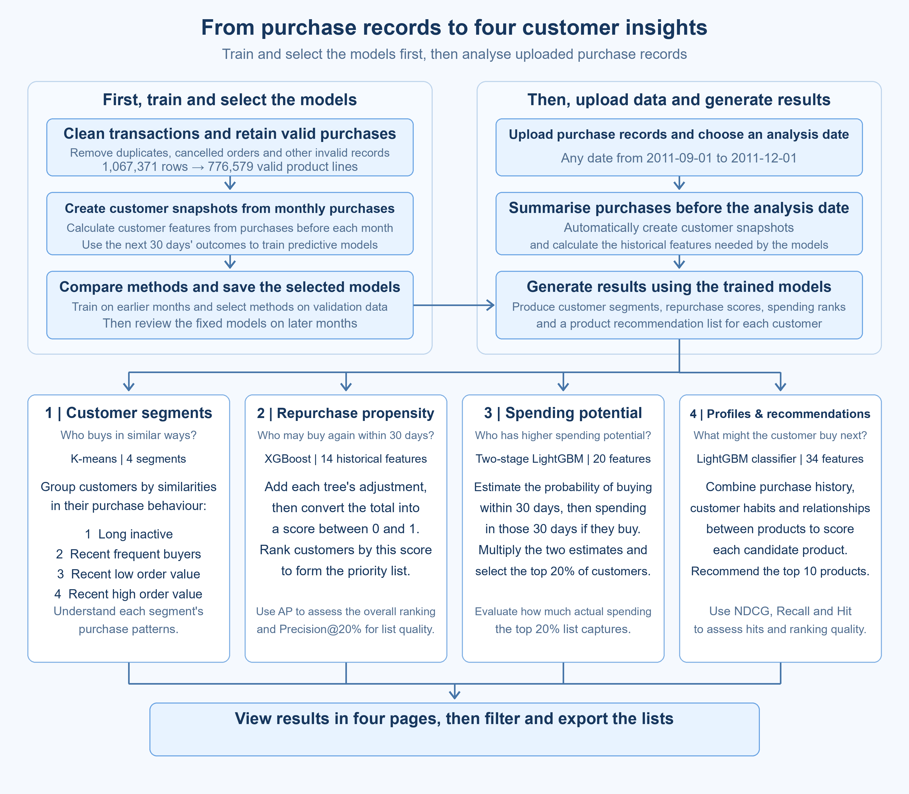
Figure 2-1 Offline development and app workflow
The four modules share a transaction source and time split, but construct samples for their own tasks. The first three mainly analyse customer snapshots; recommendation analyses customer–candidate-product pairs. Training and app use follow the same feature definitions.

2.2 Data and Sample Design

2.2.1 Data Source and Cleaning
UCI Online Retail II contains transactions from a UK online retailer from 2009‑12‑01 to 2011‑12‑09, including wholesale customers. The two annual CSV files contain 1,067,371 rows and 8 fields: invoice number, product code, description, quantity, purchase time, unit price, customer ID and country. One row represents one product line in an invoice; an order or customer usually spans multiple rows.
Cleaning standardises fields and dates, then removes exact duplicates, missing customer IDs, cancellations, invalid quantities or prices, and non-product entries such as postage and fees. It retains 776,579 qualifying product transactions and excludes 290,792 rows. Line amount is quantity × unit price. The retained records describe positive purchases; exclusion reasons are stored separately for checking.

2.2.2 Customer Snapshots and Future Labels
A customer’s purchases may be spread across many orders. On the first day of each month, customers who bought at least once in the previous 180 days each receive one row summarising their purchase status. This row is a customer snapshot. If the customer remains eligible next month, a new snapshot reflects the updated status.
Features use purchases made before the analysis date. Transactions in the following 30 days provide the answers for training and evaluation, called labels. For an analysis date of 1 August, inputs describe purchases before 1 August, and labels describe outcomes during the next 30 days from that date. A few features, such as first purchase date and cumulative spending, also use earlier available history.
Table 2-1 Eight base features in a customer snapshot
Feature | Calculation | Customer 12347
Days since last purchase | Days from the latest purchase to the analysis date | 53 days
Orders in 180 days | Count distinct qualifying invoices | 2 orders
Spending in 180 days | Sum qualifying product amounts | £1,018.77
Average order value | 180-day spending ÷ order count | £509.38
Distinct products in 180 days | Count distinct product codes | 39 products
Orders in 30 days | Count qualifying invoices in the previous 30 days | 0 orders
Orders in 90 days | Count qualifying invoices in the previous 90 days | 1 order
Observed history length | Days from the first observed purchase to the analysis date | 274 days

The example is customer 12347’s snapshot on 2011‑08‑01. The customer bought again within the next 30 days, so the repurchase label is 1. Qualifying spending during that period was £584.91, the spending label. Recommendation checks which products appeared in the next order within those 30 days. Segmentation uses no future label.
The 18 monthly snapshots from June 2010 to November 2011 contain 54,040 records covering 5,622 customers. Samples are split by month. A customer can appear in several months, allowing the models to learn from purchase states at different dates.
Table 2-2 Time-based split of customer snapshots
Purpose | Snapshot months | Records
Training | June 2010–May 2011 | 37,019
Validation and selection | June–August 2011 | 8,146
Test-period review | September–November 2011 | 8,875

2.3 Model Design for the Four Modules
Parameters are selected through forward validation within the training period: train on earlier samples whose outcomes have been fully observed, then check later months. Methods are selected on validation data and kept fixed for the September–November review. The following sections explain each module’s inputs, comparisons and outputs.

2.3.1 Customer Segmentation
Inputs and processing. Segmentation uses five purchase features: days since last purchase, 180-day order count, average order value, product variety per order, and the share of orders placed in the latest 90 days. These describe recency, frequency, order value, breadth and recent change. Total spending largely duplicates “order count × average order value”, so it is not added separately.
Order count, order value and product variety are log-transformed to reduce the influence of extreme values, then all features are standardised to comparable scales. Preprocessing settings are learned from training data.
Table 2-3 Why the three clustering algorithms are compared
Algorithm | How it groups customers | Reason for comparison
K-means | Finds a centre for each cluster and assigns customers by distance. | Centres are easy to interpret as customer profiles.
Bisecting K-means | Splits clusters step by step, selecting a cluster with high internal variation. | Tests whether hierarchical splitting gives more stable segments.
Gaussian mixture model (GMM) | Represents clusters as Gaussian distributions and assigns customers by membership probability. | Allows different cluster shapes and sizes, relaxing the K-means shape assumption.

All three algorithms are compared with 2–6 clusters. The silhouette coefficient measures separation; ARI after customer resampling measures grouping stability. Validation months check whether cluster sizes and profiles recur. Selection considers separation, stability and business interpretation together.
The selected method is K-means with 4 clusters. Two clusters achieve the highest silhouette coefficient, highlighting the difference between long-inactive and recent buyers. Four clusters retain stability while distinguishing frequent, low-order-value and high-order-value recent buyers. These profiles recur in all three validation months. The algorithm creates the groups, and the team names them from their statistics.
The groups are Group 1 Long inactive, Group 2 Recent frequent buyers, Group 3 Recent low order value, and Group 4 Recent high order value. At inference, a customer is assigned to the nearest cluster centre. Frequency describes order count, while order value describes spending per order, so frequent buyers can have higher total spending.

2.3.2 Predicting Repurchase in the Next 30 Days
Objective and label. At least one qualifying purchase in the next 30 days is labelled 1; otherwise the label is 0. The model uses information available before the analysis date to calculate a repurchase score and rank customers from highest to lowest.
Table 2-4 Three feature groups for repurchase prediction
Feature group | Information provided | Purpose
Base: 8 features | Timing, counts, spending and product variety from Table 2-1. | Describe the same base purchase status for every customer.
Base + trend: 11 features | Add recent order share, order change and a history-length flag. | Distinguish increasing from decreasing recent activity.
Base + trend + timing: 14 features | Also add active purchase periods, the last inter-order gap and a multiple-purchase flag. | Distinguish regular buying from occasional bursts.

Each group is tested with four models, giving 12 combinations. Logistic regression (LR) provides an interpretable linear reference. Spline logistic regression allows the effect of purchase recency to curve. XGBoost and LightGBM are gradient-boosted trees that learn nonlinear and combined effects of timing, frequency and spending, using different tree-building strategies.
Parameters are first selected through forward validation within training. Validation average precision (AP) then compares overall ranking, alongside precision in the top 20% of customers, assessing both the ranking and priority-list quality. The selected method is 14 features with XGBoost.
How the score is calculated. All customers pass through the same set of trees. Each tree follows the customer’s features to a leaf and outputs an adjustment. Later trees learn from the current prediction errors. The initial value and all tree adjustments are added, then converted to a score between 0 and 1:
Raw score F = initial value + sum of all tree adjustments
Repurchase score $s＝\frac{1}{1＋e^{−F}}$
The adjustments already include the learning rate. Scores compare repurchase tendencies and generate the priority list. Evaluation checks the ranking against actual 0/1 labels, primarily using AP alongside ROC-AUC, top-20% precision and the Brier score. Calculations and results appear in Part 3.

2.3.3 Spending-Potential Ranking
Objective and features. This module asks which customers to review first when places are limited. It learns from actual qualifying spending in the next 30 days, with £0 for no purchase. The 20 inputs comprise the eight base features plus recent spending windows, individual-order amounts, active purchase days, and cumulative spending and order counts from earlier history.
Future spending contains many zeros and a small number of large positive amounts. The comparison therefore includes direct amount models and a two-stage model, alongside three past-spending rules.
Table 2-5 Six methods for spending-potential ranking
Method | Basis for ranking
Past-30-day spending rule | Rank by spending already observed in the previous 30 days.
Past-90-day spending rule | Rank by spending already observed in the previous 90 days.
Past-180-day spending rule | Rank by spending already observed in the previous 180 days.
Direct LightGBM amount model | Learn the next 30 days’ spending directly with a Tweedie objective.
Direct XGBoost amount model | Also learn future spending directly, comparing a different boosting implementation.
Two-stage LightGBM | Estimate purchase occurrence and conditional total spending, then combine them into a ranking score.

Tweedie is a training loss suited to a mix of zeros and skewed positive amounts. The two-stage approach instead learns whether a customer buys and how much they spend as separate steps:
Step 1: Train a classifier on all customers to estimate p, the chance of purchasing within 30 days.
Step 2: Train Gamma regression on buyers to estimate m, total 30-day spending conditional on a purchase.
Raw spending-potential score = p × m.
For example, p = 0.6 and m = £500 give a score of £300, an estimate of expected spending over the next 30 days. Customers are ranked by this value, and the list takes customer count × 20%, rounded up. The app displays the rank. The purchase classifier in this two-stage model is trained specifically for spending ranking.
The selected method is two-stage LightGBM. Selection prioritises the share of actual spending captured by the top-20% list during validation, with checks on monthly performance and customer-resampling stability. Spending coverage equals “the list’s actual spending in the next 30 days ÷ all customers’ spending over the same period”. MAE provides an additional check on amount error. Coverage takes priority because the task is to select a customer list; the full comparison appears in Part 3. After selection, the final model is fitted on training and validation samples whose outcomes are fully observed before 1 September.

2.3.4 Purchase-Habit Profiles and Recommendations
Build the profile first. A purchase-habit profile summarises historical behaviour as features describing purchase frequency, repeat buying versus exploration, and preference concentration. The system reads the 180 days before the analysis date, organises the products in each purchase and aggregates the results.
Transactions by the same customer at the same time are treated as one purchase, with each product counted once per purchase. Each later purchase is compared with all products bought previously, and the purchased-product history is updated after every purchase.
Table 2-6 Example of calculating repeat-product share
Purchase | Products | Previously purchased products | Repeat-product share
1st | A, B | Start purchase history with A and B. | Reference purchase
2nd | A, C | A was bought before; C is new. | 1 ÷ 2 = 50%
3rd | C, D | C was bought in purchase 2; D is new. | 1 ÷ 2 = 50%

Averaging from the second purchase gives a historical repeat-product share of (50% + 50%) ÷ 2 = 50%. Another measure is top-3 product concentration = total occurrences of the three most frequently purchased products ÷ occurrences of all products. The first describes repeat buying versus exploration; the second describes concentration on a few products.
The profile also includes recent repeat-product share and its change, purchase count, comparable purchase count, distinct product count, average products per purchase, days since last purchase and purchase-history span. Together these form 10 profile features for display and recommendation.
Round 1 compares five recommendation methods. Historical purchases become a customer–product purchase-count table recording who bought what and how often. Each method uses the same customers and candidate products, recommends ten products per customer, and checks the next order within the following 30 days.
Table 2-7 Round 1 methods and reasons for comparison
Method | Recommendation approach and reason for comparison
Popular products | Recommend globally popular products as a reference independent of personal preferences.
Personal repeat purchase | Prioritise products the customer has bought repeatedly, matching replenishment and wholesale buying.
ItemKNN | Use co-purchase relationships to find similar products often bought by the same customers.
Implicit-feedback ALS | Learn customer preferences and product factors from purchase behaviour without ratings.
EASE | Learn overall product associations from sparse purchase records.

In Round 1, personal repeat purchase has the highest validation NDCG, Recall and Hit, so it remains the reference. EASE has the highest NDCG among the three learned algorithms and continues to supply association scores. Round 2 combines profiles and product associations to learn rankings for replenishment and exploration.
Round 2 compares four feature groups and three scoring models. A sample is now one customer paired with one candidate product. Inputs describe that pair’s history; the label indicates whether the product appears in the next order. Rather than directly ranking by a rule or association score as in Round 1, the model learns how to combine the signals.
Table 2-8 Four input groups in Round 2
Input group | Features | Information supplied
A Base | 15 | Whether bought before, purchase count, recency, purchase intervals and product popularity.
B Base + profile | 31 | A + 10 profile features + 6 interactions, such as repeat share × previously purchased flag.
C Base + EASE | 17 | A + EASE association score + a missing-association flag.
D Full | 34 | Combine A, B and C, plus repeat share × EASE score.

Each group is tested with LR, LightGBM classification and LightGBM ranking, giving 12 combinations. LR learns weighted feature effects; LightGBM classification learns whether a product appears in the next order; LightGBM ranking learns product order within each customer. The same model type shares parameters and samples across groups. B versus A and D versus C test profiles and their interactions; C versus A and D versus B test EASE signals.
Training retains positive products from the next order and samples a mixture of hard and random negatives from the many unpurchased products. All groups share the sampled records, and classification weights account for sampling probabilities. Evaluation and app use score the full candidate catalogue without sampling, keeping the candidate scope consistent across methods.
The app uses group D with LightGBM classification, which has the highest validation NDCG@10 in Round 2. For the selected customer and each candidate product, the system calculates 34 features and passes them to the same set of boosted trees:
Product ranking score = initial value + sum of all tree adjustments
Sort scores from highest to lowest and select the customer’s top ten products.
Both rounds prioritise NDCG@10, which rewards hits near the top. Recall@10 measures how many next-order products are covered; Hit@10 measures how many customers receive at least one hit; new-product Recall@10 separately measures exploration. Methods are compared on the same customers and months. Calculation examples and results appear separately in Part 3.

2.4 User Interface and Function Integration
Users upload purchase records and choose a date on Data import. After validation, the system calls the trained models, and all four pages share the results. It supports any date from 2011‑09‑01 to 2011‑12‑01, with filtering and list exports.
The following 2011‑12‑01 example uses 759,615 real qualifying transactions to generate 3,444 customers, with 689 in the top 20% for spending potential. The earlier August example explains samples; this December example shows app use.

2.4.1 Data Import
Upload a purchase-history CSV, choose the analysis date and click Generate analysis. The system prepares the shared analysis results and opens Customer segments.
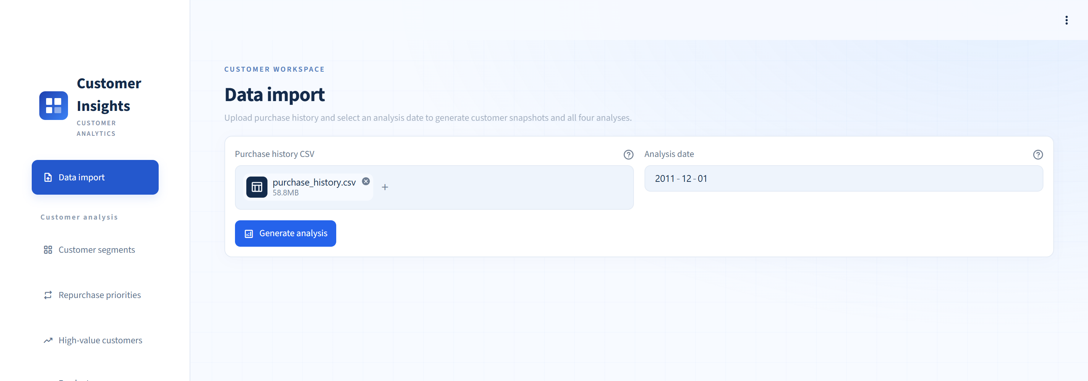
Figure 2-2 Data import and analysis-date selection

2.4.2 Customer Segments
The page shows the four customer groups, their sizes and purchasing patterns. Users can filter by segment or customer ID and export the customer list.
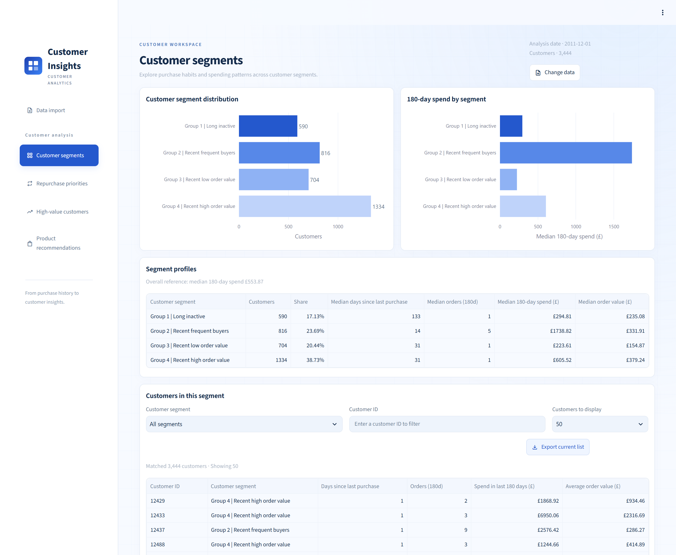
Figure 2-3 Customer segments, purchase patterns and customer lists

2.4.3 Repurchase Priorities
The page ranks customers by the XGBoost repurchase score, highlighting customers with stronger repurchase tendencies. Users can filter the list and export the selected customers.
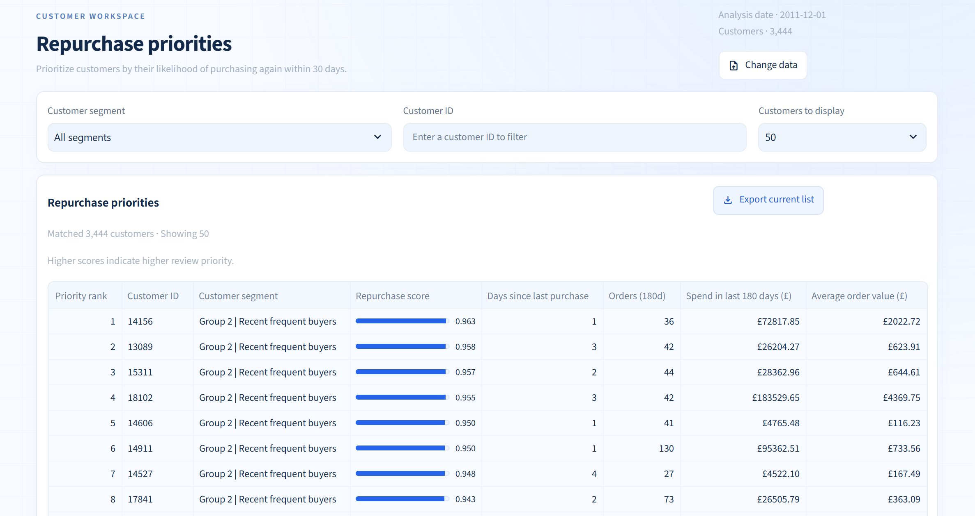
Figure 2-4 Repurchase priorities ranked by XGBoost score

2.4.4 High-Value Customers
The page lists the top 20% of customers by the two-stage LightGBM spending-potential ranking. Users can compare purchase recency and past spending, then export the priority list.
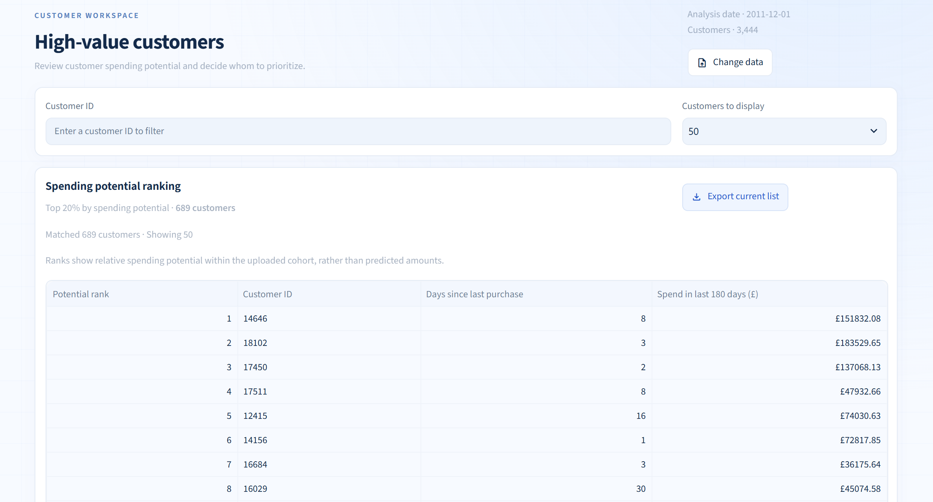
Figure 2-5 Top-20% spending-potential customer list

2.4.5 Product Recommendations
Select a customer to view their purchase-habit profile and Top 10 products from the group-D LightGBM model. In this example, customer 12347 made 3 purchases in 180 days, bought 61 distinct products and had a repeat-product share of 34.9%; the recommendation table shows products alongside purchase counts and recency.
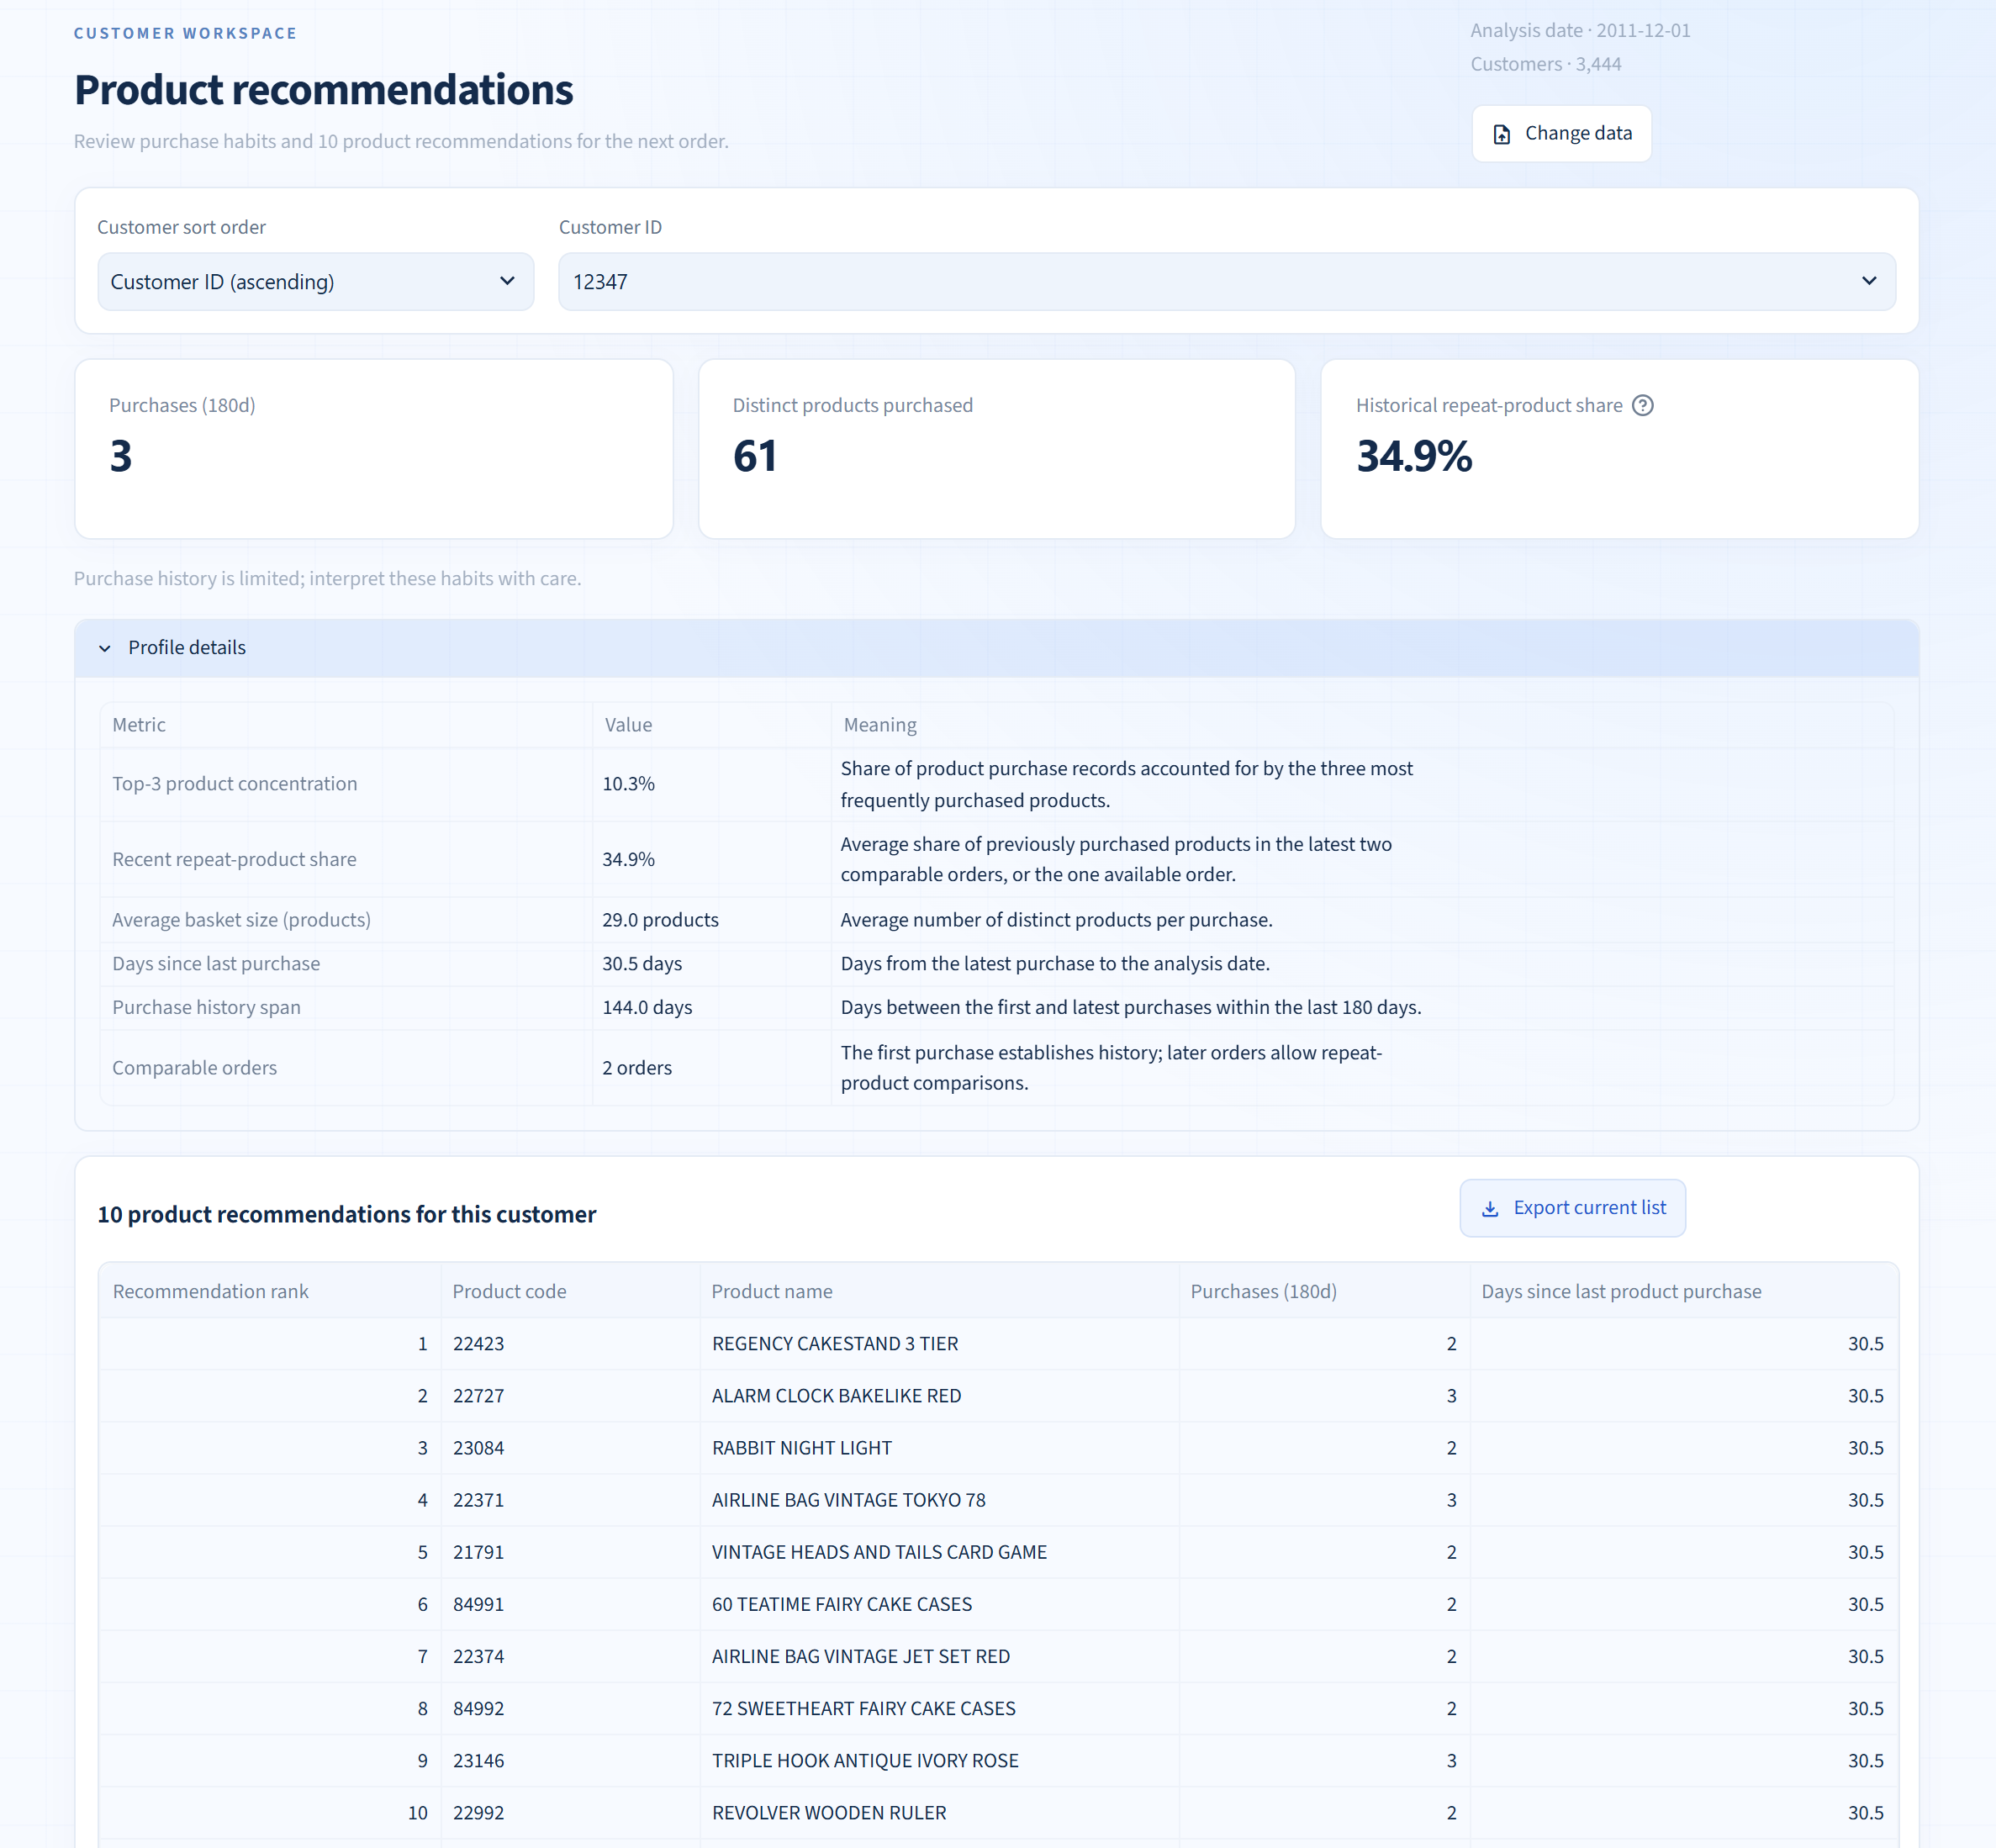
Figure 2-6 Purchase-habit profile and Top 10 products for customer 12347

