3 System Performance
This part evaluates the four objectives in turn, showing how performance is measured, what the comparisons show and which methods are used. Segmentation assesses clear and stable customer profiles; the other modules assess repurchase ranking, spending coverage and product recommendations.

3.1 Evaluation Setup
Experiments use the same customer snapshots split in time order. Each record describes one customer at one month-start. The same customer appearing in different months counts as a separate customer-month record.
Table 3-1 Time-based evaluation split
Purpose | Snapshot months | Records
Training | 2010-06–2011-05 | 37,019
Validation and selection | 2011-06–2011-08 | 8,146
Test-period review | 2011-09–2011-11 | 8,875

Earlier months train the models, and validation data select the methods. Segmentation and repurchase models are fitted on training data. Final spending and recommendation models also use validation samples whose outcomes are fully observed before 1 September. Customer histories update during September–November while model parameters stay fixed.
Methods within each module share customers, months, input scope and list size. Inputs use purchases before the analysis date; the following 30 days provide evaluation answers. Parameters are first compared through forward validation within training, followed by validation-period method selection.
Table 3-2 Evaluation units by module
Module | Evaluation population and aggregation
Segmentation | 957 held-out customers, with one snapshot per customer; five customer resamples assess grouping stability.
Repurchase | All customer-months. AP, AUC and Brier are pooled; top-20% lists are formed monthly, then pooled for list metrics.
Spending potential | Select the top 20% monthly, then average monthly spending coverage equally; MAE averages over records.
Recommendation | Main metrics cover customers with a next order within 30 days: average customers within each month, then average months equally.

3.2 Customer Segmentation
K-means, Bisecting K-means and GMM use the same five purchase features and 2–6 clusters. GMM tests diagonal and full covariance, giving 20 candidate settings in total.
Silhouette compares distance within a cluster with distance to the nearest other cluster. For each customer it is (b − a) ÷ max(a, b), where a is mean within-cluster distance and b is the nearest other-cluster mean distance. Average over customers; the range is −1 to 1, with higher values indicating clearer separation.
Stability ARI asks whether resampling training customers produces similar groups. It compares assignments for the same held-out customers and adjusts agreement for chance. The maximum is 1 for identical partitions; 0 represents chance-level agreement. We report the median across five resamples.
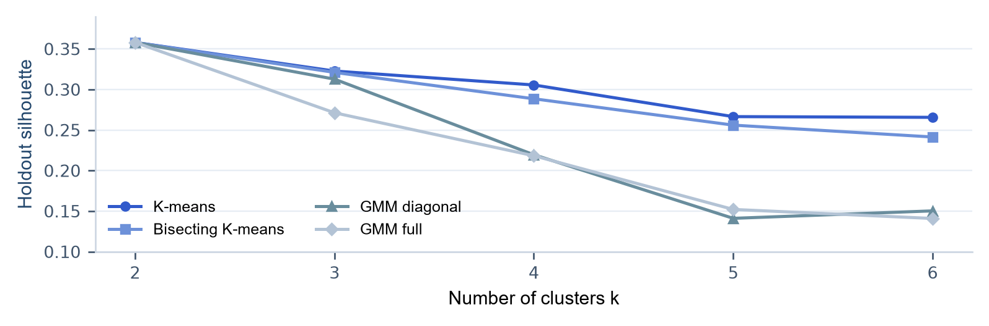
Figure 3-1 Silhouette across algorithms and cluster counts
Table 3-3 Comparison at four clusters
Four-cluster method | Silhouette ↑ | Stability ARI ↑ | Smallest validation group
K-means | 0.3056 | 0.9525 | 545
Bisecting K-means | 0.2885 | 0.9487 | 509
GMM diagonal | 0.2195 | 0.8047 | 236
GMM full | 0.2183 | 0.6768 | 341

K-means with four clusters is selected. Two clusters have the highest silhouette, 0.3580, mainly separating recent from long-inactive buyers. Four clusters further distinguish frequent, low-order-value and high-order-value recent buyers. Silhouette is 0.3056, stability ARI is 0.9525, and each validation-month group contains at least 545 customers. The four purchasing profiles recur across all three months.

3.3 Repurchase Prediction

3.3.1 Understanding Scores and List Quality
The model assigns each customer-month a score from 0 to 1 and ranks records from high to low. The answer is whether the customer purchases again within 30 days: 1 for yes and 0 otherwise. Metrics assess the overall ranking, the priority list and the individual score values.
Table 3-4 Repurchase metrics
Metric | Calculation and meaning | Range / direction
AP | Expand the list by score threshold; sum each recall increase × the precision at that threshold. Evaluates the overall ranking. | 0–1 ↑
ROC-AUC | Correctly ordered buyer/non-buyer pairs, plus half the tied pairs, divided by all such pairs. | 0–1 ↑
Precision@20% | Actual repurchases in the monthly top-20% lists ÷ list records. | 0–100% ↑
Recall@20% | Repurchases found in the top-20% lists ÷ all actual repurchases. | 0–100% ↑
Lift@20% | Top-20% precision ÷ overall repurchase rate; 1 means equal to the overall rate. | 0+ ↑
Brier | Average of (score − actual 0/1 outcome)² over all records. | 0–1 ↓

One five-customer example explains AP, AUC and Brier. The table is already sorted by score; 1 indicates an actual repurchase.
Customer | A | B | C | D | E
Score | 0.9 | 0.8 | 0.7 | 0.4 | 0.1
Outcome | 1 | 0 | 1 | 1 | 0

AP: Buyers occur at ranks 1, 3 and 4, where precision is 1/1, 2/3 and 3/4. AP = (1 + 2/3 + 3/4) ÷ 3 ≈ 0.8056. AP generally rises when buyers are concentrated near the top.
ROC-AUC: Three buyers and two non-buyers give six pairs. A wins two pairs; C and D each win one. AUC = 4 ÷ 6 ≈ 0.6667. A value of 0.5 represents near-random ordering.
Brier: A contributes (0.9 − 1)² = 0.01, while B contributes (0.8 − 0)² = 0.64. The mean is (0.01 + 0.64 + 0.09 + 0.36 + 0.01) ÷ 5 = 0.222; smaller is better.

3.3.2 Model Comparison and Monthly Results
Three feature groups contain 8 base features, 11 features with recent trends, and 14 features with purchase timing added. Each is tested with LR, spline LR, XGBoost and LightGBM, giving 12 combinations. Validation AP shows the effects of both model choice and features.
Table 3-5 Validation AP for all 12 combinations
Model | 8 base | 11 with trends | 14 with timing
LR | 0.5867 | 0.5892 | 0.5931
Spline LR | 0.5879 | 0.5907 | 0.5953
XGBoost | 0.5939 | 0.5962 | 0.6009
LightGBM | 0.5935 | 0.5950 | 0.5997

XGBoost with 14 features is selected. Validation AP is 0.6009 and Precision@20% is 60.64%. Candidates also need forward-validation AP and validation top-20% precision at least as high as base-feature LR. LightGBM with the same 14 features has AP 0.5997; the two results are close, and XGBoost is selected by validation AP.
Table 3-6 September–November test-period review
Method | AP ↑ | AUC ↑ | Precision  @20% ↑ | Recall  @20% ↑ | Brier ↓
14-feature XGBoost | 0.6201 | 0.7204 | 66.22% | 38.88% | 0.1928
8-feature LR | 0.6064 | 0.7100 | 63.96% | 37.55% | 0.1969

The review contains 8,875 customer-months, with 3,025 actual repurchases. Monthly top-20% lists total 1,776 places; XGBoost finds 1,176 repurchases. Precision = 1,176 ÷ 1,776 = 66.22%; recall = 1,176 ÷ 3,025 = 38.88%. The overall repurchase rate is 34.08%, giving 1.943× lift.
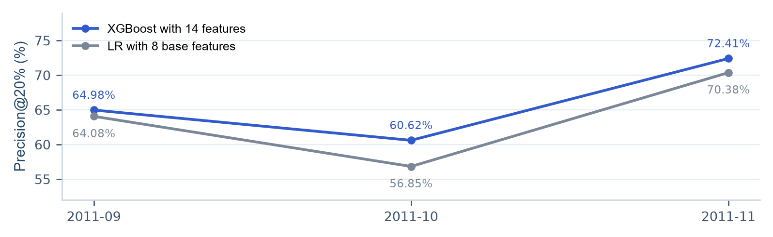
Figure 3-2 Monthly top-20% precision for XGBoost and LR
XGBoost has higher list precision than base LR in all three review months, finding 40 additional repurchasing customer-month records in total.

3.4 Spending-Potential Ranking
The task selects the top 20% of customers each month to capture more actual spending in the next 30 days. The main metric is spending coverage = actual spending by listed customers ÷ actual spending by all customers, ranging from 0–100%, with higher values better. Calculate it monthly, then average the three months equally.
MAE is an additional measure: average the absolute difference between predicted and actual spending across records. It is non-negative, measured in pounds, and lower is better. The rules estimate 30-day spending using the previous 30 days, 90-day spending ÷ 3, or 180-day spending ÷ 6.
Table 3-7 Coverage and amount error for six methods
Method | Validation  coverage ↑ | Review coverage ↑ | Review MAE ↓
Past-30-day rule | 56.14% | 55.95% | £336.68
Past-90-day rule | 67.39% | 64.56% | £270.68
Past-180-day rule | 71.37% | 67.45% | £263.47
Direct LightGBM amount model | 73.01% | 70.23% | £252.10
Direct XGBoost amount model | 72.80% | 70.45% | £252.12
Two-stage LightGBM | 73.28% | 70.23% | £253.75

Two-stage LightGBM is used. Validation coverage is 73.28%, versus 71.37% for the strongest rule, a gain of 1.91 percentage points with improvement in all three validation months. Selection also checks a mean gain of at least one point, no decline in at least two months, a worst-month loss within one point, and the direction of gains after customer resampling.
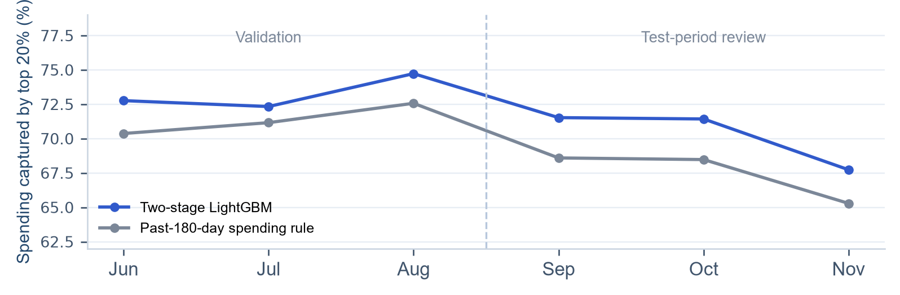
Figure 3-3 Monthly coverage for two-stage LightGBM and the 180-day rule
The method stays fixed for September–November. Mean coverage is 70.23%, versus 67.45% for the 180-day rule, a gain of 2.78 percentage points; MAE is £253.75 versus £263.47. Coverage takes priority because the task selects a customer list, while MAE adds information about amount-estimation error.

3.5 Profiles and Product Recommendations

3.5.1 Metrics and Round 1 Comparison
Each method recommends ten products to the same customers, then checks the next order within 30 days. There are 2,177 customer-months with a next order in validation and 3,025 in review; main metrics use these records. All eligible customers can receive recommendations.
Table 3-8 Recommendation metrics
Metric | Calculation and meaning | Range / direction
Recall@10 | Distinct recommended hits ÷ distinct products in the next order. Measures answer coverage. | 0–100% ↑
Hit@10 | 1 if at least one product is hit, otherwise 0; average over customers. | 0–100% ↑
NDCG@10 | A hit at rank r contributes 1 ÷ log₂(r + 1); a miss contributes 0. Sum the top ten and divide by the ideal ranking score. | 0–1 ↑
New-product Recall@10 | Hits among products not bought in the preceding 180 days ÷ next-order products in that category. | 0–100% ↑

For example, finding two of four next-order products gives 50% recall and Hit = 1. If the next order contains only A, placing A first gives NDCG = 1; placing it third gives 0.5. Metrics average customers within each month, then months equally. New-product recall uses customers whose next order contains such products.
Table 3-9 Five recommendation methods at @10
Round 1 method | Validation NDCG ↑ | Review NDCG ↑ | Review Recall ↑ | Review Hit ↑
Popular products | 0.1270 | 0.0862 | 3.65% | 39.84%
Personal repeat purchase | 0.3226 | 0.2863 | 17.17% | 75.09%
ItemKNN | 0.2015 | 0.1619 | 8.61% | 52.66%
Implicit-feedback ALS | 0.2526 | 0.2124 | 11.37% | 63.87%
EASE | 0.2779 | 0.2418 | 13.91% | 68.97%

Round 1: personal repeat purchase performs best, while EASE leads the three learned algorithms. The next round retains the repeat-purchase rule as a reference and adds EASE association scores to the candidate features, then tests customer profiles and product-level learning.

3.5.2 Round 2 Feature and Model Comparison
Round 2 treats one customer paired with one candidate product as a sample. A has 15 base purchase features; B adds profiles and interactions, giving 31; C adds EASE signals, giving 17; D combines the information, giving 34. Each group is tested with LR, LightGBM classification and LightGBM ranking.
Within each model family, groups share parameters and training samples. Validation and review score the same full product catalogue. The table compares all 12 combinations by validation NDCG@10.
Table 3-10 Validation NDCG@10 for all 12 combinations
Feature group | LR | LightGBM classifier | LightGBM ranker
A Base (15) | 0.3408 | 0.3415 | 0.0701
B Base + profile (31) | 0.3445 | 0.3424 | 0.1090
C Base + EASE (17) | 0.3394 | 0.3422 | 0.0870
D Full (34) | 0.3443 | 0.3448 | 0.1054

The current app uses full group D with LightGBM classification. Validation NDCG is 0.3448, up 0.0222 from the repeat-purchase rule at 0.3226. Recall rises from 20.01% to 21.21%, and NDCG improves in all three validation months. Within LightGBM classification, D exceeds C by 0.0026 in validation NDCG, showing a contribution from the added profiles and interactions.
Table 3-11 September–November results for the current recommender
Method | NDCG@10 ↑ | Recall@10 ↑ | Hit@10 ↑ | New products  Recall@10 ↑
Repeat-purchase rule | 0.2863 | 17.17% | 75.09% | 0.14%
D + LightGBM classifier | 0.3001 | 17.79% | 76.93% | 0.32%

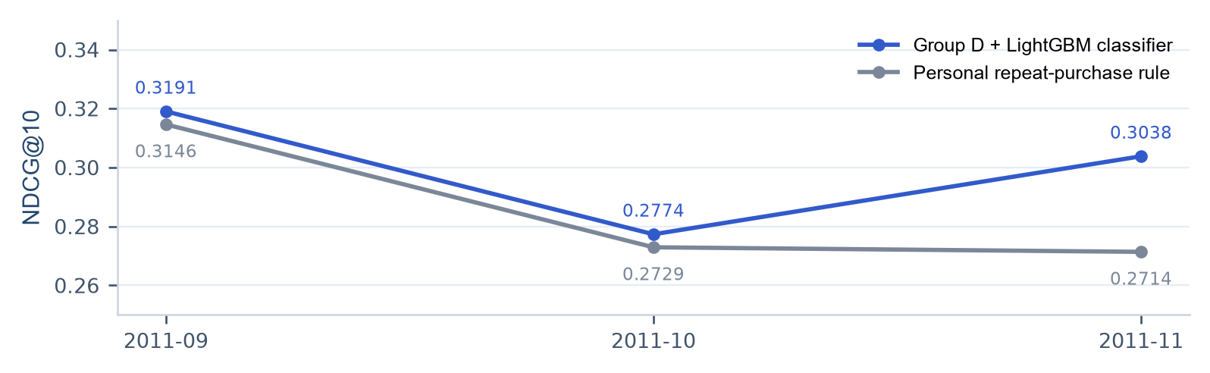
Figure 3-4 Monthly NDCG@10 for the current method and repeat-purchase rule
Review results are NDCG 0.3001, Recall 17.79% and Hit 76.93%. Relative to the rule, NDCG rises by 0.0138, Recall by 0.63 percentage points and Hit by 1.84 points. NDCG is higher than the rule in all three months.

3.6 Functional Verification and Use Case
A real upload of 759,615 purchase records, analysed on 1 December 2011, verifies the complete workflow. The system builds customer snapshots and historical features, calls the saved models, and shares the results across all four business pages.
Table 3-12 Outputs from the real upload
Output | Observed result
Customer population | 3,444 customers with a purchase in the preceding 180 days.
Customer segments | Four segments with group-level purchasing statistics.
Repurchase scores | XGBoost scores and ranks for all 3,444 customers.
Spending-potential list | 689 customers in the top 20%: 3,444 × 20%, rounded up.
Profiles and recommendations | Selecting a customer shows their purchasing profile and ten recommended products.

3.6.1 Four Outputs for One Customer
Customer 12347 made three purchases, spent £2,261.75 and bought 61 distinct products in the preceding 180 days, and is assigned to Group 2 Recent frequent buyers. The repurchase score is 0.333 and spending-potential rank is 543 of 3,444, within the top 20%. Historical repeat-product share is 34.9% and top-three product concentration is 10.3%.
Table 3-13 First three products in this customer’s recommendation list
Rank | Product code | Product name
1 | 22423 | REGENCY CAKESTAND 3 TIER
2 | 22727 | ALARM CLOCK BAKELIKE RED
3 | 23084 | RABBIT NIGHT LIGHT

An operator can review this customer’s segment, repurchase propensity, spending potential and suggested products in one analysis, then filter by customer or segment and export the lists.

3.6.2 Automated Checks
All 145 existing automated tests pass in this run. Coverage includes purchase windows and date boundaries, snapshot features, score reproduction from saved models, recommended products and order, page navigation, customer filtering and exports. The app supports any analysis date from 2011-09-01 to 2011-12-01.

