ASSIGNMENT 4

Create 3 tasks for LED blinking and prepare a report with comparison of 3 timer interrupt-based LED blinking. Analysis report should have:

1. Screenshot for both implementations
2. Time taken for execution in both implementations
3. Memory related information in both cases

Code:

// code for the program

void HAL_TIM_PeriodElapsedCallback(TIM_HandleTypeDef *htim){ if(htim->Instance==TIM2)

{

// To toggle the led.

HAL_GPIO_TogglePin(myled_GPIO_Port,myled_Pin);

}

if(htim->Instance==TIM3)

{

//Timer instance TIM3

HAL_GPIO_TogglePin(myled1_GPIO_Port,myled1_Pin);

}

if(htim->Instance==TIM5)

{

//Timer instance TIM3

HAL_GPIO_TogglePin(myled2_GPIO_Port,myled2_Pin);

}

}

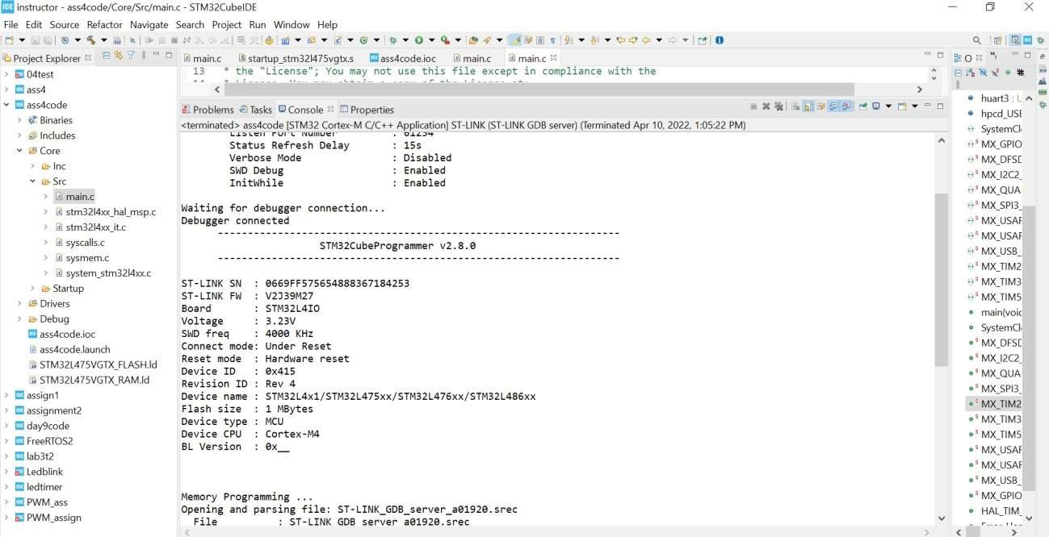

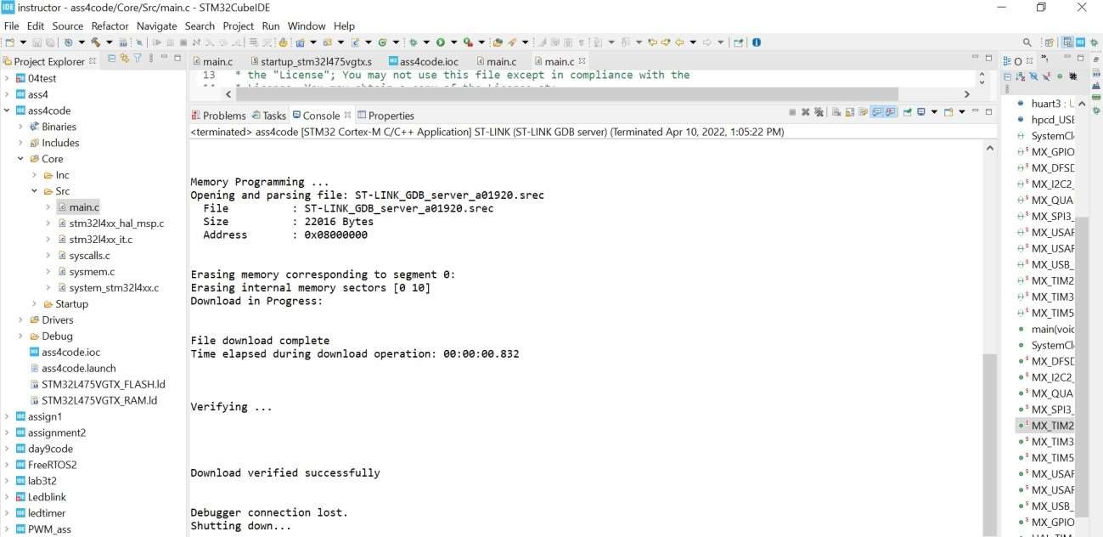

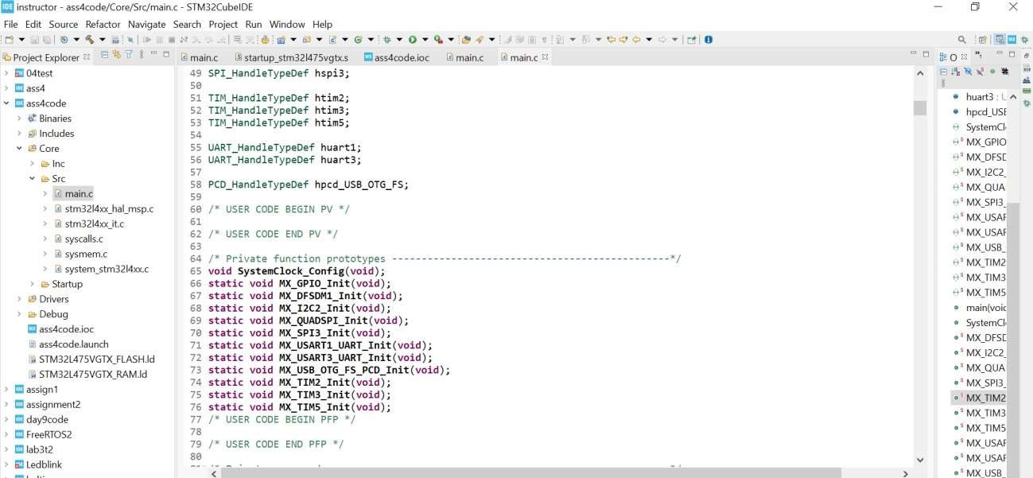

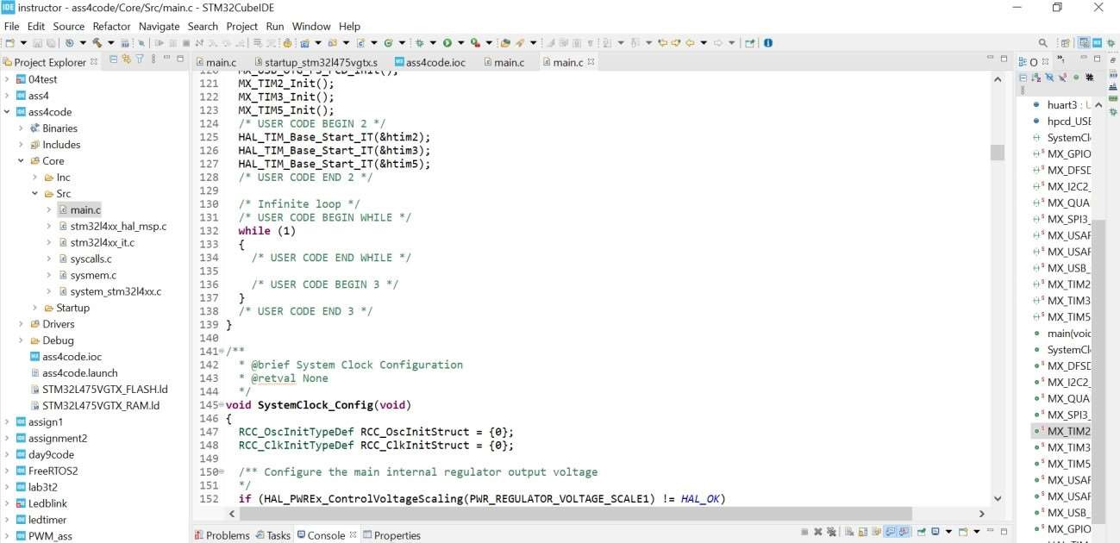

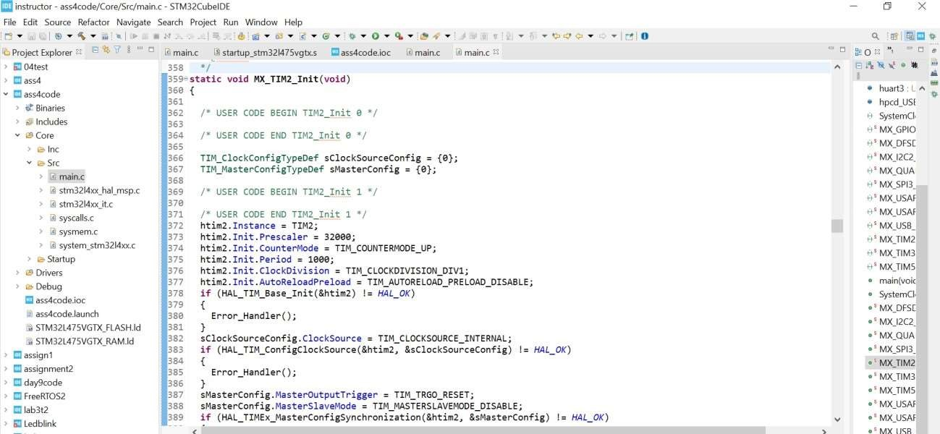

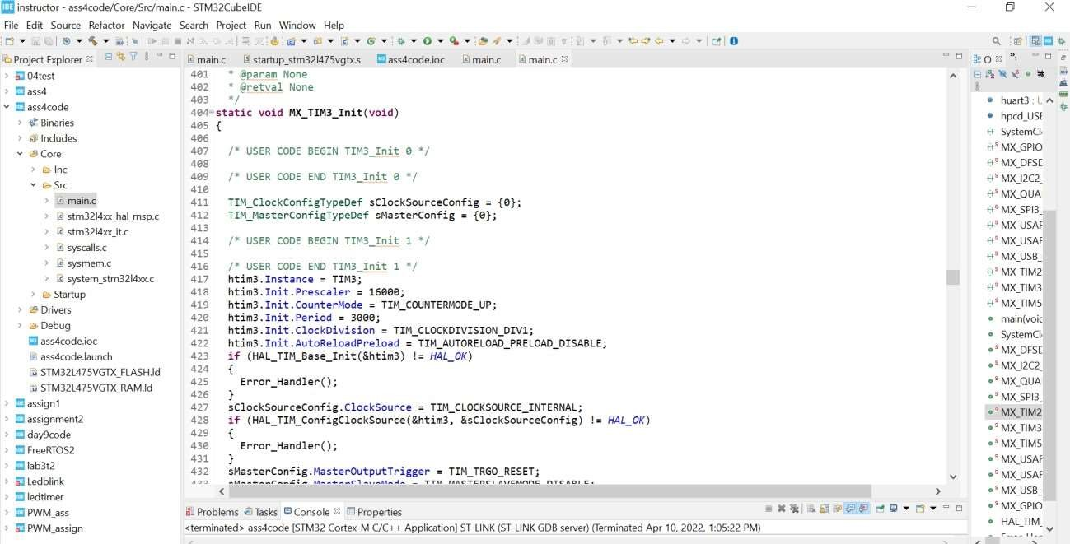

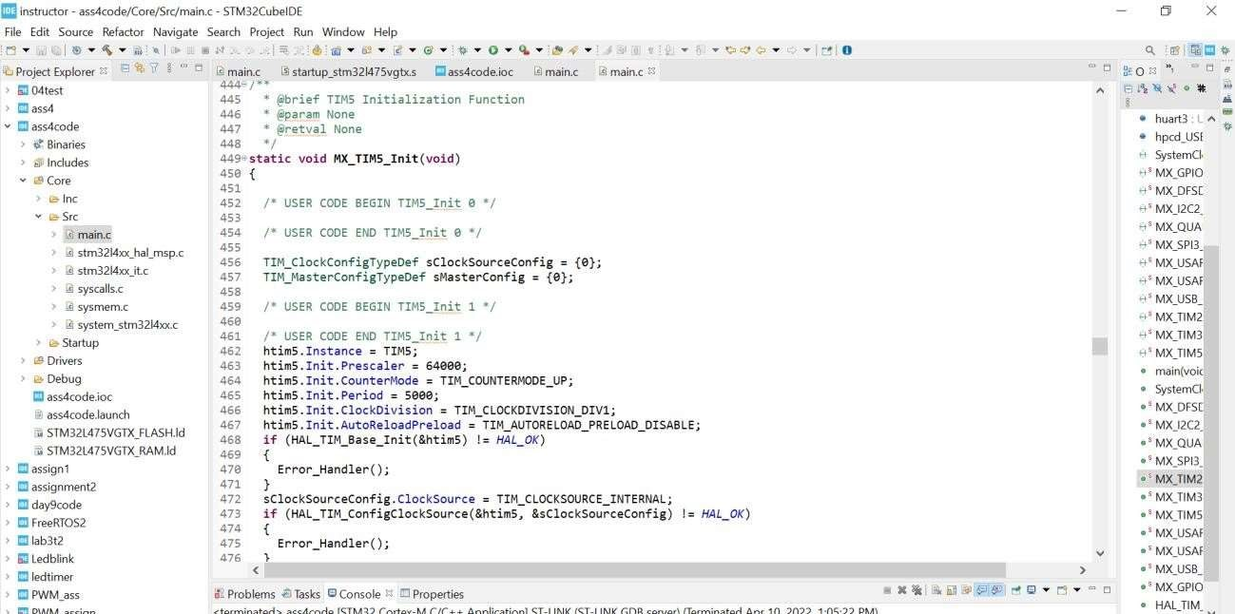

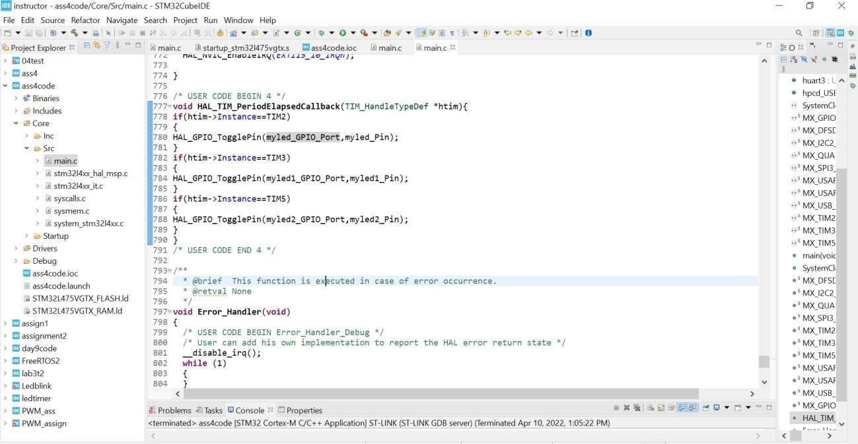

Code with RTOS:

// main loop started.

//Created task 1

static void task1_handler(void* parameters)

{

// Toggling LED1 and LED2 in a loop.

while(1)

{

printf("%s\n", (char*)parameters); HAL_GPIO_TogglePin(myled_GPIO_Port,myled_Pin); HAL_GPIO_TogglePin(myled2_GPIO_Port,myled2_Pin);

taskYIELD();

}

}

static void task2_handler(void* parameters) // Created Task 2

{

// Toggling LED1 and LED2 for task 2.

while(1)

{

printf("%s\n", (char*)parameters); HAL_GPIO_TogglePin(myled1_GPIO_Port,myled1_Pin); HAL_GPIO_TogglePin(myled_GPIO_Port,myled_Pin);

taskYIELD();

}

}

static void task3_handler(void* parameters)

{

// Toggling LED1 and LED2 for task 3.

while(1)

{

printf("%s\n", (char*)parameters); HAL_GPIO_TogglePin(myled2_GPIO_Port,myled2_Pin);

HAL_GPIO_TogglePin(myled1_GPIO_Port,myled1_Pin);

taskYIELD();

}

}

 - e x

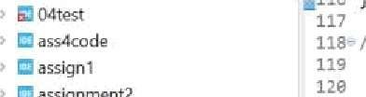

iz4

xcc_o,cznitWe• oeY

scc_osc*nitstruct

-

C

eb



@ Probkms QAs}a Al Console o E) gropart@ ^ * ! ” ” ” • ' MX.GPIO.Ini

› 8 ThkdParty/TreeRTOS

<lermineted> FreeRfOS2 {STM32 Cortes-M G'C++ Agplkzbonj ST•IJNK {it-LINE G08 seyer) @rrninated Agr 10. 202a 4 28é3 PM) ° ’ tesk1 hands



fi

STM

32

L475VGTX_FLASH.Id





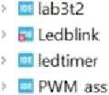



<terminated > FreeRTOS2 [STM32 Cortex-M C/C++ Applicationj ST-LINK (ST-LINK GDB server) (Terminated Apr 10, 2022. 1:31:52 PM) • main(void) : i



* ‘ taskl handle

Memony Programming ...

* ‘ task2 handle

Opening and parsing file: ST-LINt_GDB_server_a1#688.srec

File : ST- LINK_GDB_server_a14688 . srec • ‘ tasM kandle

Size : 26576 Bytes • Error Handle



4 assert failed(

Erasing memory corresponding to segment 0: Erasing internal memory sectors [0 10] Download in Progress:

F1Ie download complete

T1me eI apsed during download operation : BO: BO: BO. 813



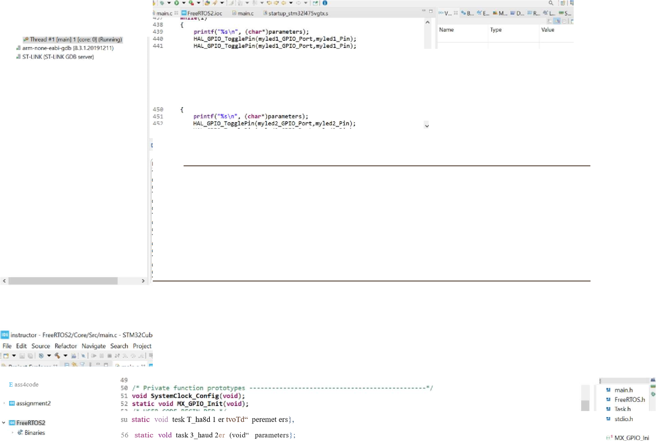

* ias k4 handlt

e

Debug

67

*/



* task handle
* ' iask3 handle



* STM 32 L4 7S\/GTX RAM.Id

 

