LandShield BD — Concept Note
LandTech 2026 · Track: Digital Land Records, Verification & Digitization
Problem statement: P3 — Fraud & Double-Selling Detection. One pipeline also delivers P1, P2, P4 and P5 (see section 1).
Team: DEEDGUARD · Live demo: landshield-bd.vercel.app · Code: github.com/A-42-018/LandSheild-BD · Video: youtu.be/ZzGZMmd4yT4
Demo prototype. All land, deed and person records are synthetic (except two sample deed PDFs supplied by our mentor for OCR testing). LandShield gives risk indicators for a human to review; it does not establish ownership or replace official verification.

1. Problem statements covered
Every LandTech problem statement is a stage of the same transfer: a deed is digitised, made verifiable, checked for fraud, mutated, and finally checked by the next buyer. LandShield builds that whole chain, with P3 as our primary statement.
Statement | What LandShield does
P1 Historical Record Digitization | Officers upload scanned deeds, khatians (CS / SA / RS / BS) and porchas. An OCR router uses a PDF's text layer only if it passes a quality gate, otherwise Tesseract (Bangla + English, OpenCV clean-up, ruled tables read cell by cell). A classifier separates modern from historical (pre-1971, also pre-1947) deeds and a parser fills a digital deed record (LHDR v1): every field keeps the normalised value, the exact Bangla text, a confidence score and its place on the page. A reviewer confirms every field; approved records are searchable by party, mouza, khatian, dag and year.
P2 Deed & Ownership Verification | On approval each record is hashed (SHA-256), Ed25519-signed, versioned and appended to a hash-chained ledger; editing any row shows exactly where the chain breaks. Reports and the downloadable digital deed PDF carry a QR code to a public check page. Verify a document copy compares an uploaded copy with the signed record and names each altered field.
P3 Fraud & Double-Selling (primary) | An explainable rule engine scores every plot 0–100 (LOW / MEDIUM / HIGH) with 22 scored rules: same plot sold twice, seller not the recorded owner, duplicate deed number, rapid resale, impossible dates, invalid deed number, registered but not mutated, mutation to another party or without a deed, area mismatches, active case, khas or acquired land, broken historical chain of title, and record-integrity failure. Every indicator shows its evidence. An Isolation-Forest anomaly hint adds at most 15 points and can never create HIGH on its own.
P4 Smart e-Mutation & Registry Workflow | Approving a deed opens an e-Mutation application by itself. Six automatic pre-checks (seller is owner, no open HIGH alert, no active case, not khas or acquired, area within holding, document approved) route it to fast track or hearing. Officers work a queue and a hearings calendar; every step is audit-logged and a rejection needs a reason. Citizens follow it on the public Track mutation page.
P5 Citizen Pre-Purchase Verification | Check before you buy: a buyer enters the plot (and the seller's name) and gets a six-point plain-language checklist in Bangla or English: seller matches owner, mutation up to date, no pending case, not khas or acquired, no open risk indicators, document authentic. Citizens can also list every plot under their NID and watch a plot for new sales, cases or mutations.

2. The problem and the Bangladesh context
A sale deed is registered at the Sub-Registry office (Ministry of Law), while the ownership record (khatian) changes only through mutation (namjari) at the AC Land office (Ministry of Land). Nobody checks both sides automatically. While mutation lags, the old owner is still the recorded owner and can sell again; a buyer often learns of a second sale, a pending case or khas status only in court. Old records add a third layer: CS, SA, RS and BS khatians from different eras, many only on paper and in Bangla, often disagree on owner, area or dag.
- Land dominates litigation. The Senior Secretary of the Ministry of Land has said almost 80 % of all court cases are land disputes [1]; land was the most common serious legal problem (29 %) in the HiiL/BRAC justice-needs survey [2].
- Land services are trust-poor. TIB's National Household Survey found that 51 % of households using land services faced corruption and 32.3 % paid bribes [3].

3. Online services
All services are in Bangla and English (Bangla numerals included) and work on a phone. Each has a citizen-charter entry (what you need, fee, time, responsible office) and a picture guide with a short Bangla voice-over video.
Service | What it does
Public — no sign-in
Track mutation | Enter the namjari application number; see Applied → Review → Hearing → Decided with dates and the office. No names shown.
Verify a document copy | Upload a photo or PDF of a deed copy; get MATCH or ALTERED with the changed fields. The file is checked and discarded.
QR check page | Scan the QR on a report or digital deed; see the signed public summary, risk level and counts, with no personal data.
Parcel map | Bangladesh from division to upazila; plot outlines with dag and khatian numbers (synthetic plots, no owner names).
Citizen tools | Land unit converter (shatangsho, katha, bigha, acre…), registration and mutation fee estimator (illustrative rates), inheritance (faraid) share calculator. Runs on the device.
Guide, citizen charter, feedback | Step-by-step picture guides and videos; feedback with a reference number and a tracked reply; a statistics infographic (sample data).
Signed-in citizens
Verify land record | District, upazila, mouza, khatian and dag → recorded owner, ownership history and graph, risk level with evidence, and a bilingual A4 report with QR.
Check before you buy | Plot + seller's name → the six-point pre-purchase checklist (section 1, P5).
Find your land by NID | Link your NID once with your date of birth; see every plot recorded in your name, now and before.
My land services | Search history, watchlist with alerts on new sales, cases or mutations, saved reports and notifications.
Officers and reviewers (office-scoped sign-in)
Upload, OCR and review | Upload deeds, khatians and porchas; review every extracted field beside the scan; four-eyes rule (the uploader cannot approve).
Alerts, e-Mutation and hearings | Risk-alert dashboard (HIGH alerts need officer sign-off and a reason to dismiss), mutation queue with pre-checks, hearings calendar.
Document library and archive | Every upload with its digital version and history; downloads (digital deed PDF, JSON, original, signed bundle); full-text archive search.
Administrators
Administration | Users and roles, approval of officer sign-up requests by land office, land-office list, public notices, ledger integrity check, audit log.

4. Architecture and tech stack
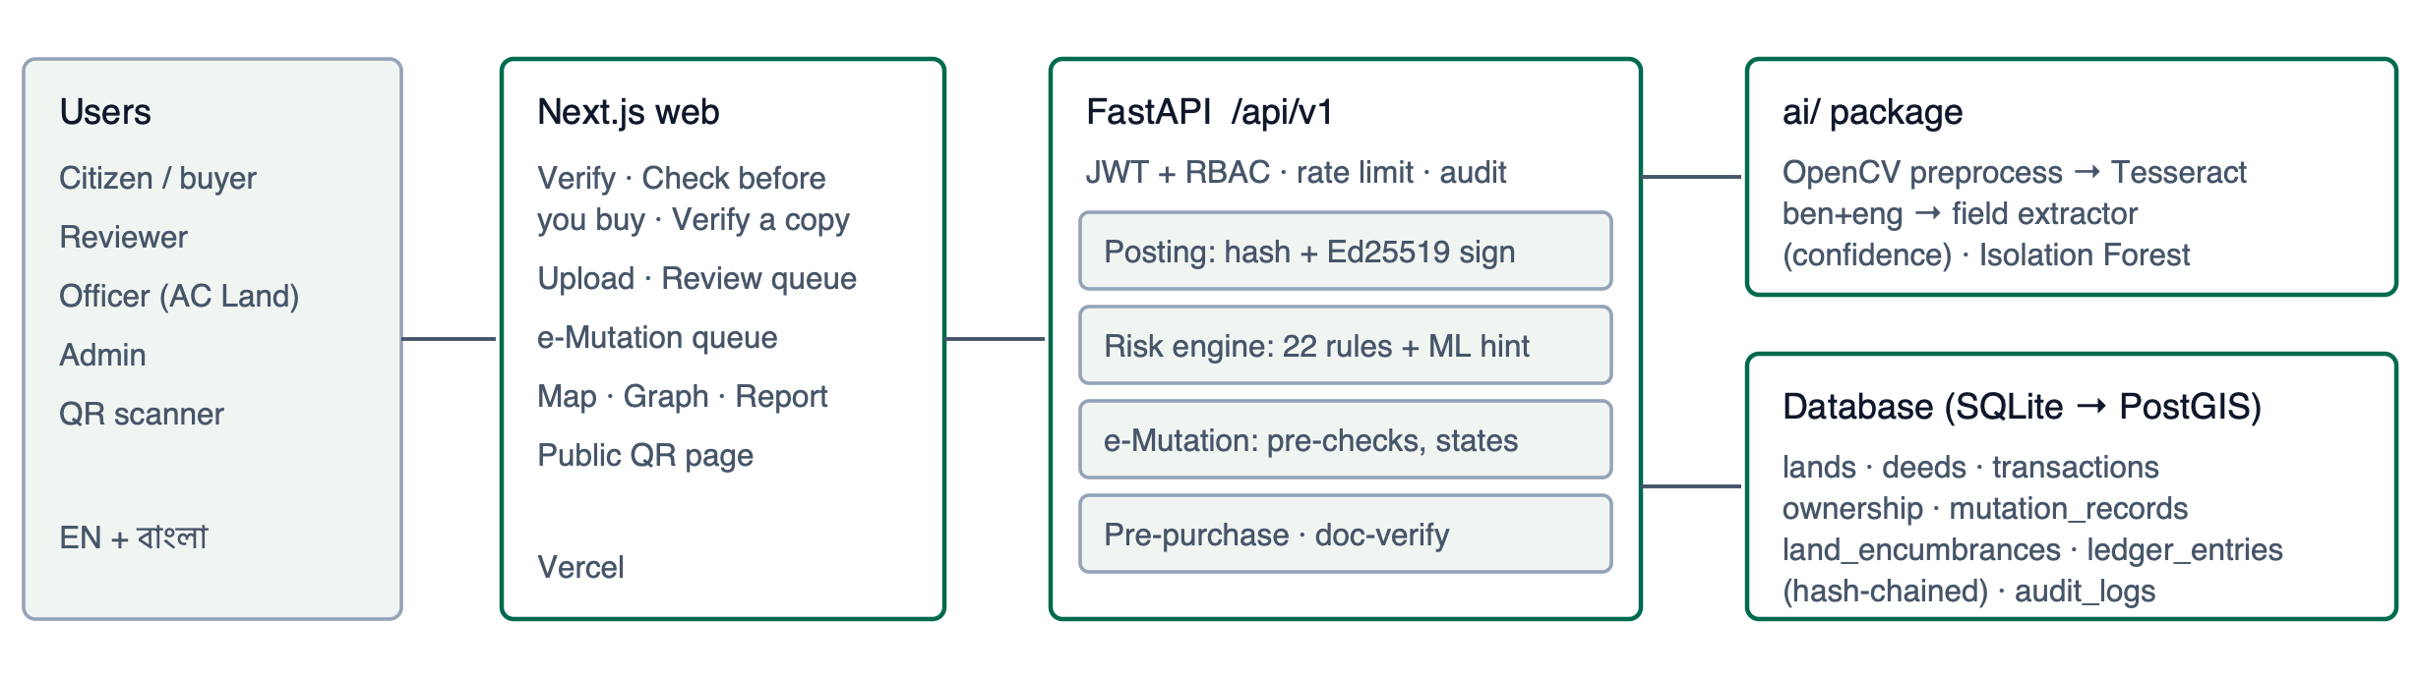
Layer | Stack
Frontend | Next.js 14 (App Router), TypeScript, Tailwind CSS, next-intl (EN + BN), TanStack Query, React Hook Form, Leaflet map, React Flow ownership graph
Backend | Python 3.11, FastAPI, SQLAlchemy 2 + Alembic, Pydantic 2, JWT + role-based access (citizen / reviewer / officer / admin), rate limits, audit log; SQLite demo, Postgres/PostGIS for scale
AI / trust | Tesseract (ben + eng) + OpenCV + PyMuPDF, rule-based and LHDR extractors, rapidfuzz Bangla-aware name matching, scikit-learn Isolation Forest; SHA-256, Ed25519, hash-chained ledger; WeasyPrint digital deed PDF with exact Bangla text layer
Quality / deploy | pytest, Vitest, Playwright end-to-end tests, ruff, TypeScript strict; Docker → Render (API), Vercel (web)

5. Key screens
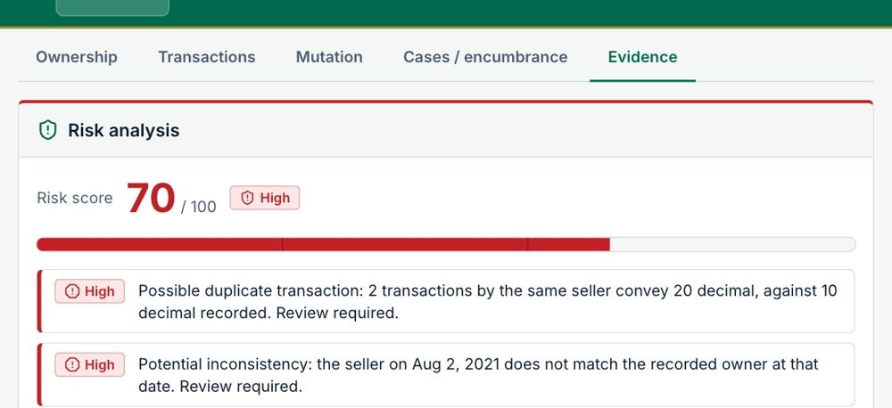  Double sale on LP-10240: HIGH 70, every indicator explained | 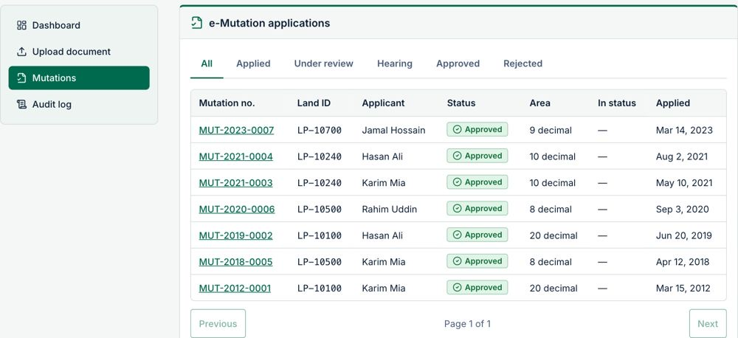  Officer e-Mutation queue, auto-created from approved deeds
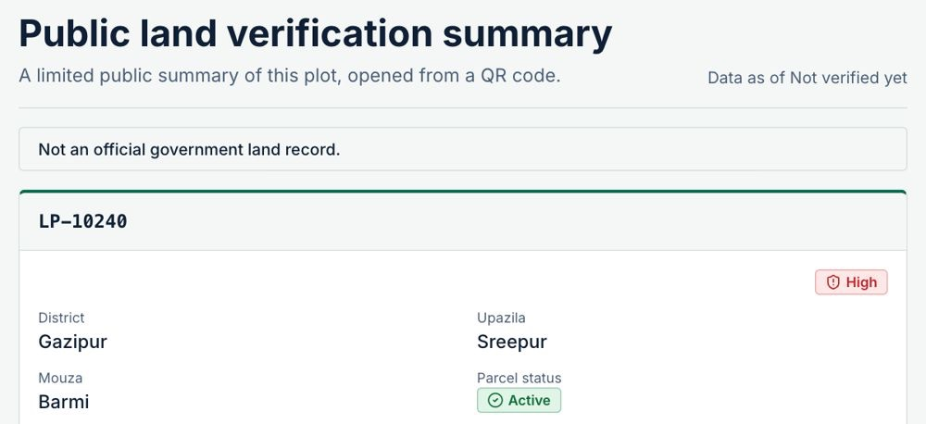  Public QR page: risk level and counts, no personal data | 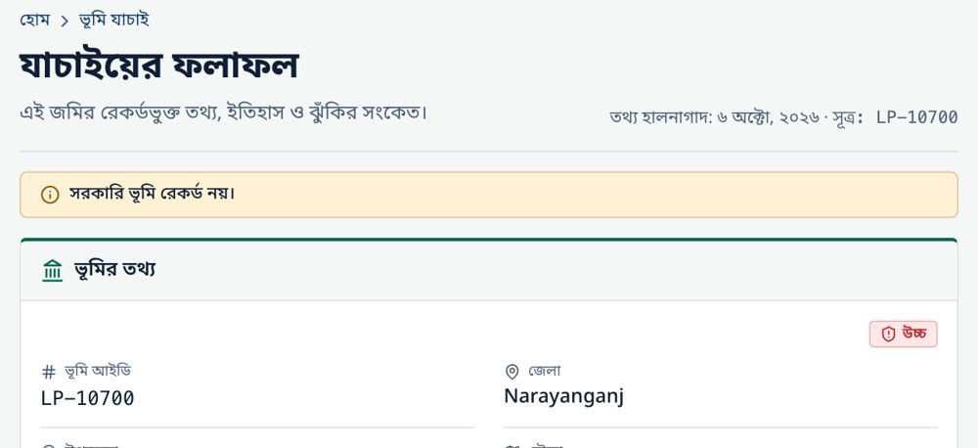  Full Bangla interface with Bangla numerals

6. AI metrics and limitations
Measure (synthetic data unless noted) | Result
Rule engine, seeded fraud scenarios | precision 1.00, recall 1.00 (0 false positives)
Anomaly model, held-out split (2 000 rows) | precision 0.974 · recall 0.935 · F1 0.954 · ROC AUC 0.998
OCR + extraction, 20 modern deeds (240 values, exact match) | 85.4 % (73.3 % without preprocessing)
Historical deeds, 12 files incl. the mentor's 2 real samples (1 064 values) | 85.9 % all values · 85.7 % of core fields (was 2.1 % before the historical pipeline)
Bangla khatian / porcha specimens | character error rate 21.6 % · parsed fields 90 %

Limitations (stated honestly). Almost every number comes from synthetic data, and real scans will score lower, so every machine-read value goes through a human reviewer. Handwritten deeds are best effort only. The anomaly score is not a probability. The ledger is only as strong as write access to the database (anchoring the chain head outside the database comes next). There is no live registry integration, and the free hosting tier sleeps, so the first request has a cold start.

7. Countrywide implementation plan
Stage | Scope | Integration
Pilot (6 months) | 1 upazila: 1 Sub-Registry + 1 AC Land office | Read-only registration and mutation feeds; digitise the pilot mouza's khatians and old deeds
District (12 months) | 1 district | Live e-Mutation API, court cause-list feed, DC office khas register
National (24–36 months) | 64 districts | Permissioned ledger nodes at Sub-Registry / AC Land / DC offices; national search; mobile + SMS "check before you buy"; bank API for collateral checks

Cross-cutting: Postgres/PostGIS and object storage; Bangla OCR fine-tuned on anonymised archives (with legal approval); data protection by design (no personal data on public pages, NIDs shown as the last 4 digits, audit trail); officer training. Expected impact: fewer double sales reaching court, faster mutation, and fewer broker visits for buyers.

8. Team, mentors and AI disclosure
Name | Role
Alif Mahmud | Backend, risk engine, e-Mutation, ledger
Ayesha Hamid Mithila | Frontend, OCR pipeline, UI, deployment
Tamanna Sultana | Mentor
Md. Jannatul Nayem | Industry mentor

AI tool disclosure. Claude (Anthropic) helped write code, tests and documentation, phase by phase. The team reviewed, ran and edited everything. Risk decisions come only from deterministic, explainable rules; an optional LLM reader for scanned deeds stays off unless an API key is set, and its output is always reviewed by a person.
Sources. [1] Daily Observer, "Land case backlog weighs on our legal system", 8 Nov 2025 (observerbd.com/news/552680). [2] HiiL & BRAC, Justice Needs and Satisfaction in Bangladesh, 2018 (brac.net). [3] TIB, Corruption in Service Sectors: National Household Survey 2023, 3 Dec 2024 (ti-bangladesh.org/en/articles/press-release/7136).

