Team#4

Sprouts
Software Design Specification (SDS)
Version: <1.0>
CM Identifier: Sprouts_SE042018SDS_v1.0

Revision History

Sl. No. | Prepared/  Modified by | E-mail | Version | Date | Approved by | Descriptions/  Remarks
1. | Salma Hanafy | salmahanafyahmed@gmail.com | 1.0 | 04/07/2018
2. | Mohammed Hamdy | Hamdymohammed146@gmail.com | 1.1 | 04/07/2018
3. | Amira  Ahmed | amira.a.amer@gmail.com | 1.2 | 04/08/2018
4. | Sahar Hossam | s7r_hossam@hotmail.com | 1.3 | 04/08/2018

Distribution list
Name | E-mail | Notes
Eng. Ali Sdeek | Alielseddeek@gmail.com | For approval

Table of Contents
1. Introduction 6
1.1 Purpose of this Document 6
1.2 Scope 6
1.3 Table of Acronyms and Definitions 6
1.3.1 Definition 6
1.4 References 6
1.5 Overview of Document 6
2. System Architecture 7
2.1 Design Patterns Description 8
2.1.1 Design Pattern I: MVC (Model-viewer-controller) 8
2.1.2 Design Pattern II: Singleton design pattern 8
3. Design Models 8
3.1 Class Diagrams 8
3.2 Interaction Diagrams 8
3.2.1 SD1: Login 8
3.2.2 SD2: Change password 9
3.2.3 SD3: View courses details 9
3.2.4 SD4: Enroll in course 10
3.2.5 SD5: View instructor’s schedule 10
3.2.6 SD6: Add a slot for a course 11
3.3 State Chart Diagrams 11
3.4 Activity Diagrams 11
3.5 Component Diagrams 11
4. Data Models 12
5. System Deployment 12
6. Traceability to Requirements 13

List of Tables

Table 1-1: Table of Acronyms and Definitions 6
Table 6-1: Traceability matrix 13

List of Figures

Figure ‎2-1: High Level view of system Architecture (MVC model) 7
Figure ‎2-2: Detailed system Architecture 7
Figure ‎3-1: SD1 Login 8
Figure ‎3-2: SD2 Change password 9
Figure ‎3-3: SD3 View courses details 9
Figure ‎3-4: SD4 Enroll in a course 10
Figure ‎3-5: SD5 View instructor's schedule 10
Figure ‎3-6: SD6 Add a slot for a course 11
Figure ‎4-1: Entity Relation Diagram for Sprouts Database 12
Figure ‎5-1: System Deployment Diagram 12

Introduction
This release of the SDS document will focus on specifying a high-level view of the architecture of our system and its components. It describes system’s architecture, system design and data models and interactions in system.

Purpose of this Document
The purpose of this document is to provide an overview of the system’s framework and to build a method of tracking the progress of the project and its compatibility with what was agreed upon in the SRS document.

Scope
This SDS applies to a web application used by volunteers, students, charity organization admin and website guests. The project is concerned with building a website for learning purposes that facilitates communication between students, volunteers and admins. Students should be able to enroll in a course, view the entire schedule as well as their own schedule. As for the instructor, he should be able view his own schedule. The admin can add another admin or instructor, add courses and assign instructors to them. The admin also have the right to assign slots to courses. In addition, all users can change their password. The development of the reservation software is out of the scope of the development process.

Table of Acronyms and Definitions

Term | Definition
Admin | Charity organization administrators
CSS | Cascading Style Sheets
HTML | Hypertext markup language to build web page structure
JS | JavaScript
MVC | model-view-controller
SD | Sequence diagram
SDS | Software Design Specification
SRS | Software Requirements Specification
Students | Children taking the offered classes
Uc | use case
Volunteers | People volunteering to be instructors
Table 1-1: Table of Acronyms and Definitions

References
- “Software Engineering”, 9th Edition, Ian Sommerville, Addison-Wesley, 2009
- Software Engineering Course Lecture Notes, Dr. Ahmed Hamdy.
- The SRS document, CM Identifier: Sprouts_SE042018_v1.0, version 1.0.

Overview of Document
In the upcoming sections the SDS will discuss:
- “System Architecture” which describes the main subsystems on which the overall system depends on and the relations among them.
- “Design Models” which contains class, interaction, activity and state chart diagrams that models the system.
- “Data Model” which describes the database used for the system and the relations among the entities and each other.
- “System Deployment” which contains some component and deployment diagrams to model how the system will be deployed.
- “Traceability to Requirements” which contains a matrix to map requirements to design elements.

System Architecture
The control model used is the Interrupt-driven Model. Interrupt-driven model is used in real time systems where interrupts are detected by and interrupt handler and passed to some other component for processing.

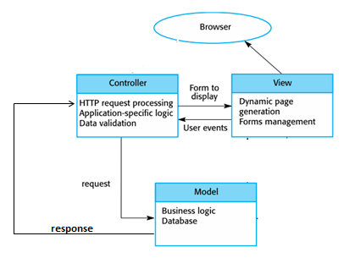
Figure ‎2-1: High Level view of system Architecture (MVC model)

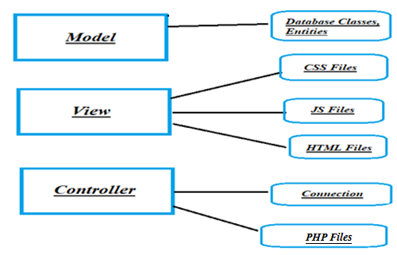
Figure ‎2-2: Detailed system Architecture

Design Patterns Description

Design Pattern I: MVC (Model-viewer-controller)
MVC is a design pattern that is based on splitting the system into 3 interconnected segments; the model which describes the database, the view which is the part of the software that the user will use as an interface to interact with the system, the control which is the connection between the View and the model, it takes information from the view and based upon it decides what queries needs to be called from the model and then returns the data retrieved from the model in an understandable way to the view.
The entire services are built based on the MVC design pattern as this provides a layer of abstraction where a change in one segment does not affect the entire system.

Design Pattern II: Singleton design pattern
This pattern is used when a class is needed to be instantiated only one time and shared by all other classes when needed.
This pattern is used with connection (connect to database) object as the connection object is shared and used by all other objects to handle all requests or views.

Design Models

Class Diagrams
Not applicable.

Interaction Diagrams

SD1: Login
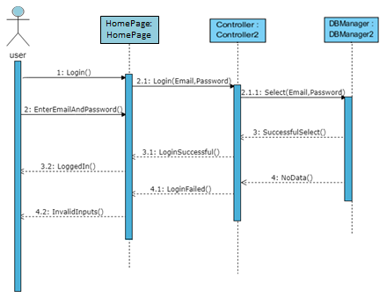
Figure ‎3-3: SD1 Login

SD2: Change password
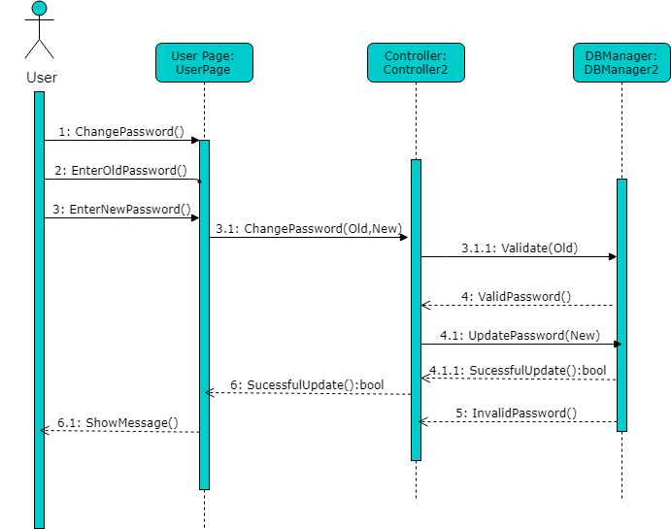
Figure ‎3-4: SD2 Change password

SD2: View courses details
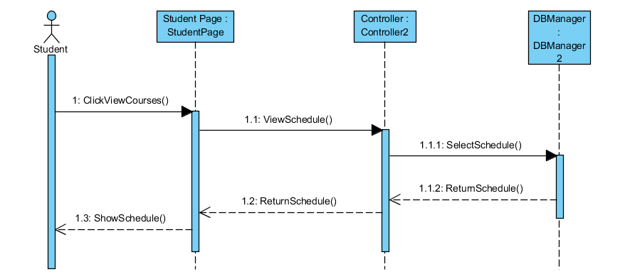
Figure ‎3-5: SD3 View courses details

SD3: Enroll in course
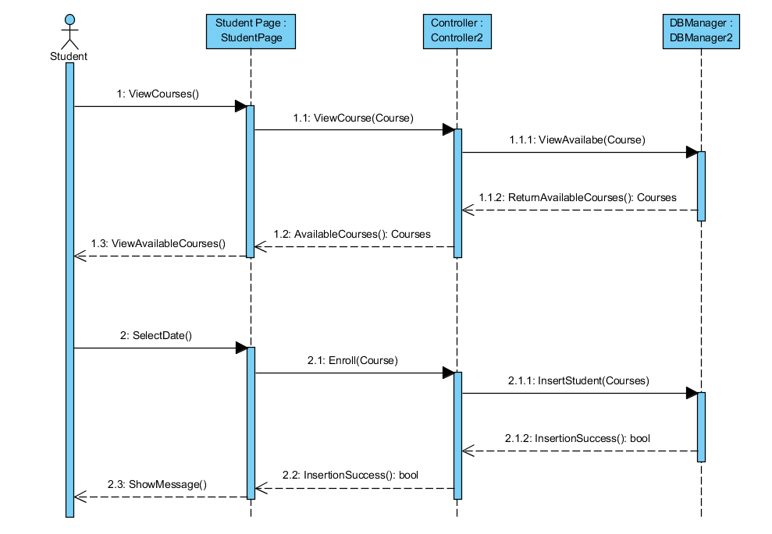
Figure ‎3-6: SD4 Enroll in a course

SD4: View instructor’s schedule
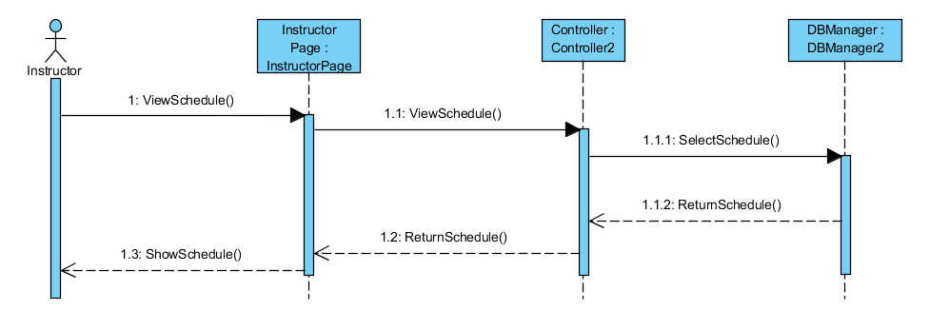
Figure ‎3-7: SD5 View instructor's schedule

SD5: Add a slot for a course
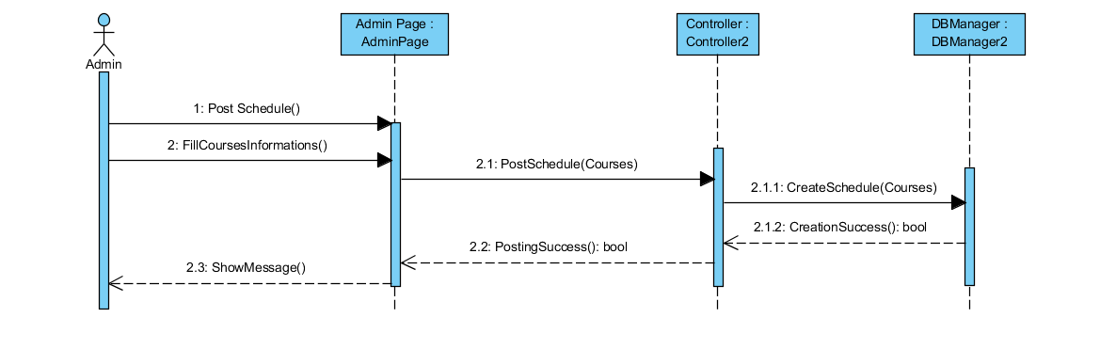
Figure ‎3-8: SD6 Add a slot for a course

State Chart Diagrams
Not applicable.

Activity Diagrams
Not needed.

Component Diagrams
Not applicable.

Data Models
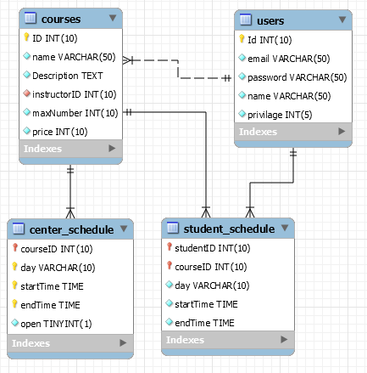
Figure ‎4-9: Entity Relation Diagram for Sprouts Database

System Deployment
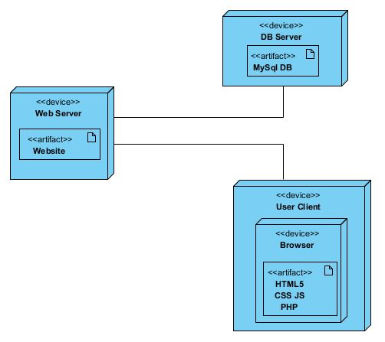
Figure ‎5-10: System Deployment Diagram

Traceability to Requirements

RID | SD1 | SD2 | SD3 | SD4 | SD5 | SD6
UC1.1 | √
UC1.2 |  | √
UC2.1 |  |  | √
UC2.2 |  |  |  | √
UC2.3
UC2.4
UC2.5
UC3.1
UC3.2
UC3.3
UC3.4 |  |  |  |  | √
UC4.1 |  |  |  |  |  | √
UC4.2
UC4.3
UC4.4
UC4.5
UC4.6
UC5.1
UC5.2
Table 6-1: Traceability matrix

