

AL-RAYAN UNIVERSITY

FACULTY OF ENGINEERING AND INFORMATION TECHNOLOGY

INFORMATION TECHNOLOGY DEPARTMENT

**Clearance Management System**

A PROJECT SUBMITED IN PARTIAL FULFILMENT THE REQUIREMENTS OF BACHELOR DEGREE IN INFORMATION TECHNOLOGY

**Written by:**

**ABDULSALAM SALIM ABDULLAH ALAUMODY**

**ABDULLAH KHAMIS ALI BA-MOMAN**

**IBRAHIM JUMAAN KHAMIS BA-DARIS**

**OSAMA ALI ABDRUBA THABT**

**SALIM MOHAMMED AWEDH HOMRAN**

**ZAKARIA WALEED SALIM GARWAN**

**Supervisor**

**Abdullah AL-Dhaibani**

**ALMUKALLA**

**February 2022**



**جامعة الريان**

**كلية الهندسة وتقنية المعلومات**

**قسم تقنية المعلومات**

**نظام إدارة إخلاء طرف**

**مشروع تخرج مقدم للحصول على**

**درجة البكالوريوس في**

**تقنية المعلومات**

**إعداد:**

**عبد السلام سالم عبد الله العمودي**

**عبد الله خميس علي بامؤمن**

**إبراهيم جمعان خميس باضريس**

**أسامه علي عبدالرب ثابت**

**سالم محمد عوض حمران**

**زكريا وليد سالم جروان**

**إشراف**

**الدكتور / عبد الله الذيباني**

**المكلا**

**فبراير-2022**

**اهداء وشكر**

نهدي هذا العمل لكل شخص ساهم في إنجاح المشروع من دكاترة أفاضل وزملاء عزيزين.

ومن باب من لا يشكر الناس لا يشكر الله لا ننسى الداعم الأول لتسهيل أمورنا في المرحلة الدراسية من الأساسي الى الجامعي الوالدين الموقرين نهدي لهم خالص العمل ممزوج بالحب المعطر بصفاء روح المستقبل.

TABLE OF CONTENT

CHAPTER 1 1

**1.1** **Introduction**  1

**1.2** **Problems Statement**  1

**1.3 Objective** 1

**1.4** **Scope of Project**  1

**1.5** **Realated work** 2

CHAPTER2 8

**2.1 Introduction** 8

**2.2 System Analysis** 8

**2.2.1 Use Case** **Diagram** 9

**2.2.2** **Context Diagram** 9

**2.2.3** **DFD level 1** 10

**2.2.4** **Level 1 Login process** 11

**2.2.5** **Level 1 Apply process** 12

**2.2.6** **Level 1 Show process** 13

**2.2.7** **Level 1 Registration check process** 14

**2.2.8** **Level 1 Department check process** 15

**2.2.9** **Level 1 Finance check process** 16

**2.2.10** **Level 1 Library check process** 17

**2.2.11** **Level 1 Secretary general check process** 18

**2.2.12** **Entity relationship diagram (ERD)** 19

**2.2.13** **Database diagram** 20

CHAPTER **3** 21

**3.1 Introduction** 22

**3.2 System design** 22

CHAPTER **4** 28

**4.1 Conclusion** 28

**4.2 Future work** 28

**References**: 29

CHAPTER 1

INTRODUCTION

**Introduction 1.1**

In light of the technological development, that has affected all aspects of life, and in light of the poor economic living situation, and based on the principle of responsibility and social concern, we have decided to launch a service that eases the burden of material and moral hardships. The service will provide the student with knowledge of what obligations he has from others before starting the graduation procedures or announcing his withdrawal from the university. It will also save you the hassle of traveling and the wasted effort in providing the obligations owed by it. The first controller of the service is the Office of Admission and Registration, the purpose of which is the student. As for those concerned with the service, they are all offices specialized in imposing a commitment or preventing it from the student. This service will be within the university's website system. It will be a sub-service that the student can benefit from at any time he wants.

**Problems Statement 1.2**

Our problems are wasting time and effort, as well as the lack of all employees at the same time, as well as manual blogging, which is perishable and difficult to search.

**1.3 Objectives**

**- General objective**

Create an electronic release system.

**- Secondary objectives**

Save time and effort.-1

2- Providing the service efficiently and effectively.

**Scope of Project 1.4**

This work is limited to a release system for graduate students only and of Al Rayan University. The system developed using asp.net MVC and SQL Server will be implemented to manage databases and at the same time make the system online.

**Out of scope:**

1- The database of student.

2- The withdrawal function.

**1.5 Related work**

In this section, we will present several previous projects and summarize the most important operations.

**1.5.1 Online Clearance System Thesis Submitted in Partial Fulfilment of the Requirement for the Degree of B.Sc**.

The online clearance system is an internet-based study initiative that will help facilitate the queuing system in the clearance process of the university. The online clearance system can provide an efficient handling of information that is very easy for universities to use since it is internet-based and can be viewed from anywhere and at any time [1].

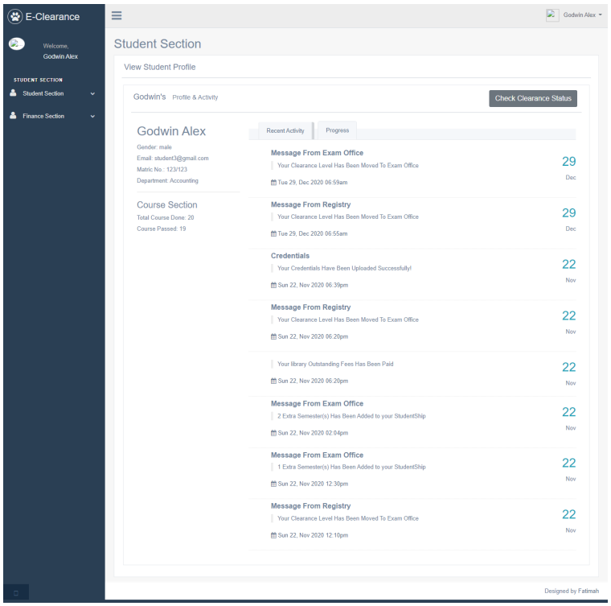

**Figure 1.1**

**1.5.2 DESIGN AND IMPLEMENTATION OF ONLINE CLEARANCE SYSTEM**

Online clearance system is a research work that will help build an effective information management for schools. It is aimed at developing a system for making clearance after graduation hitch free. The designed software will serve as a more reliable and effective means of undertaking students clearance, remove all forms of delay and stress as well as enable you understand the procedures involved as well as how to do your clearance online[2].

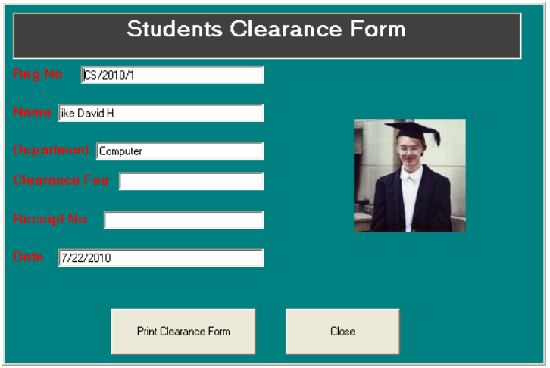

**1.2 Figure**

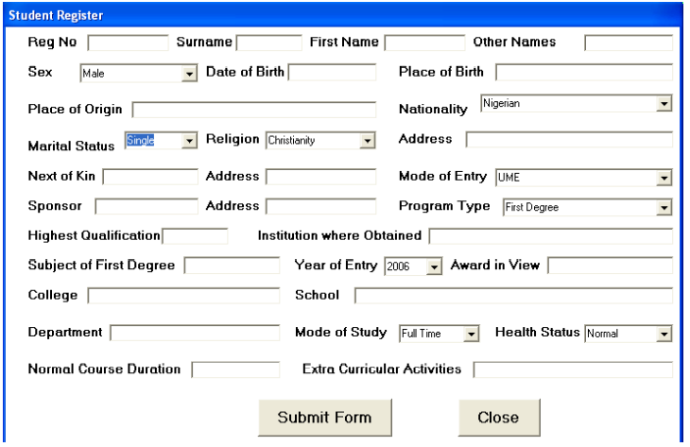

**Figure 1.3**

**1.5.3 DESIGN AND IMPLEMENTATION OF ONLINE STUDENT CLEARANCE SYSTEM**

Computer Software Based online clearance system is an internet base research work that will help build an effective information management for schools. It is aimed at developing a computer software system that replaces the manual method of clearance for graduating students. The designed software will serve as a more reliable and effective means of undertaking students clearance, remove all forms of delay and stress as well as enable you to understand the procedure involved, as well as how to do your clearance online [3].

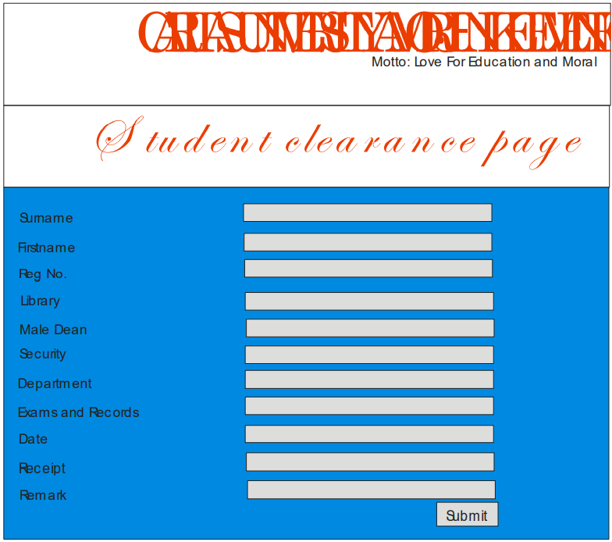

**Figure 1.4**

**1.5.4 Design and Development of Online Clearance System for Tertiary Institutions: A Case Study of Tai Solarin University of Education, Ogun State, Nigeria**

Online clearance system is an internet base research work that will help ease the queuing system in the university’s clearance process. Online clearance system will build an effective information management that is very convenient to use for schools since it is internet based and can be accessed from anywhere. It is aimed at developing a computer software system that replaces the manual method of clearance for graduating students and that also help students to carry out their clearance without coming to the various offices for clearance [4].

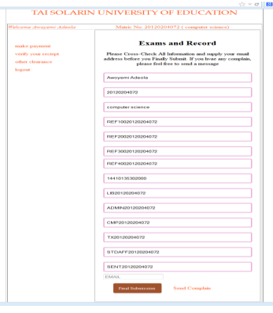

**Figure 1.5**

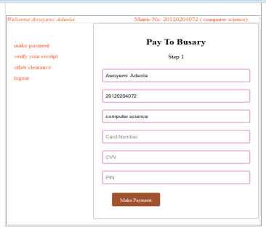

**Figure 1.6**

**1.5.5 A Web-Based Database-Driven Students ' Clearance System**

The aim of this project is to design and develop an online student’s clearance system using PHP and MySQL that will eliminate the delays in the manual process and create a central repository for students to be cleared. It will be implemented as a web-based application which will be a central repository for clearing students. The main modules of clearance system are Main Module, Clearance Registration, Cleared/ Not Cleared and Administer. The user is created and managed by the Systems Administrator using the Administer module [5].

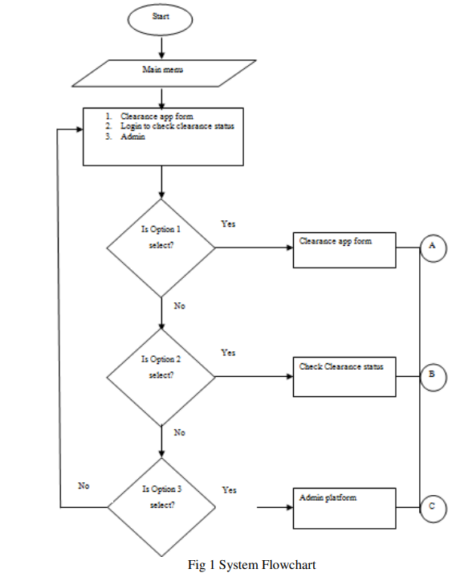

**Figure 1.7**

CHAPTER **2**

RESEARCH METHODOLOGY

**2.1 Introduction**

This chapter will contain the design of some function related work and requirements of the project. These functions contain plans of Use Case, Data Flow Diagram (DFD).

**2.2 System Analysis**

**Use Case**



**Figure 2.2.1 Use Case Diagram**



**Figure 2.2.2** **Context Diagram**

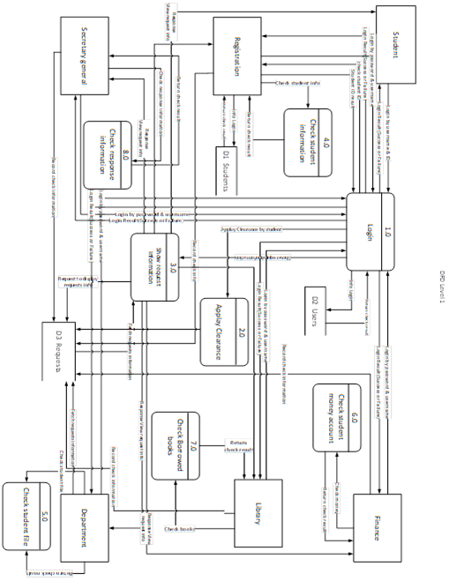

**DFD level 1 Figure 2.3**



**Level 1 Login process Figure.2.4**



**Level 1 Apply process Figure 2.5**



**Level 1 Show process Figure 2.6**



**Level 1 Registration Check process Figure 2.7**



**Level 1 Department Check process Figure 2.8**



**Level 1 Finance Check process Figure 2.9**



**Level 1 Library Check process Figure 2.10**



**Level 1 Secretary general Check process Figure 2.11**



**Figure 2.12 Entity Relationship Diagram (ERD)**

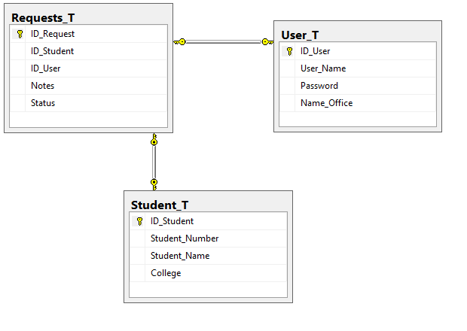

**Figure 2.13 Database Diagram**

CHAPTER 3

**3.1 Introduction**

In this chapter, we will display the most important UI in our website.

**3.2 System Design**

**3.2.1 Main Interface**

In this interface, the process of sending a request to evacuate a party to the student and displaying the details of the request and also through which office requests are displayed.

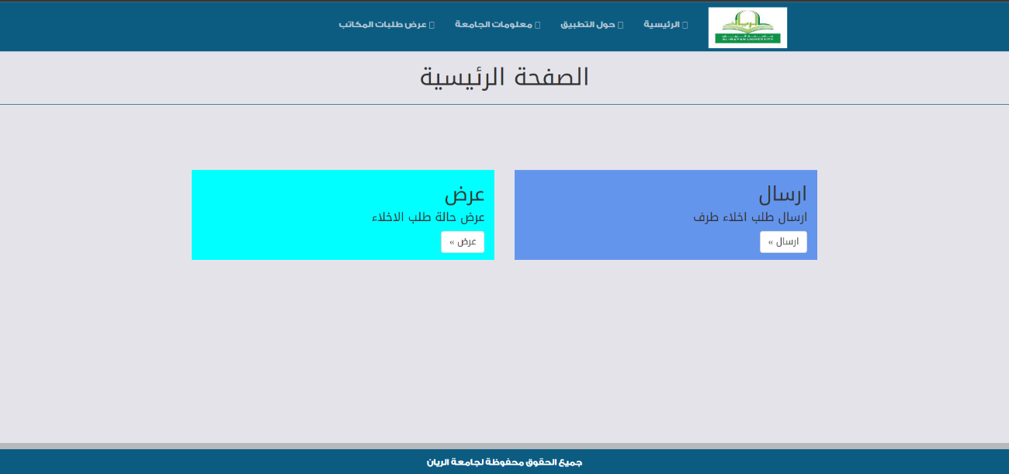

**Figure 3.1 Main Interface**

**3.2.2 Apply clearance**

The process it is a process of verifying the student’s data and through which the request to evacuate the student’s party is accepted or rejected.

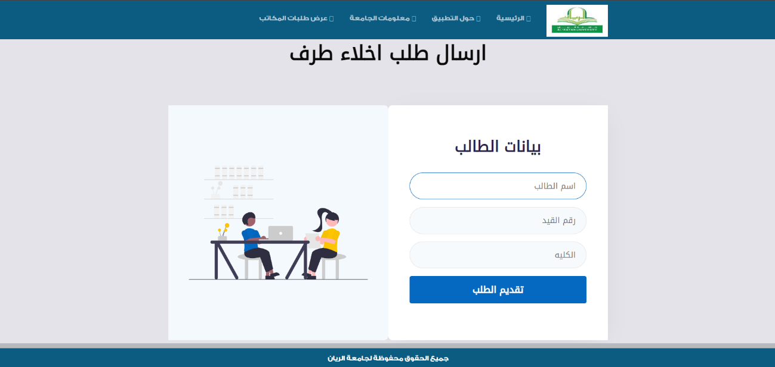

**Figure 3.2 Apply clearance 3.2.3 Login offices**

In this process, you are logged into your personal account to process the student's request.

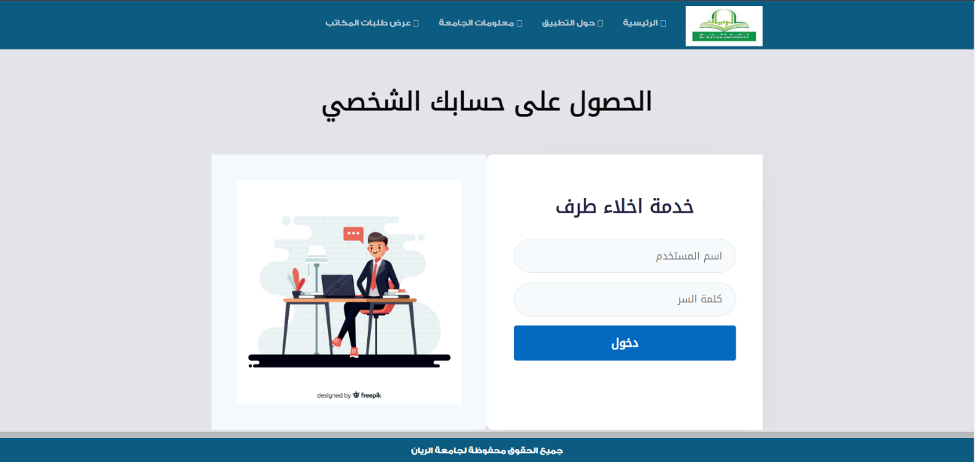

**Figure 3.3 Login offises**

**3.2.4 Requests record**

On this page, student requests are displayed and processed by the administrator.

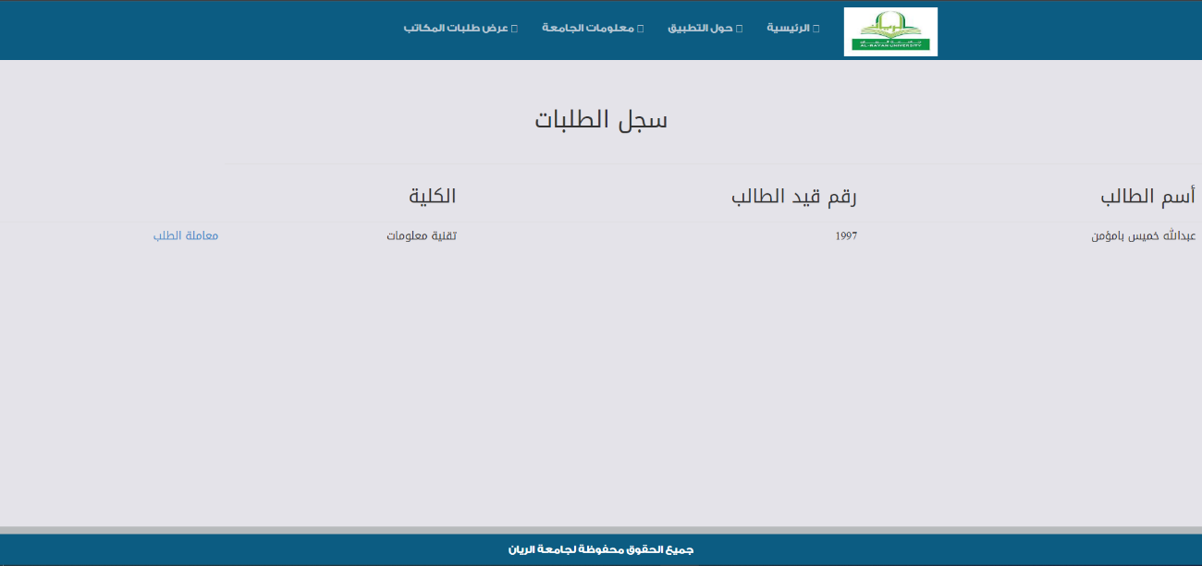

**Figure 3.4 Requests record**

**3.2.5 Processing request**

Here, the student's data is processed after the records are reviewed physically.

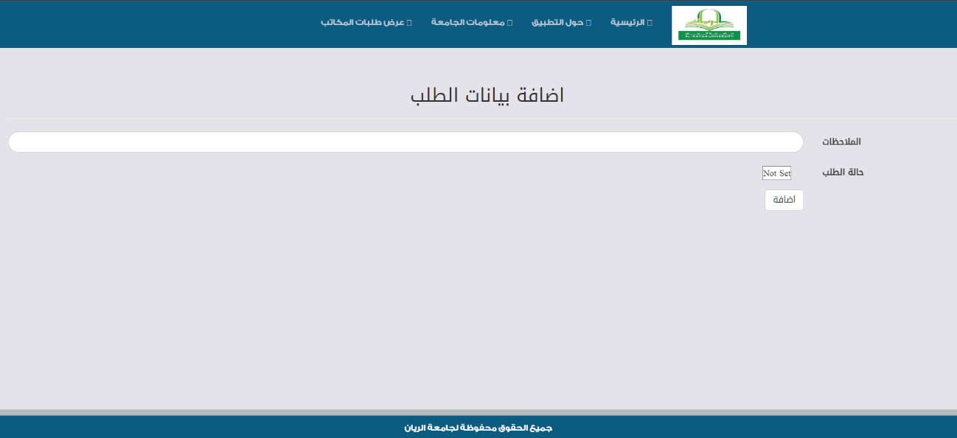

**Figure 3.5 Processing request**

**3.2.6 Show request status**

Here, the student is verified by his registration number, in order to display the status of the application.

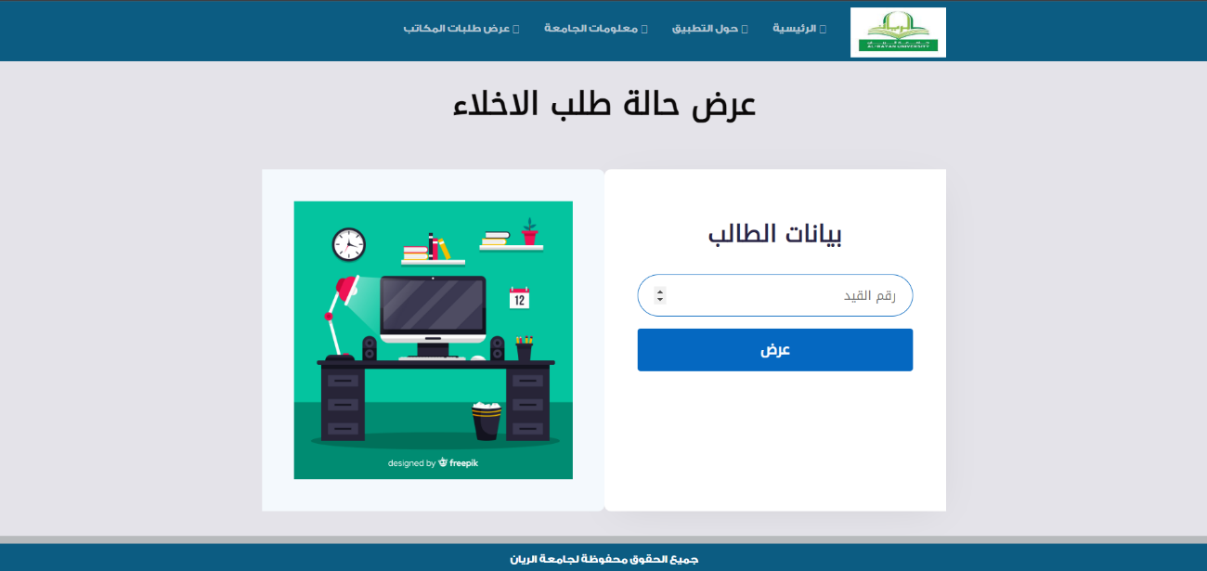

**Figure 3.6 Show request status**

**3.2.7 Request status**

On this page, the status of the application is displayed after the application has been processed by the concerned offices.

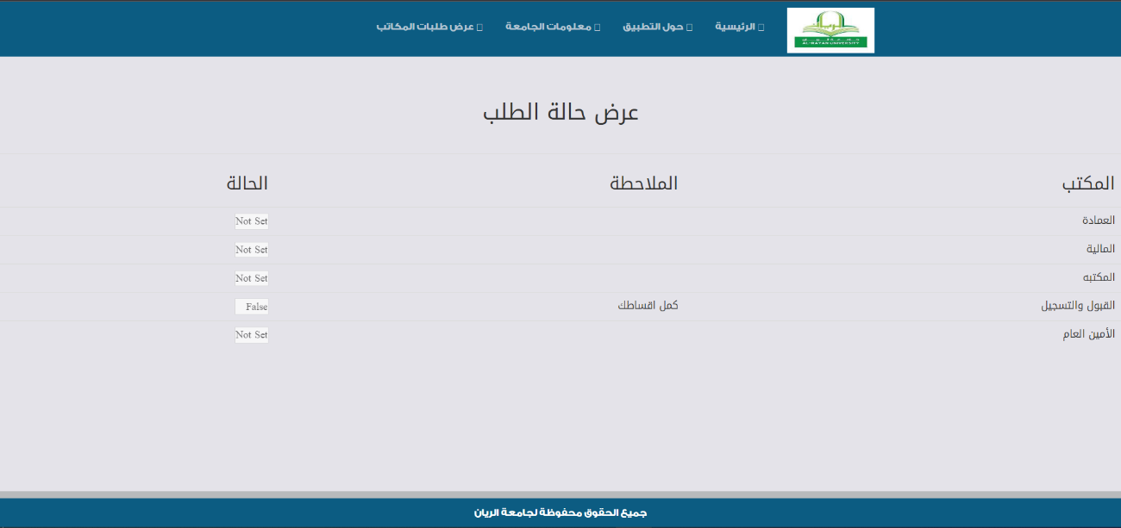

**Figure 3.7 Request status**

CHAPTER **4**

**CONCLUSION AND FUTURE WORK**

**4.1 Conclusion**

The service provided helps graduate students to save money and effort from what we have seen from the current situation in the matter of applying for a party evacuation, and also prepared the administrators to receive the evacuation request before the actual submission of the application.

**4.2 Future Work**

1. Activating the submission of the electronic evacuation certificate.

2. Giving the opportunity in the service to include registered students, not just graduates.

3. Inclusion of a special path for university employees to submit a request to release a party.

**References**:

[1] A Web-Based Database-Driven Students` Clearance System. Research paper

[2] Design and Implementation of Online Clearance System: A Case study Of Imo State University. Related papers

[3] A Case Study of Tai Solarin University of Education, Ogun State, Nigeria. Research paper

[4] [www.ijarcsse.com](http://www.ijarcsse.com) web said

[5] Submitted To The Department Of Computer Science & Information University, Enugu. Research paper