Name Student Number
Atalanta R Madzikwa D24127927
Wojcicki Ocean A00020186
Andile Ndlovu X00227203
Neal Magday A00029548

Dataset overview

Dataset name
Spotify Songs 2023

Source
Spotify Songs 2023 🎵

Description
The dataset contains a list of songs popular on Spotify in 2023. It has approximately 954 rows and 24 columns. The dataset has qualitative data and quantitative data namely:
track_name, artist(s)name, artist_count, released_year, released_month, released_day, in_spotify_playlists, in_spotify_charts, streams, in_apple_playlists, in_apple_charts, in_deezer_playlists, in_deezer_charts, in_shazam_charts, bpm, key, mode, danceability%, valence_%, energy_%, acousticness_%, instrumentalness_%, liveness_% and speechiness_%.

Data cleaning summary
Excel was used to clean the dataset by importing it, finding and removing duplicates where necessary, taking care of Missing Values, and replacing characters in text.

Importing data
After downloading the data as a CSV file the data, the data was then imported into an excel file as shown in the image below:
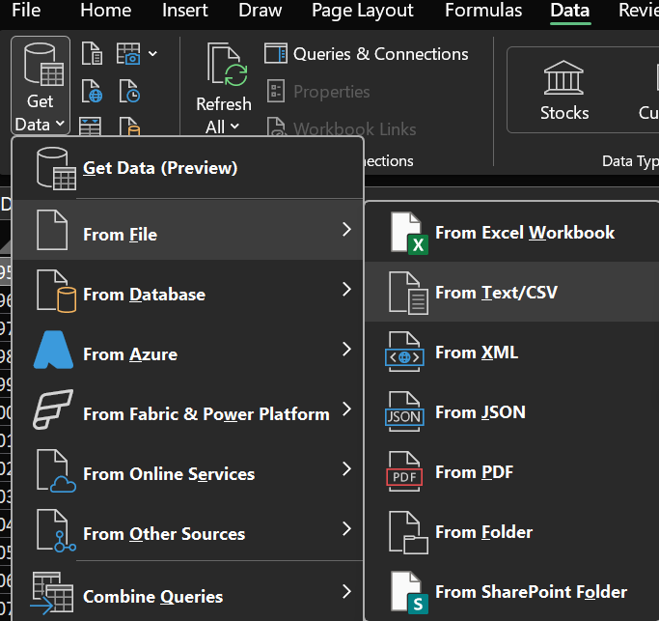
The columns selected for the data analysis include:

Categorical
Song description: track_name
Artist: artist(s)_name
Release date information: released_year, released_month, released_day

Numerical
Streams: artist_count, streams
audio features: bpm, danceability_%, and energy_%
Metrics: in_spotify_playlists, in_spotify_charts, in_apple_playlists, in_apple_charts

Removing Duplicates
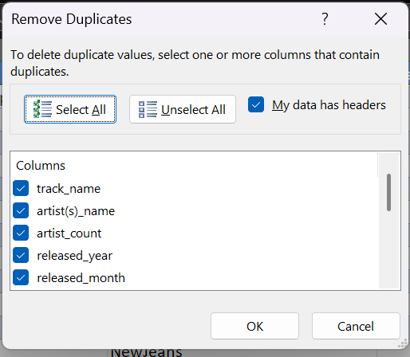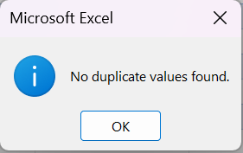
- The data did not have duplicates.

Handling Missing Values
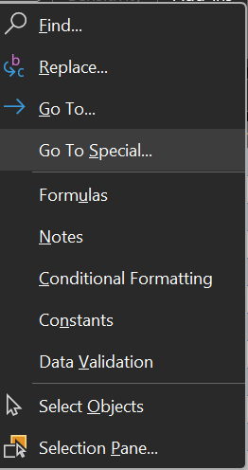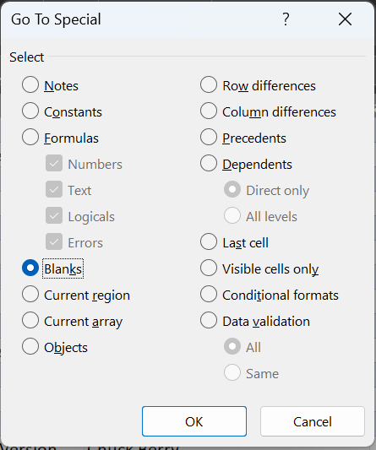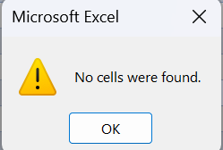
- There were no empty spaces in the dataset.

Replacing characters in text
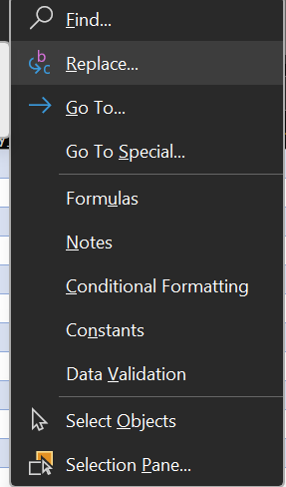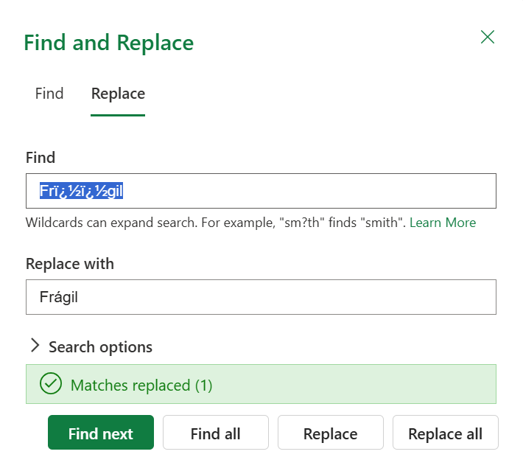

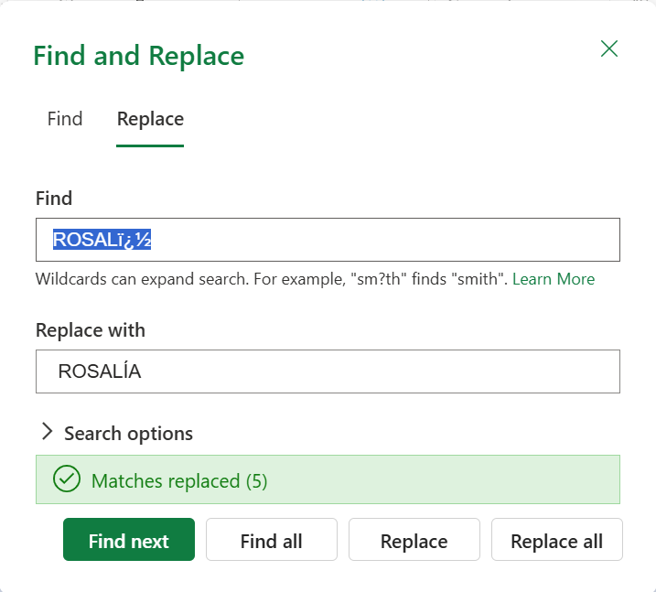

- The find and replace function was used to edit data to look more readable and presentable as shown above.

Descriptive statistics explanation

Main statistics
For the statistics the data’s mean, mode, median, min, max and the standard deviation for the streams, BPM, Apple charts, Apple playlists, sportify playlists, and the Spotify chats, as shown below:
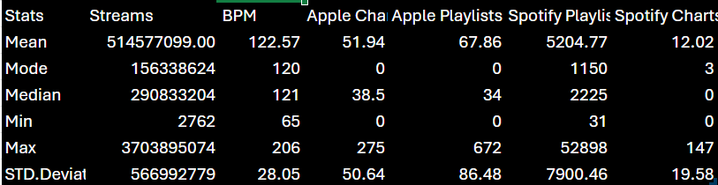
- The streams column has the largest numerical data with a mean above the median and mode, with a range of 3703892312 and a standard deviation higher than the mean.
- The BPM column has a mean slightly higher than the median and the mode and has a range of 141 and the standard deviation is lower than the Min.
- In terms of charting, for both the Apple chart and the Spotify charts they both have a min of 0. Apple has max of 275 whilst Spotify has a range of 147. The data in the apple charts is bigger than that the Spotify in terms of the mean, median, max and the standard deviation.
- In terms of playlists, Spotify playlist is bigger than that the Apple playlist in terms of the mean, median, max, min and the standard deviation and mode. Spotify also has a wider range of 52867 whilst the Apple has a range of 672.

For charts

Bpm vs average of energy percentage
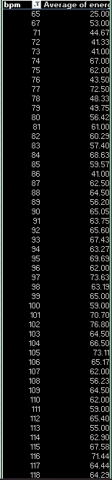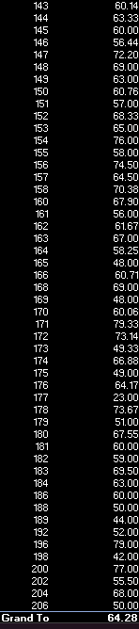

- The statistics calculates the average energy percentage given the value of the bpm which ranges from 65 to 206 bpm. To be presented in the column graph in the graphs section.

Year released vs average of streams

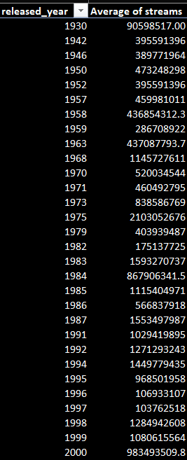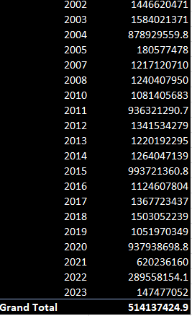

- The statistics calculates the average streams in the dataset from the year of 1930 till 2023. To be presented in the line graph in the graphs section.

Visual analysis with graphs
For the visual analysis the column chart is used to measure the bpm against energy_(%), the bar graph is used to measure how the streams frequent given the amount, and lastly the line graph is used to represent the average streams per year.

Column chart
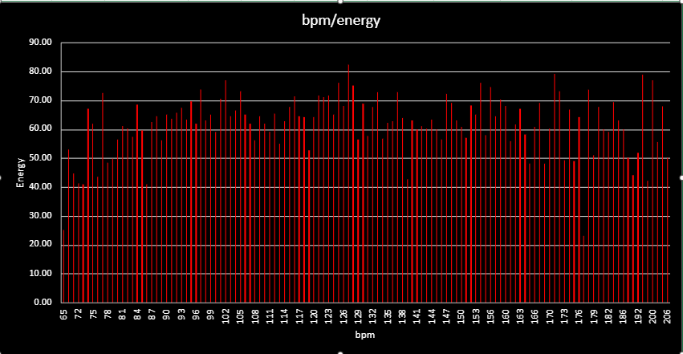
The data has the lowest percentage of approximately 23% average energy corresponding to 179 beats per minutes(bpm). The largest energy percentage of 83 percent. And the bpm ranges from 65bpm to 206bpm.

line graph
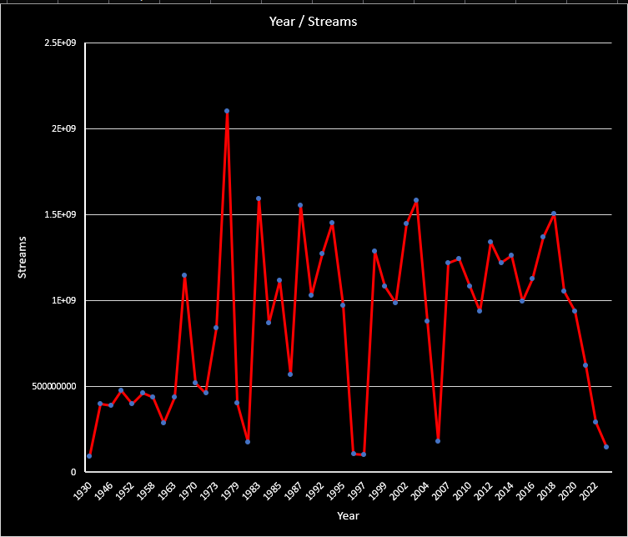

The line diagram shows that the average steams were low in the years 1930, 1996,1998 and 2023 with streams below 500000000, the same category has a more years in it. The year 1975 has the highest average streams above 2 billion streams the other years with high steams between 1.5 billion and 2.0 billion include 1984, 1988, 2003 and 2019. The rest of the years had between 500000000 and 1.5 billion average streams.

Bar graph
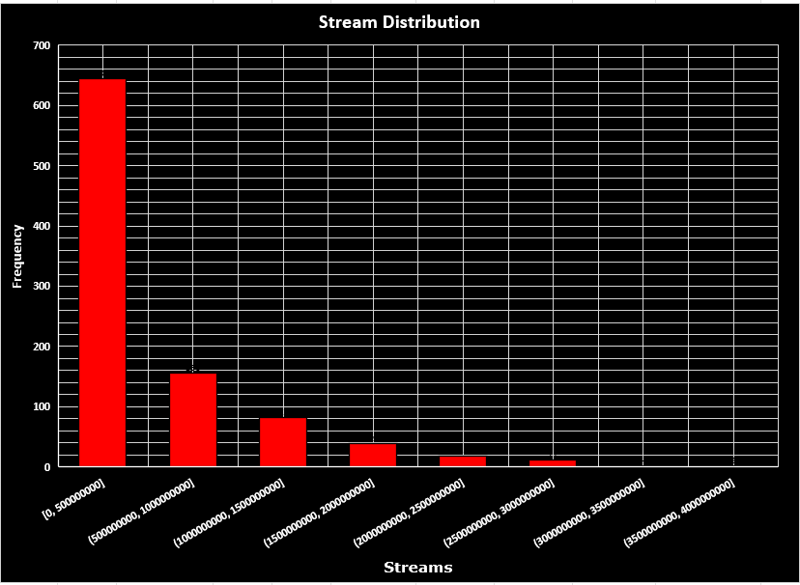
the bar graph shows that the increase of streams correlates with the decrease of the frequency. With the streams between 0 and 500000000 having an approximate frequency of 641 and the streams between 2500000000 and 3000000000 with an approximate frequency of 6.

Basic machine learning section
The machine leaning part was done in python to train the model to make predictions for the number of steams given the number of playlists a singer has with regards to the actual song. As shown in the diagram below: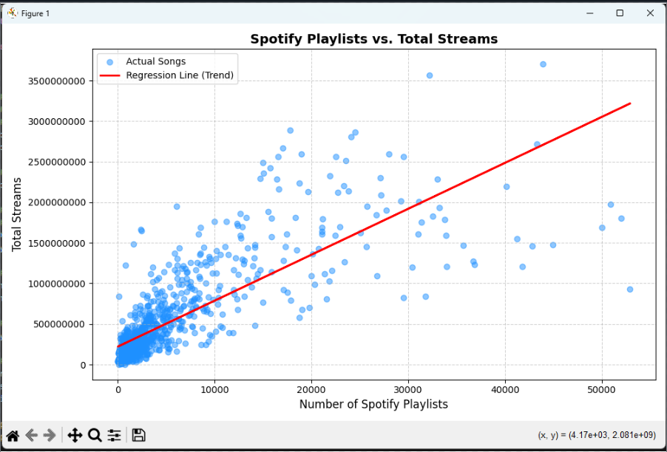
The model shows that the Total Streams increase steadily with the Number of Spotify Playlists.

Limitations and ethics
- Bias: this can be categorized in terms of the creator’s taste in music and their age range. Secondly, there is algorithmic bias, created by the system recommendations resulting in the push of certain music and particular music artists. Lastly there is representation bias, caused by the interaction between the system and some users like subscribers, age range and geography.
- Privacy: this can be caused by the machine learning data analysis, and unauthorised analysis can cause data breaches
- Intellectual Property & Scraping: there is a chance that other artists and songs are not included in the dataset due to the terms and conditions associated with their music.

Conclusion
This dataset was collected from the Spotify Songs 2023, and it shows music streamed across platforms like Spotify and Apple jus to mention the data. It was downloaded as a csv file, imported into excel file and checked for errors like duplicates, blank spaces and unnecessary characters.
The statistics like mean, mode max, min, median and standard deviation were calculated to analyse numerical data like streams, chats and playlists. Charts and graphs like the column, bar graph and line graph were used to analyse the relationships between the columns of data. Machine learning was used to help predict how data works given information.
Collecting data is a good as it brings light to certain information. However, there are some ethical issues and limitations that occur like numerous biases, privacy issues and legal restrictions. Keeping that in mind it is important to collect a wide range of data considering the ethical concerns.

