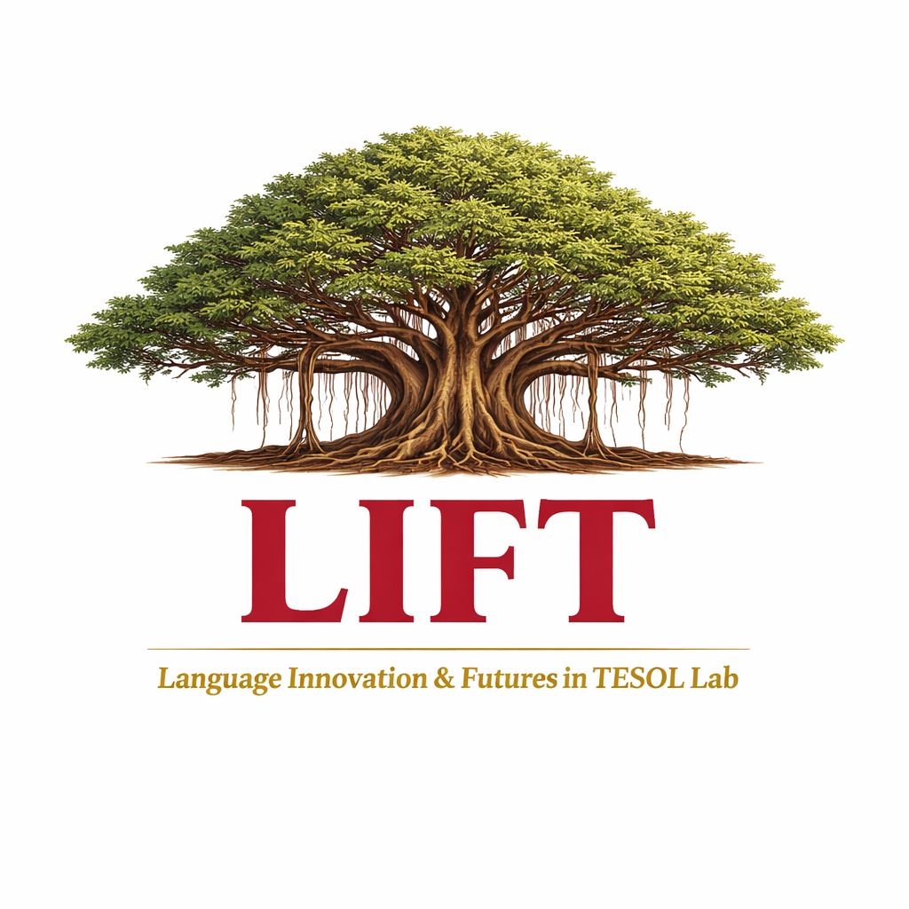 |  | LIFT  LANGUAGE INNOVATION  AND FUTURES IN TESOL LAB  BYU–Hawaii · TESOL & EIL Programs

The LIFT Lab is a mobile innovation hub housed within the BYU–Hawaii TESOL program — a space where faculty and preservice teachers build, experiment, and imagine the future of English language education together. Here, AI is not a shortcut; it is a medium for principled, creative, and transformative pedagogy.

WHAT WE DO  An Ed Tech Makerspace for Language Educators  The LIFT Lab focuses on harnessing AI tools, especially AI agents, to design and build educational technology applications, interactive websites, and pedagogical materials for English language learning and teaching. Faculty and preservice TESOL teachers collaborate to experiment with agent-driven workflows that support materials and curriculum development, assessment tools, and learner-facing platforms.  By integrating hands-on creation with critical reflection, LIFT prepares future educators not only to use AI responsibly, but to actively shape it in the field of language education, thereby fostering innovation and practical skill development at every level. Graciously funded by the Edward D. Smith Center for Teaching and Learning. Prepare, engage, improve. |  | WHO WE ARE  Community of Builders  LIFT brings together everyone invested in the future of language education:  ▸ Language educators and researchers pioneering new applications of AI in English language teaching  ▸ Preservice teachers gaining hands-on skills in building educational technology  ▸ Students wanting to become architects of learning experiences grounded in sound theory and pedagogy  ▸ Collaborators and partners from across the broader TESOL community

Deep Roots,  Wide Reach. |  | Like a banyan tree, the LIFT Lab is rooted in sound principles of language pedagogy and SLA theory, providing opportunities for scalable evidence-based practice. These roots are not constraints; they are the foundation from which we grow. |  | From that grounded base, LIFT reaches outward, exploring innovative approaches, building tools for more effective language learning, and extending its influence well beyond the shores of BYU–Hawaii. Our work connects to the global TESOL community, contributing ideas that travel far and wide.

