2023-04-05 6:02 PM

Going more in depth towards data visualisation using arcgis JS API

[Aggregation | Overview | ArcGIS Maps SDK for JavaScript 4.26 | ArcGIS Developers](https://developers.arcgis.com/javascript/latest/visualization/high-density-data/aggregation/)

What is it? What can it do?

Aggregation is the process of condensing large datasets with numerous features into layers with fewer features. This is usually achieved by summarizing points within polygons, where each polygon represents the number of points it contains.  
  
Can we use it to show hexagonal aggregated tree inventory data over the web?  
Let me try a deployment method using some coding to see how effective it is

Note: Aggregation is a server-side operation, server-side method as mentioned in the post is more useful for large data sets which cannot all be processed and loaded on to the client.

Outcome – Dropped Aggregation

2023-04-05 6:26 PM

Looking into the clint side options, Where as opacity seems like a good contender.

[Opacity | Overview | ArcGIS Maps SDK for JavaScript 4.26 | ArcGIS Developers](https://developers.arcgis.com/javascript/latest/visualization/high-density-data/opacity/)

This seems to be good for polygons to be shown, Using this to show the tree zones and canopy cover data which are available as polygons and then using clustering to show the trees since those are points seems to be a good mix of things in my mind for the time being.   
Experimenting with those and the available layers to see the outcomes.

6.32 PM  
That seems like a success.

Following the instructions and previous experiments the outcome turned out to be nice

Now the process is about figuring out the way to change the colors a bit more naturally

Trying out the js options to get that done

Esri Documentation suggest using SimpleFIllSymbol Reference to get that done.

[SimpleFillSymbol | API Reference | ArcGIS Maps SDK for JavaScript 4.26 | ArcGIS Developers](https://developers.arcgis.com/javascript/latest/api-reference/esri-symbols-SimpleFillSymbol.html)

The documentation is clear about how to get that done.

The example snippet:

let symbol = {

type: "simple-fill", *// autocasts as new SimpleFillSymbol()*

color: [ 51,51, 204, 0.9 ],

style: "solid",

outline: { *// autocasts as new SimpleLineSymbol()*

color: "white",

width: 1

}

};

With this knowledge we can figure out that by giving my code these parameters to achieve the color change

// Tree canopy layer

const treeCanopySymbol = new SimpleFillSymbol({

color: [56, 168, 0, 0.5], // green with 50% opacity

outline: {

color: [0, 0, 0, 0.5], // black with 50% opacity

width: 1

}

});

This will be the start which leads us to giving each layer we have the dedicated color we want to give them  
  
That somehow failed and now my map is just a blank canvas, There must be something wrong or a typo or something on the code.   
Let me sort that out.

6.49 PM

Renderer failed.   
  
Trying to trouble shoot and resolve this.

Found out the culprit behind that, In classic style it was the missing library load option, Forgot to add these two references

      "esri/renderers/SimpleRenderer",

      "esri/symbols/SimpleFillSymbol",

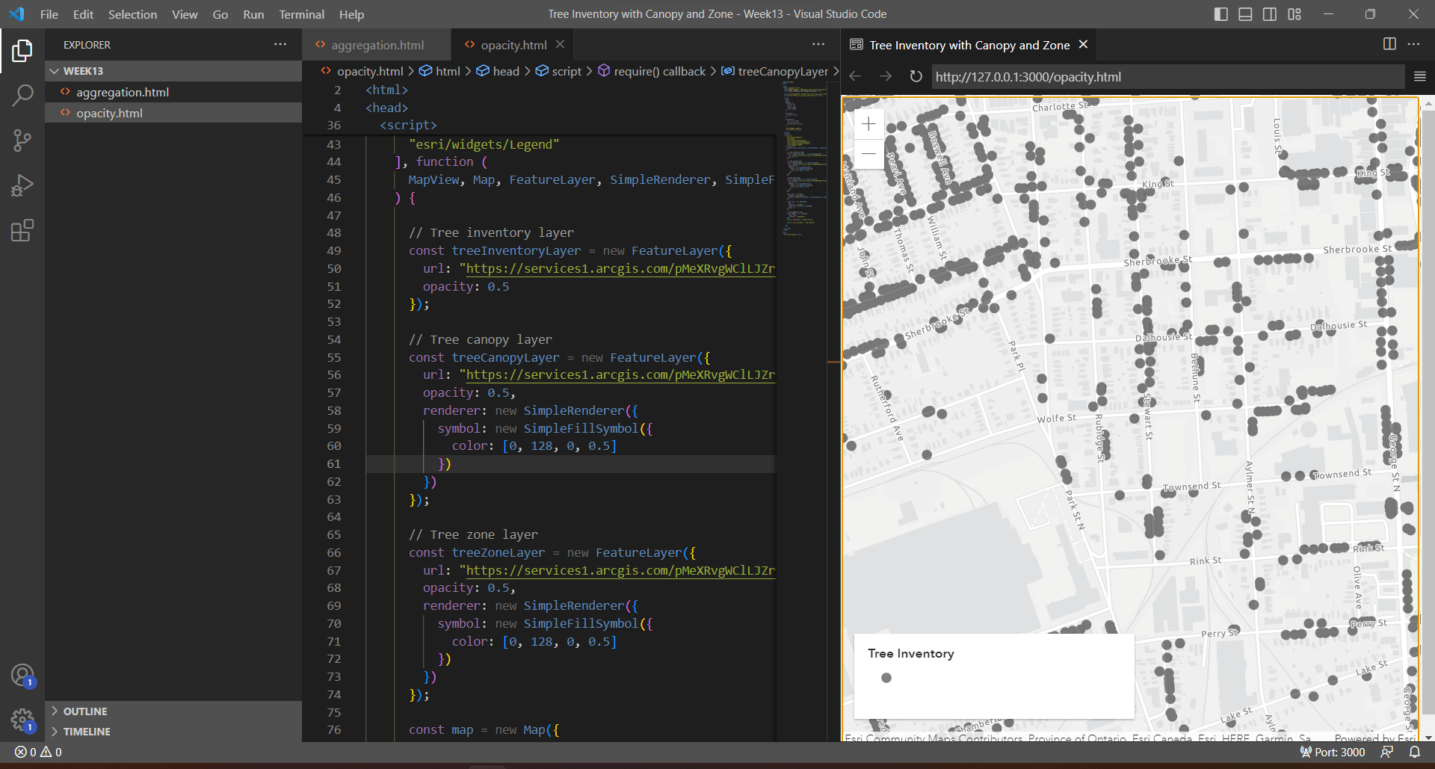

Now even with that the rendering is still not in color due to something, More trouble shooting required.

Learning about the limitation of this

In this aspect, for visualisation we have to specify renderer to each layer and associate a colour to the same. I do feel this is redundant but all things coding related there is a natural beauty in that aspect of having fine control in your hand.

The items seem to be failing to get the colours assigned.   
05-04-2023 7.18 PM  
  
Now it doesn’t even have the data to show.

Changing things to keep it simple, will now only show the tree inventory for now Will look into ways to show multiple layers later

05-04-2023 7.34 PM

Going back to the roots : A green dot to show the tree and now going to add a popup option to show the data. These can be done on other solutions fairly easy but this is the way.

Mission cleared   
05-04-2023 7.45 PM

Popup enabled using.

[Popup | API Reference | ArcGIS Maps SDK for JavaScript 4.26 | ArcGIS Developers](https://developers.arcgis.com/javascript/latest/api-reference/esri-widgets-Popup.html)

This is similar to what we got using Experience builder, it is not anything new since effectively what all the user friendly front ends of esri uses is these tools to get things done. This is pretty much exactly what must be going on on the background when exp builder does the same thing.   
  
More options to follow.

Deployment: [https://a-charvin.github.io/geom99Works/vis/opacity.html](https://a-charvin.github.io/geom99Works/vis/Point.html)