VennCreate User Manual

Lassonde School of Engineering | EECS 2311 Group 18

Authors:

Chidalu Agbakwa (216337784), Shangru Li (214488993), Jihal Patel (216376436), Robert Suwary (21544016)

2020

Table of Contents

0 Frequently Used Terms 1

0.1 Vertical Navigation Drawer 1

0.2 Titled Pane 2

0.3 Scene 3

1 General Information 4

1.1 System Overview 4

1.2 Organization of the manual 4

2 System Summary 4

2.1 System Configuration 4

2.2 User Access Levels 4

3 Getting Started 5

3.1 Installation 5

3.2 System Menu 5

4 Basic System Usage 8

4.1 Adding Text to the Venn Diagrams 8

4.2 Clearing or Erasing Item from the Word Bank 10

4.3 Creating an Item using the word bank 11

4.4 Changing the background color of the scene 12

4.5 Changing the color of the Diagram Titles 12

4.6 Changing the Left Circle Color 12

4.9 Changing the Right Circle Color 13

4.10 Changing the Left or Right Circle size 14

4.11 Changing the Left or Right Circle hover color 15

4.11 Turning ON/OFF circle hovering 17

4.12 Deleting single text from a circle 18

4.12 Editing text inside a circle 19

5 Advanced System Usage 21

5.1 Adding longer descriptions to text 21

5.2 Saving a VennCreate project 22

5.2 Loading a VennCreate project 23

5.3 Adding a Circle to a VennCreate project 24

5.4 Changing the font size of text in a specific circle 25

5.5 Changing the color of text in a specific circle 26

6 Understanding Saving Excel Sheet 28

7 Test Mode 30

7.1 Setting up the .txt file 30

7.2 Another example of the .txt file 34

7.3 Displaying the timer in Test Mode 35

7.4 Undoing and Redoing changes 36

# List of Figures

**Figure 1 - Picture of vertical navigation drawer 1**

**Figure 2 - A titled pane 2**

**Figure 3 - The VennCreate Scene 3**

**Figure 4 - VennCreate's Home Menu 5**

**Figure 5 - A Fresh VennCreate project 6**

**Figure 6 - VennCreate's Test Mode 7**

**Figure 7 - Example of using the "Get Existing Button" 7**

**Figure 8 - Adding text to the diagram 9**

**Figure 9 – Added text 9**

**Figure 10 - Clearing or Erasing item from work bank 10**

**Figure 11 - Creating an item from the word bank 11**

**Figure 12 - Changing the background color 12**

**Figure 13 - Changing the color of the left circle 13**

**Figure 14 - Changing the color of the right circle 14**

**Figure 15 - Increasing the radius of the left circle 15**

**Figure 16 - Default Hover Color of left circle 16**

**Figure 17 - Changing the hover Color of the left Circle 17**

**Figure 18 - Toggling left circle hover option 18**

**Figure 19 - Deleting text in VennCreate 19**

**Figure 20 - Editing text in VennCreate 20**

**Figure 21 - Adding longer descriptions to text 21**

**Figure 22 - Longer description pop-up 22**

**Figure 23 - Unsaved change alert 22**

**Figure 24 - Saving your VennCreate project 23**

**Figure 25 - Loading an Existing VennCreate project 24**

**Figure 26 - Result after clicking either of these buttons 25**

**Figure 27 - Increasing the font size of text in left circle 26**

**Figure 28 - Changing text color in a specific circle 27**

**Figure 29 - Example saving to CSV 28**

**Figure 30 - Project Representation in excel 29**

**Figure 31 - Setting up the .txt file 30**

**Figure 32 - A diagram depicting all the proper text location 32**

**Figure 33 - An example of Test Mode with the .txt file in figure 26 33**

**Figure 34 - Another test mode .txt example 34**

**Figure 35 - Figure 29 in test mode form 35**

**Figure 36 - Showing the timer in VennCreate 36**

**Figure 37 - Different ways to undo/redo changes in VennCreate 37**

# 0 Frequently Used Terms

In order to better understand this user manual, we have compiled a couple frequently used terms used in abundance in this manual to make sure the reader understands as clearly ass possible.

## 

## 0.1 Vertical Navigation Drawer

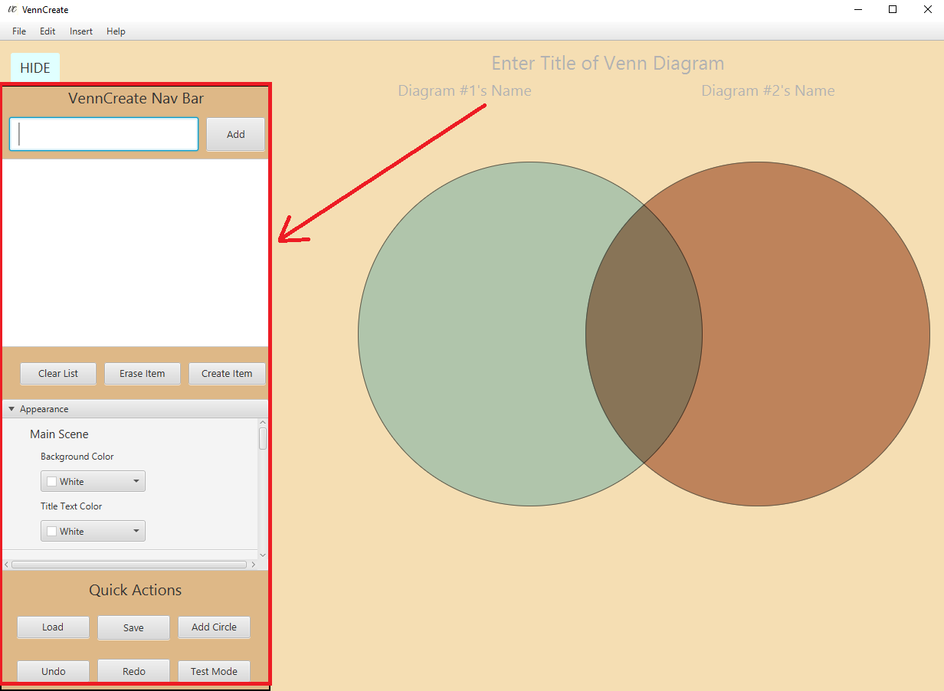

Figure - Picture of vertical navigation drawer

## 0.2 Titled Pane

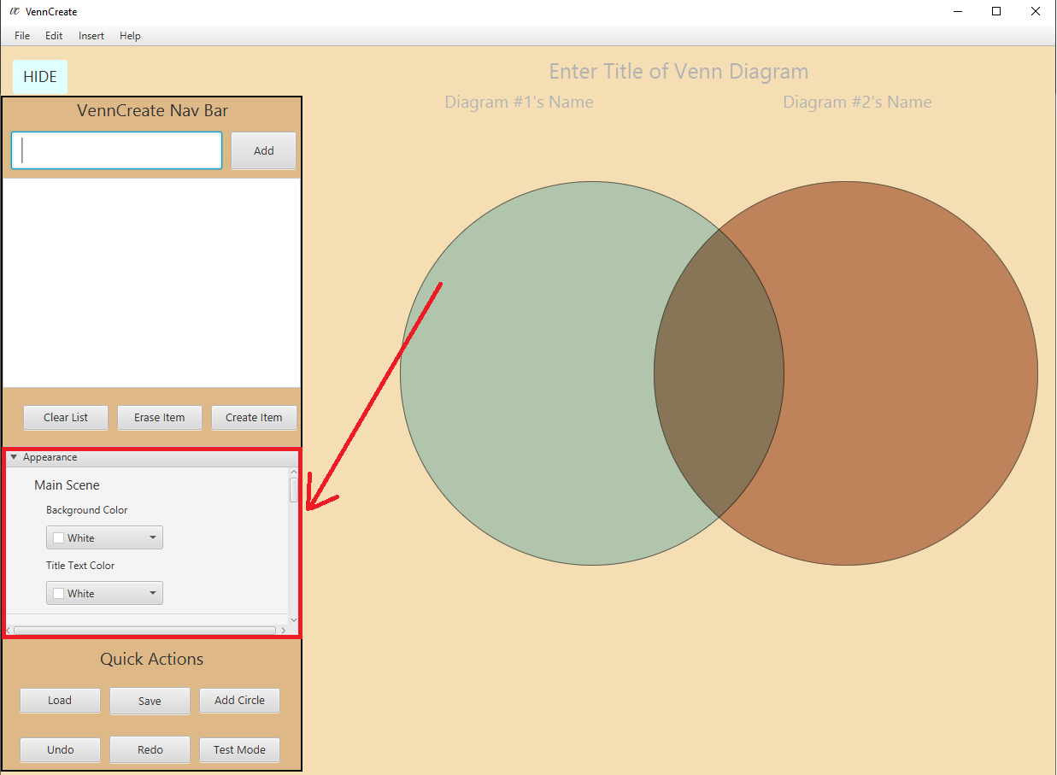

Figure - A titled pane

## 0.3 Scene

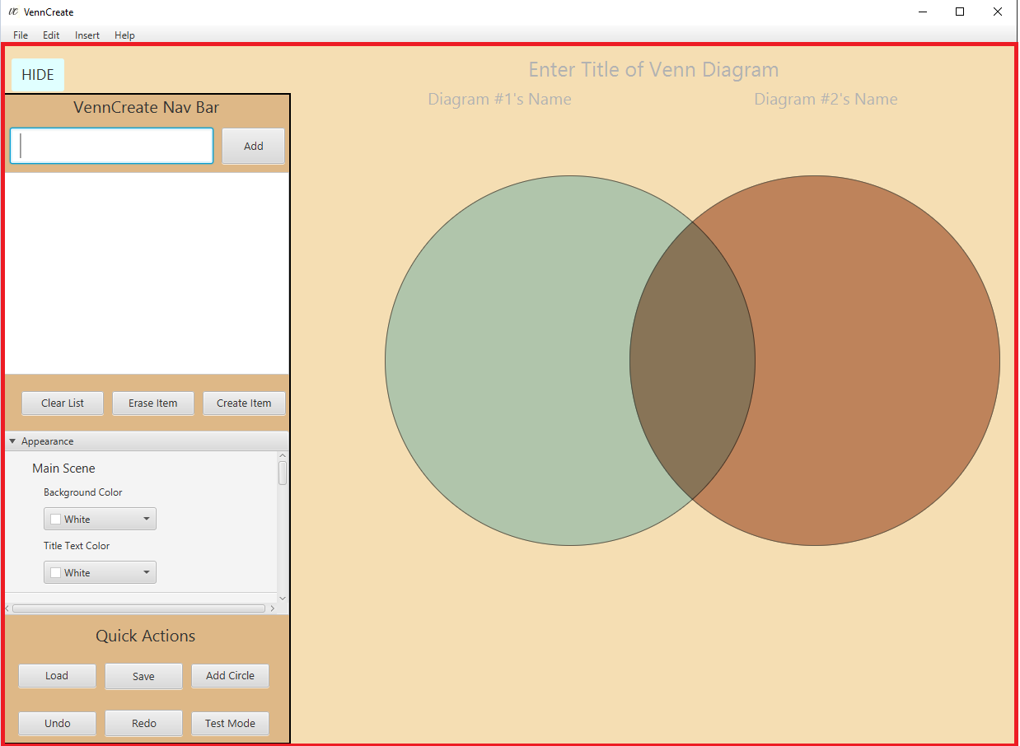

Figure - The VennCreate Scene

# 1 General Information

General Information section explains in general terms the system and the purpose for which it is intended.

## 

## 1.1 System Overview

VennCreate is an application, that allows users to make customizable Venn Diagrams which permit to comparison of up to 3 different sets at once.

## 1.2 Organization of the manual

This document describes the implementation details of VennCreate. The software will consist of two major functions. First to allow users to create customizable, elegant, and easy-to-read venn diagrams. And secondly to be able to export them as a CSV file or as a PNG/JPG file.

# 2 System Summary

System Summary section provides a general overview of the system. The summary outlines the uses of the system’s software requirements, system’s configuration, user access levels and system’s behavior in case of any contingencies.

## 2.1 System Configuration

VennCreate a desktop application written in the Java programming language. It uses the JavaFX (8) framework, and Java 1.8, and is intended to run perfectly fine on all platforms (windows, macOS, linux). It saves its application data to a CSV file that can be saved anywhere to a user’s PC. After installation, VennCreate runs perfectly without any further configuration, as so long as the user has Java 1.8 or greater on their system.

## 2.2 User Access Levels

Everyone can use the application, if it is downloaded on the users PC.

# 3 Getting Started

Getting Started section explains how to get VennCreate and install it on the device. The section presents briefly system menu.

## 3.1 Installation

The newest and latest version of VennCreate can be installed from <https://github.com/MaxsLi/VennCreate/releases>, this link includes a runnable jar file. By downloading the runnable jar file and running the command *java -jar VennCreate.jar* in terminal, will get the application up and running.

## 3.2 System Menu

Upon the successful installation of the system, running it will lead the user to the home page, where they will be greeted by a calming animation of the two circles moving back and forth along the page.

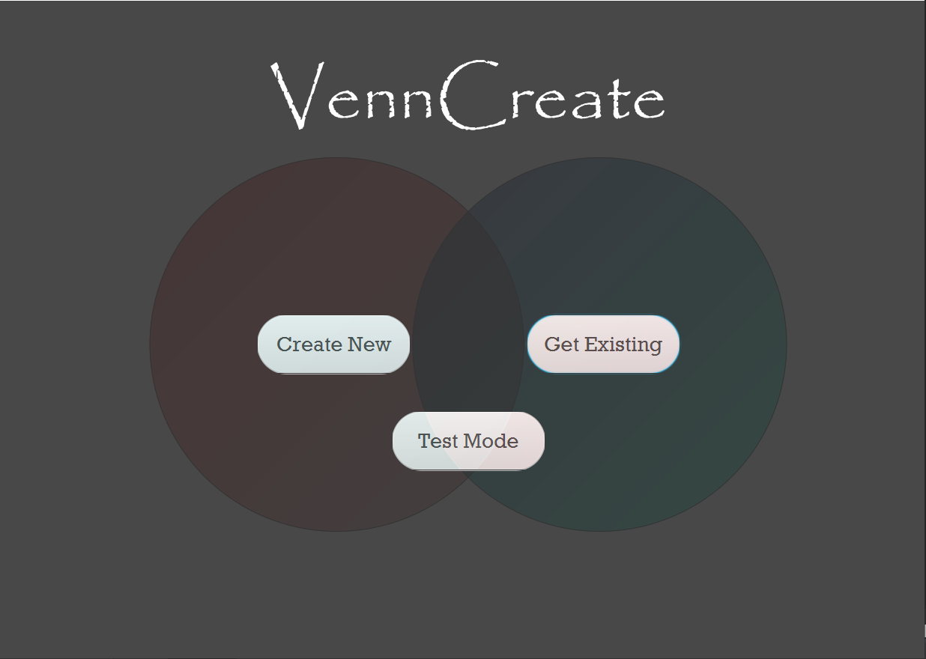

Figure - VennCreate's Home Menu

Upon entering the home page users have 1 of 3 options.

1. Create New – Clicking this button allows users to start a new fresh VennCreate project.

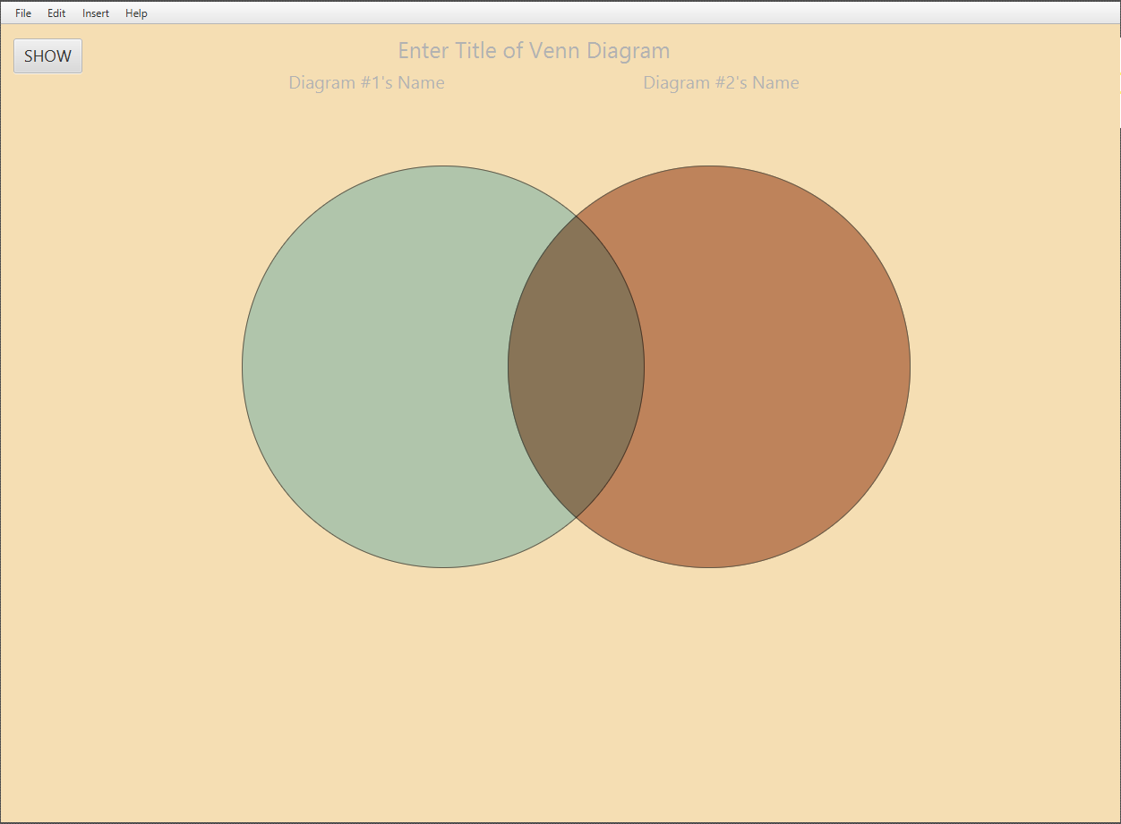

Figure - A Fresh VennCreate project

1. Test Mode – Clicking this allow the user to enter VennCreate’s test mode, where the user can test themselves on previous entered information from a .txt file. Further details of test mode will be more thoroughly explained further sections of the user manual.

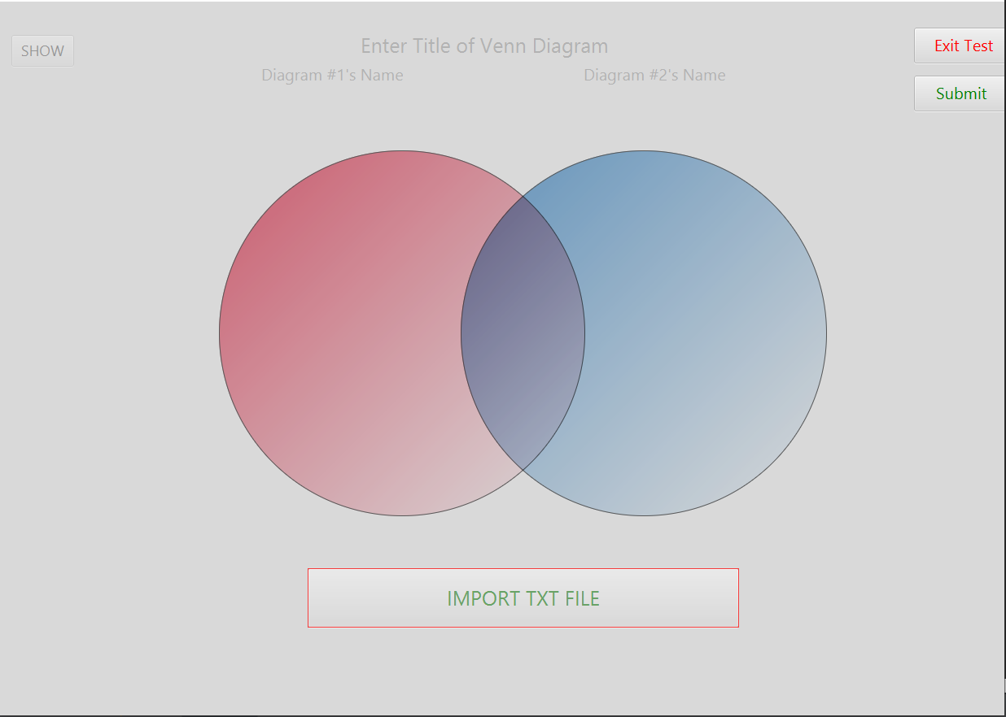

Figure - VennCreate's Test Mode

1. Get Existing – Allows a user to import a previous worked on VennCreate file and pick up where they left off. Upon clicking get existing, the users file explorer opens, where they can look for a previous worked on VennCreate .csv file.

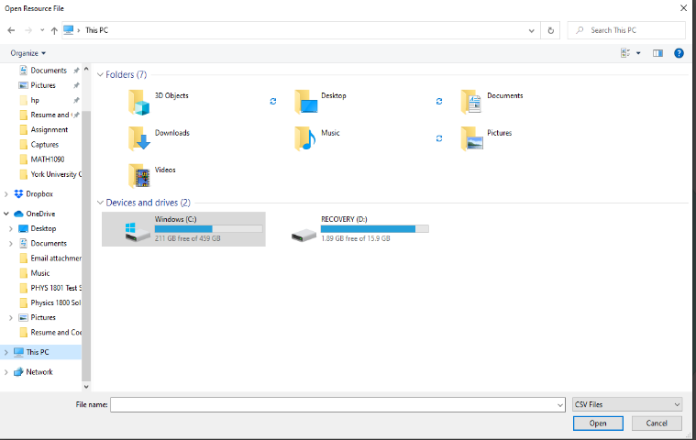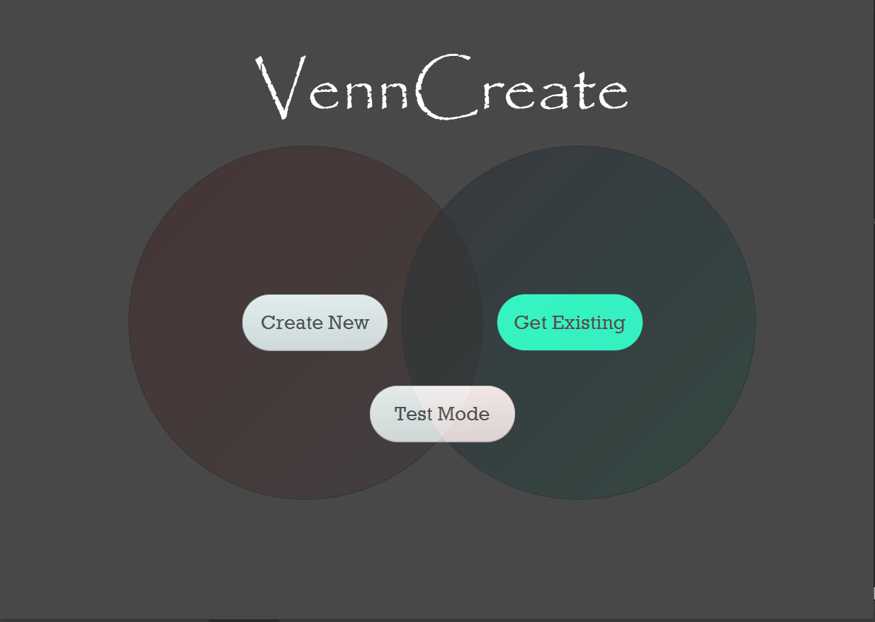

Figure - Example of using the "Get Existing Button"

# 4 Basic System Usage

This section provides a more detailed overview of the basic system features and functions.

## 4.1 Adding Text to the Venn Diagrams

Adding text to VennCreate’s venn diagrams is truly easy and intuitive.

1. Upon launching VennCreate, click “Create New” to open a new Venn Diagram or click “Get Existing” to open a previously worked on Venn Diagram
2. 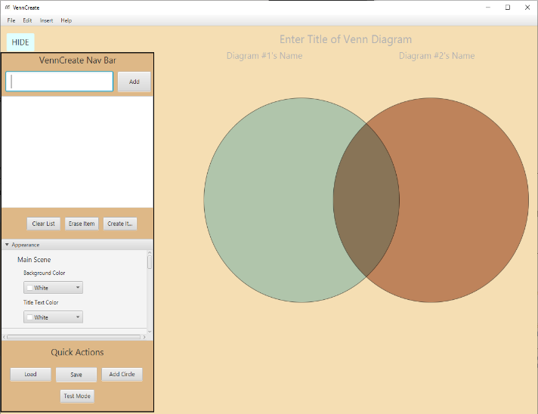Click the “Show” toggle button in the top left-hand corner of the screen to pop out the vertical navigation drawer.

Figure 6 - Vertical Navigation Drawer showing

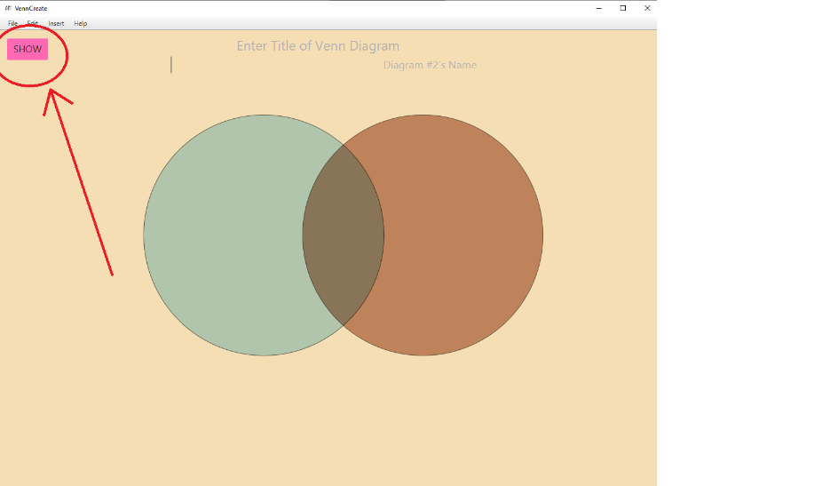

Figure 5 - Show Button

1. In the biggest text field in the vertical navigation drawer, type any text you want (it just can’t be empty or end with commas), and click add or the ENTER key on your keyboard. The new text will be added to the scene.

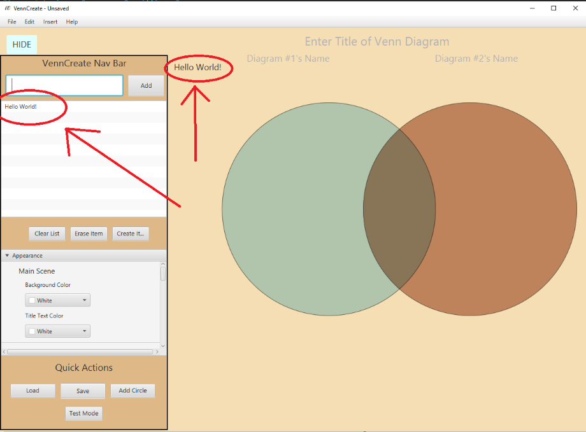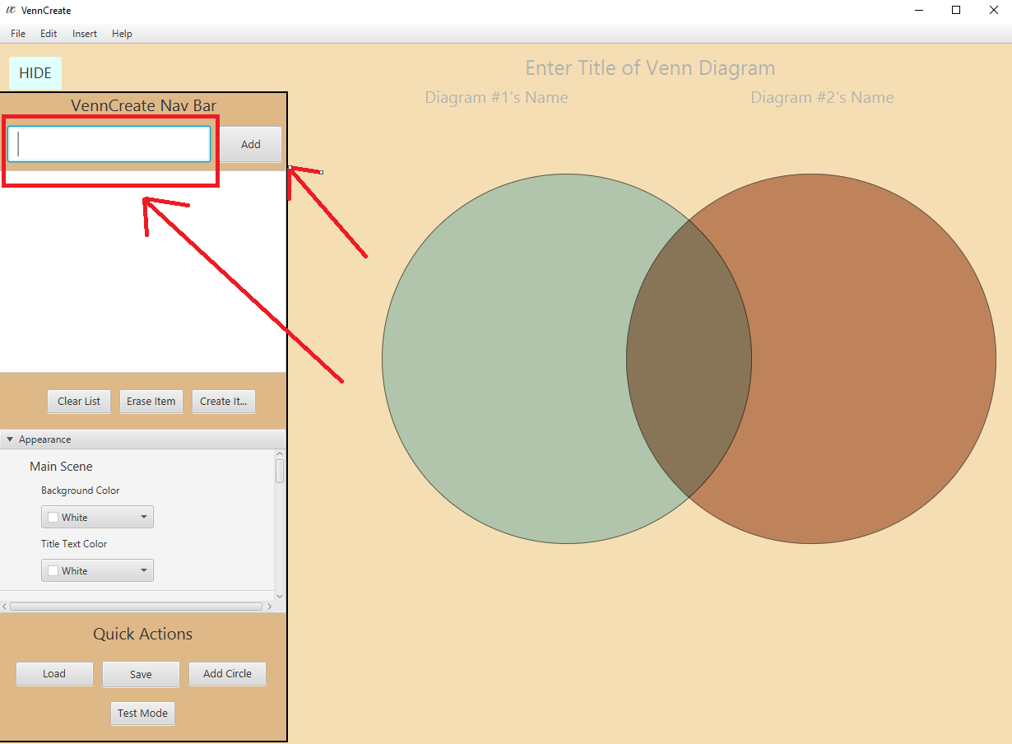

Figure - Adding text to the diagram

Figure – Added text

1. The new added text can then be freely dragged around the scene as necessary

## 4.2 Clearing or Erasing Item from the Word Bank

1) To Clear the word bank, click “Clear list”

2) To delete an individual item from the word bank, click “Erase Item”

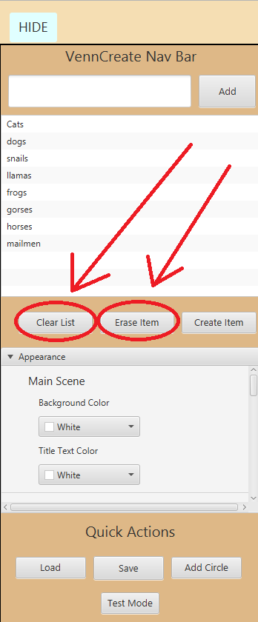

Figure - Clearing or Erasing item from work bank

## 4.3 Creating an Item using the word bank

You may have deleted an item from the circles and would like to re-make them but not type it all out again in the text fields. Well re-creating items using the word bank in VennCreate is a trivial task. Simply:

1. Click the item in the word bank you would like to create
2. Click the “Create Item” button right below it

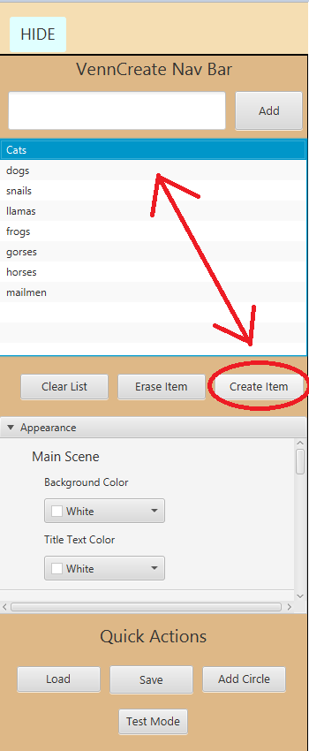

Figure - Creating an item from the word bank

## 4.4 Changing the background color of the scene

1) Open the “Appearance” title pane

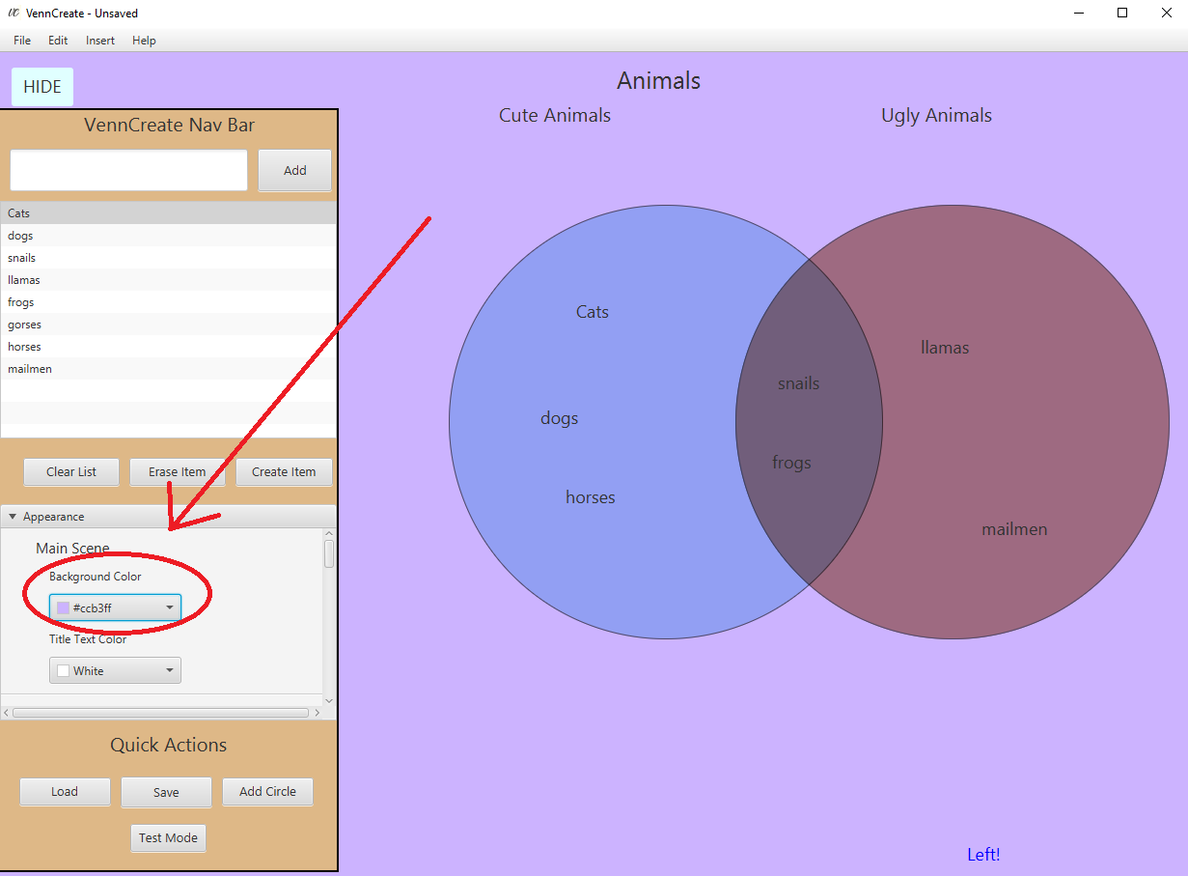2) Click on the “Background Color” ColorPicker and choose your preferred background.

Figure - Changing the background color

## 4.5 Changing the color of the Diagram Titles

1) Open the “Appearance” titled pane

2) Click on the “Title Text Color” ColorPicker and choose your preferred Title Color.

## 4.6 Changing the Left Circle Color

Say you wanted to change the left circle color in VennCreate, how would you do this?

1. Open the “Appearance” titled pane
2. Scroll down in the “Appearance” titled pane until you see the “Left Circle” portion of the titled pane
3. Choose your preferred color for the left circle.

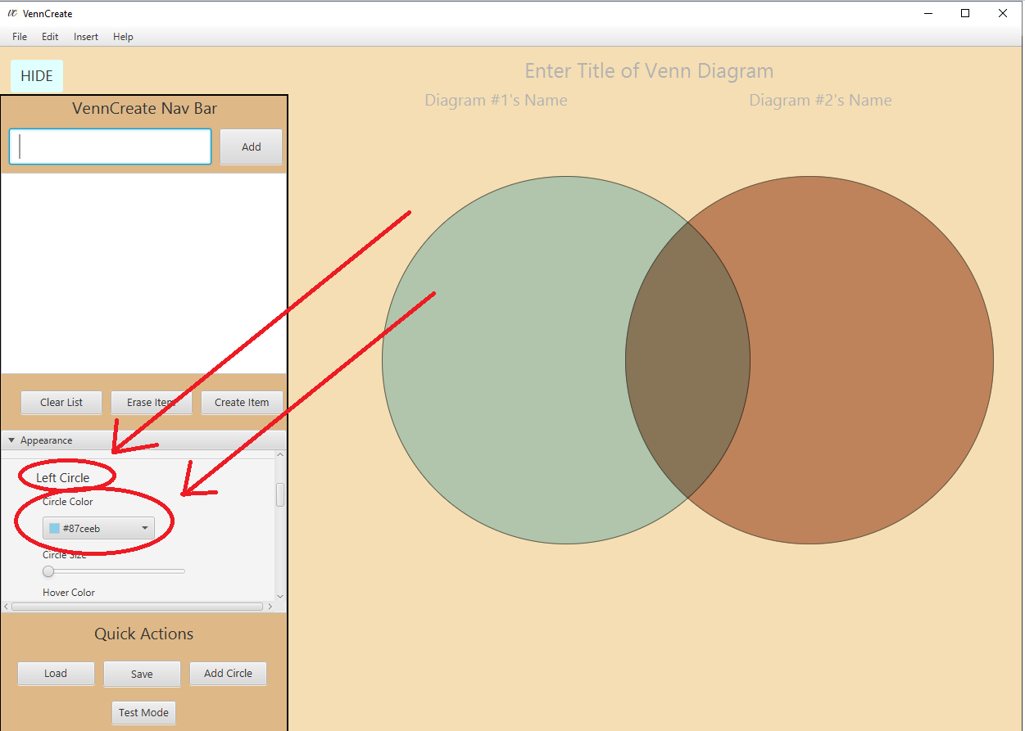

Figure - Changing the color of the left circle

## 4.9 Changing the Right Circle Color

1. Open the “Appearance” titled pane
2. Scroll down in the “Appearance” titled pane until you see the “Right Circle” portion of the titled pane
3. Choose your preferred color for the right circle.

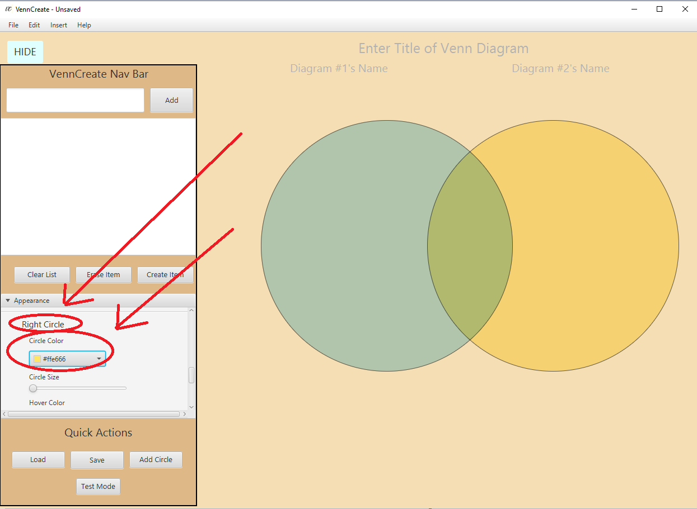

Figure - Changing the color of the right circle

## 4.10 Changing the Left or Right Circle size

1. Open the “Appearance” titled pane
2. Scroll down in the “Appearance” titled pane until you see the “Right Circle” or “Left Circle” portion of the titled pane (depending on which circle size you would like to adjust)
3. Move the circle slider to the right to increase the radius of the circle, or to the left to decrease the radius of the circle

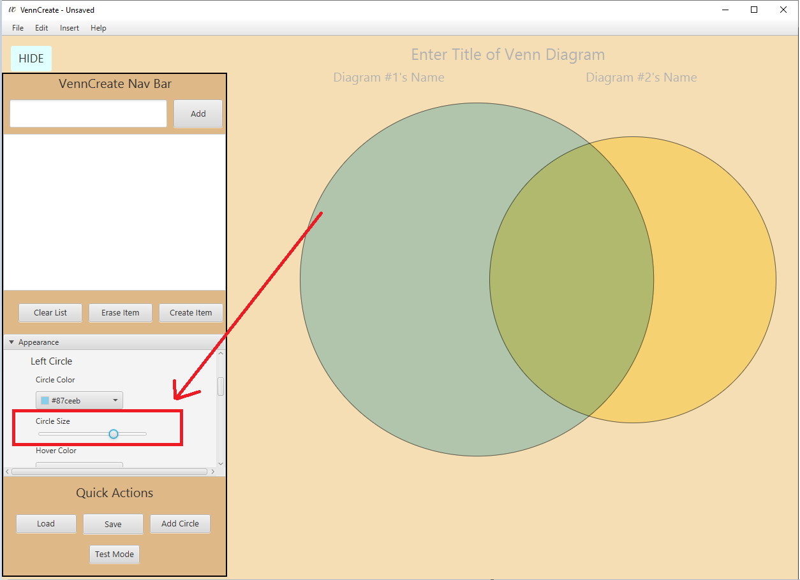

Figure - Increasing the radius of the left circle

## 4.11 Changing the Left or Right Circle hover color

By default, when a mouse cursor is hovering over a circle, the circle borders change to allow the user to know they are in the circle.

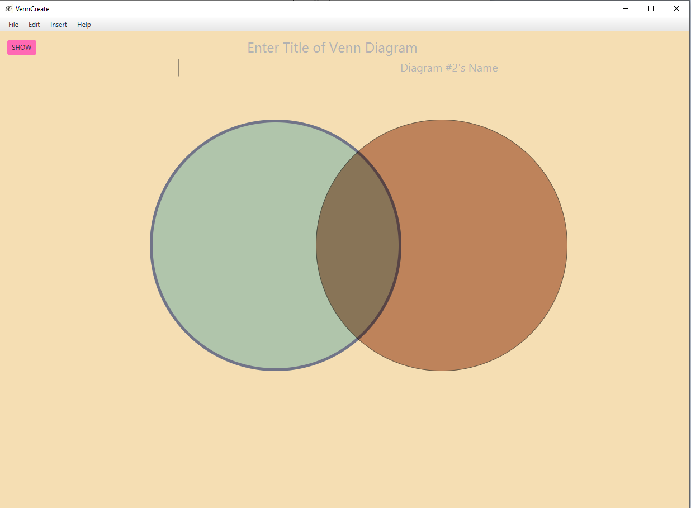

Figure - Default Hover Color of left circle

But if these default colors don’t suit your needs, VennCreate allows you to change them. To change the hover coloring of the left circle, simply:

1. Open the vertical navigation drawer, by clicking the “Show” button in the left-hand corner
2. Open the “Appearance” titled pane and scroll down until you see “Left Hover Color” (or “Right Hover Color” if you’re changing the right circle)
3. Select your preferred hover color

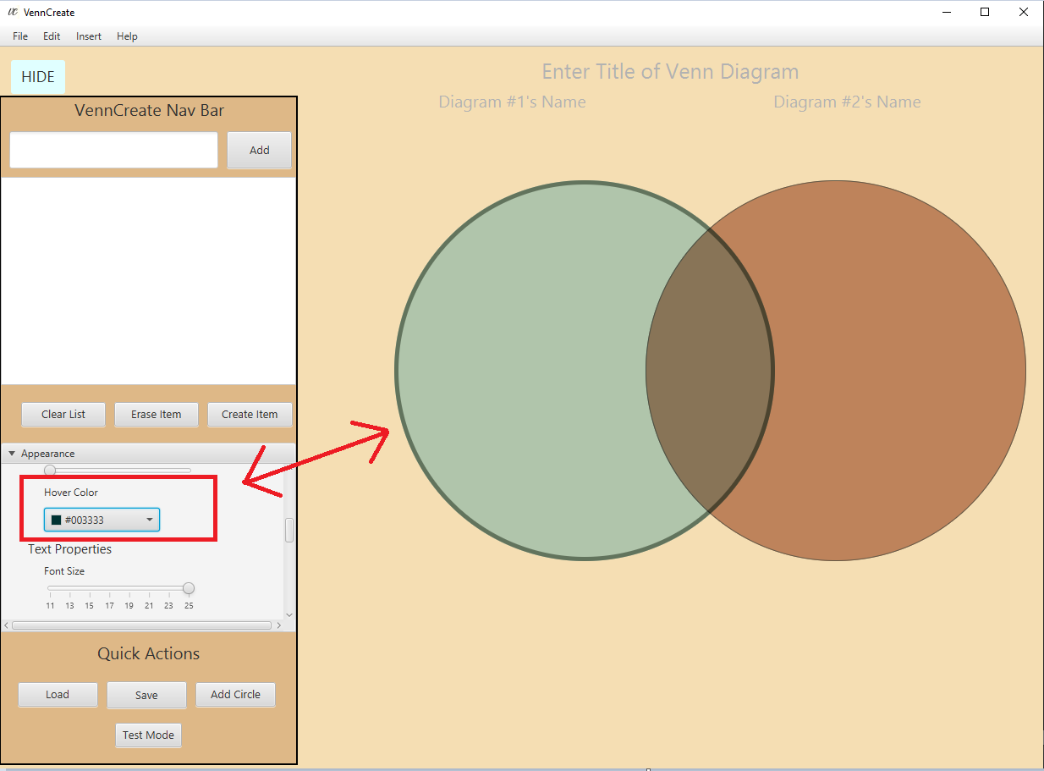

Figure - Changing the hover Color of the left Circle

## 4.11 Turning ON/OFF circle hovering

Sometimes you may want to completely turn off circle hovering, VennCreate permits this as well.

To do this simply,

1. Place you mouse cursor inside the circle you would like to toggle the hovering option
2. Right click the circle
3. When the context menu appears, click “Toggle Circle Hover”

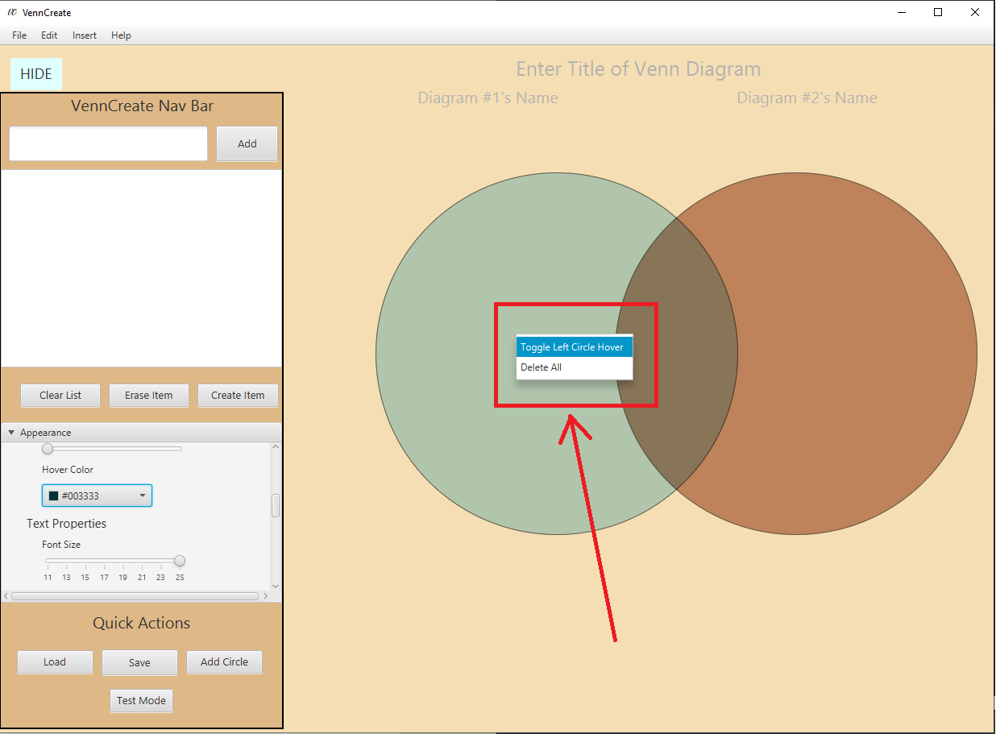

Figure - Toggling left circle hover option

## 4.12 Deleting single text from a circle

Often you will change your mind about placing text inside a circle, deleting text is easy in VennCreate.

To delete text simply:

1. Place your mouse cursor over the text you would like to delete
2. Right click the text
3. Click “Delete”

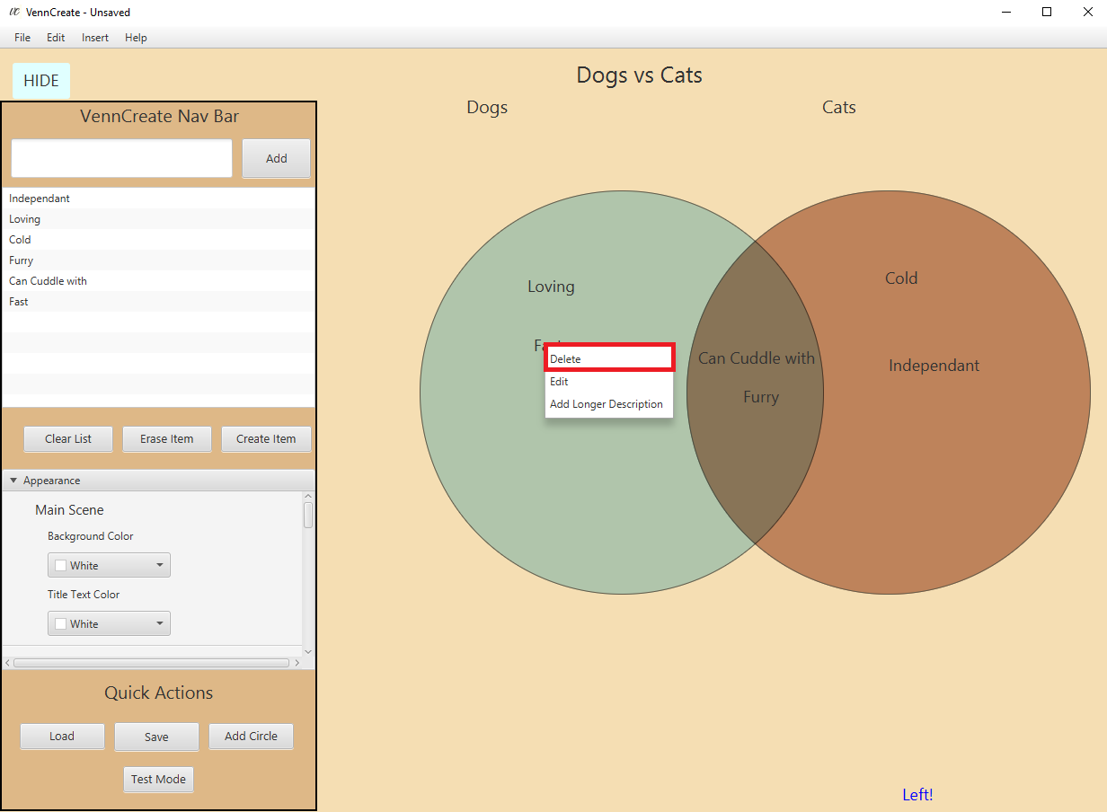

Figure - Deleting text in VennCreate

## 4.12 Editing text inside a circle

To edit text simply:

1. Place your mouse cursor over the text you would like to delete
2. Right click the text
3. Click “Edit”
4. The text will now be editable until your mouse cursor leaves the text

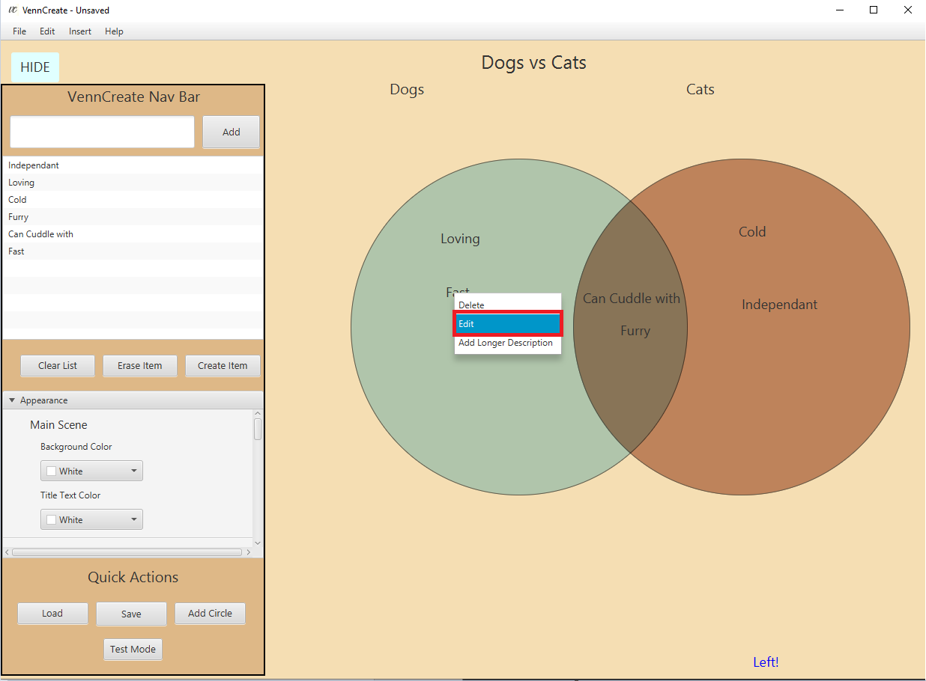

Figure - Editing text in VennCreate

# 5 Advanced System Usage

This section provides a more detailed overview of the advanced system features and functions.

## 5.1 Adding longer descriptions to text

Making text extremely long to capture a big idea can make the diagram look very messy. What if there was a way to add a longer description to text that only appears when you hover over it?

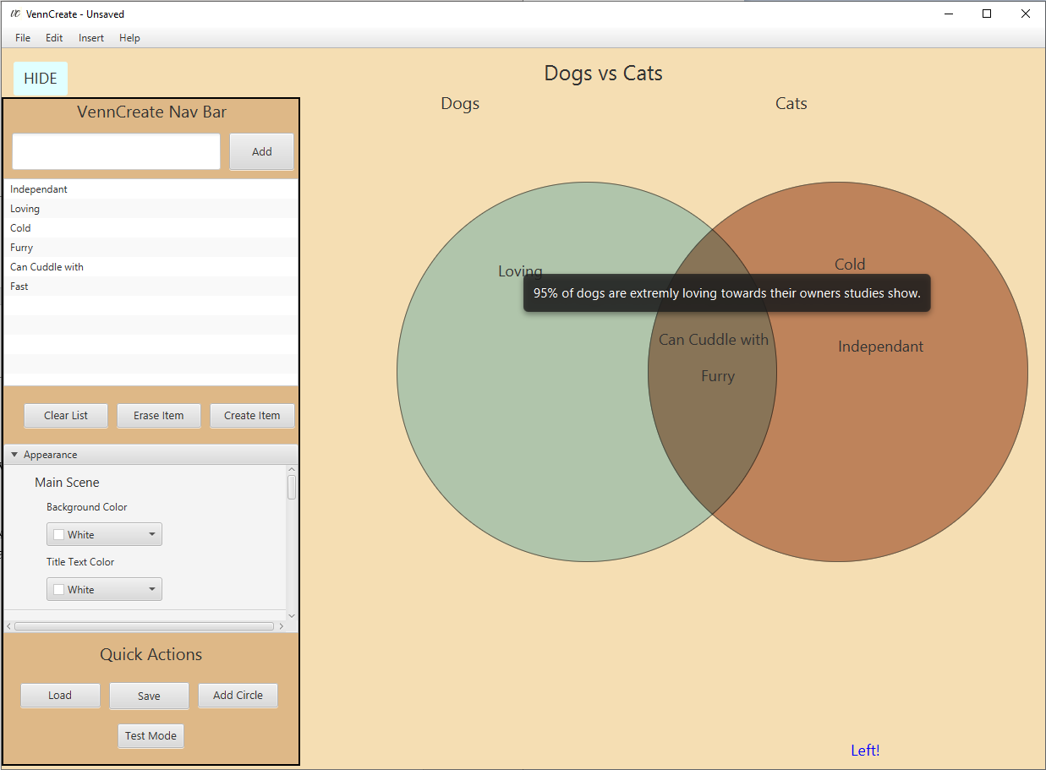

Figure - Adding longer descriptions to text

To add a longer description simply:

1. Place your mouse cursor over the text you would like to add a longer description to
2. Right-click the text
3. Click “Add longer description”
4. A popup will appear that will allow you to add a longer description to your text

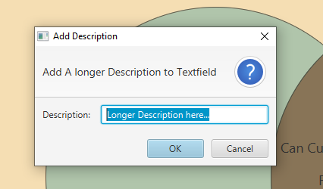

Figure - Longer description pop-up

## 5.2 Saving a VennCreate project

Every time you make a noticeable change in VennCreate the top of the stage alerts you that you have unsaved changes.

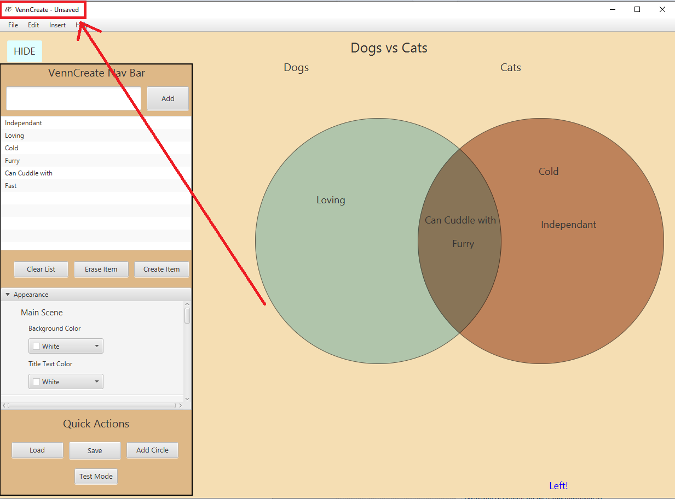

Figure - Unsaved change alert

To save you VennCreate project you can do so in one of three different ways.

1. In the “Quick Actions” part of the navigation drawer, click the “Save” button
2. In the “File” part of the menu bar, the “Save” menu item
3. Click CTRL+ s on your keyboard

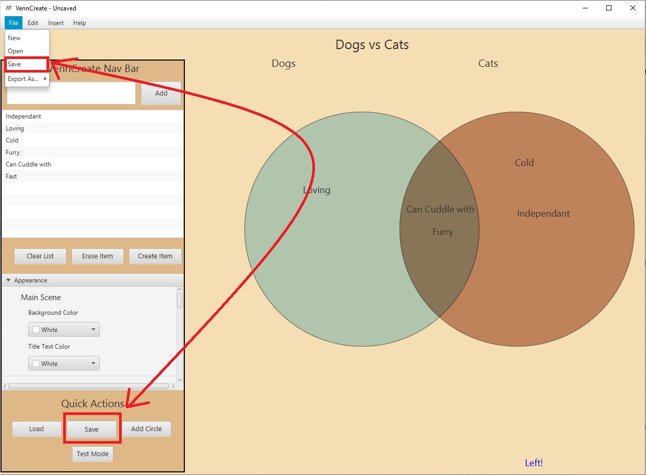

Figure - Saving your VennCreate project

## 5.2 Loading a VennCreate project

Loading an existing VennCreate project can be in one of three ways

1. On the launch page of VennCreate click “Get Existing”
2. On the “Create New” page of VennCreate, click “File” in the menu bar then click “Open”
3. In the quick actions part of the vertical navigation bar click “Load”

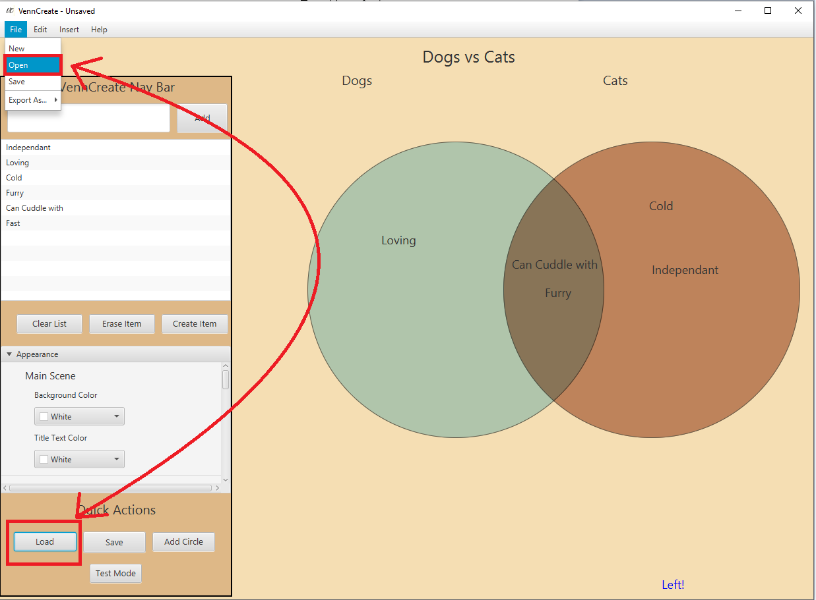

Figure - Loading an Existing VennCreate project

## 5.3 Adding a Circle to a VennCreate project

VennCreate supports up to 3 circles in the project. Circles can be added to a VennCreate project in one of two ways.

1. In the “Create New” page of VennCreate, pop open the vertical navigation drawer, go to “Quick Actions” and click “Add Circle”
2. In the menu bar click “Edit” then click “Add Circle”

A pop-up will appear after the circle has been added letting you know there is now support for a third circle inside the “Appearance” pane

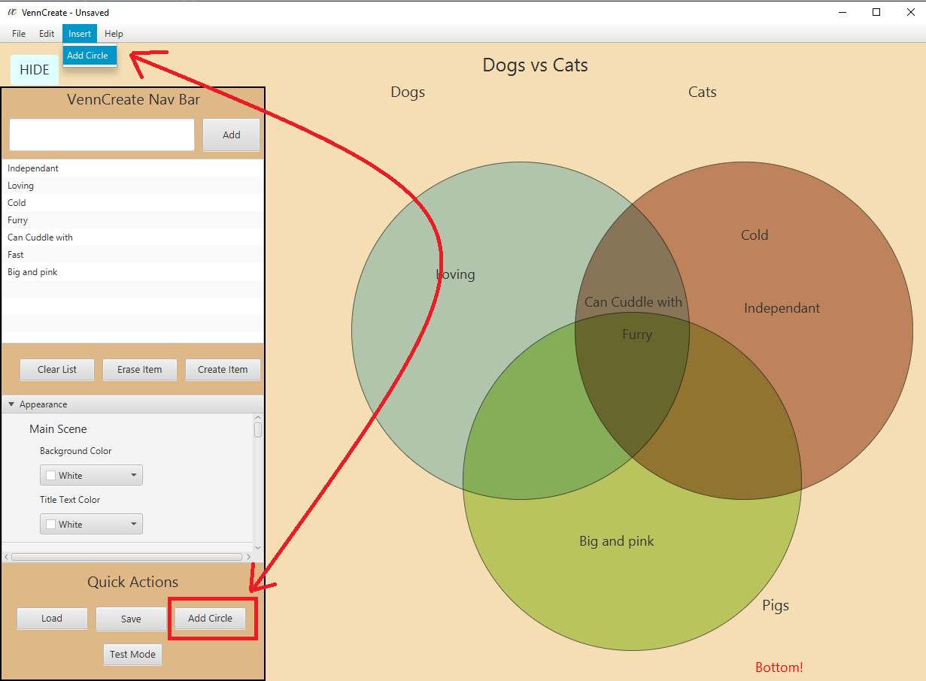

Figure - Result after clicking either of these buttons

## 5.4 Changing the font size of text in a specific circle

Say you wanted to change the font size of all the text in one circle, this can be done in VennCreate rather easily.

1. Make sure all the text you want to change the font size of is in the right circle
2. In the “Appearance” titled pane go to the respective circle section, so if I wanted to change the font size of text in the left circle I would scroll to the “Left Circle” section
3. Under “Text Properties” there is “Font Size” slider
4. Slide to the right to increase the size of text, slide to the left to decrease it

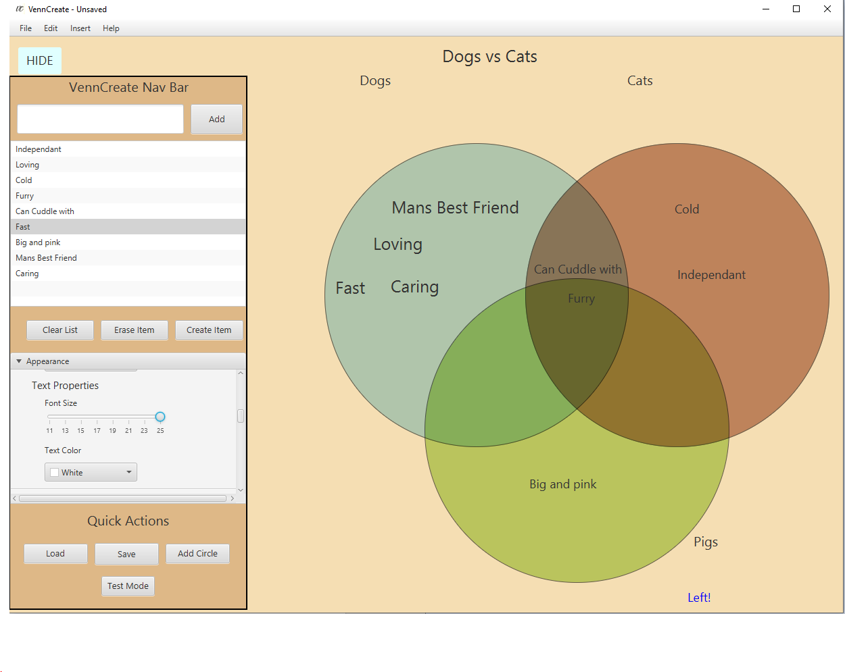

Figure - Increasing the font size of text in left circle

## 5.5 Changing the color of text in a specific circle

Say you wanted to change the color of all the text in one circle, this can be done in VennCreate rather easily.

1. Make sure all the text you want to change the color of is in the right circle
2. In the “Appearance” titled pane go to the respective circle section, so if I wanted to change the font size of text in the left circle I would scroll to the “Left Circle” section
3. Under “Text Properties” there is “Text Color” Color Picker.
4. Choose your preferred text color for that circle

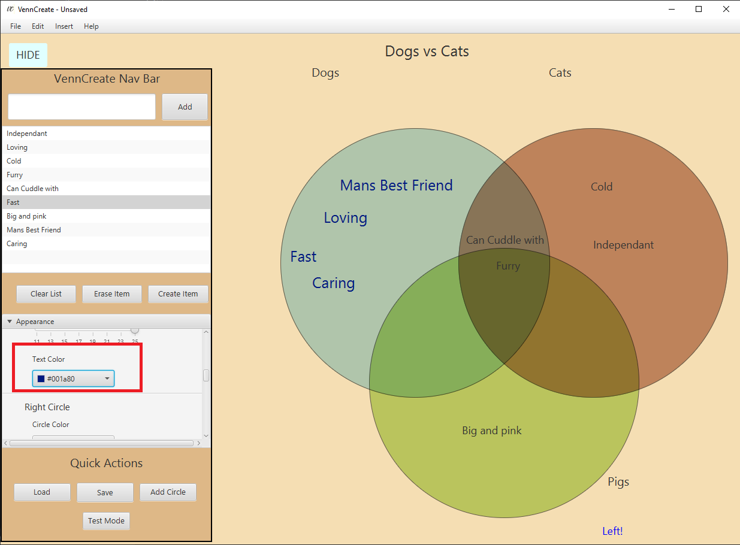

Figure - Changing text color in a specific circle

# 6 Understanding Saving Excel Sheet

For simplicity purposes, all information is saved to CSV files, and loaded from them too. This means they must be left untouched, or else your saved data will not be successfully parsed back into the application. This section hopes to educate you on how excel spread sheets (CSV files) are formatted in VennCreate to allow better understanding of the system.

Figure - Example saving to CSV

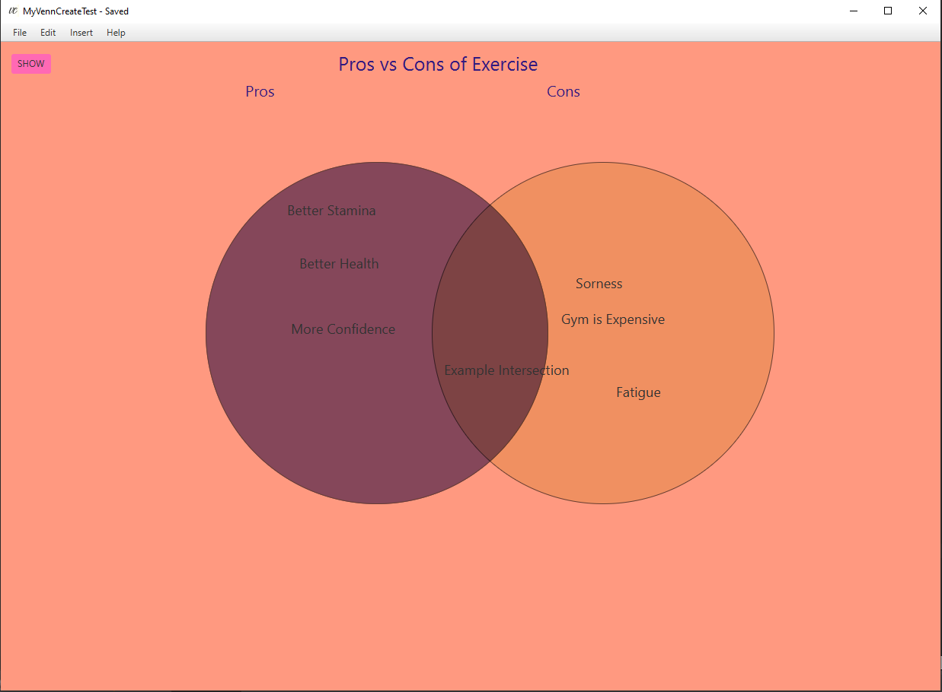

Say I saved a VennCreate project like this, how would it look in excel?

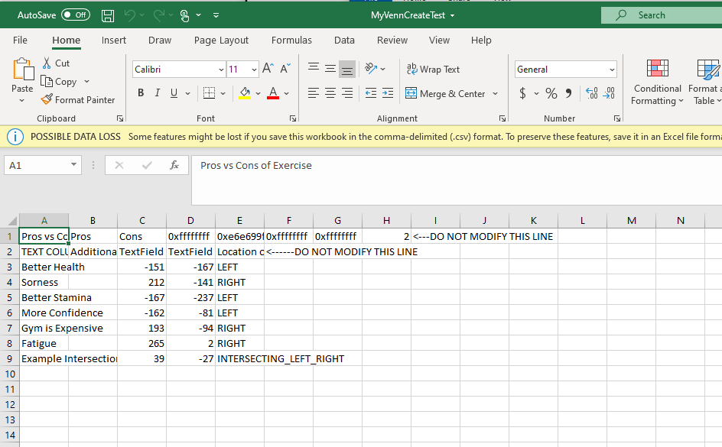

Figure - Project Representation in excel

The first line stores a lot of key information for the system.

**Line 1:**

A1) Stores the main Title of the Diagram project

B1) Stores the left circles title

C1) Stores the right circles title

D1) Stores the left circles color

E1) Stores the right circles color

F1) Stores the left circles hover color

G1) Stores the right circles hover color

H1) Stores the number of circles this application has

**Line 2:**

A2) Stores the title for “TEXT COLUMN” this is the coloum that stores all the text information of the project

B2) Stores additional descriptions associated with this text field, refer to section 5.1 to learn more about text field descriptions.

C2) Stores all the text fields x coordinates

D2) Stores all the text fields y coordinates

E2) Stores the location of the text field (which circle it belongs to)

**Line 3 and beyond:**

Every line after this represents a draggable text field and all the information associated with one.

# 7 Test Mode

New to the latest release of VennCreate, we have created a mode in the application called test mode (Figure 3). In this mode users can import a .txt file with information that they would like to be “tested” on and VennCreate will give them a test.

## 7.1 Setting up the .txt file

Setting up the .txt file must be precise in VennCreate otherwise the application will not run the test. You .txt file must abide to a specific set of rules.

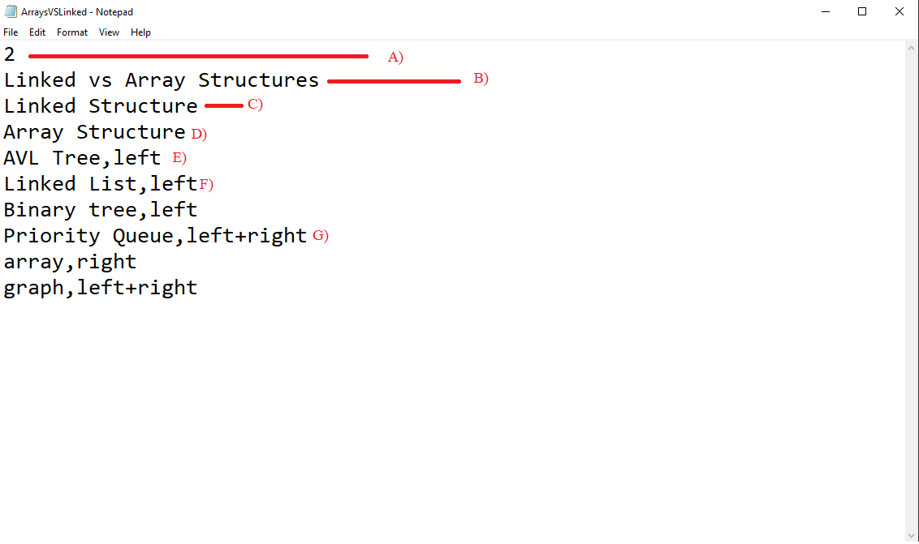

Figure - Setting up the .txt file

1. The first line MUST contain the number of circles you would like in the test. Type “2” for a two-circle test, and “3” for a three-circle test. Any other number will not allow test mode to run.
2. This is the main title of the test in my case it is called “Linked vs Array Structures”
3. This is the title of the LEFT circle
4. This is the title of the RIGHT circle
5. This line means the text “AVLTree” should be placed in the left circle
6. This means the text “Linked List” should be placed in the left circle
7. This means the text “Priority Queue” should be placed in the intersection of the left and right circle

Now we get to the contents of the test, test content is delimited by commas. On the left side of the comma is the TEXT you would like to be dragged around in the test. On the right side of the comma is the CORRECT LOCATION where the text should be placed. The correct location should follow a unique set of rules

**Rules for the correct location:**

1. “left” = The correct location of this text is when it should be placed exclusively in the left circle
2. “right” = The correct location of this text is when it is placed exclusively in the right circle
3. “left+right” (NO SPACES) = The correct location of this text is when it is placed exclusively in the intersection of left and right circle
4. “left+right+bottom” = Assuming there are three circles in this test, the correct location of this text is when it is placed in the area that intersects all three circles
5. “bottom” = Assuming there are three circles in this test, the correct location of this text is when it is placed exclusively in the bottom circle
6. “left+bottom” = Assuming there are three circles in this test, the correct location of this text is when it is placed in the intersection of the left and bottom circle
7. 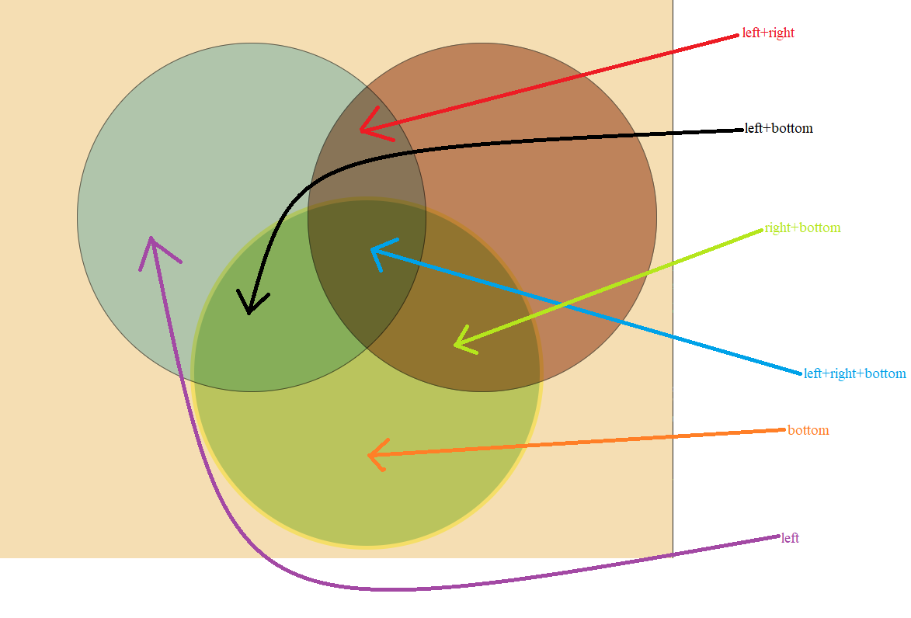“right+bottom” = Assuming there are three circles in this test, the correct location of this text is when it is placed in the intersection of the right and bottom circle

Figure - A diagram depicting all the proper text location

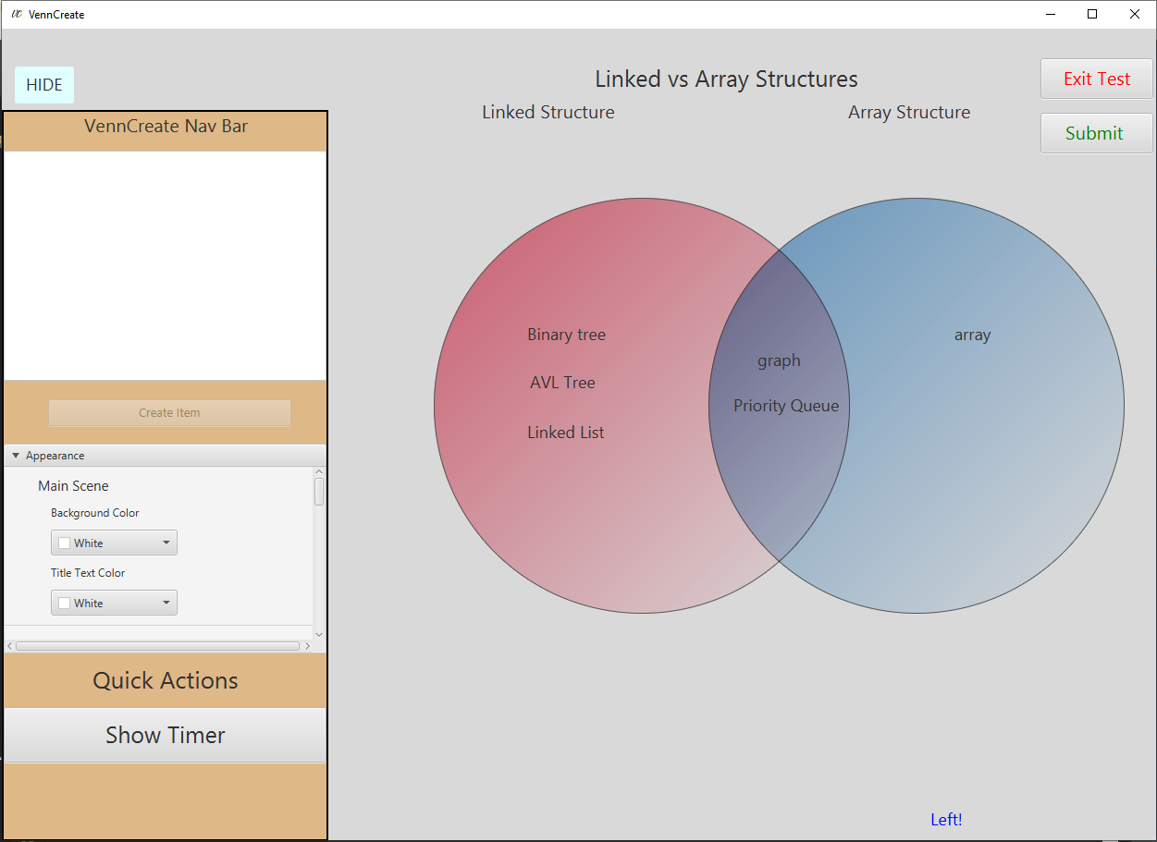

Figure - An example of Test Mode with the .txt file in figure 26

The example in the above figure (28) shows a 100% correct text placement of the test specified by figure 26. The goal of test mode is to import a txt file without seeing it and testing your memory to see if you really know all the correct placements.

## 7.2 Another example of the .txt file

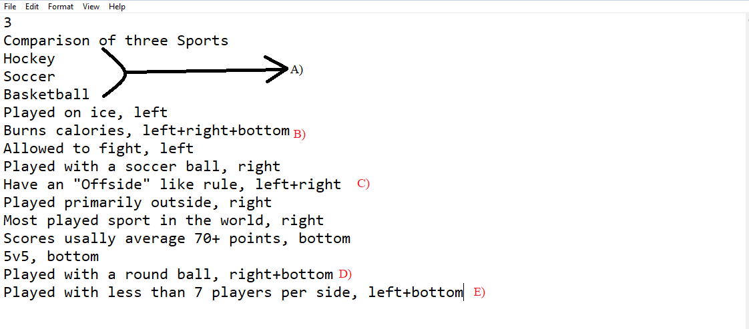

Figure - Another test mode .txt example

In this example we want to compare three items using three circles, hence the firsrt line of the .txt file being 3. The seoncd line we write the main title of our work, “Comparison of three sports” and the title of our circles will be Hockey (left circle), Soccer (right circle), and Basketball (bottom circle) respectivley (A). We then break down some of the things we wrote in this txt file:

B) All of the three sports burn calories, and thus the correct answer should be placed on the intersection of all three circles, which is why the correct location is “left+right+bottom”.

C) Hockey and soccer tend to have an offside rule (called icing in hockey) which is common to both of them. Basketball has no such rule and thus the correct location for that piece of text is in the intersection of hockey and soccer, which is “left+right”.

D) Basketball and soccer is played with a round ball, hockey is not. Thus, the correct location of that piece of text is in the intersection of Soccer and Basketball which is “right+bottom”

E) Both hockey and basketball is played with less than 7 players per side, which is why the correct location for that piece of text is “left+bottom” as it is common to just the two of the sports on the list.

The figure below represents how that .txt file looks imported into test mode

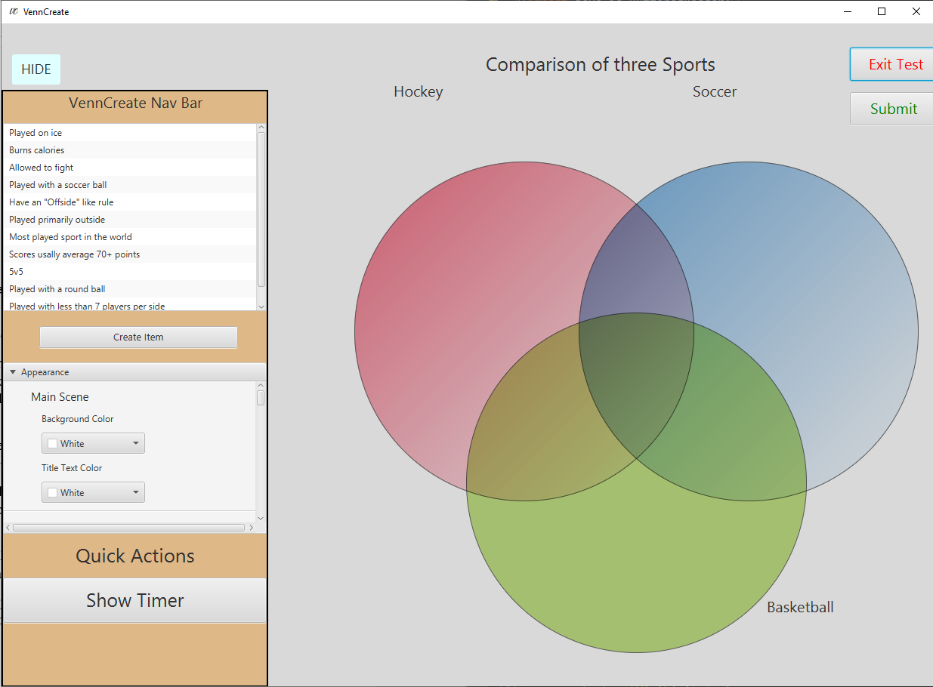

Figure - Figure 29 in test mode form

## 7.3 Displaying the timer in Test Mode

As test mode does test you on the time you take to complete the test, VennCreate does have a built-in timer to show you how much time you have spent doing this test. To show the timer simply

1. Go into test-mode
2. Open the vertical navigation drawer by clicking the “Show” button in the upper left hand corner
3. In “Quick Actions” click “Show Timer”

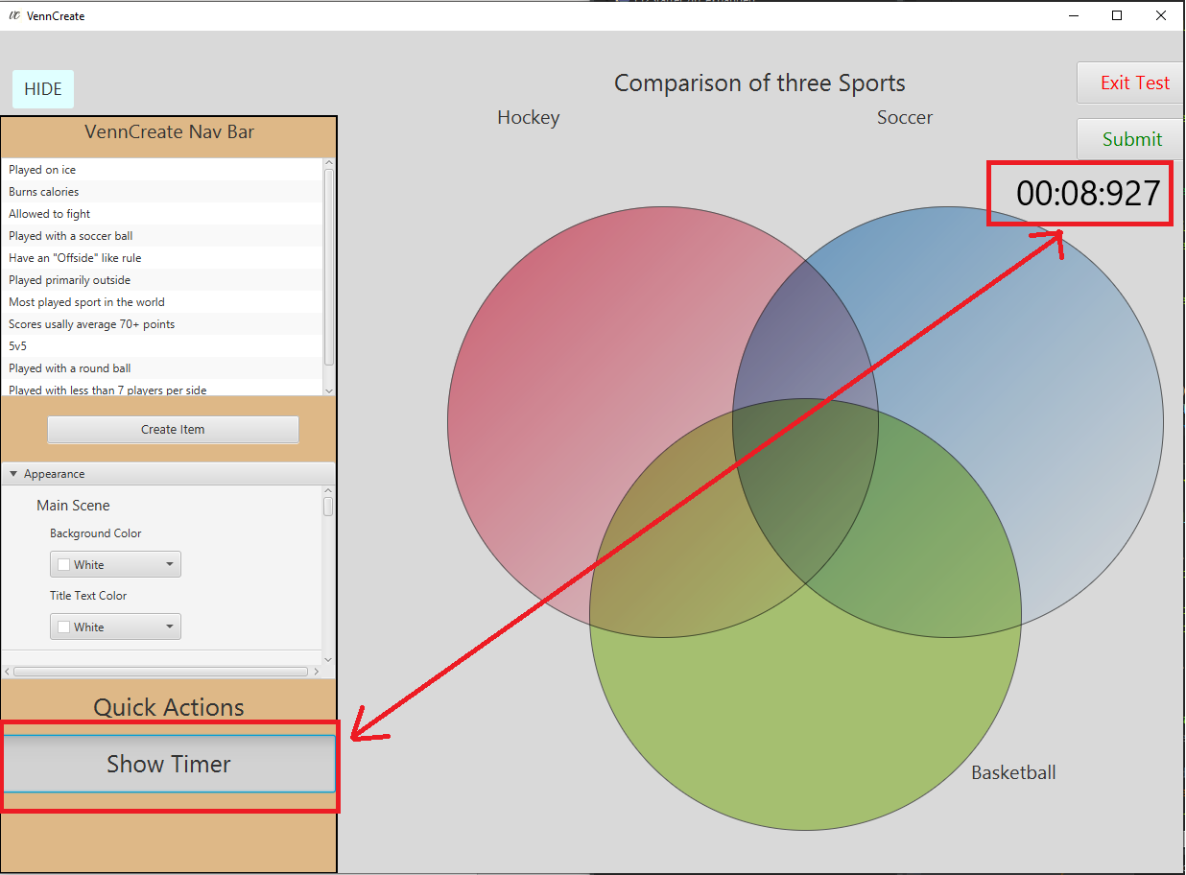

Figure - Showing the timer in VennCreate

## 7.4 Undoing and Redoing changes

Say you make a mistake using VennCreate and quickly want to undo or redo it. This can be done quite easily in VennCreate in one of three ways

1. In an open project pop out the vertical navigation drawer using the show button located in the top-left corner. Under “Quick Actions” click Undo/Redo
2. Click CTRL+z to Undo or CTRL+SHIFT+y to Redo
3. In the menu bar in the “Edit” tab click undo or redo

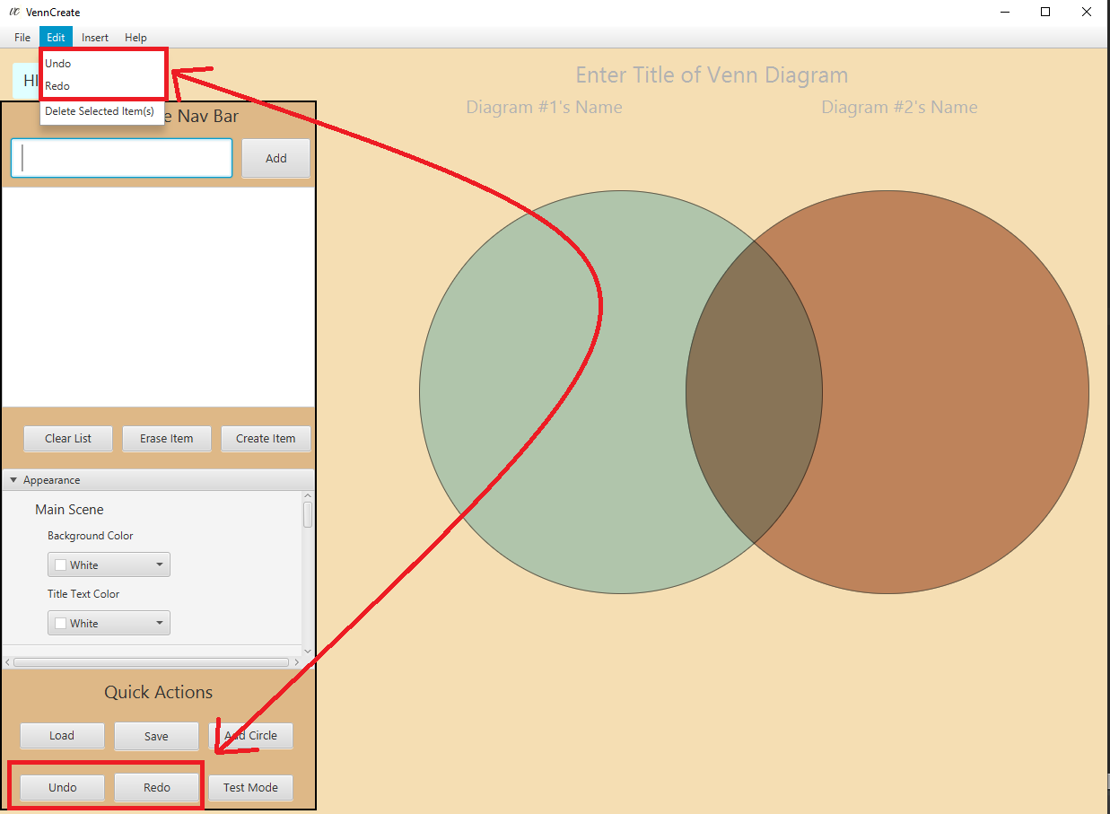

Figure - Different ways to undo/redo changes in VennCreate