1.
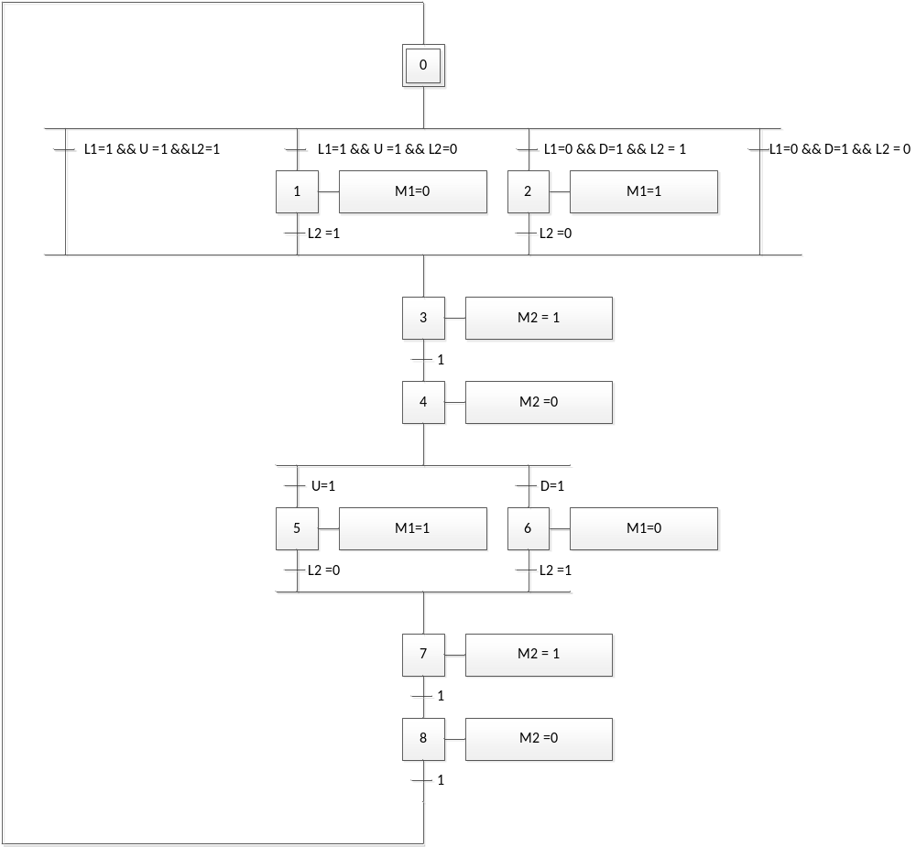

LIBRARY IEEE;
USE IEEE.STD_LOGIC_1164.all;
USE IEEE.STD_LOGIC_ARITH.ALL;
USE IEEE.STD_LOGIC_UNSIGNED.ALL;

entity grafcet_vhdl1 is
port(
clk : in std_logic;
rst : in std_logic;
L1 : in std_logic;
L2 : in std_logic;
U : in std_logic;
D : in std_logic;
M1: out std_logic;
M2 : out std_logic
);
end grafcet_vhdl1;

architecture arch of grafcet_vhdl1 is
signal X0,X1,X2,X3,X4,X5,X6,X7,X8 : std_logic;
begin
grafcet: process(CLK,RST)
begin
if RST='0' then
X0<='1'; X1<='0'; X2<='0'; X3<='0';
X4<='0'; X5<='0'; X6<='0'; X7<='0'; X8<='0';
elsif CLK'event and CLK='1' then
if X0='1' and L1='1' and U='1' and L2='1' then
X0 <= '0'; X3 <='1';
elsif X0='1' and L1='1' and U='1' and L2='0' then
X0 <= '0'; X1 <='1';
elsif X0='1' and L1='0' and D='1' and L2='1' then
X0 <= '0'; X2 <='1';
elsif X0='1' and L1='0' and U='1' and L2='0' then
X0 <= '0'; X3 <='1';

elsif X1='1' and L2='1' then
X1 <= '0'; X3<='1';

elsif X2='1' and L2 = '0' then
X2 <= '0'; X3 <= '1';

elsif X3='1' then
X3 <= '0'; X4 <= '1';

elsif X4='1'and U='1'then
X4 <= '0'; X5 <= '1';

elsif X4='1' and D='1' then
X4 <= '0'; X6 <= '1';

elsif X5='1' and L2='0'then
X5 <= '0'; X7<='1';

elsif X6='1' and L2='1' then
X6 <= '0'; X7<='1';

elsif X7='1' then
X7 <= '0'; X8 <= '1';

elsif X8='1' then
X8 <= '0'; X0 <= '1';

end if;
end if;
end process;

datapath: process(CLK,RST)
begin
if CLK'event and CLK='1' then

if X1='1' then
M1 <= '0';

elsif X2='1' then
M1 <= '1';

elsif X3='1' then
M2 <= '1';

elsif X4='1' then
M2 <= '0';

elsif X5='1' then
M1 <= '1';

elsif X6='1' then
M1 <= '0';

elsif X7='1' then
M2 <= '1';

elsif X8='1' then
M2 <= '0';

end if;
end if;
end process;
end arch;

2.
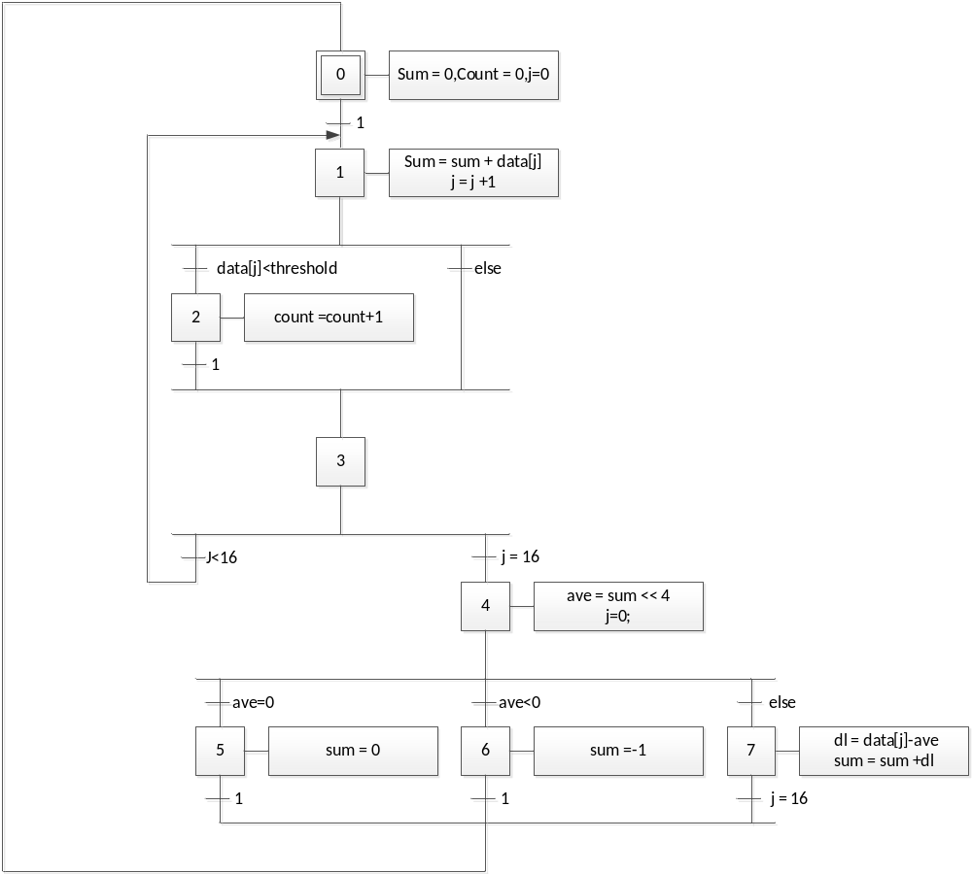

LIBRARY IEEE;
USE IEEE.STD_LOGIC_1164.all;
USE IEEE.STD_LOGIC_ARITH.ALL;
USE IEEE.STD_LOGIC_UNSIGNED.ALL;

entity grafcet_vhdl2 is
port(
clk : in std_logic;
rst : in std_logic;
threshold : in std_logic_vector(2 downto 0);
count : out std_logic_vector(4 downto 0);
sum : out std_logic_vector(7 downto 0)
);
end grafcet_vhdl2;

architecture arch of grafcet_vhdl2 is
type ram is array(0 to 15) of std_logic_vector (3 downto 0);
signal X0,X1,X2,X3,X4,X5,X6,X7 : std_logic;
signal ave : std_logic_vector (3 downto 0);
signal S_tmp : std_logic_vector(7 downto 0);
signal C_tmp : std_logic_vector(4 downto 0);
signal j : integer range 0 to 16;
signal data : ram := (
0 => "0000",
1 => "0001",
2 => "0010",
3 => "0011",
4 => "0100",
5 => "0101",
6 => "0110",
7 => "0111",
8 => "1000",
9 => "1001",
10 => "1010",
11 => "1011",
12 => "1100",
13 => "1101",
14 => "1110",
15 => "1111");

begin
sum <= S_tmp;
count <= C_tmp;
grafcet: process(CLK,RST)
begin
if RST='0' then
X0<='1'; X1<='0'; X2<='0'; X3<='0';
X4<='0'; X5<='0'; X6<='0'; X7<='0';

elsif CLK'event and CLK='1' then

if X0='1' then
X0 <= '0'; X1 <= '1';

elsif X1='1' and data(j) < threshold then
X1 <= '0'; X2 <= '1';
elsif X1='1' and data(j) >= threshold then
X1 <= '0'; X3 <= '1';

elsif X2='1' then
X2 <= '0'; X3 <= '1';

elsif X3='1' and j < 16 then
X3 <= '0'; X1 <= '1';

elsif X3='1' and j = 16 then
X3 <= '0'; X4 <= '1';

elsif X4='1' and ave = 0 then
X4 <= '0'; X5 <= '1';

elsif X4='1' and ave < 0 then
X4 <= '0'; X6 <= '1';

elsif X4='1' then
X4 <= '0'; X7 <= '1';

elsif X5='1' then
X5 <= '0'; X0 <= '1';

elsif X6='1' then
X6 <= '0'; X0 <= '1';

elsif X7='1' then
X7 <= '0'; X0 <= '1';

end if;
end if;
end process grafcet;

datapath: process(CLK,RST)
begin
if CLK'event and CLK='1' then
if X0='1' then
S_tmp <="00000000"; C_tmp <="00000";
j<=0; ave<="0000";
elsif X1='1' then
S_tmp <= S_tmp + data(j);
j <= j+1;
elsif X2='1' then
C_tmp <= C_tmp + 1;
elsif X4='1' then
ave <= S_tmp(7 downto 4);
j <= 0;
elsif X5='1' then
S_tmp <= "00000000";
elsif X6='1' then
S_tmp <= "11111111";
elsif X7='1' then
S_tmp <= S_tmp + ("0000" & data(j)) - ("0000" & ave);
end if;
end if;
end process datapath;
end arch;

3.
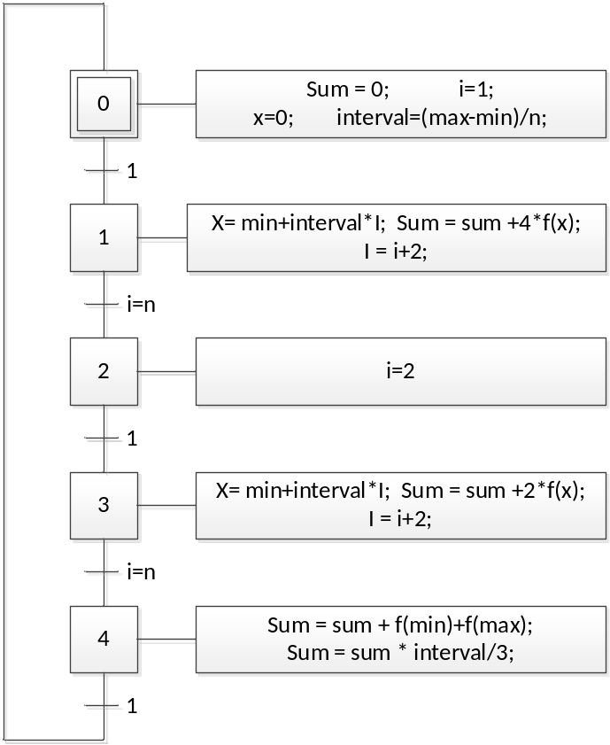
LIBRARY IEEE;
USE IEEE.STD_LOGIC_1164.all;
USE IEEE.STD_LOGIC_ARITH.ALL;
USE IEEE.STD_LOGIC_UNSIGNED.ALL;

entity grafcet_vhdl3 is
port(
clk,rst : in std_logic;
n : in std_logic(31 downto 0);
min : in std_logic(31 downto 0);
max : in std_logic(31 downto 0);
f : in std_logic(31 downto 0);
sum : out std_logic(31 downto 0)
);
end grafcet_vhdl3;

architecture arch of grafcet_vhdl3 is

signal X0,X1,X2,X3,X4 : std_logic;
signal i : std_logic;
signal S_tmp : std_logic_vector(31 downto 0);
signal interval : std_logic_vector(31 downto 0);
signal x : std_logic_vector(31 downto 0);

begin
sum <= S_tmp;
grafcet: process(CLK,RST)
begin
if RST='0' then
X0<='1'; X1<='0'; X2<='0'; X3<='0'; X4<='0';
elsif CLK'event and CLK='1' then
if X0='1' then
X0 <= '0'; X1 <= '1';
elsif X1='1' and i=n then
X1 <= '0'; X2 <= '1';
elsif X2='1' then
X2 <= '0'; X3 <= '1';
elsif X3='1' and i=n then
X3 <= '0'; X0 <= '1';
elsif X4='1'then
X4 <= '0'; X0 <= '1';
end if;
end if;
end process;

datapath: process(CLK,RST)
begin
if CLK'event and CLK='1' then
if X0='1' then
S_tmp <= "00000000 00000000 00000000 00000000";
x <= "00000000 00000000 00000000 00000000";
interval <= (max-min)/n;
elsif X1='1' then
X <= min+interval*I;
Sum <= sum +4*f(x);
i <= i+2;
elsif X2='1' then
i <= 2;
elsif X3='1' then
i <= min+interval*i;
S_tmp <= S_tmp +2*f(x);
i <= i+2;
elsif X3='1' then
S_tmp <= S_tmp + f + min + f + max;
S_tmp <= S_tmp * interval / 3;
end if;
end if;
end process;
end arch;

4.
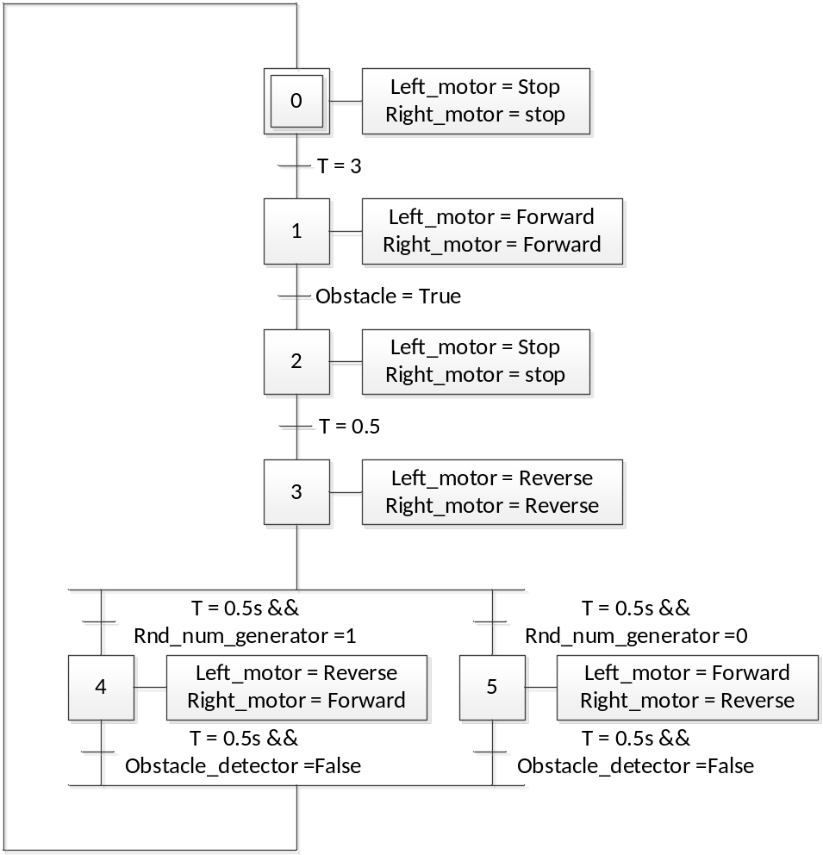
LIBRARY IEEE;
USE IEEE.STD_LOGIC_1164.all;
USE IEEE.STD_LOGIC_ARITH.ALL;
USE IEEE.STD_LOGIC_UNSIGNED.ALL;

entity grafcet_vhdl4 is
port(
CLK : in std_logic;
RST : in std_logic;
Obstacle : in std_logic;
Obstacle_detector : in std_logic;
Rnd_num_generator : in std_logic;
Tim : in std_logic_vector (3 downto 0);-- 0.5
Left_motor : out std_logic_vector (1 downto 0);--00 Reverse 11 Forward 10Stop
Right_motor : out std_logic_vector (1 downto 0)--00 Reverse 11 Forward 10Stop
);
end grafcet_vhdl4;

architecture arch of grafcet_vhdl4 is
signal X0,X1,X2,X3,X4,X5 : std_logic;
signal T : std_logic_vector (3 downto 0);

begin
T <= Tim;
grafcet: process(CLK,RST)
begin
if RST='0' then
X0<='1'; X1<='0'; X2<='0'; X3<='0';
X4<='0'; X5<='0';

elsif CLK'event and CLK='1' then
if X0='1' and Tim="0110" then --3
X0 <= '0'; X1 <= '1';

elsif X1='1' and Obstacle ='1' then
X1 <= '0'; X2 <= '1';

elsif X2='1' and Tim="0001" then--0.5
X2 <= '0'; X3 <= '1';

elsif X3='1' and Tim="0001" and Rnd_num_generator = '1' then
X3 <= '0'; X4 <= '1';

elsif X3='1' and Tim="0001" and Rnd_num_generator = '0' then
X3 <= '0'; X5 <= '1';

elsif X4='1' and Tim="0001" and Obstacle_detector = '1' then
X4 <= '0'; X0 <= '1';

elsif X5='1' and Tim="0001" and Obstacle_detector = '1' then
X5 <= '0'; X0 <= '1';

end if;
end if;
end process grafcet;

datapath: process(CLK,RST)
begin
if CLK'event and CLK='1' then

if X0='1' then
Left_motor <= "10";
Right_motor <= "10";

elsif X1='1' then
Left_motor <= "11";
Right_motor <= "11";

elsif X2='1' then
Left_motor <= "10";
Right_motor <= "10";

elsif X3='1' then
Left_motor <= "00";
Right_motor <= "00";

elsif X4='1' then
Left_motor <= "00";
Right_motor <= "11";

elsif X5='1' then
Left_motor <= "11";
Right_motor <= "00";

end if;
end if;
end process datapath;
end arch;

5.
