
Journal of Circuits, Systems, and Computers Vol. 33, No. 18 (2024) 2550008 (24 pages)
J CIRCUIT SYST COMP 2024.33. Downloaded from www.worldscientific.com
by UNIVERSIDADE DE SAO PAULO on 03/18/26. Re-use and distribution is strictly not permitted, except for Open Access articles.
#.c World Scienti¯c Publishing Company
DOI: 10.1142/S0218126625500082

E±cient Hardware Architecture Design of Radix-2² Fast Fourier Transform Using Coordinate Rotation

Digital Computer¤

Kaushik Das ,†,§ Sambhu Nath Pradhan ‡,¶ and Abhishek Bhattacharjee ‡,||
†Department of Electronics and Communication Engineering, GLA University, Mathura, Uttar Pradesh, India
‡Department of Electronics and Communication Engineering, National Institute of Technology,
Agartala, Tripura, India
§kaushik.das@gla.ac.in
¶sambhupradhan.ece@nita.ac.in
||deepbhattacharjee108@gmail.com

Received 5 March 2024
Accepted 10 July 2024
Published 12 September 2024

The fast Fourier transform (FFT) is a widely used algorithm for computing the discrete Fourier transform (DFT) in real-time signal processing. Achieving high performance with minimal resource usage is crucial for any real-time application. This paper introduces an architecture based on coordinate rotation digital computer (CORDIC) for implementing a radix-2² FFT. Traditional FFT implementations require complex twiddle factor multiplications, which is not cost-e®ective in terms of hardware utilization. To address this issue, we have proposed a radix-8 CORDIC-based approach integrated with FFT computation. The proposed radix-8 CORDIC requires fewer stages than the conventional radix-2 CORDIC, enhancing computational e±- ciency and reducing hardware utilization. The feedforward radix-2² FFT architecture is pre- sented where the butter°ies of the FFT are computed with the help of radix-8 CORDIC. A total of three FFT architectures are developed supporting 16-, 1024- and 2048-point FFTs. The proposed FFT architectures are developed using Verilog-HDL code and implemented on a Virtex-7 ¯eld-programmable gate array (FPGA). The FPGA-based radix-2² FFT achieves a clock frequency of 323.4 MHz and utilizes minimal FPGA resources. Processing of 2048 data samples takes only 4.06 µS by the proposed FPGA-based design. Additionally, two ASICs have been designed: the 1024-point FFT ASIC occupies an area of 1.079 mm², and the 2048-point FFT ASIC occupies an area of 1.544 mm². The proposed FFT ASICs have better-normalized area per FFT and energy per FFT than the state-of-the-art designs.

Keywords: Radix-2² FFT; CORDIC; FPGA; feedforward architectures; ASIC.

*This paper was recommended by Regional Editor Zoran Stamenkovic.
§ Corresponding author.

K. Das, S. N. Pradhan & A. Bhattacharjee
J CIRCUIT SYST COMP 2024.33. Downloaded from www.worldscientific.com
by UNIVERSIDADE DE SAO PAULO on 03/18/26. Re-use and distribution is strictly not permitted, except for Open Access articles.

- Introduction
The Fourier transform is a technique of converting a time-domain signal into a frequency-domain signal by which we can analyze the frequency components present in a signal. The Fourier transform o®ers an important conversion tool for signal processing, which is almost impossible to tackle in the time domain. The DFT is used extensively in many digital signal processing (DSP) applications. Due to the high computational complexity in the case of DFT, the hardware implementation of DFT is not an easy task. The fast Fourier transform (FFT) is an algorithm by which the exact same results as that of DFT can be achieved by using fewer operations as compared to DFT. Till date, many FFT algorithms were proposed by the authors such as radix-r, split-radix and radix-r^{k} algorithm.^{1,2} The FFT algorithm proposed by Cooley and Tukey is widely used to compute N-point DFT when N can be expressed as the power of two. The DFT has a computational complexity of O(N ²), whereas the FFT algorithm reduces the computational complexity of the DFT to O (N log₂(N )).
Coordinate rotation digital computer (CORDIC) is an iterative process and needed only simple add and shift operation in order to perform many complex cal- culations like logarithmic, hyperbolic, trigonometric, real and complex multiplica- tion, square root ¯ndings and many more.³ With all these applications, CORDIC becomes an important part of many DSP-based systems. The number of iterations required in the case of traditional radix-2 CORDIC algorithm is more, which limits the use of radix-2 CORDIC for high-speed design. To tackle this issue, several high radix CORDIC algorithms are proposed in order to reduce the iteration number and due to which the latency time of the design is also reduced.^{4,5} For m-bit precision, the conventional radix-2 CORDIC algorithm takes m-iterations. Whereas, the radix-4 CORDIC algorithm requires m/2 iterations.^{5,6} CORDIC is basically a rotation-based algorithm that can compute complex mathematical functions by rotating the vector in a two-dimensional plane. The CORDIC can be used in mainly two modes which are rotation and vectoring modes.⁷
In Aggarwal et al.,⁸ the authors have presented a recon¯gurable CORDIC algorithm, their proposed design has a relatively less area complexity. The design presented in Shukla and Ray⁹ needs very less iterations for the CORDIC imple- mentation. However, the main disadvantage of this design is the high hardware complexity. A hardware architecture design for the radix-8 CORDIC was presented in Changela et al.¹⁰ The selection function for the radix-8 CORDIC is di±cult to implement due to the fact that it is not an integer power of two. There are nine directions of rotations in radix-8 CORDIC, and it is time-consuming to select a suitable angle out of the nine elementary angles. The authors have used the SRT division method to calculate the selection function.¹⁰
The problem with using the SRT division method is that it increases the latency of the design.¹¹ The authors have used the radix-8 SRT division method to reduce the latency. However, choosing the quotient digits gets more complicated as the

E±cient Hardware Architecture Design of Radix-2² FFT Using CORDIC
J CIRCUIT SYST COMP 2024.33. Downloaded from www.worldscientific.com
by UNIVERSIDADE DE SAO PAULO on 03/18/26. Re-use and distribution is strictly not permitted, except for Open Access articles.

radix number increases. In our radix-8 CORDIC, we solved this problem by pre- computing all the directions of rotations for the given input angle. In Tang and Xu,¹² a ¯eld-programmable gate array (FPGA)-based architecture for the noniterative version of radix-8 CORDIC was presented. The FPGA-based design of a recon¯- gurable radix-2 CORDIC that works in the circular, linear, and hyperbolic coordi- nate systems is presented in Mohamed et al.¹³ The main disadvantages of the design are that the design consumes more hardware resources and has a low frequency of operation.
Till date, many parallel and pipelining hardware architecture designs for the FFT algorithm were presented. The FFT designs with parallel architectures were pre- sented in Liu et al.¹⁴ and El-Motaz et al.¹⁵ Di®erent algorithms are found in the literature that are widely used to solve various mathematical problems.^{16,17} To meet superior performance and real-time requirements, many pipelined hardware archi- tectures for the FFT were proposed.^{18,19} The pipelined architectures are divided into two main types, namely, feedback architecture and feedforward architecture. The feedback architectures are further divided into two main types, single-path delay feedback (SPDF) and multi-path delay feedback (MPDF).^{18,20} The SPDF archi- tecture can continuously process data with one sample per clock cycle. On the other hand, MPDF architecture can process many samples in each clock cycle. The multi- path delay commutator (MPDC) or feedforward architectures are also capable of processing many samples per clock cycle.¹⁸
In Ref. 21, a distributed arithmetic (DA)-based radix-2 FFT that operates on complex binary number system (CBNS) was presented. Compared to the design proposed in Ref. 21, our design needs very few LUTs and the execution time of our design is also very less. A low-cost and power-e±cient processor design for FFT was proposed in Kang et al.²² The SPDF architecture for the FFT which supports 46 di®erent sizes of FFT was presented in Shih et al.²³ In order to reduce the number of operations in an FFT ASIC, the authors have used the concept of hashing and lookup table (LUT).²⁴ The ASIC can process only 128 points and has relatively more execution time. Ingemarsson et al. presented a single-stream feedforward (SFF) architecture for the FFT.²⁵ The design's two main drawbacks are more hardware utilization and high execution time.
FPGA and ASIC implementation of memory-based FFT was proposed by Wang et al.²⁶ Their proposed ASIC was operated only with a 150 MHz clock frequency. The authors have proposed a hardware architecture design for the pipelined FFT, which includes serial and parallel split and merge processing butter°y units.²⁷ The proposed method uses a lot of FPGA resources. Moreover, for multiplication operation, the authors used an extra multiplier and divider circuit to compensate for the fractional part, which further will increase the area and computation time of the design.²⁷ A CORDIC-based implementation of FFT is presented in Inguva and Seventiline.²⁸ The authors have used the canonical signed-digit (CSD) approach and the Hcub method for the reduction of hardware resources. Still, the design consumes more hardware resources, and the operating frequency of the design is also less.²⁸

K. Das, S. N. Pradhan & A. Bhattacharjee
J CIRCUIT SYST COMP 2024.33. Downloaded from www.worldscientific.com
by UNIVERSIDADE DE SAO PAULO on 03/18/26. Re-use and distribution is strictly not permitted, except for Open Access articles.

There are many works that have been done on FFT to reduce the area and power of the FFT design. In Ayinala et al.,²⁹ the authors have used the folding transfor- mation and register minimization technique to reduce the power and area of the FFT design. The authors have presented a mixed SPDF and SPDC pipelined radix-2 FFT architecture to reduce the complex multipliers as well as complex adders require- ment. However, the disadvantage of the design is the high latency and low throughput.³⁰ In Wang et al.,³¹ a mixed-decimation MPDF method for the radix-2^{k} FFT algorithm was presented. The design presented by the authors has a reduced computational delay and has a low-memory requirement.³¹
A summary of recent related works found in the literature is presented in Table 1. In the last two decades, several FPGA and ASIC-based architectures for the FFT algorithm were presented. However, in almost all the designs, two common problems are seen which are more hardware requirement and high-execution time. In this paper, we have presented an FPGA- and ASIC-based design for radix-2² FFT. The butter°ies of the FFT are computed by using a radix-8 CORDIC. With the help of radix-8 CORDIC, we have reduced the iteration stages in the CORDIC to m/3 (for m-bit precision). The radix-8 CORDIC has nine directions of rotation and due to which the delay of the design increases. To solve this problem, we have precomputed all the directions of rotation.
The proposed design has high throughput, less execution time and less hardware requirement as compared to the existing designs. The feedforward architecture of the FFT can process four samples in each clock cycle, due to which the throughput of the design is increased. The pipeline architecture has been used with parallel processing in order to achieve a faster implementation. The proposed FPGA-based 1024-point FFT architecture has an area saving of 17.73% and 1.49 times faster as compared to

Table 1. Summary of some recent related works found in the literature.

Year Key contributions

2023 A processor design for the FFT that supports 60-mode was proposed in Ref. 32. In this design, the authors introduced a con°ict-free memory access scheme using fusion shift and a hopping- based approach to cut down on cycle costs for data allocation. The operating clock frequency of the design is 1 GHz and has a throughput of 3.92 GS/s³²
2022 The authors have proposed an FFT processor based on the split-radix algorithm.³³ To reduce the complexity of the design, the authors presented a data °ow graph, whichcrequires no non- trivial twiddle factors in the odd stages of the algorithm. Their 256-point FFT architecture achieved a clock frequency of 877 MHz and a power consumption of 597.94 mW³³
2023 In Ref. 34, an FFT architecture for the processing of real-valued and complex-valued signals is proposed. The architecture can process two samples simultaneously. The authors designed an ASIC using 65 nm technology, and the ASIC has an area of 0.97 mm² ³⁴
2024 A serial commutator pipelined FFT architecture was presented in Ref. 35. In this design, the authors basically tried to reduce the number of multiplexers in the circuit. By this, they were able to reduce the overall hardware consumption of the FFT design³⁵
2024 In Ref. 36, the authors presented a CBNS based FFT ASIC. By using the CBNS representation, the authors have reduced the hardware cost as well as the computational time. The ASIC has a core area of 1.11 mm² and was designed using a 180 nm cell library

E±cient Hardware Architecture Design of Radix-2² FFT Using CORDIC

the best available design. The proposed ASIC has the least normalized area and energy per FFT compared to the available design. Also, the proposed ASIC can be operated at a faster rate.
The remainder of the paper is arranged as follows. Sections 2 and 3 cover the theory of the radix-2² FFT and the radix-8 CORDIC, respectively. Section 4 presents the details of the proposed radix-8 CORDIC's hardware architecture. The feedfor- ward architecture of the proposed four-parallel radix-2² FFT using radix-8 CORDIC as the butter°y unit is presented in Sec. 5. Section 6 includes the results and dis- cussion. Section 7 concludes.

- Radix-2² FFT Algorithm
For an input sequence x½n], the N-point DFT for the sequence can be given as follows:

X½k]¼
N-1

n¼0
X
x½n]W ^{kn}; k ¼ 0; 1; .. . ; N - 1; ð1Þ

where W ^{kn} ¼ e^{-jð}2nÞkn is known as the twiddle factor. The FFT is an algorithm by
N
N N
which the DFT can be computed e±ciently. The radix-2 FFT algorithm decomposes Eq. (1), into even (k ¼ 2m) and odd (k ¼ 2m þ 1) number of samples as shown in Eqs. (2) and (3), respectively.

N -1
X2
n¼0
x½n]þ x n þ
2

X½2m]¼

N mn

N -1
X2
WN=2; ð2Þ
x½n]- x n þ
2

X½2m þ 1]¼
N mn n

n¼0
where N is an integer power of 2 and 0 S m S N=2 - 1. Based on the simple archi- tecture of radix-2 algorithm, the radix-2² algorithm was developed and it requires log₄N - 1 number of iteration stages. This is same as the iteration stages required by a radix-4 FFT. The radix-2² algorithm requires very few multipliers, which makes the architecture simple and suitable for pipeline implementation of FFT. The generalized expression of the radix-2² algorithm can be de¯ned by the following equation³⁷:
WN=2W_{N} ; ð3Þ
^{N} -1
X

X½k
4
þ 2k þ 4k ]¼
½Gðk ; k ; k Þ]W ^{k}3 n3 ; ð4Þ

where
1 2 3
n3 ¼0
1 2 3 N
4

Gðk ; k ; k Þ¼ x½n ]þ ð-1Þ^{k}1 x n
1
2
3
3
3
2
þ N þ ð-jÞðk₁þ2k₂Þ

x n
3
þ N þ ð-1Þ^{k}1 x n
þ 3N W n₃ðk₁þ2k₂Þ; ð5Þ

J CIRCUIT SYST COMP 2024.33. Downloaded from www.worldscientific.com
by UNIVERSIDADE DE SAO PAULO on 03/18/26. Re-use and distribution is strictly not permitted, except for Open Access articles.
Gðk ; k ; k Þ¼ ½X þ ð-jÞ^{ðk}1 þ2k2 ÞY ]W ^{n}3 ðk1 þ2k2 Þ: ð6Þ
4
3
4
N
1 2 3 N

K. Das, S. N. Pradhan & A. Bhattacharjee
J CIRCUIT SYST COMP 2024.33. Downloaded from www.worldscientific.com
by UNIVERSIDADE DE SAO PAULO on 03/18/26. Re-use and distribution is strictly not permitted, except for Open Access articles.
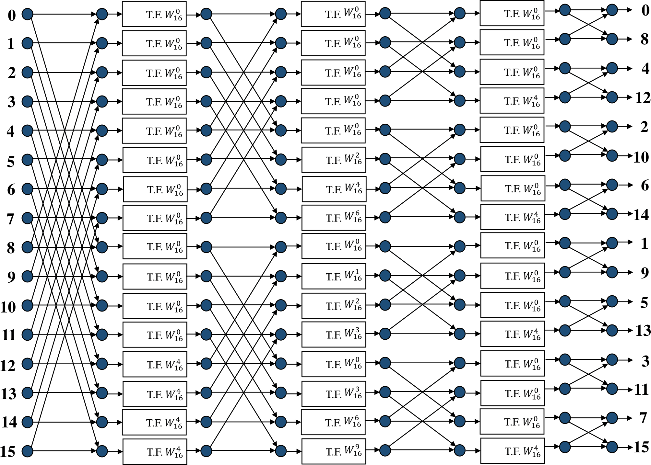

Fig. 1. Flow graph representation of 16-point radix-2² DIF FFT algorithm (TF=twiddle factor).

In Eq. (6), X and Y are the two radix-2 FFTs and Gðk₁; k₂; k₃Þ consisting of X and Y is also a radix-2 FFT with an extra complex multiplier. The °ow graph represen- tation of a 16-point radix-2² DIF FFT algorithm is shown in Fig. 1.

- Radix-8 CORDIC Algorithm
The main reason behind the use of radix-8 CORDIC is that the number of iterations is decreased if we use radix-8 CORDIC instead of radix-2 CORDIC. In order to compute the total number of rotations for the precision of m-bit, the radix-2 algo- rithm requires m iterations, whereas the number of iterations is decreased to m/3 if we use radix-8 CORDIC. The CORDIC algorithm is based on a two-dimensional xy-plane vector rotation which is shown in Fig. 2. As shown in Fig. 2, the two- dimensional vector B_{n}ðx_{n}; y_{n}Þ with angle 0 is rotated anticlockwise by an amount
of angle (3. The rotated vector B_{nþ1} has coordinates (x_{nþ1}; y_{nþ1}) and angle (0 þ (3).
The iterative equations of the radix-8 CORDIC algorithm are given as follows:
x_{nþ1} ¼ x_{n} - a_{n}r^{-n}y_{n}; ð7Þ
y_{nþ1} ¼ y_{n} þ a_{n}r^{-n}x_{n}; ð8Þ
z_{nþ1} ¼ z_{n} - tan⁻¹ða_{n}r^{-n}Þ; ð9Þ
where r denotes the radix of the CORDIC (for radix-8, r ¼ 8), a 2 Z, -4 S a S 4 denotes the rotational direction for each iteration, z₀ is the angle of rotation, x₀ and y₀ are the initial vector coordinates. Similarly, x_{nþ1} and y_{nþ1} are the vector

E±cient Hardware Architecture Design of Radix-2² FFT Using CORDIC
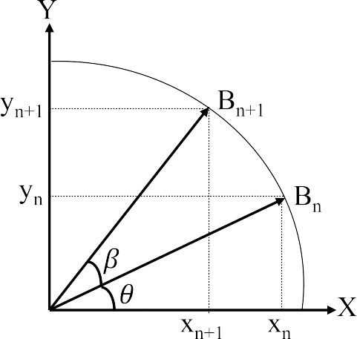

Fig. 2. Two-dimensional vector rotation of the CORDIC.

coordinates obtained by employing (n þ 1) micro-rotation and z_{nþ1} is the angle to be rotated. The ¯nal coordinates obtained should be multiplied by a scale factor K⁻¹ and can be given by

K⁻¹ ¼ ð1 þ a² 8^{-2n}Þ⁻1 ¼ ð1 þ a² 2^{-6n} ⁻1
ð10Þ

n ² n
Þ 2 :

In case of radix-8 CORDIC, the scale factor depends on the sequence a_{n} and therefore it is variable. The value of K varies from 1 to 4.41 in case of radix-8 CORDIC.
J CIRCUIT SYST COMP 2024.33. Downloaded from www.worldscientific.com
by UNIVERSIDADE DE SAO PAULO on 03/18/26. Re-use and distribution is strictly not permitted, except for Open Access articles.

- Proposed Radix-8 CORDIC Architecture
In this paper, a hardware architecture for a parallel CORDIC algorithm with high performance and low latency is presented in order to compute the multiplication of the complex twiddle factor. In the case of radix-2 CORDIC, the latency is high. In Antelo et al.,⁵ the authors have reduced the latency of radix-2 CORDIC with the help of redundant arithmetic (RA) and radix-4 number system. However, compared to radix-2 arithmetic, the delay required by the redundant radix-4 arithmetic (RR4A) is more in order to ¯nd out the direction of rotation iteratively. The reason is that in the case of radix-4 CORDIC, ¯ve rotation direction values are present and it takes more time to select among them. However, in the case of our proposed radix-8 CORDIC for the given input angle, we have precomputed all the directions of rotations in order to solve this problem.³⁸
As shown in Fig. 3, the a prediction block and x/y path are the two basic blocks of the proposed CORDIC rotator. For the given target angle 0, an values are pre- computed by the a prediction block. For every clock cycle, the a_{n} values are sent through the di®erent stages of the x/y path in a sequential manner.

K. Das, S. N. Pradhan & A. Bhattacharjee
J CIRCUIT SYST COMP 2024.33. Downloaded from www.worldscientific.com
by UNIVERSIDADE DE SAO PAULO on 03/18/26. Re-use and distribution is strictly not permitted, except for Open Access articles.
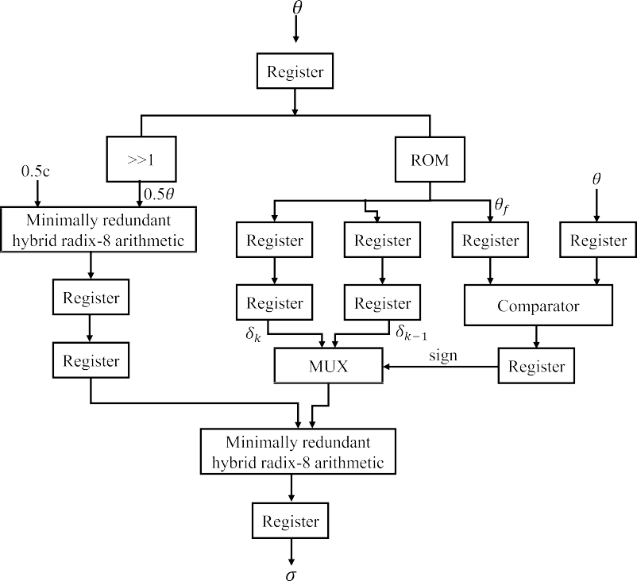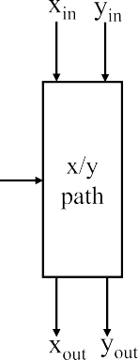

Fig. 3. Block diagram representation of the a prediction block with the x/y path.

  - Precomputation of the direction of rotation ð¾ precomputationÞ
The main reason for high latency in the case of the CORDIC-based design is that in these designs, the direction of rotations is calculated in an iterative manner. In our case, latency is reduced by using the a precomputation module. For any given input angle, the a precomputation module calculates the direction of rotation before the start of the rotation in the x/y data path. The values are calculated by using the following formula³⁸:
a ¼ b þ 0:5c þ "₀signð0Þþ 8; ð11Þ
where b ¼ 0:50, c ¼ 2 - P1 ð2^{-i} - tan⁻¹ð2^{-i}ÞÞ is a constant, 8 ¼ P n=3ð" a Þ
i¼0
i¼1
i
i
denotes the total amount of o®set and in the ith iteration, the partial o®set is denoted by "_{i} and is given by "_{i} ¼ ð2^{-i} - tan⁻¹ð2^{-i}ÞÞ. By using simple addition, a can be calculated from 0 and the same is realized by using minimally redundant
radix-8 arithmetic (RR8A),³⁹ which is shown in Fig. 3. The reason behind the use of RA is that the latency of the design can be reduced with the help of it. The °ow graph to compute the minimally RA is shown in Fig. 4.
The values of 8 for a given range and precision of the angle 0 are precomputed and are stored in a ROM. 0f is the reference angle and each location of the ROM is

E±cient Hardware Architecture Design of Radix-2² FFT Using CORDIC
J CIRCUIT SYST COMP 2024.33. Downloaded from www.worldscientific.com
by UNIVERSIDADE DE SAO PAULO on 03/18/26. Re-use and distribution is strictly not permitted, except for Open Access articles.
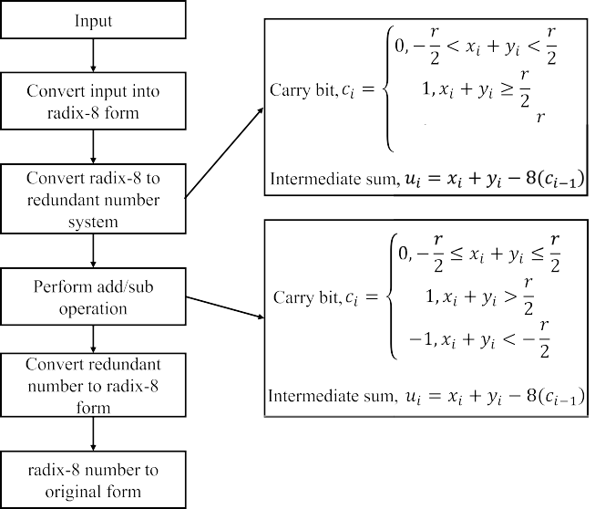

Fig. 4. Flow diagram to compute minimally RA.

comprised of a reference angle, the previous reference angle and two o®set values
ð8_{k}; 8_{k-1}Þ. A ROM with size 2^{dm=3e} 3m is considered in order to store the values of
8 for the input angle in the range of ð- ^{n} ; ^{n}Þ with a precision of m-bit.³⁸ The 0_{f}
2 2
represents the angle corresponding to each of the 8 and calculated from the sum-
mation of angles for the starting m/3 micro-rotations. In order to get a correct o®set value, 0_{f} value should be less than the target angle value. To choose between the two o®set values stored in the ROM, a 2:1 multiplexer is used which is dependent on the select signal S. The 0 values are compared with 0_{f} values with the help of the comparator and the select signal S is generated, where S ¼ 0, when 0 > 0ref for
selecting 8_{k} and S ¼ 1, when 0< 0_{ref} for selecting 8_{k-1}.
The 0:5c with 2's complement binary representation has been converted to a minimally redundant radix-8 (mRR8) format which is having a delay as that of an XOR gate.³⁹ It produces the redundant representation of 0:5c with a digit set f-4; -3; -2; -1; 0; 1; 2; 3; 4g. The radix-8 complement representation of E₀, 0:50 and 8_{ROM} is added with the mRR8 format of 0:5c by using three minimally redundant hybrid radix-8 adders in order to obtain a 2 f-4; -3; -2; -1; 0; 1; 2; 3; 4g. Each of which is having a delay of 2t_{FA}, t_{FA} is the delay of one full adder. The 0 is right shifted by one to obtain 0:50.

  - Scale factor
The scale factor is not a constant for radix-8 CORDIC. The ¯nal coordinate values of the rotated vector are scaled by a scale factor given by Eq. (10). Here, we have taken the ¯rst (m=8 þ 1) iterations in order to compute the K⁻¹ and after these iterations,

K. Das, S. N. Pradhan & A. Bhattacharjee
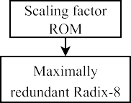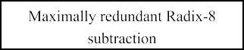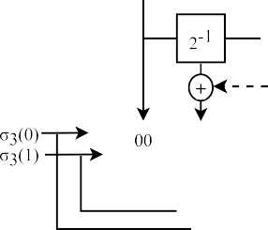

Fig. 5. Computation of scale factor for a precision of 16-bit.

the value of the scale factor tends towards unity. In this design, parallel to micro- rotations evaluation we can obtain the scale factor. For each iteration n, a² can take
n
any one value out of 0, 1, 4, 9 and 16. For m-bit precision, 5^{b}mcþ1 m possible numbers of scale factors need to be stored in a ROM. For n 2 b^{m} þ 1c, the ROM size
8
8
can be decreased by performing the approximation of the scale factor with the ¯rst two terms of its Taylor series expansion (TSE), when the value of m is m S 16 (the details about the TSE can be found in Antelo et al.⁵).
For n 2 b ^{m} þ 1c, the approximation of the scale factor can be done by the ¯rst three terms of its TSE, when m is m > 16.⁵ For precision of 16-bit, in order to store 5³ scale factors we need a 125 16 ROM. With the help of a circuit which is shown in Fig. 5, we can compute the scale factors for the next iteration. Thus parallel to the computation of the x/y coordinates we can compute the values for the scale factors. For the ¯rst two iterations, the values of the scale factor K₂⁻¹ can be obtained as
12

K ⁻¹ ¼ ð1 þ 8^{-2n}
2 -¹

_{n} a_{n} Þ
Y2
K2-1 ¼
K_{n}⁻¹: ð13Þ
n¼0
2 ; ð12Þ

By performing add and shift operations on the data present in the ROM, the scale factor for the next iteration K₃⁻¹ is calculated. This is achieved by taking the ¯rst
J CIRCUIT SYST COMP 2024.33. Downloaded from www.worldscientific.com
by UNIVERSIDADE DE SAO PAULO on 03/18/26. Re-use and distribution is strictly not permitted, except for Open Access articles.

E±cient Hardware Architecture Design of Radix-2² FFT Using CORDIC
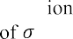

Fig. 6. The block diagram represents the x/y path of the proposed CORDIC design (for 16-bit).

two terms of their TSE as

K3-1 ¼ K2-1 1 -

1 -1
2-18a32
2

2

: ð14Þ

To get the proper coordinate values for x and y, the K⁻¹ values are multiplied with the x and y values. In our design, in the multiplier, we have reduced the number of nonzero digits in order to decrease the number of partial products. The scale factor is represented by using canonical signed digit because it is helpful for the reduction of nonzero digits.⁴⁰ In Fig. 6, we have shown the x/y data path of the proposed radix-8 CORDIC architecture.
J CIRCUIT SYST COMP 2024.33. Downloaded from www.worldscientific.com
by UNIVERSIDADE DE SAO PAULO on 03/18/26. Re-use and distribution is strictly not permitted, except for Open Access articles.

  - The x/y data path
For the precision of m-bit, the proposed architecture needs m/3 stages. Every stage of the x/y data path needs a 2:1 multiplexer, an AND gate and a maximally redundant radix-8 adder or subtractor in order to realize Eqs. (7) and (8), which is shown in Fig. 7. The rounding error and the angle approximation error (AAE) a®ect the computational accuracy of the x and y coordinates. The AAE is due to the representation of rotation angle in quantized form.
After every m iteration, truncation of intermediate outputs produces a rounding error of log₂m bits. For the implementation of the radix-8 CORDIC algorithm, some additional log₂m bits known as guard bits also need to be considered.⁴ Therefore, for

K. Das, S. N. Pradhan & A. Bhattacharjee
J CIRCUIT SYST COMP 2024.33. Downloaded from www.worldscientific.com
by UNIVERSIDADE DE SAO PAULO on 03/18/26. Re-use and distribution is strictly not permitted, except for Open Access articles.
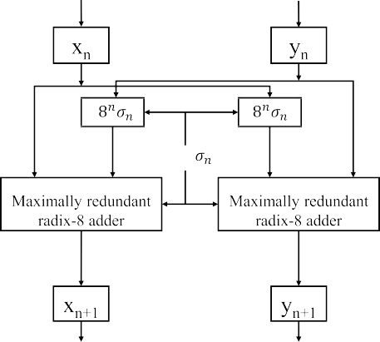

Fig. 7. The block diagram represents a microrotation in x/y path.

16-bit precision, we have taken a data bus of 20-bit wide in order to design the x/y data path. The scaled x and y coordinates are converted to a radix-2 binary repre- sentation and the converters are designed using multiplexer cells with tree-based approach. The redundant to binary converter is designed with the help of this approach having a delay of only 0:5ðdlog2meþ 3ÞtFA.

- The Architecture of the Proposed Radix-2² Feedforward FFT
In this proposed design, we have replaced the complex rotators with the help of radix-8 CORDIC. The proposed DIF FFT is designed using radix-2² feedforward architecture. The radix-2² feedforward architecture for the computation of 16-point and 64-point FFT is shown in Fig. 8. The R2 block, as shown in Fig. 8, denotes the radix-2 butter°y structure having complex inputs and outputs. The R2 COR1 block consists of radix-2 butter°ies utilizing a single radix-8 CORDIC unit, whereas the R2 COR2 block comprises radix-2 butter°ies with two radix-8 CORDIC units instead of complex rotators. The steps involved in order to com- pute the radix-8 CORDIC are explained in Sec. 4. The trivial rotations' (TR) block is responsible for the computation of all the TR. The TR can be obtained by only changing the sign of the data and/or by doing the interchange between imaginary and real parts.
The internal block diagram representation of the R2 COR1 and R2 COR2 is shown in Figs. 9(a) and 9(b), respectively. The size of the delay line is dependent on the total delay generated by the radix-8 CORDIC unit. The order of data at stages 1{4 of Fig. 8(a) is shown in Fig. 10. The proposed radix-2² FFT can process four samples per clock cycle. As shown in Fig. 10, the samples with indices f0, 8, 4 and 12g arrive at the di®erent terminals at the same clock cycle. Whereas the samples having the indices f0, 1, 2 and 3g arrive at the same terminal at the consecutive clock cycles.

E±cient Hardware Architecture Design of Radix-2² FFT Using CORDIC
J CIRCUIT SYST COMP 2024.33. Downloaded from www.worldscientific.com
by UNIVERSIDADE DE SAO PAULO on 03/18/26. Re-use and distribution is strictly not permitted, except for Open Access articles.
hoang
2026-04-04 09:10:54
--------------------------------------------
n3 = 0
hoang
2026-04-04 09:11:13
--------------------------------------------
n3 = 1
hoang
2026-04-04 09:11:31
--------------------------------------------
n3 = 2

(a)

(b)

Fig. 8. Feedforward FFT design using CORDIC (a) for 16-point and (b) for 64-point.

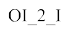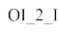

(a) (b)

Fig. 9. Block diagram of (a) R2COR1 and (b) R2COR2 block.
n3 = 0
n3 = 0
n3 = 1
n3 = 1
n3 = 2
n3 = 2

(a) (b)
n3 = 0
n3 = 0
n3 = 1
n3 = 1
n3 = 2
n3 = 2

(c) (d)

Fig. 10. Data °ow representation for each stage of Fig. 8(a): (a) stage 1 (b) stage 2 (c) stage 3 and
(d) stage 4.

K. Das, S. N. Pradhan & A. Bhattacharjee
J CIRCUIT SYST COMP 2024.33. Downloaded from www.worldscientific.com
by UNIVERSIDADE DE SAO PAULO on 03/18/26. Re-use and distribution is strictly not permitted, except for Open Access articles.
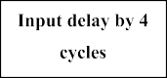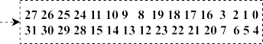

(a)
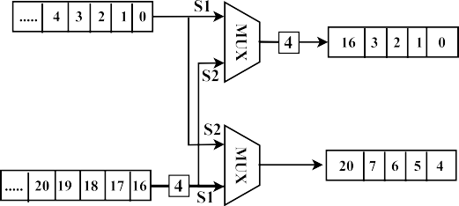

(b)

Fig. 11. The architecture of the input scheduler used in Fig. 8.

At the ¯rst phase (S1), the upper input enters the upper MUX and the input that is delayed enters the lower MUX, for the four cycles. The multiplexers switch to the second phase (S2) after the four cycles and in that phase, the lower MUX takes the data from the upper input and produces the output. In the same phase, the upper MUX only receives the data from the lower input. The lower output is separated by a distance of four from the data °owing out of the upper output delay line.
In Fig. 11(a), we have shown the example of a data °ow using the input scheduler architecture shown in Fig. 11(b). The architecture basically consists of multiplexers and bu®ers to perform the required operation. As shown in Fig. 11(b), two incoming data are separated by 16 in this example, whereas any two output data are separated by four. In order to delay the input by 4 clock cycles, an input delay line with four shift registers is used.

- Results and Discussion
The architecture of the proposed CORDIC-based radix-2² FFT is designed using Verilog-HDL and the Verilog code for the design is written in Xilinx Vivado design suite software. After the radix-2² FFT code is written using Verilog-HDL, the code is tested by giving some test input. The output of the Vivado simulator for 16-point

E±cient Hardware Architecture Design of Radix-2² FFT Using CORDIC
J CIRCUIT SYST COMP 2024.33. Downloaded from www.worldscientific.com
by UNIVERSIDADE DE SAO PAULO on 03/18/26. Re-use and distribution is strictly not permitted, except for Open Access articles.
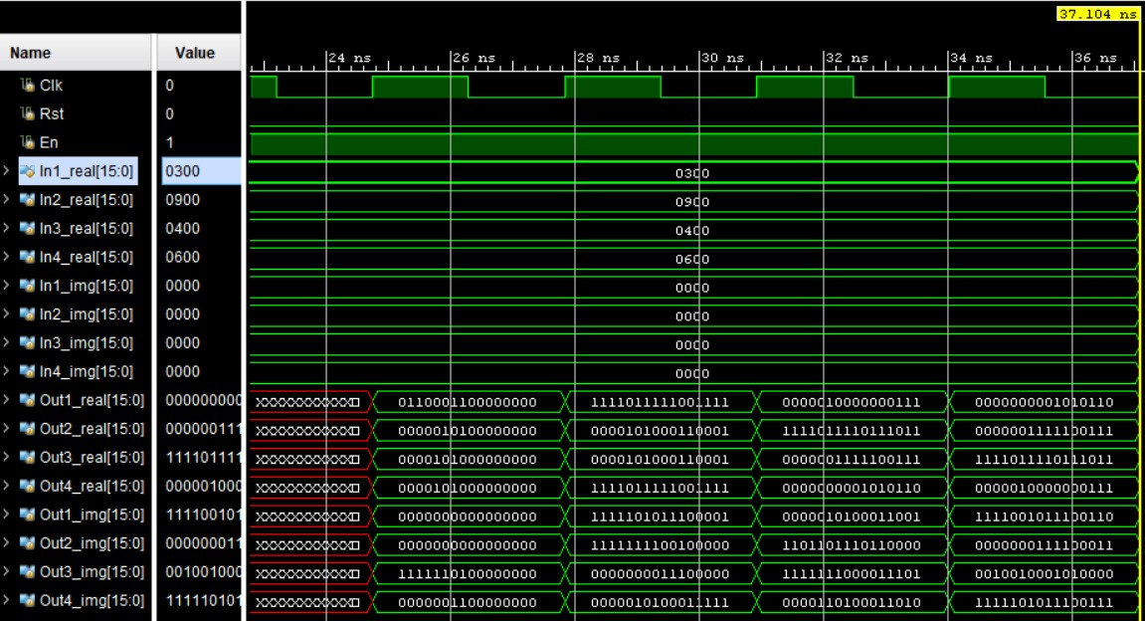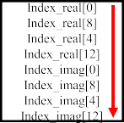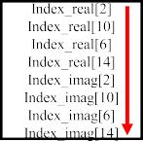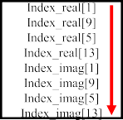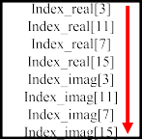

Fig. 12. The output of the Vivado simulator for 16-point FFT.

FFT is shown in Fig. 12. After that, the FFT code is synthesized and implemented by targeting a Virtex-7 FPGA (VC707 Evaluation Platform xc7vx485t®g1761-2). When the FPGA-based results for the radix-2² FFT using CORDIC are obtained as desired. The code is taken into the Cadence Genus tool and synthesis operation is done to obtain a gate level netlist ¯le.
During the synthesis process, SCL 180 nm cell library is used. The synthesized constraint ¯le and the synthesized module ¯les for the computation of the FFT are taken into the Cadence Innovus tool and all the types of placement and routing (PnR) operations are done. To check the accuracy of the proposed FFT design, the FFT is also calculated for the same inputs by using the MATLAB inbuilt function \®t". The outputs of the proposed design and the MATLAB are shown in Table 2.
For the proposed 1024-point FFT, a complex signal y(t) is taken as an input, which is given by yðtÞ¼ 0:8 sinðf₁ pi tÞþ i 0:5 sinðf₂ pi tÞ. The plot of the signal y(t) is shown in Fig. 13. In our experiment, we have taken the values of f₁ ¼ 100 Hz and the values of f₂ ¼ 200 Hz. The input signal y(t) is generated and sampled. The samples are converted into hexadecimal format and saved in a .dat ¯le, and linked to the Verilog code of our proposed radix-2² FFT design.
Figure 14 shows the FFT spectrum of the signal y(t) obtained by using the MATLAB function (using the inbuilt function \®t") and using our proposed design. In the case of our proposed design, ¯xed-point arithmetic (eight integer bits and eight

K. Das, S. N. Pradhan & A. Bhattacharjee
J CIRCUIT SYST COMP 2024.33. Downloaded from www.worldscientific.com
by UNIVERSIDADE DE SAO PAULO on 03/18/26. Re-use and distribution is strictly not permitted, except for Open Access articles.

Table 2. Output comparison of the proposed design with MATLAB for 16-point FFT.

Index | Input | MATLAB output | Post-implemented HDL output
0 | 8 | 99:0000 þ 0:0000i | 99:0000 þ 0:0000i
1 | 5 | 4:0288 þ 5:1014i | 4:0273 þ 5:0977i
2 | 0 | -8:1924 - 5:1213i | -8:1914 - 5:1211i
3 | 14 | 0:3392 - 13:1018i | 0:3359 - 13:1016i
4 | 5 | 10:0000 - 3:0000i | 10:0000 - 3:0000i
5 | 12 | 3:9034 - 1:8886i | 3:9023 - 1:8867i
6 | 3 | 10:1924 þ 0:8787i | 10:1914 þ 0:875i
7 | 4 | -8:2715 þ 36:3146i | -8:2695 þ 36:3125i
8 | 8 | 5:0000 þ 0:0000i | 5:0000 þ 0:0000i
9 | 2 | -8:2715 - 36:3146i | -8:2695 - 36:3125i
10 | 9 | 10:1924 - 0:8787i | 10:1914 - 0:875i
11 | 1 | 3:9034 þ 1:8886i | 3:9023 þ 1:8867i
12 | 10 | 10:0000 þ 3:0000i | 10:0000 þ 3:0000i
13 | 3 | 0:3392 þ 13:1018i | 0:3359 þ 13:1016i
14 | 9 | -8:1924 þ 5:1213i | -8:1914 þ 5:1211i
15 | 6 | 4:0288 - 5:1014i | 4:0273 - 5:0977i

fractional bits) is used, due to which some truncation and rounding errors are observed in our case.
The output of the Verilog code of the radix-2² FFT is saved in a .dat ¯le, signal-to- noise ratio (SNR) and peak SNR (PSNR) values are calculated for the HDL code output and MATLAB function output. The SNR is de¯ned as the ratio of input signal power to the power of the background noise. The PSNR is de¯ned as the ratio

Fig. 13. The plot of the real and imaginary part of the signal y(t).

E±cient Hardware Architecture Design of Radix-2² FFT Using CORDIC
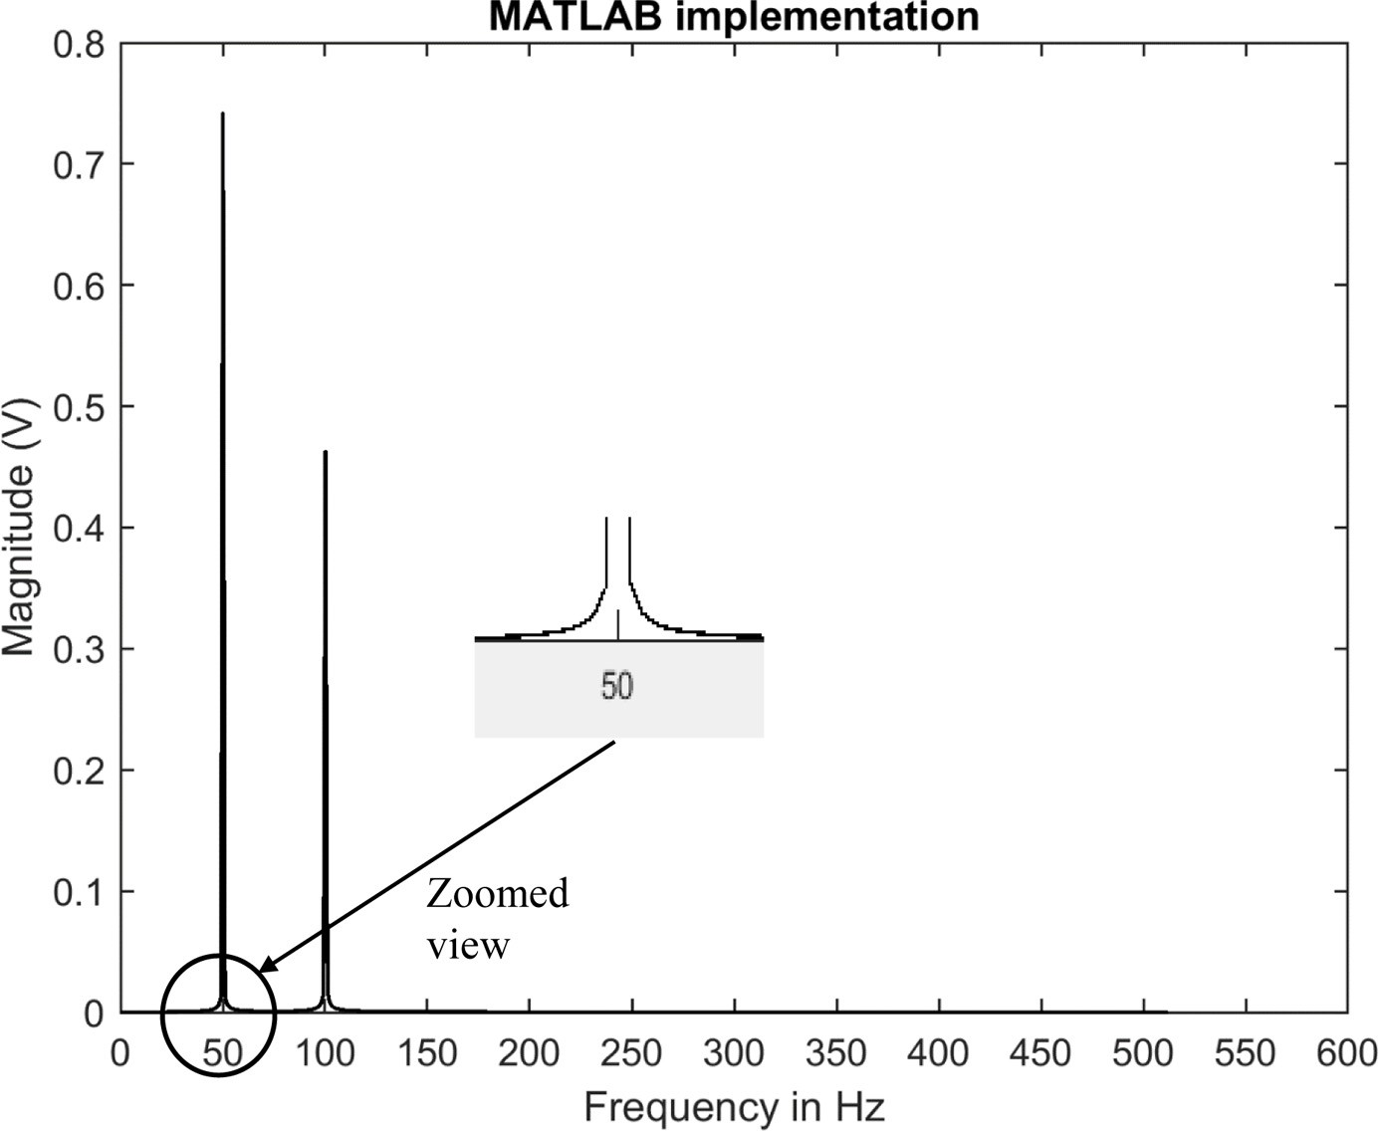
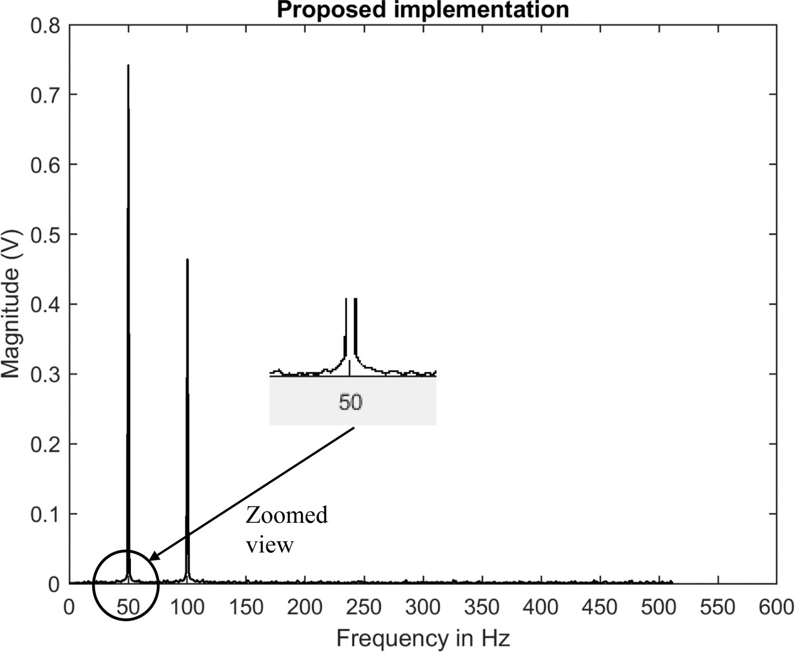

(a) (b)

Fig. 14. FFT spectrum (a) MATLAB implementation and (b) of the proposed HDL-based design.

of an input signal's greatest power to the mean sum of all squared di®erences. The PSNR is given by the following formula:

PSNR ¼ 10 log
0
BB@ 1
N

N

i¼1
P

2
max
X

ðX_{i} - Y_{i}Þ
1
2 CCA

; ð15Þ

where X_{i} and Y_{i} are the outputs of the proposed design and the output of the MATLAB implementation, respectively. X_{max} is the maximum value (amplitude) of the given input. In Table 3, we have shown the comparison of our proposed HDL implementation with the MATLAB implementation by considering two parameters such as SNR and PSNR. As it can be seen from Table 3, due to the reason of quantization and truncation error for 1024 point FFT, we have a loss of 3.37 dB and there is a loss 2.08 dB for 2048 point FFT. The PSNR values are also shown in Table 3.
J CIRCUIT SYST COMP 2024.33. Downloaded from www.worldscientific.com
by UNIVERSIDADE DE SAO PAULO on 03/18/26. Re-use and distribution is strictly not permitted, except for Open Access articles.
As shown in Table 4, the proposed radix-8 CORDIC design is compared with some existing designs in terms of FPGA resources utilized and maximum clock frequency. As compared to the Xilinx CORDIC IP,⁴¹ Aggarwal et al.,⁸ Tang and Xu¹² and Mohamed et al.¹³ in our case, we have an advantage of higher clock frequency. Also, the proposed design consumes 17.17% fewer FPGA resources than Xilinx CORDIC IP. As compared to the design proposed in Mohamed et al.,¹³ there

Table 3. SNR values of our proposed HDL implementation and MATLAB implementation.

Point of FFT | Proposed SNR (dB) | MATLAB SNR (dB) | PSNR (dB)
1024 | 55.27 | 58.64 | 66.14
2048 | 58.95 | 61.03 | 70.32

K. Das, S. N. Pradhan & A. Bhattacharjee
J CIRCUIT SYST COMP 2024.33. Downloaded from www.worldscientific.com
by UNIVERSIDADE DE SAO PAULO on 03/18/26. Re-use and distribution is strictly not permitted, except for Open Access articles.

Table 4. The comparison of the proposed radix-8 CORDIC design with some existing CORDIC-based designs.

References | FPGA used | Data width | Slice LUTs | Slice registers | Clock frequency
Xilinx CORDIC IP V.6³⁶ | Virtex-7 | 16-bit | 1201 | 1146 | 200 MHz
Aggarwal et al.⁸ | Virtex-5 | 16-bit | 1301 | 205 | 202.065 MHz
Tang et al.¹² | Kintex UltraScale | 16-bit | 300+5 DSPs | 98 | 250 MHz
Mohamed et al.¹³ | Artix-7 | 16-bit | 2202 | 645 | 276.6 MHz
Proposed | Virtex-7 | 16-bit | 1185 | 759 | 363 MHz
Proposed | Virtex-7 | 20-bit | 1512 | 1093 | 354 MHz
Proposed | Virtex-7 | 24-bit | 1986 | 1458 | 338 MHz

is a saving of 31.71% FPGA resources in our case. The number of slice LUTs and the number of slices registered and consumed by the design proposed in Tang and Xu¹² is less. However, the design needs ¯ve DSPs for its FPGA implementation.¹² The area occupied by the DSPs and BRAMs in the case of the Xilinx Virtex-7 FPGA family is high. Each DSP block of the Virtex-7 FPGA family has an accumulator and a 25 18 multiplier and consumes an area approximately equivalent to 500 slices.⁴² Similarly, the block RAM occupies an area almost equal to 1,700 slices.⁴³
Table 5 shows a detailed comparison of the proposed design with some other existing designs. Our proposed design is compared with the other designs in three di®erent data points, which are 16 points, 1024 points and 2048 points, respectively. There are many designs available in the literature that will use the dedicated block RAM and DSP of the FPGA. For the purpose of comparison, we have converted the blocks into equivalent slices. Here, the area utilization of the di®erent designs is compared in terms of the number of slices. In the case of Nguyen et al.¹⁹ and Inguva

Table 5. Comparison of our FPGA-based FFT design with other designs.

No. of points | References | Data width | No. of LUTs | Block RAM | No. of DSPs | Total LUTs | Samples/ cycle | Execution time (µS) | Clock frequency
16 | Kumar et al.²⁷ | 16-bit | 909 | 0 | 12 | 6,909 | 2 | 0.09 | 100 MHz
16 | Bowlyn et al.²¹ | 28-bit | 38,072 | 0 | 0 | 38,072 | 16 | --- | 75 MHz
16 | Proposed | 16-bit | 3,209 | 0 | 0 | 3,209 | 4 | 0.04 | 323.4 MHz
1024 | Ingemars. et al.²⁵ | 16-bit | 1,781 | 6 | 16 | 19,981 | 1 | 2.08 | 505 MHz
1024 | Gamdo et al.¹⁸ | 16-bit | 1,425 | 0 | 48 | 25,425 | 4 | 1.06 | 270 MHz
1024 | Nguyen et al.¹⁹ | 16-bit | 15,452 | 0 | 0 | 15,452 | 2 | 2.60 | 200 MHz
1024 | Wang et al.³¹ | 16-bit | 8,678 | 10 | 45 | 39,678 | 4 | 1.75 | 305 MHz
1024 | Kumar et al.²⁷ | 16-bit | 5282 | 0 | 62 | 36,282 | 2 | 6.39 | 100 MHz
1024 | Proposed | 16-bit | 12,712 | 0 | 0 | 12,712 | 4 | 1.74 | 323.4 MHz
2048 | Nguyen et al.¹⁹ | 16-bit | 19,414 | 0 | 0 | 19,414 | 2 | 5.17 | 200 MHz
2048 | Wang et al.³¹ | 16-bit | 9,223 | 19 | 50 | 50,373 | 4 | 3.53 | 305 MHz
2048 | Ayinala et al.²⁹ | 16-bit | 9,893 | 23 | 54 | 56,443 | 4 | 4.65 | 312 MHz
2048 | Inguva et al.²⁸ | 12-bit | 19,242 | 0 | 0 | 19,242 | 2 | 5.5 | 200 MHz
2048 | Proposed | 16-bit | 17,801 | 0 | 0 | 17,801 | 4 | 4.06 | 323.4 MHz

E±cient Hardware Architecture Design of Radix-2² FFT Using CORDIC
J CIRCUIT SYST COMP 2024.33. Downloaded from www.worldscientific.com
by UNIVERSIDADE DE SAO PAULO on 03/18/26. Re-use and distribution is strictly not permitted, except for Open Access articles.

Fig. 15. Bar graph showing the hardware resources utilized for calculating 1024 and 2048 point FFT.

and Seventiline²⁸ the authors have used CORDIC to compute the butter°y struc- ture. In Ayinala et al.,²⁹ Wang et al.,³¹ Kumar et al.²⁷ and Garrido et al.,¹⁸ the authors have used complex multipliers for the butter°y unit. However, in our case, we have used radix-8 CORDIC for the construction of butter°y unit.
For storing the twiddle angles in our case, we have used slice registers and memory LUTs. To compute the rotations, the proposed design took m/3 iterations for the m-bit precision. Whereas to compute the same task, the radix-2 CORDIC needs m iterations. This is one of the main reasons why the proposed design has less hardware utilization as compared to other proposed designs. For the 1024 points FFT, the execution time in Garrido et al.¹⁸ is less. However, the disadvantage of the design is the high area utilization. The FPGA resources utilized can be better ana- lyzed from the bar graph shown in Fig. 15. Also, our design achieved a higher throughput of 1293.6 Mega samples per second (MSps).
The layout of the FFT is shown in Fig. 16. Two di®erent Cadence tools are used for making the layout. By using the Cadence Genus tool, the code is synthesized and the cell library used is SCL 180 nm. After getting the synthesized netlist from the Genus tool, the netlist is imported to the Cadence Innovus tool to complete the PnR steps. In this work, the Mentor Calibre tool is used for the DRC, LVS and also for Antenna rule check.
Table 6 presents the speci¯cations of the FFT ASICs designed with SCL 180 nm cell library. As shown in Table 6, the proposed FFT design is compared with the other two designs by considering the parameters core area, power dissipation, data width, clock rate, normalized energy, normalized area and execution time. The proposed design has the least normalized energy and area per FFT as compared to

K. Das, S. N. Pradhan & A. Bhattacharjee
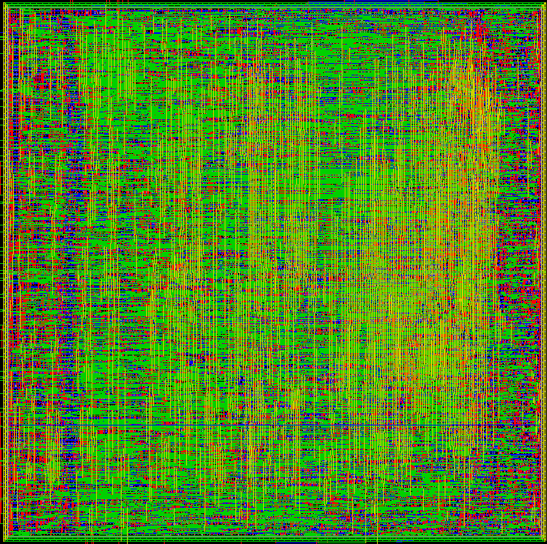

Fig. 16. Layout of the 1024 point radix-2² FFT.

the other mentioned FFT designs (normalized values are calculated using Eqs. (16) and (17), these equations are found in Ref. 26). As compared to the other FFT ASIC, our FFT ASIC can be operated at a higher clock frequency and has very less exe- cution time. For the 2048 points FFT, the proposed design is 30.59 times faster as compared to the design proposed in Kang et al.²²
Power clock cycles for execution

Norm: Energy=FFT ¼
Clock frequency N (Technology) ( V )2
; ð16Þ

Norm: Area=FFT ¼
Core area
180 nm
1:8

: ð17Þ

N (Technology)2 2 WL þ 1 (WL)2
J CIRCUIT SYST COMP 2024.33. Downloaded from www.worldscientific.com
by UNIVERSIDADE DE SAO PAULO on 03/18/26. Re-use and distribution is strictly not permitted, except for Open Access articles.
180 nm
3
24
3
24
The proposed ASIC implementation of the FFT is also compared with the state- of-the-art FFT ASIC designs by considering the same technology library. As com- pared to the method presented in Ref. 22, the proposed FFT ASIC has a little more

Table 6. Comparison of our ASIC-based FFT design with other designs.
References | 22 | 26 | Proposed | Proposed | Proposed | Proposed
Points (N ) | 2048 | 2048{16384 | 1024 | 2048 | 2048 | 2048
Cell library | 110 nm | 40 nm | 180 nm | 180 nm | 110 nm | 40 nm
Area of core | 0.42 mm² | 2.358 mm² | 1.079 mm² | 1.544 mm² | 0.65 mm² | 0.32 mm²
Power dissipation | 3.64 mW | 38.76 mW | 81.32 mW | 108.63 mW | 57.00 mW | 25.92 mW
Voltage | 1.2 V | 1.1 V | 1.8 V | 1.8 V | 1.2 V | 1.1 V
Clock frequency | 50 MHz | 150 MHz | 285.7 MHz | 285.7 MHz | 298.33 MHz | 315.05 MHz
Execution time | 139.5 µS | 27.81 µS | 1.95 µS | 4.56 µS | 4.37 µS | 4.14 µS
Norm. Energy/FFT | 0.92 nJ | 8.02 nJ | 0.17 nJ | 0.25 nJ | --- | ---
Norm. Area/ | 1.34 mm² | 4.94 mm² | 1.05 mm² | 0.75 mm² | --- | ---

FFT( 10⁻³ mm²Þ

E±cient Hardware Architecture Design of Radix-2² FFT Using CORDIC
J CIRCUIT SYST COMP 2024.33. Downloaded from www.worldscientific.com
by UNIVERSIDADE DE SAO PAULO on 03/18/26. Re-use and distribution is strictly not permitted, except for Open Access articles.

core area and power dissipation. However, the design presented in Ref. 22 has a very high-execution time and less clock frequency than our design. The proposed design is
31.92 times faster than the design presented in Ref. 22. The execution time is the most crucial parameter in any real-time signal processing. The proposed design has the least execution time as compared to the other mentioned designs. The proposed design outperforms the design presented in Ref. 26 in all respects. As compared to Ref. 26, the proposed design has less core area and power dissipation. Also, the proposed design has much less execution time and high-clock frequency compared to the design presented in Ref. 26.
The hardware architecture design of FFT using FPGA and ASIC technology is pivotal in various industry sectors due to their distinct advantages. FPGAs o®er
°exibility and rapid prototyping, making them ideal for applications in wireless communication (such as orthogonal frequency-division multiplexing in 5G base stations), real-time audio and video processing, and medical imaging systems like MRI and CT scanners. On the other hand, ASICs provide high performance, which is crucial for high-volume production applications such as telecommunication satellites, high-performance computing (HPC) for scienti¯c simulations, consumer electronics like DSP chips in smartphones and autonomous vehicles.

- Conclusion
In this paper, we have presented hardware architecture design for the CORDIC- based radix-2² FFT. The proposed design's performance is evaluated in terms of computational speed, throughput, word length, hardware resource utilization, power dissipation and clock frequency. Our approach involved utilizing radix-8 CORDIC for constructing the butter°y units and replacing complex adders and multipliers. In this work, we have reduced the execution time and area of the design by lowering the number of rotational iterations and by precomputing the rotational directions in the CORDIC unit. The implemented radix-2² FFT has a simple architecture as that of a radix-2 FFT and can process four samples per clock cycle. When compared with the existing designs, the proposed design takes much less time to execute and uses fewer hardware resources. The design based on FPGA operates at a clock frequency of
323.4 MHz. The application speci¯c integrated circuit has a small core area and can operate at a higher clock frequency. Due to the regularity of the proposed FFT architectures, the proposed design is well-suited for computing large-point FFT. In the future, by introducing the concept to higher radix FFT, execution time can be reduced further. In addition, better performance with minimal area consumption can be achieved by introducing pipelining in the higher radix FFT.

Acknowledgments
This work was ¯nancially supported by the SMDP-C2SD project sponsored by Meity, Government of India.

K. Das, S. N. Pradhan & A. Bhattacharjee
J CIRCUIT SYST COMP 2024.33. Downloaded from www.worldscientific.com
by UNIVERSIDADE DE SAO PAULO on 03/18/26. Re-use and distribution is strictly not permitted, except for Open Access articles.

ORCID
Kaushik Das  https://orcid.org/0000-0002-3467-1182
Sambhu Nath Pradhan  https://orcid.org/0000-0002-5461-6535 Abhishek Bhattacharjee  https://orcid.org/0000-0002-9664-1050

References
- K. R. Rao, D. N. Kim and J. J. Hwang, Fast Fourier Transform: Algorithms and Applications (New York, NY, 2010). doi:10.1007/978-1-4020-6629-0.
- A. Cortes, I. Velez and J. F. Sevillano, Radix r^{k} FFTs: Matricial representation and SDC/ SDF pipeline implementation, IEEE Trans. Signal Process. 57 (2009) 2824{2839. doi:10.1109/TSP.2009.2016276.
- P. K. Meher, J. Valls, T. B. Juang, K. Sridharan and K. Maharatna, 50 years of CORDIC: Algorithms, architectures, and applications, IEEE Trans. Circuits Syst. I: Regul. Pap. 56 (2009) 1893{1907. doi:10.1109/TCSI.2009.2025803.
- Y. Parmar and K. Sridharan, Precomputation-based radix-4 CORDIC for approximate rotations and Hough transform, IET Circuits, Devices Syst. 12 (2018) 413{423. doi:10.1049/iet-cds.2017.0492.
- E. Antelo, J. Villalba, J. Bruguera and E. Zapata, High performance rotation archi- tectures based on the radix-4 CORDIC algorithm, IEEE Trans. Comput. 46 (1997) 855{870. doi:10.1109/12.609275.
- B. Lakshmi and A. S. Dhar, VLSI architecture for parallel radix-4 CORDIC, Micro- process. Microsyst. 37 (2013) 79{86. doi:10.1016/j.micpro.2012.12.001.
- P. Choudhary and A. Karmakar, CORDIC based implementation of fast fourier trans- form, 2nd Int. Conf. Computer and Communication Technology, Allahabad, India, 2011,
pp. 550{555, doi:10.1109/ICCCT.2011.6075128.
- S. Aggarwal, P. K. Meher and K. Khare, Concept, design, and implementation of recon¯gurable CORDIC, IEEE Trans. Very Large Scale Integr. (VLSI) Syst. 24 (2016) 1588{1592. doi:10.1109/TVLSI.2015.2445855.
- R. Shukla and K. C. Ray, Low latency hybrid CORDIC algorithm, IEEE Trans. Comput.
63 (2014) 3066{3078. doi:10.1109/TC.2013.173.
- A. Changela, M. Zaver and A. Lakhlani, ASIC implementation of high performance radix-8 CORDIC algorithm, Int. Conf. Advances in Computing, Communications and Informatics (IEEE, 2018), pp. 699{705. doi:10.1109/ICACCI.2018.8554883.
- S. F. Obermann and M. J. Flynn, Division algorithms and implementations, IEEE Trans.
Comput. 46 (1997) 833{854. doi:10.1109/12.609274.
- W. Tang and F. Xu, A noniterative radix-8 CORDIC algorithm with low latency and high e±ciency, Electronics 9 (2020) 1521. doi:10.3390/electronics9091521.
- S. M. Mohamed, W. S. Sayed, A. G. Radwan and L. A. Said, FPGA implementation of recon¯gurable CORDIC algorithm and a memristive chaotic system with transcendental nonlinearities, IEEE Trans. Circuits Syst. I: Regul. Pap. 69 (2022) 2885{2892. doi:10.1109/TCSI.2022.3165469.
- C. Liu, Aygn, K. and Ylmaz, A., A parallel FFT-accelerated layered-medium integral- equation solver for electronic packages, Int. J. Numer. Model.: Electron. Netw. Devices Fields 33 (2019) 1{17. doi:10.1002/jnm.2684.
- M. A. El-Motaz, O. A. Nasr and K. Osama, A CORDIC-friendly FFT architecture,
Int. Wireless Communications and Mobile Computing Conf., Nicosia, Cyprus, 2014,
pp. 1087{1092. doi:10.1109/IWCMC.2014.6906506.

E±cient Hardware Architecture Design of Radix-2² FFT Using CORDIC
J CIRCUIT SYST COMP 2024.33. Downloaded from www.worldscientific.com
by UNIVERSIDADE DE SAO PAULO on 03/18/26. Re-use and distribution is strictly not permitted, except for Open Access articles.

- K. Das and S. N. Pradhan, Hardware architecture design for complementary ensemble empirical mode decomposition algorithm, Integration 91 (2023) 153{164. doi:10.1016/j. vlsi.2023.03.011.
- Z. Abo-Hammour, O. Abu Arqub, S. Momani and N. Shawagfeh, Optimization solution of Troesch's and Bratu's problems of ordinary type using novel continuous genetic algorithm, Discret. Dyn. Nat. Soc. 2014 (2014) 1{15. doi:10.1155/2014/401696.
- M. Garrido, J. Grajal, M. A. Sanchez and O. Gustafsson, Pipelined radix-2^{k} feedforward FFT architectures, IEEE Trans. Very Large Scale Integr. (VLSI) Syst. 21 (2013) 23{32. doi:10.1109/TVLSI.2011.2178275.
- N. H. Nguyen, S. A. Khan, C. H. Kim and J. M. Kim, A high-performance, resource- e±cient, recon¯gurable parallel-pipelined FFT processor for FPGA platforms, Micro- process. Microsyst. 60 (2018) 96{106. doi:10.1016/j.micpro.2018.04.003.
- S. N. Tang, J. W. Tsai and T. Y. Chang, A 2.4-GS/s FFT processor for OFDM-based WPAN applications, IEEE Trans. Circuits Syst. I: Regul. Pap. 57 (2010) 451{455. doi:10.1109/TCSII.2010.2048373.
- K. Bowlyn and S. Hounsinou, An improved distributed multiplier-less approach for radix-
2 FFT, IEEE Lett. Comput. Soc. 3 (2020) 54{57. doi:10.1109/LOCS.2020.3014354.
- G. Kang, W. Choi and J. Park, Embedded DRAM-based memory customization for low- cost FFT processor design, IEEE Trans. Very Large Scale Integr. (VLSI) Syst. 25 (2017) 3484{3494. doi:10.1109/TVLSI.2017.2752265.
- X. Shih, H. Chou and Y. Liu, VLSI design and implementation of recon¯gurable 46-mode combined-radix-based FFT hardware architecture for 3GPP-LTE applications, IEEE Trans. Circuits Syst. I: Regul. Pap. 65 (2018) 118{129. doi:10.1109/TCSI.2017.2725338.
- S. M. Noor, E. John and M. Panday, Design and implementation of an ultralow-energy FFT ASIC for processing ECG in cardiac pacemakers, IEEE Trans. Very Large Scale Integr. (VLSI) Syst. 27 (2019) 983{987. doi:10.1109/TVLSI.2018.2883642.
- C. Ingemarsson and O. Gustafsson, SFF --- The single-stream FPGA-optimized feed- forward FFT hardware architecture, J. Signal Process. Syst. 90 (2018) 1583{1592.
doi:10.1007/s11265-018-1370-y.
- J. Wang, S. Li and X. Li, Scheduling of data access for the Radix-2k FFT processor using single-port memory, IEEE Trans. Very Large Scale Integr. (VLSI) Syst. 28 (2020) 1676{1689. doi:10.1109/TVLSI.2020.2992021.
- G. P. Kumar, B. T. Krishna and K. Pushpa, Optimized pipelined fast fourier transform using split and merge parallel processing units for OFDM, Wirel. Pers. Commun. 117 (2021) 3067{3089. doi:10.1007/s11277-020-07471-3.
- S. C. Inguva and J. B. Seventiline, Implementation of FPGA design of FFT architecture based on CORDIC algorithm, Int. J. Electron. 108 (2021) 1914{1939. doi:10.1080/ 00207217.2020.1870750.
- M. Ayinala, M. Brown and K. K. Parhi, Pipelined parallel FFT architectures via folding transformation, IEEE Trans. Very Large Scale Integr. (VLSI) Syst. 20 (2012) 1068{1081. doi:10.1109/TVLSI.2011.2147338.
- Z. Wang, X. Liu, B. He and F. Yu, A combined SDC-SDF architecture for normal i/o pipelined radix-2 FFT, IEEE Trans. Very Large Scale Integr. (VLSI) Syst. 23 (2015) 973{977. doi:10.1109/TVLSI.2014.2319335.
- J. Wang, C. Xiong, K. Zhang and J. Wei, A mixed-decimation MDF architecture for radix-2k parallel FFT, IEEE Trans. Very Large Scale Integr. (VLSI) Syst. 24 (2016) 67{78. doi:10.1109/TVLSI.2015.2402207.
- Y. Guo, Z. Wang, Q. Hong, H. Luo, X. Qiu and L. Liang, A 60-mode high-throughput parallel-processing FFT processor for 5G/4G applications, IEEE Trans. Very Large Scale Integr. (VLSI) Syst. 31 (2023) 219{232. doi:10.1109/TVLSI.2022.3227346.

K. Das, S. N. Pradhan & A. Bhattacharjee
J CIRCUIT SYST COMP 2024.33. Downloaded from www.worldscientific.com
by UNIVERSIDADE DE SAO PAULO on 03/18/26. Re-use and distribution is strictly not permitted, except for Open Access articles.

- J. Hazarika, S. R. Ahamed and H. B. Nemade, Low-complexity, energy-e±cient fully parallel split-radix FFT architecture, Electron. Lett. 58 (2022) 678{680. doi:10.1109/ ISCAS.2003.1205774.
- A. X. G. X. Chelliah, A normal I/O order optimized dual-mode pipelined FFT archi- tecture for processing real-valued signals and complex-valued signals, AEU-Int. J. Elec- tron. Commun. 170 (2023) 154782. doi:10.1016/j.aeue.2023.154782.
- H. Fang, Z. Ma, F. Yu, B. Zhao and B. Zhang, Optimised serial commutator FFT architecture in terms of multiplexers, IEEE Trans. Circuits Syst. II: Express Br. 71(1) (2024) 445{449. doi:10.1109/TCSII.2023.3304696.
- K. Das, E. H. Reddy, A. Mandal, S. N. Pradhan and A. Bhattacharjee, Area-time-energy e±cient architecture of CBNS-based fast fourier transform, Int. J. Circuit Theory Appl. (2024). doi:10.1002/cta.4075.
- S. He and M. Torkelson, A new approach to pipeline FFT processor, Proc. Int. Conf. Parallel Processing, Honolulu, HI, USA, 1996, pp. 766{770. doi:10.5555/645606.661012.
- M. Kuhlmann and K. K. Parhi, P-CORDIC: A precomputation based rotation CORDIC algorithm, Appl. Signal Process. 2002 (2002) 936{943. doi:10.1155/S1110865702205028.
- K. K. Parhi, VLSI Digital Signal Processing Systems (John Wiley and Sons, 1999).
- G. A. Ruiz and M. Granda, E±cient canonic signed digit recoding, Microelectron. J. 42
(2011) 1090{1097. doi:10.1016/j.mejo.2011.06.006.
- Xilinx Inc., LogiCORE IP CORDIC v6.0, product speci¯cations IPPG105 (2017).
- Xilinx Inc., User guide for 7 series DSP48E1 slice (2014). Available at: http://www.xilinx. com/support/documentation/user guides/ug479 7Series DSP48E1.pdf.
- Xilinx Inc., User guide for 7 series FPGAs memory resources (2014). Available at: http:// www.xilinx.com/support/documentation/user guides/ug473 7Series Memory Resour- ces.pdf.

