A website where people can post articles and customers can benefit from the content of the website.

In this project I tried to make the UI very simple and clear.

The website is based on grid system that consist of 5 main pages: **home, about ,contact, login for admins who want to post article and lastly a post page where admins can post new article.**

**The home page:**

It consists of **four** grid columns **one** for header and navbar, **the second** for content which include articles in cards that are easy to read, and some actions that can be performed within the cards contents, **the third** column is for the side bar, it has a list of titles of the articles which navigate the user to a specific area in the content section and it has some free space for advertisement. **Last column** is a footer section that include the social media accounts for the website .

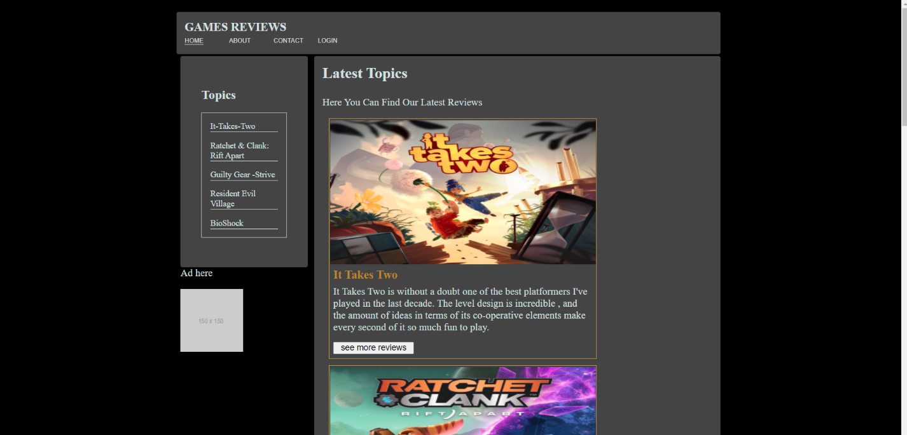



**About page:**

A simple page that have the same theme as the home page that contain a brief history about the website and how its started and evolved overtime it also include a navbar to navigate you to other page

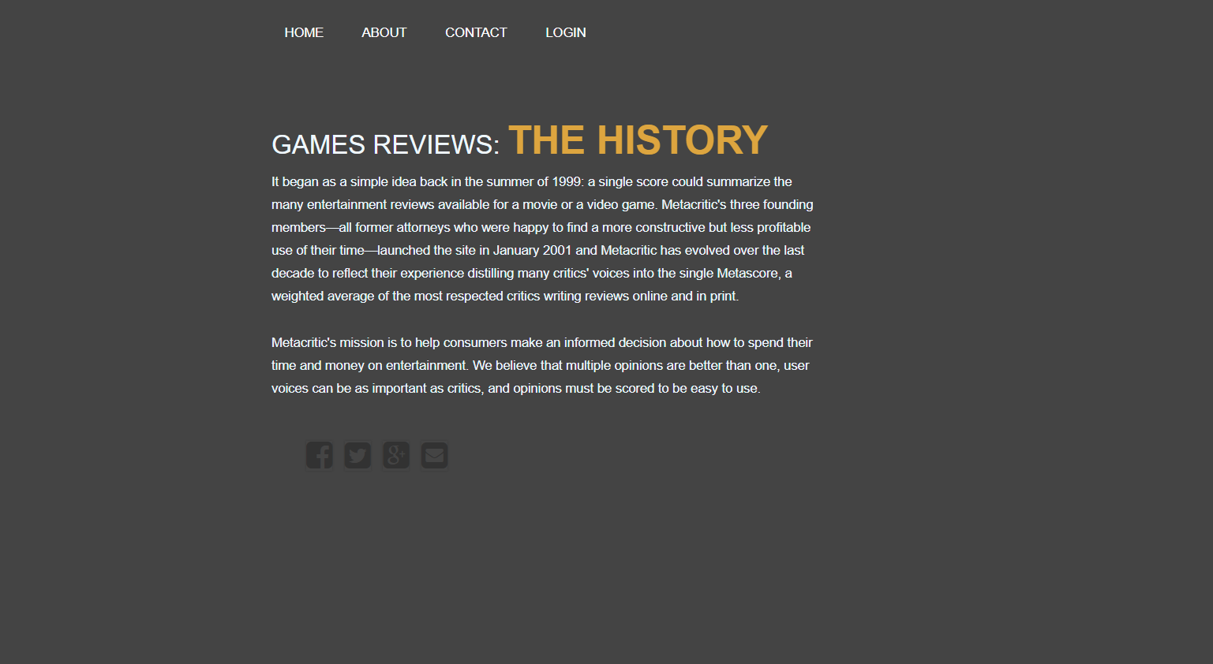

**Contact page:**

if a user or customer has some issue or want to provide a feedback about articles or help us improve our website and the contents that we provide he can contact us from this section.

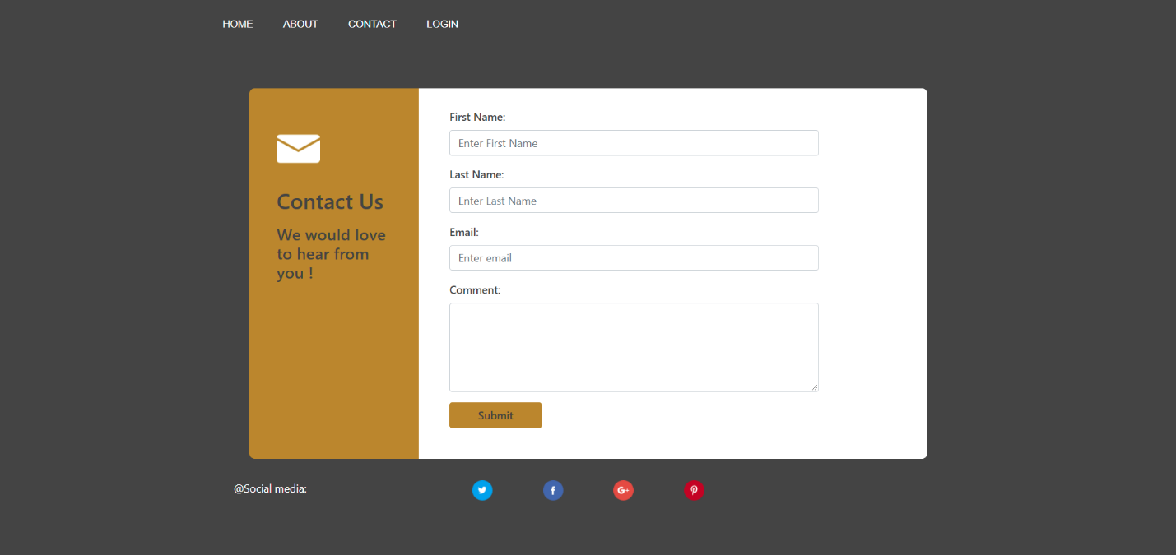

**Log in page:**

A log in page for the admins to access an area were they can post new articles and it can only be accessed from the login page

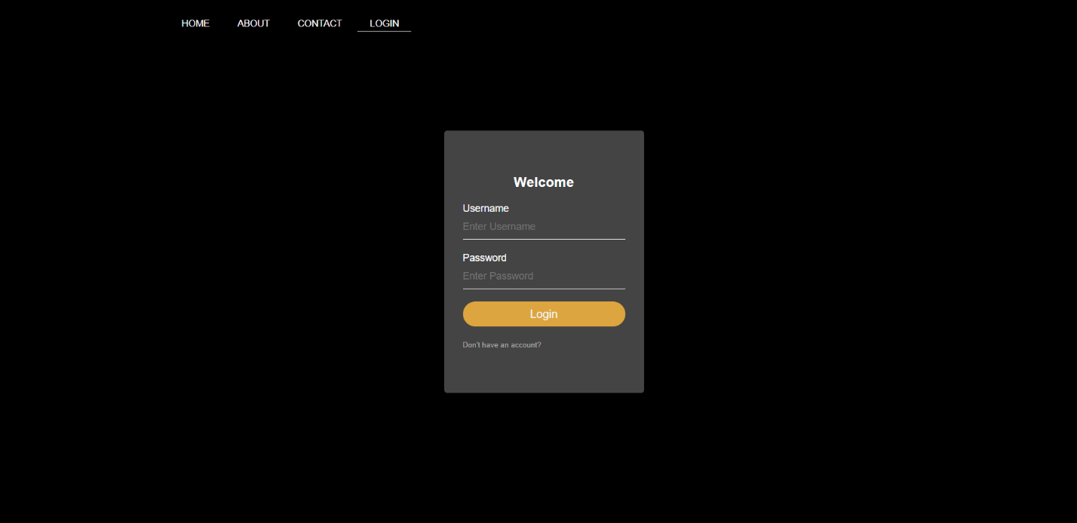

**Admins page:**

A page that’s can only be accessed from the login page it has a text area where admins can write the new articles and post it

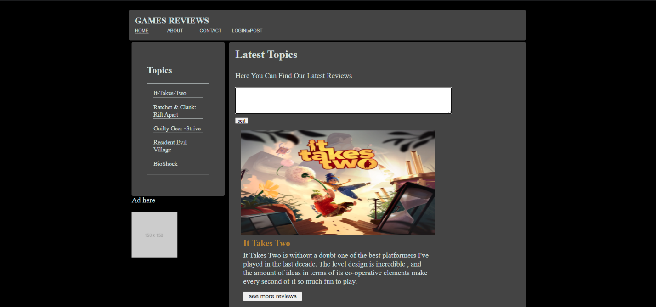

In this project I used

1. HTML to bullied and structure the layout of the website
2. CSS to modify and design the colors and other components of the website
3. Java script to make some logic in the website so admin can post articles
4. Bootstrap to help me get some prebuilt structure for ex: the cards in the home page
5. VC to help me write my code
6. Git and github to upload my files