Two-Way ANOVA: Advanced Topics in Stats II

2022-02-22

Today we will discuss the Analysis of Variance (ANOVA) from a factorial perspective.

Review:

What is a One-Way ANOVA? >

What are the statistical assumptions of an ANOVA? >

What is a One-Way Repeated Measures ANOVA? >

New Material:

What is a Two-Way ANOVA? >

What is a Three-Way ANOVA? >

# Analysis Framework

1. Load the Data  
  
2. Understand the data (Distribution, Variability, Outliers)  
 * Summary Statistics  
 * Data Visualization  
 * Outliers  
  
3. Check Assumptions  
 * Normality of Residuals or DV by group  
 * Homogeneity (Equality) of Variance or Sphericity  
 * Independent Samples  
   
4. Conduct the Statistical Test  
 * Run ANOVA  
   
5. Conduct Post-Hoc Analyses as needed  
 * Pairwise *t*-tests  
 * One-Way ANOVAs

# One-Way ANOVA (Between-Subjects)

## 1. Load the Data

# Loading the Data  
penguins <- palmerpenguins::penguins # Loads the dataset called 'penguins' from the palmerpengins package and assigns it the name "penguins"  
?penguins # Loads the help menu giving some descriptive information for the dataset  
glimpse(penguins) # Gives a quick view of the structure of the dataset.

## Rows: 344  
## Columns: 8  
## $ species <fct> Adelie, Adelie, Adelie, Adelie, Adelie, Adelie, Adel…  
## $ island <fct> Torgersen, Torgersen, Torgersen, Torgersen, Torgerse…  
## $ bill_length_mm <dbl> 39.1, 39.5, 40.3, NA, 36.7, 39.3, 38.9, 39.2, 34.1, …  
## $ bill_depth_mm <dbl> 18.7, 17.4, 18.0, NA, 19.3, 20.6, 17.8, 19.6, 18.1, …  
## $ flipper_length_mm <int> 181, 186, 195, NA, 193, 190, 181, 195, 193, 190, 186…  
## $ body_mass_g <int> 3750, 3800, 3250, NA, 3450, 3650, 3625, 4675, 3475, …  
## $ sex <fct> male, female, female, NA, female, male, female, male…  
## $ year <int> 2007, 2007, 2007, 2007, 2007, 2007, 2007, 2007, 2007…

Research Question: We are interested in determining if different species of penguins have different flipper lengths and whether that varies according to sex.

What is the DV? >

What is/are the IV(s)? How many levels do they have? >

## 2. Understand the data (Distribution, Variability, Outliers)

* Summary Statistics

penguins %>%   
 group_by(species, sex) %>%   
 get_summary_stats(flipper_length_mm, type = "mean_sd")

## # A tibble: 8 × 6  
## species sex variable n mean sd  
## <fct> <fct> <chr> <dbl> <dbl> <dbl>  
## 1 Adelie female flipper_length_mm 73 187.8 5.595  
## 2 Adelie male flipper_length_mm 73 192.4 6.599  
## 3 Adelie <NA> flipper_length_mm 5 185.6 6.107  
## 4 Chinstrap female flipper_length_mm 34 191.7 5.754  
## 5 Chinstrap male flipper_length_mm 34 199.9 5.977  
## 6 Gentoo female flipper_length_mm 58 212.7 3.898  
## 7 Gentoo male flipper_length_mm 61 221.5 5.673  
## 8 Gentoo <NA> flipper_length_mm 4 215.8 1.258

penguins_complete <- penguins %>% filter(!is.na(sex))

What are your observations given the descriptive statistics? >

* Data Visualization

# Boxplot  
penguins_complete %>%   
 ggplot() +   
 aes(x = species, y = flipper_length_mm, color = sex) +   
 geom_boxplot() +  
 geom_jitter(alpha = 0.2, width = .1)

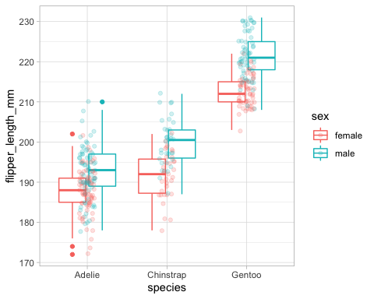

# Continuous Density Plot  
penguins_complete %>% ggplot() +   
 aes(x = flipper_length_mm, fill = sex) +   
 geom_density() +   
 facet_grid(species ~ .)

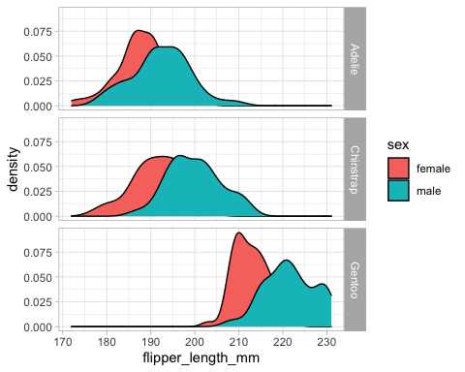

What are your observations (distribution, variability) given these data visualizations? >

* Outliers

penguins_complete %>%   
 group_by(species, sex) %>%   
 rstatix::identify_outliers(flipper_length_mm) # Produces a table of outliers and extreme cases.

## # A tibble: 4 × 10  
## species sex island bill_length_mm bill_depth_mm flipper_length_… body_mass_g  
## <fct> <fct> <fct> <dbl> <dbl> <int> <int>  
## 1 Adelie fema… Biscoe 37.8 18.3 174 3400  
## 2 Adelie fema… Biscoe 37.9 18.6 172 3150  
## 3 Adelie fema… Dream 35.7 18 202 3550  
## 4 Adelie male Torge… 44.1 18 210 4000  
## # … with 3 more variables: year <int>, is.outlier <lgl>, is.extreme <lgl>

Are there any outliers in these data? >

## 3. Check Assumptions

* Normality of Residuals or DV by group

*a. Analyzing the ANOVA model residuals. This approach is generally easier to do and helpful if there are many groups. This is the approach we will take.*

# Assumption testing- Normality of Residuals- QQ Plot  
model <- lm(flipper_length_mm ~ species * sex, data = penguins_complete)  
ggqqplot(residuals(model)) # Graphically depicts the correlation of these data and a normal distribution.

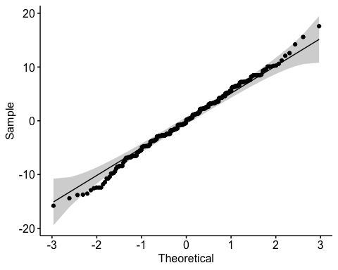

# Shapiro-Wilkes Test  
shapiro_test(residuals(model)) # Statistically determines normality of these data.

## # A tibble: 1 × 3  
## variable statistic p.value  
## <chr> <dbl> <dbl>  
## 1 residuals(model) 0.9955 0.4480

*b. Checking Normality for each group separately. This might be helpful if you have only a few groups.*

# Assumption testing- Normality DV by groups  
ggqqplot(penguins_complete, "flipper_length_mm") +  
 facet_grid(sex ~ species)# Graphically depicts the correlation of these data and a normal distribution.

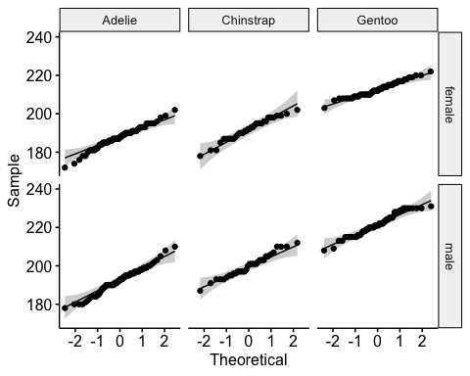

# Shapiro-Wilkes Test  
penguins_complete %>%  
 group_by(species, sex) %>%  
 shapiro_test(flipper_length_mm) # Statistically determines normality of these data.

## # A tibble: 6 × 5  
## species sex variable statistic p  
## <fct> <fct> <chr> <dbl> <dbl>  
## 1 Adelie female flipper_length_mm 0.9841 0.4912   
## 2 Adelie male flipper_length_mm 0.9843 0.4984   
## 3 Chinstrap female flipper_length_mm 0.9716 0.5074   
## 4 Chinstrap male flipper_length_mm 0.9753 0.6201   
## 5 Gentoo female flipper_length_mm 0.9739 0.2450   
## 6 Gentoo male flipper_length_mm 0.9618 0.05452

*Note: may be overly sensitive if data is more than 50. In that case, the qq plot is preferred.*

Are these data normally distributed? >

*If the data are not normally distributed, a Kruskal-Wallis test is a non-parametric alternative to the One-Way ANOVA.*

* Homogeneity (Equality) of Variance

# Residuals vs Fitted Plot  
plot(model, 1) # Graphically compares the residuals to fitted values (mean of each group)

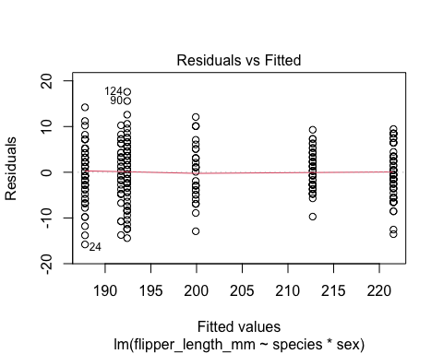

# Assumption testing- Homogeneity of Variance  
penguins_complete %>% levene_test(flipper_length_mm ~ species*sex) # Statistically shows homogeneity of variance.

## # A tibble: 1 × 4  
## df1 df2 statistic p  
## <int> <int> <dbl> <dbl>  
## 1 5 327 2.408 0.03652

*If the data do not have homogeneity of variance, a welch one way ANOVA test can be performed (welch_anova_test())*

Do these data meet the assumption of homogeneity of variance? >

* Independent Samples

Are these independent samples? >

## 4. Conduct the Statistical Test

* Run ANOVA

# One-Way ANOVA- Tests of Between-Subject with equal variance  
penguins_complete %>%   
 anova_test(flipper_length_mm ~ species * sex)

## ANOVA Table (type II tests)  
##   
## Effect DFn DFd F p p<.05 ges  
## 1 species 2 327 784.583 1.57e-125 * 0.828  
## 2 sex 1 327 122.119 2.46e-24 * 0.272  
## 3 species:sex 2 327 5.144 6.00e-03 * 0.031

Interpret the interaction effect between species and sex, is this effect significant and how would you interpret it? >

*Interpreting the interaction effect*

*If a significant two-way interaction exists, then the effect that one IV has on the DV is dependent on the level of a second IV. If you have a significant two-way interaction, you would then find the simple main effects (run one-way ANOVAs to determine if there is a simple main effect, if there is, a pairwise comparison would be used to determine which groups are different).*

*For a non-significant two-way interaction you can determine if there is a significant main effect from the ANOVA table and follow it up with a pairwise comparison between groups to determine where the differences exist.*

*ANOVA tests determine whether there is a difference among groups. Multiple Comparisons Tables (pairwise_t_test) are used to understand where the differences exist. We will interpret the adjusted p-value (p.adj). This adjusted value uses a Holm correction to account for multiple tests (adjusts the $α).$*

We have a significant interaction effect. Therefore, we will run multiple one-way ANOVAs to determine the simple main effects and visualize the means to determine where the difference exists.

## 5. Conduct Post-Hoc Analyses as needed

* Pairwise *t*-tests

penguins_complete %>%   
 group_by(sex) %>%   
 anova_test(flipper_length_mm ~ species)

## # A tibble: 2 × 8  
## sex Effect DFn DFd F p `p<.05` ges  
## * <fct> <chr> <dbl> <dbl> <dbl> <dbl> <chr> <dbl>  
## 1 female species 2 162 411.8 3.03e-64 * 0.836  
## 2 male species 2 165 384.4 7.92e-63 * 0.823

penguins_complete %>%   
 group_by(sex) %>%   
 pairwise_t_test(flipper_length_mm ~ species)

## # A tibble: 6 × 10  
## sex .y. group1 group2 n1 n2 p p.signif p.adj p.adj.signif  
## * <fct> <chr> <chr> <chr> <int> <int> <dbl> <chr> <dbl> <chr>   
## 1 female flip… Adelie Chins… 73 34 2.72e- 4 *** 2.72e- 4 ***   
## 2 female flip… Adelie Gentoo 73 58 1.71e-63 **** 5.13e-63 ****   
## 3 female flip… Chins… Gentoo 34 58 3.5 e-43 **** 7.01e-43 ****   
## 4 male flip… Adelie Chins… 73 34 2.31e- 8 **** 2.31e- 8 ****   
## 5 male flip… Adelie Gentoo 73 61 4.55e-63 **** 1.36e-62 ****   
## 6 male flip… Chins… Gentoo 34 61 1.5 e-36 **** 3 e-36 ****

penguins_complete %>%   
 group_by(species) %>%   
 anova_test(flipper_length_mm ~ sex)

## # A tibble: 3 × 8  
## species Effect DFn DFd F p `p<.05` ges  
## * <fct> <chr> <dbl> <dbl> <dbl> <dbl> <chr> <dbl>  
## 1 Adelie sex 1 144 20.78 1.09e- 5 * 0.126  
## 2 Chinstrap sex 1 66 33.02 2.53e- 7 * 0.334  
## 3 Gentoo sex 1 117 97.05 4.87e-17 * 0.453

# Data Visualizaiton  
penguins_complete %>%   
 group_by(species, sex) %>%   
 get_summary_stats(flipper_length_mm, type = "mean_sd") %>%   
 ggplot() +   
 aes(x = species, y = mean, color = sex) +   
 geom_path(aes(group = sex))

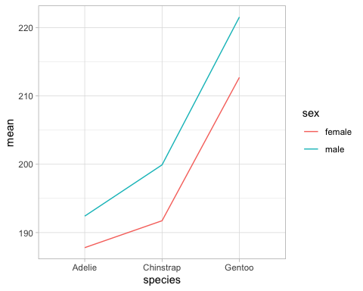 Interpret the results >

# Two-Way Mixed-Measures ANOVA

## 1. Load the Data

# Loading the Data  
grit <- pl462::grit # Loads the dataset called 'grit' from the pl462 package and assigns it the name "penguins"  
?grit # Loads the help menu giving some descriptive information for the dataset  
glimpse(grit) # Gives a quick view of the structure of the dataset.

## Rows: 432  
## Columns: 5  
## $ sex <chr> "F", "F", "F", "F", "F", "F", "F", "F", "F", "F", "F", "F", "F…  
## $ athlete <chr> "N", "N", "N", "N", "N", "N", "Y", "Y", "Y", "N", "N", "N", "N…  
## $ id <int> 1, 1, 1, 2, 2, 2, 3, 3, 3, 4, 4, 4, 5, 5, 5, 6, 6, 6, 7, 7, 7,…  
## $ class <chr> "entry", "freshmen", "sophmore", "entry", "freshmen", "sophmor…  
## $ grit <dbl> 4.375000, 4.000000, 4.166667, 3.250000, 3.500000, 3.000000, 4.…

Research Question: We are interested in determining whether grit changes based on when the measure is taken (matriculation, freshmen year, sophomore year) and the biological sex of the participant.

What is the DV? >

What is/are the IV(s)? How many levels do they have? >

## 2. Understand the data (Distribution, Variability, Outliers)

* Summary Statistics

grit %>%   
 group_by(class, sex) %>%   
 get_summary_stats(grit, type = "mean_sd")

## # A tibble: 6 × 6  
## sex class variable n mean sd  
## <chr> <chr> <chr> <dbl> <dbl> <dbl>  
## 1 F entry grit 72 3.568 0.605  
## 2 M entry grit 72 3.705 0.485  
## 3 F freshmen grit 72 3.708 0.643  
## 4 M freshmen grit 72 3.856 0.618  
## 5 F sophmore grit 72 3.681 0.638  
## 6 M sophmore grit 72 3.852 0.606

What are your observations given the descriptive statistics? >

* Data Visualization

# Boxplot  
grit %>%   
 ggplot() +   
 aes(x = class, y = grit, fill = sex) +   
 geom_boxplot()

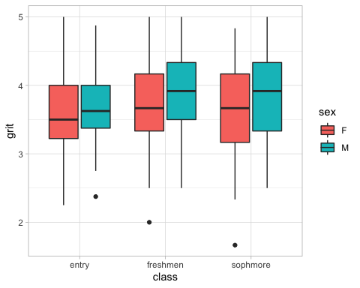

# Continuous Density Plot  
grit %>% ggplot() +   
 aes(x = grit, fill = sex, group = sex) +   
 geom_density(alpha = .5) +   
 facet_grid(class ~ .)

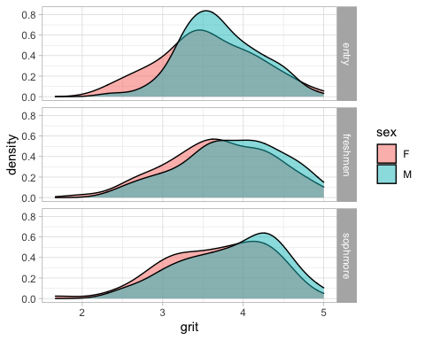

What are your observations (distribution, variability) given these data visualizations? >

* Outliers

grit %>%   
 group_by(class, sex) %>%   
 rstatix::identify_outliers(grit) # Produces a table of outliers and extreme cases.

## # A tibble: 3 × 7  
## sex class athlete id grit is.outlier is.extreme  
## <chr> <chr> <chr> <int> <dbl> <lgl> <lgl>   
## 1 M entry N 132 2.375 TRUE FALSE   
## 2 F freshmen N 43 2 TRUE FALSE   
## 3 F sophmore N 43 1.667 TRUE FALSE

Are there any outliers in these data? >

## 3. Check Assumptions

* Normality of Residuals or DV by group

*a. Analyzing the ANOVA model residuals. This approach is generally easier to do and helpful if there are many groups. This is the approach we will take.*

# Assumption testing- Normality of Residuals- QQ Plot  
model <- lm(grit ~ class*sex, data = grit)  
ggqqplot(residuals(model)) # Graphically depicts the correlation of these data and a normal distribution.

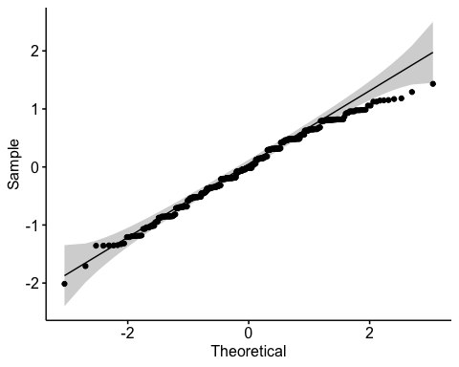

# Shapiro-Wilkes Test  
shapiro_test(residuals(model)) # Statistically determines normality of these data.

## # A tibble: 1 × 3  
## variable statistic p.value  
## <chr> <dbl> <dbl>  
## 1 residuals(model) 0.9892 0.002854

*b. Checking Normality for each group separately. This might be helpful if you have only a few groups.*

# Assumption testing- Normality DV by groups  
  
ggqqplot(grit, "grit") + facet_grid(sex ~ class) # Graphically depicts the correlation of these data and a normal distribution.

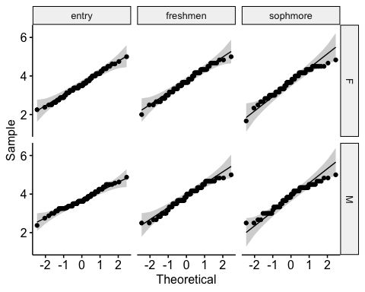

# Shapiro-Wilkes Test  
grit %>%  
 group_by(class, sex) %>%  
 shapiro_test(grit) # Statistically determines normality of these data.

## # A tibble: 6 × 5  
## sex class variable statistic p  
## <chr> <chr> <chr> <dbl> <dbl>  
## 1 F entry grit 0.9905 0.8691   
## 2 M entry grit 0.9839 0.4890   
## 3 F freshmen grit 0.9839 0.4884   
## 4 M freshmen grit 0.9706 0.08981  
## 5 F sophmore grit 0.9630 0.03270  
## 6 M sophmore grit 0.9606 0.02380

*Note: may be overly sensitive if data is more than 50. In that case, the qq plot is preferred.*

Are these data normally distributed? >

*If the data are not normally distributed, a Kruskal-Wallis test is a non-parametric alternative to the One-Way ANOVA (kruskal_test()).*

* Sphericity *variance of the differences between groups should be equal. This can be checked using the Mauchly’s test of sphericity. This is automatically reported and adjusted with anova_test()*

## 4. Conduct the Statistical Test

* Run ANOVA

# One-Way Repeated Measures ANOVA- Tests of Within-Subject.  
grit %>%   
 anova_test(wid = id, dv = grit, within = class, between = sex)

## ANOVA Table (type II tests)  
##   
## $ANOVA  
## Effect DFn DFd F p p<.05 ges  
## 1 sex 1 142 3.203 0.076 0.016000  
## 2 class 2 284 6.049 0.003 * 0.012000  
## 3 sex:class 2 284 0.072 0.930 0.000142  
##   
## $`Mauchly's Test for Sphericity`  
## Effect W p p<.05  
## 1 class 0.999 0.918   
## 2 sex:class 0.999 0.918   
##   
## $`Sphericity Corrections`  
## Effect GGe DF[GG] p[GG] p[GG]<.05 HFe DF[HF] p[HF] p[HF]<.05  
## 1 class 0.999 2, 283.66 0.003 * 1.013 2.03, 287.7 0.003 *  
## 2 sex:class 0.999 2, 283.66 0.930 1.013 2.03, 287.7 0.930

Interpret the results >

## 5. Conduct Post-Hoc Analyses as needed

* Pairwise *t*-tests

grit %>%   
 pairwise_t_test(grit ~ class,  
 paired = TRUE)

## # A tibble: 3 × 10  
## .y. group1 group2 n1 n2 statistic df p p.adj p.adj.signif  
## * <chr> <chr> <chr> <int> <int> <dbl> <dbl> <dbl> <dbl> <chr>   
## 1 grit entry freshmen 144 144 -3.240 143 0.001 0.004 **   
## 2 grit entry sophmore 144 144 -2.800 143 0.006 0.012 *   
## 3 grit freshmen sophmore 144 144 0.3511 143 0.726 0.726 ns

Interpret the results >