**Structure Charts: Assignment 3**

Team Pac-Men

Austin FitzGerald, Nate Braukhoff, Nathan Stelken, Myles Heinzen

**Austin FitzGerald:**

Source files include WorldBuilder.java, BodyComponent.java, TransformComponent.java, AnimationComponent.java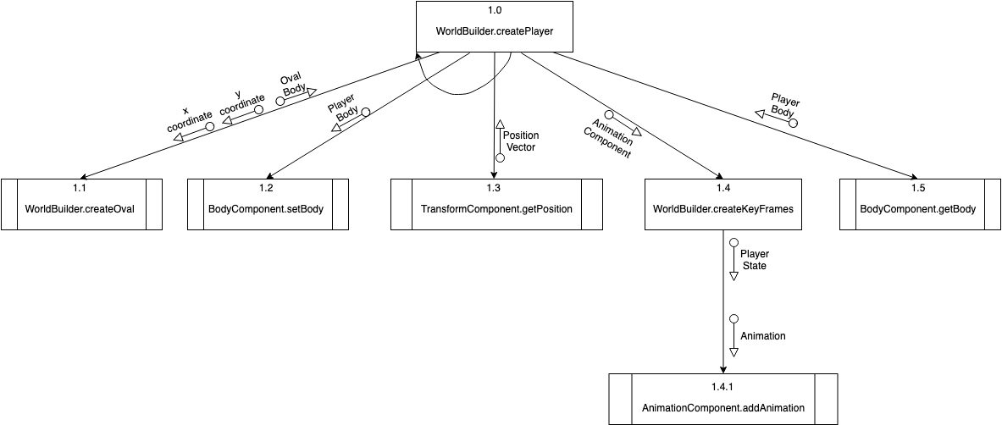

**Nate Braukhoff**

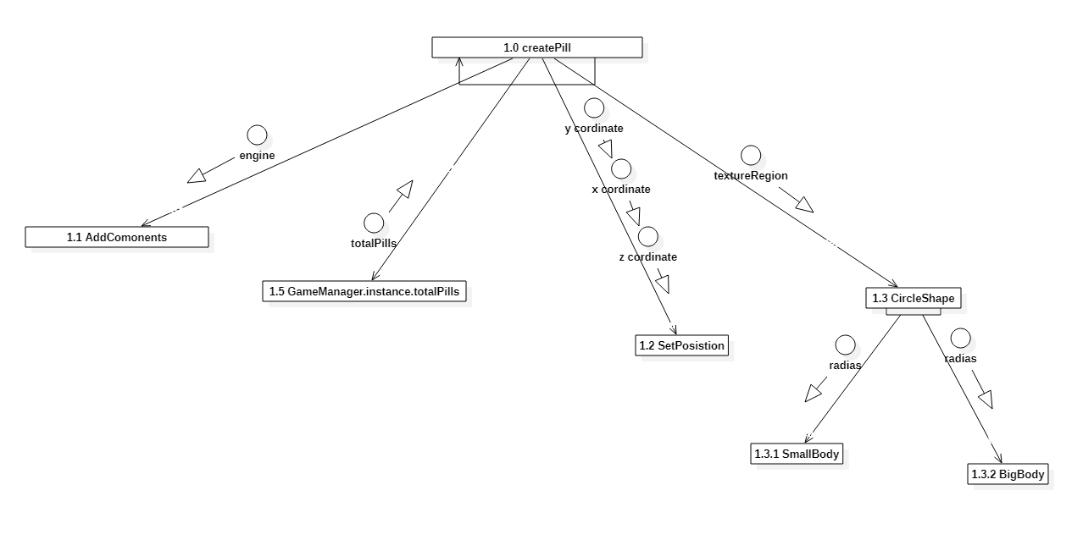

**Myles Heinzen**

Source can be found in edu.team08.pacman.WorldBuilder.java



Nathan Stelken

PlayerControlSystem, BodyComponent, StateComponent, InputManager

