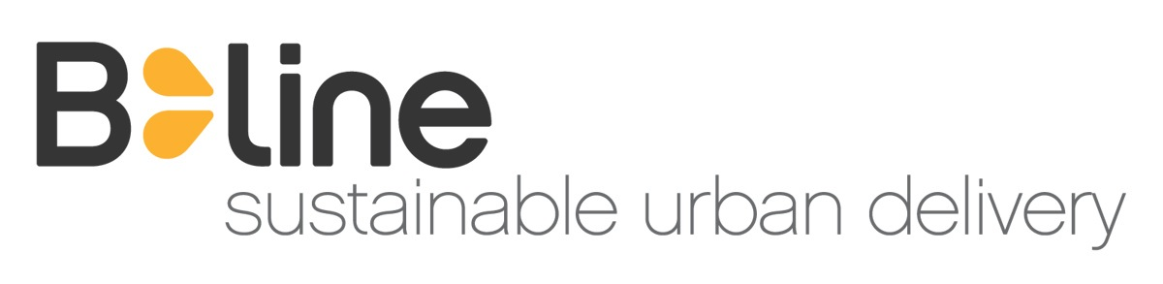**B-LINE SUSTAINABLE URBAN DELIVERY**

**Memorandum of Understanding with New Avenues for Futel**

**August 14, 2015**

1. **Purpose**

This Memorandum of Understanding (“MoU”) outlines the agreement between B-Line Sustainable Urban Delivery (“B-Line”) and Futel (“Client”). B-Line will provide advertising services using electric-assisted trike during the designated Period.

1. **Services**

A. Advertising Service

B-line will run exclusive 3-panel artwork on the trike between Dec 1, 2015 and March 1, 2016, 2015, for at least 50 hours during that period, to advertise Futel. Client is not held accountable for additional hours of advertising that may be displayed on the trikes.

III. Pricing and Payment:

|  |  |  |  |
| --- | --- | --- | --- |
| **Service** | **Hours** | **Rate** | **Total** |
| **Advertising on B-line trike: Dec 1 2015 – March 1, 2016** | 50 | Donation (value: $2,000) | $0 |
| **Set of signs – 3 panels** |  | $175 (at cost) | $175 |
| **TOTAL** |  |  | $175 |

* + Modifications. Client shall notify B-Line of changes or alterations to agreed-upon services by 5:00pm three (3) days before trikes are to run advertising via email ([dorothy.mitchell@b-linepdx.com](mailto:franklin@b-linepdx.com)) or phone (503-957-6652).
  + Other:
  + Client is responsible for design of creative assets, to be provided to B-line in PDF form for printing.
  + Signage will be displayed as “remnant time,” with exposure during at least 50 hours during the designated period.
  + Client may, at their discretion, provide B-line with promotional handouts to share during delivery routes (i.e. flyers, postcards).
  + Client will provide B-line rider/brand ambassadors with appropriate messaging to share in order to answer questions from people whom rider/ambassadors engage on the street.
  + B-Line and Client will establish a chain of contact to ensure prompt communication and customer service.
  + Client will take reasonable steps to keep B-Line knowledgeable and up-to-date on Client’s products and services.

IV. **Representations, Warranties, Indemnification, and Severability**

* + Client represents and warrants that:
    - All information provided by Client or its representatives (including the names and addresses of the Recipients) is complete and accurate;
    - All applicable laws and regulations have been complied with;
  + Client shall indemnify and be liable to B-Line for any loss or damage arising out of Client’s breach of its representations and warranties.
  + The invalidity or unenforceability of any provision of this MoU shall not affect any other part of this MoU.

**V. Term and Termination**

* + The term of this agreement shall commence on Dec 1, 2015 and shall continue through March 1, 2016. At the end of the Period this MoU shall automatically terminate.
  + B-Line may terminate this MoU at any time with ten days’ written notice.
  + In the event Client breaches this MoU, B-Line may at its sole discretion:
    - Terminate this MoU immediately,
    - Provide Client with ten days to cure the breach. If Client fails to cure the breach within the specified period, B-Line may terminate this MoU immediately.

*The Parties agree to the Memorandum of Understanding* *above.*

FREEROOT VENTURES, INC,

Incorporated in the State of Oregon and doing business as,

B-LINE SUSTAINABLE URBAN DELIVERY,

By: ___________________________ Date: _________________________

Name: Dorothy Mitchell

Title: Director of Sales and Marketing

CLIENT

By: ___________________________ Date: _________________________

Name: Elijah St. Clair

Title: Co-founder, Futel