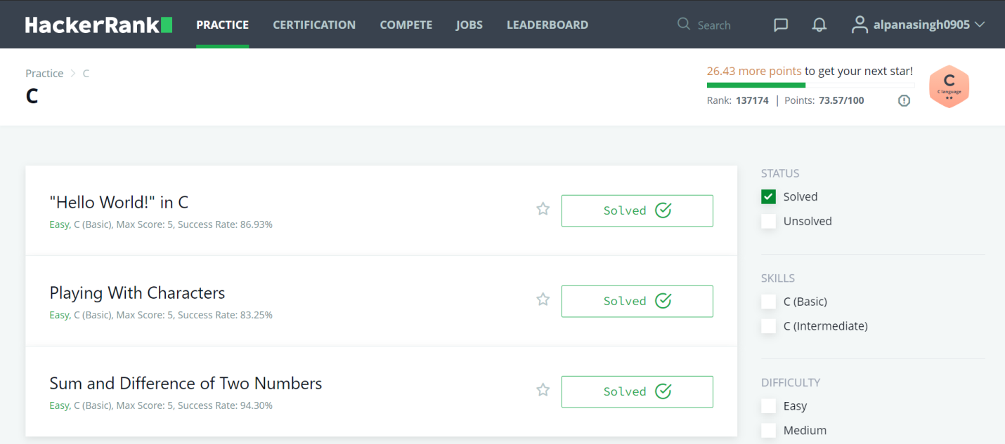

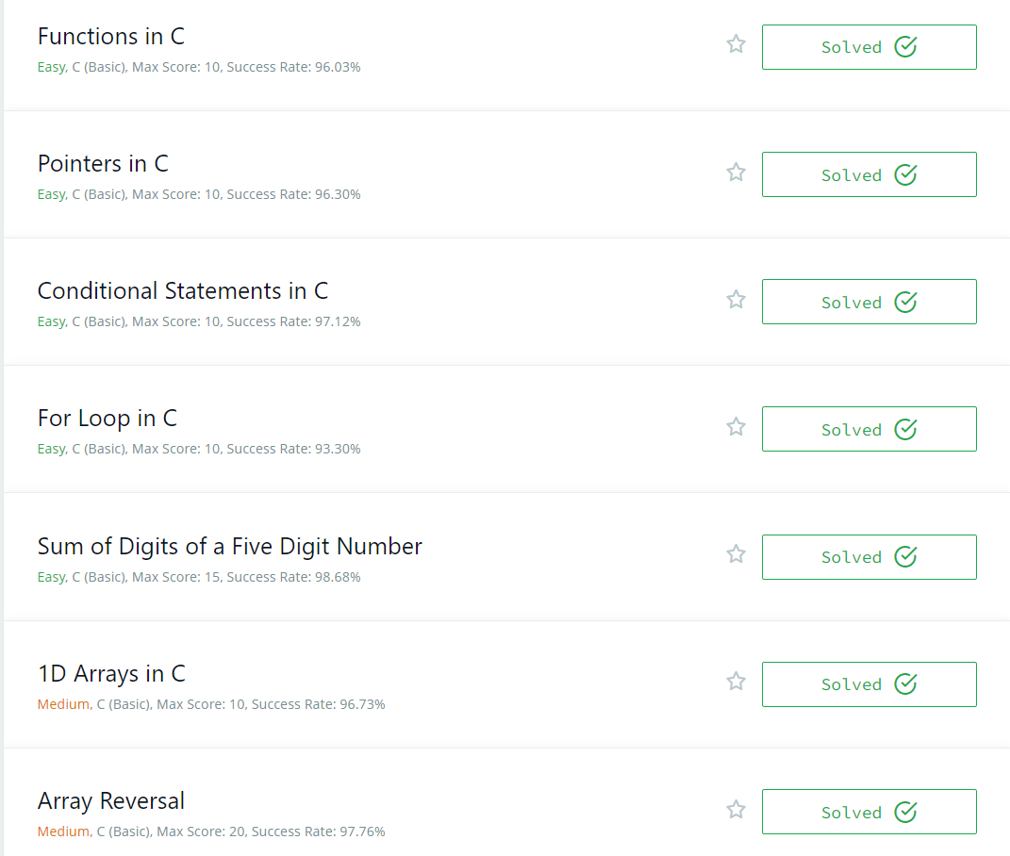

# "Hello World!" in C

**#include** **<**stdio.h**>**

**int** main()

{

**char** str[100];

    scanf("%[^\n]%*c",str);

    printf("Hello, World!\n");

    printf("%s",str);

**return** 0;

}

# Playing With Characters

**#include** **<**stdio.h**>**

**#include** **<**string.h**>**

**#include** **<**math.h**>**

**#include** **<**stdlib.h**>**

**int** main()

{

**char** ch,s[100],sen[500];

    scanf("%c",&ch);

    scanf("%s",s);

    scanf("\n");

    scanf("%[^\n]%*c",sen);

    printf("%c\n",ch);

    printf("%s\n",s);

    printf("%s",sen);

**return** 0;

}

# Sum and Difference of Two Numbers

**#include** **<**stdio.h**>**

**#include** **<**string.h**>**

**#include** **<**math.h**>**

**#include** **<**stdlib.h**>**

**int** main()

{

**int** a,b;

**float** c,d;

    scanf("%d\t",&a);

    scanf("%d\n",&b);

    scanf("%f\t",&c);

    scanf("%f",&d);

    printf("%d\t",a+b);

    printf("%d\n",a-b);

    printf("%.1f\t",c+d);

    printf("%.1f",c-d);

**return** 0;

}

# Functions in C

**#include** **<**stdio.h**>**

**int** max_of_four(**int** a,**int** b,**int** c,**int** d)

{

**if**((a>b)&&(a>c)&&(a>d))

**return** a;

**else** **if**((b>a)&&(b>c)&&(b>d))

**return** b;

**else** **if**((c>a)&&(c>b)&&(c>d))

**return** c;

**else**

**return** d;

}

**int** main() {

**int** a, b, c, d;

    scanf("%d %d %d %d", &a, &b, &c, &d);

**int** ans = max_of_four(a, b, c, d);

    printf("%d", ans);

**return** 0;

}

# Pointers in C

**#include** **<**stdio.h**>**

**void** update(**int** *a,**int** *b)

{

**int** t;

**if**(*a<*b)

    {

        t=*a;

        *a=*b;

        *b=t;

    }

}

**int** main() {

**int** a, b;

**int** *pa = &a, *pb = &b;

    scanf("%d %d", &a, &b);

    update(pa, pb);

    printf("%d\n%d", a+b, a-b);

**return** 0;

}

# Conditional Statements in C

**#include** **<**stdio.h**>**

**int** main()

{

**int** n;

    scanf("%d",&n);

**switch** (n)

    {

**case** 1:

        printf("one");

**break**;

**case** 2:

        printf("two");

**break**;

**case** 3:

        printf("three");

**break**;

**case** 4:

        printf("four");

**break**;

**case** 5:

        printf("five");

**break**;

**case** 6:

        printf("six");

**break**;

**case** 7:

        printf("seven");

**break**;

**case** 8:

        printf("eight");

**break**;

**case** 9:

        printf("nine");

**break**;

**default**:

        printf("Greater than 9");

**break**;

**return** 0;

    }

}

# For Loop in C

**#include** **<**stdio.h**>**

**int** main()

{

**int** a, b;

    scanf("%d\n%d", &a, &b);

**for** (**int** i=a; i<b+1; i++)

    {

**switch**(i)

        {

**case** 1: printf("one\n");

**break**;

**case** 2: printf("two\n");

**break**;

**case** 3: printf("three\n");

**break**;

**case** 4: printf("four\n");

**break**;

**case** 5: printf("five\n");

**break**;

**case** 6: printf("six\n");

**break**;

**case** 7: printf("seven\n");

**break**;

**case** 8: printf("eight\n");

**break**;

**case** 9: printf("nine\n");

**break**;

**default**:

**if** (i % 2)

                    printf("odd\n");

**else**

                    printf("even\n");

        }

    }

**return** 0;

}

# Sum of Digits of a Five Digit Number

**#include<**stdio.h**>**

**int** main()

{

**int** n;

    scanf("%d",&n);

**int** d,t,s=0;

    t=n;

**while**(t>0)

    {

        d= t%10;

        s=s+d;

        t=t/10;

    }

    printf("%d\n",s);

**return** 0;

}

# 1D Arrays in C

**#include<**stdio.h**>**

**int** sumofarr(**int** a[100],**int** n)

{

**int** i,sum=0;

**for**(i=0; i<n; i++)

    {

         sum+=a[i];

    }

**return** sum;

}

**int** main()

{

**int** a[1000],i,n,sum;

    scanf("%d", &n);

**for**(i=0; i<n; i++)

    {

        scanf("%d",&a[i]);

    }

    sum=sumofarr(a,n);

    printf("%d",sum);

}

# Array Reversal

**#include<**stdio.h**>**

**int** main()

{

**int** a[1000],b[1000],c,d,n;

    scanf("%d",&n);

**for**(c=0;c<n;c++)

    {

        scanf("%d",&a[c]);

    }

**for**(c=n-1,d=0;c>=0;c--,d++)

    {

        b[d]=a[c];

    }

**for**(c=0;c<n;c++)

    {

        a[c]=b[c];

    }

**for**(c=0;c<n;c++)

    {

        printf("%d ",a[c]);

    }

**return** 0;

}