EX NO: 10 RECRUITMENT SYSTEM
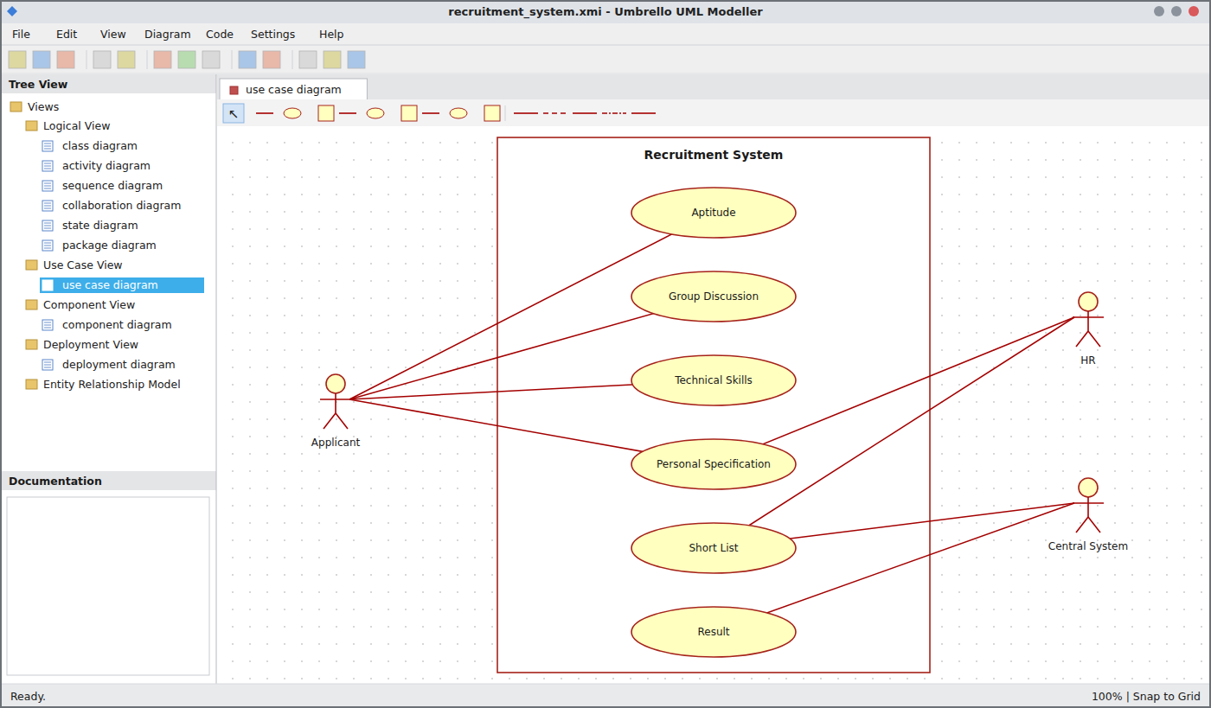
Use Case Diagram
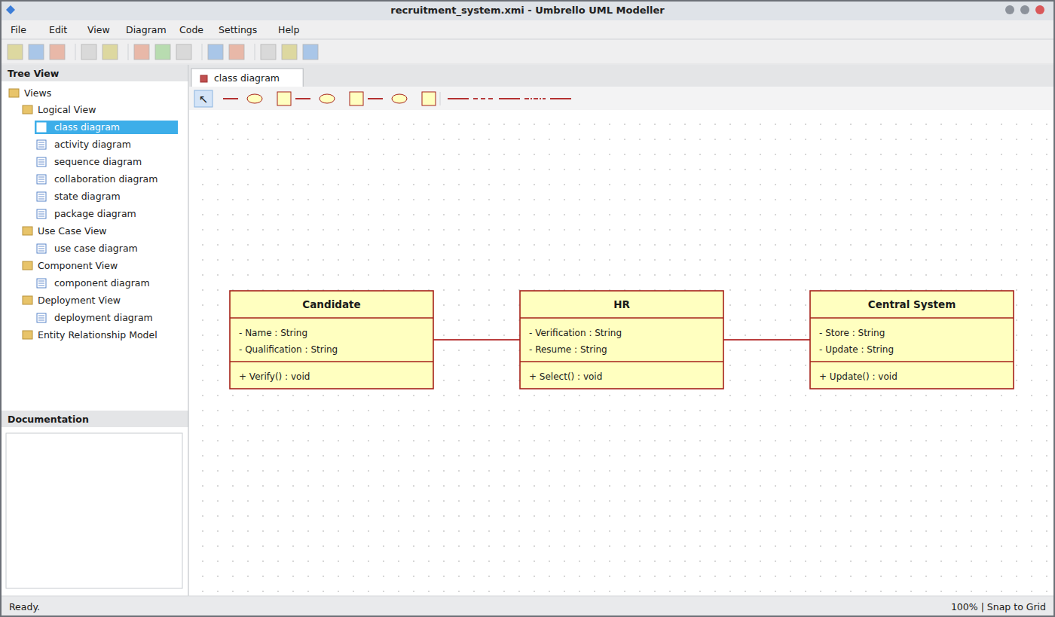
Class Diagram
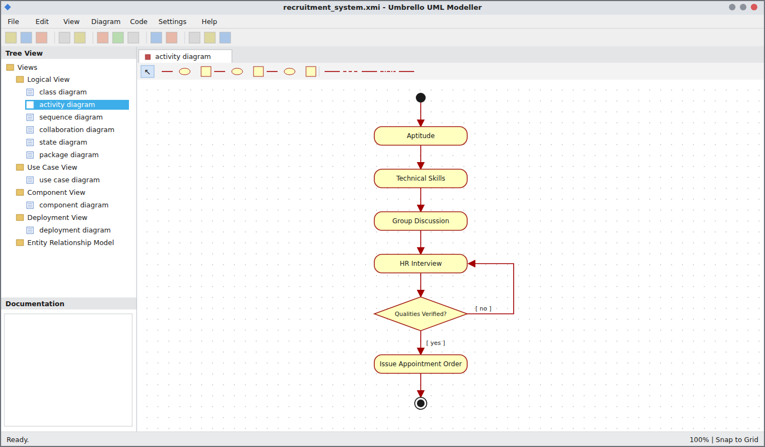
Activity Diagram
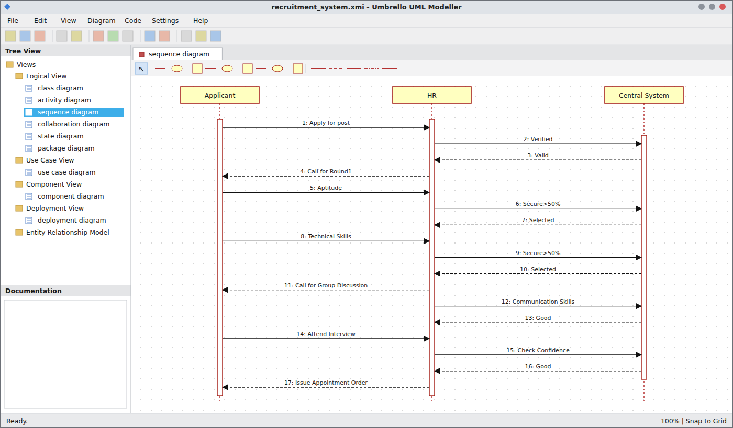
Sequence Diagram
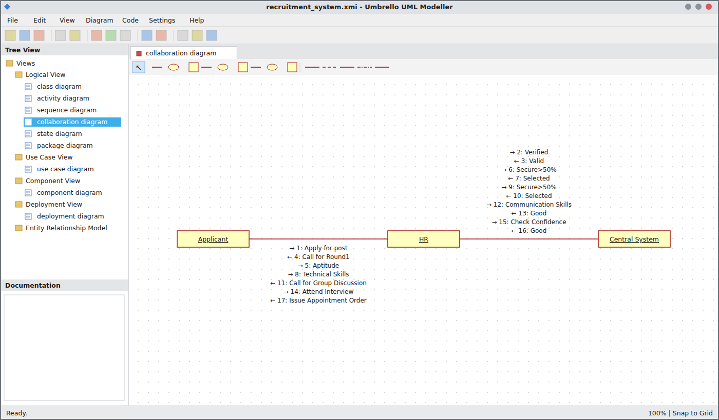
Collaboration Diagram
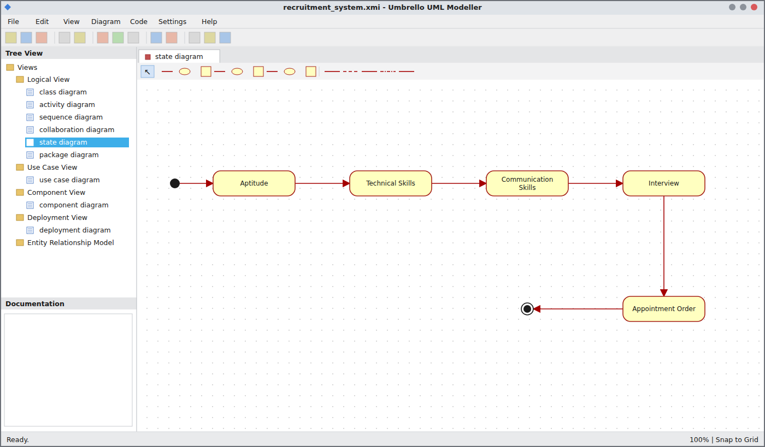
State Chart Diagram
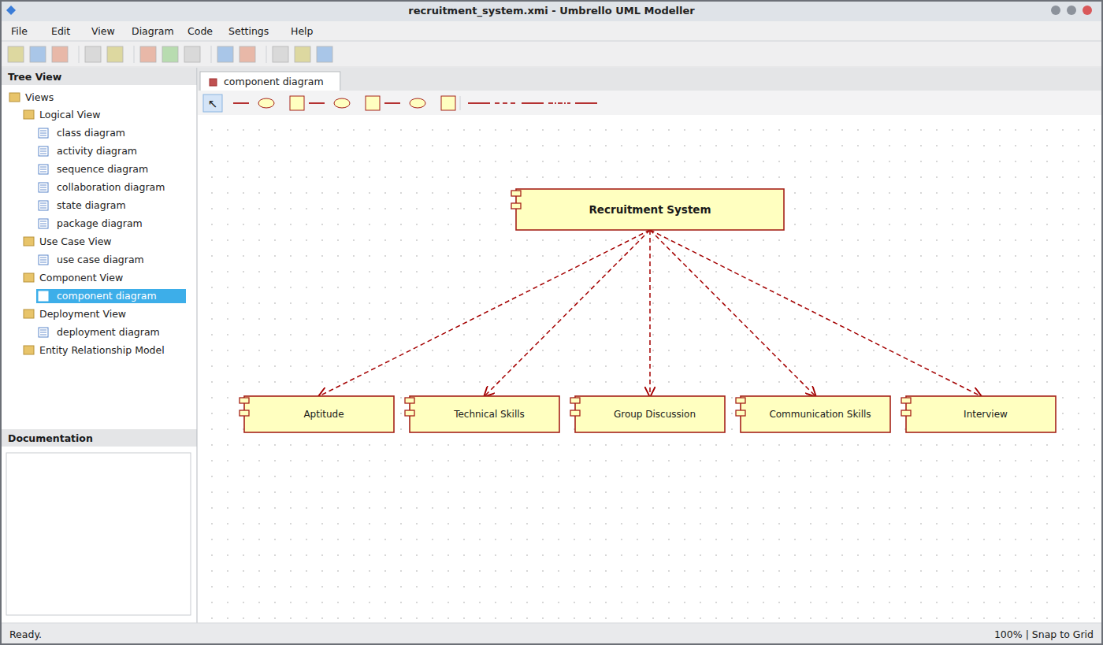
Component Diagram
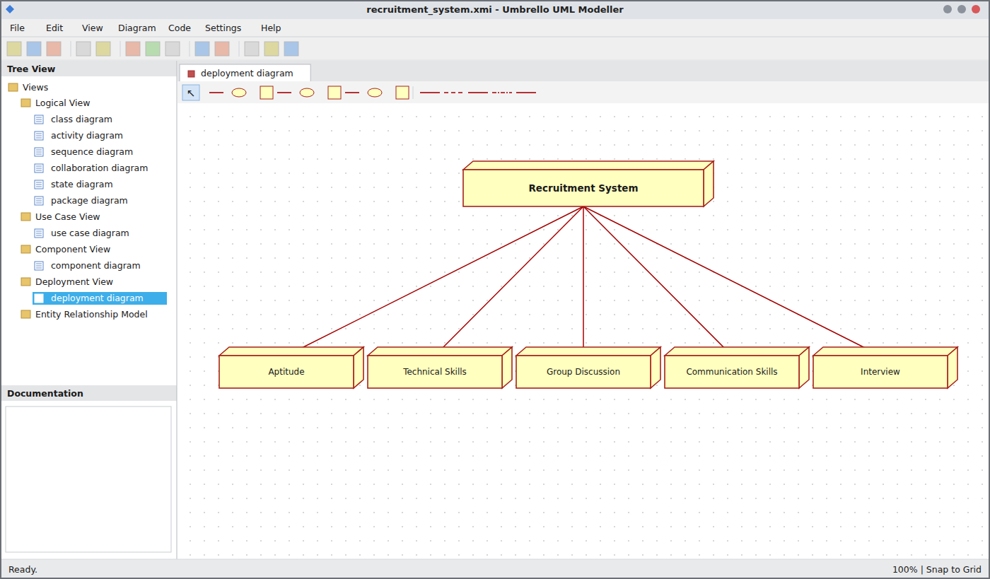
Deployment Diagram
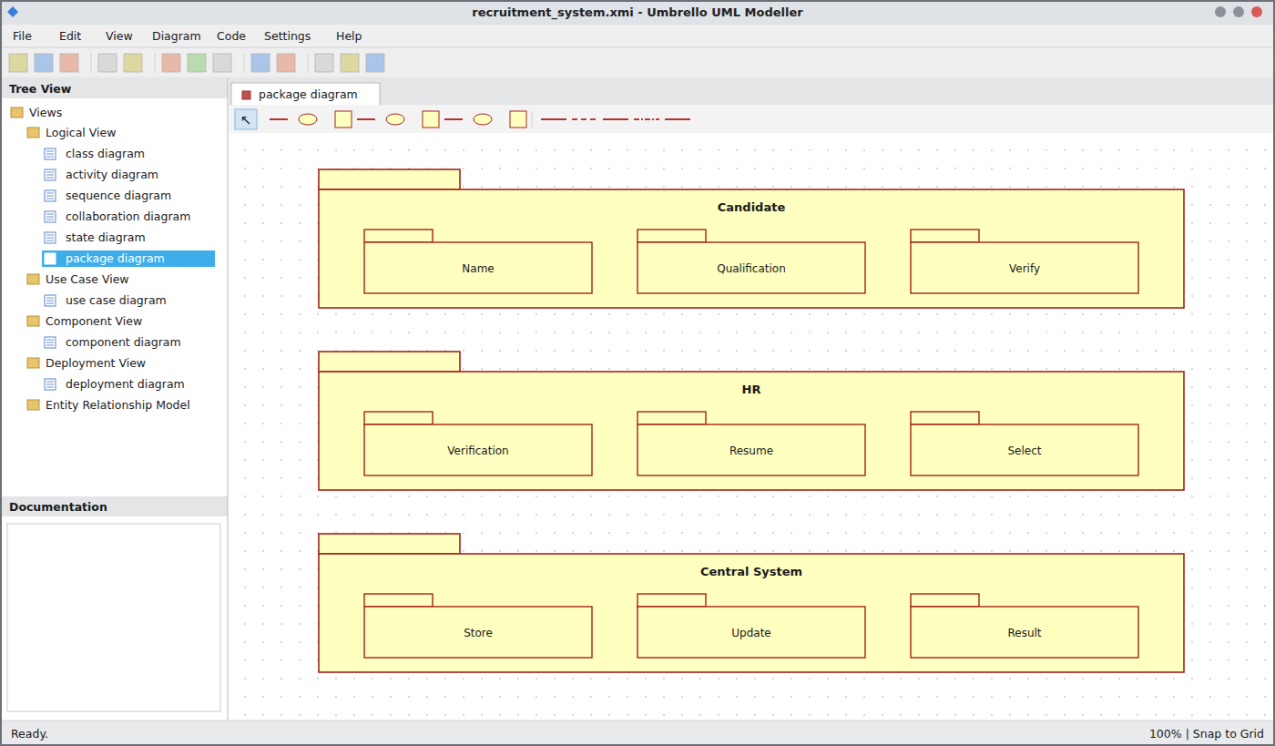
Package Diagram
WEBPAGE SCREENSHOT
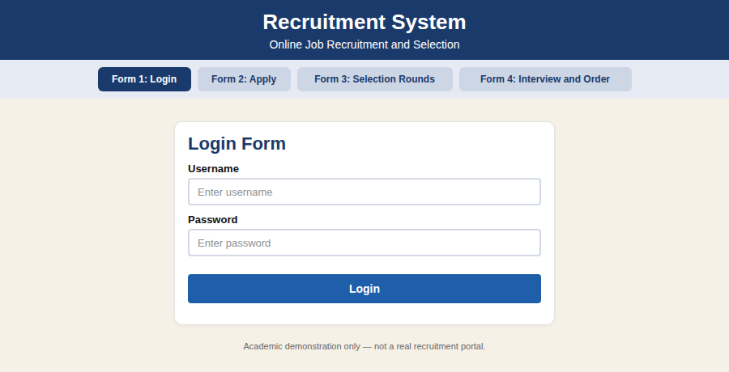
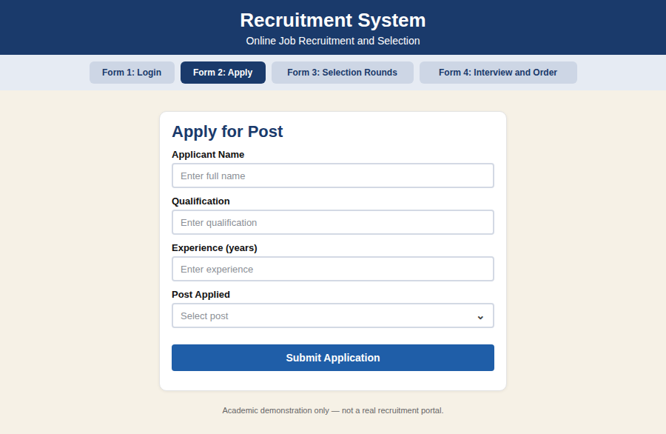
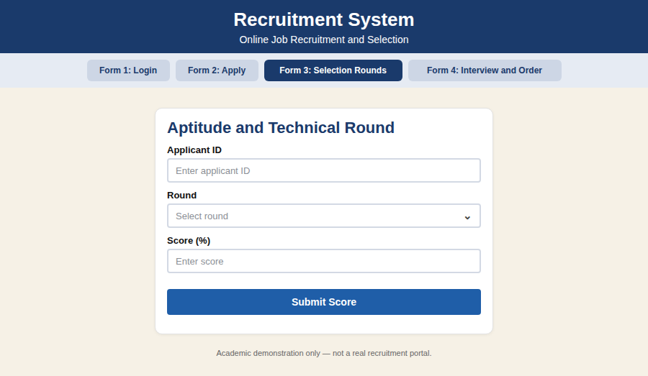
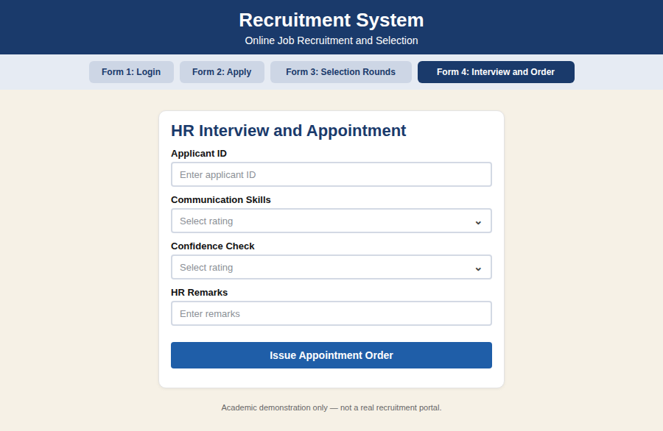
DATABASE SCREENSHOT
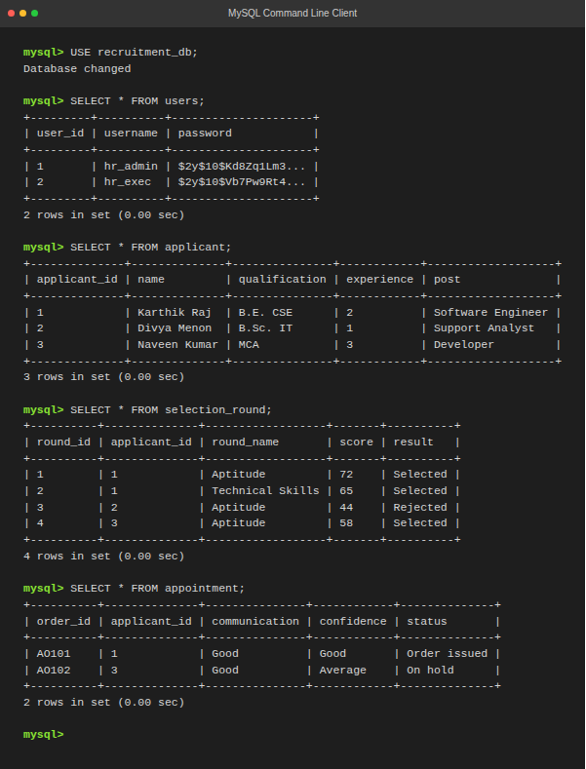
PSEUDO CODE
1. Application and Verification
BEGIN
APPLICANT applies for the post
HR verifies the details
IF details are valid THEN
CENTRAL SYSTEM stores the details
HR calls applicant for Round 1
ELSE
DISPLAY "Invalid details"; ASK for correct details
ENDIF
END
2. Aptitude and Technical Skills
BEGIN
READ aptitude score
IF score > 50% THEN
SET aptitude = SELECTED
READ technical skills score
IF score > 50% THEN
SET technical = SELECTED
CALL applicant for group discussion
ELSE
DISPLAY "Not selected"
ENDIF
ELSE
DISPLAY "Not selected"
ENDIF
END
3. Group Discussion, Interview and Appointment
BEGIN
CHECK communication skills
IF communication is good THEN
APPLICANT attends interview
HR checks confidence
IF confidence is good THEN
ISSUE appointment order
ELSE
DISPLAY "Not selected"
ENDIF
ELSE
DISPLAY "Not selected"
ENDIF
END

EX NO: 11 CONFERENCE MANAGEMENT SYSTEM
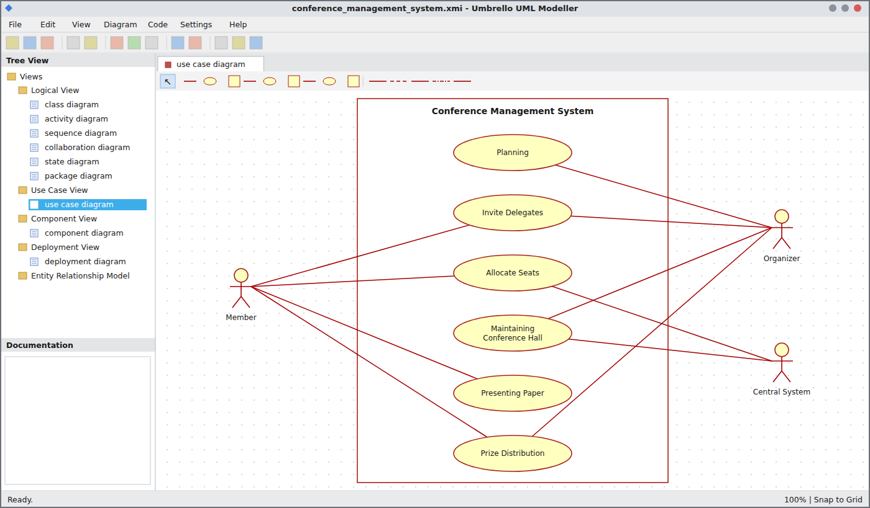
Use Case Diagram
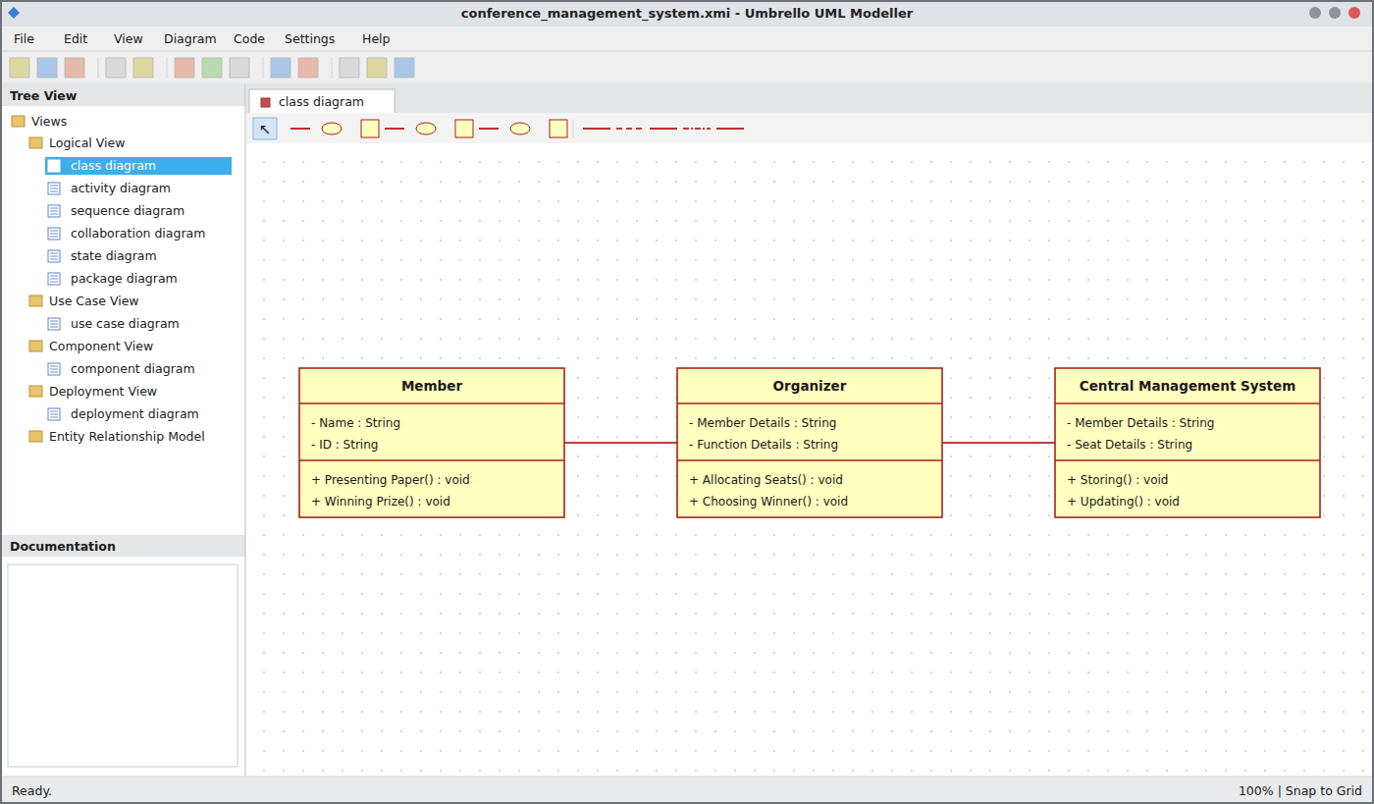
Class Diagram
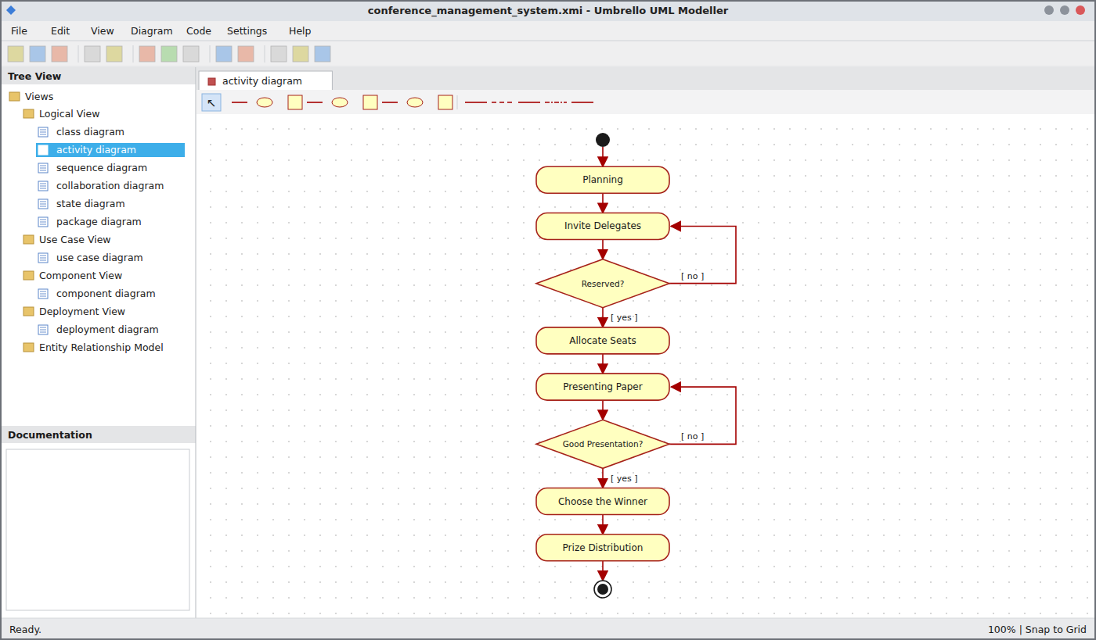
Activity Diagram
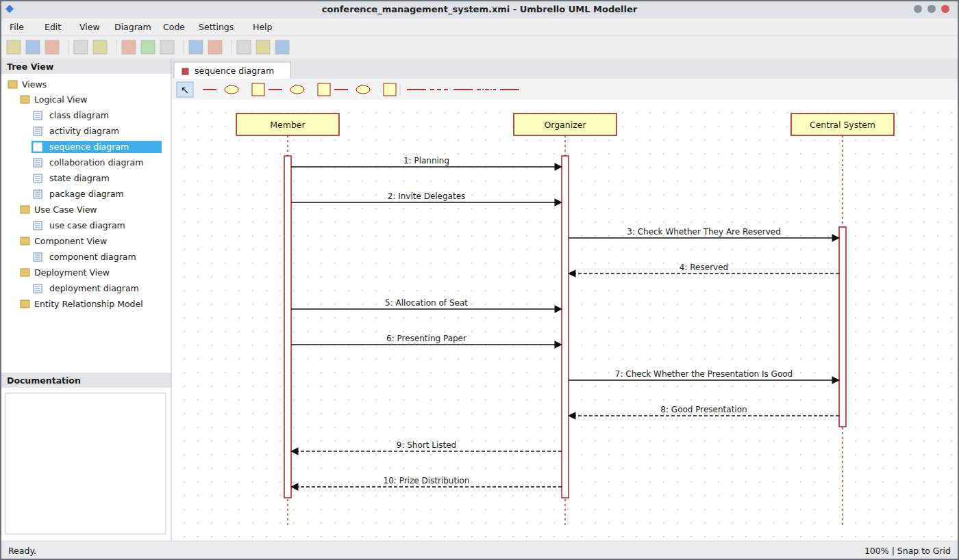
Sequence Diagram
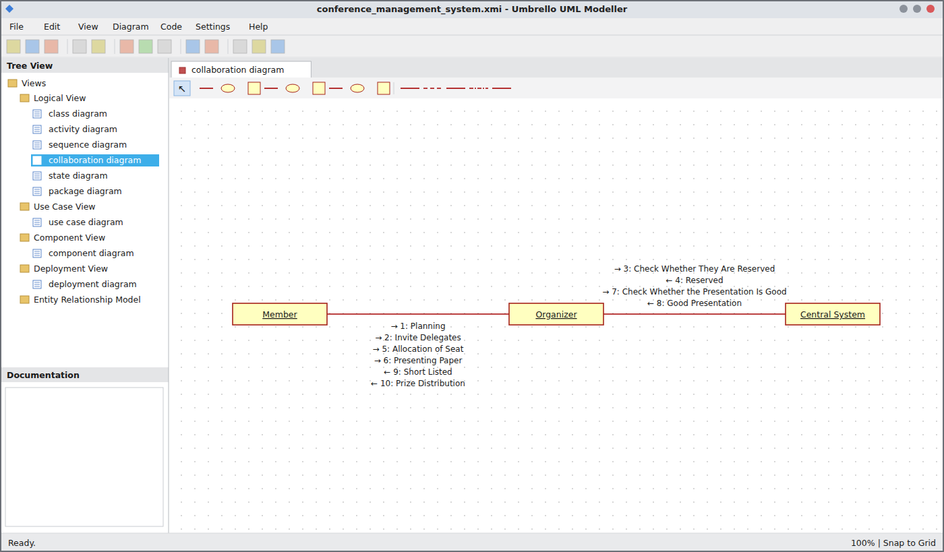
Collaboration Diagram
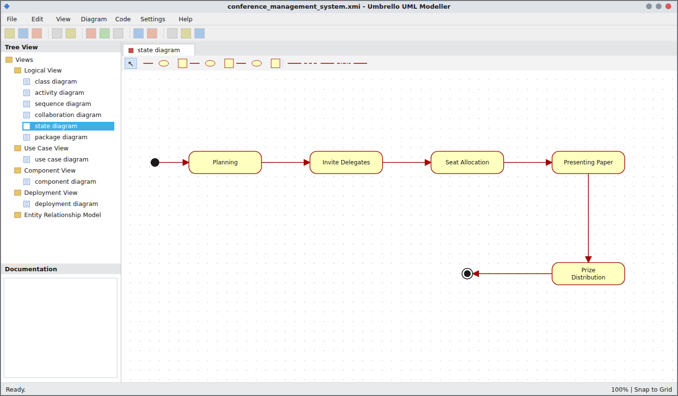
State Chart Diagram
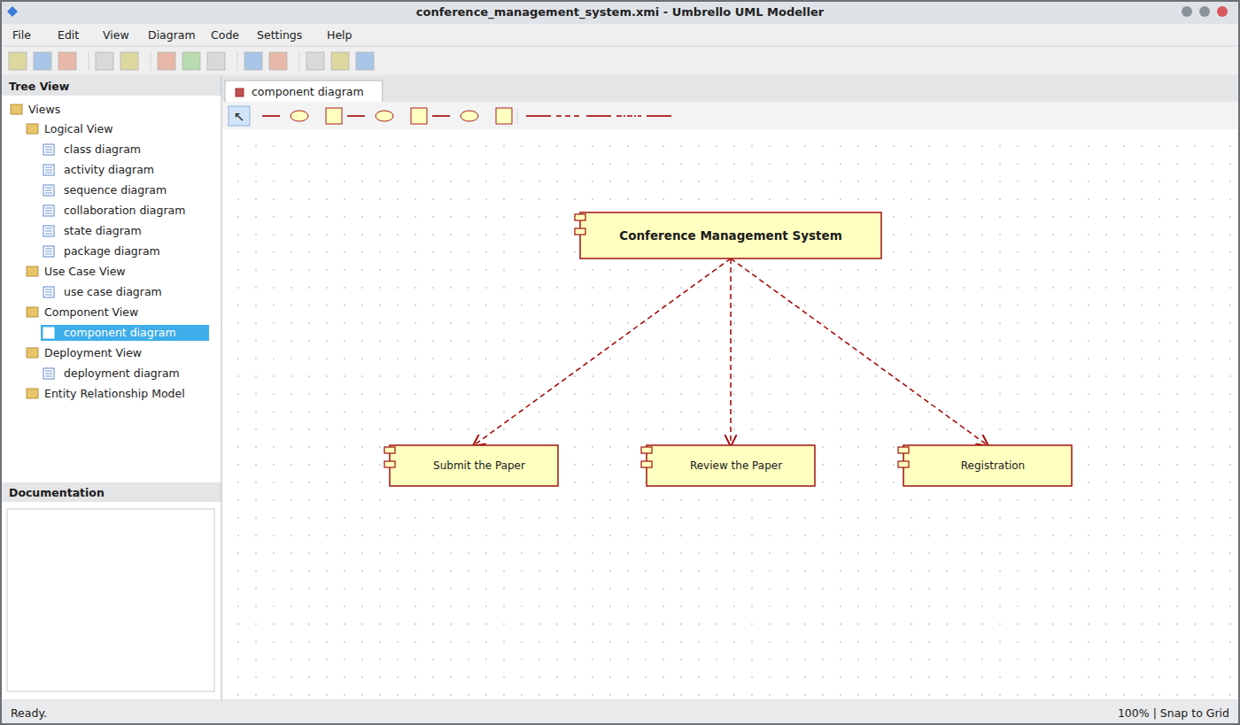
Component Diagram
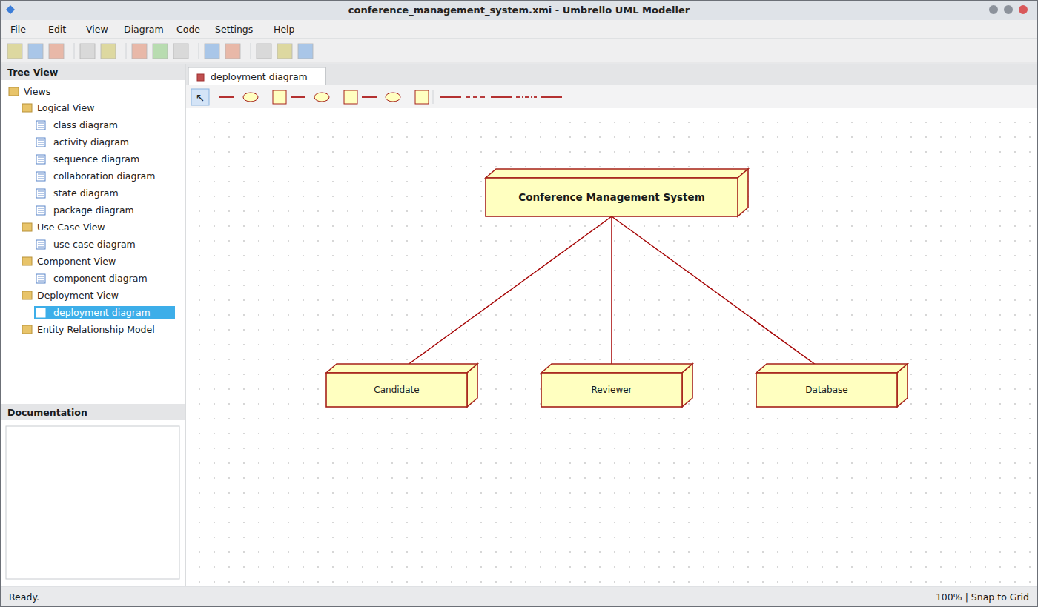
Deployment Diagram
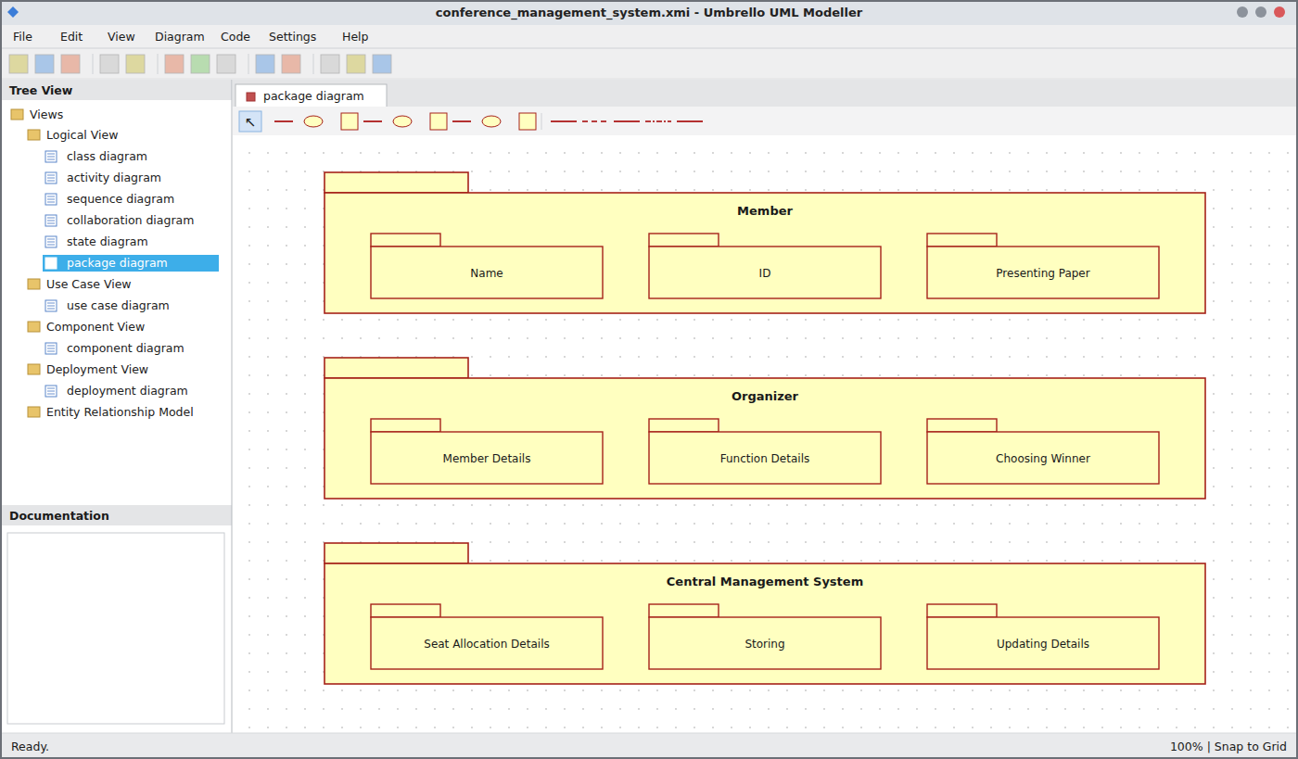
Package Diagram
WEBPAGE SCREENSHOT
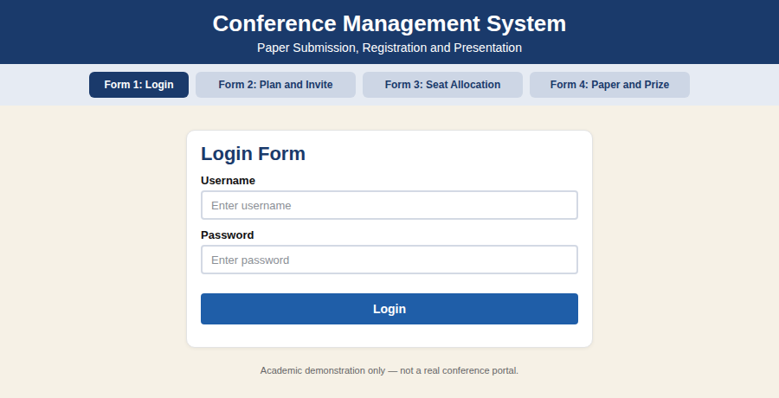
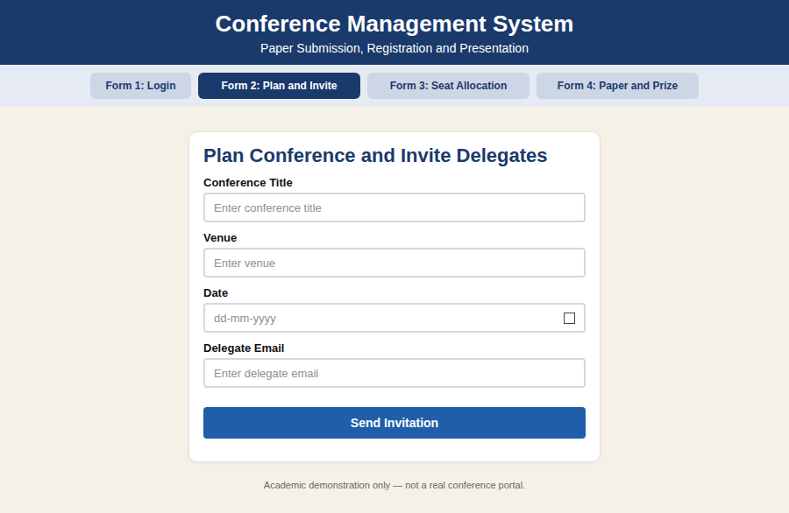
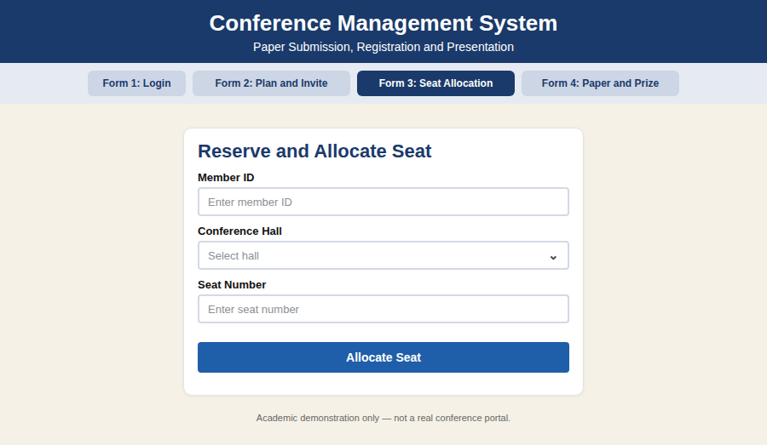
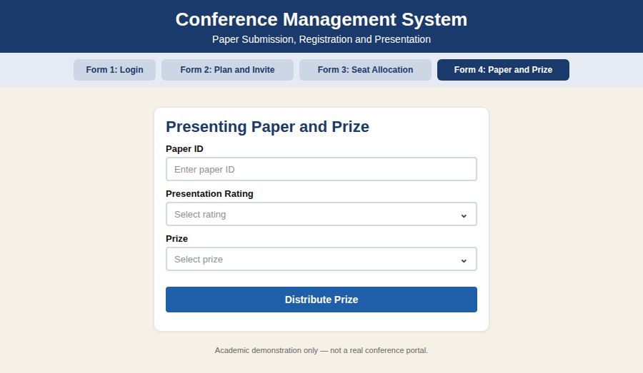
DATABASE SCREENSHOT
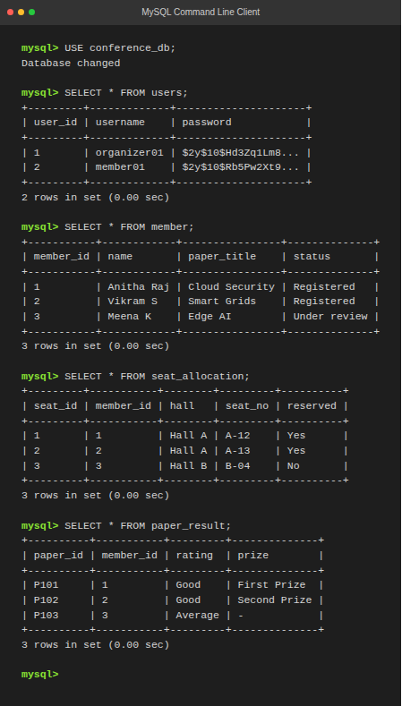
PSEUDO CODE
1. Planning and Invitation
BEGIN
ORGANIZER plans the conference
ORGANIZER invites delegates
MEMBER registers and submits the paper
CENTRAL SYSTEM stores member details
END
2. Seat Reservation and Allocation
BEGIN
ORGANIZER checks whether seats are reserved
IF seat is reserved THEN
ALLOCATE seat to member
ELSE
DISPLAY "Seat not reserved"; ASK member to register
ENDIF
END
3. Presentation and Prize Distribution
BEGIN
MEMBER presents the paper
ORGANIZER checks the presentation
IF presentation is good THEN
ADD member to short list
CHOOSE the winner
DISTRIBUTE prize to winner
ELSE
DISPLAY "Not short listed"
ENDIF
END

EX NO: 12 FOREIGN TRADING SYSTEM
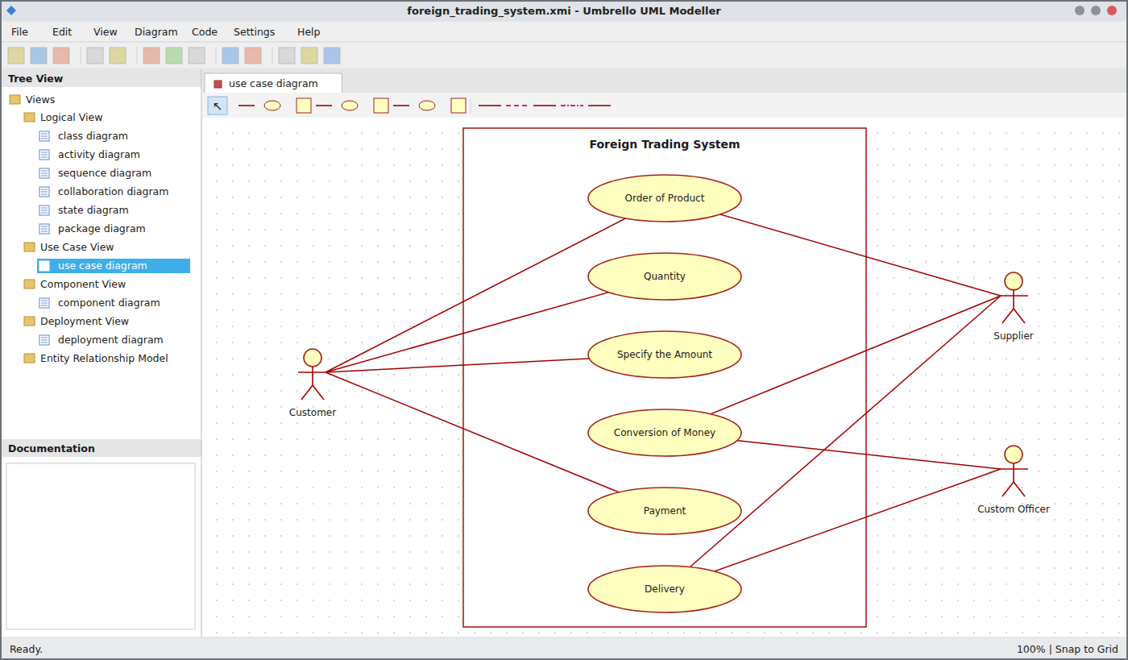
Use Case Diagram
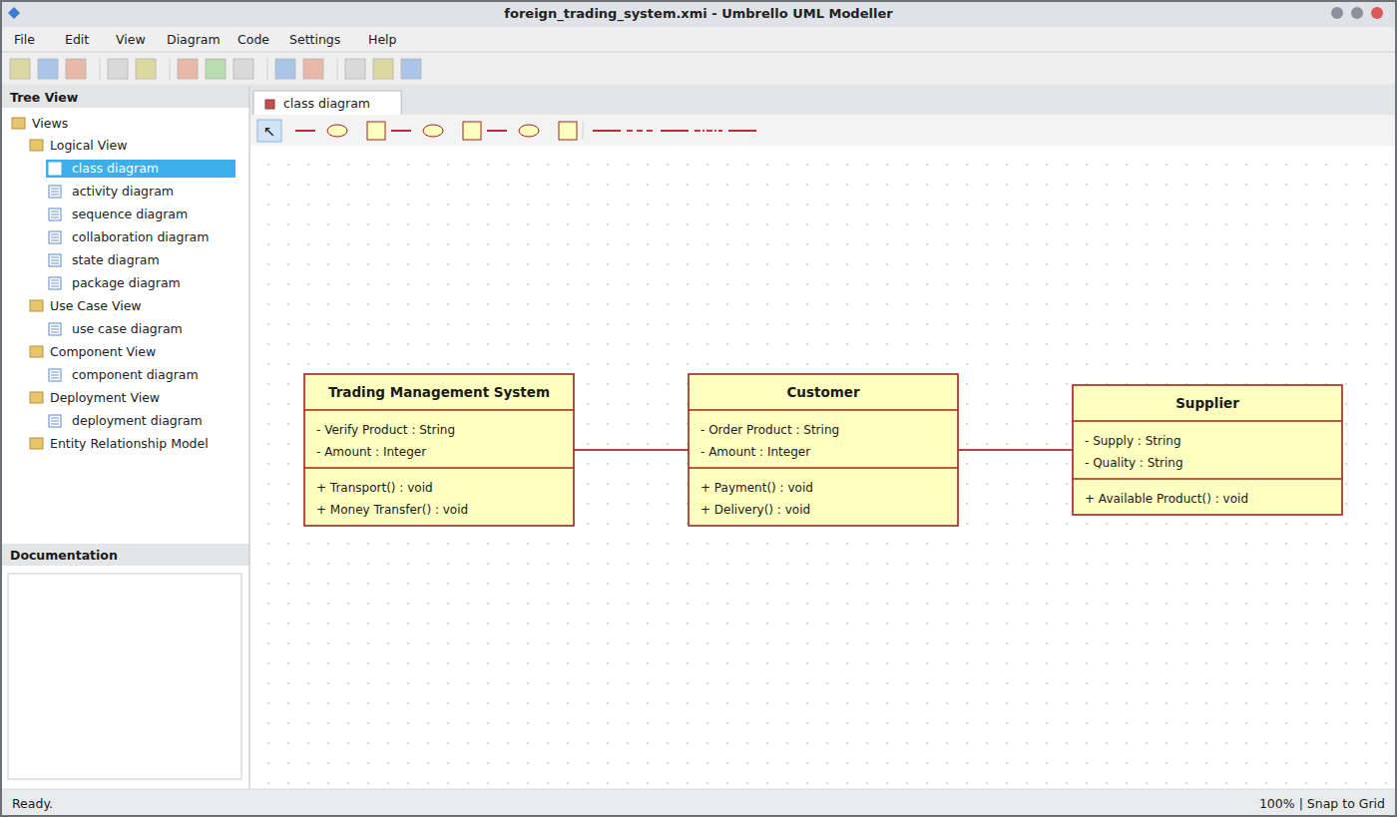
Class Diagram
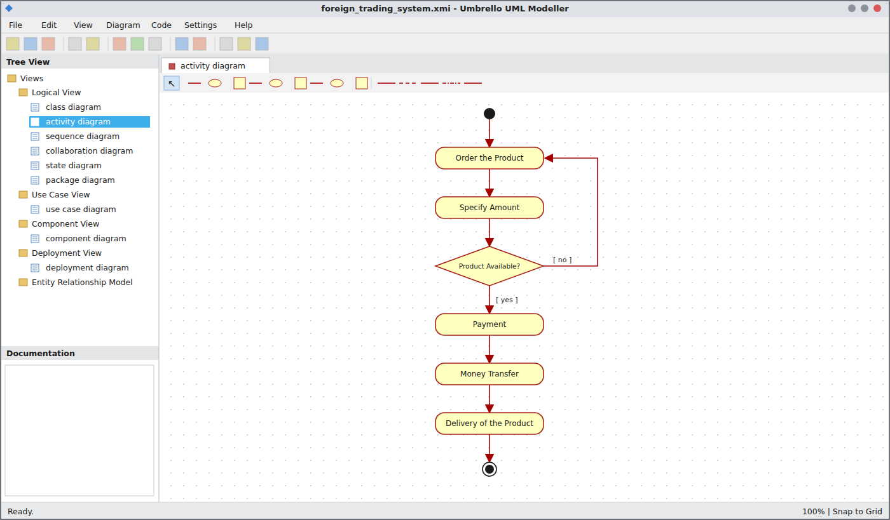
Activity Diagram
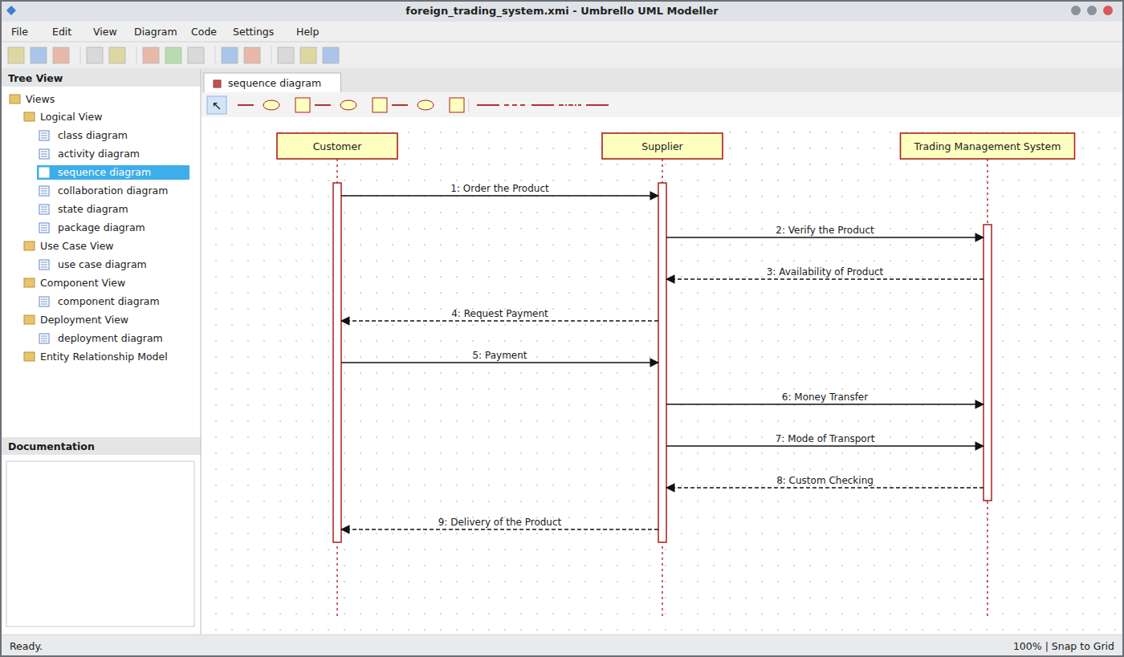
Sequence Diagram
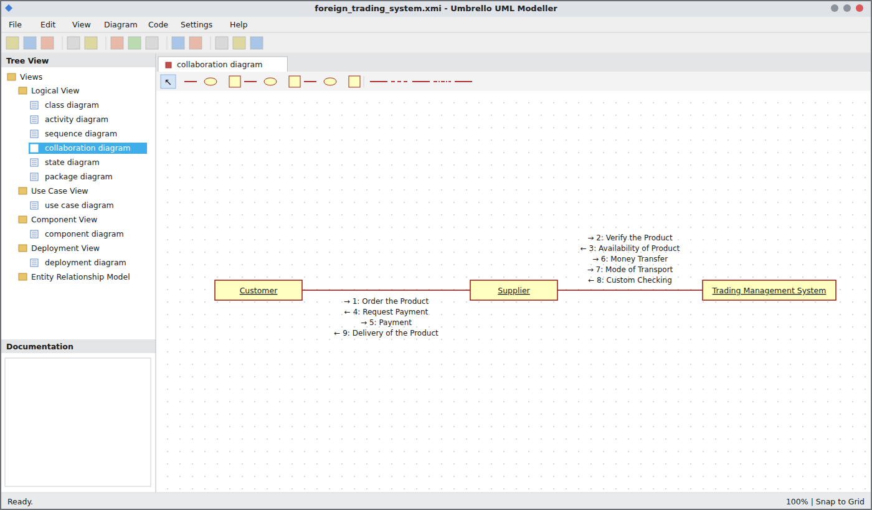
Collaboration Diagram
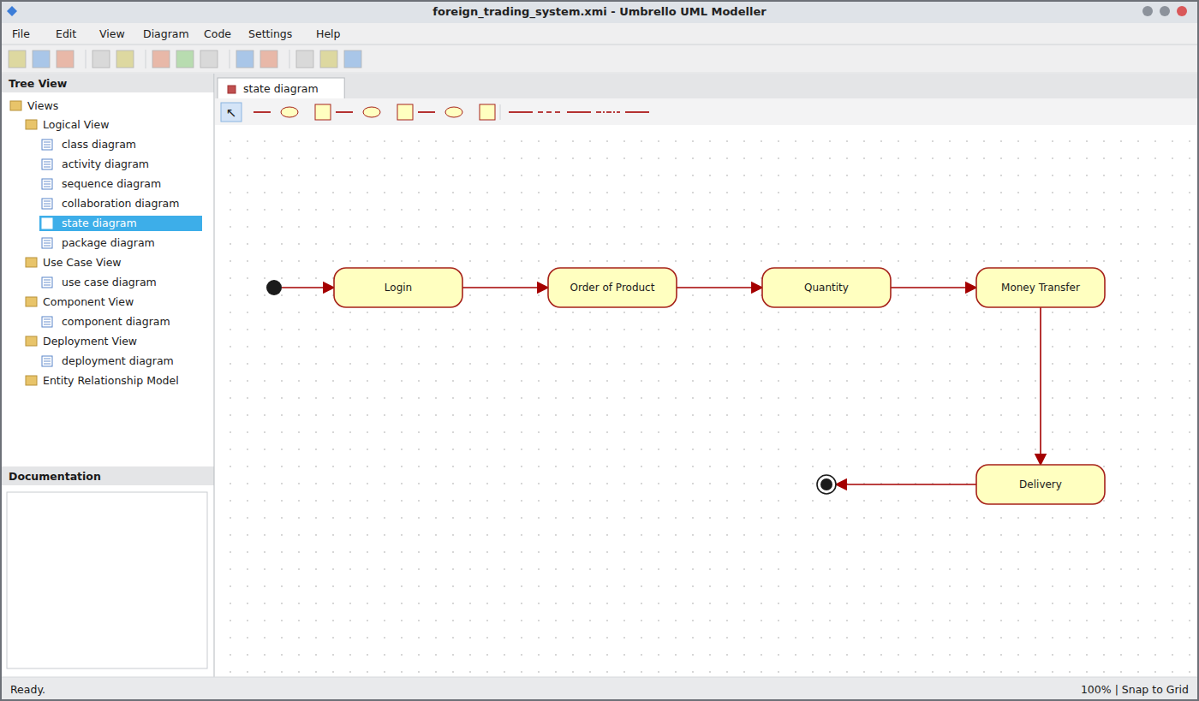
State Chart Diagram
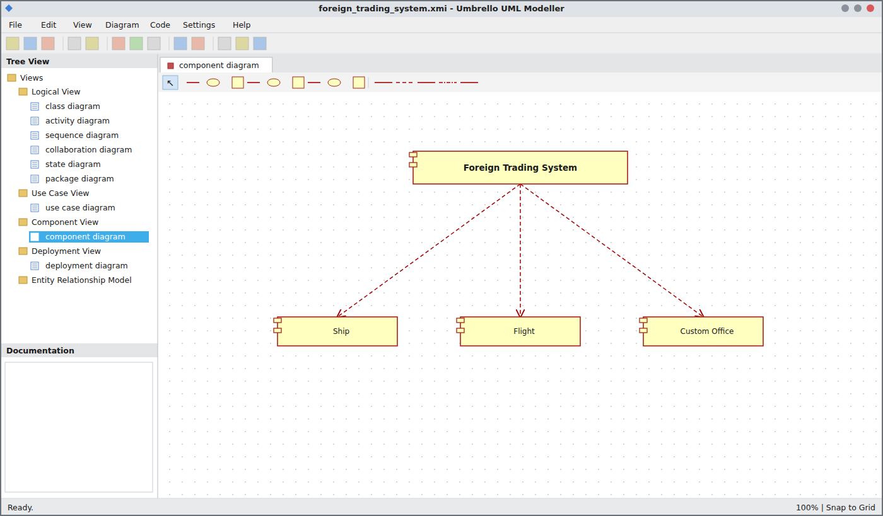
Component Diagram
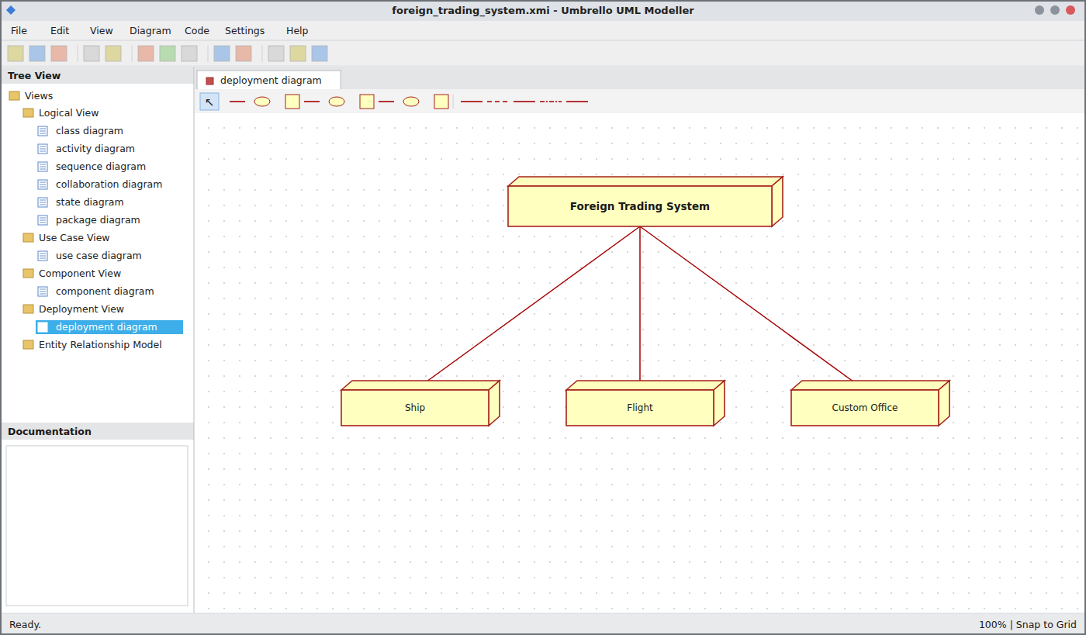
Deployment Diagram
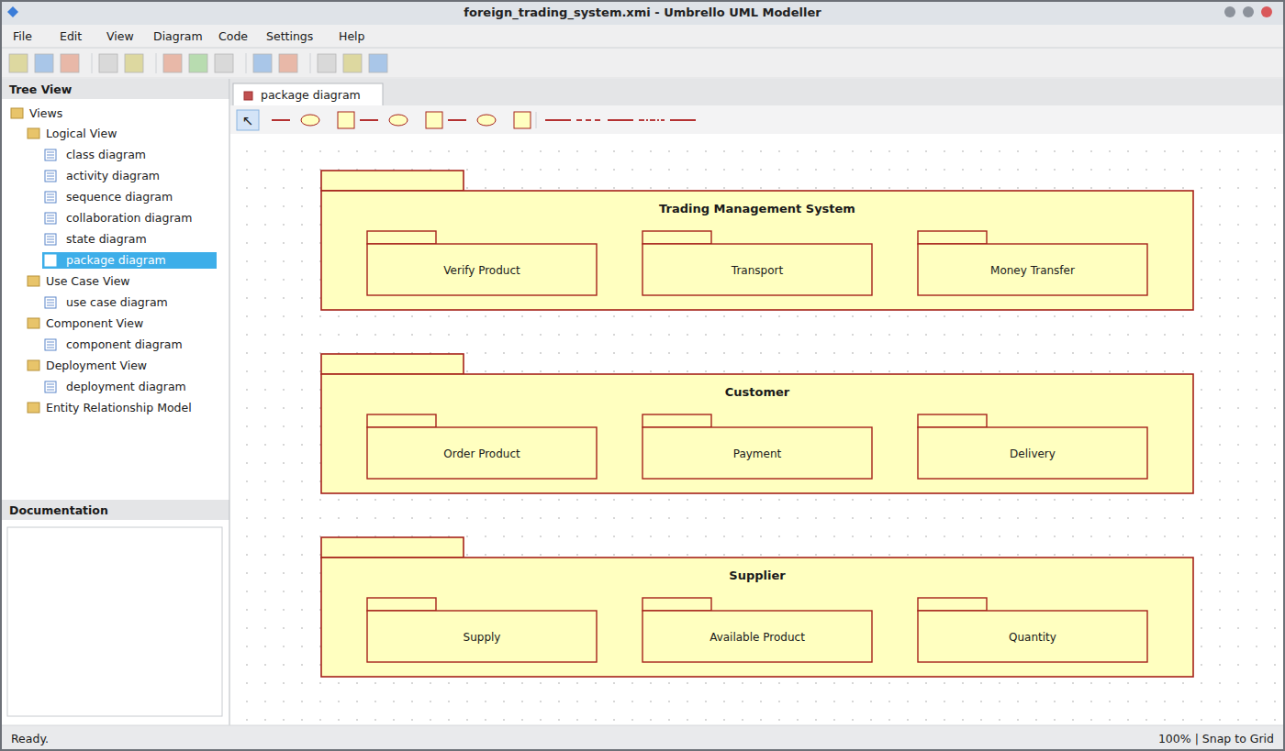
Package Diagram
WEBPAGE SCREENSHOT
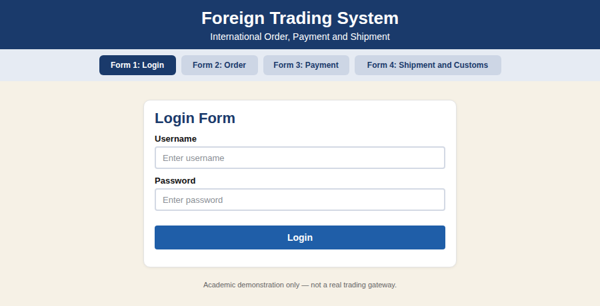
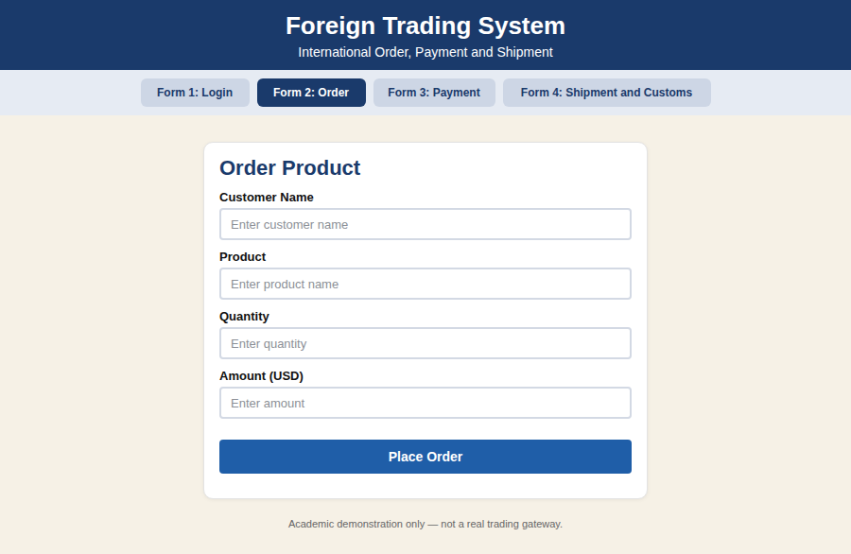
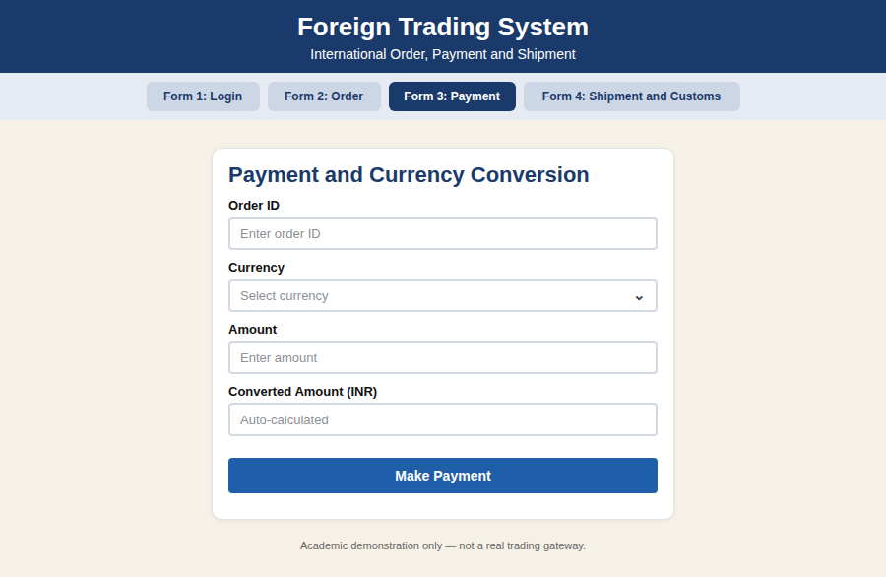
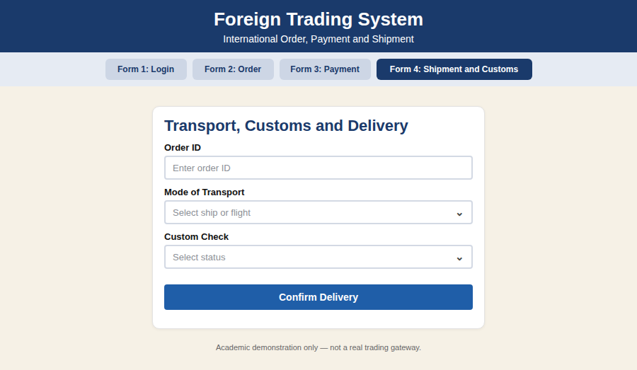
DATABASE SCREENSHOT
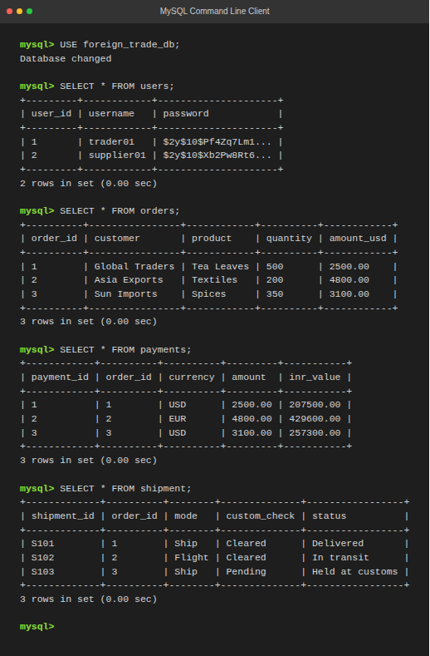
PSEUDO CODE
1. Order and Product Verification
BEGIN
CUSTOMER orders the product and quantity
SUPPLIER verifies the product
IF product is available THEN
SEND availability to customer
REQUEST payment
ELSE
DISPLAY "Product not available"
ENDIF
END
2. Payment and Money Transfer
BEGIN
CUSTOMER specifies the amount
CONVERT money to supplier currency
CUSTOMER makes payment
TRADING MANAGEMENT SYSTEM performs money transfer
SUPPLIER receives the amount
END
3. Transport, Customs and Delivery
BEGIN
SUPPLIER selects mode of transport (SHIP or FLIGHT)
CUSTOM OFFICER checks the goods
IF custom check is cleared THEN
DELIVER product to customer
ELSE
DISPLAY "Held at customs"
ENDIF
END

EX NO: 13 BPO MANAGEMENT SYSTEM
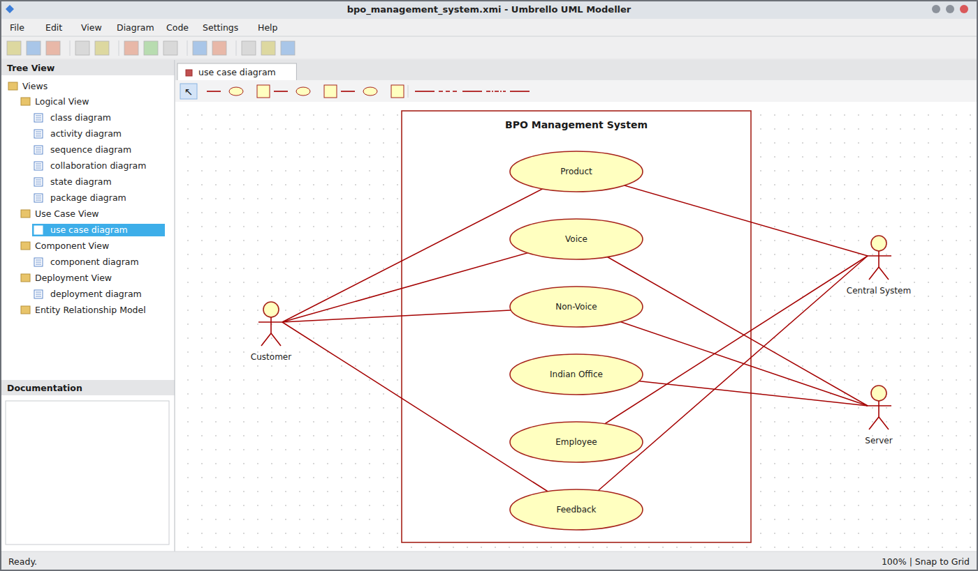
Use Case Diagram
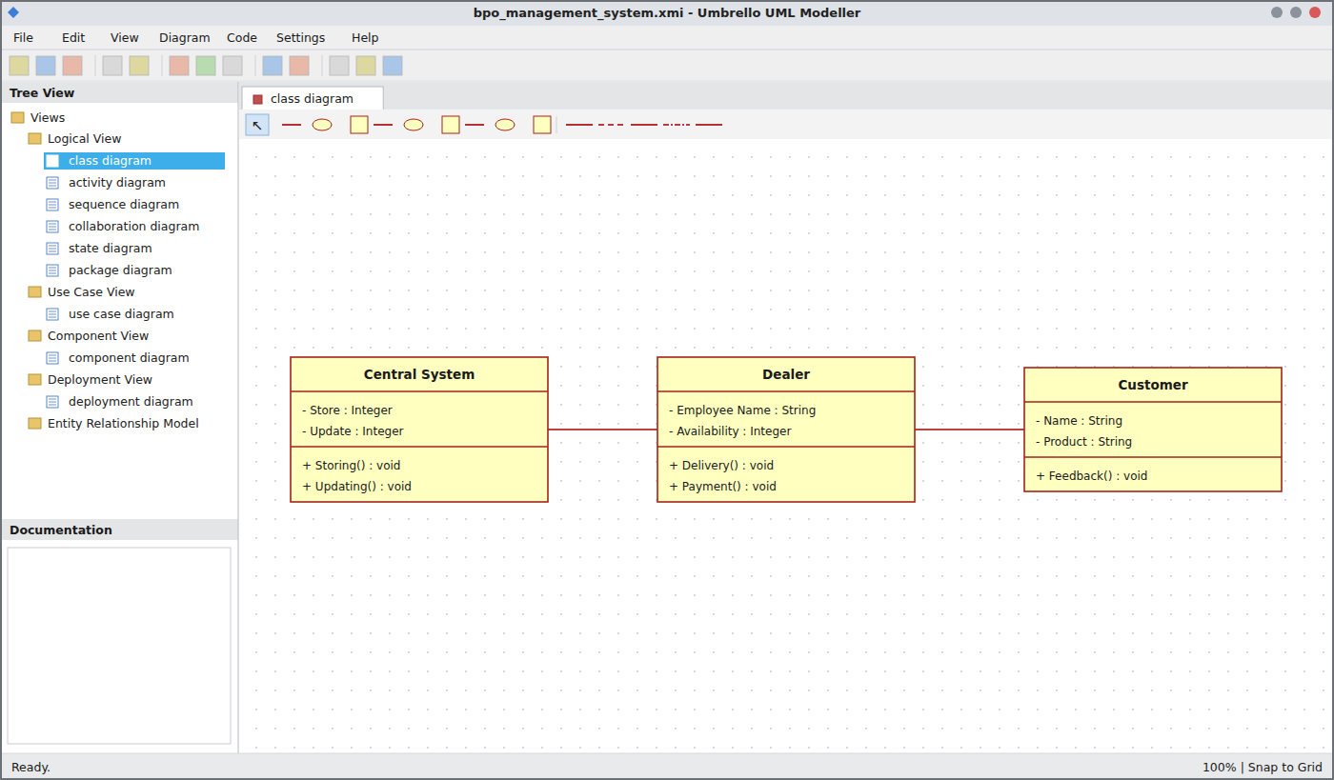
Class Diagram
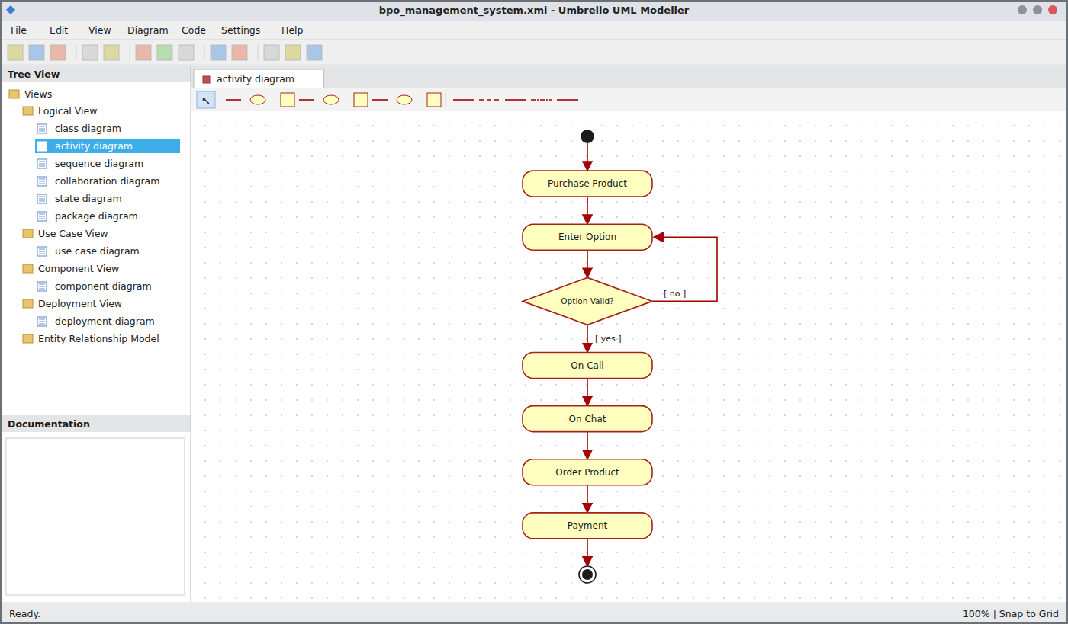
Activity Diagram
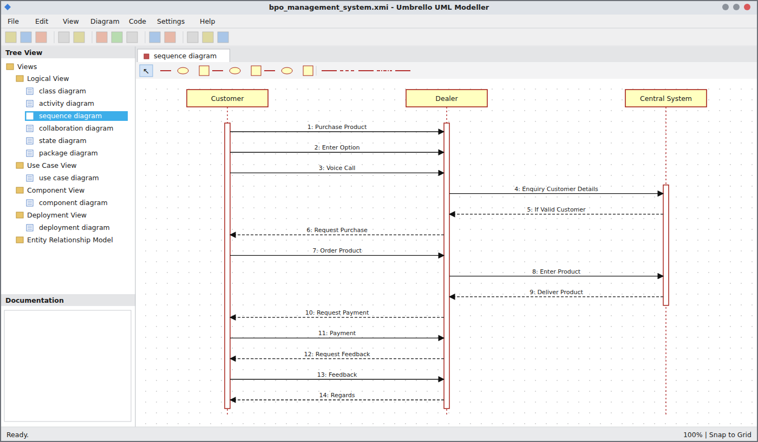
Sequence Diagram
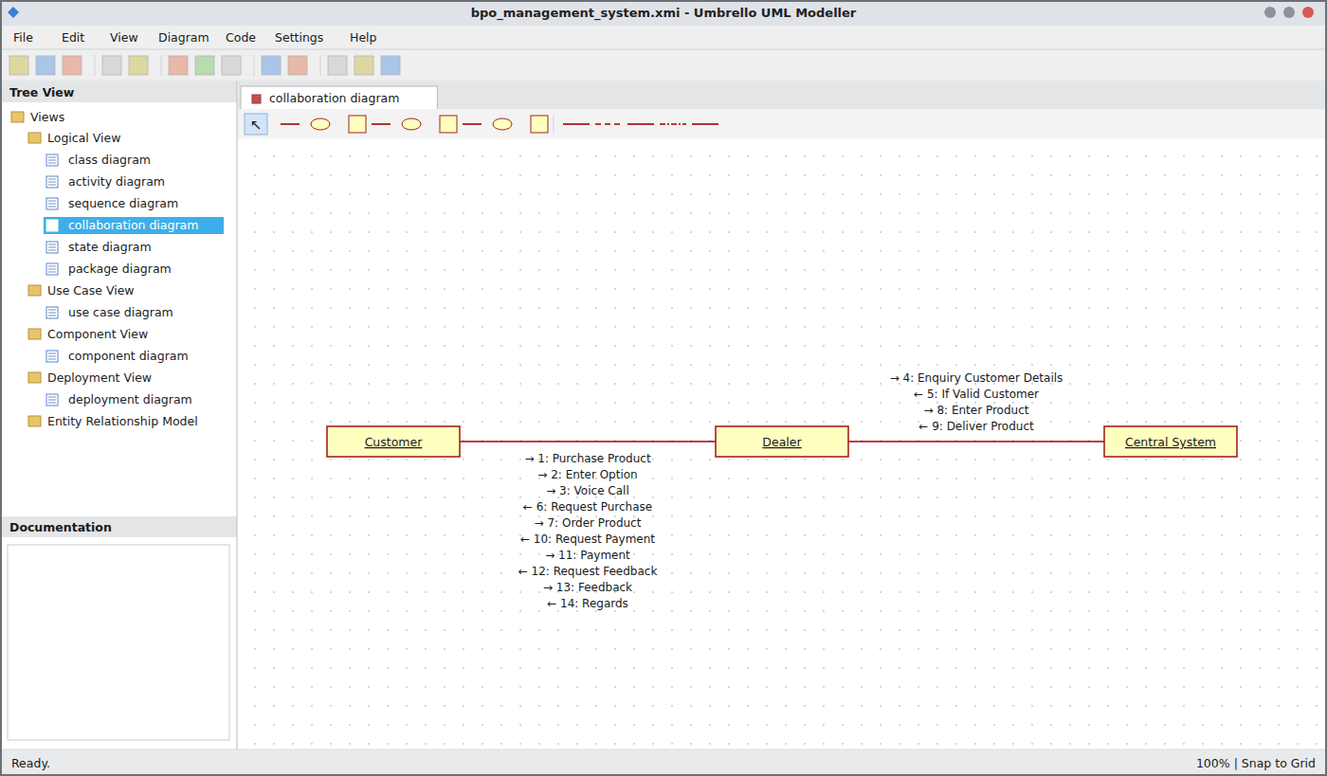
Collaboration Diagram
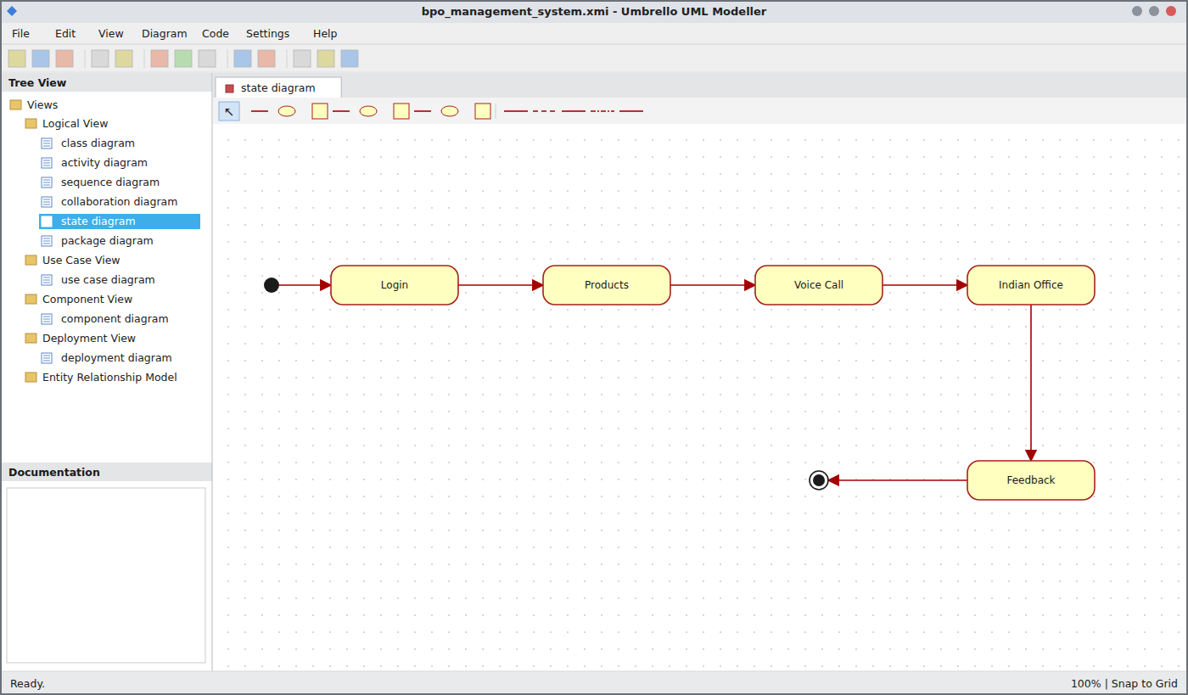
State Chart Diagram
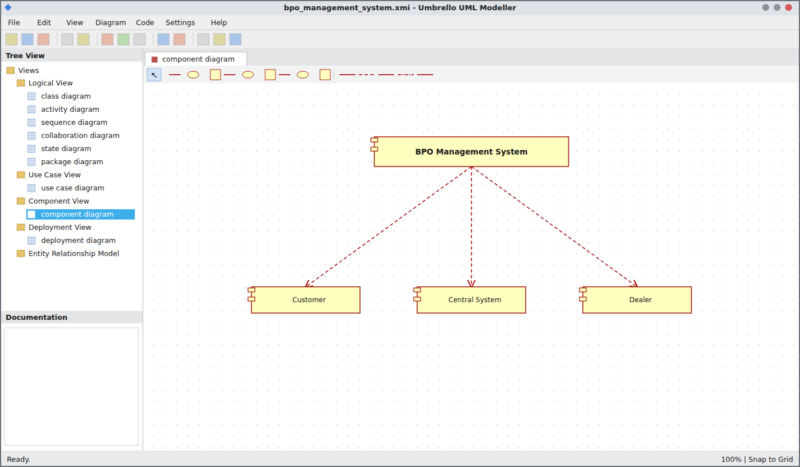
Component Diagram
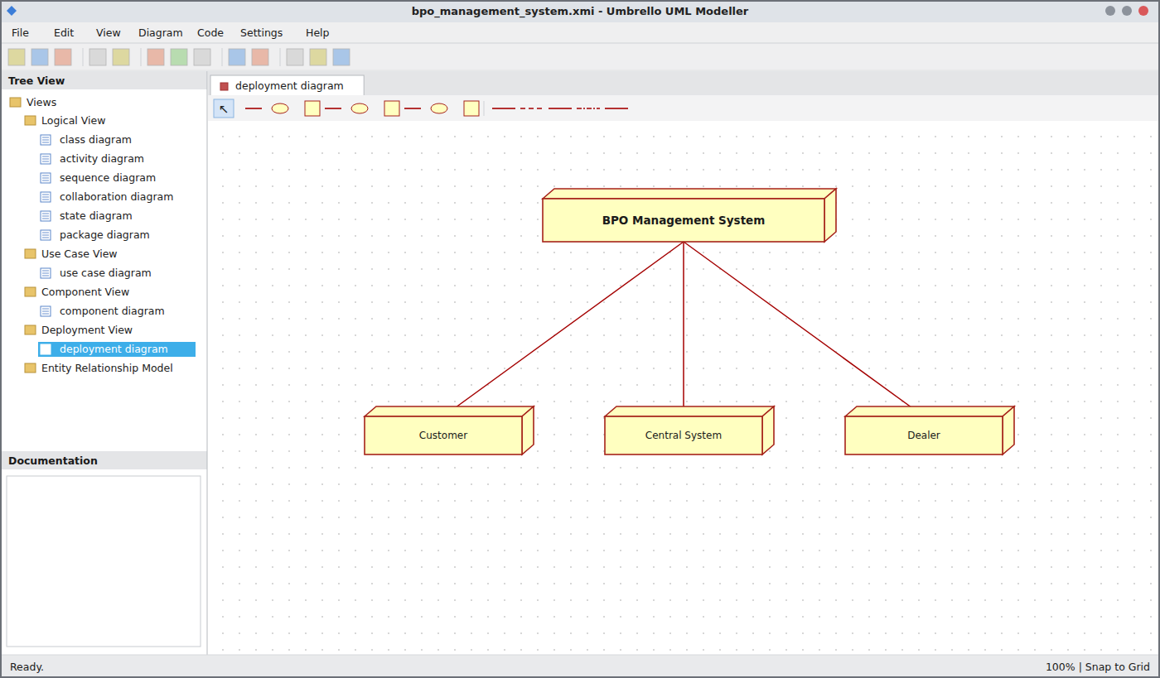
Deployment Diagram
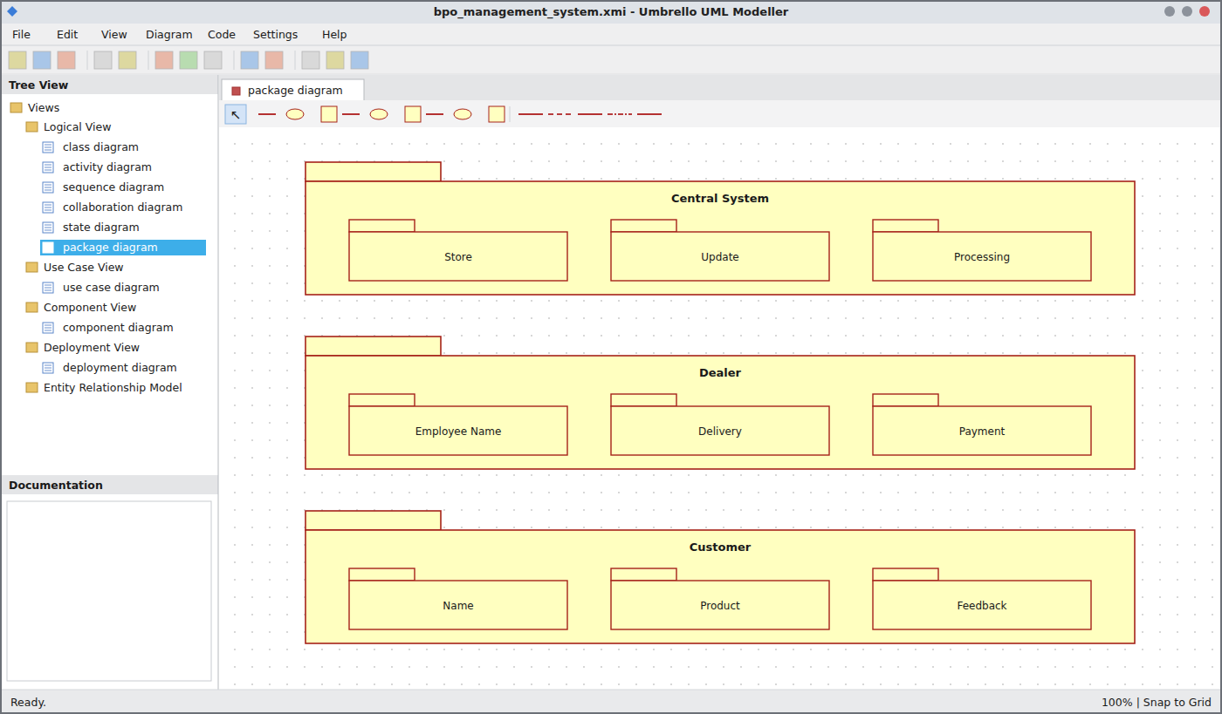
Package Diagram
WEBPAGE SCREENSHOT
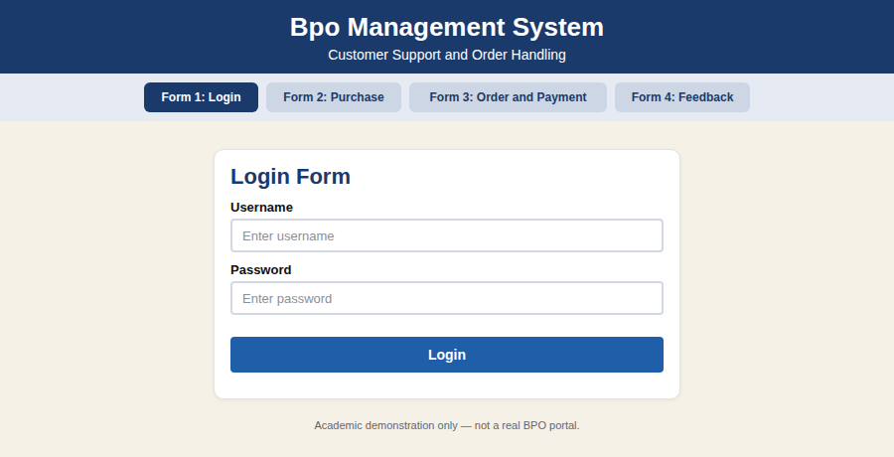
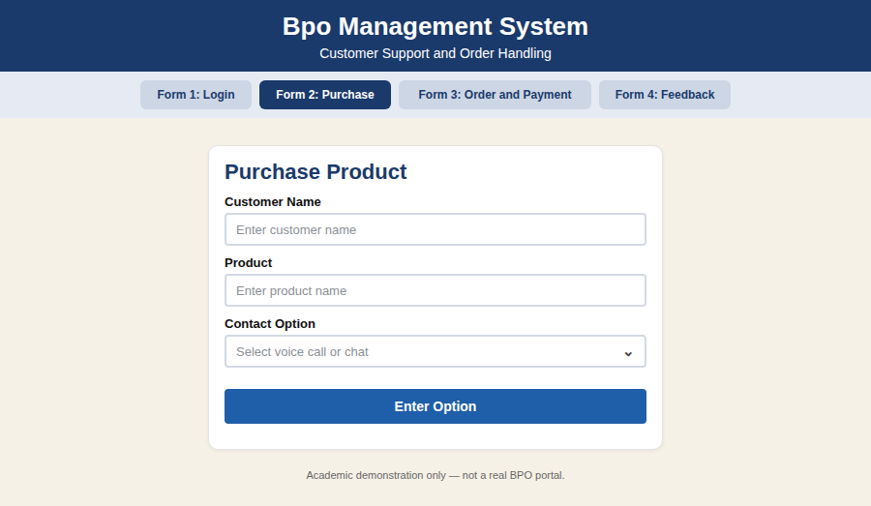
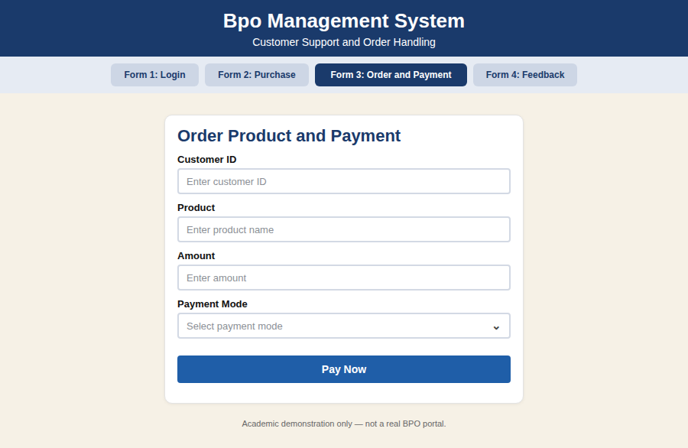
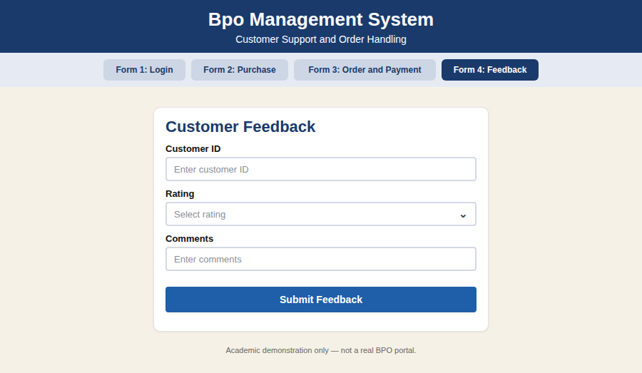
DATABASE SCREENSHOT
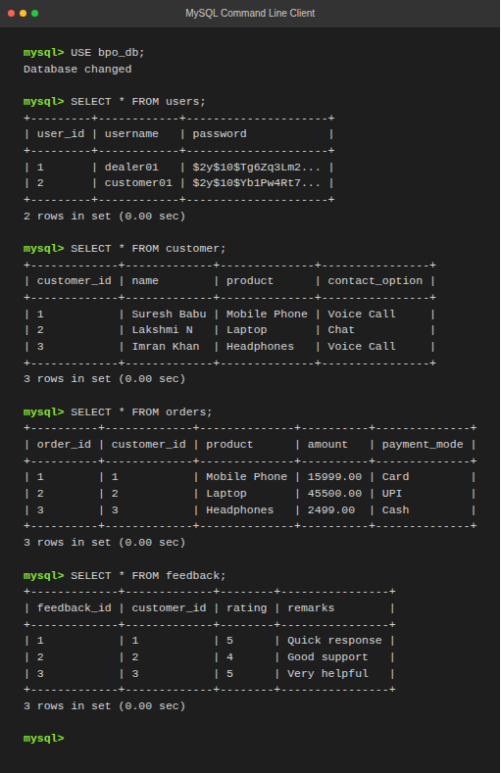
PSEUDO CODE
1. Login and Option
BEGIN
CUSTOMER logs in to the BPO website
READ product to purchase
ENTER option (VOICE CALL or CHAT)
IF option is valid THEN
CONNECT customer to dealer
ELSE
ASK option again
ENDIF
END
2. Customer Enquiry and Order
BEGIN
DEALER enquires customer details from CENTRAL SYSTEM
IF customer is valid THEN
DEALER requests purchase
CUSTOMER orders the product
DEALER enters product in CENTRAL SYSTEM
DELIVER product
ELSE
DISPLAY "Invalid customer"
ENDIF
END
3. Payment and Feedback
BEGIN
DEALER requests payment
CUSTOMER makes payment
DEALER requests feedback
CUSTOMER gives feedback
DEALER sends regards
CENTRAL SYSTEM updates the details
END

