Asa Hayes GEOG-232 Breyer 30 September 2020

**Lab 4: Data Classification**

Q1 (10 pts): Take a screenshot of your UpperGulfCoast_tracts attribute table.

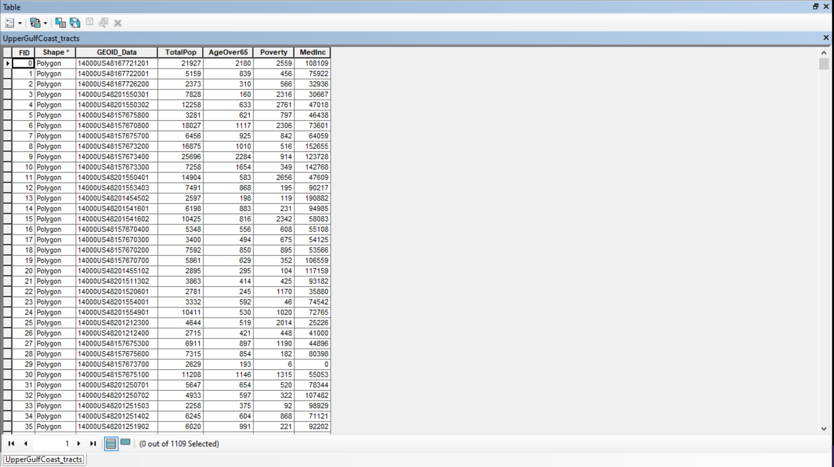

Q2 (10 pts): ArcMap provides a total of seven options for classification methods. In your own words, describe how each classification method sets class breaks.

* Manual: Allows you to arbitrarily select the breaks at whichever interval is desired.
* Equal Interval: Sets each interval as the same size. Regardless of the amount of data within each category, the value range covered by each class is equal to all others.
* Defined Interval: Rather than determine a range to fit a set number of classes like Equal Interval, this option determines the amount of classes to cover the data given an interval size. Each interval is the same size, but the amount of intervals is decided by ArcMap.
* Quantile: Sets each interval to contain an equal amount of data points as the others. This usually results in varying interval sizes, especially on data with high variance.
* Natural Breaks: Designed to create intervals that emphasize difference. Useful for categorizing multi-modal data with “clusters” of similar points.
* Geometric Interval: Bases interval splits on a computed geometric series. The intent is that both the ranges and number of data points in each break are near to each other, to compromise between Equal and Quantile intervals.
* Standard Deviation: Each break is determined by distance (positive and negative) in Standard Deviations from the mean. Useful for finding outliers or mean-conformal areas.

Q3 (10 pts): Take a screenshot of your preferred classification method for each vulnerability indicator. Make sure your screenshot includes the Table of Contents so that the class breaks are visible.

AgeOver65: Natural Breaks, 5 Classes

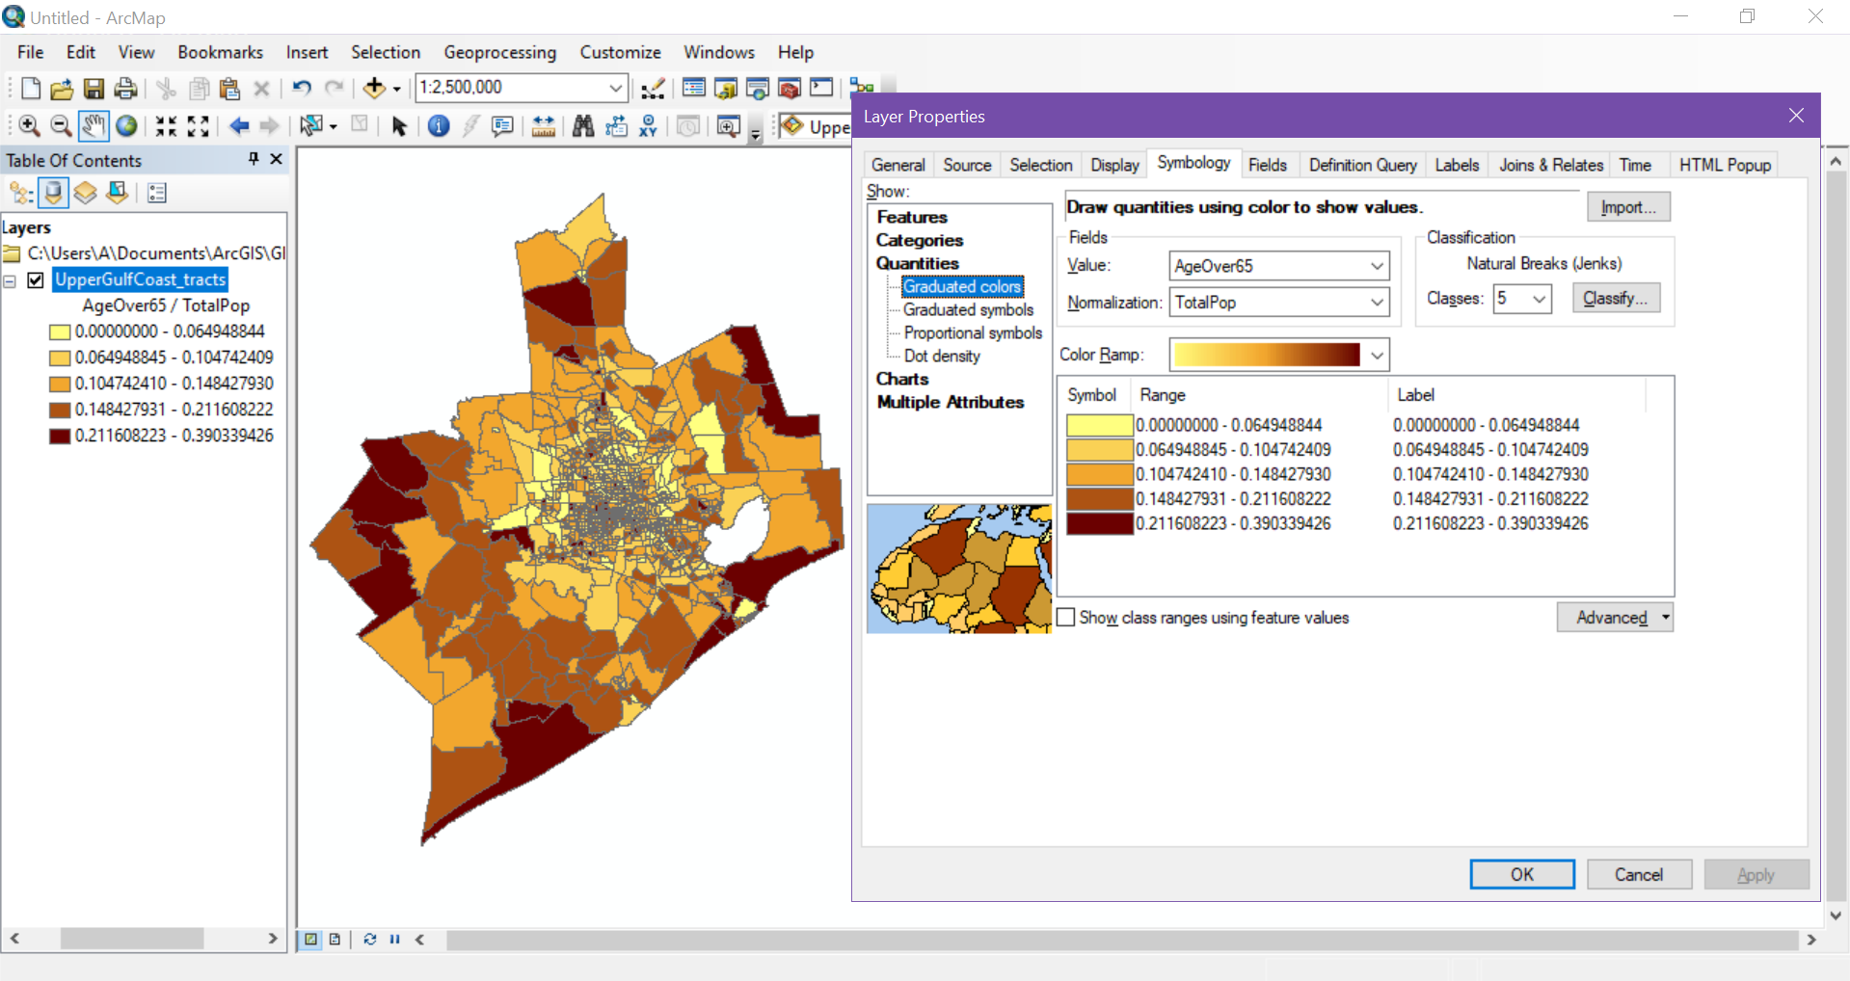

Poverty: Quantile Interval, 5 Classes

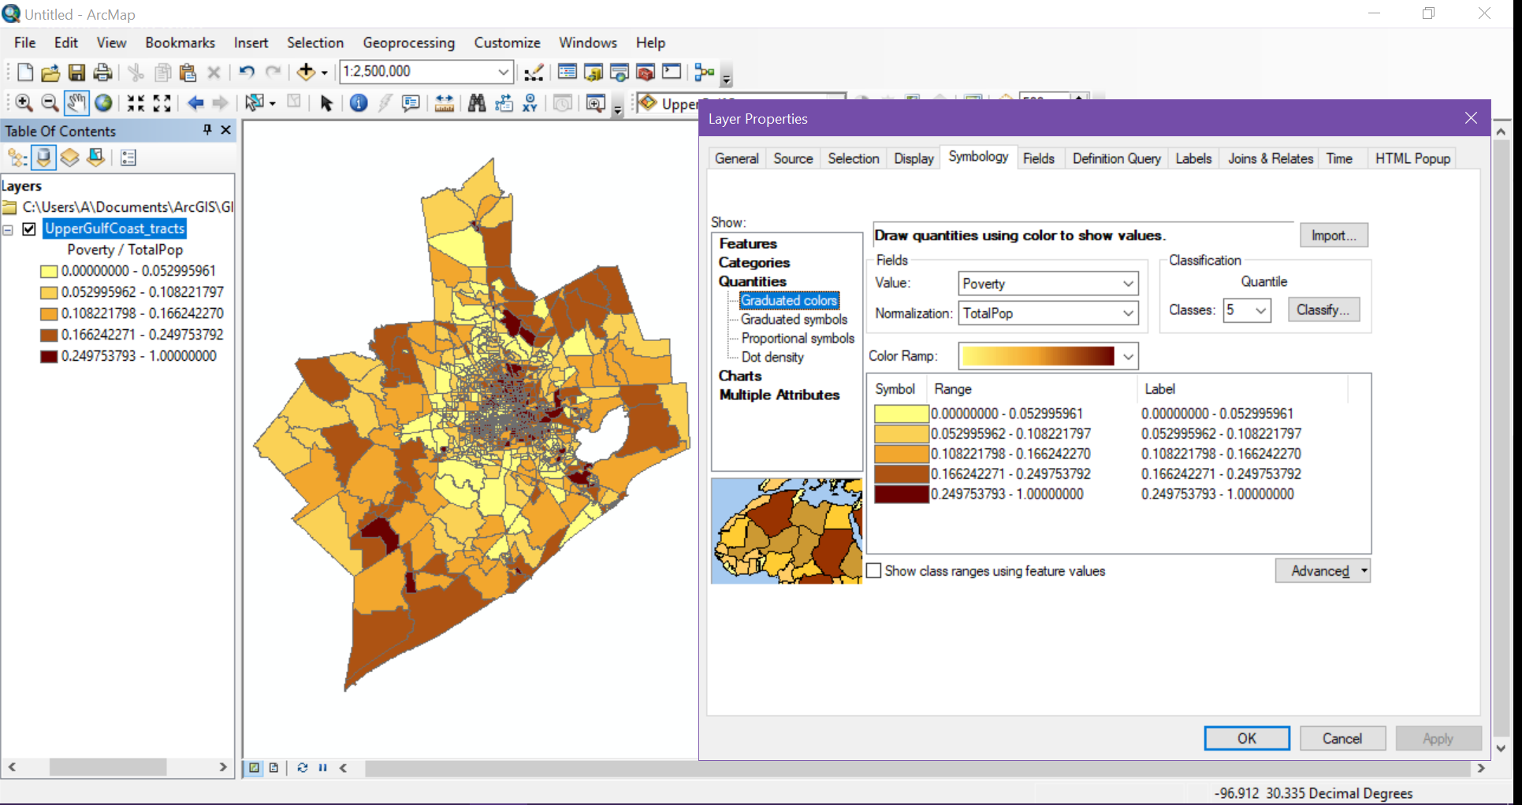

MedInc: Quantile, 4 Classes

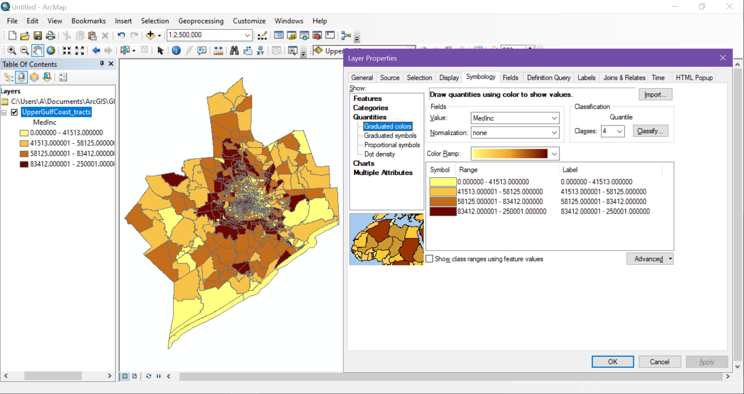

Q4 (10 pts): What classification method did you use for each vulnerability indicator? How many classes did you select? Why did you make that selection? Discuss the advantage or disadvantage of your selection (aim for around 4-5 sentences).

* AgeOver65: To start, Manual, Defined, and Standard Dev. Intervals would not be useful for this metric. I then looked for a setting that would emphasize the higher age values, in keeping with this being a risk assessment map. Though it is the default setting, Natural Breaks and 5 classes fit the display trend I was looking for without washing out either end of the spectrum too harshly. However, as this representation is useful for this specific purpose, looking for other trends would be hampered, and the number of classes may lead to different insights if lowered or raised.
* Poverty: As this metric also requires more attention to the lower values, the same interval settings were discarded as unhelpful, unwieldy, or poorly fitting. Natural breaks was discarded as well, as the relatively small proportion of low poverty areas was washing out the high poverty areas. While Quantile and Geometrical were both considered close for this category, Quantile looked more useful and distinct than geometrical, especially with 5 breaks. More breaks would have made the map more split and confusing for no reason, while less breaks would reach the same washing-out issue.
* MedInc: While there would normally be more to be gleaned from a dataset such as this, overcomplicating the ranges for a risk-evalutation would not be helpful. The lower amount of classes reflects this, as we mainly need to determine areas where thresholds of income (which relate to people’s ability to prepare for/respond to disasters) are more general. The higher end specifically needed to be de-emphasized, as higher value areas would be less likely to need additional resources. The best representation for both of these qualities was met by Quantile intervals.

Q5 (10 pts) For the AgeOver65 and Poverty indicators, higher values are expected to worsen vulnerability. For the MedInc indicator, lower values are expected to worsen vulnerability. Given this, where in the Upper Gulf Coast of Texas do you see areas of increased vulnerability to hazards for each variable? Are there areas where multiple indicators of vulnerability tend to coincide? Describe the spatial patterns in each variable that helped you come to this conclusion.

AgeOver65 has most of its high-risk populations in tracks at or near the outskirts of our pictured area, especially near the coast. Populations of those over 65 seem to increase with distance from the center of the metropolitan area. The same is true to a lesser extent of proportion below the poverty line. However, there are also many tracts within the metro area with large amounts of poverty as well. Though inverted from the poverty statistics, median income moves in this general pattern as well. As all these patterns line up, especially when visually compared side by side, it is likely that the suburban area surrounding the city is of least general risk over all of these factors. The combination of low income and high elderly populations shows the outskirts of the displayed area as the highest risk, with sections of the inner city only shortly behind due to the high poverty but low elderly population.