Asa Hayes GEOG-232 Breyer 14 October, 2020

**Lab 5: Thematic Map Symbols**

Part 1

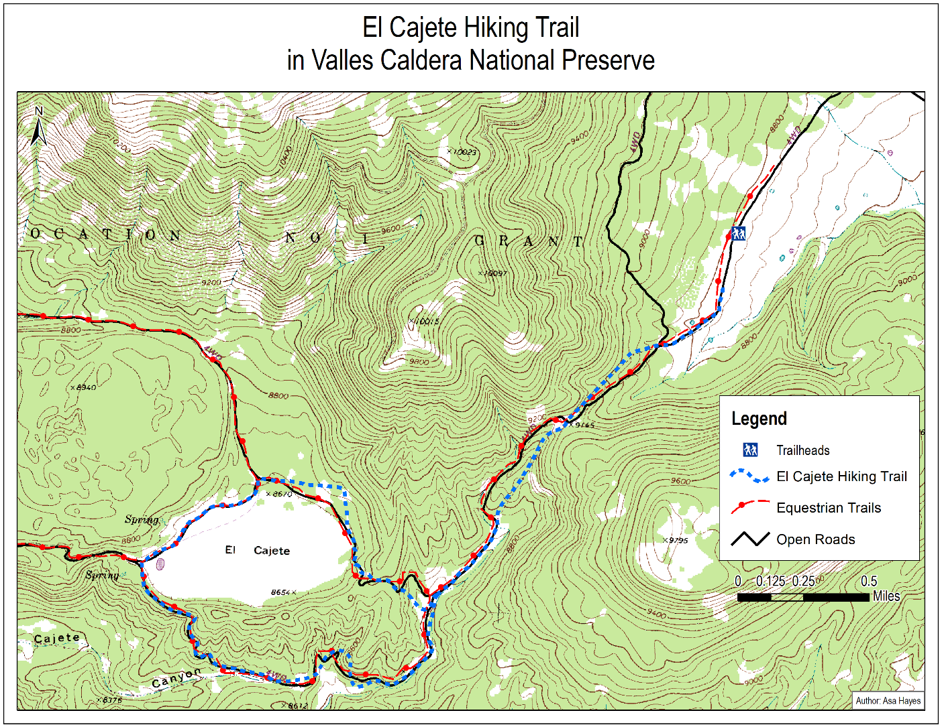

Part 2

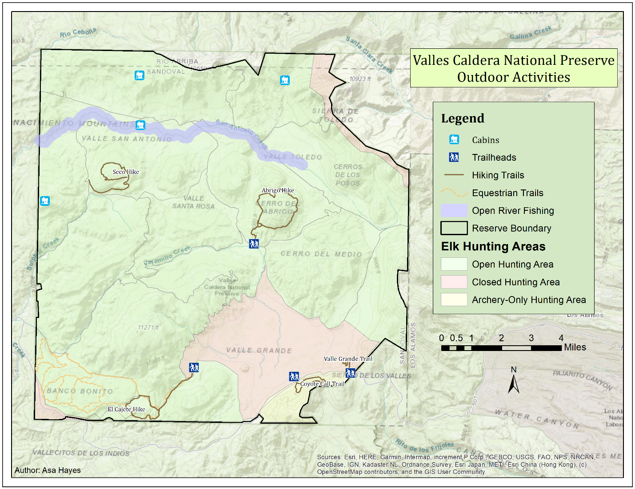

Part 3

Write at least 4 sentences evaluating your overall map design. Your response should discuss what sort of impression your map might make on a member of the general public  
who is unfamiliar with the area being mapped and ways your map could be further improved. (5 points)

The imagery is overlaid with the elements I chose to provide a reasonable reference to the landscape around, and also to lessen the impact of the many hunting areas splitting up the reserve. Regardless of the title, the legend should make it clear that this map is more for the specifically outdoor activities of the area. None of the elements are very complex, and the one main complex feature, the different elk hunting regions, was simplified to only highlight the exceptions to the norm rather than categorize each individual area. The one thing I’m not fully confident on is the colors, especially on the title & legend boxes. I wanted them to not stand out too much from the colors of the basemap but not blend in either, and I’m not sure if these shades accomplished that properly.

2. Evaluate the symbolization decisions you made for each of the 5 data sets you used in  
your map for Part 2. In your response, please create subheadings for each dataset and  
answer the following questions about each: (1 point each x 5 data sets = 15 points total).  
a. Where does this layer stand in the intellectual hierarchy for your map? Is it the  
main topic of the map or a supporting data set to add context?  
b. How did you translate this data set’s position in the intellectual hierarchy into a  
visual hierarchy? Be specific about why you chose the specific symbol types,  
colors, and sizes

* Reserve Boundary:
  + Hierarchy: Quite low. Mainly serves to set the scope of the reserve.
  + This was left as default, being essentially just a slightly thicker version of the borders between the hunting areas, as a barrier between the reserve and its surroundings.
* Elk Hunting Areas:
  + Hierarchy: While most areas are visually subdued, it is one of the main points of the map, due to the prevalence of the preserve as a hunting spot.
  + This was somewhat complicated to work out, as I needed to have all the areas displayed, but not in a way that would clutter the entire map. By making use of the <all other values> range in the categorization, I was able to have all the regular hunting zones shown while only strongly emphasizing the restricted areas. Color choice was easy, green for “ok to hunt”, yellow for “caution, only some hunting”, red for “stop hunting”.
* Open River Fishing:
  + Hierarchy: Still very high importance on the map, only slightly less than hunting due to smaller area.
  + While very simple, the partially transparent blue area serves several purposes. It was able to overlay the hunting area boundaries and leave them visible, as well as the river in the basemap. The blue lets it stand out from most other map elements as eye catching and easy to find for those looking for fishing.
* Hiking Trails:
  + Hierarchy: High, about on par with hunting or fishing due to its relative popularity.
  + The hiking trails stand out from the rest of the features via the color difference, along with labelling and the trailhead symbols (which do not warrant a description in and of themselves). As the most prevalent “foreground” feature, their importance was necessary to display.
* Equestrian Trails:
  + Hierarchy: Somewhat near the middle, as relatively few people would be likely to ride horses out of the total visitor base.
  + The color and pattern difference set it apart from the hiking trails, but it only needed to be minimally distinct and visible as it stayed in its corner.
* Cabins:
  + Hierarchy: Mid to low. Though there are few of them, having the locations be at least somewhat visible would be useful for planning.
  + The Style reference option was useful here, as having a roughly standard icon would make the meaning clear at a glance without the legend. I would have preferred the icon to be a different color than the trailhead icon, but the designs are distinct enough to where it should not be much of an issue.