Asa Hayes GEOG-232-502 Breyer 9 September 2020

Lab 1: Intro to ArcMap

**Question 1** (10 points) - Examine the Metadata for the World_Countries shapefile.

a) How accurate and/or up to date is this shapefile depicting the world’s countries?

This layer shows world borders as they were in 2008.

b) What new countries have been created after this data were created?

Kosovo was founded in 2008 shortly after this map was created (as it does not appear in the attribute table), and South Sudan was founded in 2011, both after gaining independence from other nearby nations.

**Question 2** (10 points) – Look at the attribute table, specifically the POP_CLASS and POP_RANK fields.

a) Which POP_RANK numbers do you need in order to select cities with greater than or equal to 1 million people?

As listed in POP_CLASS next to POP_RANK, Rank 2 represents 1mil-4,999,999, with Rank 1 being 5mil+. We need POP_RANK 1 and 2.

b) What type of data is POP_RANK? Is it nominal, ordinal, interval or ratio?

POP_RANK is ordinal, since there are a set amount of discrete number values for it relative to the population. The population itself would be ratio data, as it would have a valid 0 value.

c) What about POP_CLASS?

POP_CLASS is interval data, as it delineates the specific intervals of values in each rank. It is not ratio, as 0 is still included with non-zero values.

**Question 3** (4 points) – How many records were selected?

256/2539 records were selected with expression ‘ “POP_RANK” <= 2’.

Question 4 (6 points) – Take a Screenshot of your new symbology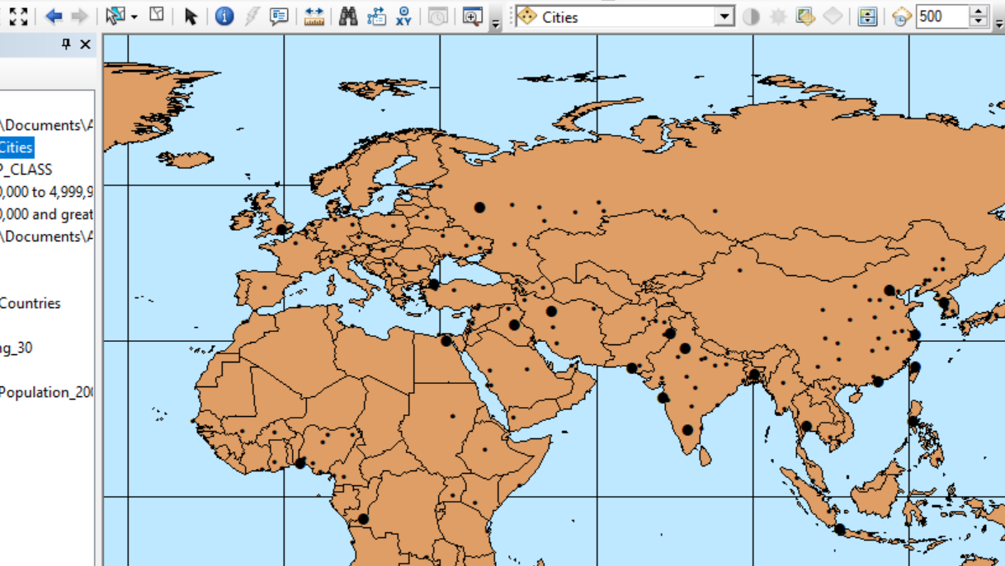

Question 5 (6 points) – Take a Screenshot of your new labeling.

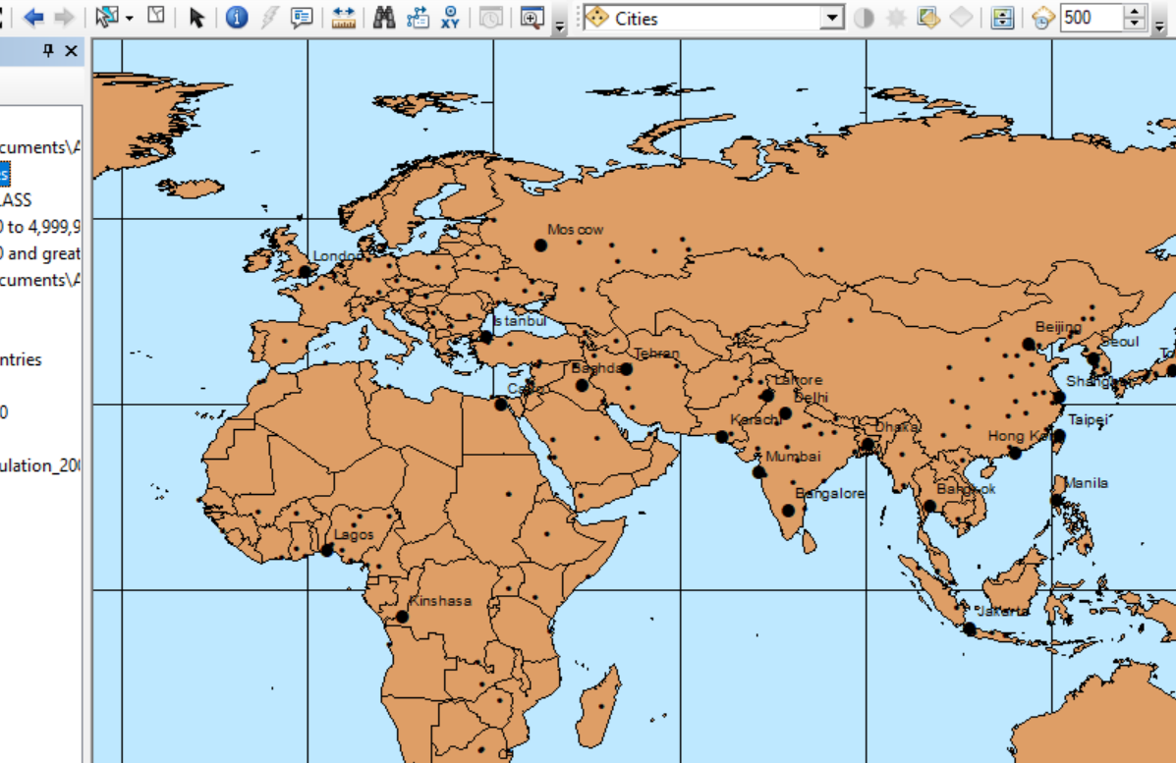

Question 6 (8 points) – Take a Screenshot of your new symbology. In the screenshots caption, describe it the population density is: nominal, ordinal, interval, ratio?

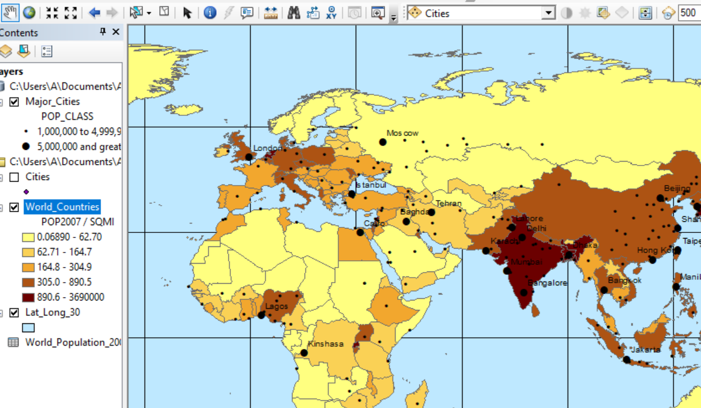

Population Density is ratio data. Though it isn’t the case in any records on our map, a given area can have a valid pop. density of 0 if no one lives there, so we have a valid null.

Question 7 (6 points) – Take a Screenshot of your map with the new basemap.

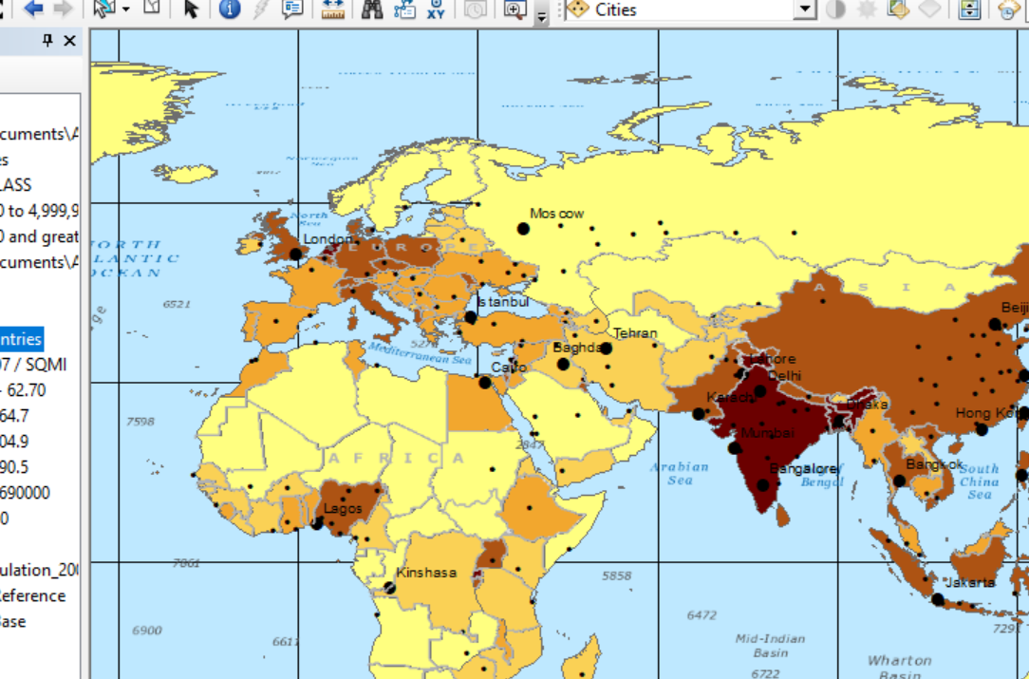

Basemap chosen: National Geographic - Oceans