Asa Hayes GEOG-232-502 Breyer 15 September 2020

**Lab 2: Map Projections**

Q1(2pt): What’s the location of Las Cruces, NM in DMS format? Hint: zoom into Las Cruces as far as possible to get an accurate reading.

Las Cruces is at 106°45'52.467"W, 32°17'50.75"N

Q2 (2pt): What’s the location of Las Cruces, NM in Decimal Degrees format?

Las Cruces is at -106.764574, 32.297430 Decimal Degrees.

Q3 (2pts): What’s the distance between Las Cruces and Sydney, Australia in kilometers?

The distance between the two locations is 12,948.735284 Kilometers

Q4 (2pts): What’s the distance between Las Cruces and Sydney, Australia in miles?

This converts to 8,045.95499 miles.

Q5 (4 pts): Are the latitude and longitude lines straight lines intersecting at right angles? Are the geometric symbols still circles? How are they distorted? Is the distortion the same in all parts of the map?

While the latitude lines are still straight, the longitude lines are not. The lines do not meet at right angles either, as the inward-facing side of any given box is by necessity shorter than the outward facing side, thus preventing a regular shape. The reason for this is the area distortion that has the land seem to expand & stretch as it moves away from the pole. This is reflected both in the size & shape of the squares, as well as the “circles” which are now oblong, thin at the pole and wide at the edge.

Q6 (4pts): Describe the transformation of the circles when you applied the each of the projections. Are there any true circles in these projections? If so, which ones? What does the different sizes of the circles tell you about distortion?

The conic projection, similar to the azimuthal projection, had thin, oblong “circles” that grew wider further from the centerpoint. However, in this projection, the difference in area is more pronounced with circles around the equator being dramatically larger than near the edges. This trait in turn is shared by the cylindrical projection, but not with the radial stretching due to the different shape base. The circles appear regular around the equator in this projection, growing larger and longer near the poles to show the distortion/stretching of these areas, however there are true circles (i.e. corresponding to a perfectly circular area on the globe) on all of these projections. There appears to only be true circles on the cylindrical projection on the equator, but each is a matter of perspective and more depends on the base projection that the circles were drawn on. Viewing the circles on the default equal-area projection has them all as perfect circles, viewing on the other projections shows ovals, but all correspond to the same actual circular area.

Q7 (4pts): Compare the Mollweide and Robinson projections. Name your chosen projections and, in a few sentences, discuss which one distorts the most or least in terms of shape, area, and distance and which one is the most pleasing visually, in your opinion. Include Screenshots of both projections.

Mollweide:

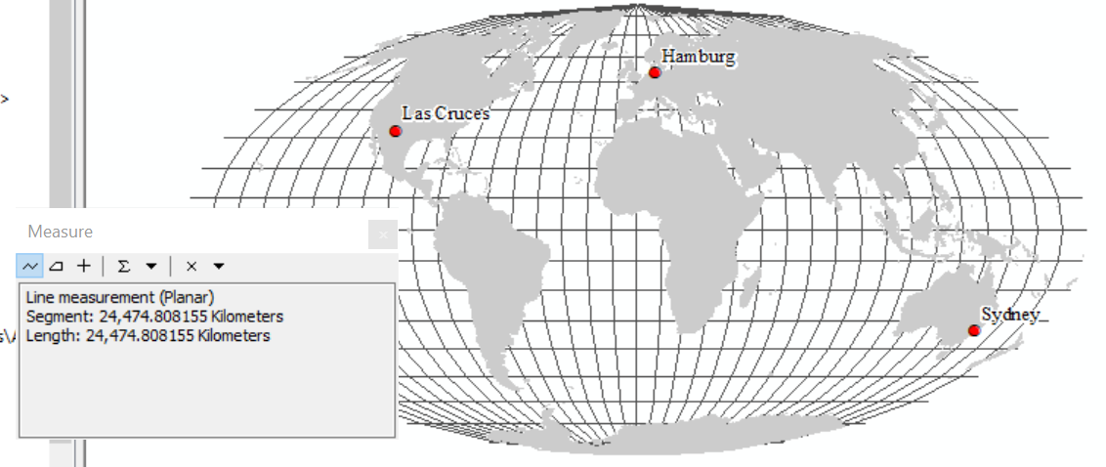

Robinson:

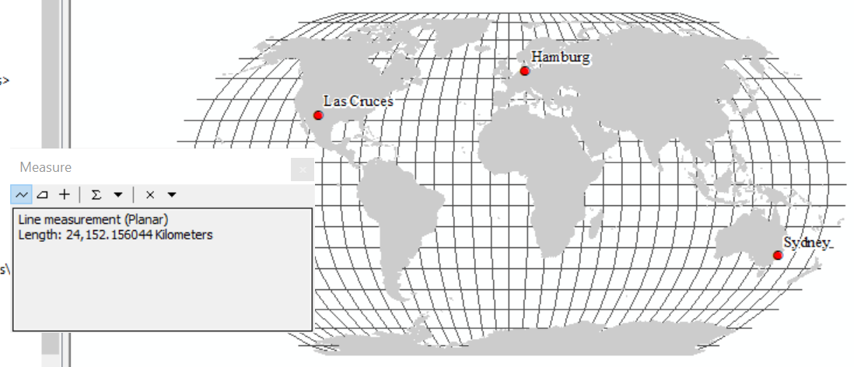

For shape, the Robinson projection does better, North America for example looks compacted in the Mollweide projection. For area, Mollweide does better as it is an equal area map. For distance, the Robinson projection leads, both visibly and from the lower distance result that is closer to the true distance. Visually, my preference is the Mollweide projection for aesthetics, but each has advantages and drawbacks in practical use.

Q8 (6pts): Compare the Albers Equal Area, Lambert Conformal Conic, and Equidistant Conic projections. Name the projections and discuss which one distorts the most or least in terms of shape, area, and distance and which one is the most pleasing visually. Include screen captures of all three projections.

Equal Area Conic:

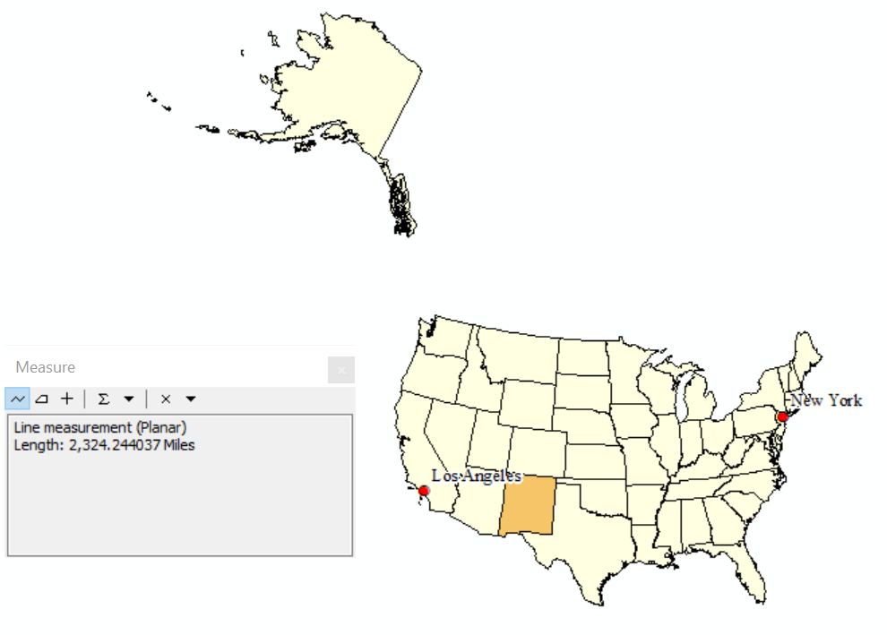

Conformal Conic:

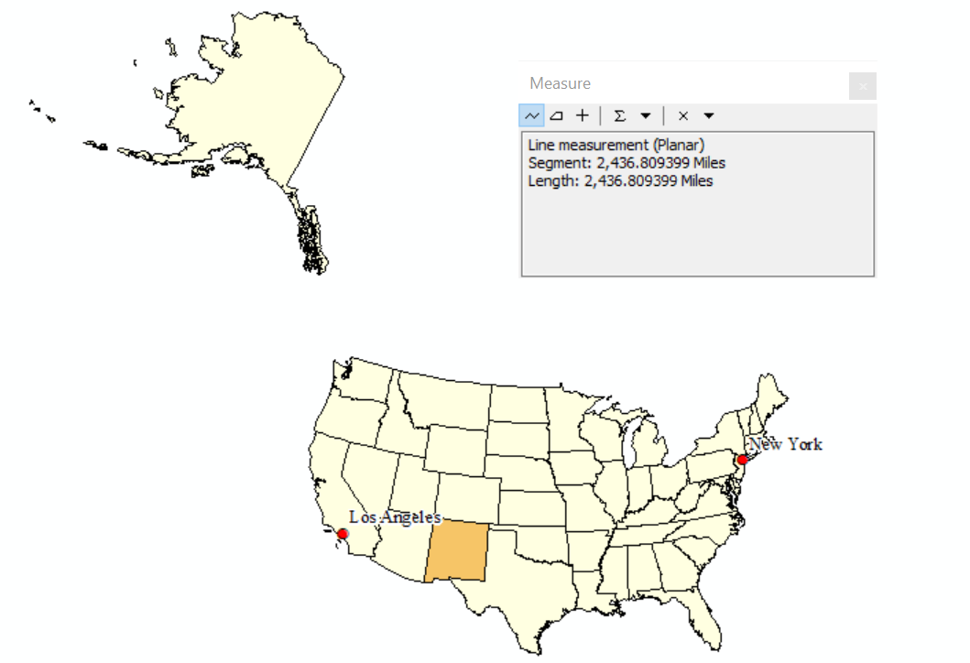

Equidistant Conic:

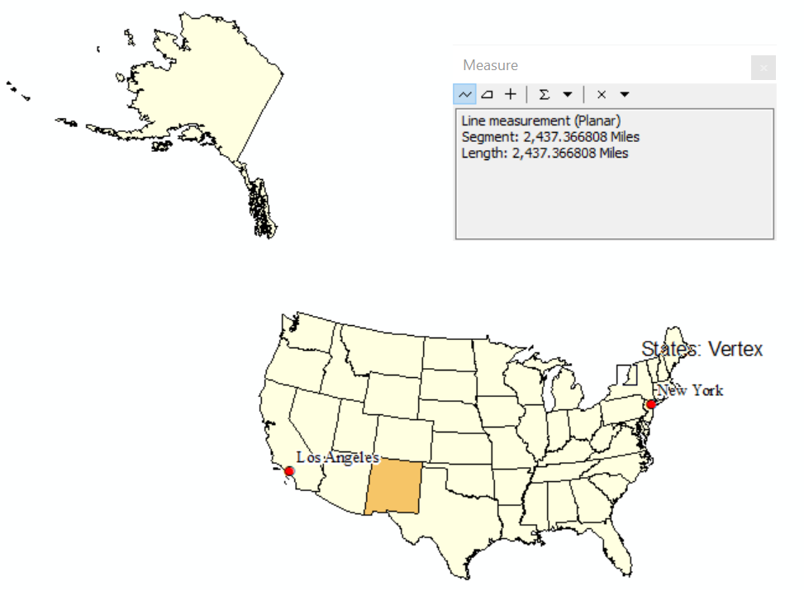

Working nominally, the conformal conic projection preserves shape best, while area and distance are best shown by the equal-area conic and equidistant conic respectively. The differences in each are not readily visible at this stage, mostly manifesting around the smaller, easily skewed northeastern states, which is to be expected due to the same projection shape and area.

Q9 (4pts): Take a Screen Capture of your final modified projection.

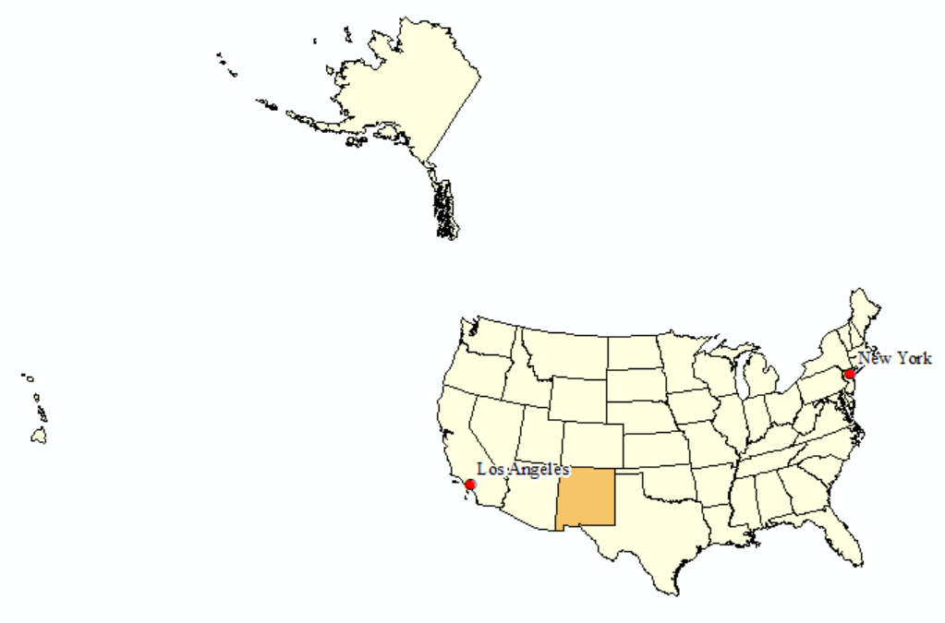

Q10 (2pts): What’s the projection used with the State Plane Coordinate System you just selected? (Hint: in the Data Frame Properties window, click Modify to get a full view of the specified parameters)

The projection for SPCS-New Mexico-Central is Transverse Mercator.

Q11 (5pts): Fill out the following information about the Coordinate System you just selected:

a. Spheroid: Clarke 1866

b. Central Meridian: -106.25

c. Latitude of Origin: 31.0

d. False Easting: 500,000.0

e. False Northing: 0.0

Q12 (4pts): Name the projection you used to look at the New Mexico data frame and discuss how much it distorts in terms of shape, area, and distance, relative to the State Plane system. Which one is the most pleasing visually, in your opinion? Include screenshots of your data using both projections.

SPCS-NM-Central (Transverse Mercator):

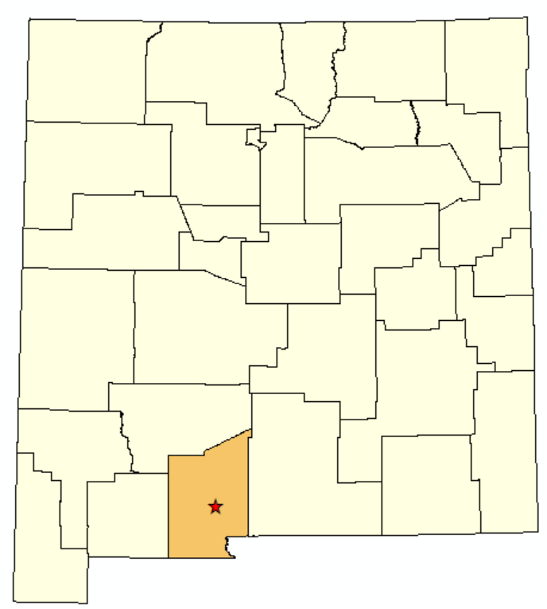

U.S. National Atlas Equal-Area (Lambert Azimuthal Equal-Area):

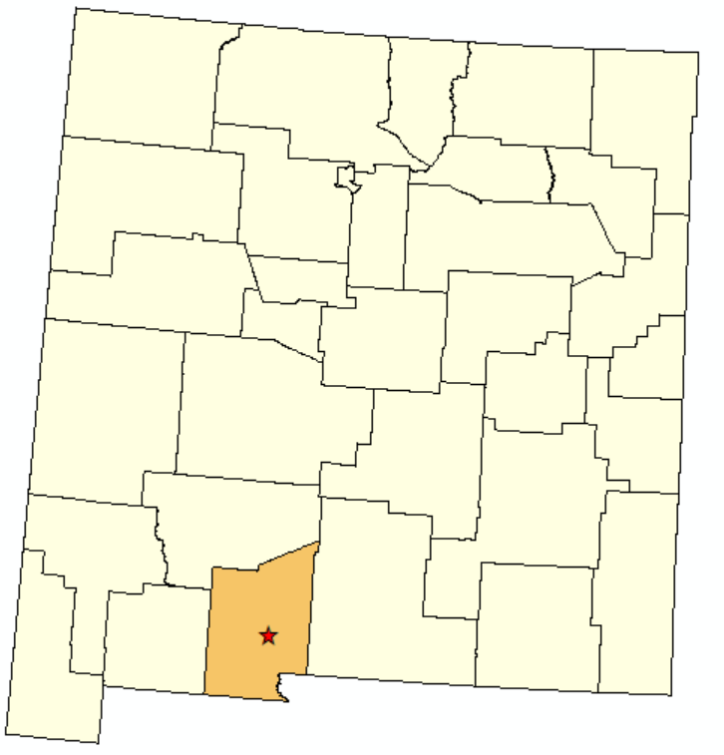

While the Atlas projection is more accurate to the shape and area of New Mexico compared to the globe, the direction-preserving State Plane projection seems more eye-catching. This may however just be due to how commonplace the “directly upright, aligned” design that most U.S./state maps display.

Q14 (10 pts): Based on how different projections change both the level of distortion in maps as well as their visual appeal, discuss in a paragraph (5 sentences) why projections are critical to consider when developing maps in cartography.

Choosing a projection in cartography is similar to finding the correct composition for a subject when painting. Using the wrong angle or perspective in either activity leads to a host of issues in creating an easily visible subject that also draws the eye to explore it. Too much distortion on a map from improper use of a projection will render a map nearly worthless for reference or navigation, but having one be too rigid/unappealing/boring will (in many cases) make your map less utilized even if it is accurately depicting the area. A balance must be struck to ensure usefulness and aesthetics are both present in a map, but neither detracts from the other (or as little as possible). Maps are after all made for people to read and use, so if they can’t or don’t want to read yours, you’ll need to go back to the drawing board, sometimes literally.

Q14 (10 pts): Add a screenshot of the Source tab for NM_BLM-Wilderness.

