Asa Hayes

GEOG-361-502

Due 28 Feb. 2019

Lab 03: Photogrammetry

**Part 1**

**Q1.** Compute the spatial resolution of pixels (m) in the aerial photograph ap_1-9-149. Include a filled-out version of the following tables in your report.

|  |  |  |
| --- | --- | --- |
| **Transect** | **N Paces** | **Distance (m)** |
| 1 & 2 Distance | 50 | 80 |
| 3 & 4 Distance | 24 | 36 |

|  |  |  |  |
| --- | --- | --- | --- |
| **Transect** | **Real Transect Size (m)** | **Size in ap_1-9-149 (px)** | **Computed Pixel Size (m)** |
| 1 & 2 Distance | 80 | 149.3452 | 0.5356717189 |
| 3 & 4 Distance | 36 | 70.4557 | 0.5109593688 |

**Q2**. Calculate the pixel spatial resolution of pixels (m) using three objects in the georeferenced image **college_doq**. The first one has been started for you. Include in your report the completed table below.

|  |  |  |  |
| --- | --- | --- | --- |
| **Object** | **Size in of object in college_doq (m)** | **Size of object in ap_1-9-149 (px)** | **Computed Pixel Size (m)** |
| Albritton Bell Tower | 17.5 | 33.0151 | 0.5300604875 |
| Evans Library | 155.0202 | 313.2491 | 0.4948783572 |
| Kyle Field (turf) | 159.4522 | 320.5059 | 0.4975016061 |

**Q3.** Now compare the two methods you have just employed. What are advantages of determining pixel scale using *in situ* measurements? What are advantages of using georeferenced imagery?

Using in-situ scaling, as long as you have the image, a way to measure pixels, and waypoints to pace between, you can get a good idea of the image’s pixel density. Programs that can just measure pixels on an image are common, free, and have low requirements, to where some even work on phone, so that allows for much faster measurement if you lack alternatives. But, if you have a georeferenced image to compare to, you can not only get a much more accurate measurement, but a faster one as well due to the several less steps involved.

**Q4.** Determine the height and width of the scanned aerial photograph ap_1-9-149 in real world. This can be done by simply multiplying the image size (rows and columns) by your computed pixel size in meters. Show your calculation process and results.

1. As all values average and converge to approx. 0.5m as well as it being a common pixel size, 0.5 will be used for pixel size (pS).
2. The size of ap_1-9-149 is 10200 samples (columns) by 11428 lines (rows).
3. To convert pixels to real distances, multiply by pS:
   1. 10200 * 0.5 = 5100m width
   2. 11428 * 0.5 = 5174m height

Answer: Image Area is 5100m wide, 5174m high

**Q5.** You should have noticed that ap_1-9-149 does not have a typical aerial photograph size. The scanner used to digitize the aerial photograph has a scanner bed of 8.5”x14”, and the size of original aerial photo is 9” x 9”, so the scanned area is actually 8.5” x 9” in. What is the approximate resolution of the scanner, in terms of pixels per inch, that was used to scan the original aerial photographs? Show your calculation process and results.

1. PPI = diagonal length in pix / diagonal length in inches
2. PPI = sqrt(10200^2 + 11428^2) / sqrt(8.5^2 + 9^2)
3. PPI = 15317.937 / 12.379
4. PPI = 1237.127

Answer: Scanner Resolution is 1237.127 ppi

**Q6.** Calculate the Representative Fraction Scale of the scanned aerial photograph ap_1-9-149. A representative fraction scale (e.g., 1:10,000) means that one unit (say m) on the printed photograph equals how many units (m) in the real world. Show your calculation process and results.

1. 8.5 * 2.54 (convert to cm) = 21.59cm image width 🡪 0.2159m
2. From **Q4**, true width of image is 5100m
3. 5100m / 0.2159m = 23622.047 scaling

Answer: Representative Fraction is 1:23622.047

**Q7.** From the photograph ap_1-9-149 determine the focal length (in millimeters) of the camera used to take the picture (refer to the figure in instructions from your Jensen, 2007 textbook). The information is not be in the exact same place, but you should be able to figure it out.

1. Image’s Orientation is reversed from the example given in the instructions, the focal length can be found upside down near the bottom left.

Answer: Focal Length is 153.28mm

**Q8.** Now that you know the representative fraction scale (s) and the focal length of the camera (f), calculate the height of the aircraft (H) in meters using the following equation:

s = f / H

Note: Since Bryan-College Station is pretty flat, we will take this to be the average scale over the entire photograph. Show your calculation process and results.

1. Scale # (s) = 23622.047, focal length (f) = 153.28mm 🡪 0.15328m
2. s = f / H
3. 1 / 23622.047 = 0.15328m / H
4. H / 23622.047 = 0.15328m
5. H = 0.15328m * 23622.047
6. H = 3620.787m

Answer: The aircraft taking this image was flying at 3620.787m.

**Part 2**

**Q9.** Determine the principal point of the scanned image. To do this you need to connect the fiducial marks of the image. Unfortunately, in the process of scanning the image into the computer we were unable to scan all 6 fiducial marks. However, you should be able to determine the center from the 4 remaining corner fiducial marks. Once you have drawn the lines, you should know the pixel x and y of the Principal Point (PP) and, knowing the scanner resolution, be able to calculate its position from the upper right corner of the image. Include the completed table below in your report. Show your calculation process and results.

Note: I had not noticed the tip box with the vector annotation layer, so I used 3 segments generated by the measurement tool, recorded the coordinates of the centermost point of the midpoint-box of each line, and averaged them. I also did the mm coordinates by ratios instead of with pixel density.

Top-Bottom: (5131,5708), TopLeft-BottomRight: (5134,5711), TopRight-BottomLeft: (5134,5712)

Point Avg. (px) = (5133,5710) [rounded to nearest pixel]

Process for finding mm coordinates:

1. 5133 / 10200 = 0.5032 (x ratio), 5710 / 11428 = 0.4996 (y ratio)
2. 22.59cm (width, from **Q6**) * 0.5032 = 11.368cm -> 113.68mm (x coord,)
3. 22.86cm (height) * 0.4996 = 11.422cm -> 114.22mm (y coord.)

|  |  |
| --- | --- |
| Principle Point (px) | Principle Point (mm) |
| X: 5133 | X: 113.68 |
| Y: 5710 | Y: 114.22 |

**Q10.** Determine the height of the Albritton Bell Tower. You should be able to easily determine the radial distance [r] from the Principal Point to the top of Albritton Bell Tower. To determine the displacement [d], you need to locate a point on the top of the bell tower and a point immediately underneath at the intersection between the bell tower and the ground and calculate the radial difference between them. With this information you should be able to determine the elevation using equation (3) above. Please show your work and results.

For r, measured pixel distance between top of Tower & PP is 4463.1618px. Using pixel size of 0.5 from **Q1**, this distance converts to 2231.5809m.

For d, measured pixel distance between top and bottom of Tower is 55.7859px. Using pixel size of 0.5m from **Q1**, this distance converts to 27.89295m.

1. h = d*H / r
2. h = 27.89295m *3620.787m / 2231.5809m
3. h = 49.129m

Answer: Height = 45.257m

**Part 3**

**Q11.** Determine the absolute parallax (P) between the two stereo images. This requires identifying the Principal Point (PP) and Conjugate Principal Point (CPP) in both aerial photographs. Since you have already located the PP in ap_1-9-149, you will have to locate the CPP, which is the location in this aerial photograph that is the PP in ap_1-9-148. Once the CPP has been located you should draw a line linking the PP and CPP on this image. You will need to locate the PP and CPP in ap_1-9-148 in the same way that you located it in the first image (although you may have to use different fiducial marks). Once you have located the PP and CPPs on both images, complete the following table and calculate the average airbase distance as well. Be sure to include your measurements in both pixels and mm.

|  |  |  |  |  |  |
| --- | --- | --- | --- | --- | --- |
| Image | Principal Point | | Conjugate Principal Point | | Distance |
| ap_1-9-148 (px) | X: 5157px | Y: 5671 px | X: 5419 px | Y: 1210 px | 4468.6872 px |
| ap_1-9-148 (mm) | X: 114.21mm | Y: 113.43 mm | X: 120.01 mm | Y: 24.20 mm | 89.42 mm |
| ap_1-9-149 (px) | X: 5133 px | Y: 5170 px | X: 4952 px | Y: 9584 px | 4417.4802 px |
| ap_1-9-149 (mm) | X: 113.68 mm | Y: 114.22 mm | X: 109.67 mm | Y: 191.71 mm | 77.69 mm |
| Average Distance (px): 4443.0837 px | | | | | |
| Average Distance (mm): 83.555mm | | | | | |

83.555mm distance --> 0.083555m

0.083555 * 23622.047 (scale) = 1973.740m true distance

Answer: Avg. Airbase/Abs. Parallax is 1973.740m

**Q12.** Determine the differential parallax (dp) which is the differential parallax in an object between the two photographs. This is the tricky part in the operation. To calculate dp it is necessary to measure the distance from the top and bottom of the object relative to a fiducial line which is perpendicular to the airbase. This must be done for both images. Please show your work and your results.

Object Used: O&M Building

1. dp = P_a – P_b, P_a = X_a – X’a, P_b = X_b – X’b
2. P_a = 1238.5309 – 1,307.5000 = -68.9691, * 0.5 (px to m) = -34.48455m
3. P_b = 1247.0000 – 1261.0000 = -14, * 0.5 (px to m) = -7m
4. Both converted to positive for proper ordering
5. Dp = 34.48455m – 7m = 27.48455 meters

Answer: dp is 27.48455m

**Q13.** Now you have all the information you need to determine the elevation of Albritton Bell Tower using equation (5) from instructions. Please show all your work and your results.

1. (H – h) = 3620.787m , P = 1973.740m , dp = 27.48455m
2. h_0 = 3620.787m * ( 27.48455m / (1973.740m + 27.48455m) )
3. h_0 = 49.727m

Answer: Tower is 49.727m

**Q14.** Please prepare a short write-up comparing all the methods that you have used to determine the height of the building. Please tell me which method you find to be the most accurate and which you find to be the most preferable and why you found them to be accurate and preferable, respectively. You should also include in your report two image maps showing the locations of PPs, CPPs, air base, fiducial lines, and labeling the objects that you have measured.

The two main methods used in this lab were the relief displacement method and the parallax method. For accuracy, we can look to the baseline official height of the tower, that being 42m. The closer of the two was the relief method at 45m and 3m error, with parallax at nearly 50m and 8m error. However due to the increased number of steps, factors, and possible points of failure, the parallax method may be more accurate despite not being so in this case due to this being an initial attempt. While the easy answer as to which is more preferable would be the relief method due to it being easier and more accurate in this case, the parallax method may be more accurate if done correctly, for example via automation, which would solve the ease of use issue as well. Overall, my personal preference just based on this lab would be the relief method, but each method (and others not covered in this lab) will likely be better on a case by case basis.

Key for Images:

Blue Lines are main fiduciary lines

Green Lines are airbases

Orange Lines are fiduciary lines perpendicular to airbase

Red Text shows PP, CPP, and measured buildings

Annotated Image: ap_1-9-149

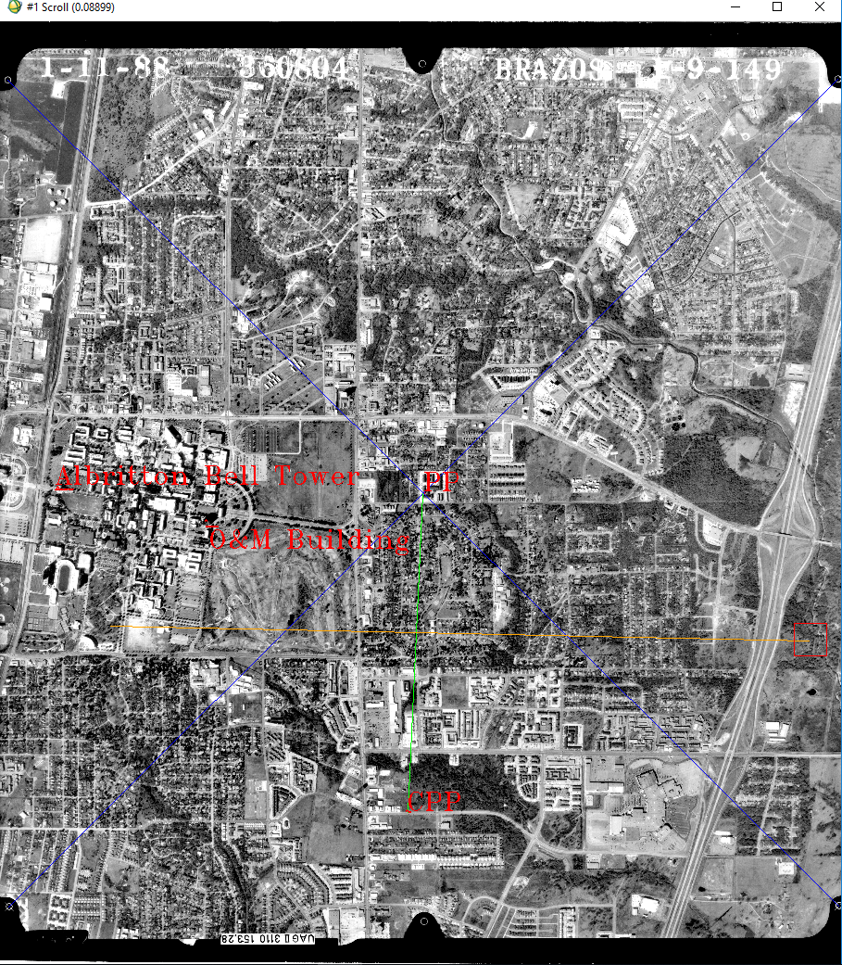

Annotated Image: ap_1-9-148

