Student’s Name: Cyron Hercules

Lecturer’s Name: S.Mohammed

Subject’s Name: Web Design

Date: 27/07/2022

Cryon’s Clothing Store Website Report

I hope that you are ok Mr. Tech-Lead. This report is an update on what I have done on the website thus far. Again, I would like to thank you for this opportunity. I have learned many things and gained a lot of real-world experience. The store is mostly locally focused but soon I plan to make it global. We would need to communicate more with the banks and shipping systems in order to do that. But first, it is my belief that starting locally would be the better option to commence this project. For your clarity, I have produced some visuals so that you can quickly get an idea of how the website was planned(wireframes) and how the website has been made. I hope that you are pleased with the results;

The below images are representations of the website’s wireframe for both Desktop/Tablet and mobile view

**Desktop view:**

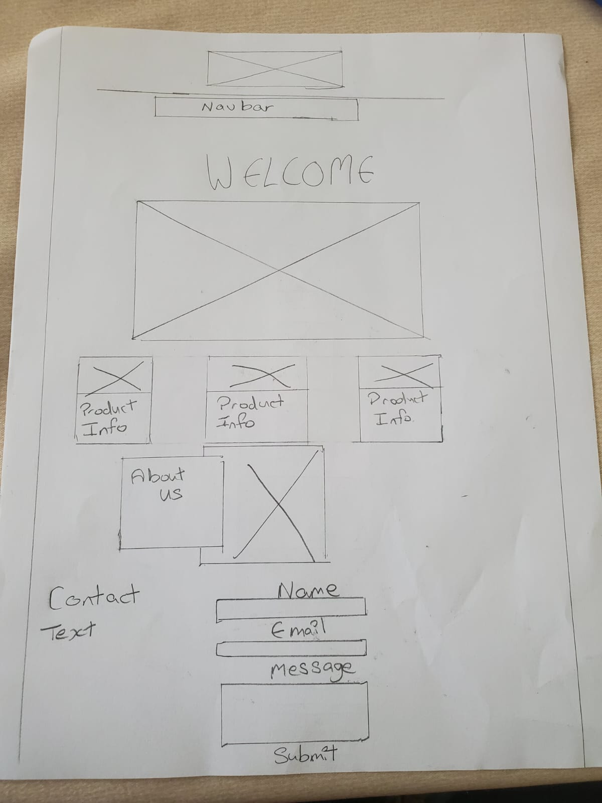

**Mobile View:**

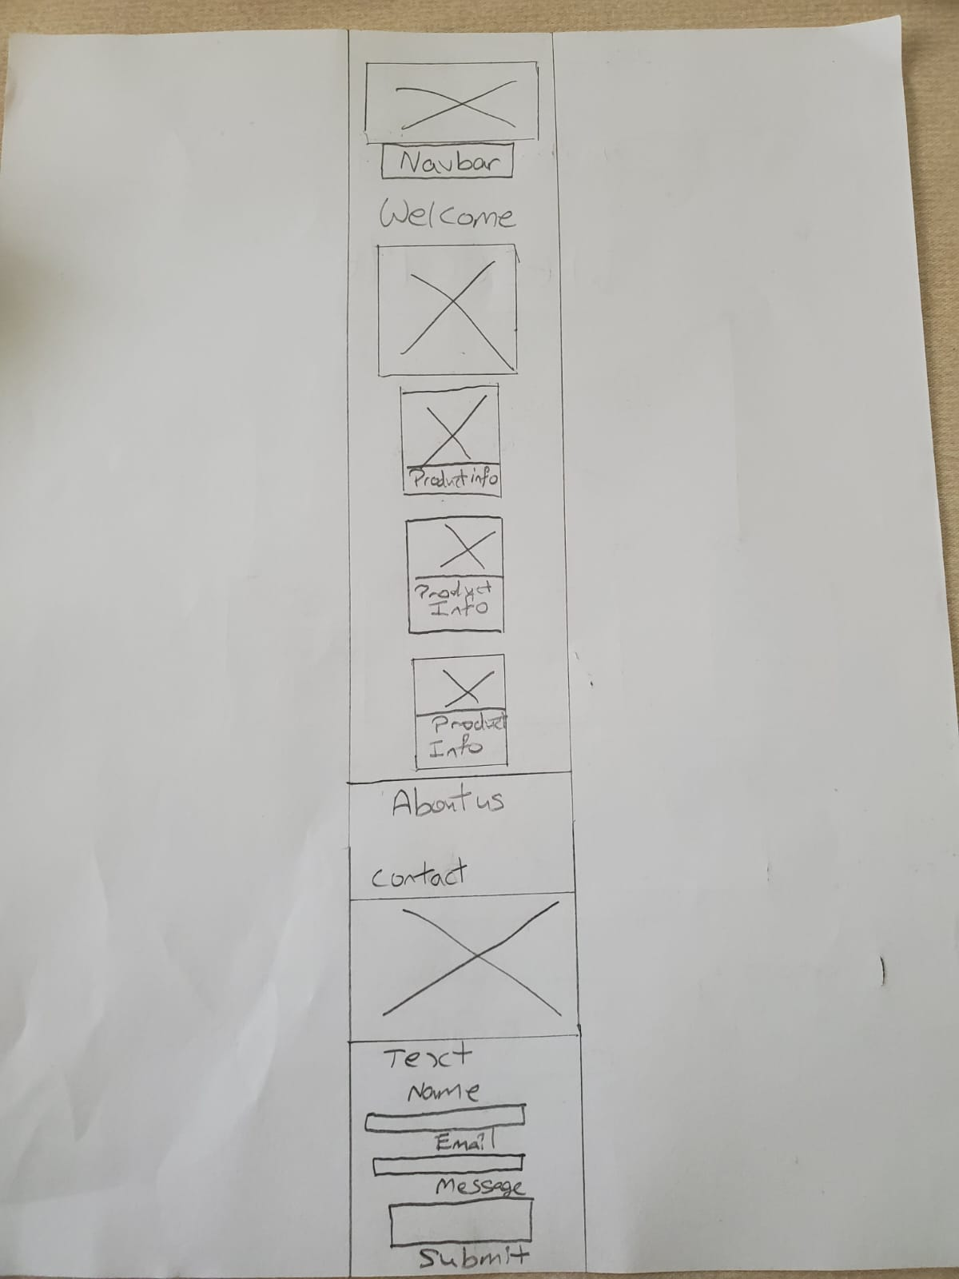

This image is a preview of how the home page has been produced. For the simplicity of this report, I have not included all of the images as I was you to capture the main ideas. However, you can access the full website with the HTML and CSS documents that I have uploaded for you.

Top Welcome page:

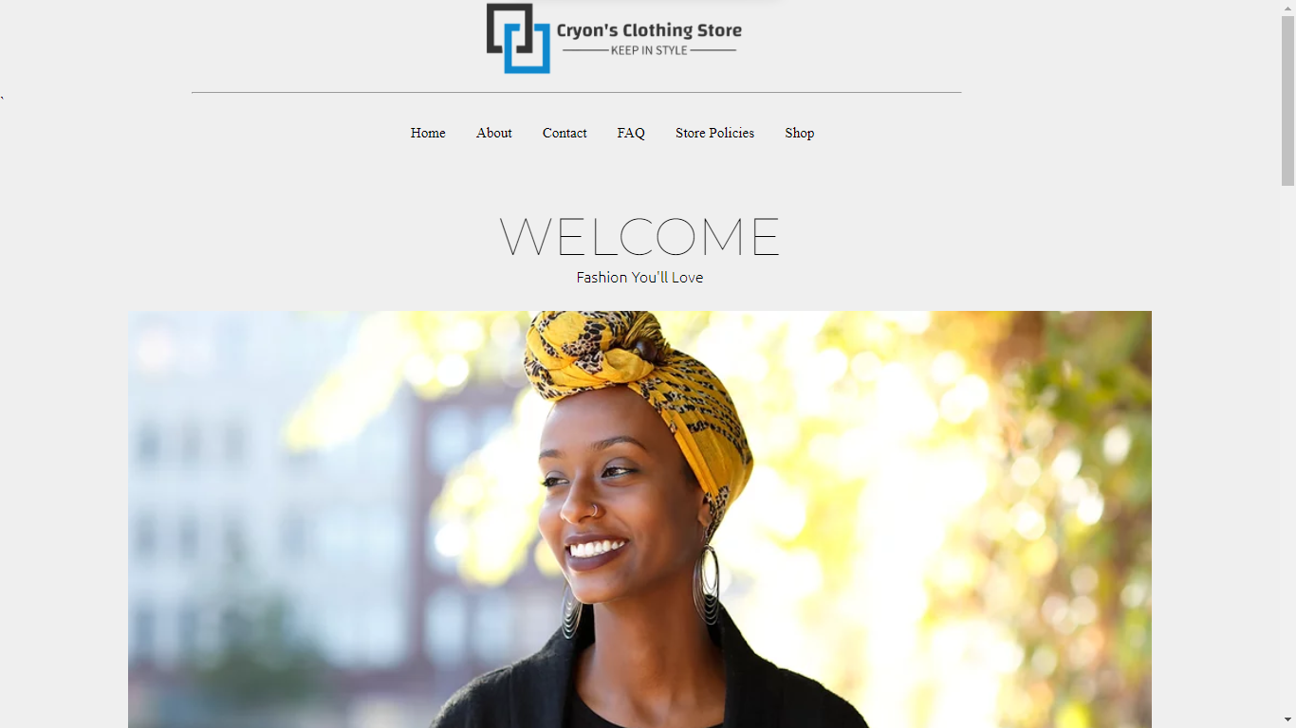

**Products containers**

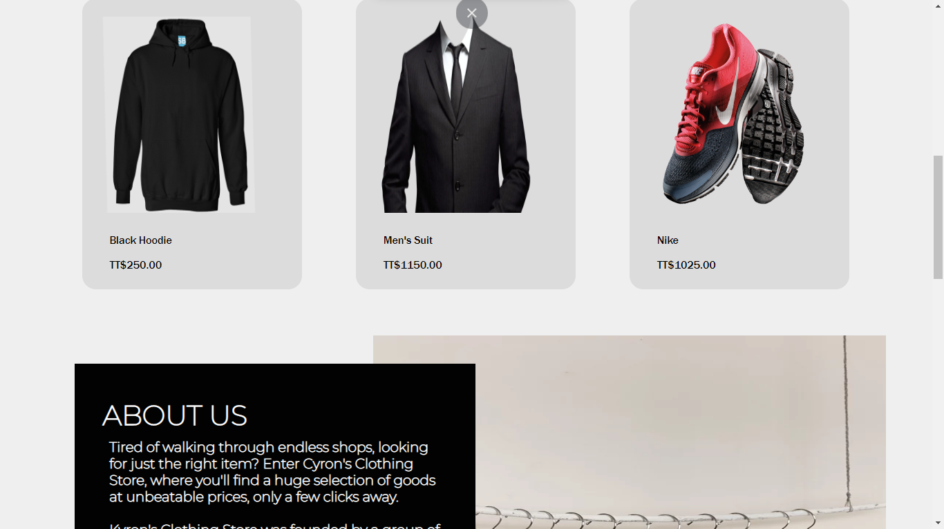

**About us:**

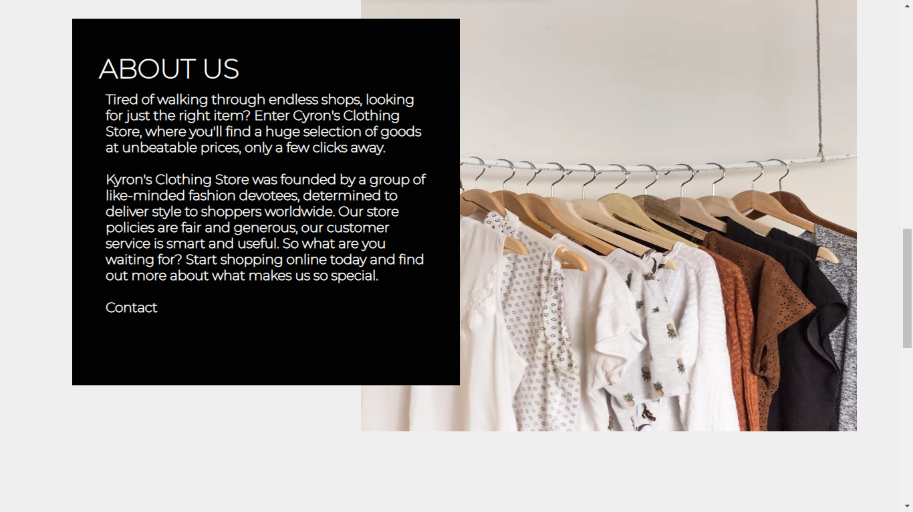

**Contact:**

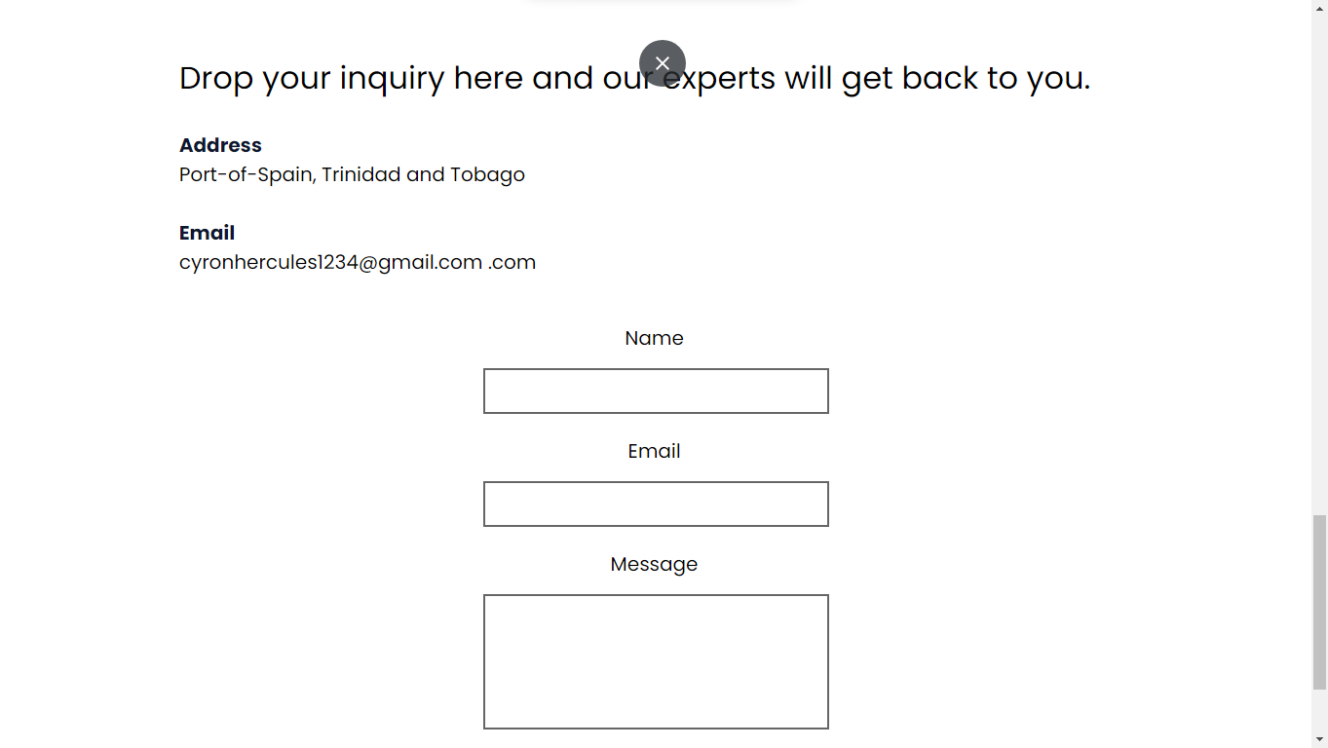

Developer Tools:

The mobile view is a very important aspect of responsive websites, especially since users are more involved in mobile technology, users are more to visit the website on their phones rather than on their computers. Hence, using the developer tools to simulate different devices was essential for this project. Therefore, I have created the website for over 20 different devices.

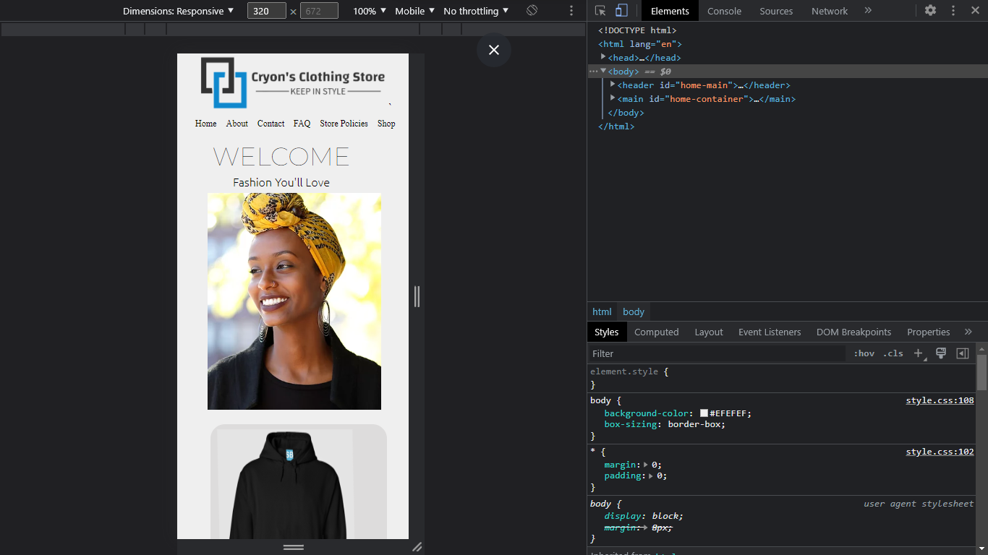

HTML and CSS Validatione

Aside from learning how to code and creating a functional website. I needed to ensure that it was Validated that way I can ensure that I am coding accurate and it would help in the long term if I need to debug. The following are evidence of my index.html(home page) and styles.css(main file for styling the website) validation. I have used <https://validator.w3.org/> for the validation

**Index.html**

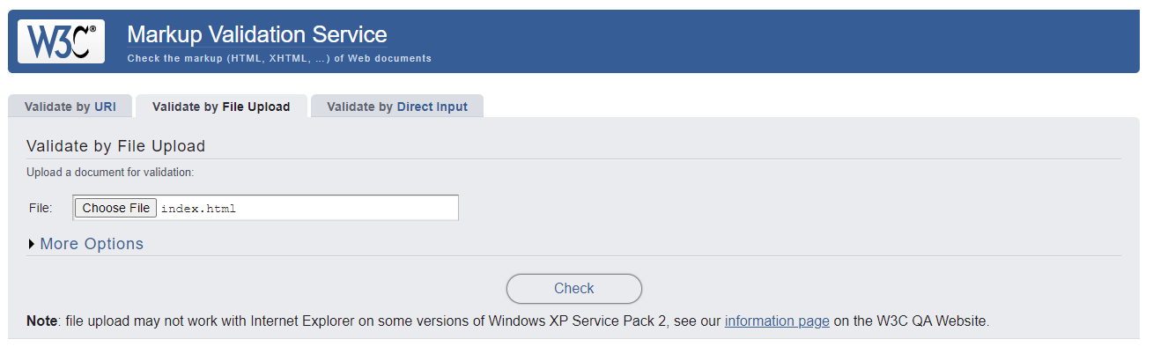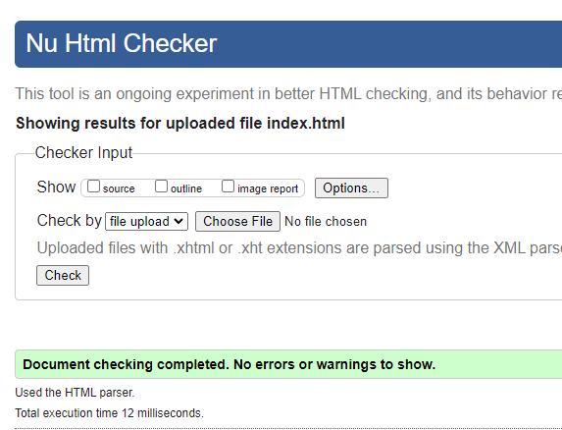

**Styles.css**

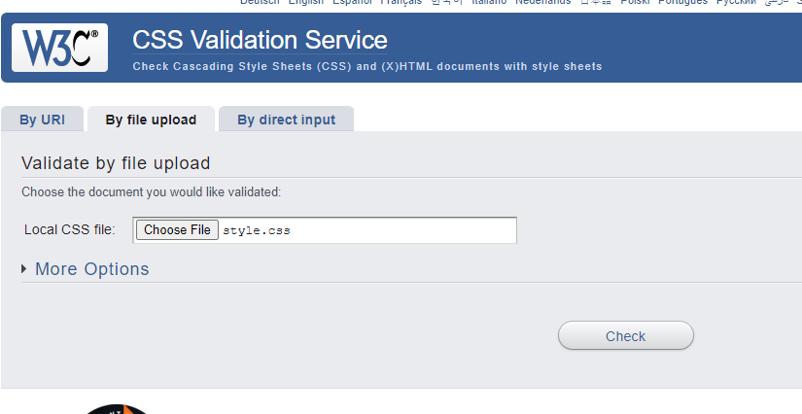

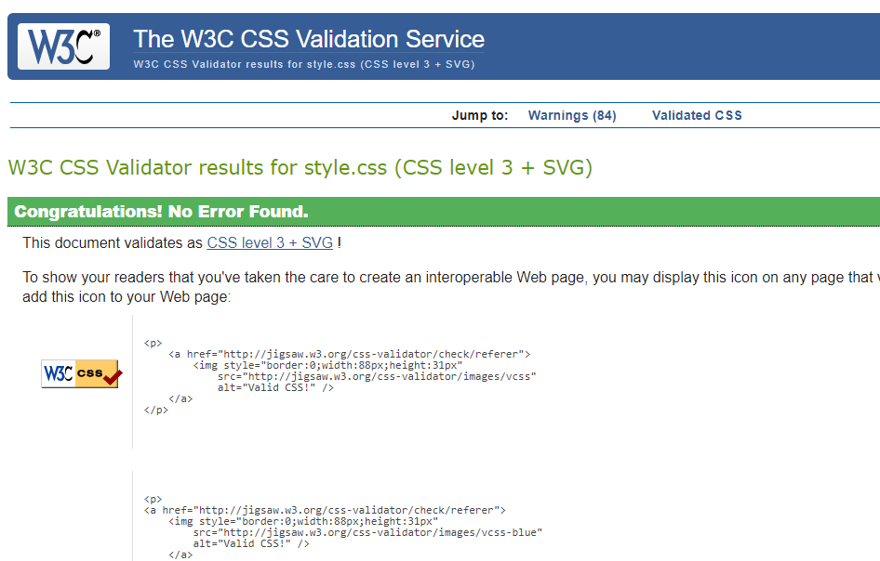

**Story Board Form**

| Storyboard Form | | | |
| --- | --- | --- | --- |
| Website Project Name: *Cyron’s Clothing Store* | | | |
| Page Title: INFO 0211 WEB DESIGN | | | File name: 20201235cyronhercules |
| Layout Type: *1 column responsive* | | | |
| Purpose of page | | To make Cyron’s clothing store supplies more accessible | |
| Meta Data | | Title tags, Meta description, Viewport tag, Hreflang tags, link tags and script tag | |
| Links on the page | | Home, About, Contact, Faq, Safety Policies and Shop | |
| User Interaction | | Navigation Links | |
| Graphical Elements/Images | | Icons, Images and buttons | |
| Style - Color specs and Font specs | | Fonts: Montserrat, Ubuntu, Poppins, Franklin Gothic Medium, Arial Narrow, Arial, sans-serif, Helvetica, Segoe UI, Tahoma, Geneva, Verdana, Lobster, Abel  Color spec: Light whitish-grey | |
| Structural/Semantic Details | | Html, head, body, div, section, main, header, span, ul, nav, form | |
|  | | | |