Exercise 1

Traffic capture

Selected enx0c37965f8a22 to capture from
Captured Packets:
- Domain Name System (Query)
- Address Resolution Protocol (request and reply)
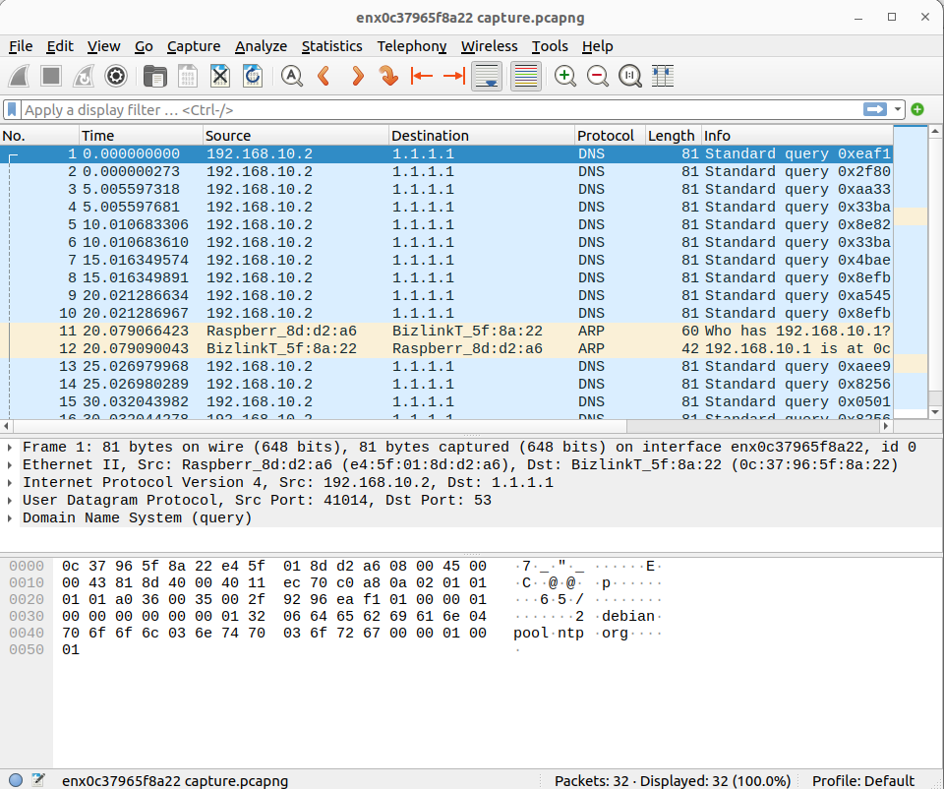

Selected enp0s31f6
Apply display filter HTTP
start capture and stop
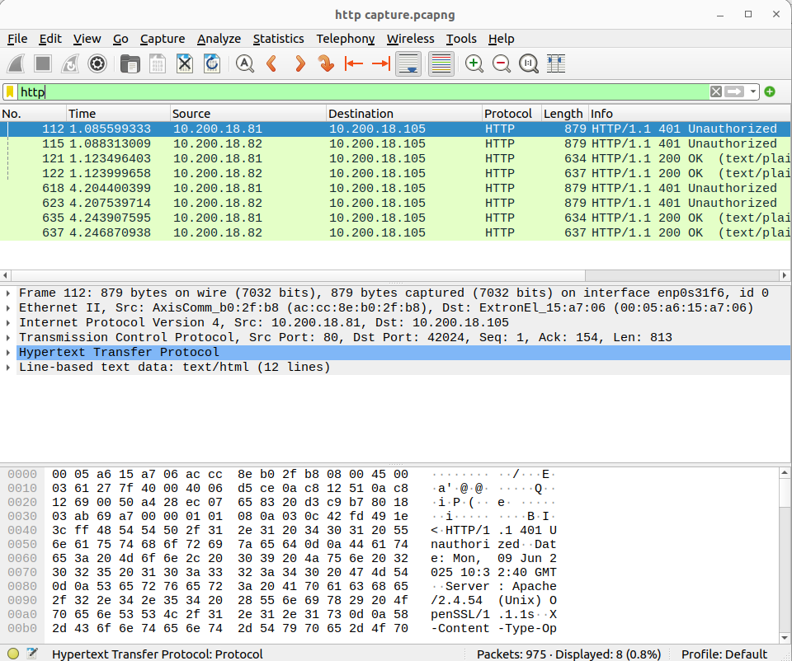

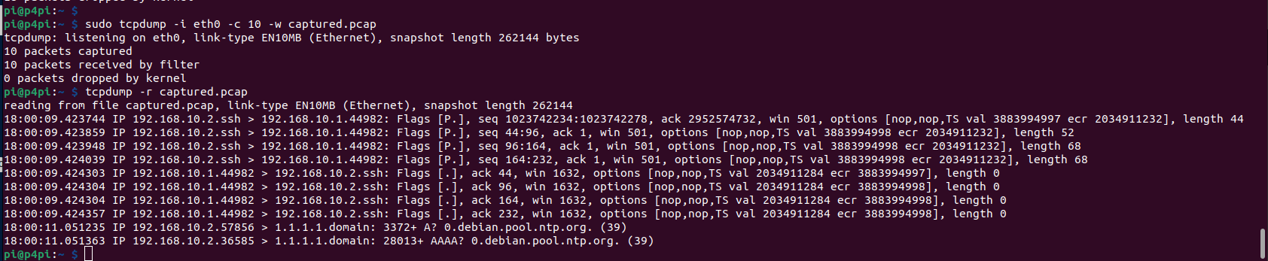
Capture Raspberry Pi using tcp dump

Sending Traffic

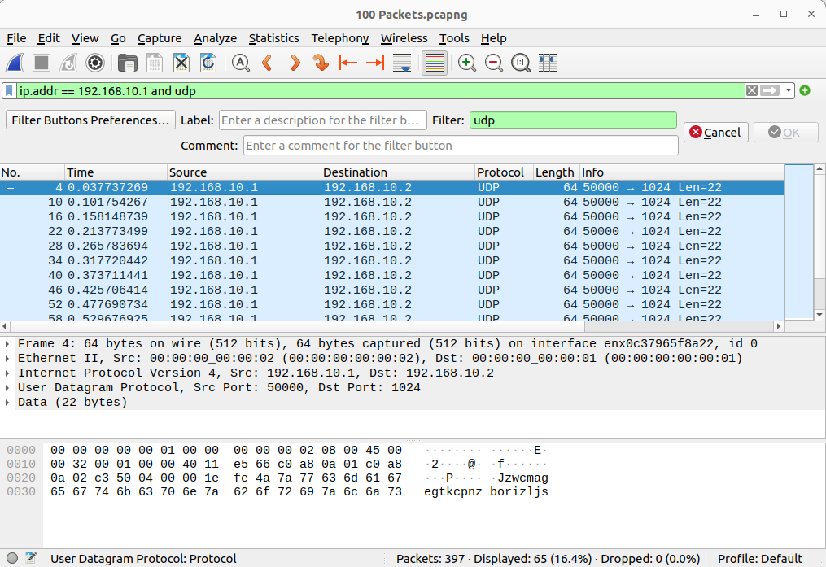

1. Can you define a filter to capture only the packets you sent?
Using ip.addr == 192.168.10.1 and udp

2. What is the packet size?
512bits

3. What is the protocol used (TCP or UDP)?
UDP

Modified Script send_TCP.py
