Exercise 4

Not dropped traffic sending 3 packets
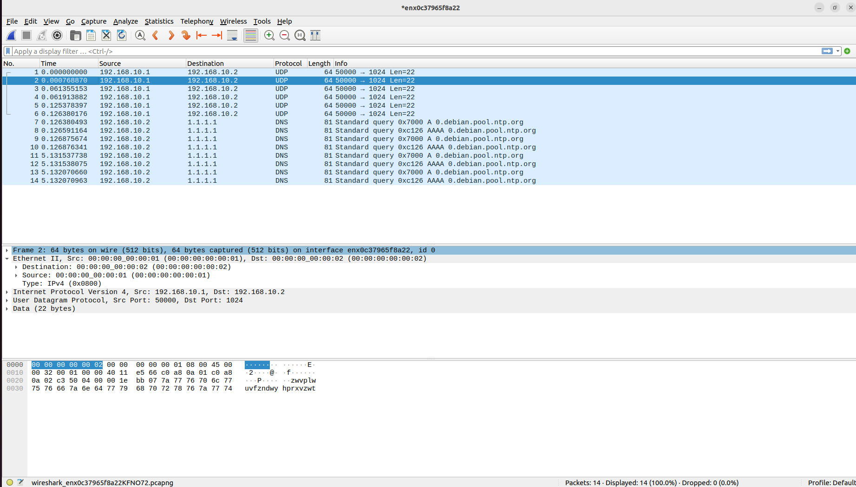
Added MyIngress.drop CA:FE:CA:FE:CA:FE
Dropped packets (changed src mac to CA:FE:CA:FE:CA:FE on send.py)
