Exercise 5
Stage 1:
Tested unchanged calc.p4 received error:
calc.p4(114): [--Wwarn=parser-transition] warning: check_p4calc: implicit transition to ‘reject’
state check_p4calc {
^^^^^^^^^^^
[--Wwarn=unsupported] warning: Explicit transition to reject not supported on this target

Stage 2:
Inserted header and initialised values
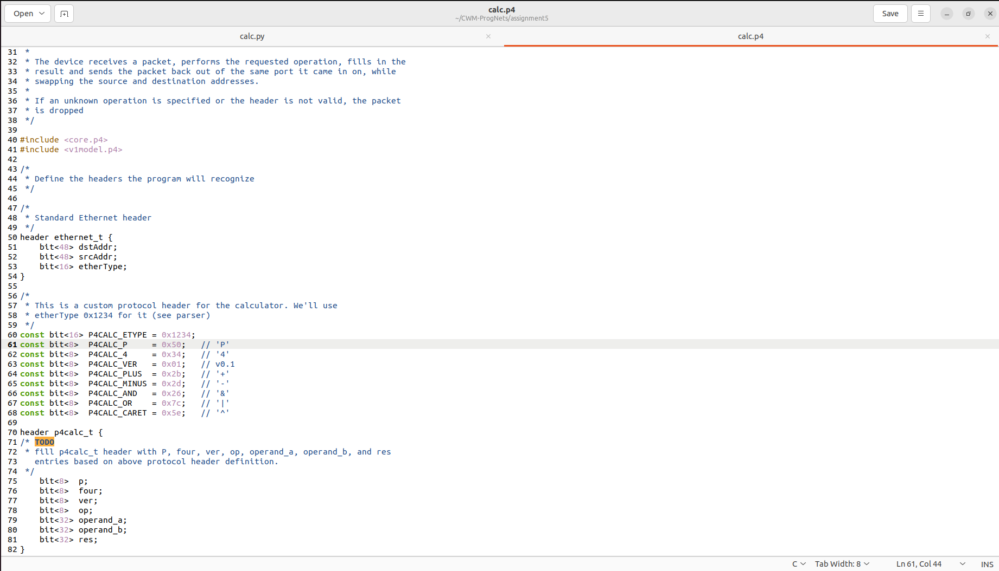
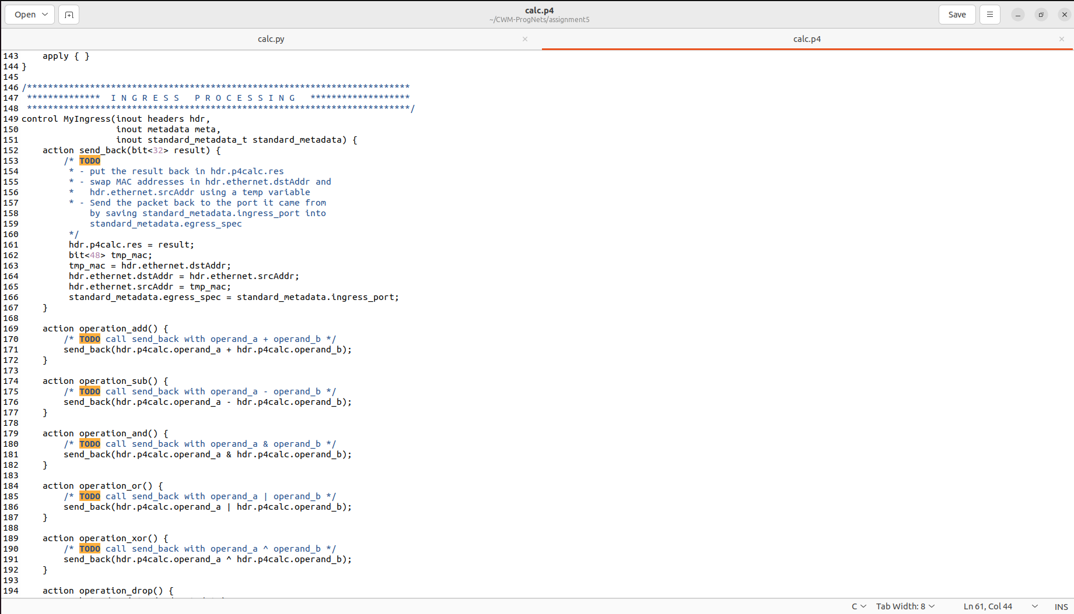
Created actions
Changed the interface address on calc.py to enx0c37965f8a22 so it would run on my computer.

