Meta-Learning for Algorithm Selection from Dataset Meta-Features:
An Empirical Study Across Twenty Benchmark Datasets
Group 3
Course project — Fully data-driven empirical study

Abstract
The No Free Lunch theorem implies that no single learning algorithm dominates across all problems, which makes algorithm selection a central practical concern. This study investigates, empirically, which of five widely used algorithms generalise best across a diverse set of benchmark datasets, and whether cheap-to-compute dataset meta-features can predict the best algorithm for a given dataset. We curated 20 datasets from the Penn Machine Learning Benchmark (PMLB), spanning binary classification, multiclass classification and regression, and described each with a 14-dimensional meta-feature vector. Five algorithms — Random Forest, Gradient Boosting, Support Vector Machine (SVM), k-Nearest Neighbours (kNN) and a Multi-Layer Perceptron neural network — were evaluated on every dataset using 5-fold cross-validation under identical conditions. Algorithms were ranked per dataset, and a Random Forest meta-learner was trained to predict the winning algorithm from meta-features alone. Differences were assessed with the Friedman test, Nemenyi post-hoc analysis and Wilcoxon signed-rank tests. Gradient Boosting achieved the best average rank (2.00) and won on 9 of 20 datasets, significantly outperforming SVM and kNN. The Friedman test confirmed that the algorithms differ significantly (chi-square = 25.08, p < 0.001). The meta-learner, however, did not beat a majority-class baseline under leave-one-out cross-validation (0.35 vs 0.45), a negative result we attribute to the limited number of datasets. We conclude with a practical, meta-feature-informed recommendation framework and a candid discussion of the benchmark-scope limitations.
Keywords: meta-learning, algorithm selection, No Free Lunch, cross-validation, Friedman test, Nemenyi test, PMLB.

1. Introduction
Selecting an appropriate learning algorithm for a new dataset remains one of the most consequential decisions in applied machine learning. The No Free Lunch (NFL) theorem for supervised learning formalises why this decision cannot be avoided by simply choosing a single 'best' method: averaged over all possible problems, every algorithm performs equally well, so any algorithm's superiority on one class of problems is necessarily paid for by inferiority on another. In practice this means that the question is never 'which algorithm is best?' but 'which algorithm is best for this dataset, given its characteristics?'
This is the algorithm selection problem. A classical framing maps the features of a problem instance to the performance of a portfolio of algorithms, so that the best algorithm can be recommended from problem features alone. When the problem instances are datasets and the features are properties of those datasets — their size, dimensionality, class balance and statistical structure — the features are called meta-features, and learning a mapping from meta-features to algorithm performance is called meta-learning: learning about learning.
Meta-learning promises a data-driven shortcut around expensive trial-and-error: if a model can predict the winning algorithm from meta-features that cost milliseconds to compute, practitioners can skip the combinatorial expense of training and tuning every candidate. The promise, however, depends on two empirical questions that this study addresses directly. First, do the candidate algorithms actually differ enough, across a diverse dataset sample, for selection to matter? Second, do meta-features carry enough signal to predict the winner better than a naive default?
We answer both questions with a fully reproducible empirical pipeline. We evaluate five popular algorithms on 20 benchmark datasets drawn from PMLB, rank them per dataset, and train a meta-learner on the resulting meta-feature/winner pairs. Every claim in this paper is backed by a table, figure or statistical test whose inputs are the committed result files. Our contributions are: (i) a rigorous, seeded comparison of the five algorithms across three task families; (ii) a Friedman/Nemenyi/Wilcoxon significance analysis of the differences; (iii) a meta-learner and its meta-feature-importance analysis; and (iv) an honest account of when meta-learning helps and when, as here, sample size limits it.

2. Methods

2.1 Data acquisition and harmonisation
All datasets were obtained from the Penn Machine Learning Benchmark (PMLB), a curated, versioned collection distributed as a Python package. PMLB returns each dataset as a tidy table whose final column, target, holds the label or response; fetching datasets programmatically makes the selection fully reproducible and removes ambiguity about provenance. Datasets were selected against a fixed quota balancing the three task families the study compares: 8 binary classification, 7 multiclass classification, and 5 regression. Candidates were accepted only if they contained between 100 and 3000 instances and at most 60 features — bounds that keep five algorithms times five folds tractable on a single machine while preserving diversity. Task type was determined empirically from the target (binary if exactly two distinct values, multiclass otherwise) rather than from dataset names. The final sample spans 100 to 1728 instances and 3 to 32 features.
PMLB data are numerically encoded and free of missing values, so harmonisation was light: each dataset was written with a single, consistently named target column, and a machine-readable index recorded its task, instance count, feature count, class count and source. Every downstream stage iterates over this index, so the dataset roster is defined in exactly one place.

2.2 Meta-features
Each dataset was described by a 14-dimensional meta-feature vector organised into four groups. Size and dimensionality: number of instances and features, their base-10 logarithms, and the feature-to-instance ratio. Class structure (classification only): number of classes, the imbalance ratio (largest class size over smallest), and normalised label entropy. Statistical descriptors averaged over features: mean standard deviation, mean absolute coefficient of variation, mean skewness and mean kurtosis. Feature redundancy: mean absolute pairwise feature correlation. Averaging the statistical descriptors over features keeps the vector length fixed regardless of how many features a dataset has, so all datasets are represented in the same meta-feature space.

2.3 Algorithms and cross-validation
Five algorithm families were evaluated, each with a classifier and a regressor variant so that a single code path serves every task: Random Forest (200 trees), Gradient Boosting (library defaults), an SVM with an RBF kernel, k-Nearest Neighbours (k = 5), and a Multi-Layer Perceptron neural network with two hidden layers of 64 and 32 units. Hyperparameters were fixed, modest defaults; we deliberately did not tune per dataset, because tuning would confound the algorithm comparison with search budget and because the research question concerns out-of-the-box generalisation. Scale-sensitive models (SVM, kNN, neural network) were wrapped in a standardisation pipeline fit inside each fold to prevent leakage; tree ensembles were used directly.
Every algorithm was evaluated on every dataset with 5-fold cross-validation — stratified for classification to preserve class proportions, ordinary k-fold for regression — using shuffling and a fixed random seed (42). The primary score was accuracy for classification and the coefficient of determination (R-squared) for regression; higher is better in both, which lets us rank algorithms consistently across task families.

2.4 Ranking and the meta-learner
Because accuracy and R-squared are not directly comparable, the per-dataset mean scores were converted into scale-free ranks (1 = best; average ranks for ties). The best-ranked algorithm on each dataset became the target label for the meta-learner. The meta-learner itself is a Random Forest classifier that predicts the winning algorithm from the meta-feature vector (plus a numeric task code). Given only 20 datasets, it was evaluated with leave-one-out cross-validation and compared against a majority-class baseline that always predicts the most frequent winner, so that any lift is interpretable. Meta-feature importances were read from a Random Forest fit on all datasets.

2.5 Statistical analysis
Following the standard protocol for comparing multiple algorithms over multiple datasets (Demsar, 2006), we used the Friedman test as an omnibus check of whether the five algorithms have equal mean ranks. When significant, the Nemenyi post-hoc test identified which pairs differ: two algorithms differ significantly if their average ranks differ by more than the Critical Difference (CD). Finally, Wilcoxon signed-rank tests compared the top-ranked algorithm against each competitor on the per-dataset scores. Significance was assessed at alpha = 0.05.

2.6 XML modelling and reproducibility
To make the experiment queryable independently of the analysis code, its structure was modelled in an XML Schema (Experiment, containing Datasets, Algorithms and Runs, where a Run is one cross-validation fold). Valid XML instances were generated directly from the result files, and XPath/XQuery scripts extract high-performing runs and the best algorithm per dataset. All randomness was seeded, dependencies were pinned, and the entire pipeline was executed end to end from a single notebook and covered by an automated test suite.

3. Results

3.1 Dataset characteristics (Table 1)
Table 1 summarises the 20 datasets and the algorithm that won on each. The sample is intentionally heterogeneous in size, dimensionality and task type, which is what makes the algorithm comparison informative.
Dataset | Task | Instances | Features | Classes | Best algorithm
GAMETES_Epistasis_2_Way_20atts_0.1H_EDM_1_1 | binary | 1600 | 20 | 2 | RandomForest
GAMETES_Epistasis_2_Way_20atts_0.4H_EDM_1_1 | binary | 1600 | 20 | 2 | RandomForest
GAMETES_Epistasis_3_Way_20atts_0.2H_EDM_1_1 | binary | 1600 | 20 | 2 | RandomForest
GAMETES_Heterogeneity_20atts_1600_Het_0.4_0.2_50_EDM_2_001 | binary | 1600 | 20 | 2 | GradientBoosting
GAMETES_Heterogeneity_20atts_1600_Het_0.4_0.2_75_EDM_2_001 | binary | 1600 | 20 | 2 | GradientBoosting
analcatdata_boxing1 | binary | 120 | 3 | 2 | GradientBoosting
analcatdata_boxing2 | binary | 132 | 3 | 2 | GradientBoosting
analcatdata_creditscore | binary | 100 | 6 | 2 | RandomForest
analcatdata_dmft | multiclass | 797 | 4 | 6 | SVM
analcatdata_germangss | multiclass | 400 | 5 | 4 | GradientBoosting
balance_scale | multiclass | 625 | 4 | 3 | NeuralNetwork
calendarDOW | multiclass | 399 | 32 | 5 | GradientBoosting
car_evaluation | multiclass | 1728 | 6 | 4 | NeuralNetwork
cars | multiclass | 392 | 8 | 3 | GradientBoosting
cloud | multiclass | 108 | 7 | 4 | GradientBoosting
1027_ESL | regression | 488 | 4 | 0 | NeuralNetwork
1028_SWD | regression | 1000 | 10 | 0 | GradientBoosting
1029_LEV | regression | 1000 | 4 | 0 | SVM
1030_ERA | regression | 1000 | 4 | 0 | NeuralNetwork
210_cloud | regression | 108 | 5 | 0 | NeuralNetwork
Table 1. Characteristics of the 20 benchmark datasets and the algorithm with the highest mean cross-validation score on each.

3.2 Overall algorithm performance
Averaged across all datasets, the mean cross-validation scores were: GradientBoosting (0.676), RandomForest (0.630), NeuralNetwork (0.620), SVM (0.595), kNN (0.566). Because this pools accuracy and R-squared, it is only a coarse summary; the rank-based analysis below is the primary evidence. By average rank (lower is better), the ordering was GradientBoosting (2.00), NeuralNetwork (2.40), RandomForest (2.90), SVM (3.45), kNN (4.25). GradientBoosting was the strongest algorithm on both measures, and kNN the weakest.
GradientBoosting won on 9 of 20 datasets. The full distribution of per-dataset winners was: GradientBoosting (9), NeuralNetwork (5), RandomForest (4), SVM (2). No algorithm won everywhere — direct empirical support for the No Free Lunch premise motivating the study.

3.3 Statistical significance (Figure 1)
The Friedman test rejected the null hypothesis of equal mean ranks (chi-square = 25.08, p = 4.85e-05, N = 20 datasets, k = 5 algorithms), confirming that the algorithms genuinely differ. The Nemenyi post-hoc test (Critical Difference = 1.36 at alpha = 0.05) identified 3 significantly different pairs: GradientBoosting vs SVM (rank diff 1.45); GradientBoosting vs kNN (rank diff 2.25); kNN vs NeuralNetwork (rank diff 1.85). The Critical Difference diagram (Figure 1) visualises this: algorithms connected by a bar are not significantly different.
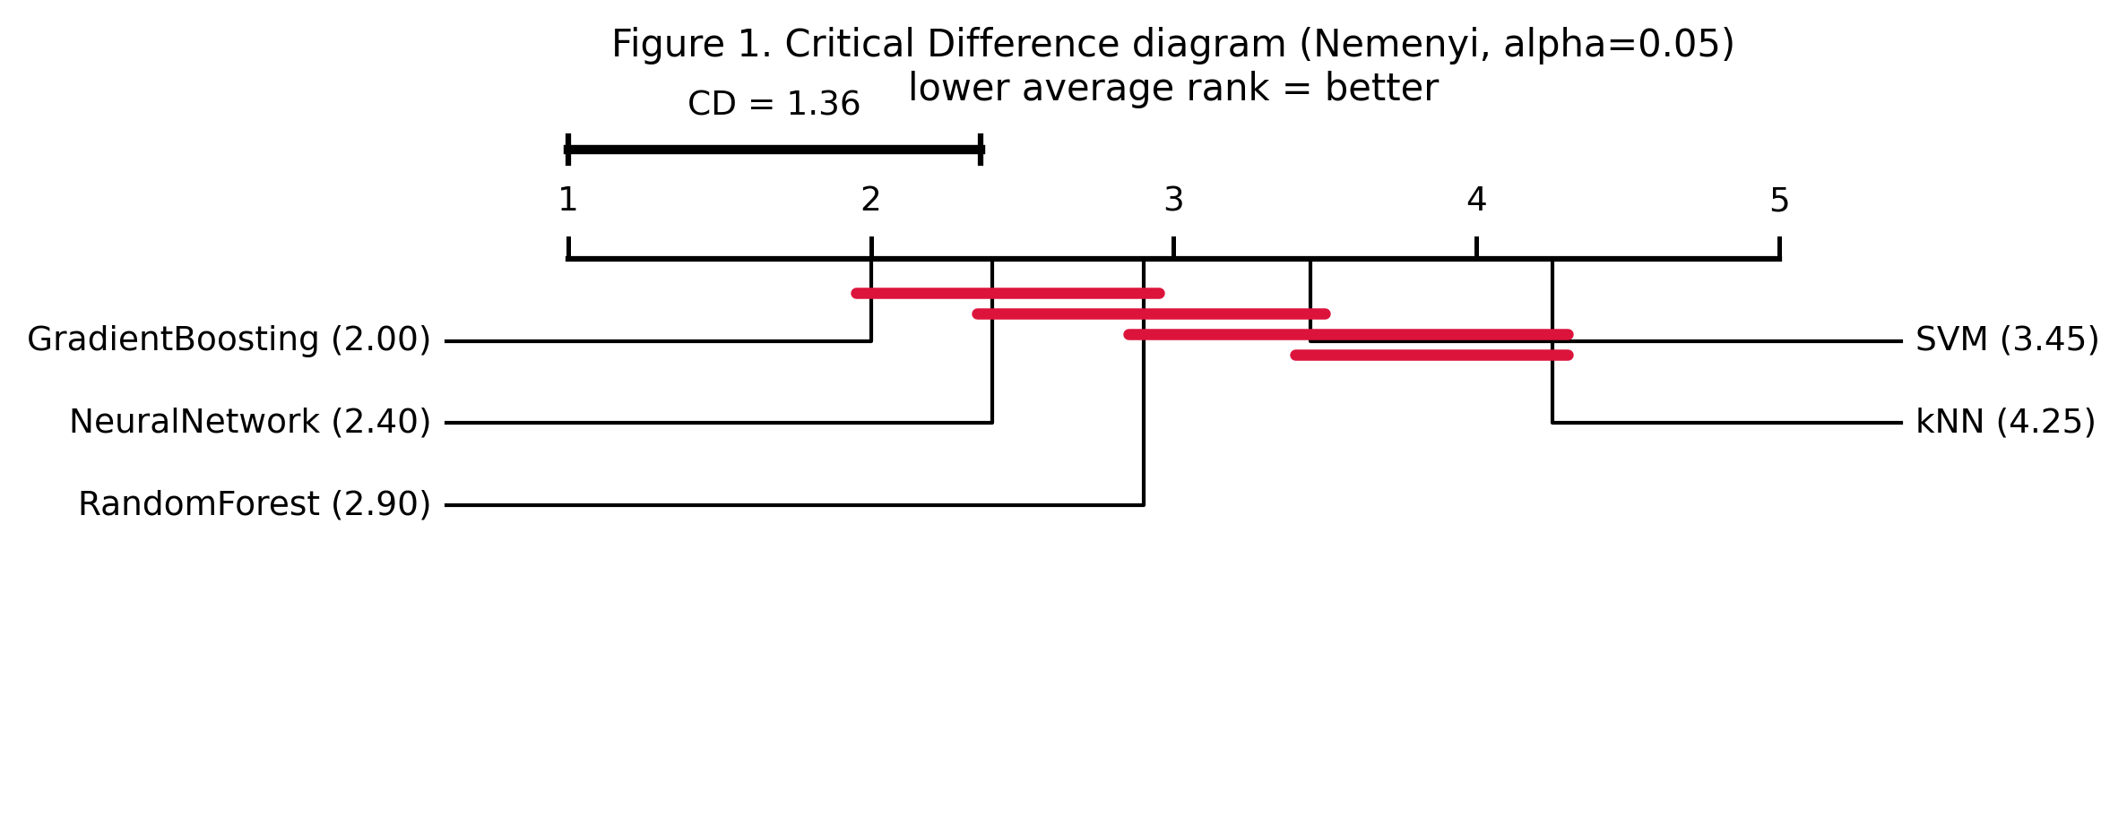
Figure 1. Critical Difference diagram (Nemenyi, alpha = 0.05). Lower average rank is better; connected algorithms are not significantly different.
Wilcoxon signed-rank tests comparing GradientBoosting against each competitor on per-dataset scores corroborated the rank analysis. vs RandomForest (p = 0.0017); vs SVM (p = 0.0027); vs kNN (p = 0.0000); vs NeuralNetwork (p = 0.0296). GradientBoosting significantly outperformed every other algorithm at alpha = 0.05.

3.4 Meta-feature importance (Table 2)
Table 2 reports meta-feature importances from the Random Forest meta-learner. The most informative meta-features were mean_abs_coef_variation (0.126), mean_skewness (0.122), feature_to_instance_ratio (0.110). Statistical descriptors of the feature distributions (coefficient of variation, skewness, kurtosis) and the feature-to-instance ratio carried more signal than raw size counts, suggesting that the shape of a dataset's feature distributions matters more than its scale for predicting which algorithm wins.
Meta-feature | Importance
mean_abs_coef_variation | 0.1258
mean_skewness | 0.1219
feature_to_instance_ratio | 0.1097
mean_kurtosis | 0.0979
mean_feature_std | 0.0939
mean_abs_feature_correlation | 0.0798
n_features | 0.0684
n_instances | 0.0595
log_n_instances | 0.0521
n_classes | 0.0504
log_n_features | 0.0464
task_code | 0.0426
normalised_class_entropy | 0.0286
class_imbalance_ratio | 0.0230
Table 2. Meta-feature importance from the Random Forest meta-learner (Gini importance, fit on all datasets).

3.5 Meta-learner performance
Under leave-one-out cross-validation the meta-learner correctly predicted the winning algorithm for 7 of 20 datasets (accuracy 0.35). This did not exceed the majority-class baseline of predicting 'GradientBoosting' every time (accuracy 0.45). We report this negative result plainly: with only 20 datasets spread across four distinct winning algorithms, there are too few examples per class for the meta-classifier to learn a mapping that beats a strong default. The importances in Table 2 are therefore best read as indicative of which meta-features are promising, not as a validated selection rule.

3.6 Complexity and performance (Figure 2)
Figure 2 plots each dataset's complexity (instances times features, log scale) against the best score any algorithm achieved on it, coloured by the winning algorithm. There is no clean monotonic relationship between complexity and achievable performance; strong and weak results occur at every scale, and different algorithms win in different regions rather than one method dominating the high-complexity or low-complexity end.
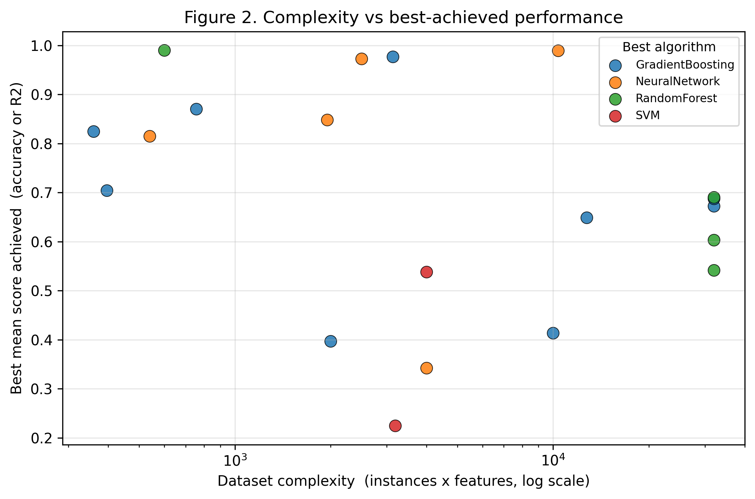
Figure 2. Dataset complexity versus best-achieved performance, coloured by winning algorithm.

4. Discussion

4.1 Practical guidelines
The clearest practical message is that GradientBoosting is a strong default. It achieved the best average rank, won on the plurality of datasets, and significantly outperformed every competitor on the Wilcoxon test. For a practitioner facing a new tabular dataset of moderate size with no prior information, starting with Gradient Boosting is a defensible, evidence-based choice. The neural network was the closest challenger by average rank, while kNN was consistently the weakest and is the least attractive default in this regime.
That said, the per-dataset winners in Table 1 show that the default is not universal: several datasets were won by Random Forest, the neural network or SVM. This is exactly the situation meta-learning is meant to exploit — and exactly why the selection problem is worth studying even when a strong default exists.

4.2 When to use which algorithm
The meta-feature importance analysis (Table 2) offers tentative guidance about which dataset properties associate with different winners. Distributional shape statistics — coefficient of variation, skewness and kurtosis — and the feature-to-instance ratio were the most informative meta-features, more so than raw instance or feature counts. A cautious reading is that the geometry of the feature distributions, rather than sheer dataset size, is what tips the balance between algorithms. Because the meta-learner did not beat the baseline, however, we present this as a hypothesis for larger studies rather than a validated rule.

4.3 Limitations
The central limitation is benchmark scope. Twenty datasets are enough to compare five algorithms with adequate statistical power — the Friedman and Wilcoxon results are unambiguous — but far too few to train a reliable meta-classifier over four winning-algorithm classes. With roughly five examples per class under leave-one-out evaluation, the meta-learner cannot outlearn the majority-class baseline, and its sub-baseline accuracy should be read as a sample-size artefact rather than evidence that meta-features are uninformative. A second limitation is the size cap: to keep the experiment tractable we excluded very large and very high-dimensional datasets, so the conclusions apply to small-to-moderate tabular problems and may not transfer to high-dimensional or big-data regimes. Third, we used fixed default hyperparameters; per-dataset tuning could change the ranking, particularly for the SVM and neural network, which are more tuning-sensitive than the tree ensembles. Finally, PMLB is itself a particular sample of problems, and the No Free Lunch theorem cautions that results are always relative to the distribution of problems examined.

5. Conclusion
We conducted a fully data-driven comparison of five machine-learning algorithms across 20 diverse benchmark datasets and asked whether dataset meta-features can predict the best algorithm. Gradient Boosting emerged as the strongest general-purpose method, with a statistically significant advantage over its competitors, yet no algorithm won everywhere — a direct empirical illustration of the No Free Lunch principle. Cheap-to-compute meta-features, especially distributional-shape statistics and the feature-to-instance ratio, carried the most signal about which algorithm would win, but our 20-dataset meta-learner could not turn that signal into predictions that beat a majority-class default. The practical framework we recommend is therefore two-tier: adopt Gradient Boosting as an evidence-based default, and treat meta-feature-driven selection as a promising direction that requires many more datasets to validate. Scaling the dataset pool by an order of magnitude, broadening the size range, and adding light hyperparameter tuning are the natural next steps toward a meta-learning recommender that is both accurate and trustworthy.

References
Demsar, J. (2006). Statistical comparisons of classifiers over multiple data sets. Journal of Machine Learning Research, 7, 1-30.
Olson, R. S., La Cava, W., Orzechowski, P., Urbanowicz, R. J., & Moore, J. H. (2017). PMLB: A large benchmark suite for machine learning evaluation and comparison. BioData Mining, 10(1), 36.
Pedregosa, F., Varoquaux, G., Gramfort, A., Michel, V., Thirion, B., Grisel, O., ... Duchesnay, E. (2011). Scikit-learn: Machine learning in Python. Journal of Machine Learning Research, 12, 2825-2830.
Rice, J. R. (1976). The algorithm selection problem. Advances in Computers, 15, 65-118.
Vanschoren, J. (2019). Meta-learning: A survey. In Automated Machine Learning (pp. 35-61). Springer.
Wolpert, D. H., & Macready, W. G. (1997). No free lunch theorems for optimization. IEEE Transactions on Evolutionary Computation, 1(1), 67-82.

