**OAK-D CM4 PoE (Integrated RPi CM4 host)**

# Features

* Movidius Myriad X VPU
* RPi CM4 system on module
* 32Kb I2C EEPROM
* 802.3af, Class 3 PoE compliance
* 1000BASE-T speeds
* 2x 2-lane MIPI connects OV9282 1MP global shutter cameras with no IR filter
* 1x center 4-lane MIPI connects IMX378 12 MP color rolling shutter camera
* ¼ -20 tripod mount on the bottom of the unit
* VESA-spec (2x horizontal 7.5cm / vertical 2x 35mm, M4) two sets of mounting holes on the back of the unit
* IP67 rated enclosure

# Applications

* Industrial automation
* Robotics
* Surveillance IP camera
* Security systems
* Remote intelligence

# Description

The Luxonis OAK-D CM4 PoE is an AI Edge vision system driven by Movidius Myriad X VPU. The system is powered over a USB Type-C. OAK-D CM4 PoE has three on-board cameras which implement stereo and RGB vision, piped directly into the DepthAI Myriad X VPU for depth and AI processing. The data is then output to an onboard Raspberry Pi CM4 host, via USB 3.1 Gen1. OAK-D CM4-PoE can work as a stand alone device and can be accessed over SSH. OAK-D CM4 PoE offers full 802.3af, Class 3 PoE compliance with 1000BASE-T speeds.

**Device Information**

|  |  |
| --- | --- |
| **PART NUMBER** | **SIZE (WxHxD)** |
| OAK-D CM4 PoE | 130mm x 64mm x 30mm |

# 

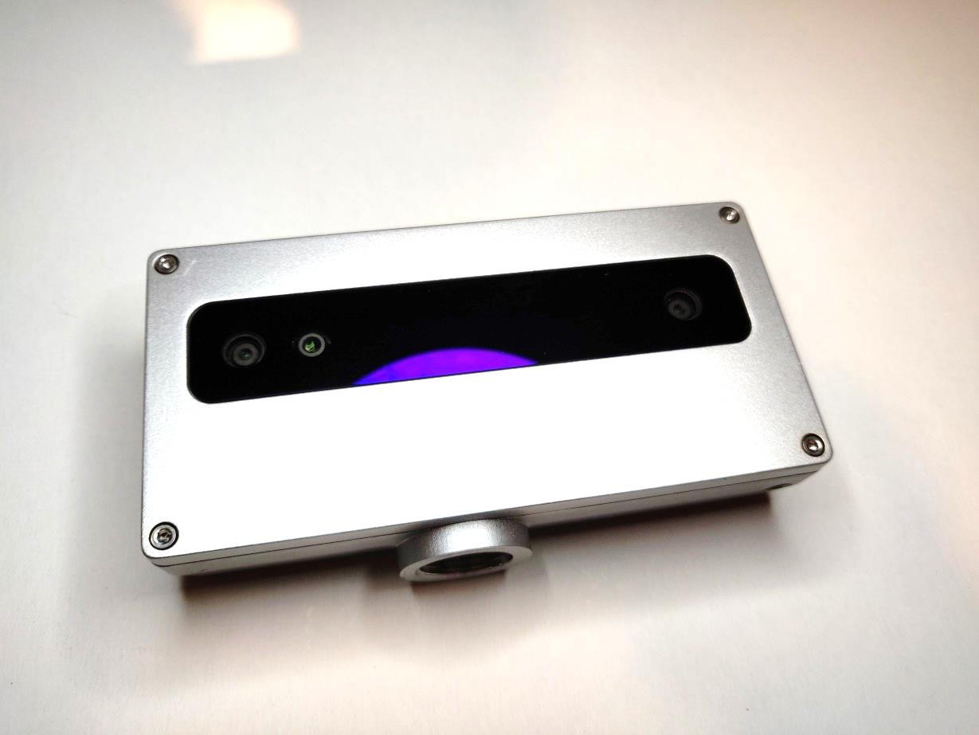

Figure 1 – OAK-D CM4 PoE

**Table of Contents**

1 Features 1

2 Applications 1

3 Description 1

4 Electrical Characteristics 3

4.1 Absolute Maximum Ratings1 3

4.2 Recommended Operating Conditions 3

5 Raspberry Pi CM4 powered 4

6 Camera sensors characteristics 4

6.1 Center Color Camera 4

6.2 Stereo vision gray scale camera 5

7 Mechanical Information 5

|  |  |  |  |  |  |
| --- | --- | --- | --- | --- | --- |
| Electrical Characteristics | |  |  |  |  |
| Absolute Maximum Ratings1 | | |  |  |  |
|  | | |  |  |  |
| **SYMBOL** | **RATINGS** | | **MIN** | **MAX** | **UNIT** |
| **V**POE | 802.3af, Class3 input supply voltage range.2 | | 37 | 57 | V |
| **I**POE | Maximum input current requirement | |  | 0.35 | A |
| **T**stq | Ambient temperature | | 0 | 60 | C |

## 

## Recommended Operating Conditions

|  |  |  |  |  |  |
| --- | --- | --- | --- | --- | --- |
| **SYMBOL** | **RATINGS** | **MIN** | **TYP** | **MAX** | **UNIT** |
| **V**BUS | VBUS input supply voltage |  | 52 | 55 | V |
| **P** | Power consumption requirement | 4 | 5 | 6 | W |
| **PIDLE** | VBUS idle power draw (Myriad X booted) |  | 2.5 |  | W |
| **T**A | Ambient operating temperature |  |  | 50 | °C |

1. Stresses beyond those listed under *Absolute Maximum Ratings* may cause permanent damage to the device. These are stress ratings only, which do not imply functional operation of the device at these or any other conditions beyond those indicated under *Recommended* *Operating Conditions*. Exposure to absolute-maximum-rated conditions for extended periods may affect device reliability.
2. According to industry standard 802.3af, Class 3 PoE specifications

# Raspberry Pi CM4 powered

OAK-D CM4 PoE incorporates Raspberry Pi Compute Module 4 and by default comes equipped with CM4004032.

OAK-SoM-Pro and RPi CM4 module are connected over PCIe/USB bridge VL806 from VLI. The same USB bridge is used on the Raspberry Pi4, though in the OAK-D CM4 PoE it requires a custom FW flashed to the SPI EEPROM.

EEPROM is flashed during production testing so there is no need to update it later.

Raspberry Pi CM 4 specifications:

* Broadcom BCM2711 quad-core Cortex-A72 (ARM v8) 64-bit SoC @ 1.5GHz
* H.265 (HEVC) (up to 4Kp60 decode), H.264 (up to 1080p60 decode, 1080p30 encode)
* OpenGL ES 3.1, Vulkan 1.0
* Options for 1GB, 2GB, 4GB or 8GB LPDDR4-3200 SDRAM (depending on variant)
* Options for 0GB ("Lite"), 8GB, 16GB or 32GB eMMC Flash memory (depending on variant)

For more information related to the RPi CM4 module an official product site can be found on the appended link [here](https://www.raspberrypi.com/products/compute-module-4/?variant=raspberry-pi-cm4001000).

# Camera sensors characteristics

|  |
| --- |
| Center Color Camera |

The color sensor on the stereo depth module in addition to color image provides texture information. Usages for the texture information include overlay on a depth image to create a color point cloud and overlay on a 3D model for reconstruction.

|  |  |
| --- | --- |
| **Parameter** | **Value** |
| **Image sensor** | Sony IMX378 |
| **Active pixels** | 4056x3040@60fps |
| **Output video format** | RAW12/10/8 |
| **Focus type** | Auto Focus 8cm - ∞ / Fixed Focus 50cm- ∞ |
| **FOV** | 78° |
| **Shutter Type** | Rollign shutter |
| **IR sensitive** | No |

## Stereo vision gray scale camera

Stereo cameras compare the features and based on the disparity determines the distance/depth of the object tracked on by the product. It also provides the depth map in color and raw depth map in gray scale.

|  |  |
| --- | --- |
| **Parameter** | **Value** |
| **Image sensor** | OmniVision OV9282 |
| **Active pixels** | 1280x800@120FPS |
| **Output video format** | 8/10-bit RAW |
| **Focus type** | Fixed Focus 19.6cm - ∞ |
| **FOV** | 89.5° |
| **Shutter Type** | Global shutter |
| **IR sensitive** | No |

# Mechanical Information

The following information is [the most](http://www.ti.com/corp/docs/legal/termsofuse.shtml) [current](http://www.ti.com/corp/docs/legal/termsofuse.shtml) data available for the designated device. This data is subject to change without notice and without revision of this document.

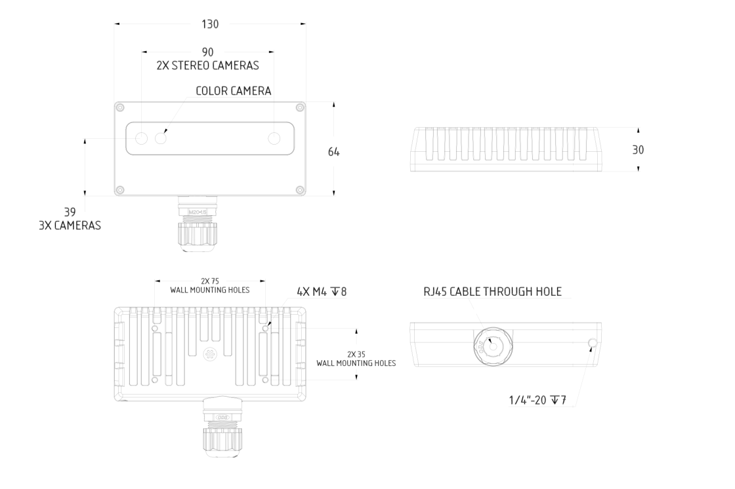

Figure 2 – OAK-D CM4 PoE Mechanical measurements