**OAK-D Lite (default USB boot)**

# Features

* Movidius Myriad X VPU
* 32Kb I2C EEPROM
* USB3.1, gen2 10gbps
* 2x 1-lane MIPI connects OV7251 0.31MP global shutter cameras with no IR filter
* 1x center 4-lane MIPI connects IMX214 13.1 MP color rolling shutter camera
* ¼ -20 tripod mount on the bottom of the unit
* VESA-spec (7.5cm, M4) set of mounting holes on the back of the unit

# Applications

* Industrial automation
* Robotics
* Surveillance IP camera
* Security systems
* Remote intelligence

# Description

The Luxonis OAK-D Lite is an AI Edge vision system driven by Movidius Myriad X VPU. The system is powered over a USB Type-C. OAK-D Lite has three on-board cameras which implement stereo and RGB vision, piped directly into the DepthAI Myriad X VPU for depth and AI processing. The data is then output to a host via USB 3.1 Gen1. OAK-D Lite is an entry-level small form factor device, but capable of running all the same pipelines and models just like any other Luxonis OAK-D product as it is based on the same core processing unit Myriad X.

**Device Information**

|  |  |
| --- | --- |
| **PART NUMBER** | **SIZE (WxHxD)** |
| OAK-D Lite | 91mm x 28mm x 17.5mm |

# 

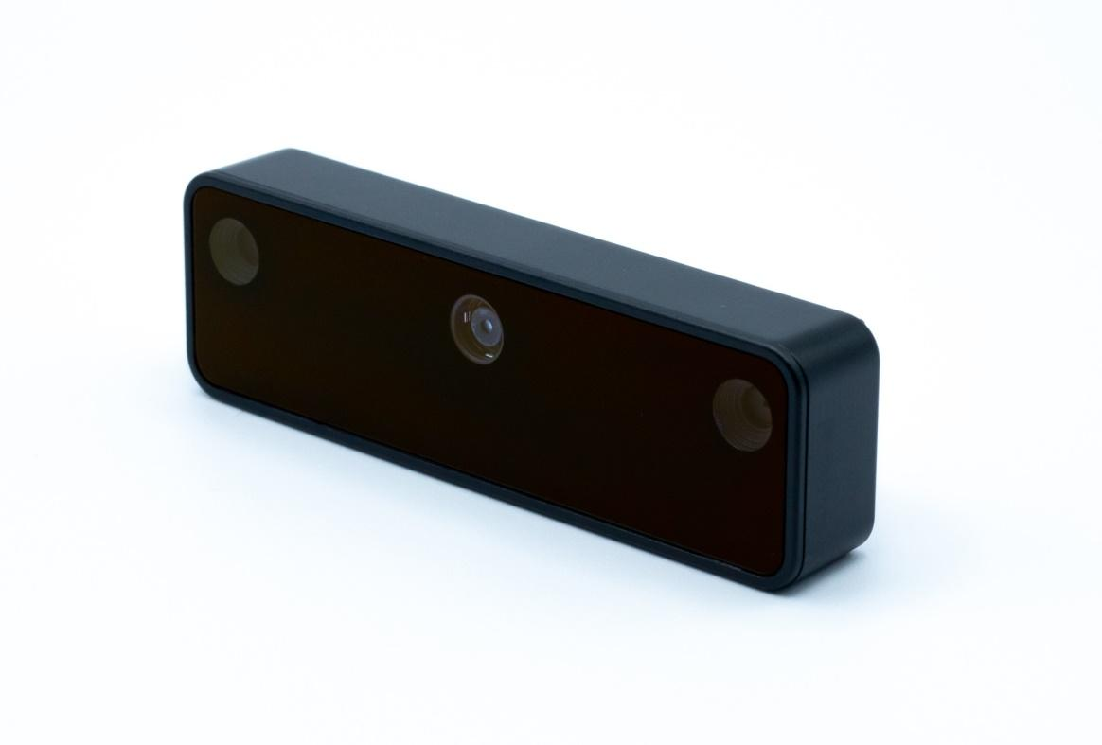

*Figure 1 – OAK-D Lite*

**Table of Contents**

**1** **Features 1**

**2** **Applications 1**

**3** **Description 1**

**4** **Electrical Characteristics 3**

4.1 Absolute Maximum Ratings1 3

4.2 Recommended Operating Conditions 3

**5** **Camera sensors characteristics 4**

5.1 Center Color Camera 4

5.2 Stereo vision grayscale camera 4

**6** **OAK-D Lite with use of Y-adapter 5**

**7** **Mechanical Information 5**

|  |  |  |  |  |  |
| --- | --- | --- | --- | --- | --- |
| Electrical Characteristics | |  |  |  |  |
| Absolute Maximum Ratings1 | | |  |  |  |
|  | | |  |  |  |
| **SYMBOL** | **RATINGS** | | **MIN** | **MAX** | **UNIT** |
| **V**BUS | USB input supply voltage range.2 | | 3.5 | 5.5 | V |
| **I**VBUS | Maximum input current requirement | |  | 1.5 | A |
| **T**stq | Ambient temperature | | 0 | 60 | C |

## 

## Recommended Operating Conditions

|  |  |  |  |  |  |
| --- | --- | --- | --- | --- | --- |
| **SYMBOL** | **RATINGS** | **MIN** | **TYP** | **MAX** | **UNIT** |
| **V**BUS | VBUS input supply voltage |  | 5V | 5.25 | V |
| **P** | Power consumption requirement | 4 | 5 | 6 | W |
| **PIDLE** | VBUS idle power draw (Myriad X booted) |  | 2.5 |  | W |
| **T**A | Ambient operating temperature |  |  | 50 | °C |

1. Stresses beyond those listed under *Absolute Maximum Ratings* may cause permanent damage to the device. These are stress ratings only, which do not imply functional operation of the device at these or any other conditions beyond those indicated under *Recommended* *Operating Conditions*. Exposure to absolute-maximum-rated conditions for extended periods may affect device reliability.
2. According to industry standard Universal Serial Bus (USB) specifications

# Camera sensors characteristics

|  |
| --- |
| Center Color Camera |

The color sensor on the stereo depth module in addition to the color image provides texture information. Usages for the texture information include overlay on a depth image to create a color point cloud and overlay on a 3D model for reconstruction.

|  |  |
| --- | --- |
| **Parameter** | **Value** |
| **Image sensor** | Sony IMX214 |
| **Active pixels** | 4208x3120 @60fps |
| **Lens Size:** | 1/3.1 inch |
| **Focus type** | Auto Focus 8cm - ∞ / Fixed Focus 50cm- ∞ |
| **FOV** | DFOV: 81.3 ° |
| **Shutter Type** | Electronic shutter |
| **IR sensitive** | No |

## Stereo vision grayscale camera

Stereo cameras compare the features and based on the disparity determines the distance/depth of the object tracked on by the product. It also provides the depth map in color and raw depth map in grayscale.

|  |  |
| --- | --- |
| **Parameter** | **Value** |
| **Image sensor** | OmniVision OV7251 |
| **Active pixels** | 640x480@120FPS |
| **Output video format** | 8/10-bit RAW |
| **Focus type** | Fixed Focus 6.5cm - ∞ |
| **FOV** | DFOV: 85.6 ° HFOV: 72.9 ° VFOV: 57.7 ° |
| **Shutter Type** | Global shutter |
| **IR sensitive** | No |

# OAK-D Lite with use of Y-adapter

Consumption of OAK-D Lite can be higher and will fall out of the USB2 maximum specified range of 900mA. If the host is capable of delivering only 900mA current over a single USB port then Y-adapter provides an option to have a separate power supply connected to the same USB device along with the data connection from the host. This allows that OAK-D Lite can still be run on devices such as Raspberry Pi4 and similar hosts with lower power capabilities on USB ports.

# Mechanical Information

The following information is [the most](http://www.ti.com/corp/docs/legal/termsofuse.shtml) [current](http://www.ti.com/corp/docs/legal/termsofuse.shtml) data available for the designated device. This data is subject to change without notice and without revision of this document.

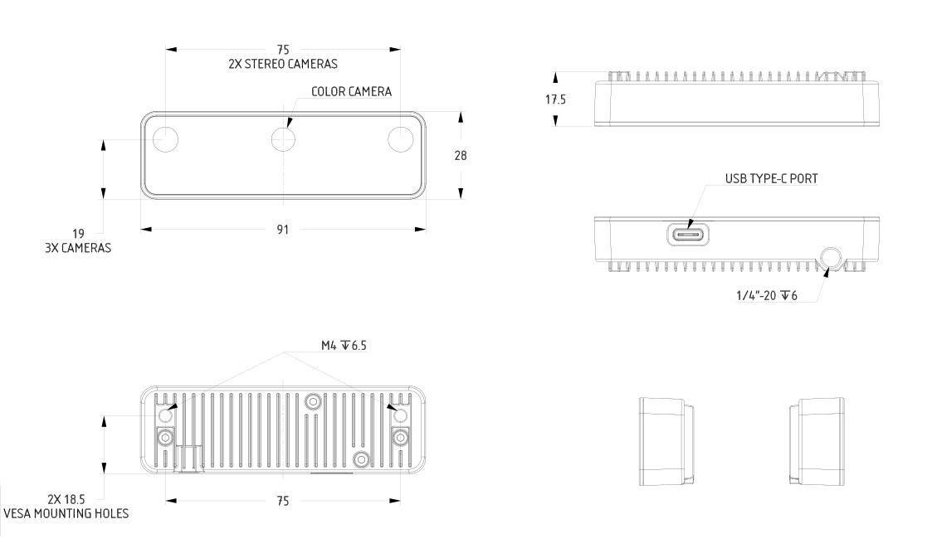

*Figure 2 – OAK-D Lite Mechanical measurements*