**OAK-D Pro (USB boot with 256Mbit NOR flash)**

# Features

* Movidius Myriad X VPU
* 256/512/1024MBit QSPI NOR Flash
* 32Kb I2C EEProM
* USB3.1, gen2 10gbps
* 2x 2-lane MIPI connects OV9282 1MP global shutter cameras with no IR filter
* 1x center 4-lane MIPI connects IMX378 12 MP color rolling shutter camera
* Active IR stereo
* IR Laser dot projector (Belago 1.1)
* IR Flood LED light (SFH 4725AS)
* ¼ -20 tripod mount on the bottom of the unit
* VESA-spec (7.5cm, M4) set of mounting holes on the back of the unit

# Applications

* Industrial automation
* Robotics
* Surveillance IP camera
* Security systems
* Remote intelligence

# Description

The Luxonis OAK-D Pro is an AI Edge vision system driven by Movidius Myriad X VPU. The system is powered over a USB Type-C. OAK-D Pro has three onboard cameras which implement stereo and RGB vision, piped directly into the DepthAI Myriad X VPU for depth and AI processing. The data is then output to a host via USB 3.1 Gen1. In addition to stereo cameras, the OAK-D Pro also features IR active illumination in the form of a laser dot projector. It actively illuminates the area in the camera field of view using 4700 laser dots. The OAK-D Pro also features an IR LED flood light to help in low light situations.

**Device Information**

| **PART NUMBER** | **SIZE (WxDxH)** |
| --- | --- |
| OAK-D Pro | 97mm x 22.9mm x 29.5mm |



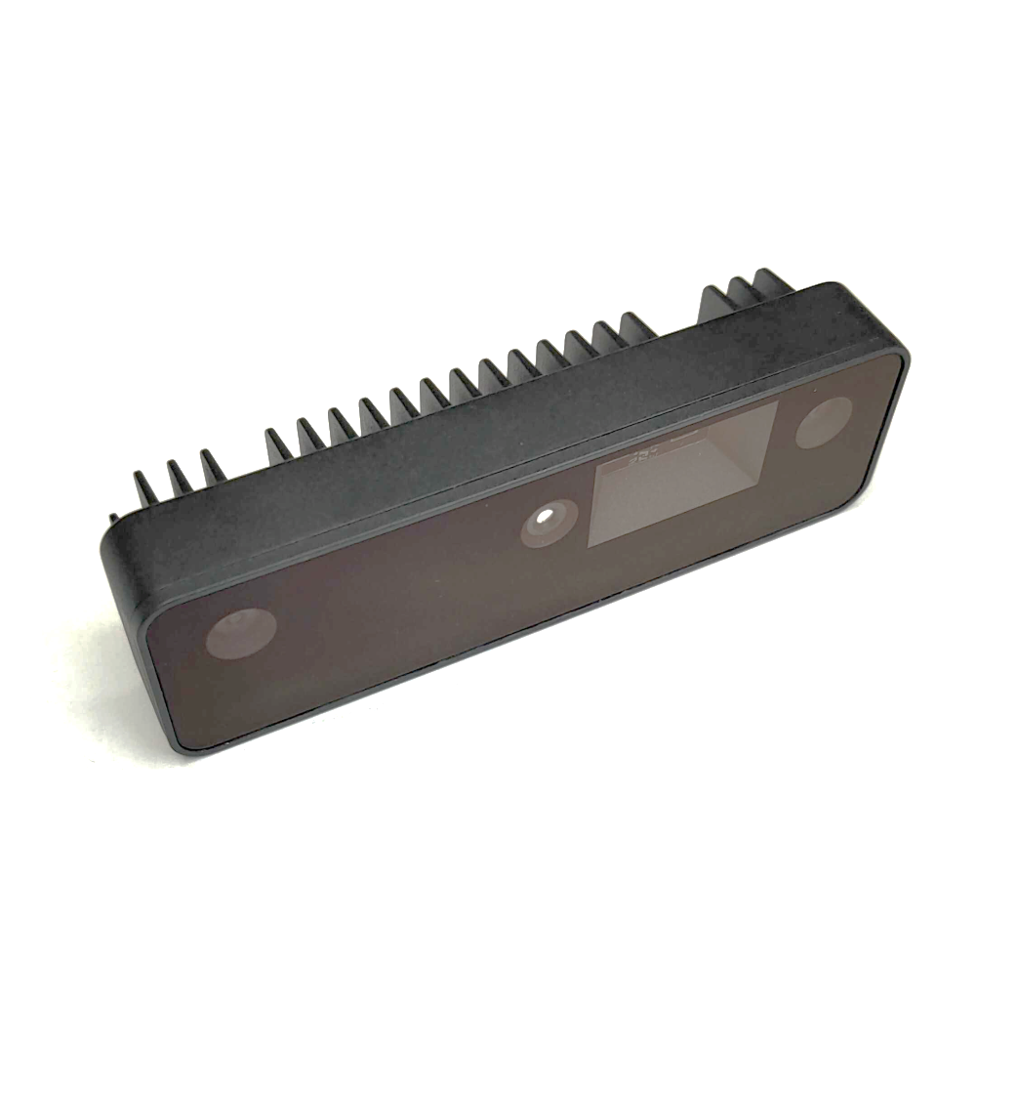

*Figure 1 – OAK-D Pro*

**Table of Contents**

**1** **Features 1**

**2** **Applications 1**

**3** **Description 1**

**4** **Electrical Characteristics 3**

4.1 Absolute Maximum Ratings1 3

4.2 Recommended Operating Conditions 3

**5** **Camera sensors characteristics 4**

5.1 Center Color Camera 4

5.2 Stereo vision GRAYSCALE camera 4

**6** **Active illumination 4**

6.1 IR dot projector 5

6.2 IR flood illumination LED 5

**7** **Inertial Measurement Unit (IMU) 6**

**8** **OAK-D Pro with use of Y-adapter 6**

**9** **Mechanical Information 6**

**10** **Certification statement 7**

**11** **Cautionary Statement 7**

**12** **Support 7**



| Electrical Characteristics | |  |  |  |  |
| --- | --- | --- | --- | --- | --- |
| Absolute Maximum Ratings1 | | |  |  |  |
|  | | |  |  |  |
| **SYMBOL** | **RATINGS** | | **MIN** | **MAX** | **UNIT** |
| **V**BUS | USB input supply voltage range.2 | | 3.5 | 5.5 | V |
| **I**VBUS | Maximum input current requirement | |  | 2 | A |
| **T**stq | Ambient temperature | | 0 | 60 | C |

## Recommended Operating Conditions

| **SYMBOL** | **RATINGS** | **MIN** | **TYP** | **MAX** | **UNIT** |
| --- | --- | --- | --- | --- | --- |
| **V**BUS | VBUS input supply voltage |  | 5V | 5.25 | V |
| **P** | Power consumption requirement | 4 | 6 | 7.5 | W |
| **PIDLE** | VBUS idle power draw (Myriad X booted) |  | 2.5 |  | W |
| **T**A | Ambient operating temperature |  |  | 50 | °C |

1. Stresses beyond those listed under *Absolute Maximum Ratings* may cause permanent damage to the device. These are stress ratings only, which do not imply functional operation of the device at these or any other conditions beyond those indicated under *Recommended* *Operating Conditions*. Exposure to absolute-maximum-rated conditions for extended periods may affect device reliability.
2. According to industry standard Universal Serial Bus (USB) specifications

# Camera sensors characteristics

| Center Color Camera |
| --- |

The color sensor on the stereo depth module in addition to the color image provides texture information. Usages for the texture information include overlay on a depth image to create a color point cloud and overlay on a 3D model for reconstruction.

| **Parameter** | **Value** |
| --- | --- |
| **Image sensor** | Sony IMX378 |
| **Active pixels** | 4056x3040@60fps |
| **Output video format** | RAW12/10/8 |
| **Focus type** | Auto Focus 8cm - ∞ / Fixed Focus 50cm- ∞ |
| **FOV** | 78° |
| **Shutter Type** | Rolling shutter |
| **IR sensitive** | No |

## Stereo vision grayscale camera

Stereo cameras compare the features and based on the disparity determines the distance/depth of the object tracked on by the product. It also provides the depth map in color and the raw depth map in grayscale.

| **Parameter** | **Value** |
| --- | --- |
| **Image sensor** | OmniVision OV9282 |
| **Active pixels** | 1280x800@120FPS |
| **Output video format** | 8/10-bit RAW |
| **Focus type** | Fixed Focus 19.6cm - ∞ |
| **FOV** | 89.5° |
| **Shutter Type** | Global shutter |
| **IR sensitive** | Yes |

# Active illumination

## IR dot projector

OAK-D Pro doesn’t include IR filter on mono cameras (production version will have notch IR filters at 940nm), which allows only visible light and IR light from illumination LED/laser dot projector to the camera..

Laser dot projector projects 4700 dots in front of the device, which helps with disparity matching, especially for low-visual-interest surfaces (blank surfaces with little to no texture), such as a wall or floor. The technique that we use is called ASV - conventional active stereo vision - as stereo matching is performed on the device the same way as on OAK-D (passive stereo). The projector meets the CLASS 1 specification which means no harm can be done with the laser source either to human skin or eye.

| **Parameter** | **Value** |
| --- | --- |
| **Projector** | Dot-Pattern Infrared Illuminator |
| **Projector type** | VCSEL (vertical cavity surface emitting laser) |
| **Wavelength** | 940nm |
| **Control** | Using strobe signal from the left stereo camera (PWM) |
| **Compliance** | Class 1, IEC 60825-1:2014 Edition 3 |
| **FOI (Field of illumination)** | HFOI: 61°+/-4°, VFOI: 78°+/-4° |

## IR flood illumination LED

Blanket IR LED illumination allows perceiving low-light and no-light environments. You can run your AI/CV processes on frames that are illuminated by the IR LED. Note that the color camera doesn’t perceive IR light, so you would need to use a mono camera stream for your AI/CV processes.

| **Parameter** | **Value** |
| --- | --- |
| **Projector** | IR Light Emitting Diode |
| **Wavelength** | 940 nm |
| **Control** | Using strobe signal from the left stereo camera (PWM) |
| **Compliance** | IEC 62471:2006 |
| **FOI (Field of illumination)** | FOI: 80° |

# Inertial Measurement Unit (IMU)

OAK-D Pro integrates a 9-Axis (Acceleration, Gyroscope, and magnetometer) BNO086 inertial measurement unit. MotionEngine 9-Axis and 6-Axis Sensor Fusion provide raw, calibrated sensor orientation data for more accurate heading and orientation.

# OAK-D Pro with use of Y-adapter

Due to IR light sources the consumption of OAK-D Pro can be higher and will fall out of the USB2 maximum specified range of 900mA. If the host is capable of delivering only 900mA current over a single USB port then Y-adapter provides an option to have a separate power supply connected to the same USB device along with the data connection from the host. This allows that OAK-D Pro can still be run on devices such as Raspberry Pi4 and similar hosts with lower power capabilities on USB ports.

# Mechanical Information

The following information is [the most](http://www.ti.com/corp/docs/legal/termsofuse.shtml) [current](http://www.ti.com/corp/docs/legal/termsofuse.shtml) data available for the designated device. This data is subject to change without notice and without revision of this document.

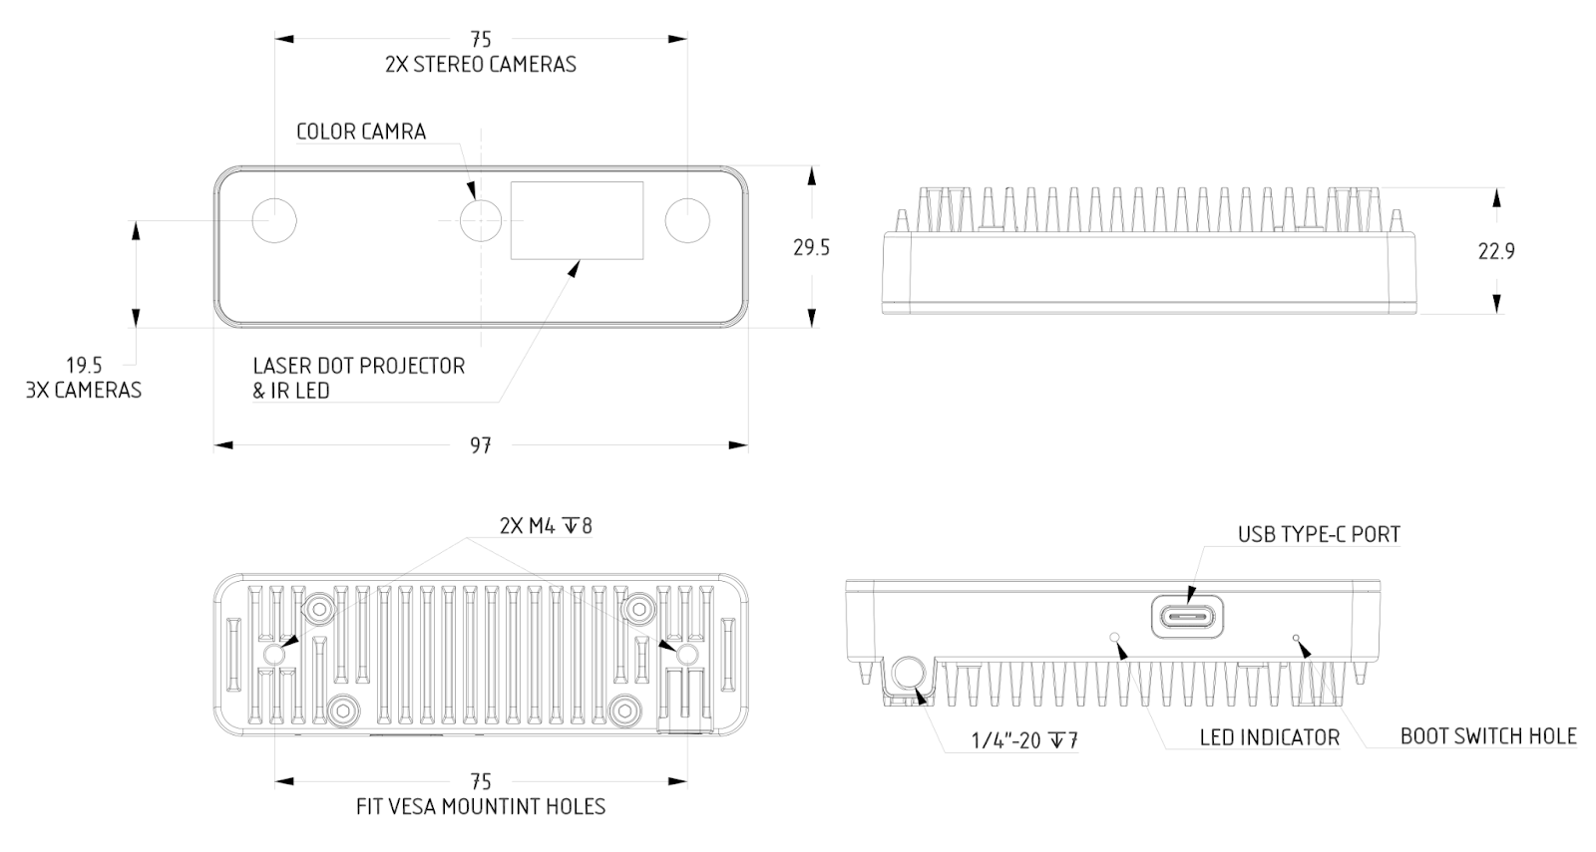

*Figure 2 – OAK-D Pro Mechanical measurements*

# Certification statement

This product is classified as a Class 1 Laser Product under the EN/IEC 60825-1, Edition 3 (2014) internationally.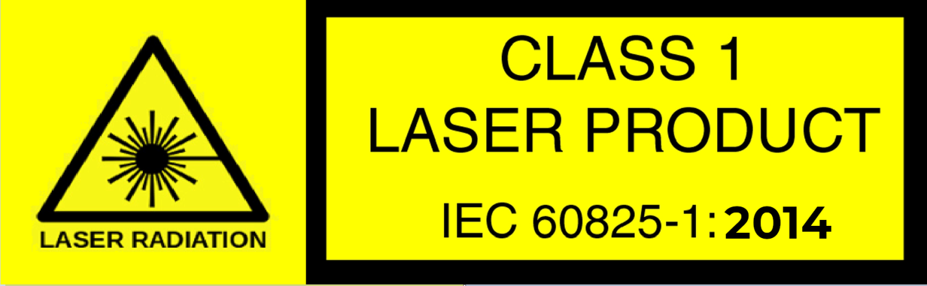

# Cautionary Statement

Do not power on the product if any external damage was observed.

Do not attempt to open any portion of this laser product.

Invisible laser radiation when opened. Avoid direct exposure to the beam.

There are no user serviceable parts with this laser product.

Modification or service of the stereo module, specifically the infrared projector, may cause the emissions to exceed Class 1.

No magnifying optical elements, such as eye loupes and magnifiers, are allowed.

Do not try to update camera firmware that is not officially released for specific camera module and revision.

# Support

If having any issue with the device or using SW cloned from Github, please contact [support@luxonis.com](mailto:support@luxonis.com) or reach out to Discord public server.