**OAK-D S2 (USB boot)**

# Features

* Movidius Myriad X VPU
* 32Kb I2C EEPROM
* USB3.1, gen2 10gbps
* 2x 2-lane MIPI connects OV9282 1MP global shutter cameras with no IR filter
* 1x center 4-lane MIPI connects IMX378 12 MP color rolling shutter camera
* ¼ -20 tripod mount on the bottom of the unit
* VESA-spec (7.5cm, M4) set of mounting holes on the back of the unit

# Applications

* Industrial automation
* Robotics
* Surveillance IP camera
* Security systems
* Remote intelligence

# Description

The Luxonis OAK-D S2 is an AI Edge vision system driven by Movidius Myriad X VPU. The system is powered over a USB Type-C. OAK-D S2 has three on-board cameras which implement stereo and RGB vision, piped directly into the DepthAI Myriad X VPU for depth and AI processing. The data is then output to a host via USB 3.1 Gen1

**Device Information**

|  |  |
| --- | --- |
| **PART NUMBER** | **SIZE (WxHxD)** |
| OAK-D S2 | 97mm x 29.5mm x 22.9mm |

# 

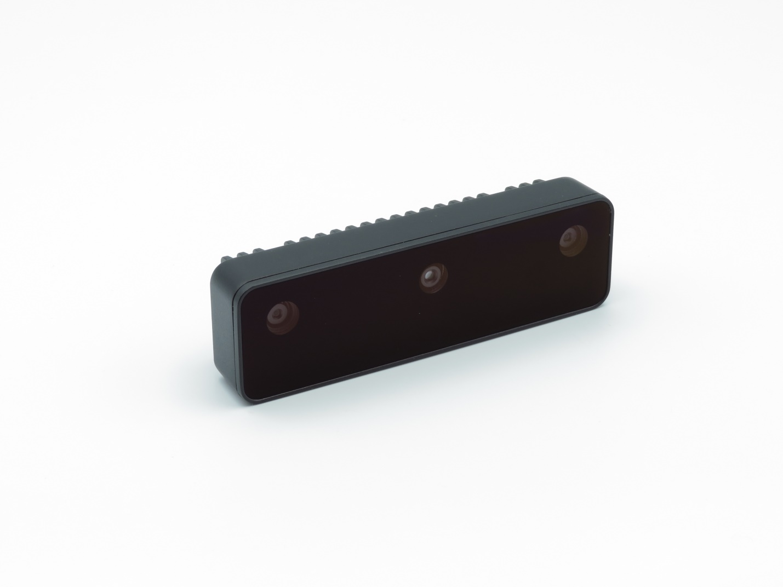

Figure 1 – OAK-D S2

**Table of Contents**

1 Features 1

2 Applications 1

3 Description 1

4 Electrical Characteristics 3

4.1 Absolute Maximum Ratings1 3

4.2 Recommended Operating Conditions 3

5 Camera sensors characteristics 4

5.1 Center Color Camera 4

5.2 Stereo vision gray scale camera 4

6 Mechanical Information 5

|  |  |  |  |  |  |
| --- | --- | --- | --- | --- | --- |
| Electrical Characteristics | |  |  |  |  |
| Absolute Maximum Ratings1 | | |  |  |  |
|  | | |  |  |  |
| **SYMBOL** | **RATINGS** | | **MIN** | **MAX** | **UNIT** |
| **V**BUS | USB input supply voltage range.2 | | 3.5 | 5.5 | V |
| **I**VBUS | Maximum input current requirement | |  | 2 | A |
| **T**stq | Ambient temperature | | 0 | 60 | C |

## 

## Recommended Operating Conditions

|  |  |  |  |  |  |
| --- | --- | --- | --- | --- | --- |
| **SYMBOL** | **RATINGS** | **MIN** | **TYP** | **MAX** | **UNIT** |
| **V**BUS | VBUS input supply voltage |  | 5V | 5.25 | V |
| **P** | Power consumption requirement | 4 | 6 | 7.5 | W |
| **PIDLE** | VBUS idle power draw (Myriad X booted) |  | 2.5 |  | W |
| **T**A | Ambient operating temperature |  |  | 50 | °C |

1. Stresses beyond those listed under *Absolute Maximum Ratings* may cause permanent damage to the device. These are stress ratings only, which do not imply functional operation of the device at these or any other conditions beyond those indicated under *Recommended* *Operating Conditions*. Exposure to absolute-maximum-rated conditions for extended periods may affect device reliability.
2. According to industry standard Universal Serial Bus (USB) specifications

# Camera sensors characteristics

|  |
| --- |
| Center Color Camera |

The color sensor on the stereo depth module in addition to color image provides texture information. Usages for the texture information include overlay on a depth image to create a color point cloud and overlay on a 3D model for reconstruction.

|  |  |
| --- | --- |
| **Parameter** | **Value** |
| **Image sensor** | Sony IMX378 |
| **Active pixels** | 4056x3040@60fps |
| **Output video format** | RAW12/10/8 |
| **Focus type** | Auto Focus 8cm - ∞ / Fixed Focus 50cm- ∞ |
| **FOV** | 78° |
| **Shutter Type** | Rolling shutter |
| **IR sensitive** | No |

## Stereo vision gray scale camera

Stereo cameras compare the features and based on the disparity determines the distance/depth of the object tracked on by the product. It also provides the depth map in color and raw depth map in gray scale.

|  |  |
| --- | --- |
| **Parameter** | **Value** |
| **Image sensor** | OmniVision OV9282 |
| **Active pixels** | 1280x800@120FPS |
| **Output video format** | 8/10-bit RAW |
| **Focus type** | Fixed Focus 19.6cm - ∞ |
| **FOV** | 89.5° |
| **Shutter Type** | Global shutter |
| **IR sensitive** | No |

# Mechanical Information

The following information is [the most](http://www.ti.com/corp/docs/legal/termsofuse.shtml) [current](http://www.ti.com/corp/docs/legal/termsofuse.shtml) data available for the designated device. This data is subject to change without notice and without revision of this document.

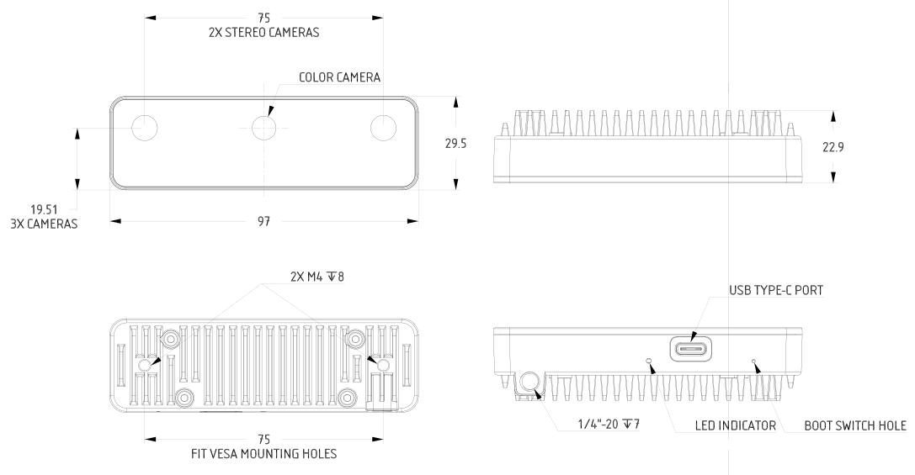

Figure 2 – OAK-D S2 Mechanical measurements