**OAK-D Pro PoE**

# Features

* Movidius Myriad X VPU
* 256/512/1024MBit QSPI NOR Flash
* 32Kb I2C EEProM
* Gigabit Ethernet + PoE power
* 2x 2-lane MIPI connects OV9282 1MP global shutter cameras with no IR filter
* 1x center 4-lane MIPI connects IMX378 12 MP color rolling shutter camera
* Active IR stereo
* IR Laser dot projector (Belago 1.1)
* IR Flood LED light (SFH 4725AS)
* ¼ -20 tripod mount on the bottom of the unit
* VESA-spec (7.5cm, M4) set of mounting holes on the back of the unit

# Applications

* Industrial automation
* Robotics
* Surveillance IP camera
* Security systems
* Remote intelligence

# Description

The Luxonis OAK-D Pro PoE is an AI Edge vision system driven by Movidius Myriad X VPU. The system is powered with Power over Ethernet (PoE). OAK-D Pro PoE has three on-board cameras which implement stereo and RGB vision, piped directly into the DepthAI Myriad X VPU for depth and AI processing. The data is then output to a host via Gigabit Ethernet connection. In addition to stereo cameras the OAK-D Pro PoE also features IR active illumination in the form of a laser dot projector. It actively illuminates the area in the camera field of view using 4700 laser dots. The OAK-D Pro PoE also features an IR LED flood light to help in low light situations.

**Device Information**

|  |  |
| --- | --- |
| **PART NUMBER** | **SIZE (WxHxD)** |
| OAK-D-Pro PoE | 111 mm x 47 mm x 31.1 mm |

# 

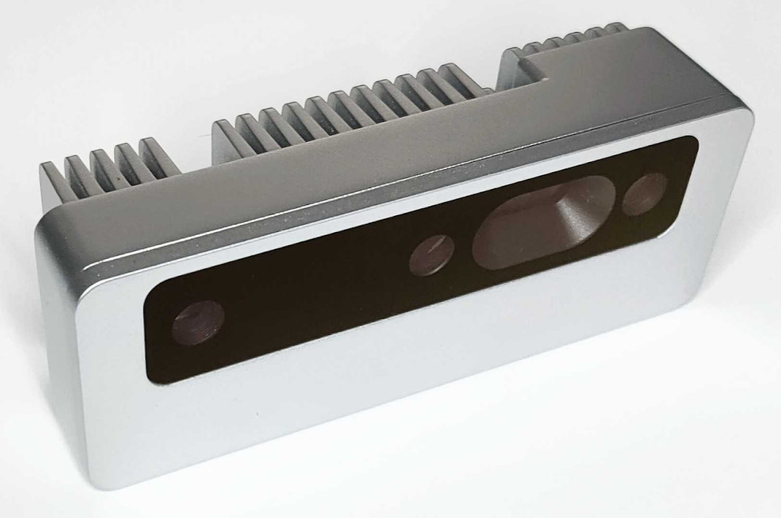

Figure 1 – OAK-D Pro PoE

**Table of Contents**

1 Features 1

2 Applications 1

3 Description 1

4 Electrical Characteristics 3

4.1 Absolute Maximum Ratings1 3

4.2 Recommended Operating Conditions 3

5 Camera sensors characteristics 4

5.1 Center Color Camera 4

5.2 Stereo vision gray scale camera 4

6 Active illumination 5

6.1 IR dot projector 5

6.2 IR flood illumination LED 5

7 Inertial Measurement Unit (IMU) 6

8 Auxiliary interface 6

9 Connectors 7

10 Mechanical Information 8

11 Certification statement 9

12 Cautionary Statement 9

13 Support 9

|  |  |  |  |  |  |
| --- | --- | --- | --- | --- | --- |
| Electrical Characteristics | |  |  |  |  |
| Absolute Maximum Ratings1 | | |  |  |  |
|  | | |  |  |  |
| **SYMBOL** | **RATINGS** | | **MIN** | **MAX** | **UNIT** |
| **V**POE | 802.3af, Class3 input supply voltage range.(2) | | 37 | 57 | V |
| **V**BUSIN | USB input supply voltage range.(2) | | 3.5 | 5.5 | V |
| **I**VBUS | Maximum input current requirement | |  | 2 | A |
| **T**stq | Ambient temperature | | 0 | 60 | C |

## Recommended Operating Conditions

|  |  |  |  |  |  |
| --- | --- | --- | --- | --- | --- |
| **SYMBOL** | **RATINGS** | **MIN** | **TYP** | **MAX** | **UNIT** |
| **V**POE | PoE input voltage range(2) | 37 |  | 57 | V |
| **V**BUSIN | VBUS input supply voltage |  | 5V | 5.25 | V |
| **V**io-imax | Maximum input voltage for GPIO pins |  |  | 5.5 | V |
| **V**io-omax | Maximum output voltage for GPIO pins |  |  | 3.3 | V |
| **P** | Power consumption requirement | 4 | 6 | 7.5 | W |
| **PIDLE** | VBUS idle power draw (Myriad X booted) |  | 2.5 |  | W |
| **T**A | Ambient operating temperature |  |  | 50 | °C |

1. Stresses beyond those listed under *Absolute Maximum Ratings* may cause permanent damage to the device. These are stress ratings only, which do not imply functional operation of the device at these or any other conditions beyond those indicated under *Recommended* *Operating Conditions*. Exposure to absolute-maximum-rated conditions for extended periods may affect device reliability.
2. Power supply designed according to 802.3af (802.3at Type 1) standard.
3. According to industry standard Universal Serial Bus (USB) specifications.

# Camera sensors characteristics

|  |
| --- |
| Center Color Camera |

The color sensor on the stereo depth module in addition to color image provides texture information. Usages for the texture information include overlay on a depth image to create a color point cloud and overlay on a 3D model for reconstruction.

|  |  |
| --- | --- |
| **Parameter** | **Value** |
| **Image sensor** | Sony IMX378 |
| **Active pixels** | 4056x3040@60fps |
| **Output video format** | RAW12/10/8 |
| **Focus type** | Auto Focus 8cm - ∞ / Fixed Focus 50cm- ∞ |
| **FOV** | 78° |
| **Shutter Type** | Rolling shutter |
| **IR sensitive** | No |

## Stereo vision gray scale camera

Stereo cameras compare the features and based on the disparity determines the distance/depth of the object tracked on by the product. It also provides the depth map in color and raw depth map in gray scale.

|  |  |
| --- | --- |
| **Parameter** | **Value** |
| **Image sensor** | OmniVision OV9282 |
| **Active pixels** | 1280x800@120FPS |
| **Output video format** | 8/10-bit RAW |
| **Focus type** | Fixed Focus 19.6cm - ∞ |
| **FOV** | 89.5° |
| **Shutter Type** | Global shutter |
| **IR sensitive** | Yes |

# Active illumination

## IR dot projector

OAK-D Pro PoE doesn’t include IR filter on mono cameras (production version will have notch IR filters at 940nm), which allows only visible light and IR light from illumination LED/laser dot projector to the camera..

Laser dot projector projects 4700 dots in front of the device, which helps with disparity matching, especially for low-visual-interest surfaces (blank surfaces with little to no texture), such as a wall or floor. Technique that we use is called ASV - conventional active stereo vision - as stereo matching is performed on device the same way as on OAK-D (passive stereo). The projector meets the CLASS 1 specification which means no harm can be done with the laser source either to human skin or eye.

|  |  |
| --- | --- |
| **Parameter** | **Value** |
| **Projector** | Dot-Pattern Infrared Illuminator |
| **Projector type** | VCSEL (vertical cavity surface emitting laser) |
| **Wavelength** | 940nm |
| **Control** | Using strobe signal from the left stereo camera (PWM) |
| **Compliance** | Class 1, IEC 60825-1:2014 Edition 3 |
| **FOI (Field of illumination)** | HFOI: 61°+/-4°, VFOI: 78°+/-4° |

## IR flood illumination LED

Blanket IR LED illumination allows perceiving low-light and no-light environments. You can run your AI/CV processes on frames that are illuminated by the IR LED. Note that color camera doesn’t perceive IR light, so you would need to use mono camera stream for your AI/CV processes.

|  |  |
| --- | --- |
| **Parameter** | **Value** |
| **Projector** | IR Light Emitting Diode |
| **Wavelength** | 940 nm |
| **Control** | Using strobe signal from the left stereo camera (PWM) |
| **Compliance** | IEC 62471:2006 |
| **FOI (Field of illumination)** | FOI: 80° |

# Inertial Measurement Unit (IMU)

OAK-D Pro PoE integrates a 9-Axis (Acceleration, Gyroscope and magnetometer) BNO086 inertial measurement unit. MotionEngine 9-Axis and 6-Axis Sensor Fusion provides raw, calibrated sensor orientation data for more accurate heading and orientation.

# Auxiliary interface

1. **USB**:

Device supports USB 2.0 interface used as a host to control external devices. Optionally this interface is used to reprogram the OAK-D-PRO-POE device (GPIO 0 needs to be pulled high during boot up in this case)

1. **GPIO**:

GPIO 0 – General purpose input output pin. This pin is used to put the device in to USB boot by pulling this pin high with a 10k resistor during startup. Also this pin is multiplexed with the Strobe functionality.

GPIO 1 – General purpose input output pin. This pin also supports UART_TX or I2C_SDA functionality.

GPIO 2 – General purpose input output pin. This pin also supports UART_RX or I2C_SCL functionality.

1. **FSYNC**:

Frame synchronization signal for cameras. This pin can be configured as an input or an output.

1. **STROBE:**

Strobe signal for controlling external lights. Multiplexed with GPIO 0.

1. **5V:**

This pin is used for sourcing 5V power to accessory devices connected to the M8 connector. If trying to boot the device in USB boot mode, this pin can also sink current.

# Connectors

OAK-D Pro PoE features an M12 connector for connecting to host via Ethernet and providing power, and M8 auxiliary connector.

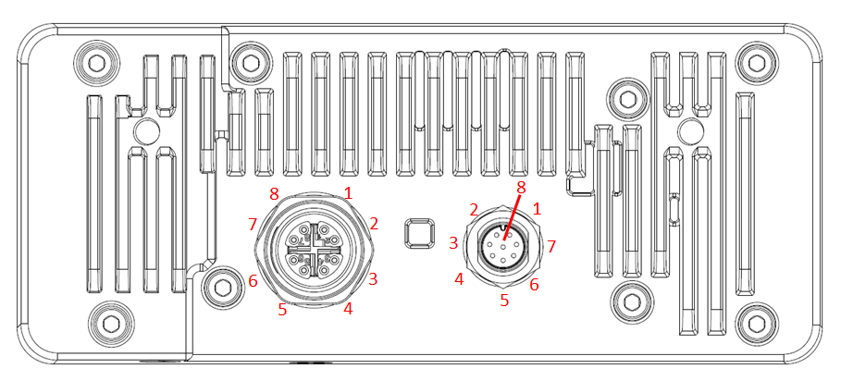

Ethernet M12 connector, X-Coded, Female

|  |  |
| --- | --- |
| 1 | Ethernet MX0+ |
| 2 | Ethernet MX0- |
| 3 | Ethernet MX1+ |
| 4 | Ethernet MX1- |
| 5 | Ethernet MX3+ |
| 6 | Ethernet MX3- |
| 7 | Ethernet MX2+ |
| 8 | Ethernet MX2- |

Auxiliary M8 connector, A-Coded, Male

|  |  |
| --- | --- |
| 1 | GPIO 0 / Strobe |
| 2 | FSYNC |
| 3 | USB+ |
| 4 | USB- |
| 5 | 5V |
| 6 | GPIO 1 |
| 7 | GPIO 2 |
| 8 | GND |

# Mechanical Information

The following information is [the most](http://www.ti.com/corp/docs/legal/termsofuse.shtml) [current](http://www.ti.com/corp/docs/legal/termsofuse.shtml) data available for the designated device. This data is subject to change without notice and without revision of this document.

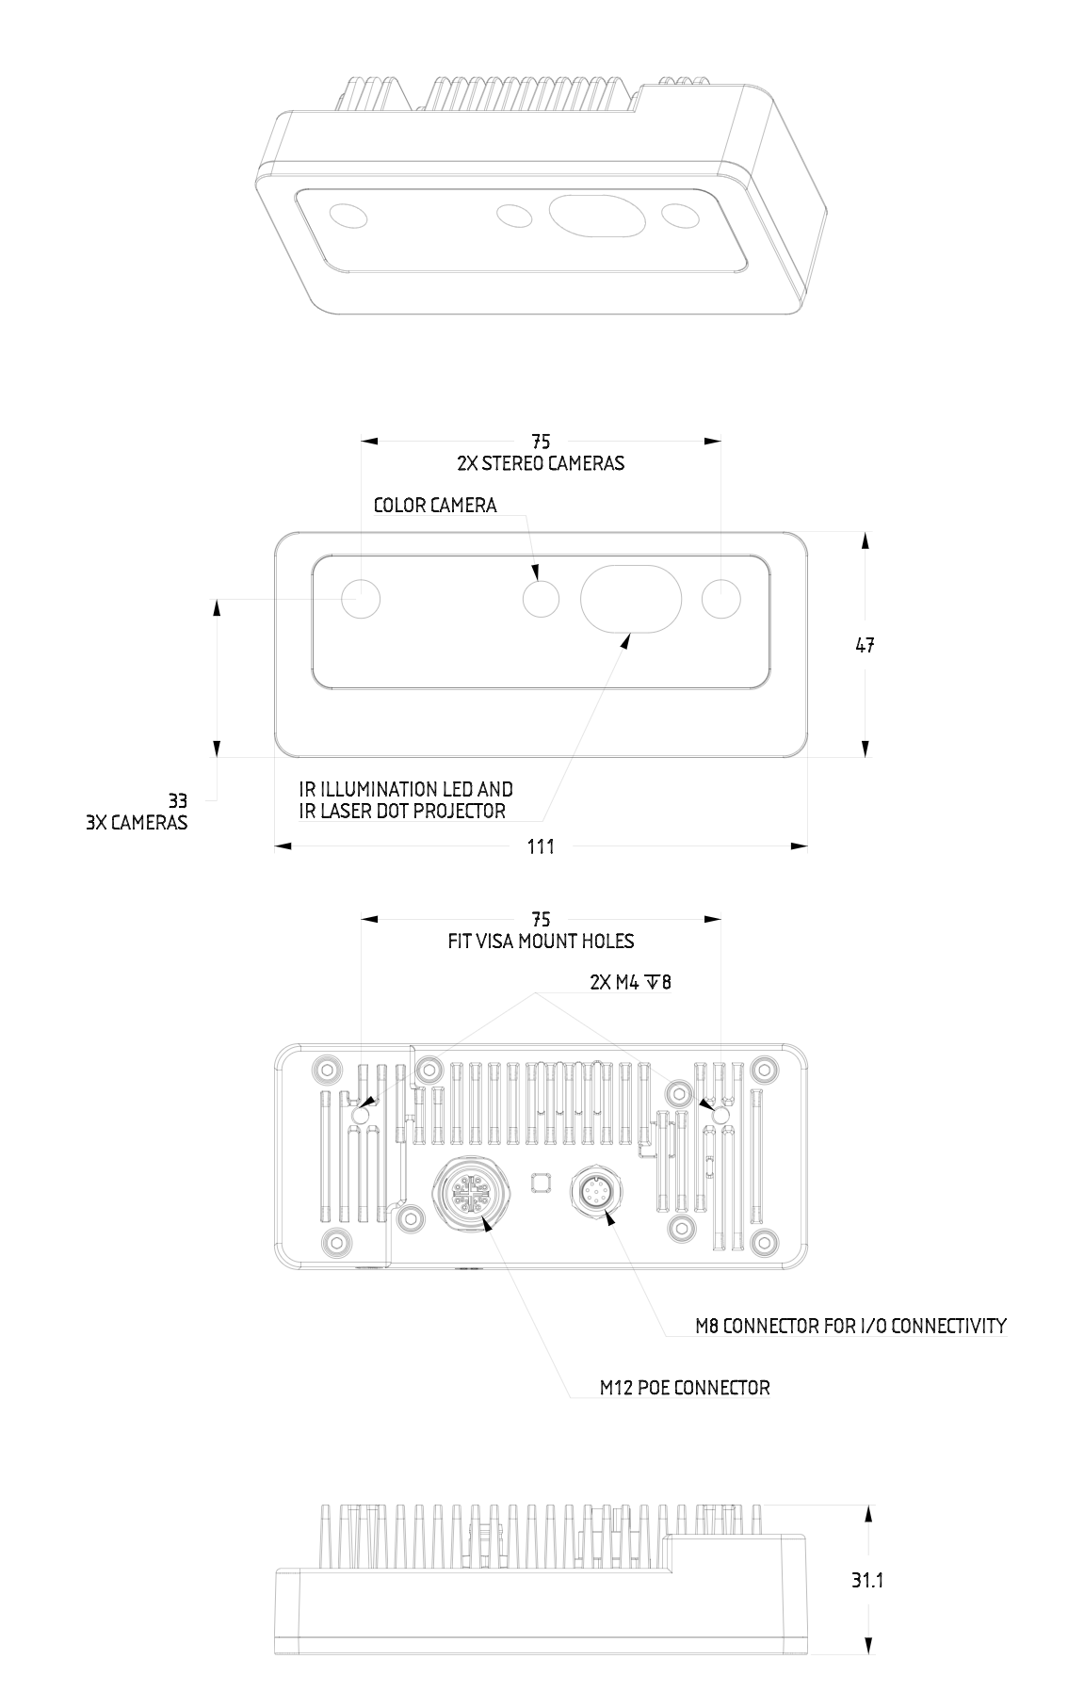

Figure 2 – OAK-D Pro PoE Mechanical measurements

# 

# Certification statement

This product is classified as a Class 1 Laser Product under the EN/IEC 60825-1, Edition 3 (2014) internationally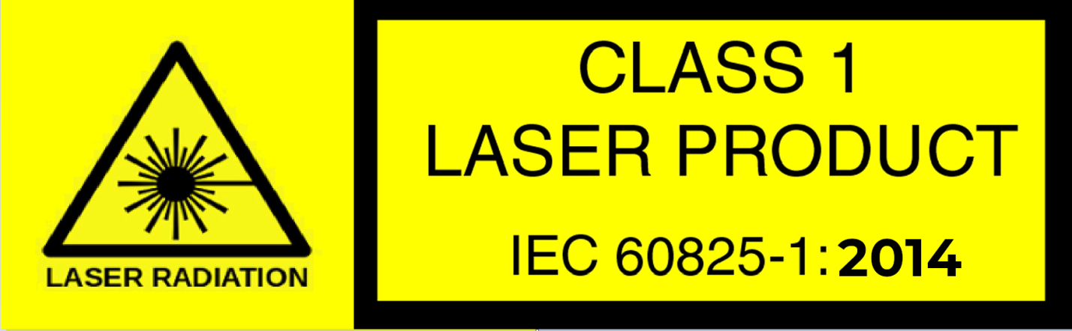

# Cautionary Statement

Do not power on the product if any external damage was observed.

Do not attempt to open any portion of this laser product.

Invisible laser radiation when opened. Avoid direct exposure to the beam.

There are no user serviceable parts with this laser product.

Modification or service of the stereo module, specifically the infrared projector, may cause the emissions to exceed Class 1.

No magnifying optical elements, such as eye loupes and magnifiers, are allowed.

Do not try to update camera firmware that is not officially released for specific camera module and revision.

# Support

If having any issue with the device or using SW cloned from Github, please contact [support@luxonis.com](mailto:support@luxonis.com) or reach out to Discord public server.