**OAK-D S2 PoE**

# Features

* Movidius Myriad X VPU
* 256/512/1024MBit QSPI NOR Flash
* 32Kb I2C EEPROM
* Gigabit Ethernet + PoE power
* 2x 2-lane MIPI connects OV9282 1MP global shutter cameras with no IR filter
* 1x center 4-lane MIPI connects IMX378 12 MP color rolling shutter camera
* ¼ -20 tripod mount on the bottom of the unit
* VESA-spec (7.5cm, M4) set of mounting holes on the back of the unit
* IP67 rated

# Applications

* Industrial automation
* Robotics
* Surveillance IP camera
* Security systems
* Remote intelligence

# Description

The Luxonis OAK-D S2 PoE is an AI Edge vision system driven by Movidius Myriad X VPU. The system is powered with Power over Ethernet (PoE). OAK-D S2 PoE has three on-board cameras which implement stereo and RGB vision, piped directly into the DepthAI Myriad X VPU for depth and AI processing. The data is then output to a host via Gigabit Ethernet connection using an M12 X-coded connector.

The OAK-D S2 PoE also features auxiliary M8 connector that provides USB and GPIO capability to control external devices.

**Device Information**

|  |  |
| --- | --- |
| **PART NUMBER** | **SIZE (WxHxD)** |
| OAK-D-S2-PoE | 111 mm x 47 mm x 31.1 mm |

# 

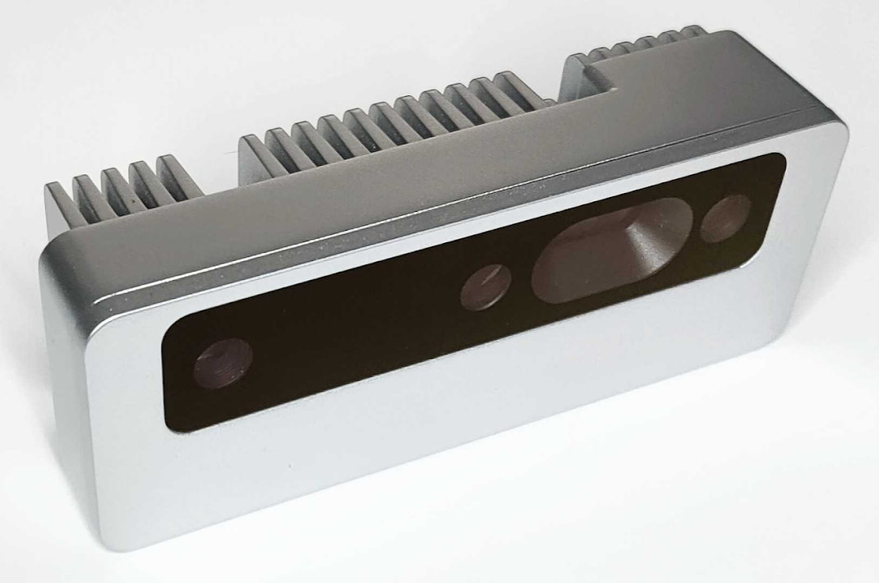

Figure – OAK-D S2 PoE

**Table of Contents**

1 Features 1

2 Applications 1

3 Description 1

4 Electrical Characteristics 3

4.1 Absolute Maximum Ratings1 3

4.2 Recommended Operating Conditions 3

5 Camera sensors characteristics 4

5.1 Center Color Camera 4

5.2 Stereo vision gray scale camera 4

6 Inertial Measurement Unit (IMU) 5

7 Auxiliary interface 5

8 Connectors 6

9 Mechanical Information 7

10 Support 8

|  |  |  |  |  |  |
| --- | --- | --- | --- | --- | --- |
| Electrical Characteristics | |  |  |  |  |
| Absolute Maximum Ratings1 | | |  |  |  |
|  | | |  |  |  |
| **SYMBOL** | **RATINGS** | | **MIN** | **MAX** | **UNIT** |
| **V**POE | 802.3af, Class3 input supply voltage range.(2) | | 37 | 57 | V |
| **V**BUSIN | USB input supply voltage range.(3) | | 3.5 | 5.5 | V |
| **I**VBUS | Maximum input current requirement | |  | 2 | A |
| **T**stq | Ambient temperature | | 0 | 60 | C |

## Recommended Operating Conditions

|  |  |  |  |  |  |
| --- | --- | --- | --- | --- | --- |
| **SYMBOL** | **RATINGS** | **MIN** | **TYP** | **MAX** | **UNIT** |
| **V**POE | PoE input voltage range(2) | 37 |  | 57 | V |
| **V**BUSIN | VBUS input supply voltage |  | 5V | 5.25 | V |
| **V**io-imax | Maximum input voltage for GPIO pins |  |  | 5.5 | V |
| **V**io-omax | Maximum output voltage for GPIO pins |  |  | 3.3 | V |
| **P** | Power consumption requirement | 4 | 6 | 7.5 | W |
| **PIDLE** | VBUS idle power draw (Myriad X booted) |  | 2.5 |  | W |
| **T**A | Ambient operating temperature |  |  | 50 | °C |

1. Stresses beyond those listed under *Absolute Maximum Ratings* may cause permanent damage to the device. These are stress ratings only, which do not imply functional operation of the device at these or any other conditions beyond those indicated under *Recommended* *Operating Conditions*. Exposure to absolute-maximum-rated conditions for extended periods may affect device reliability.
2. Power supply designed according to 802.3af (802.3at Type 1) standard.
3. According to industry standard Universal Serial Bus (USB) specifications.

# Camera sensors characteristics

|  |
| --- |
| Center Color Camera |

The color sensor on the stereo depth module in addition to color image provides texture information. Usages for the texture information include overlay on a depth image to create a color point cloud and overlay on a 3D model for reconstruction.

|  |  |
| --- | --- |
| **Parameter** | **Value** |
| **Image sensor** | Sony IMX378 |
| **Active pixels** | 4056x3040@60fps |
| **Output video format** | RAW12/10/8 |
| **Focus type** | Auto Focus 8cm - ∞ / Fixed Focus 50cm- ∞ |
| **FOV** | 78° |
| **Shutter Type** | Rolling shutter |
| **IR sensitive** | No |

## Stereo vision gray scale camera

Stereo cameras compare the features and based on the disparity determines the distance/depth of the object tracked on by the product. It also provides the depth map in color and raw depth map in gray scale.

|  |  |
| --- | --- |
| **Parameter** | **Value** |
| **Image sensor** | OmniVision OV9282 |
| **Active pixels** | 1280x800@120FPS |
| **Output video format** | 8/10-bit RAW |
| **Focus type** | Fixed Focus 19.6cm - ∞ |
| **FOV** | 89.5° |
| **Shutter Type** | Global shutter |
| **IR sensitive** | Yes |

# Inertial Measurement Unit (IMU)

OAK-D S2 PoE integrates a 9-Axis (Acceleration, Gyroscope and magnetometer) BNO086 inertial measurement unit. MotionEngine 9-Axis and 6-Axis Sensor Fusion provides raw, calibrated sensor orientation data for more accurate heading and orientation.

# Auxiliary interface

1. **USB**:

Device supports USB 2.0 interface used as a host to control external devices. Optionally this interface is used to reprogram the OAK-D-S2-POE device (GPIO 0 needs to be pulled high during boot up in this case)

1. **GPIO**:

GPIO 0 – General purpose input output pin. This pin is used to put the device in to USB boot by pulling this pin high with a 10k resistor during startup. Also this pin is multiplexed with the Strobe functionality.

GPIO 1 – General purpose input output pin. This pin also supports UART_TX or I2C_SDA functionality.

GPIO 2 – General purpose input output pin. This pin also supports UART_RX or I2C_SCL functionality.

1. **FSYNC**:

Frame synchronization signal for cameras. This pin can be configured as an input or an output.

1. **STROBE:**

Strobe signal for controlling external lights. Multiplexed with GPIO 0.

1. **5V:**

This pin is used for sourcing 5V power to accessory devices connected to the M8 connector. If trying to boot the device in USB boot mode, this pin can also sink current.

# Connectors

OAK-D S2 PoE features an M12 connector for connecting to host via Ethernet and providing power, and M8 auxiliary connector.

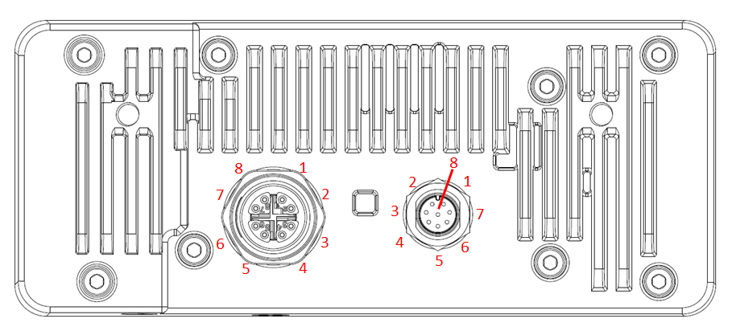

Ethernet M12 connector, X-Coded, Female

|  |  |
| --- | --- |
| 1 | Ethernet MX0+ |
| 2 | Ethernet MX0- |
| 3 | Ethernet MX1+ |
| 4 | Ethernet MX1- |
| 5 | Ethernet MX3+ |
| 6 | Ethernet MX3- |
| 7 | Ethernet MX2+ |
| 8 | Ethernet MX2- |

Auxiliary M8 connector, A-Coded, Male

|  |  |
| --- | --- |
| 1 | GPIO 0 / Strobe |
| 2 | FSYNC |
| 3 | USB+ |
| 4 | USB- |
| 5 | 5V |
| 6 | GPIO 1 |
| 7 | GPIO 2 |
| 8 | GND |

# Mechanical Information

The following information is [the most](http://www.ti.com/corp/docs/legal/termsofuse.shtml) [current](http://www.ti.com/corp/docs/legal/termsofuse.shtml) data available for the designated device. This data is subject to change without notice and without revision of this document.

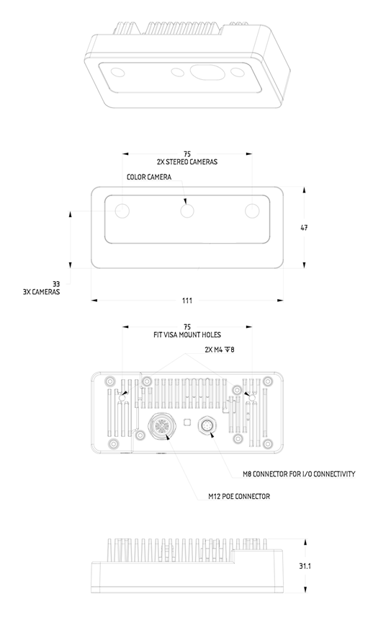

Figure 2 – OAK-D S2 PoE Mechanical measurements

# 

# Support

If having any issue with the device or using SW cloned from Github, please contact [support@luxonis.com](mailto:support@luxonis.com) or reach out to Discord public server.