**OAK-D PoE**

# Features

* Movidius Myriad X VPU
* 256/512/1024MBit QSPI NOR Flash
* 16GB eMMC 5.1
* 32Kb I2C EEProM
* Gigabit Ethernet + PoE power
* 2x 2-lane MIPI connects OV9282 1MP global shutter cameras with no IR filter
* 1x center 4-lane MIPI connects IMX378 12 MP color rolling shutter camera
* ¼ -20 tripod mount on the bottom of the unit
* 2x horizontal 4.5cm / vertical 2x 37.5mm, M4, two sets of mounting holes on the back of the unit
* IP67 rated enclosure

# Applications

* Industrial automation
* Robotics
* Surveillance IP camera
* Security systems
* Remote intelligence

# Description

The Luxonis OAK-D PoE is an AI Edge vision system driven by Movidius Myriad X VPU. The system is powered with Power over Ethernet (PoE). OAK-D PoE has three on-board cameras which implement stereo and RGB vision, piped directly into the DepthAI Myriad X VPU for depth and AI processing. The data is then output to a host via Gigabit Ethernet connection.

Connecting device with Cat5e or higher end ethernet cable is recommended to meet maximum speed and PoE requirements. On the device end standard RJ45 cable connector should be used.

**Device Information**

|  |  |
| --- | --- |
| **PART NUMBER** | **SIZE (WxHxD)** |
| OAK-D-PoE | 130 mm x 65 mm x 29.9 mm |

# 

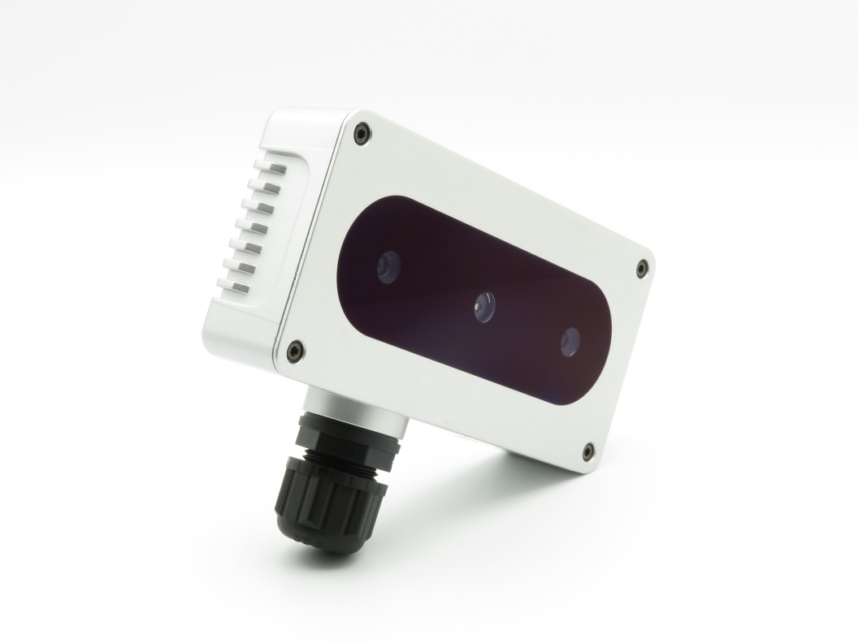

Figure – OAK-D PoE

**Table of Contents**

1 Features 1

2 Applications 1

3 Description 1

4 Electrical Characteristics 3

4.1 Absolute Maximum Ratings1 3

4.2 Recommended Operating Conditions 3

5 Camera sensors characteristics 4

5.1 Center Color Camera 4

5.2 Stereo vision gray scale camera 4

6 Active illumination 5

6.1 IR dot projector 5

6.2 IR flood illumination LED 5

7 Connectors 6

8 Mechanical Information 7

|  |  |  |  |  |  |
| --- | --- | --- | --- | --- | --- |
| Electrical Characteristics | |  |  |  |  |
| Absolute Maximum Ratings1 | | |  |  |  |
|  | | |  |  |  |
| **SYMBOL** | **RATINGS** | | **MIN** | **MAX** | **UNIT** |
| **V**BUSIN | 802.3af, Class3 input supply voltage range.2 | | 3.5 | 5.5 | V |
| **I**POE | Maximum input current requirement | |  | 0.35 | A |
| **T**stq | Ambient temperature | | 0 | 60 | C |

## Recommended Operating Conditions

|  |  |  |  |  |  |
| --- | --- | --- | --- | --- | --- |
| **SYMBOL** | **RATINGS** | **MIN** | **TYP** | **MAX** | **UNIT** |
| **V**POE | PoE input voltage range(2) | 44 |  | 57 | V |
| **P** | Power consumption requirement | 2 | 2.25 | 5.5 | W |
| **PIDLE** | VBUS idle power draw (Myriad X booted) |  | 2.5 |  | W |
| **T**A | Ambient operating temperature |  |  | 50 | °C |

1. Stresses beyond those listed under *Absolute Maximum Ratings* may cause permanent damage to the device. These are stress ratings only, which do not imply functional operation of the device at these or any other conditions beyond those indicated under *Recommended* *Operating Conditions*. Exposure to absolute-maximum-rated conditions for extended periods may affect device reliability.
2. Power supply designed according to 802.3af (802.3at Type 1) standard.

# Camera sensors characteristics

|  |
| --- |
| Center Color Camera |

The color sensor on the stereo depth module in addition to color image provides texture information. Usages for the texture information include overlay on a depth image to create a color point cloud and overlay on a 3D model for reconstruction.

|  |  |
| --- | --- |
| **Parameter** | **Value** |
| **Image sensor** | Sony IMX378 |
| **Active pixels** | 4056x3040@60fps |
| **Output video format** | RAW12/10/8 |
| **Focus type** | Auto Focus 8cm - ∞ / Fixed Focus 50cm- ∞ |
| **FOV** | 78° |
| **Shutter Type** | Rolling shutter |
| **IR sensitive** | No |

## Stereo vision gray scale camera

Stereo cameras compare the features and based on the disparity determines the distance/depth of the object tracked on by the product. It also provides the depth map in color and raw depth map in gray scale.

|  |  |
| --- | --- |
| **Parameter** | **Value** |
| **Image sensor** | OmniVision OV9282 |
| **Active pixels** | 1280x800@120FPS |
| **Output video format** | 8/10-bit RAW |
| **Focus type** | Fixed Focus 19.6cm - ∞ |
| **FOV** | 89.5° |
| **Shutter Type** | Global shutter |
| **IR sensitive** | Yes |

# Mechanical Information

The following information is [the most](http://www.ti.com/corp/docs/legal/termsofuse.shtml) [current](http://www.ti.com/corp/docs/legal/termsofuse.shtml) data available for the designated device. This data is subject to change without notice and without revision of this document.

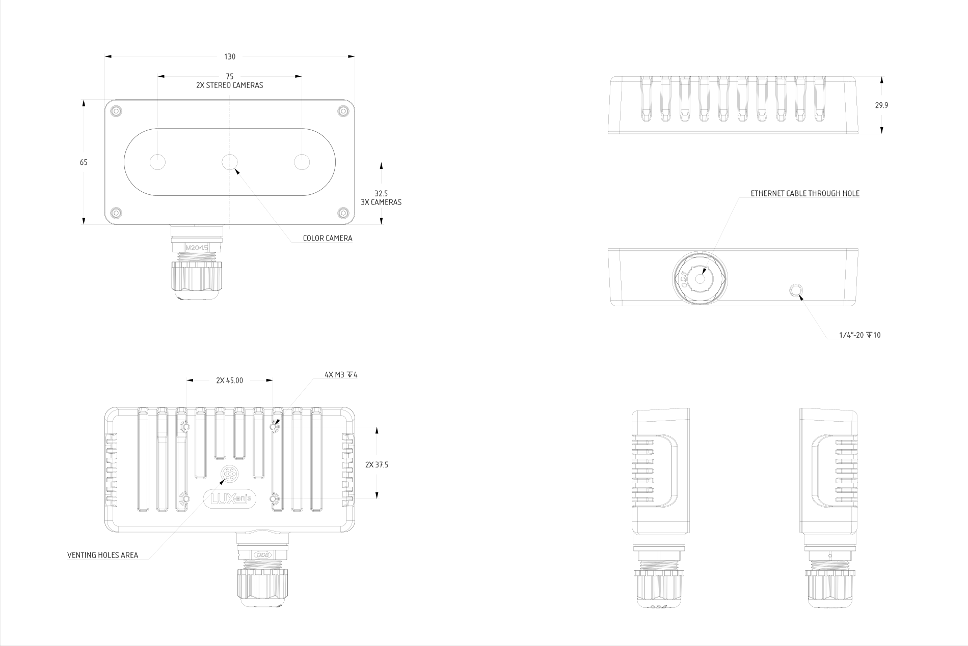

Figure 2 – OAK-D PoE Mechanical measurements