1. Flask Application with /api Route
In this task, a Flask web application was created with an /api route that returns data in JSON format. The data was stored inside a backend JSON file and was read dynamically whenever the route was accessed. The Flask application processed the file content and returned it as a JSON response through the API endpoint. This task demonstrated how backend APIs work, how JSON responses are generated, and how Flask handles routing and file operations.
The task also helped in understanding:
- Flask route creation
- JSON response handling
- Backend file reading
- API development basics

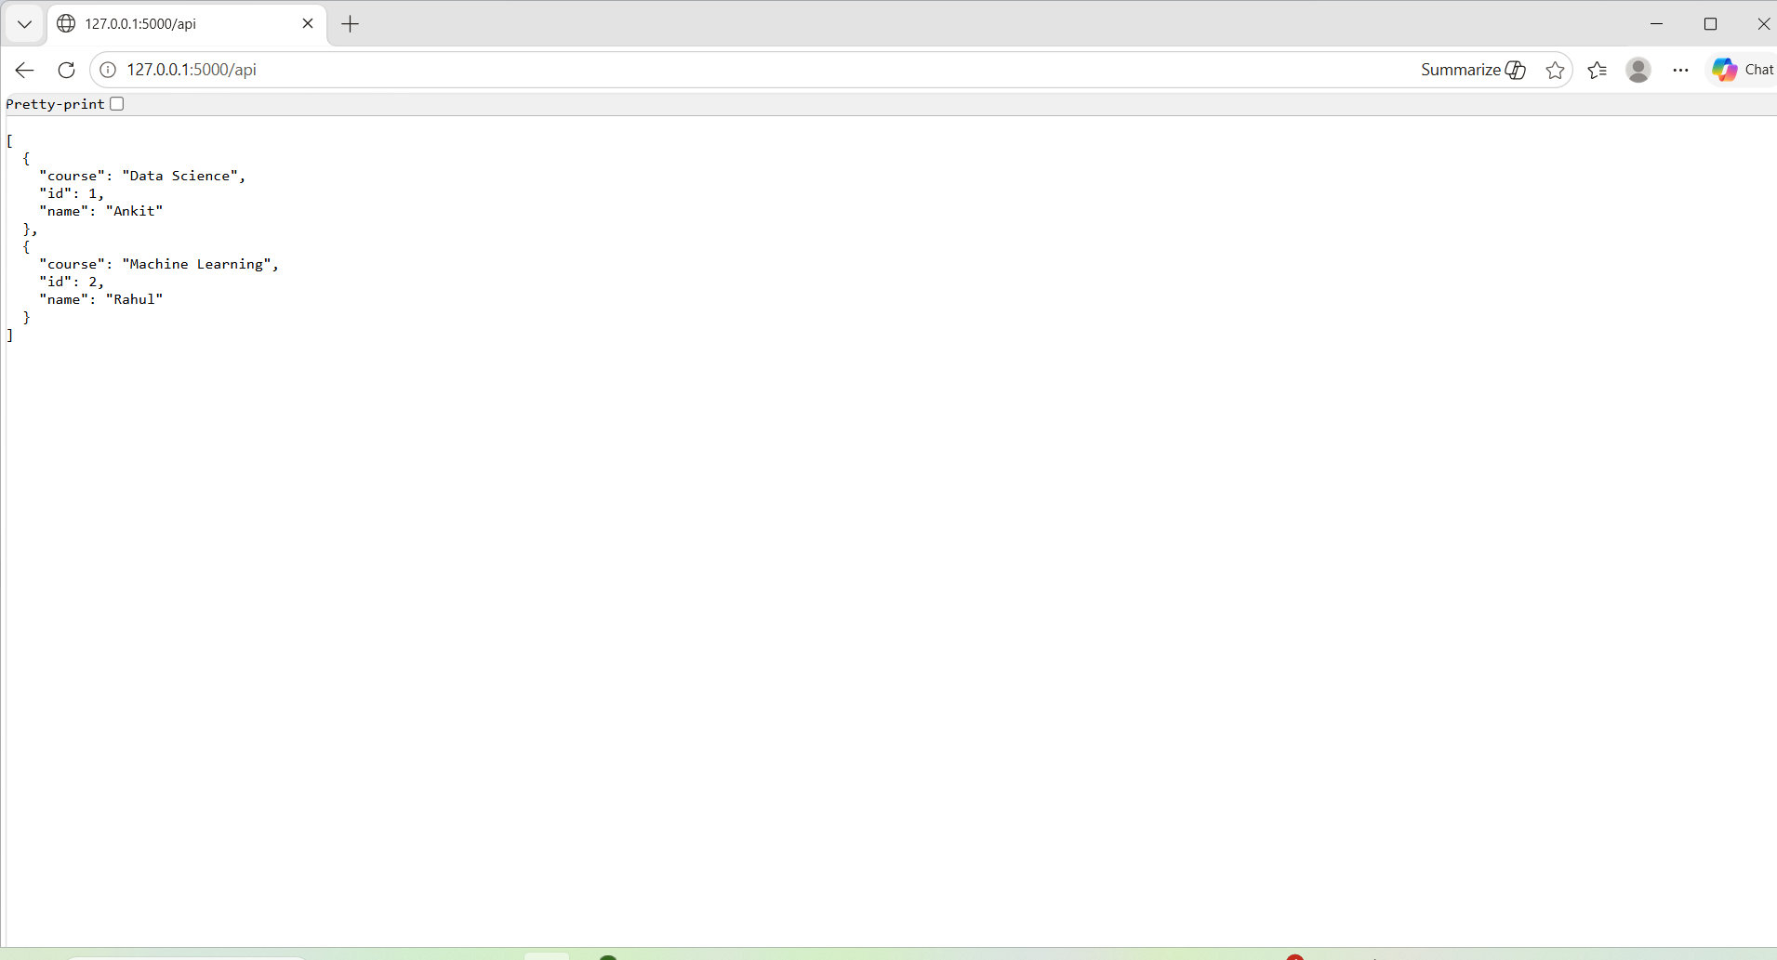

2. Frontend Form with MongoDB Atlas Integration
In this task, a frontend HTML form was created to collect user details such as name and email. When the form was submitted, the data was sent to the Flask backend using a POST request. The backend then connected to MongoDB Atlas and stored the submitted data inside a MongoDB collection.
If the data was inserted successfully, the user was redirected to a success page displaying the message:
Data submitted successfully
If an error occurred during submission, the error message was displayed on the same page without redirecting the user. This demonstrated form handling, backend validation, database connectivity, and error handling in Flask applications.
This task helped in understanding:
- Frontend and backend integration
- Form submission handling
- MongoDB Atlas connectivity
- Database insertion operations
- Redirect handling in Flask
- Error handling mechanisms
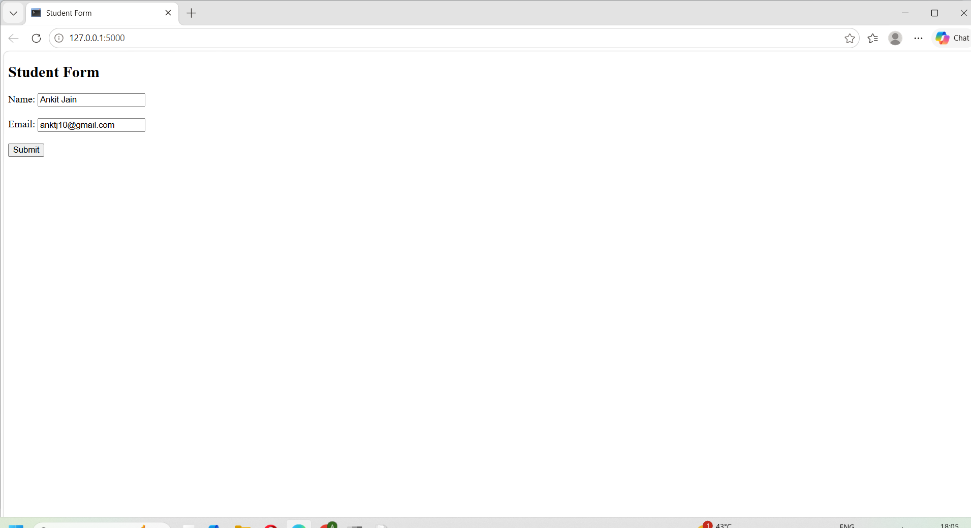
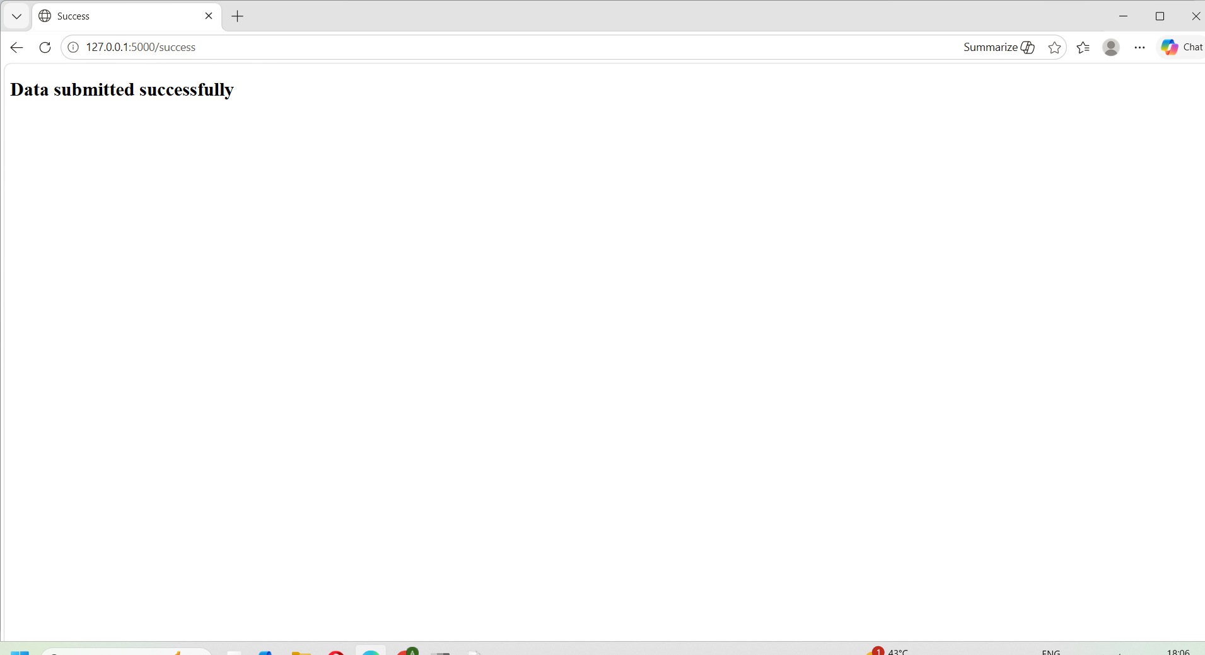

3. MongoDB Atlas Configuration
MongoDB Atlas was used as the cloud database service for storing form data. A free cluster was created, database access credentials were configured, and network access permissions were enabled. The MongoDB connection string was used in the Flask application to establish secure communication between the backend and the database.
This task demonstrated:
- Cloud database setup
- Database authentication
- Remote database connectivity
- Integration of MongoDB with Flask
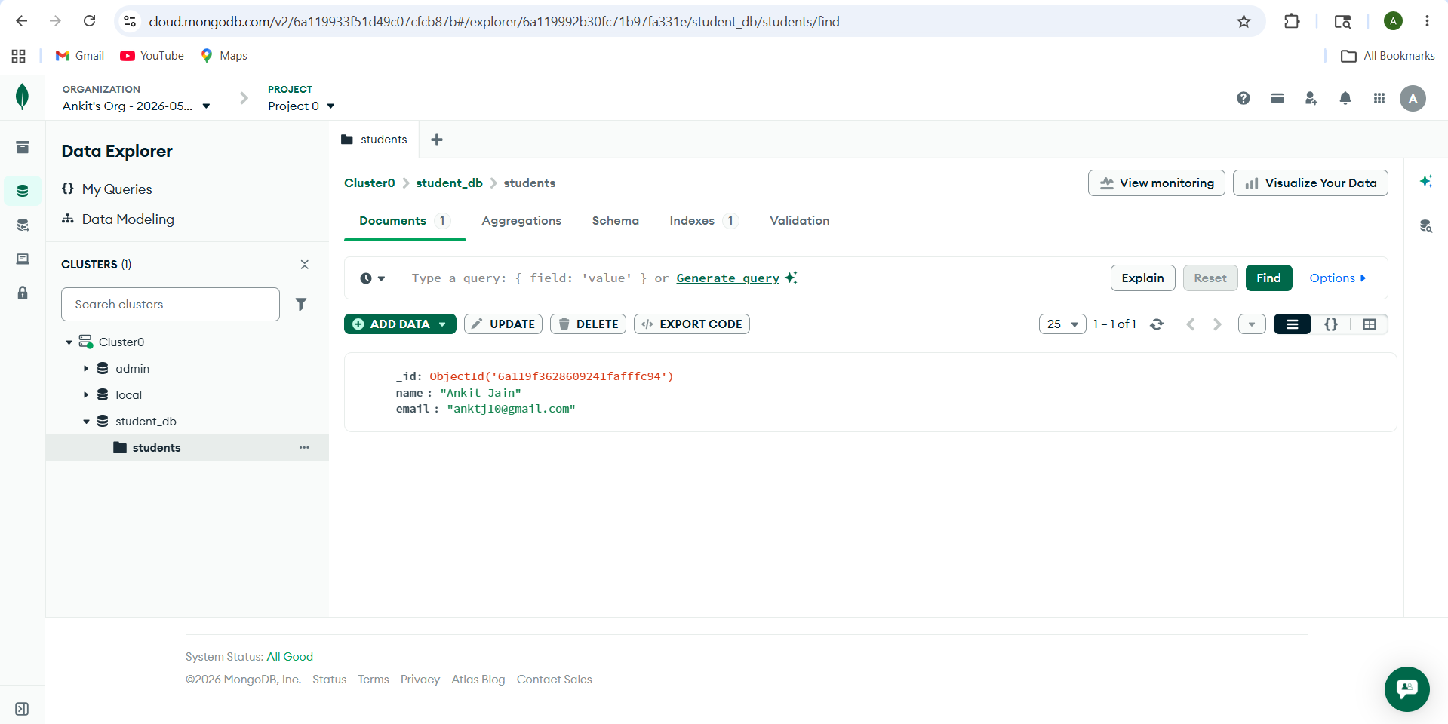

Conclusion
Through this assignment, important full-stack web development concepts were implemented successfully using Flask and MongoDB Atlas. The project included API development, JSON handling, frontend form creation, backend processing, cloud database integration, error handling, redirection handling, and secure credential management. These tasks provided practical experience in building and managing modern web applications using Python Flask and MongoDB.

