1. Creating and Renaming Files/Directories
In this task, a new directory was created to understand how folders are managed in Linux. Inside the directory, an empty text file was created to practice file creation operations. The file was then renamed to learn how Linux handles moving and renaming files using terminal commands. This task helped in understanding basic file system navigation and file management operations in Ubuntu.

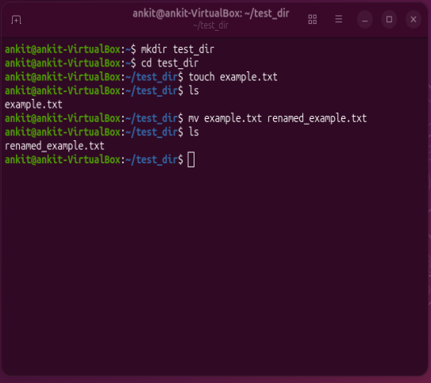

2. Viewing File Contents
This task involved displaying the contents of the system file /etc/passwd, which stores user account information in Linux systems. The complete file contents were viewed first, followed by displaying only the first few lines and the last few lines separately. This demonstrated how Linux commands can efficiently read large files and extract only the required portions of data.

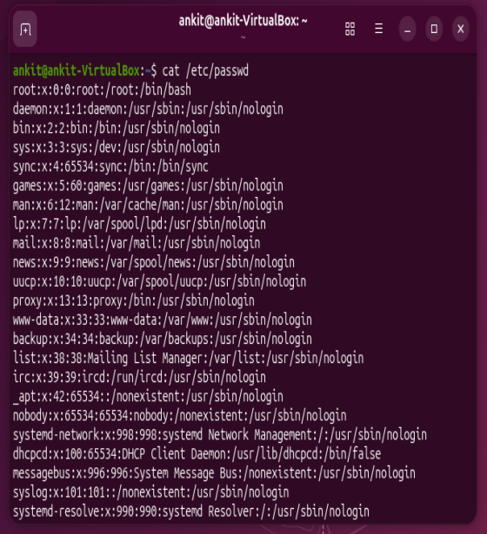
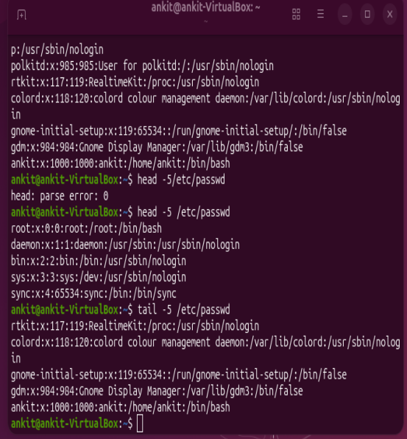

3. Searching for Patterns
In this task, pattern searching was performed within a file using a text searching utility. The word "root" was searched inside the /etc/passwd file to identify lines containing that specific keyword. This activity demonstrated how Linux can quickly filter and locate relevant information from large text files, which is useful in system administration and log analysis.
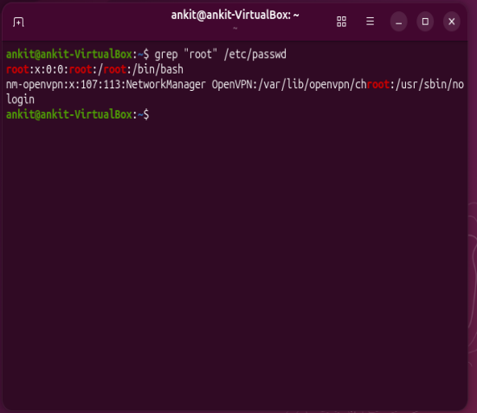

4. Zipping and Unzipping
This task focused on file compression and extraction. The created directory was compressed into a ZIP archive to reduce storage size and make file sharing easier. Later, the compressed archive was extracted into another directory to restore the original contents. This demonstrated how Linux handles file archiving and data compression operations.
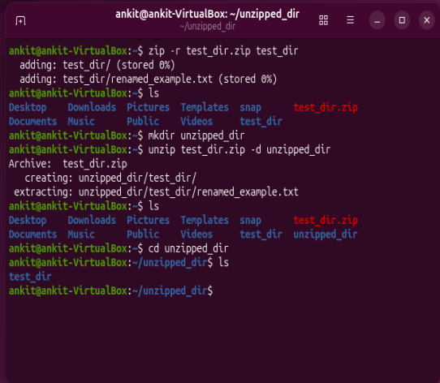

5. Downloading Files
In this task, a file was downloaded from the internet using a command-line downloading utility. This demonstrated how Linux systems can retrieve files directly from web URLs without using a graphical browser. Such commands are commonly used for downloading software packages, datasets, scripts, and updates in server environments.
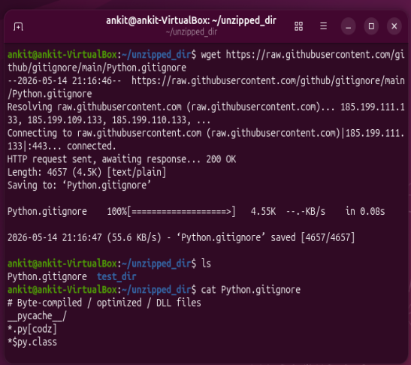
6. Changing Permissions
This task involved creating a file and modifying its access permissions. The permissions were changed to read-only mode so that users could only read the file and not modify or execute it. This demonstrated Linux file security and permission management concepts, which are important for protecting files and controlling user access.
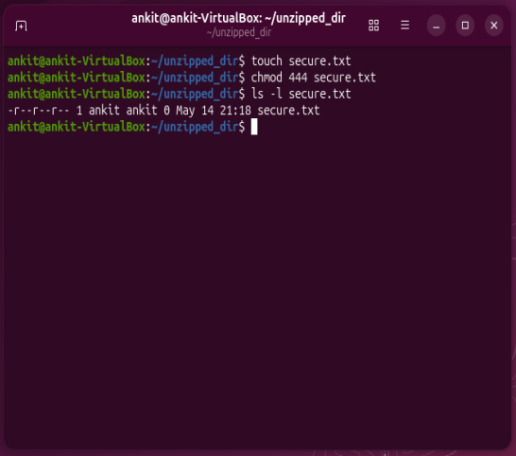
7. Working with Environment Variables
In this task, a custom environment variable was created and assigned a value. Environment variables are used in Linux to store system-wide or user-specific information that programs and processes can access during execution. This task helped in understanding how temporary variables can be created and accessed within a terminal session.
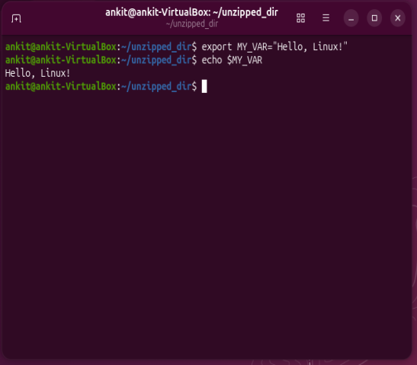

Conclusion
Through this assignment, I performed various fundamental Linux terminal operations, including file handling, content viewing, pattern searching, file compression, downloading resources, permission management, and environment variable handling. These tasks provided practical exposure to Ubuntu command-line operations and improved understanding of Linux system administration basics.

