Slide 2 Notes:

In the US, electric vehicle sales did not begin in the consumer market until around 2017, and sales in the US have increased exponentially since that time.  Looking at the Florida market what does this mean?  Every few blocks there is a fuel station, we are here to answer the question on with the increase of sales of EV’s will there be a need to increase the alternate fuel/EV charging stations?

Slide 3 Notes:

Are team all based out of Florida wanted to drill into the data on EV registration in Florida as it corresponds to the quantity of alternate fuel stations for the Florida counties.  Will the data we analyze allow us to predict needs  the future of electric charging stations based on the registration of these vehicles in Florida?

Slide 8 Notes:

Though we based our data off of EV registration of consumers, we do see an increase of businesses investing in EV rentals, EV trucking/shipping, and EV for business use.

We all know that feeling seeing the gas light come on in our vehicles, having fuel stations not far in these emergencies is vital.   So the question is, as the future is heading for this path of more Electric Vehicles, is there a need for more charging stations?

Slide 9 Viz & Notes:

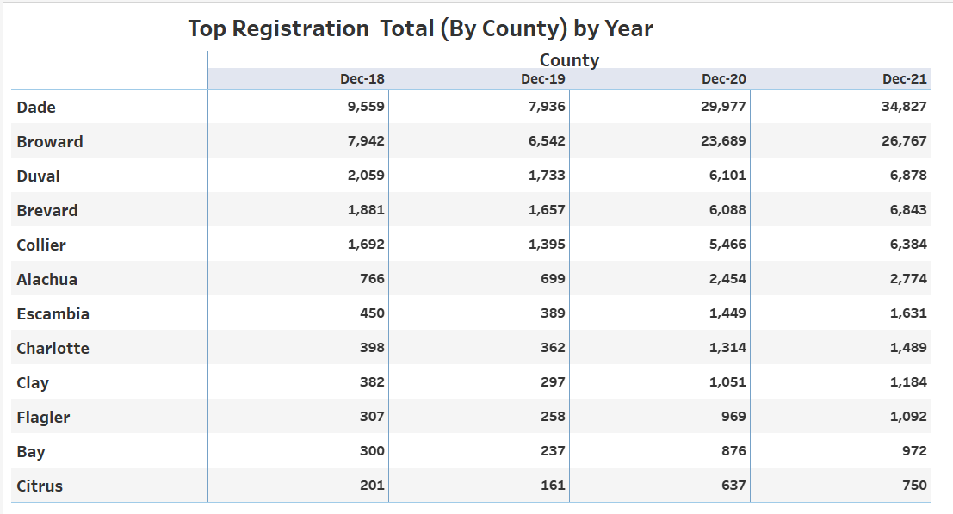

Looking at some of the Counties with the highest registration of EVs in Florida increase year over year is apparent to the growth in consumer EV registration.

Slide 11 Notes:

This boot camp we used many programs. This project was interesting, seeing how all these programs can be used to help us analyze the data.