**Product Name:**

SLAY

**Team Name:**

Score Flux

**Members:**

Petra Andraschko

Jatin Patel

Taylor Addington

Alegna M. Medina Rodriguez

PITCH:

SLAY is a top down hack and slash set in the dark medieval Queendom of Runoz where the player, assuming the role of the knight-in-training Azael, fights hordes of evil creatures, in order to defeat the big bad evil alongside your trusty animal companion.

COMPARABLE PRODUCTS:

**The Legend of Zelda (Original)**

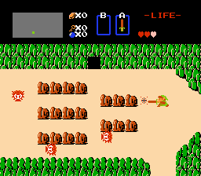

Camera perspective, Map style, combat style.

**The Binding of Isaac**

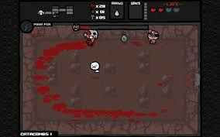

Camera perspective, combat style.

**Castlevania (Original)**

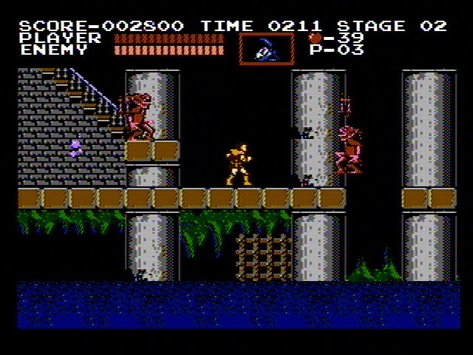

<UI inspiration>

**Crawl**

< >

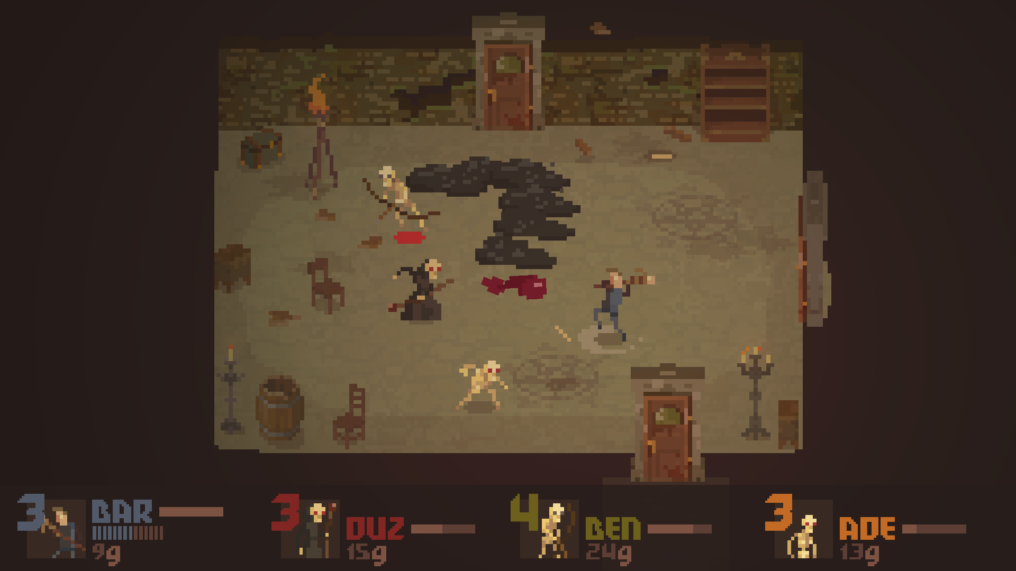

<Similar color scheme/ palette>

**Enter the Gungeon**

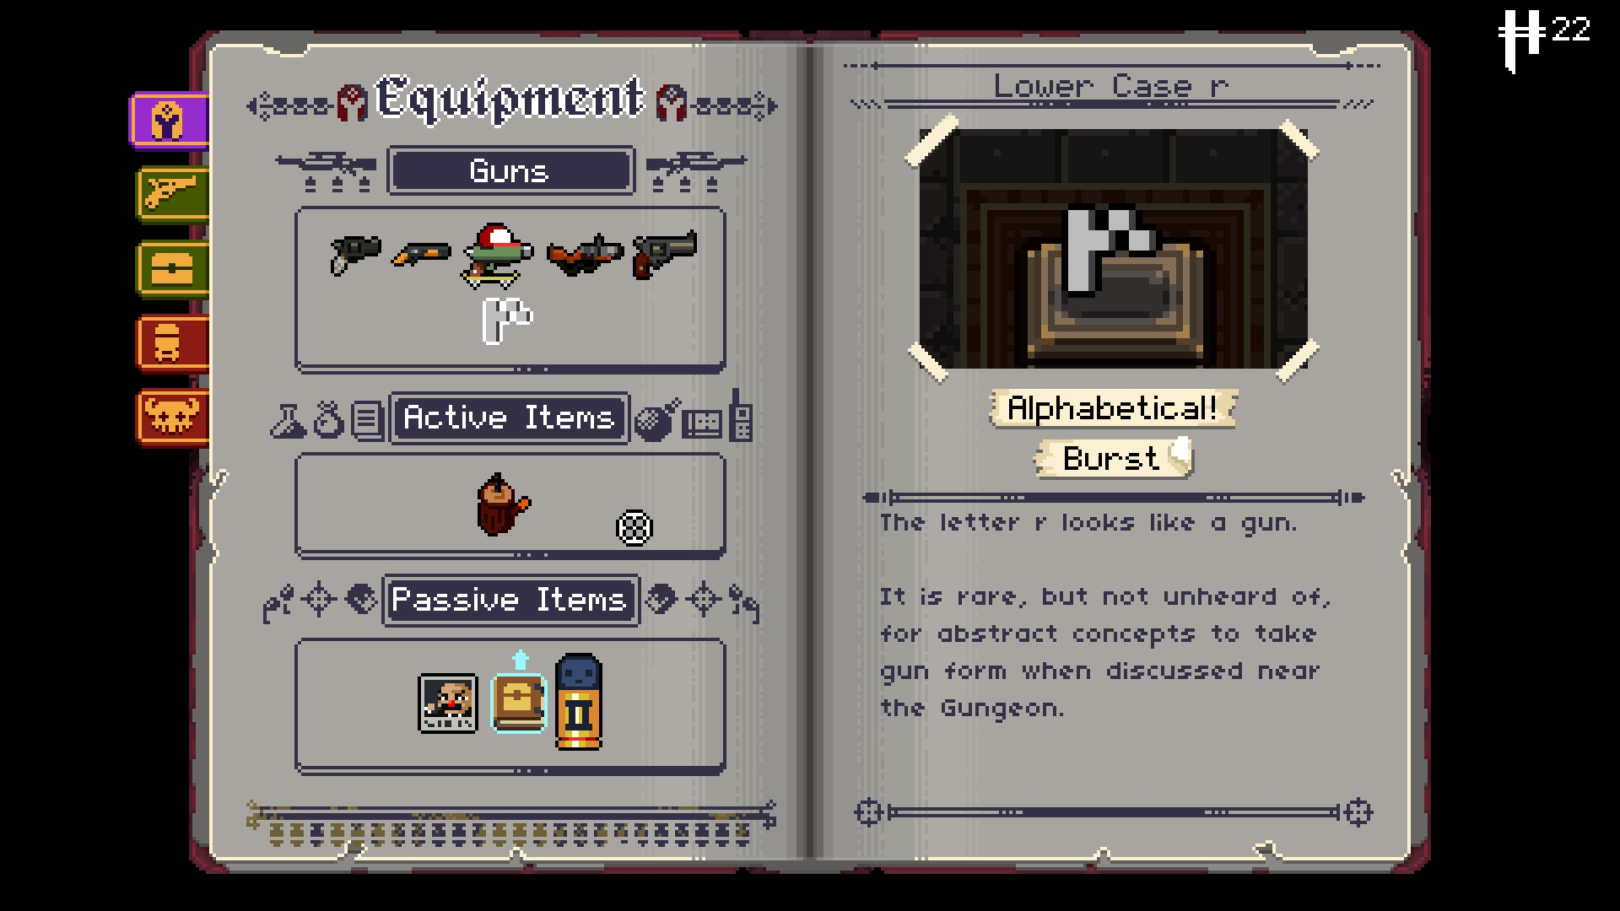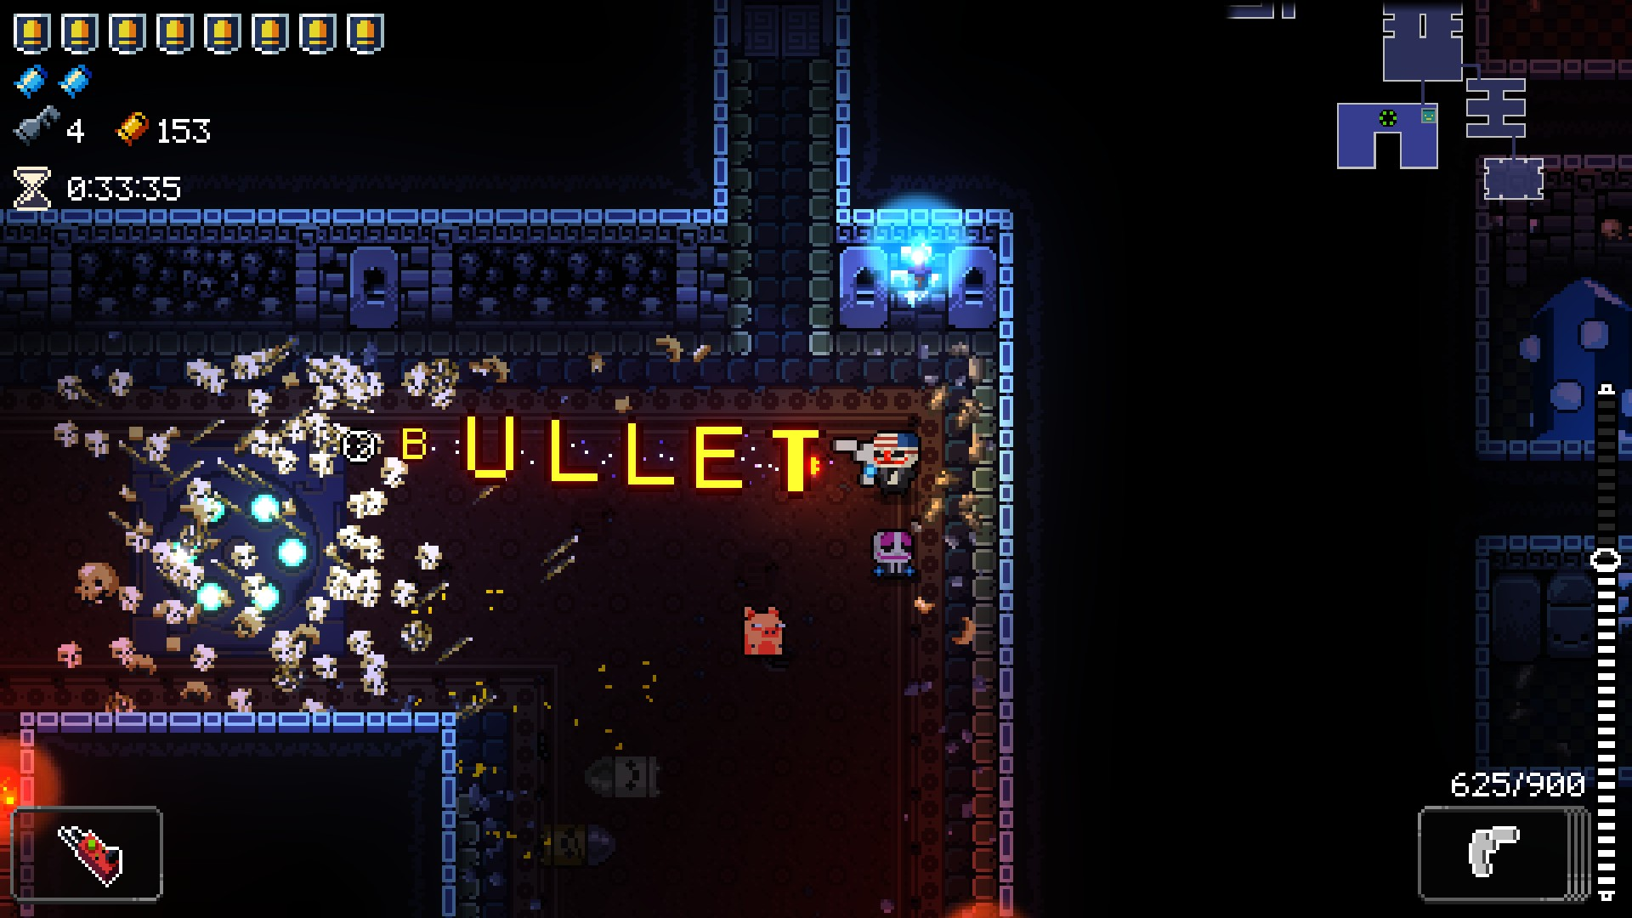

<Silly weapons>

**TYPOGRAPHY:**

Title Font



Body Font



**COLOR PALETTE:**

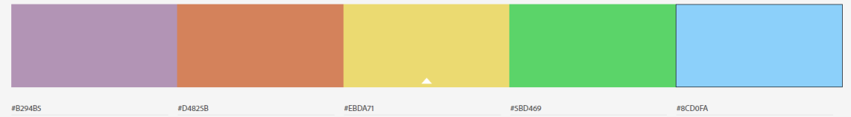

**IMAGE/TEXTURE GALLERY:**