Compiled by
Petra Andraschko
Jatin Patel
Taylor Addington
Alegna M. Medina Rodriguez

Project Hack’n’Slash

Last updated: June 8, 2019

Overview - Executive summary

Elevator Pitch / High Concept
Tiny Dust is the fast-paced story of a hero in the search for a mystical box that is said to be the one piece of resistance against a great evil, he must hack and slash his way through forests and plains. His goal: free the townspeople from a hopeless demise...or is it?

Genre
Fantasy, Action, Hack/Slash, Adventure, Retro

Key/Exotic Features
- Crafting System (Modular?)
  - Craft many different weapons made from different materials
- Animal Companion
  - Can attack for you or retrieve enemy drops
- Room Layout Option
  - Choose what your fate will be
- Hidden rooms
- Side-scrollers
- New Game +
- Dungeons

Target Audience
Primary:
Nostalgic older gamers
Secondary:
Newer/Younger gamers

Play Action and Cadence
Overwhelming combat against hordes of enemies. Fast paced. Rewarding and tense combat.

Win Condition / Player Goal
Beat the bosses the find all the parts of a box to lock a mythical evil terrorizing a world back in its confines.

Loss Condition / Continuation
You lose if you run out of lives (restart entire game)
You continue at a previously gained checkpoint if you have remaining lives.

Comparable products

The Legend of zelda (original)
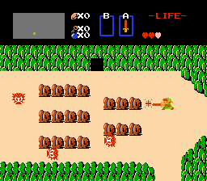
Camera perspective, Map style, combat style.

The Binding of isaac
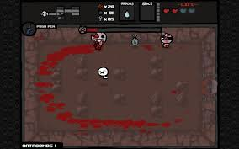
Camera perspective, combat style.

<Original Castelvania>
< 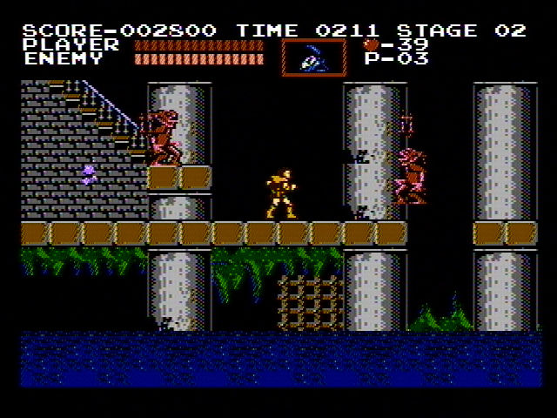 >
<UI inspiration>

<Crawl>
< 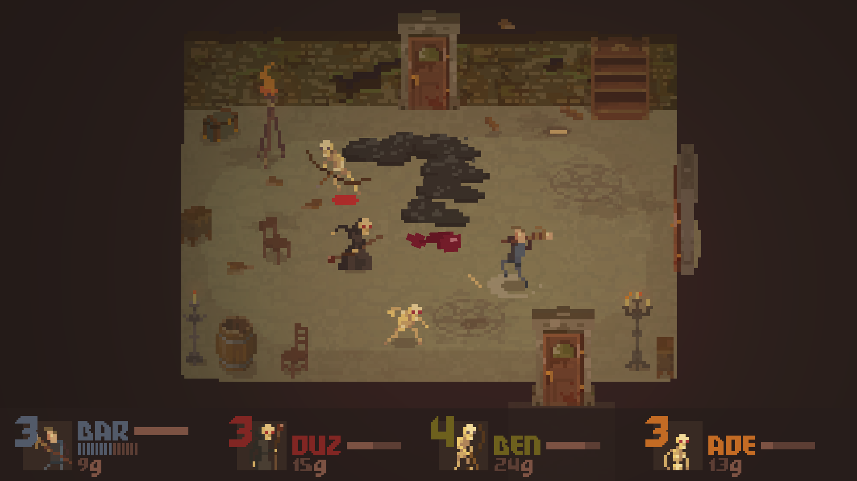>
<Similar color scheme/ palette>

<Enter the gungeon>
< 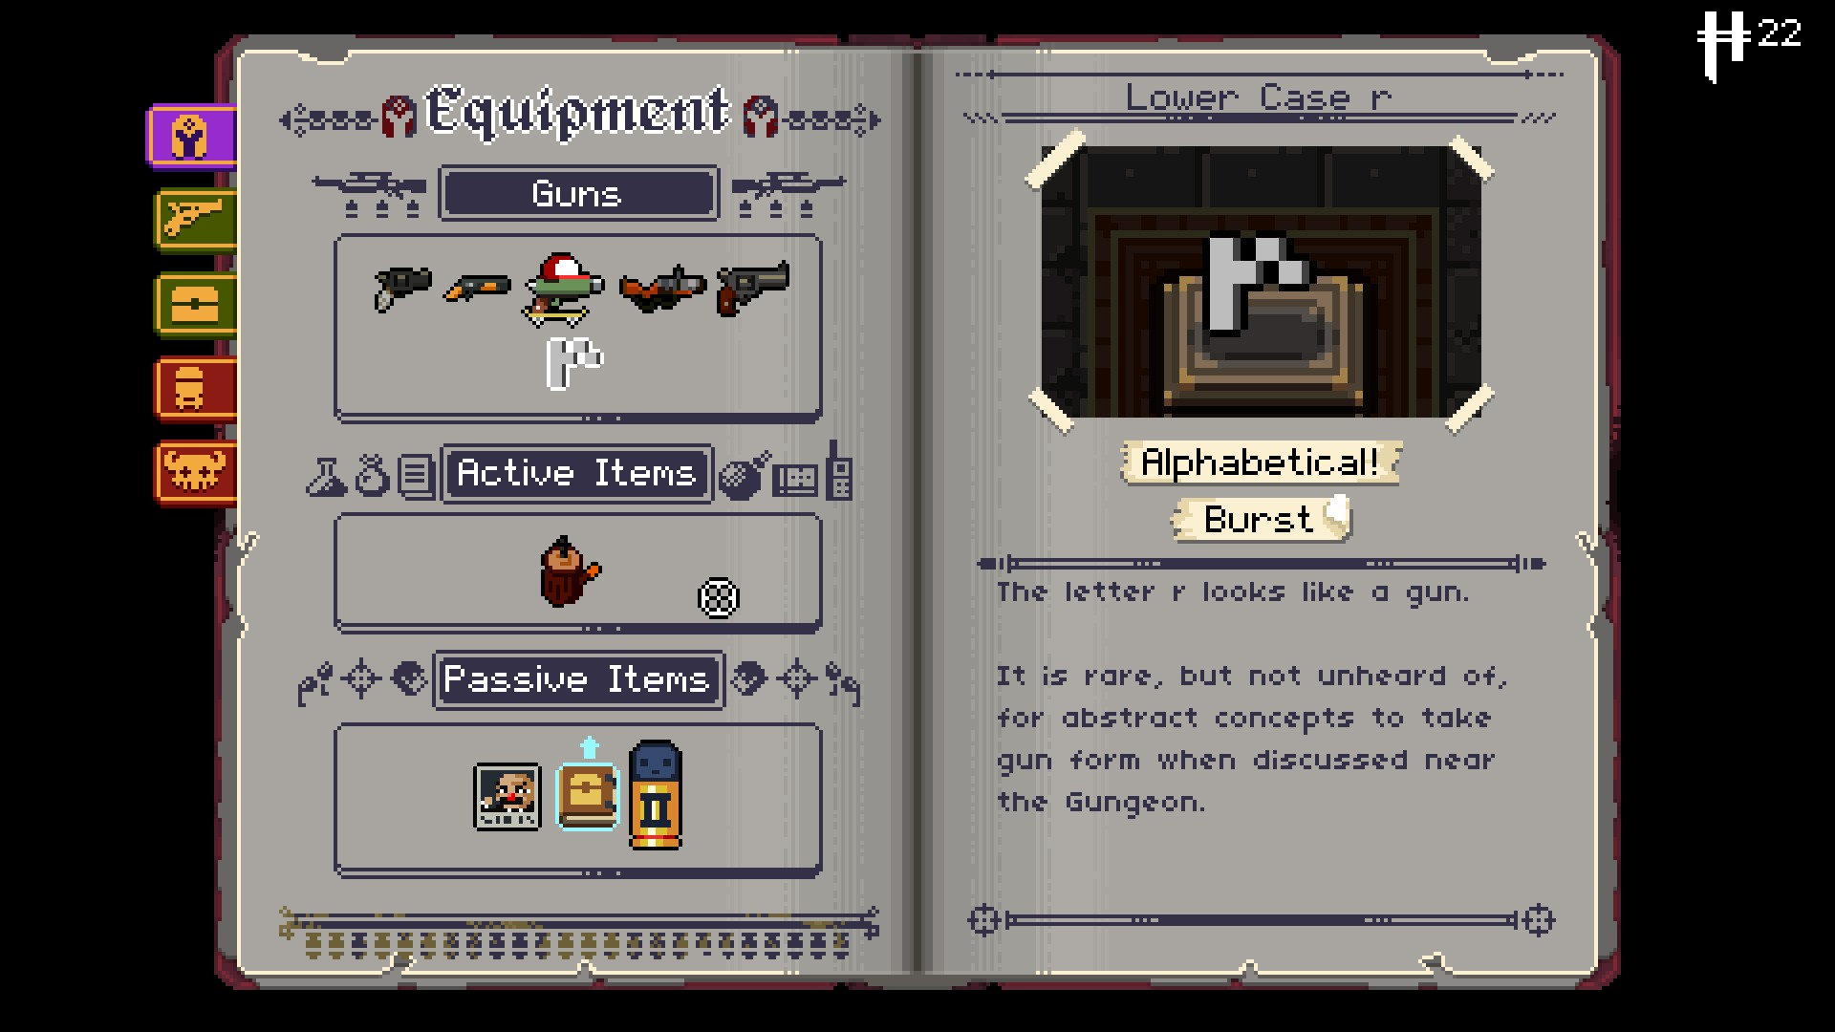 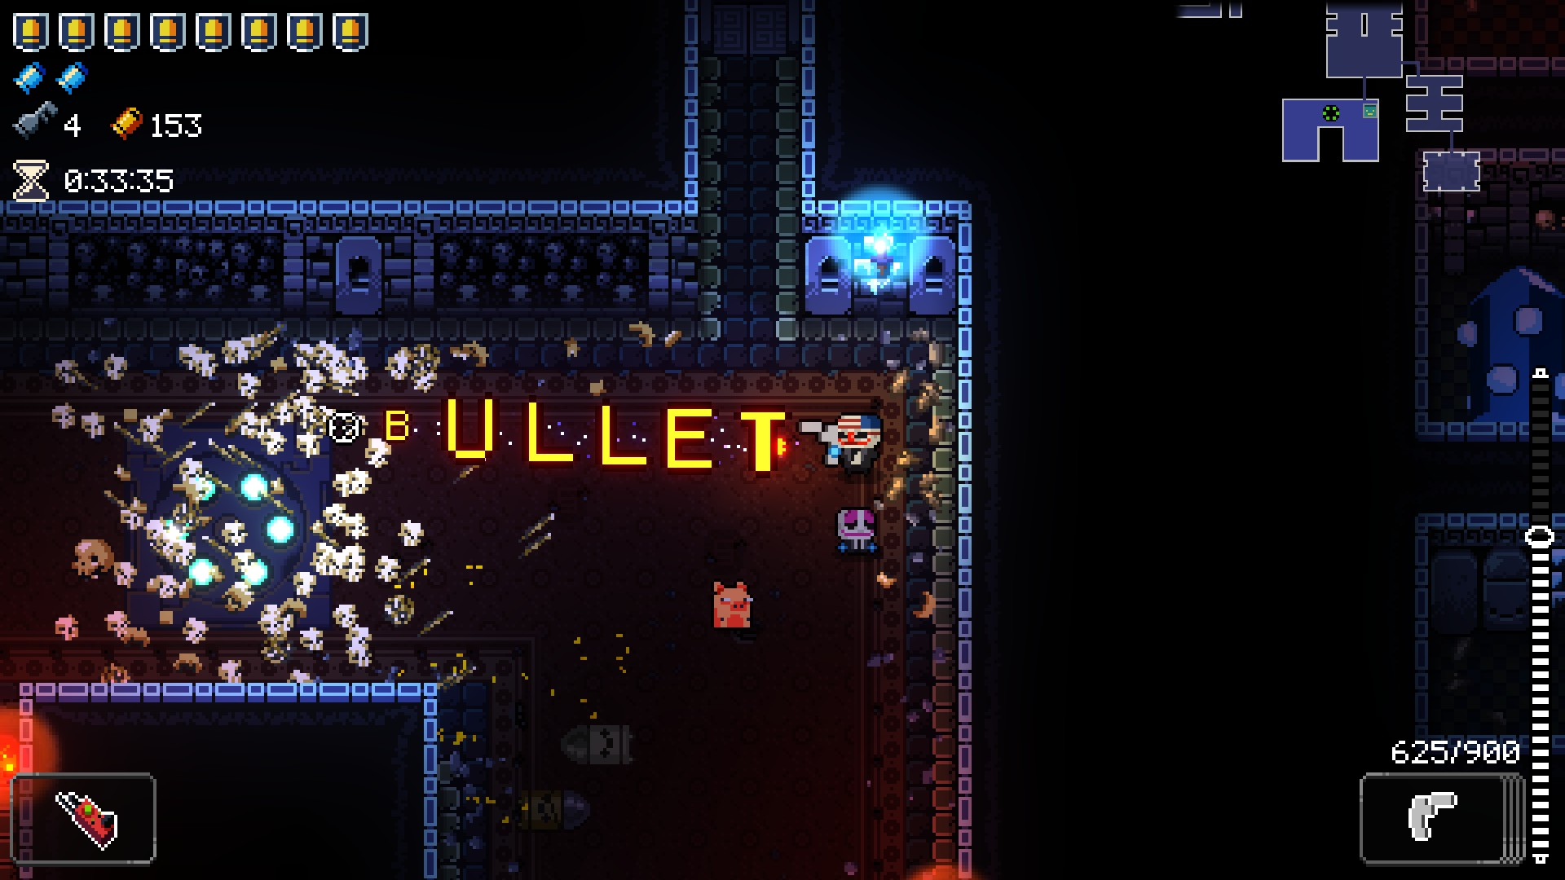>
<Silly weapons>

<Product Name>
<Picture of comparable portion>
<Description of comparable portion>

Art and Production Design

Art / visual Style
Pixelated, Dark/Dull color pallet, simple sprites/visual design, clean/readable screen.
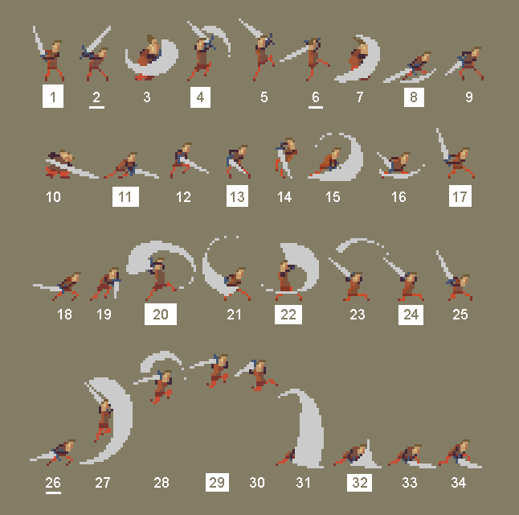

Music Style
Classic arcade/8 bit/16 bit video game music, tense, focusing

https://westarmusic.sourceaudio.com/#!details?id=19037852
https://patrickdearteaga.com/audio/Heroic%20Intrusion.ogg

SFX Style
8 Bit, retro, electronic SFX
https://opengameart.org/content/rpg-sound-pack

Interactivity

Camera Logic
Stay centered on player, edge snapping.
<Quick camera mockup below>
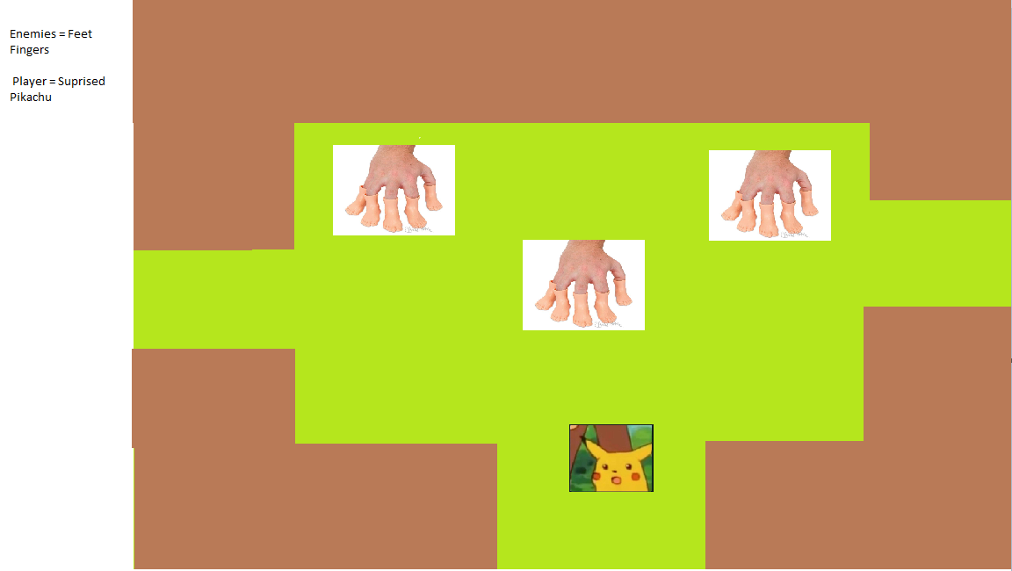
Room transitions legend of zelda style, seamless update as an extra goal

Controls

PC Controls

- WASD or Arrows
- Left Click – Attack 1
- Right Click - Attack 2
- 1,2,3,4 Inventory controls
- <Control>
- <Control>
- <Control>
- <Control>
- <Control>
- <Control>

WebPlayer Controls

- WASD or Arrows
- Left Click – Attack 1
- Control - Attack 2 (if right mouse conflict)
- 1,2,3,4 Inventory controls
- <Control>
- <Control>
- <Control>
- <Control>
- <Control>
- <Control

Scope

Game Progress – Player Milestones
- Release the Town from enemies(unlock shop/crafting system) gain a box piece
- Head to any of the 3 environments and Defeat the environments Semi boss to gain a box piece
- Unlock animal companion
- Continue to defeat other Semi-bosses in their environment and gain their pieces
- Reconstruct box
- Defeat Boss

Worlds/Levels
Town, Forest, Beach, Plains, Castle
~4-6 minutes per level
20-30 minutes.

Mechanics

Combat
Room Locks down when enemies spawn (no separate screen)
Combat starts when enemies ambush you, ends when all enemies are dead, or you die.

Leveling system
Killing enemies gains experience
Enemies stats scaling based on player level
Static stat boost per level
Unlock new materials on certain levels

Gold
Enemies drop gold and XP
Gold can be spent in shop, XP works towards increasing level

Shop/Inventory
Player can journey to the physical shop to spend gold on new weapons and/or consumables.
Weapons can be switched mid-combat, only two weapons are equipped at a time, one of which is a locked in base weapon.

Player abilities
- Blocking
- Rolling
- Magic attacks
- Wield different weapon types

Enemy types
- Slimes
  - Melee type
- Skeletons
  - Projectile type
- Magicians
  - Magic type

Boss encounters
- 1 End boss
  - Hope
    - Phase 1: Scythe
    - Phase 2: Magic
      - Bullet hell
    - Final phase: gun
      - Aim
      - Pause
      - Hitscan attack

- 3 mid-bosses
  - Elite Slime
    - melee attacks
  - Elite Magician
    - magic attacks
  - Elite Skeleton
    - projectile attacks

item types
- Health potions
- Mana potions
- Ammo for projectile weapons
- Sword
- Spear
- Scythe
- Hammer
- Greataxe
- Longbow
- Shortbow
- Crossbow
- Pistol
- Fireball magic
- Lightbeam magic
- Lightning magic
- Ice magic
- currency

Unlockables
- Materials
- Animal companion
- Weapon cores
- Magic cores
- Box pieces (Story)

