**Allan M. French**

**▶ Data Analyzed ● Beans Counted ● Numbers Crunched ◀**

Transform Data into Business Intelligence ✦ Manage Financial Resources

Data Analyst ✦ Staff Accountant ✦ Excel Projects ✦ Internal Auditing ✦ Cost Accounting

[www.LinkedIn.com/in/AllanMFrench](http://www.LinkedIn.com/in/AllanMFrench)

### Commendations and References

I have received the following recognition over the course of my career. Key passages are quoted here, but ***original documents may be inspected*** at an appropriate time. Personal references and additional professional references can also be provided.

* Letter of reference from a **finance manager** at a Fortune 500 corporation

*“He worked very hard to learn the assignment and took complete ownership of it. […] The true character of a person is shown when they are given a job that no-one wants to do, and does it well.”*

* Appreciation expressed by a **recurring client**, re QuickBooks-to-Excel data cleansing

*“Last year you updated our main database and you did a great job. It has been the fewest returns on mailing [even though] we did twice as much volume as before.”*

* Reference letter from the **company president** of a surety bonding agency, where I was an intern

*“Work concentrated on determining the creditworthiness of [large general contractors]. He was strong in his financial analysis of an account […] and the financial implications of a credit decision.”*

* The **IT manager** of a nonprofit organization client, described the set of macro-assisted Excel spreadsheets that I prepared for them.

*“One of the most impressive pieces of ‘macro-logy’ I have seen in my 25 years in the business.”*

* An e-mail note from a **marketing dept. colleague** at a large SaaS company, who disliked having to record purchase requisitions within Oracle Financials

*“Knowing that someone [else] is doing the PRs takes a weight off my shoulders.”*

I handled accounting tasks on behalf of a product marketing team (who were not trained in accounting). My role was not mission-critical, but it made life easier for 17 coworkers.

* Special Achievement Award, issued by the **division manager** (my supervisor’s manager)

*“In recognition of the manner in which you have completed your assigned tasks.”*

* Received a thank-you note from **my manager** at a nonprofit organization, several months after I had left

*“If you had not [set up the bank transfers binder] and organized the information the way you did, I would not have been able to complete the reports […] The time you saved me tonight is greatly appreciated.”*

* As noted on the first page, source documents for all of these quotations (and a few more) can be inspected upon request.

### Deep Commitment and Wide Experience



I have worked in various types of “recordkeeping roles” since I had my first “office job” at age 15. There was a period when I held a series of brief temp jobs, in which I handled *accounts payable for 8 companies in quick succession* and processed *payroll at 4 of them*.

Between the career positions and the short-term projects, I have *utilized a dozen ERP systems and G/L accounting programs*. I developed the ability to be flexible and learn quickly; which is a good trait, since I love learning new software!

The lists below demonstrate that, despite a varied career, I am not a “job-hopper.” ***It is my sincere intent to achieve long-term employment in my next direct-hire position***.

**Long-Term Commitments**

* **8+ years**: See the *“Leadership & Presentations”* section of my résumé, regarding my pro-bono service as a newspaper columnist, with monthly circulation of approximately 3,000 issues.
* **6.3 years**: American Century Investments
* **3.3 years**: U.S. Geological Survey (continuous part-time student employment)
* **2.9 years**: C.J. Olson Cherries (first as an employee, then periodically as a consultant)
* **2.6 years**: SLAC National Accelerator Laboratory (intermittent; student employment)
* **2.5 years**: Housing For Independent People

**Employer Satisfaction**

* The previous page lists quotations from ***seven*** of my managers and colleagues, each citing their satisfaction.
* ***Four*** staffing agencies together utilized me on ***thirteen*** assignments, and ***three*** agency assignments were extended.
* ***Four*** seasonal or intermittent employers invited me back to serve again.

### (Just For Fun)

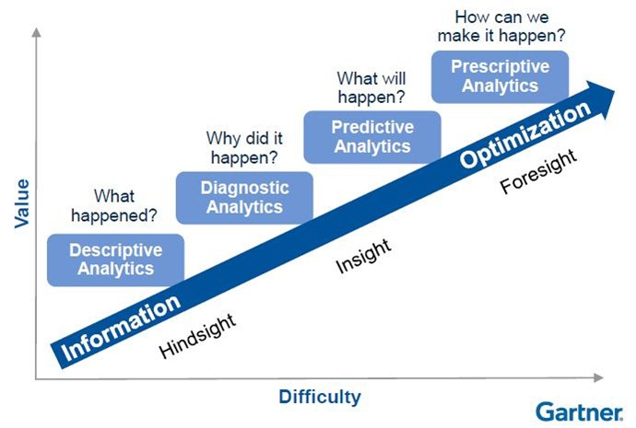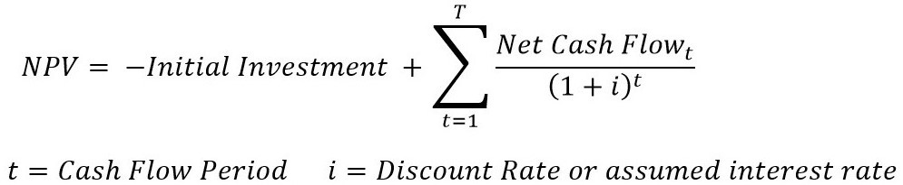

**Four Types of Data Analytics**

**Cashflow Analysis; Net Present Value and the Time Value of Money**