SUPERMARKET SALES ANALYSIS
AICTE | IBM SkillsBuild Data Analytics with AI Internship 2026 | BharatCares
Data Analytics Capstone Project
AI-Powered Data Analytics Masterclass Series — Final Project

Prepared by
Aman Kumawat
Jaipur Engineering College and Research Centre (JECRC)
September 2026

1. Problem Statement
This project analyzes 500 sales transactions from a four-branch supermarket chain (Jaipur, Mumbai, Delhi, and Bengaluru) to uncover patterns in product performance, branch performance, category trends, payment behaviour, and customer satisfaction. The goal is to turn raw transaction data into clear, data-backed business insights and recommendations — and to only present a claim once it has been checked directly against the numbers, rather than accepting an AI-generated suggestion at face value.

PROJECT OBJECTIVE & BUSINESS QUESTIONS
Objective: Convert the supplied supermarket transaction data into reproducible, evidence-based insights that can support decisions about products, branches, categories, payments, customer types, and customer satisfaction.
Business questions addressed:
1. How does revenue vary across the complete months available in the dataset?
2. Which products and categories contribute most to sales?
3. How do the four branches compare in total sales?
4. How evenly are the four payment methods used?
5. How do Member and Normal transactions differ in volume, revenue, and average transaction value?
6. How do customer ratings vary by category, and is rating linearly associated with transaction sales value?
7. What limitations prevent stronger causal or customer-level conclusions?

2. Dataset
The dataset contains 500 supermarket sales transactions across 13 fields, covering product, branch, city, customer type, gender, quantity, unit price, payment method, rating, and sales.
Rows (transactions) | 500
Columns | 13 — Invoice ID, Date, Branch, City, Customer Type, Gender, Product, Category, Quantity, Unit Price, Payment, Rating, Sales
Date range | 1 Jan 2026 – 1 Jul 2026 (July has only 7 transactions, all on 1 Jul — partial month)
Branches / Cities | A – Jaipur, B – Delhi, C – Mumbai, D – Bengaluru
Categories | 8 — Beverages, Personal Care, Dairy, Grocery, Fruits, Snacks, Vegetables, Bakery
Unique products | 20
Customer types | Member, Normal
Payment methods | UPI, Card, Net Banking, Cash
Total revenue | ₹244,411.08
Dataset source | Google Sheet supplied in the internship brief; the submitted workbook is the Excel export used for reproducible analysis.
Dataset file used: SUPER MARKET DATA.xlsx (the supplied project dataset/export).

DATA DICTIONARY
The following fields are used in the analysis. Definitions are based on the supplied dataset structure.
Field | Meaning / analytical role
Invoice ID | Unique transaction identifier
Date | Transaction date
Branch | Branch code (A–D)
City | Branch location
Customer Type | Member or Normal
Gender | Customer gender recorded in the source data
Product | Individual product name
Category | Product category
Quantity | Units purchased in the transaction
Unit Price | Price per unit
Payment | Payment method used
Rating | Customer rating on a 0–5 scale
Sales | Transaction sales value; validated against Quantity × Unit Price
Scope limitation: the dataset does not contain customer IDs, cost/margin, discounts, inventory, promotions, staffing, or footfall information. These missing dimensions limit customer-level, profitability, and causal conclusions.

3. Methodology — Steps Used for Analysis
- Collected and loaded the dataset into a pandas DataFrame.
- Checked the data for missing values, duplicate invoice IDs, and verified that Sales = Quantity × Unit Price for every row.
- Grouped and summarised the data by product, branch, category, payment method, customer type, and month.
- Created 7 visualisations to compare results across these dimensions.
- Converted each observation into a business insight, proposed tentative hypotheses where a pattern needed explaining, and derived practical recommendations.
Used AI as a drafting/brainstorming aid for analytical questions and hypothesis wording; all numerical results and claims were verified programmatically against the dataset.
- Cross-checked every number below directly against the dataset before writing it down — including catching a partial month and a near-tie that could otherwise have been mis-stated as a clear “winner.”

3.1 Responsible AI Use
AI was used as a supporting tool for brainstorming analytical questions, structuring the report, and refining hypothesis wording. It was not treated as the source of truth for numerical results. All reported figures were calculated from the supplied dataset with Python and cross-checked before inclusion. Where the data could not establish causation, explanations are explicitly labelled as hypotheses and the additional evidence needed to test them is identified.

4. Data Quality Check
Before any analysis, the dataset was checked for the kind of issues that quietly distort results:
- Missing values: none, across all 500 rows and 13 columns.
- Duplicate Invoice IDs: none — all 500 transactions are unique.
- Sales formula: Sales matches Quantity × Unit Price to 2 decimal places for all 500 rows, so the Sales column did not need to be recalculated.
- Date coverage: the data runs from 1 Jan to 1 Jul 2026. July contains only 7 transactions, all dated 1 July — a single day, not a full month.
Why this matters: a first pass at “monthly revenue” would show July as the lowest month by a huge margin — but that is a data-coverage artefact, not a business decline. This report excludes the partial July month from month-over-month comparisons (Section 5.1) rather than presenting an unverified claim, in line with the “never present an unverified AI claim” principle from the masterclass.

5. Exploratory Data Analysis
Seven visualisations were built to answer the core business questions. Each is followed by a plain-language observation — a direct read of the chart, with no interpretation added yet.

5.1 Monthly Revenue Trend
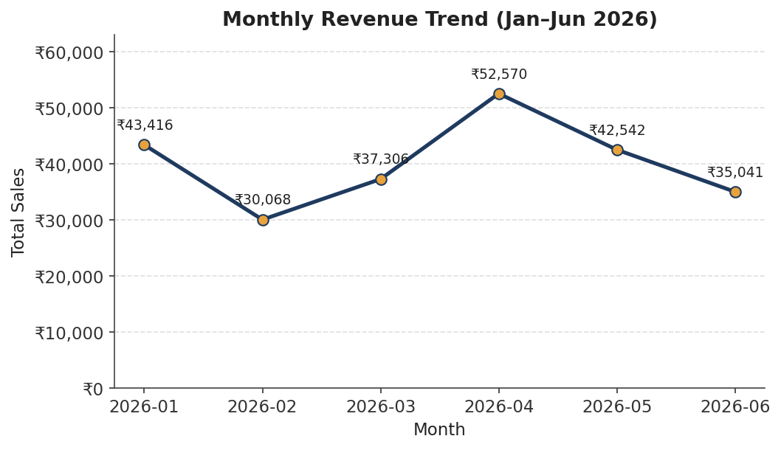
Figure 1. Total sales by month, January–June 2026 (July excluded — partial month).
Observation: Among the six complete months, revenue peaked in April 2026 (₹52,569.77) and was lowest in February 2026 (₹30,068.15). This is month-to-month variation in the available period; a longer time series would be needed to establish a recurring seasonal pattern.

5.2 Top Products
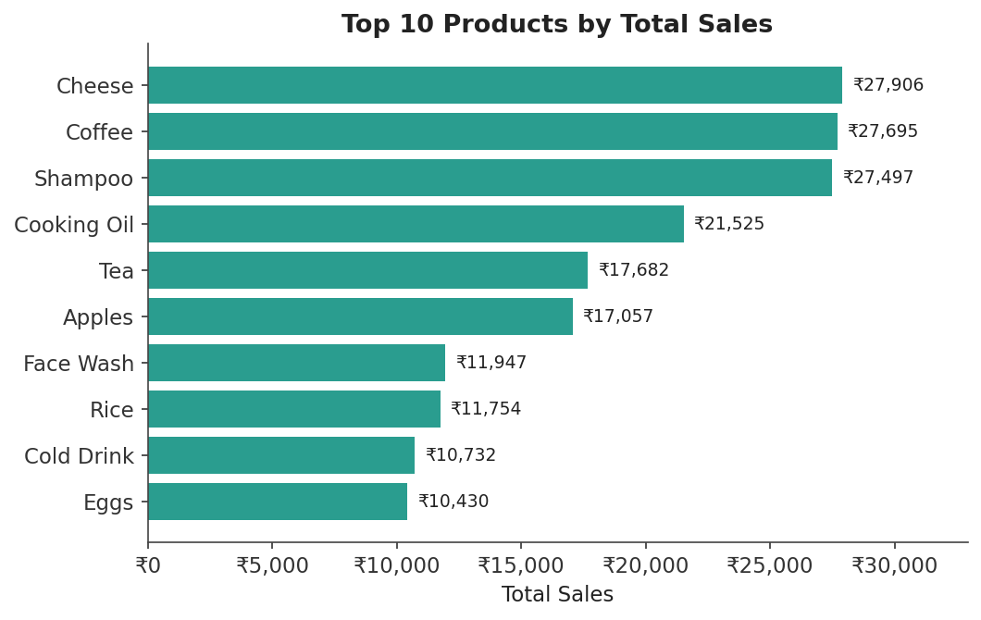
Figure 2. Top 10 products by total sales.
Observation: Cheese is the top-selling product (₹27,906.30), closely followed by Coffee (₹27,694.87) and Shampoo (₹27,497.48) — the top three are within 1.5% of each other. Biscuits is the lowest of the 20 products (₹3,908.87).

5.3 Branch Performance
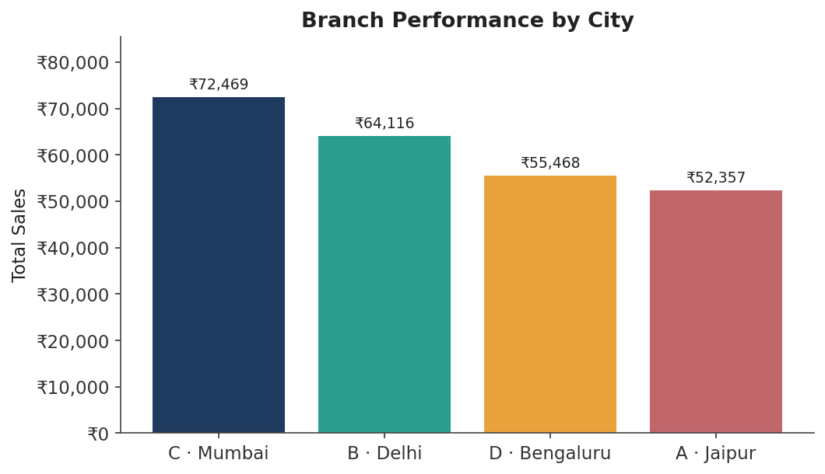
Figure 3. Total sales by branch and city.
Observation: Branch C in Mumbai generated the highest sales (₹72,469.45); Branch A in Jaipur generated the lowest (₹52,357.08) — a ≈1.4× spread across the four branches.

5.4 Category Performance
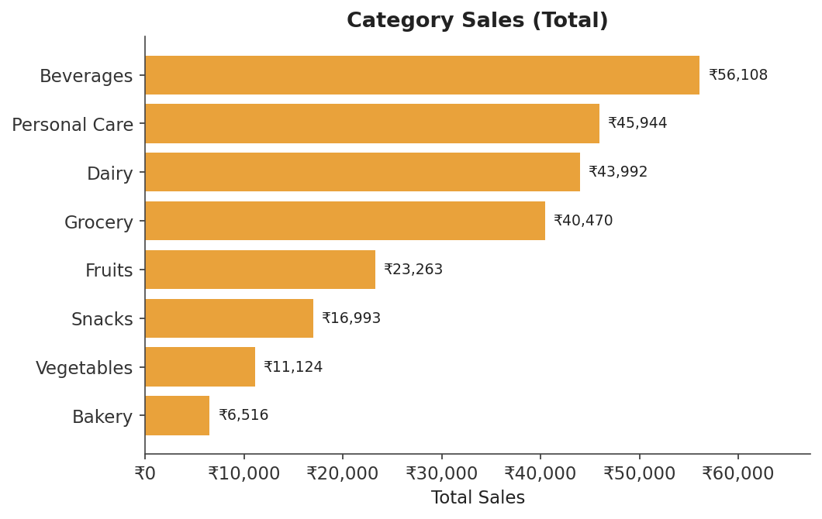
Figure 4. Total sales by product category.
Observation: Beverages is the top category (₹56,108.24, ≈23% of total revenue); Bakery is the lowest (₹6,516.10, ≈2.7%) — an ≈8.6× gap, the widest disparity among the dimensions analysed here.

5.5 Payment Method Distribution
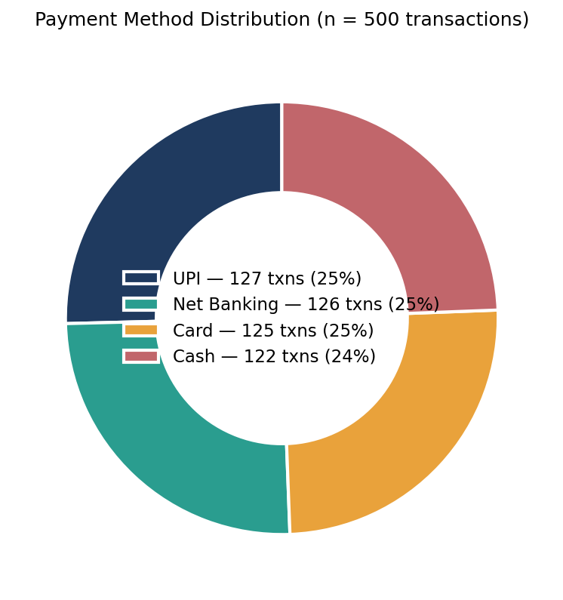
Figure 5. Share of transactions by payment method (n = 500).
Observation: The four payment methods are used almost equally — UPI (127), Net Banking (126), Card (125), and Cash (122) — all within 5 transactions of each other.

5.6 Member vs. Normal Customers
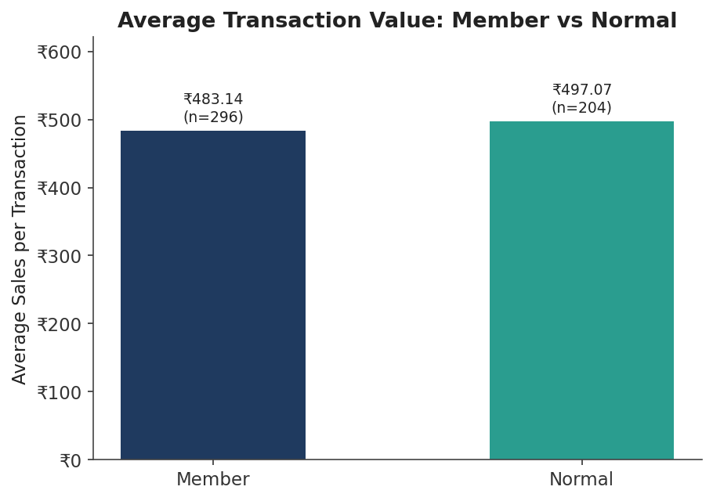
Figure 6. Average transaction value by customer type.
Observation: Members placed more orders (296 vs. 204) and generated more total revenue (₹143,009.30 vs. ₹101,401.78), but their average transaction value was slightly lower (₹483.14) than Normal customers’ (₹497.07).

5.7 Customer Ratings by Category
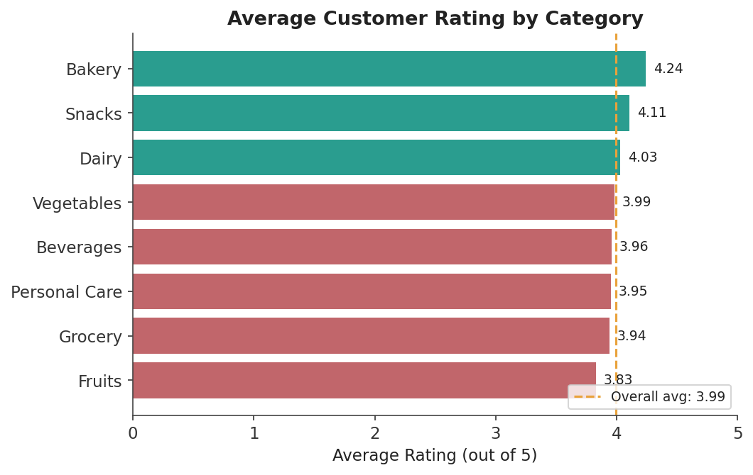
Figure 7. Average customer rating by category, against the overall average (3.99).
Observation: The overall average rating is 3.99 / 5. Bakery is rated highest (4.24) despite being the lowest-revenue category, while Fruits is rated lowest (3.83). The transaction-level Pearson correlation between rating and sales value is −0.047, indicating little linear association in this dataset; this does not by itself prove independence or causation.

6. Key Insights
Insights go one step beyond the observations above: they explain why a pattern matters to the business, without claiming more than the data can support.
Insight 1 — Month-to-month revenue varies across the available period. The Jan–Jun range (₹30,068–₹52,570) is about 1.75×. April is the highest complete month and February the lowest, but six complete months are not enough to establish a recurring seasonal pattern; longer historical data would strengthen any seasonality conclusion.
Insight 2 — Product revenue is diversified; category revenue is concentrated. No single product dominates — the top 3 are within 1.5% of each other. Yet Beverages alone drives ≈23% of revenue, and the top three categories together account for ≈60%. The business is more exposed to a category-level shift than to any one product underperforming.
Insight 3 — Branch sales differ across the four locations. Mumbai is highest at ₹72,469.45 and Jaipur is lowest at ₹52,357.08, a ≈1.4× spread. The difference is large enough to investigate, but the available sales data alone does not identify its cause.
Insight 4 — Payment behaviour shows no dominant channel. With all four methods within a 5-transaction band out of 500, there is no clear dominant channel. UPI leads the second-place method by only one transaction.
Insight 5 — The Member customer type has higher transaction volume, not a larger average transaction. Members account for 296 transactions and ₹143,009.30 in revenue versus 204 transactions and ₹101,401.78 for Normal customers, while average transaction value is ₹483.14 versus ₹497.07. Because there is no customer ID, this dataset cannot establish individual loyalty, retention, visit frequency per person, or lifetime value.
Insight 6 — Ratings and transaction sales value show little linear association. Bakery is the lowest-selling category but the highest-rated; Fruits is rated lowest. Jaipur has both the lowest branch sales and lowest branch rating, while Bengaluru has the highest branch rating without being the top-selling branch. These patterns justify tracking sales and satisfaction separately, but they do not establish that the metrics are independent.

7. Limitations and Scope
The analysis is intentionally limited to what can be supported by the supplied transaction-level dataset.
• The dataset contains 500 transactions and only six complete months; the available period is not sufficient to establish a recurring seasonal pattern with confidence.
• There is no customer ID, so Member vs. Normal analysis is at the transaction/customer-type level and cannot measure individual retention, visits per person, or lifetime value.
• The dataset contains sales but not cost, margin, discounts, inventory, promotions, staffing, or footfall data; sales differences therefore do not establish profitability or their underlying causes.
• The rating–sales Pearson correlation is a transaction-level association measure; a low correlation does not prove independence, causation, or the absence of other relationships. July’s seven transactions on 1 July are excluded from month-to-month comparisons because July is a partial month.

8. Hypotheses
A hypothesis is a possible explanation for a pattern — not a confirmed fact. The three strongest insights above (2, 3, and 6) are carried forward here, each with more than one plausible explanation.
Hypothesis 1 — Category concentration (Beverages vs. Bakery): Beverages’ lead might be driven by higher repeat-purchase frequency as an everyday consumable, or by a wider product range within the category. Bakery’s low share could possibly reflect fewer SKUs, shelf-life limits on how much stock is kept, or lower footfall in that aisle — the data cannot confirm which factor, or combination, is responsible.
Hypothesis 2 — Branch gap (Mumbai vs. Jaipur): Branch C’s stronger performance may be related to store location, local footfall, or regional demand patterns. Jaipur’s combination of the lowest revenue and lowest rating could possibly share one underlying cause (e.g., store experience or staffing), though it might equally be two unrelated issues — this would need direct customer or staff feedback to confirm.
Hypothesis 3 — Ratings may reflect factors other than transaction value: Because rating has little linear correlation with sales value, customers may be responding to service, staff, store environment, or other factors rather than transaction value alone. This is only a hypothesis and would require direct customer feedback or additional variables to test.

9. Recommendations (Business Decisions)
Recommendation 1 — Protect the Beverages lead while testing Bakery’s ceiling. Maintain strong shelf placement and stock levels for Beverages, and run a small, time-boxed pilot in Bakery (e.g., expanded assortment or a placement change). Compare category Sales before and after the pilot rather than assuming the cause in advance.
Recommendation 2 — Compare branch practices before attributing the sales gap to a specific cause. Review staffing, layout, local marketing, and other operational factors across the Mumbai and Jaipur branches, and collect direct customer feedback at Jaipur before deciding which intervention is appropriate.
Recommendation 3 — Track sales and satisfaction as two separate KPIs. Don’t assume a strong-selling category or branch is automatically satisfying customers, or vice versa. Monitor a minimum rating threshold per category/branch alongside revenue, and flag any that is strong on one metric and weak on the other — Bakery, Fruits, and Jaipur are the current examples — for a closer look.
Recommendation 4 — Maintain availability of all four payment methods. The transaction counts are close (UPI 127, Net Banking 126, Card 125, Cash 122), so this dataset does not provide a strong basis for prioritising one payment channel over the others.

10. Conclusion
This analysis turned 500 raw transactions into a verified view of the supermarket’s performance: meaningful month-to-month variation across the six complete months; product-level diversification alongside category concentration in Beverages; a ≈1.4× branch sales gap between Mumbai and Jaipur; payment transaction counts that are close across all four methods; higher transaction volume and total revenue for the Member customer type but a slightly smaller average transaction; and little linear association between rating and transaction sales value. Every quantitative claim in this report was checked against the project dataset, including the Sales = Quantity × Unit Price check to 2 decimal places and the exclusion of partial July data from monthly comparisons. The accompanying notebook reproduces the data loading, validation, calculations, and visualisations from the supplied workbook.

11. Submission Package
The Google Form requires four files. The submission package is:
• Report — AmanKumawat_SupermarketSalesAnalysis_ProjectReport.docx
• Code — AmanKumawat_SupermarketSalesAnalysis.ipynb
• Requirements — requirements.txt
• README — README.md
Note: The Google Form requires four uploads—Code, Requirements, Project Report, and README. The dataset workbook is used by the notebook but is not one of the four upload fields shown in the form.

