clc;

clear all;

close all;

a=rgb2gray(imread('\\homes.mtu.edu\home\Desktop\target.jpg')); figure;imshow(a,[])

%2D fft

t = fft2(a);

D=100;

[M N]=size(a);

%defing the filter, high pass filter

Y = fftshift(fft2(a));

[rows, columns] = size(Y);

B= Y;

centerX = round(N / 2);

centerY = round(M / 2);

% Filter: Erase center spike.

filterWidth = 100;

% zeroing out the high frquencies in the middle

B(centerY-filterWidth:centerY+filterWidth, centerX-filterWidth : centerX+filterWidth) = 0;

%applying filter to the freqencey domian

filteredImage = abs(ifft2(ifftshift(B)));

max(filteredImage(:))

min(filteredImage(:))

figure;

imshow(filteredImage, [])

axis on;

ans =

183.9350

ans =

0.0014

1

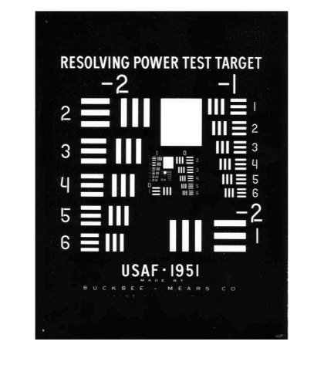2

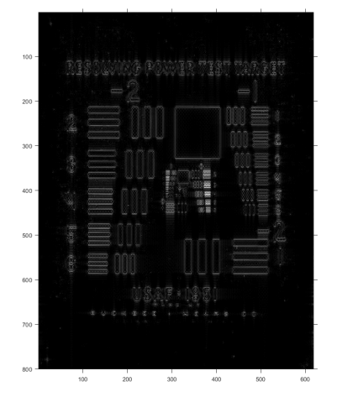*Published with MATLAB® R2019a*

3